|  |  |
| --- | --- |
| 3GPP TR 38.881 V18.0.0 (2023-12) | |
| Technical Report | |
| 3rd Generation Partnership Project;  Technical Specification Group Radio Access Networks;  Lower MSD for inter-band CA/EN-DC/DC combinations  (Release 18) | |
|  | |
|  | 3GPP-logo_web |
|  | |
| The present document has been developed within the 3rd Generation Partnership Project (3GPP TM) and may be further elaborated for the purposes of 3GPP. The present document has not been subject to any approval process by the 3GPPOrganizational Partners and shall not be implemented. This Specification is provided for future development work within 3GPPonly. The Organizational Partners accept no liability for any use of this Specification. Specifications and Reports for implementation of the 3GPP TM system should be obtained via the 3GPP Organizational Partners’ Publications Offices. | |

|  |
| --- |
|  |
| ***3GPP***  Postal address  3GPP support office address  650 Route des Lucioles – Sophia Antipolis  Valbonne – FRANCE  Tel.: +33 4 92 94 42 00 Fax: +33 4 93 65 47 16  Internet  <http://www.3gpp.org> |
| ***Copyright Notification***  No part may be reproduced except as authorized by written permission. The copyright and the foregoing restriction extend to reproduction in all media.  © 2023, 3GPP Organizational Partners (ARIB, ATIS, CCSA, ETSI, TSDSI, TTA, TTC).  All rights reserved.  UMTS™ is a Trade Mark of ETSI registered for the benefit of its members  3GPP™ is a Trade Mark of ETSI registered for the benefit of its Members and of the 3GPP Organizational Partners LTE™ is a Trade Mark of ETSI registered for the benefit of its Members and of the 3GPP Organizational Partners  GSM® and the GSM logo are registered and owned by the GSM Association |

Contents

Foreword 5

1 Scope 7

2 References 7

3 Definitions of terms, symbols and abbreviations 8

3.1 Terms 8

3.2 Symbols 8

3.3 Abbreviations 8

4 Background 9

4.1 Objective 9

5 Band combinations selected for lower MSD analysis 9

6 Study of MSD improvement 9

6.1 General 9

6.2 Feasibility study 10

6.2.1 Evaluation from Huawei [8] 10

6.2.1.1 MSD analysis assumptions 10

6.2.1.2 MSD by Harmonic Mixing 10

6.2.1.3 MSD by Cross-band Isolation 10

6.2.1.4 MSD by Harmonic Interference 11

6.2.1.5 MSD by Dual-UL Inter-Modulation Distortion 12

6.2.1.6 Summary of MSD 13

6.2.2 Evaluation from Samsung [9] 14

6.2.2.1 CA\_n3-n78 MSD Analysis on IMD2 14

6.2.2.2 CA\_n3-n78 MSD Analysis on IMD4 15

6.2.2.3 CA\_n3-n78 MSD Analysis on 2nd Harmonic 15

6.2.2.4 CA\_n28-n40 MSD Analysis on 3nd Harmonic mixing 16

6.2.2.5 CA\_n1-n3 MSD Analysis on cross band isolation 17

6.2.3 Evaluation from Nokia [10] 18

6.2.3.1 2nd UL harmonic for CA\_3-n78 18

6.2.3.1.1 MSD improvement by single RF component performance improvement 18

6.2.3.1.2 Possible way to achieve 20 dB MSD improvement 20

6.2.3.1.3 20 dB MSD improvement with less isolation improvement in Path 2 &3 20

6.2.3.1.4 How to achieve MSD = 0 dB 21

6.2.3.2 2nd order harmonic mixing for CA\_n3-n78 22

6.2.3.3 IMD2 for CA\_n3-n78 23

6.2.3.4 MSD improvement and MSD types 24

6.2.4 Evaluation from Qualcomm [11] 25

6.2.5 Evaluation from Apple [12] 30

6.2.5.1 CA\_n3-n78 UL 2nd harmonic MSD analysis 30

6.2.5.2 CA\_n3-n78 2UL IMD2 MSD analysis 32

6.2.5.3 CA\_n28-n40 3rd order harmonic mixing MSD analysis 34

6.2.6 Evaluation from ZTE [13] 36

6.2.7 Evaluation from LGE [14] 41

6.2.8 Evaluation from Xiaomi [15] 42

6.2.8.1 2nd harmonic MSD analysis for CA\_n3-n78 42

6.2.8.2 IMD MSD analysis for CA\_n3-n78 43

6.2.8.2.1 IMD2 MSD 44

6.2.8.2.2 IMD4 MSD 45

6.2.8.3 Comparison of MSD improvement for different MSD types 46

6.2.8.4 Cross band isolation for CA\_n1-n3 (R4-2219037) 46

6.2.9 Evaluation from Meta [16] 47

6.2.9.1 MSD evaluation results by Harmonic problem 47

6.2.9.2 MSD evaluation results by cross band isolations 48

6.2.9.3 MSD evaluation results by dual uplink transmission 49

6.3 Conclusion 50

7 Study of signalling for improved lower MSD 50

7.1 Possible MSD reporting approaches 50

7.1.1 Candidate solution 1: MSD reporting depending on frequency region 50

7.1.2 Candidate solution 2: MSD reporting for frequency regions affected by self-interference 53

7.1.2.1 Basic MSD information unit 53

7.1.2.2 Reporting of low-MSD information 54

7.1.2.2.1 Aspect of higher order band combinations 54

7.1.2.2.2 Aspect of power classes 54

7.1.2.2.3 Network query based reporting 55

7.1.2.2.3.1 Effect of introducing frequency range as one of the filtering conditions 56

7.1.2.2.3.2 Effect of introducing network preferred minimum Lower MSD class as one of the filtering conditions 57

7.1.3 Candidate solution 3: MSD reporting for frequency regions affected by self-interference 58

7.1.3.1 Basic MSD information unit 58

7.1.3.2 Reporting of low-MSD information 60

7.2 Conclusion 61

Annex A (informative): Change history 64

# Foreword

This Technical Report has been produced by the 3rd Generation Partnership Project (3GPP).

The contents of the present document are subject to continuing work within the TSG and may change following formal TSG approval. Should the TSG modify the contents of the present document, it will be re-released by the TSG with an identifying change of release date and an increase in version number as follows:

Version x.y.z

where:

x the first digit:

1 presented to TSG for information;

2 presented to TSG for approval;

3 or greater indicates TSG approved document under change control.

y the second digit is incremented for all changes of substance, i.e. technical enhancements, corrections, updates, etc.

z the third digit is incremented when editorial only changes have been incorporated in the document.

In the present document, modal verbs have the following meanings:

**shall** indicates a mandatory requirement to do something

**shall not** indicates an interdiction (prohibition) to do something

The constructions “shall” and “shall not” are confined to the context of normative provisions, and do not appear in Technical Reports.

The constructions “must” and “must not” are not used as substitutes for “shall” and “shall not”. Their use is avoided insofar as possible, and they are not used in a normative context except in a direct citation from an external, referenced, non-3GPP document, or so as to maintain continuity of style when extending or modifying the provisions of such a referenced document.

**should** indicates a recommendation to do something

**should not** indicates a recommendation not to do something

**may** indicates permission to do something

**need not** indicates permission not to do something

The construction “may not” is ambiguous and is not used in normative elements. The unambiguous constructions “might not” or “shall not” are used instead, depending upon the meaning intended.

**can** indicates that something is possible

**cannot** indicates that something is impossible

The constructions “can” and “cannot” are not substitutes for “may” and “need not”.

**will** indicates that something is certain or expected to happen as a result of action taken by an agency the behaviour of which is outside the scope of the present document

**will not** indicates that something is certain or expected not to happen as a result of action taken by an agency the behaviour of which is outside the scope of the present document

**might** indicates a likelihood that something will happen as a result of action taken by some agency the behaviour of which is outside the scope of the present document

**might not** indicates a likelihood that something will not happen as a result of action taken by some agency the behaviour of which is outside the scope of the present document

In addition:

**is** (or any other verb in the indicative mood) indicates a statement of fact

**is not** (or any other negative verb in the indicative mood) indicates a statement of fact

The constructions “is” and “is not” do not indicate requirements.

# 1 Scope

The present document is a technical report for study of lower MSD for inter-band CA/EN-DC/DC combinations.

# 2 References

The following documents contain provisions which, through reference in this text, constitute provisions of the present document.

- References are either specific (identified by date of publication, edition number, version number, etc.) or non‑specific.

- For a specific reference, subsequent revisions do not apply.

- For a non-specific reference, the latest version applies. In the case of a reference to a 3GPP document (including a GSM document), a non-specific reference implicitly refers to the latest version of that document *in the same Release as the present document*.

[1] 3GPP TR 21.905: “Vocabulary for 3GPP Specifications”.

[2] RP-210890, “New WID on New WID on simultaneous Rx/Tx band combinations for CA, SUL, MR-DC and NR-DC”.

[3] 3GPP TS 38.101-1: “NR; User Equipment (UE) radio transmission and reception; Part 1: Range 1 Standalone”.

[4] 3GPP TS 38.101-2: “NR; User Equipment (UE) radio transmission and reception; Part 2: Range 2 Standalone”.

[5] 3GPP TS 38.101-3: “NR; User Equipment (UE) radio transmission and reception; Part 3: Range 1 and Range 2 Interworking operation with other radios”.

[6] R4-2214452, “WF on study for lower MSD”, Huawei, HiSilicon

[7] R4-2217723, “WF on study for lower MSD”, Huawei, HiSilicon

[8] R4-2216776, “Further discussion on the feasibility of improving MSD”, Huawei, HiSilicon

[9] R4-2215734, “Views on feasibility of improved MSD”, Samsung

[10] R4-2215792, “Feasibility study on amount of MSD improvement”, Nokia

[11] R4-2215379, “Investigation of band combinations for MSD reduction”, Qualcomm

[12] R4-2215666, “Further analyses and views on MSD improvement for inter-band CA and DC”, Apple

[13] R4-2215889, “Discussion on lower MSD for inter-band CA/ENDC”, ZTE

[14] R4-2216187, “MSD evaluation considering the high PCB isolation for CA n1-n3”, LG Electronics

[15] R4-2216145, “Discussion on lower MSD for inter-band CA/EN-DC/DC”, Xiaomi

[16] R4-2218297, “On MSD evaluation with new assumptions for MSD improvement”, Meta

# 3 Definitions of terms, symbols and abbreviations

## 3.1 Terms

For the purposes of the present document, the terms given in 3GPP TR 21.905 [1] and the following apply. A term defined in the present document takes precedence over the definition of the same term, if any, in 3GPP TR 21.905 [1].

## 3.2 Symbols

For the purposes of the present document, the following symbols apply:

<symbol> <Explanation>

## 3.3 Abbreviations

For the purposes of the present document, the abbreviations given in 3GPP TR 21.905 [1] and the following apply. An abbreviation defined in the present document takes precedence over the definition of the same abbreviation, if any, in 3GPP TR 21.905 [1].

ACLR Adjacent Channel Leakage Ratio

ACS Adjacent Channel Selectivity

A-MPR Additional Maximum Power Reduction

BCS Bandwidth Combination Set

CA Carrier Aggregation

CC Component Carrier

DC Dual Connectivity

EIRP Equivalent Isotropically Radiated Power

EN-DC E-UTRA/NR DC

EVM Error Vector Magnitude

FDM Frequency Division Multiplexing

FR Frequency Range

ENBW The aggregated bandwidth of an E-UTRA sub-block and an adjacent NR sub-block

ITS Intelligent Transportation System

ITU-R Radiocommunication Sector of the International Telecommunication Union

MBW Measurement bandwidth defined for the protected band

MPR Allowed maximum power reduction

MSD Maximum Sensitivity Degradation

MCG Master Cell Group

NR New Radio

NS Network Signalling

NSA Non-Standalone, a mode of operation where operation of an other radio is assisted with an other radio

OOB Out-of-band

OOBE Out-of-band emission

OTA Over The Air

PRB Physical Resource Block

PSCCH Physical Sidelink Control Channel

PSSCH Physical Sidelink Shared Channel

RE Resource Element

REFSENS Reference Sensitivity

RF Radio Frequency

Rx Receiver

SCG Secondary Cell Group

SCS Subcarrier spacing

SEM Spectrum Emission Mask

SL Sidelink

SUL Supplementary uplink

TDM Time Division Multiplex

Tx Transmitter

UE User Equipment

UL MIMO Up Link Multiple Antenna transmission

ULSUP Uplink sharing from UE perspective

# 4 Background

## 4.1 Objective

The objectives of the lower MSD objective in the Rel-18 UE RF FR1 WI are as follows:

**Investigate the feasibility of lower MSD for inter-band CA/EN-DC/DC combinations [RAN4]**

- Select a limited set of band combinations (2-4 combinations) to cover all types of MSD (harmonic, harmonic mixing, IMD and cross band isolation)

- Study how the MSD performance can be improved for the example band combinations

- Study of MSD improvement with different MSD sources (harmonics, IMD2/3/4/5, cross band isolation and harmonic mixing)

- Study the feasibility of and options for allowing a UE to signal improved lower MSD performance capability for combinations where MSD is allowed

- Aim to conclude the study phase by RAN#99, and further discuss in RAN#99 how to handle the objective based on the study progress.

# 5 Band combinations selected for lower MSD analysis

The following example band combinations are used to study the feasibility of MSD improvement for different MSD types:

- CA\_n28-n40 (harmonic mixing)

- CA\_n41-n77 (cross band isolation)

- CA\_n1-n3-n78 and fallback combinations (IMD on the 3rd band, cross band isolation on CA\_n1-n3 using 50MHz channel bandwidth, IMD2/4 and 2nd harmonic and harmonic mixing on CA\_n3-n78)

Note 1: All supported power classes for the above example band combinations can be analyzed.

# 6 Study of MSD improvement

## 6.1 General

The purpose of study of MSD improvement is to justify whether it is feasible to improve the MSD for a band combination with reasonable implementation assumptions, which is the basis for the next stage study of signaling part of the WI objective for lower MSD.

It was agreed in WF [7] that no unified assumptions are needed for the evaluation of MSD improvement, e.g. reference architectures, antenna isolation, PCB isolation, component linearity, etc. The following feasibility study are carried out by companies separately with own analysis assumptions for reference. Apart from the assumptions, if listed, the evaluation results for the example band combinations as well as the observations are captured in the feasibility study respectively.

## 6.2 Feasibility study

### 6.2.1 Evaluation from Huawei [8]

#### 6.2.1.1 MSD analysis assumptions

Some common RF assumptions are listed in Table 6.2.1.1-1 below, which are the baseline for the following MSD analysis. Some parameters such as PCB/antenna isolation may be varied to evaluate their effect on the MSD performance. Other parameters related to certain types of MSD are described in the individual sub-sections.

Table 6.2.1.1-1: Common RF assumptions

|  |  |
| --- | --- |
| Diplexer/Triplexer Isolation | 15 dB |
| Antenna Isolation | 10 dB |
| PCB isolation | 70 dB |
| Front-end insertion loss | 4~5 dB |
| PA output power | 27~28 dBm |

#### 6.2.1.2 MSD by Harmonic Mixing

The L-H band combinations such as CA\_n20-n40, CA\_n28-n40 and CA\_n18-n41 are susceptible to harmonic mixing problems. More than 30dB MSD is specified for CA\_n28-n40 when the mixing product of the UL in band n40 and the 3rd harmonic of the DL LO in band n28 falls within the receiver channel bandwidth. The MSD requirements reuse those for LTE CA\_28-40, which were defined based on the study of several contributions.

According to the analysis, the conductive path from the aggressor band transmitter to the victim band receiver dominates the interference level. And the victim band receiver **duplexer/filter rejection** at the aggressor frequency is the key factor in addition to the victim band receiver **mixer harmonic suppression**. Figure 6.2.1.2-1 shows the MSD variation with the optimization of the two key factors.

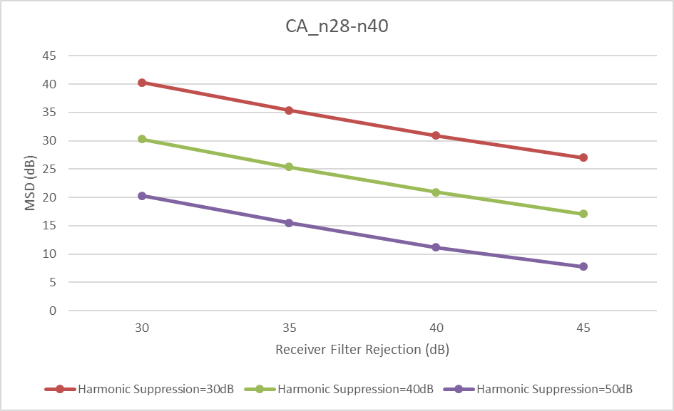

Figure 6.2.1.2-1: MSD by harmonic mixing varies with the receiver filter rejection and the mixer harmonic rejection. The PCB isolation of 70 dB is assumed.

#### 6.2.1.3 MSD by Cross-band Isolation

As seen from the REFSENS requirements in TS 38.101-1, the MSD is usually more severe when the source of cross-band isolation interference is “ACLR1” or “ACLR2” (e.g. CA\_n18-n28, CA\_n5-n28). If the aggressor channel BW is large (e.g. 50/100MHz), the MSD may increase to more than 10 or even above 20 dB (e.g. CA\_n1-n3, CA\_n1-n40), even if the source is classified as “>ACLR2”. It’s worth noting that the spec requirements target the worst cases, where the aggressor carrier frequency is set as close as possible to that of the victim.

As shown by the previous analysis, the PA noise and cross-band isolation are the main factors affecting the MSD when the carrier frequencies and UL RB allocation are fixed.

#### 6.2.1.4 MSD by Harmonic Interference

The band combination of CA\_n3-n78 or DC\_3\_n78 may suffer from MSD caused by H2 of the UL in band 3/n3 falling into the DL of band n78. All the RF components in the front-end of band 3/n3 could contribute to the generation of H2, including: duplexer, antenna switch, diplexer/triplexer and etc. It was identified that the main factors are:

- PA linearity

- Total filter attenuation (including Harmonic Trap Filter and B3 duplexer)

- PCB isolation.

The filter survey shows that the B3 duplexer attenuation at B42 ranges from 10 to 27 dB, and the discussions indicates that 30 dB is possible for future design. Additionally, the following assumptions were considered optimistic at that time: PA H2 = -35 dBc, HTF = 30dB and PCB isolation (@3.5GHz) = 70dB.

By tuning the total filter attenuation and the PCB isolation while fixing the PA H2=-35dBc, the MSD trend is obtained as shown in Figure 6.2.1.4-1.

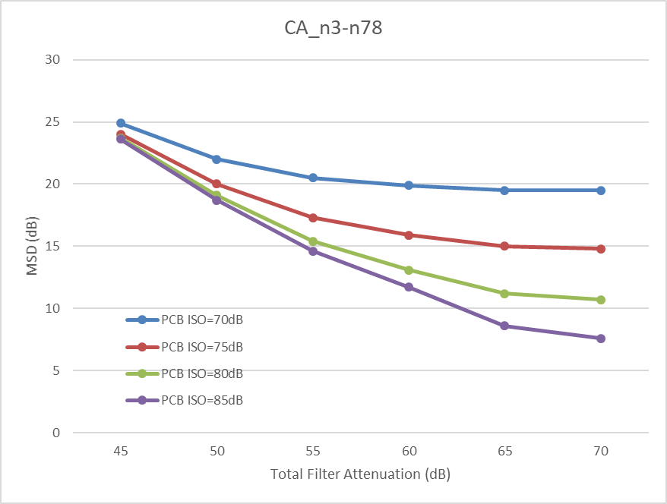

Figure 6.2.1.4-1: MSD by Tx harmonic varies with the Tx filter attenuation and the PCB isolation. The PA H2 is assumed to be -35dBc.

Figure 6.2.1.4-2 illustrates the combination of carrier frequencies that may suffer from MSD caused by Tx harmonic.

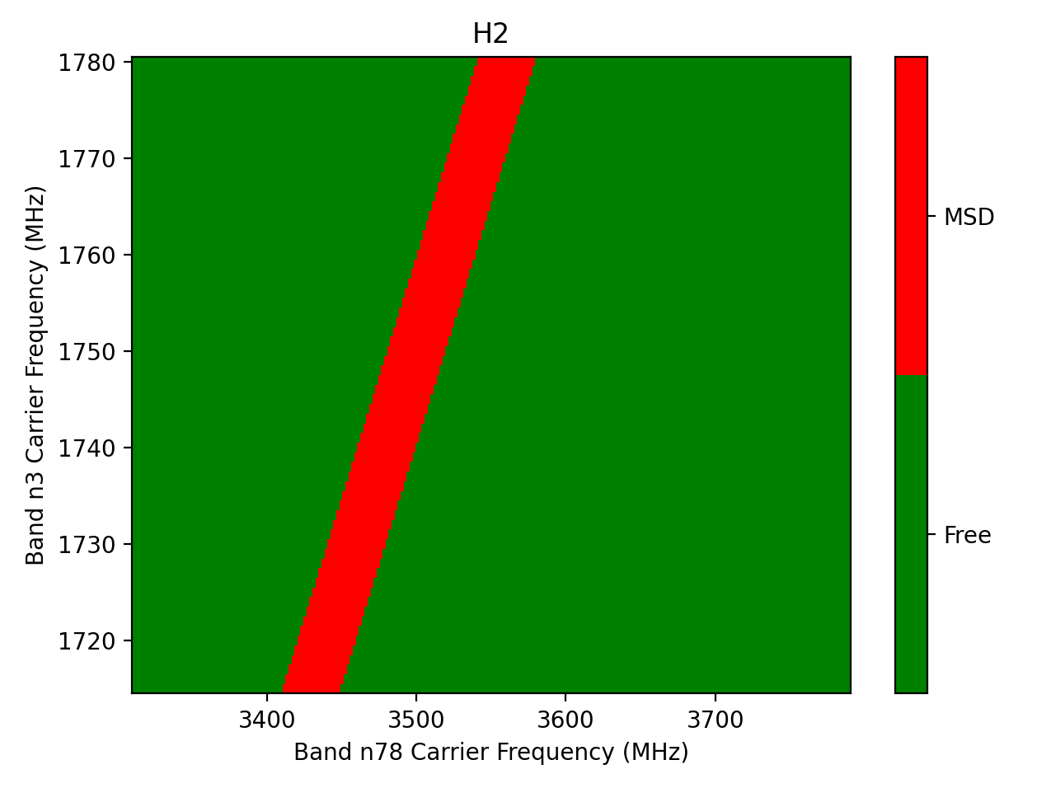

Figure 6.2.1.4-2: Illustration of carrier frequency combinations that may be affected by MSD caused by H2. CBW: 10MHz for n3, 20MHz for n78.

#### 6.2.1.5 MSD by Dual-UL Inter-Modulation Distortion

When both uplinks are active, the DL band n3 of CA\_n3-n78 may suffer from IMD2 and IMD4 of the dual-UL. It has been identified that PCB isolation and antenna isolation are the main factors. The MSD trend is reproduced in Figure 6.2.1.5-1 below.

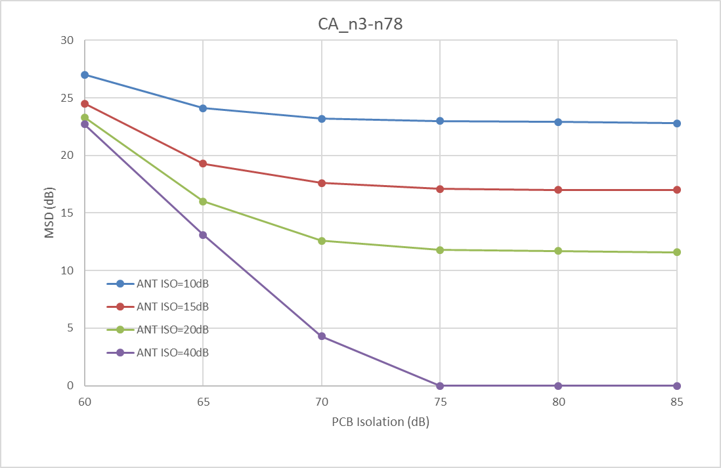

Figure 6.2.1.5-1: MSD caused by IMD2 for CA\_n3-n78 varies with different PCB isolation and antenna isolation. The 40dB antenna isolation is impractical for small form-factor UEs but serves as a performance indicator for conductive measurements.

In order for the self-interference to fall within the own receiver, the aggressors’ carrier frequencies and the victims’ carrier frequencies need to satisfy certain mathematical constraints, subject to the order of the IMD. Figure 6.2.1.5-2 indicates the occurrences of IM interferences for CA\_n3-n78.

|  |  |
| --- | --- |
|  |  |

**Figure 6.2.1.5-2: Illustration of the relationship between IMD and the carrier frequencies. The red color indicates that the IM product may fall into the victim Rx channel, assuming CBW: 10MHz for n3, 20MHz for n78.**

It can be seen that for the majority of the carrier frequency configurations of CA\_n3-n78, there’s no self-interference from IMD2 or IMD4 or H2. Furthermore, when MSD from IMD2 happens for a given deployment, MSD from IMD4 does not, or vice visa. Since n78 is a TDD band, the MSD caused by H2 of n3 will not happen at the same time as the MSD caused by IMD2 or IMD4 of the dual UL.

#### 6.2.1.6 Summary of MSD

Based on the above discussions, the key contributors for different types of MSDs are summarized in Table below.

Table 6.2.1.6-1: Key contributors for different MSD types

|  |  |
| --- | --- |
| MSD Types | Key Contributors |
| Harmonic Mixing (e.g. UL1/DL3, UL1/DL5, UL2/DL3, UL3/DL2) | Victim filter rejection and mixer harmonic suppression |
| Tx Harmonic (e.g. H2/3/4/5) | Aggressor PA linearity, harmonic filter and duplexer attenuation, PCB isolation |
| Cross-band Isolation (e.g. ALCR1/2, >ACLR2) | Aggressor PA noise and filter attenuation |
| Dual-UL IMD (e.g. IMD2/3/4/5/7) | PCB isolation, antenna isolation |

It has been shown that the MSD may be improved by optimizing the key contributors listed in Table 6.2.1.6-1. However, it can also be seen that for large MSD values (>20dB) it would be very challenging to reduce them to below 10dB. Furthermore, we can make the following observations:

**Observation 1: Different types of MSDs may have different limiting factors. Which one can be improved for what band combinations are design choices of the UE implementation.**

**Observation 2: For large MSD values (>20dB) it’s very challenging to reduce them to below 10dB. The relatively small MSD values (<10 dB) may be further improved depending on UE implementation.**

**Observation 3: The antenna isolation plays an important role in MSD performance. However, the effect is not verified by the existing conductive tests.**

**Observation 4: For a given band combination, MSD from different sources are unlikely to happen simultaneously, depending on the configuration of carrier frequencies, duplex mode of the component bands, the order of IMD or harmonics and etc*.***

### 6.2.2 Evaluation from Samsung [9]

#### 6.2.2.1 CA\_n3-n78 MSD Analysis on IMD2

The component linearity parameters and initial isolation parameters adopted in our calculation was summarized in Table 6.2.2.1-1 and Table 6.2.2.1-2 respectively.

Table 6.2.2.1-1 Front-end component linearity parameters for MSD calculation

|  |  |  |  |  |
| --- | --- | --- | --- | --- |
| Component | IP2(dBm) | IP3(dBm) | IP4(dBm) | IP5(dBm) |
| Ant. Switch | 112 | 68 | 56 | 53 |
| Triplexer | 115 | 86 | 55 | 53 |
| Duplexer | 100 | 74 | 55 | 53 |
| PA Forward | 28 | 30 | 32 | 27 |
| PA Reversed | 40 | 28 | 33 | 32 |
| LNA | 5 | -6 | -6 | -10 |

Table 6.2.2.1-2 Front-end component isolation

|  |  |  |
| --- | --- | --- |
| Isolation Parameter | Value (dB) | Comment |
| Antenna to Antenna | 10 | Main antenna to diversity antenna |
| PA (out) to PA (in) | 65 | PCB isolation (PA forward mixing) |
| Triplexer | 15 | Low/high/very high band isolation |
| PA (out) to PA (out) | 65 | PCB isolation (PA reverse mixing) |
| LNA (in) to PA (out) | 65 | Cross-band (B42 filter + triplexer) |
| LNA (in) to PA (out) | 65 | PCB isolation (B42 PA leakage into B3 LNA) |
| Duplexer | 50 | Tx band rejection at Rx band |

It is observed that PCB isolation, antenna isolation and duplexer isolation are the main contributors for MSD due to IMD2, the affected dominant items are marked as blue in the link budget calculation process of IMD2 presented in Table 6.2.2.1-3.

Table 6.2.2.1-3 Link budget analysis for CA\_n3-n78 IMD2



As recorded in WF, the feasible antenna isolation used in Lower MSD study is 10-20dB, while the feasible range of PCB isolation need further discussion. Under this premise we have evaluated the MSD improvement over antenna isolation up to 20dB and PCB isolation up to 85dB which are the two contributors to all kinds of MSD improvement, as Figure 6.2.2.1-1 without taking into account the practical implementation. Note that the feasibility of PCB isolation is subject to the group’s further confirmation.

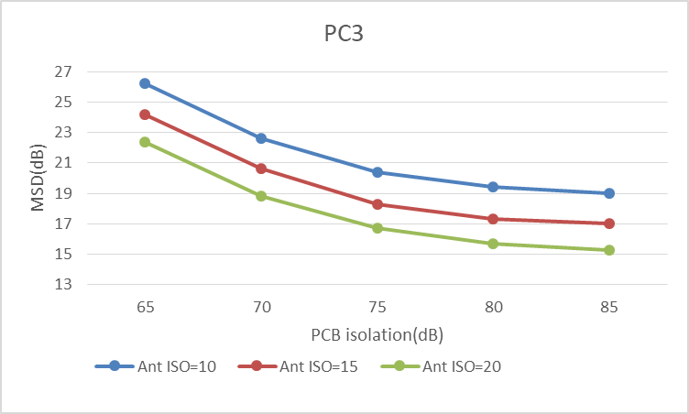

Figure 6.2.2.1-1 IMD2 MSD trend analysis over better PCB isolation and antenna isolation

**Observation 1: It is observed that in terms of PC3, MSD due to IMD2 of CA\_n3-n78 could be reduced to around 15dB with 85dB PCB isolation and 20dB antenna isolation, in contrast to 26dB specified MSD.**

#### 6.2.2.2 CA\_n3-n78 MSD Analysis on IMD4

The link budget calculation process of IMD4 is presented in Table 6.2.2.2-1 and the MSD improvement over antenna isolation up to 20 dB and PCB isolation up to 85 dB is presented in Figure 6.2.2.2-1.

Table 6.2.2.2-1 Link budget analysis for CA\_n3-n78 IMD4



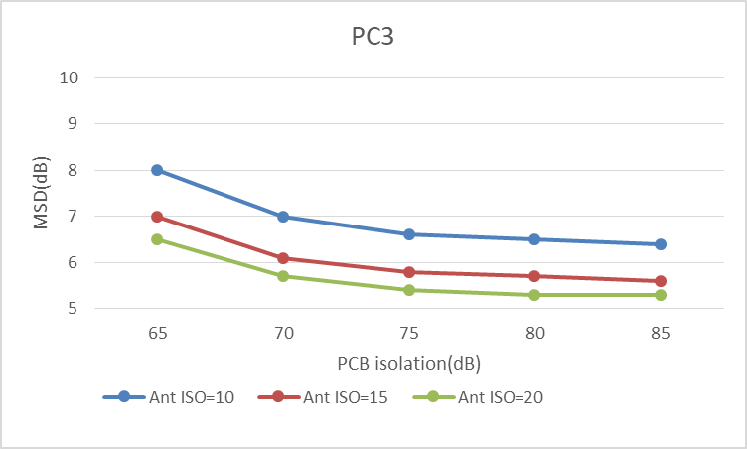

Figure 6.2.2.2-1 IMD4 MSD analysis over better PCB isolation and antenna isolation

**Observation 2: It is observed that in terms of PC3, MSD due to IMD4 of CA\_n3-n78 could be reduced to around 5dB with 85dB PCB isolation and 20dB antenna isolation, in contrast to 8dB specified MSD.**

#### 6.2.2.3 CA\_n3-n78 MSD Analysis on 2nd Harmonic

It is observed that PCB isolation, antenna isolation and PA harmonic rejection are the main contributors of the MSD due to harmonic, the link budget calculation process and its initial adopted RF component assumption are presented in Table 6.2.2.3-1 and similar as above the MSD improvement over antenna isolation up to 20 dB and PCB isolation up to 85 dB is presented in Figure 6.2.2.3-1.

Table 6.2.2.3-1 RF Component assumption and Link budget analysis for CA\_n3-n78 2nd harmonic MSD



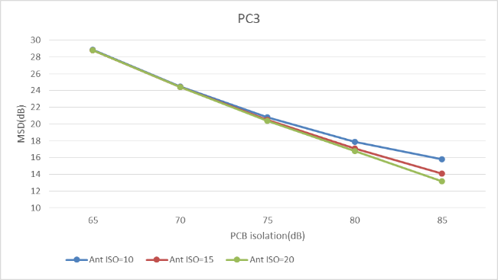

Figure 6.2.2.3-1 Harmonic MSD analysis over better PCB isolation and antenna isolation

Observation 3: It is observed that in terms of PC3, MSD due to 2nd harmonic of CA\_n3-n78 could be reduced to around 13dB with 85dB PCB isolation and 20dB antenna isolation, in contrast to 23.9dB specified MSD.

#### 6.2.2.4 CA\_n28-n40 MSD Analysis on 3nd Harmonic mixing

It is observed that PCB isolation, lower band Rx filter selectivity and Rx 3rd order harmonic rejection are the main contributors of the MSD due to harmonic mixing, the link budget calculation process and its initial adopted RF component assumption are presented in Table 6.2.2.4-1, based on our analysis larger antenna isolation has almost no contribution to the MSD improvement since it only affects the diversity conductive path which has less influence on Diversity MSD.

The MSD improvement over Rx 3rd harmonic rejection up to 30 dB and PCB isolation up to 85 dB is presented in Figure 6.2.2.4-1, without taking into account the practical implementation. Note that the antenna isolation assumption is 10dB considering antenna isolation has almost no contribution to the MSD improvement.

Table 6.2.2.4-1 RF Component assumption and Link budget analysis for CA\_n28-n40 3rd harmonic mixing MSD



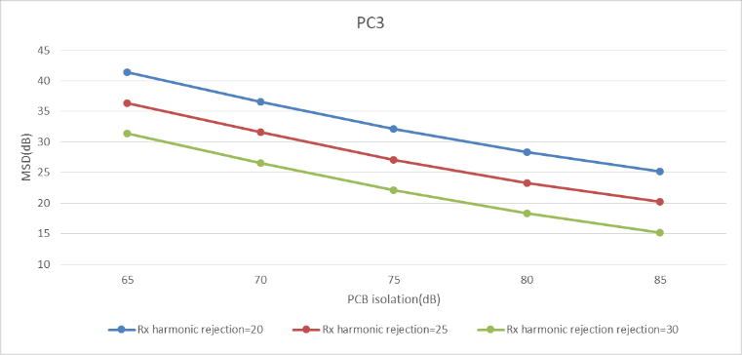

Figure 6.2.2.4-1 Harmonic mixing MSD analysis over better PCB isolation and Rx harmonic rejection

**Observation 4: It is observed that in terms of PC3, MSD due to 3rd harmonic mixing of CA\_n28-n40 could be reduced to around 25dB with 85dB PCB isolation and 20dB antenna isolation, in contrast to 37.8dB specified MSD. Note that antenna isolation has almost no contribution to the MSD improvement.**

**Observation 5: It is observed that in terms of PC3, MSD due to 3rd harmonic mixing of CA\_n28-n40 could be reduced to around 15dB with 85dB PCB isolation and 30dB Rx harmonic rejection, in contrast to 37.8dB specified MSD.**

#### 6.2.2.5 CA\_n1-n3 MSD Analysis on cross band isolation

The link budget calculation process and its initial adopted RF component assumption are presented in Table 6.2.2.5-1, similar as above the MSD improvement trend over antenna isolation up to 20 dB and PCB isolation up to 85 dB is presented in Figure 6.2.2.5-1.

Table 6.2.2.5-1 RF Component assumption and Link budget analysis for CA\_n1-n3 cross band isolation MSD



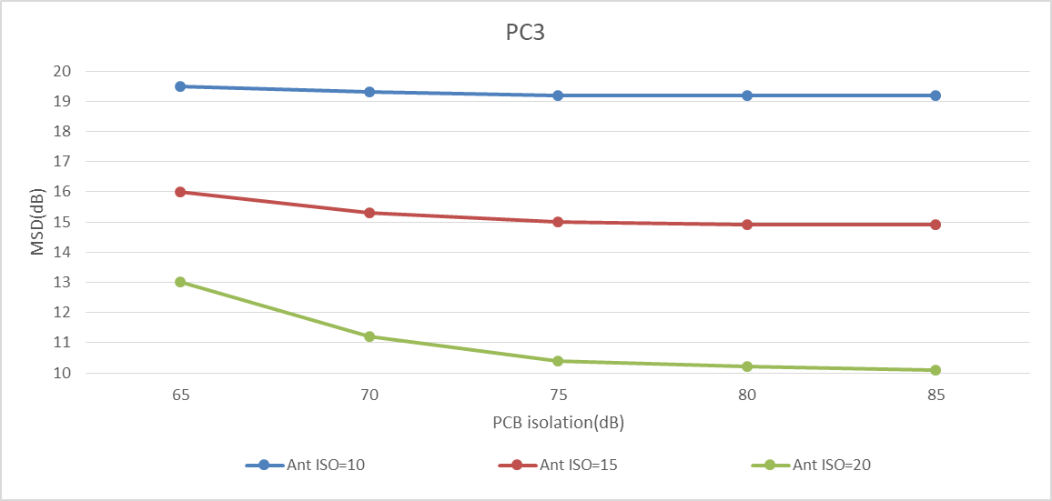

Figure 6.2.2.5-1 Cross band isolation analysis over better PCB isolation and antenna isolation

**Observation 6: It is observed that in terms of PC3, MSD due to cross band isolation of CA\_n1-n3 could be reduced to around 10dB with 85dB PCB isolation and 20dB antenna isolation, in contrast to [19.7]dB specified MSD.**

### 6.2.3 Evaluation from Nokia [10]

#### 6.2.3.1 2nd UL harmonic for CA\_3-n78

##### 6.2.3.1.1 MSD improvement by single RF component performance improvement

There would be multiple ways to improve MSD due to UL harmonics. In order to show a specific example, we assume a following condition captured in Table 6.2.3.1.1-1.

Table 6.2.3.1.1-1: MSD calculation where PA H2 is 35 dBc.

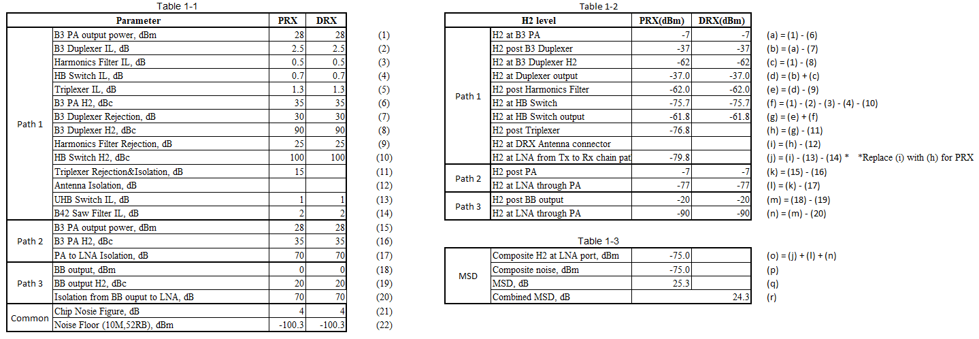

The derived MSD is almost the same as that of specified MSD, i.e., 23.9 dB. The further proposed improved MSD value by assuming PA H2 of 48 dBc and the MSD becomes 14.3 dB as shown in Table 6.2.3.1.1-2, which means 10 dB improvement is possible.

Table 6.2.3.1.1-2: MSD calculation where PA H2 is 48 dBc.

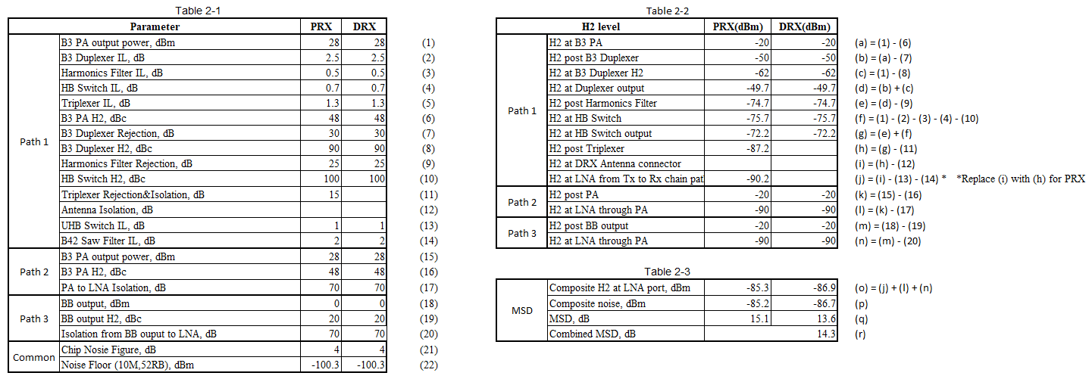

**Observation 1: Feasibility of MSD improvement by PA H2 performance improvement was already proposed by a UE vendor in reference contribution, where it showed 10 dB improvement is possible.**

Now the question is what if PA H2 with even better performance is used, whether the amount of MSD is further improved or not. The amount of the MSD improvement by PA H2 performance improvement **alone** starts to saturate when PA H2 approaches to 50 dBc and the MSD couldn’t be lower than 11.4 dB even if PA H2 was infinite. This is because as the noise in Path 1 becomes lower thanks to PA H2 improvement, the noise from Path 3 appears as the next gating factor since PA H2 doesn’t reduce noise in Path 3 at all. Hence, in order to improve MSD further, the noise from Path 3 must be also reduced.

Next, we’ll take a look at the amount of MSD improvement by assuming that isolations like PCB in Path 2 and Path 3 alone or PA H2 alone is improved in Figure 1 which shows how much MSD improvement can be obtained by improving PA H2 from 35 dBc to 75 dBc or isolation in Path 2 and Path 3 from 70 to 110 dB. It’s noted that we don’t have an intention to discuss if 75 dBc and 110 dB are feasible or not. They are just used to see the trend of MSD improvement by PA H2 or isolation improvement. Regarding MSD improvement vs PA H2 improvement, as mentioned before, the MSD improvement is saturated at around 50 dBc. With respect to MSD improvement vs isolation improvement, the amount of MSD improvement starts to saturate at around 90 dB and even if isolation was infinity, the MSD couldn’t be lower than 9.4 dB.

**Observation 2: Around 10 dB MSD improvement for CA\_n3-n78 2nd UL harmonics is feasible at least e.g., by PA H2 suppression of 48 dBc or isolation like PCB in Path 2 and Path 3 of 85 dB. Single RF component performance improvement alone, however, cannot achieve even better MSD like 20 dB since other gating factor(s) appears in one or two of the three Paths once noise in two or one of the three Paths is improved.**

Figure 6.2.3.1.1-1: MSD improvement by H2 PA suppression or isolation improvement by the same amount in Path 2&3

##### 6.2.3.1.2 Possible way to achieve 20 dB MSD improvement

With consideration of Observation 2, we take into account multiple components performance improvement impact on combined MSD. Figure 2 shows relation between the combined MSD improvement and improvements due to combinations of PA H2 suppression in Path 1, antenna isolation in DRX Path 1 and an isolation in Path 2 and Path 3.

Figure 6.2.3.1.2-1: Impact of antenna isolation, PA H2 suppression and isolation in Path 2/3 on combined MSD

From Figure 6.2.3.1.2-1, in order to achieve around 20 dB MSD improvement, in case PA H2 suppression is 48 dBc, around 20 dB isolation improvement for Path 2 and Path 3 is needed. In case PA H2 suppression is 35 dBc, even if antenna isolation is 20 dB, 20 dB MSD is not possible (around 19 dB seems possible) under the assumption of Table 6.2.3.1.1-1.

**Observation 3: In case of PA H2 suppression of 35 dB, 20 dB MSD improvement is not possible even if antenna isolation is 20 dB and isolation improvement of Path 2&3 was infinity if the other assumptions are the same as those in Table 6.2.3.1.1-1.**

**Observation 4: In order to achieve 20 dB MSD improvement with PA H2 suppression of 48 dBc, around 25 dB isolation improvement, i.e., 95 dB isolation, for Path 2 &3 is required if the other assumptions are the same as those in Table 6.2.3.1.1-1.**

Next, we discuss the impact of antenna isolation performance improvement on the combined MSD. One of the important aspects of antenna isolation in terms of MSD improvement is that the contribution of it to MSD improvement applies to only MSD for DRX under the UE architecture assumption in reference, which is achieved by reducing the composite H2 level at LNA (and hence MSD) in Path 1 for “DRX”. It’s noted that even if a UE architecture to enable a UE to obtain antenna isolation for PRX is assumed, the conclusion does not change that much for at least MSD due to UL harmonics since it only improves H2 levels at LNA for PRX and DRX for Path 1 only. Therefore, antenna isolation does not help improve combined MSD if DRX H2 level at LNA for Path 1 is lower than those for Path 2 and 3 and helps improve combined MSD a little if DRX H2 level at LNA for Path 1 is higher than those for Path 2 and 3, though the help can be around 5 dB at maximum with antenna isolation of 20 dB.

**Observation 5: Antenna isolation improvement helps improve combined MSD more when DRX H2 levels at LNA for Paths 2 and 3 are even lower than DRX H2 level at LNA for Path 1 while the amount of maximum improvement by antenna isolation is around 5 dB with antenna isolation of 20 dB.**

##### 6.2.3.1.3 20 dB MSD improvement with less isolation improvement in Path 2 &3

In this sub-section, we discuss a way to mitigate the required isolation improvement in Path 2 and 3 by reducing respective MSDs (composite H2 levels) for PRX and DRX in a similar level from the conditions in Table 6.2.3.1.1-1. It is noted that in order to achieve 20 dB improved combined MSD, i.e., MSD = around 4 dB, H2 levels at LNA from each of the paths for both PRX and DRX must be lower than approximately -103 dBm, i.e., values in (j), (l) and (n) must be lower than or equal to -103 dBm except for DRX H2 level at (j) whose value is already -105.2 dBm. A specific example is summarized in Table 6.2.3.1.3-1, where combined MSD is 3.67 dB can be obtained.

**Observation 6: If harmonic filter rejection, HB switch H2 and Triplexer Rejection towards H2 are improved by 8 dB, 8 dB and 5 dB, respectively, all the LNA H2 levels at the three Paths are almost equally lower than or equal to -103 dBm, as shown in Table 3, the required isolation of Path 2 & 3 can be reduced to 83 dB from 95 dB.**

##### 6.2.3.1.4 How to achieve MSD = 0 dB

It is not hard to anticipate that achieving MSD improvement of 24 dB, i.e., MSD = 0 dB, even more challenging than achieving that of 20 dB. When MSD improvement of 20 dB is achieved, H2 levels from all the paths for PRX and DRX must be already similar levels or composite H2 level for DRX is even smaller than that for PRX. The former means that even if a component performance is improved and one or some of H2 levels at LNA at Path 1, 2 and/or 3 for PRX and/or DRX are improved, the other H2 levels stay as a gating factor. The latter means that the composite level for PRX must be improved. In any case, multiple components performance must be improved, but cost for MSD improvement becomes higher. For more specific, Figure 3 shows relation between respective H2 levels improvement and combined MSD assuming that H2 levels from the three Paths are improved in the same amount from the condition shown in Table 6.2.3.2-1. For example, 1 dB in the horizontal line means -116 (-115 dBm - 1 dB) dBm for Path 1 DRX and -106 (-105 dBm - 1 dB) dBm for Path 1/2/3 PRX and Path 2/3 DRX and so on.

Figure 6.2.3.1.4-1: Required LNA PRX or DRX H2 levels for all the three path

Figure 6.2.3.1.4-1 says that to improve MSD from 1 dB to almost 0 dB, the respective H2 levels must be improved by at least 10 dB, which means that an additional 10 dB isolation improvement for path 2 and 3 is needed and H2 levels in path 1 somehow need to be improved by 10 dB, but the options are very limited since triplexer would have challenges in having more attention than 20 dB so that RF components performance prior to the triplexer must be improved.

**Observation 7: Theoretically it is not impossible to achieve MSD = 0dB for CA\_n3-n78 for 2nd UL harmonic. However, as MSD approaches 0 dB, it requires more cost, i.e., components performance improvement compared to the cost to improve MSD by 20 dB.**

#### 6.2.3.2 2nd order harmonic mixing for CA\_n3-n78

Regarding CA\_n3-n77, MSD for this CA band combination has not been specified in 38.101-1 while that for corresponding EN-DC, MSD is defined in 38.101-3. The values for MSD for EN-DC are extracted from Table 7.3B.2.3.2-1 in 38.101-3 as follows.

Table 6.2.3.2-1: Extract from Table 7.3B.2.3.2-1 in TS38.101-3

|  |  |  |  |  |  |  |  |  |  |  |  |  |
| --- | --- | --- | --- | --- | --- | --- | --- | --- | --- | --- | --- | --- |
| E-UTRA or NR Band / Channel bandwidth of the affected DL band / MSD | | | | | | | | | | | | |
| UL band | DL band | 5  MHz  (dB) | 10 MHz  (dB) | 15 MHz  (dB) | 20 MHz  (dB) | 25 MHz  (dB) | 40 MHz  (dB) | 50 MHz  (dB) | 60 MHz  (dB) | 80 MHz  (dB) | 90 MHz  (dB) | 100 MHz  (dB) |
| n77 | 3 | 5.7 | 4.0 | 3.0 | 2.7 |  |  |  |  |  |  |  |
| n78 | 3 | 5.7 | 4.0 | 3.0 | 2.7 |  |  |  |  |  |  |  |

A technical analysis to justify MSD = 0 dB for CA\_n3-n78 was submitted in a reference contribution, where Tx power at LNA input are summarized in Table 5, where Direct Signal Path corresponds to Path 1 in Section 6.2.3.1.1 and PCB Coupling Path corresponds to Path 2 in Section 6.2.3.1.1, respectively. It should be noted that in case of analysis for harmonic mixing, consideration of Path 3 in Section 6.2.3.1.1 is not necessary since the BB output power is always even lower than that PA output power in Path 2 by PA gain as far as the same PCB isolation is assumed. The contribution shared the fact that there is a mixier with the spur rejection of about 66 dBc for mixing with 2LO and it enables UEs to have MSD = 0 dB. Moreover, the reference contribution implies that MSD = 0 dB for CA\_n3-n78 can be achieved with PCB isolation of 84 (70 dB + 14 dB) dB instead of using the mixer with 66 dBc rejection.

Table 6.2.3.2-2: Extract of Table 1 from [4]

As can be seen in Table 6.2.3.2-2, RF components like antenna isolation, filter isolations in Path 1 cannot contribute to improving combined MSD since noise level from Path 2 is higher by 14 dB for PRX and 24 dB for DRX until the noise level in Path 2 approaches close to that in Path 1. 14 dB noise reduction for Path 2 means that PCB isolation must be improved from 70 dB to 84 dB. However, as can be seen in Figure 4, when PCB isolation is 85 dB, combined MSD itself if almost zero dB (Combined MSD is below 1 dB even with mixer spur rejection is 45 dBc) so that there is no room for antenna isolation to contribute to the improvement.

Figure 6.2.3.2-1: MSD relation b/w PCB isolation and Mixer spur rejection for 2nd harmonic mixing

Figure 6.2.3.2-1 also shares the information that combined MSD is almost the same if the same amount of PCB isolation improvement or Mixer spur rejection improvement is achieved, though Mixer spur rejection improvement can give a little bit lager MSD improvement by PCB isolation improvement (see e.g., the top red horizontal dashed line. A point where PCB isolation of 70 dB line has 50 dBc(45+5) mixer spur rejection is lower than a point where PCB isolation of 75 dB(70+5) line has 45 dBc mixer spur rejection). This is theoretically valid since mixer spur rejection applies to the composite noise consisting of Path 1 and Path 2 while PCB isolation only improves noise from Path 2. Finally, although MSD = 0 dB is possible, the cost performance becomes worse as the MSD approaches 0 dB. For instance, in order to achieve 5 dB MSD improvement, i.e., MSD = 2 dB, PCB isolation, mixer spur rejection or the sum of both requires around from 8 dB to 12 dB improvement while to achieve 6 dB MSD improvement, i.e., MSD = 1 dB, PCB isolation, mixer spur rejection or the sum of both requires around 12 to 15 dB improvement.

**Observation 8: MSD of 0 dB for CA\_n3-n78 harmonic mixing is feasible by PCB isolation improvement, e.g., 84 dB, mixer spur rejection improvement, e.g., 66 dBc or combination of the two RF components performance improvement, e.g., PCB isolation is 75 dB and mixer spur rejection is 60 dBc. Antenna isolation improvement doesn’t help improve MSD for 2nd harmonic mixing for CA\_n3-n78.**

#### 6.2.3.3 IMD2 for CA\_n3-n78

MSD due to IMD2 for CA\_n3-n78 were discussed intensively. Table 6.2.3.3-1 is a summary of IMD2 analysis from a reference, where yellow cells are affected by PCB isolation, aqua cells are affected by antenna isolation, green cells are affected by PCB isolation as well as antenna isolation. Hence, under the conditions in Table 6.2.3.3-1, it is expected that if only PCB isolation is improved, MSD improvement would start to saturate when the PCB isolation approaches to approximately 80 dB, since IMD2 from antenna switch and diplexer stay at -75 dBm in PRX. Antenna isolation improvement can contribute to reduce IMD2 in DRX so that the combined MSD can be improved accordingly. Hence, if both PCB isolation and antenna isolation are improved, the MSD can be further improved. However, even if PCB isolation as well as antenna isolation are improved, IMD2 from antenna switch and diplexer stay at -75 dBm in PRX. Hence, in order to reduce the combined MSD significantly, IP2 for these RF components needs to be improved.

Table 6.2.3.3-1: IMD2 analysis for CA\_n3-n78 from [5]

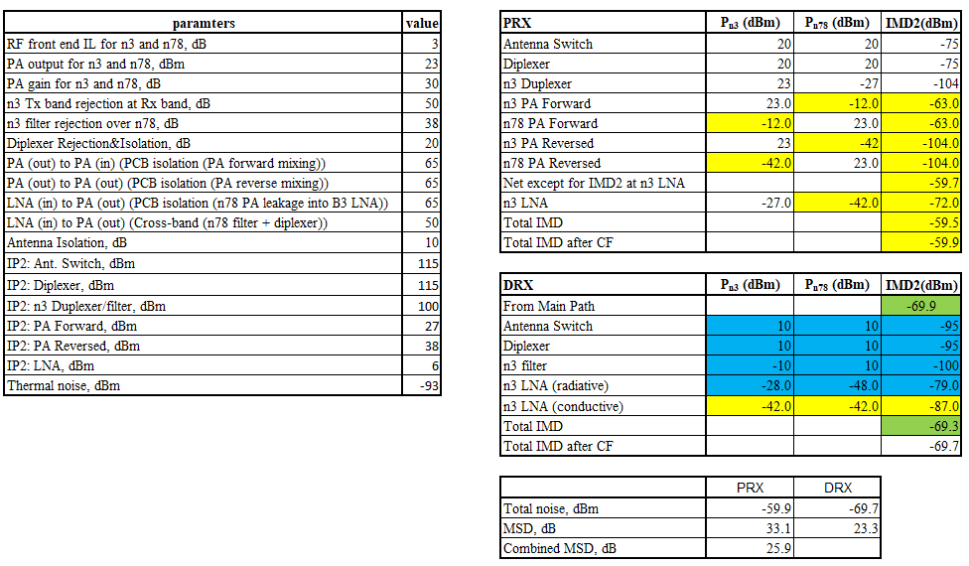

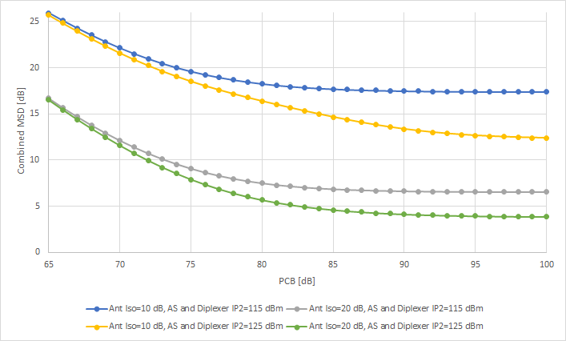

Figure 6.2.3.3-1: relation b/w IMD, PCB isolation, Ant Iso and IP2 of Antenna switch & Diplexer

From Figure 6.2.3.3-1, it can be seen that the around 20 dB MSD improvement is possible if IP2 for diplexer and Antenna switch are 125 dBm, PCB isolation is 80 dB and antenna isolation is 20 dB under the conditions of Table 6.2.3.3-2. Theoretically MSD of 0 dB is possible while the cost is significantly high but the gain = “the amount of MSD improvement”/”the amount of RF component improvement” becomes less and less.

**Observation 9: Around 10 dB MSD improvement of IMD2 for CA\_n3-n78 is possible if antenna isolation is around 20 dB or PCB isolation is around 80 dB. Around 20 dB improvement is also possible, if IP2 of antenna switch as well as diplexer is around 125 dBm. Further MSD improvement is also possible while the cost and performance = “the amount of MSD improvement”/”the amount of RF component performance improvement” becomes less and less.**

#### 6.2.3.4 MSD improvement and MSD types

The below Figure 6.2.3.4-1 shows relation between the amount of the MSD improvements and the amount of PCB isolation improvement for different MSD types. It should be noted that assumed UE RF architecture is basically the same across the MSD evaluations for MSD types while some device performance assumptions, e.g., RF front end loss are different across MSD types so that this can be used only as a guide.

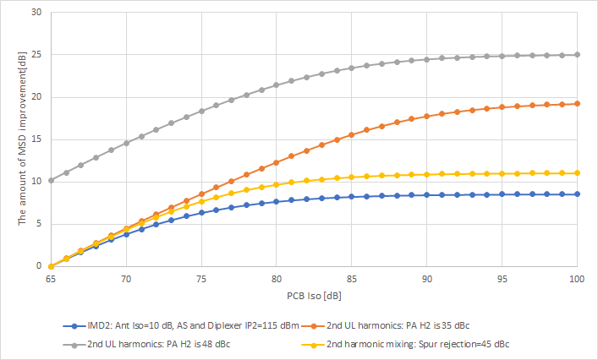

Figure 6.2.3.4-1: The amount of MSD improvement vs PCB isolation improvement

From the Figure 6.2.3.4-1, all the three MSD types has a similar trend when PCB isolation is roughly up to 75 dB. Then, gradually, 2nd UL harmonic starts to show a different trend than the other 2nd harmonic mixing and IMD2 Moreover, grey line is the case that PCB isolation as well as PA H2 improvement for 2nd UL harmonic are considered. The amount of the MSD improvement is quite different from the other MSD types as well as the same MSD type whose PA H2 performance is 35 dBc. Moreover, given that it is not always the case that UE vendors will always use PCB isolation alone to improve MSD, the amount of MSD improvement can be very different from MSD types to types.

**Observation 10: The amount of the MSD improvement is not always the same or similar across MSD types even if one common RF component performance improvement is considered. Provided that it is not always the case that UE vendors will always use one single RF component performance improvement, e.g., only PCB isolation, to improve MSD, the amount of MSD improvement can be very different from MSD types to types.**

### 6.2.4 Evaluation from Qualcomm [11]

For the band combination CA\_n1-n3-n78 it is seen that CA\_n3-n78 has IMD2, IMD4 and HD2 impairments.

Based on typical numbers Table 6.2.4-1 gives an analysis for IMD2 for CA-n3\_n78 where the IMD2 product of n78 Tx and n3 Tx fall into n3 Rx.

Table 6.2.4-1: CA-n3\_n78 budget for IMD2

|  |  |  |  |  |  |
| --- | --- | --- | --- | --- | --- |
| Ant-Ant Isolation | 10 | dB |  |  |  |
| PCB Isolation | 70 | dB |  |  |  |
| Power class | PC2 |  |  |  |  |
| n77 PA output power | 30 | dBm |  |  |  |
| IMD2 at n78 PA output | -71 | dBm |  |  |  |
| Diplexer attenuation | 15 | dB |  |  |  |
| Total IMD2 @n78 ANT | -86.0 | dBm |  |  |  |
| Total IMD2 @n3 ANT | -96.0 | dBm |  |  |  |
| n77 jammer @ n3 PA input | -40.0 | dBm |  |  |  |
| IMD2 at n3 PA output | -65.0 | dBm |  |  |  |
| Post PA IL | 2.0 | dB |  |  |  |
| Total IMD2 @n3 ANT | -63.0 | dBm |  |  |  |
| PRX n3 path |  |  |  | DRX n3 path |  |
|  |  |  |  |  |  |
| Mixer IIP2 | 72.0 | dB |  | 72.0 | dB |
| LNA IIP2 | 30.0 | dBm |  | 30.0 | dBm |
| Noise from mixer IIP2 distortion | -96.0 | dBm |  | -96.0 | dBm |
| Rx IMD @ ANT | -94.0 | dBm |  | -94.0 | dBm |
| Total distortion @ n3 ANT | -63.0 | dBm |  | -73.0 | dBm |
| Reference sensitivity | -98.0 | dBm |  | -98.0 | dBm |
| Thermal noise | -94.0 | dBm |  | -94.0 | dBm |
| total noise @ n3 ANT | -63.0 |  |  | -72.9 | dBm |
| MRC Sensitivity | -72.4 |  |  |  | dBm |
| MSD | 25.6 |  |  |  | dB |

Based on the above numbers it is seen that for improvement in PCB and antenna isolation the MSD due to IMD2 behaves as indicated in table 6.2.4-2.

Table 6.2.4-2: CA-n3\_n78 MSD for IMD2 as a function of PCB and antenna isolation

|  |  |  |
| --- | --- | --- |
| Ant ISO (dB) | PCB ISO (dB) | MSD (dB) |
| 10 | 70 | 25.6 |
| 10 | 80 | 17.3 |
| 10 | 90 | 13.0 |
| 20 | 70 | 24.6 |
| 20 | 80 | 14.4 |
| 20 | 90 | 8.1 |

From the results in table 6.2.4-2 it can be clearly seen that the MSD for IMD2 can be reduced by increasing both the PCB and antenna isolations.

**Observation 1: For CA-n3\_n78 the MSD due to IMD2 where n78 Tx and n3 Tx mix and fall into n3 Rx shows the following behaviour with PCB and antenna isolation:**

|  |  |  |
| --- | --- | --- |
| Ant ISO (dB) | PCB ISO (dB) | MSD (dB) |
| 10 | 70 | 25.6 |
| 10 | 80 | 17.3 |
| 10 | 90 | 13.0 |
| 20 | 70 | 25.6 |
| 20 | 80 | 14.4 |
| 20 | 90 | 8.1 |

Similar analysis for CA-n3\_n78 for IMD4 where the IMD4 of n78 Tx and 3\*n3 Tx falls into n3 Rx shows the following behaviour of MSD with PCB and antenna isolation given in table 6.2.4-3.

Table 6.2.4-3: CA-n3\_n78 MSD for IMD4 as a function of PCB and antenna isolations

|  |  |  |
| --- | --- | --- |
| Ant ISO (dB) | PCB ISO (dB) | MSD (dB) |
|  |  |  |
| 10 | 70 | 9.5 |
| 10 | 80 | 5.5 |
| 10 | 90 | 4.0 |
| 20 | 70 | 4.8 |
| 20 | 80 | 3.9 |
| 20 | 90 | 2.7 |

From the results in table 6.2.4-3 it is seen that the MSD for IMD4 can be reduced by increasing both the PCB and antenna isolations.

**Observation 2: For CA-n3\_n78 the MSD due to IMD4 where n78 Tx and 3\*n3 Tx mix and fall into n3 Rx shows the following behaviour with PCB and antenna isolation:**

|  |  |  |
| --- | --- | --- |
| Ant ISO (dB) | PCB ISO (dB) | MSD (dB) |
|  |  |  |
| 10 | 70 | 9.5 |
| 10 | 80 | 5.5 |
| 10 | 90 | 4.0 |
| 20 | 70 | 4.8 |
| 20 | 80 | 3.9 |
| 20 | 90 | 2.7 |

For CA-n3\_n78 for the 2nd harmonic of n3 Tx falling into n78 Rx we have the following typical budget

Table 6.2.4-4: CA-n3\_n78 budget for HD2

|  |  |  |  |  |  |
| --- | --- | --- | --- | --- | --- |
| Band | n3 |  |  |  |  |
| HD order | 2 |  |  |  |  |
| Rx BW | 100 | MHz |  |  |  |
| PC | 2 |  |  |  |  |
| Ant-Ant Isolation | 10 | dB |  |  |  |
| PCB Isolation | 70 | dB |  |  |  |
| n3 PA HD2 | -6 | dBm |  |  |  |
| HD2 filtering in Tx chain | 48 | dB |  |  |  |
| Triplexer attenuation | 25 | dB |  |  |  |
| n3 HD2 @Ant | -79 | dB |  |  |  |
| PRX n78 path |  |  |  | DRX n78 path |  |
|  |  |  |  |  |  |
| Rx FE loss | 3 | dB |  | 3 | dB |
| Total HD pwr at Ant input | -72.9 | dBm |  | -72.9 | dBm |
| Thermal noise @RX Ant | -81.5 | dBm |  | -81.5 | dBm |
| total noise @ n3 ANT | -72.3 | dBm |  | -72.3 | dBm |
| Reference sensitivity | -85.5 | dBm |  | -85.5 | dBm |
| MRC Sensitivity | -73.6 |  |  |  | dBm |
| MSD | 11.9 |  |  |  | dB |

It is seen that for improvement in PCB and antenna isolation the MSD due to HD2 behaves as indicated in table 6.2.4-5.

Table 6.2.4-5: CA-n3\_n78 MSD for HD2 as a function of PCB and antenna isolation

|  |  |  |
| --- | --- | --- |
| PCB ISO (dB) | Ant ISO (dB) | MSD (dB) |
| 70 | 10 | 11.9 |
| 80 | 10 | 4.4 |
| 90 | 10 | 1.7 |
| 70 | 20 | 11.8 |
| 80 | 20 | 3.9 |
| 90 | 20 | 0.7 |

**Observation 3: For CA-n3\_n78 the MSD due to HD2 where the second harmonic of n3 falls into n78 Rx shows the following behaviour with PCB and antenna isolation:**

|  |  |  |
| --- | --- | --- |
| PCB ISO (dB) | Ant ISO (dB) | MSD (dB) |
| 70 | 10 | 11.9 |
| 80 | 10 | 4.4 |
| 90 | 10 | 1.7 |
| 70 | 20 | 11.8 |
| 80 | 20 | 3.9 |
| 90 | 20 | 0.7 |

For CA-n41\_n77 where cross band isolation is an issue with Tx noise from n41 falling into n77 and vis-a-versa. The below table shows the budget for n77 Tx noise falling into n41.

Table 6.2.4-6: CA-n41\_n77 budget for cross band isolation with n41 victim

|  |  |  |  |  |  |
| --- | --- | --- | --- | --- | --- |
| Aggressor band | n77 | PC3 |  |  |  |
| Victim band | n41 |  |  |  |  |
| Transceiver noise at PA output | -154.5 | dBm/Hz |  |  |  |
| PA output noise | -150 | dBm/Hz |  |  |  |
| Total noise at PA output | -148.7 | dBm/Hz |  |  |  |
| Antenna iso | 15 | dB |  |  |  |
| Tx noise @Rx | -163.7 | dBm/Hz |  |  |  |
| PRX path for n41 |  |  |  | DRX path for n41 |  |
| DL BW | 10.0 | MHz |  | 10 | MHz |
| Rx thermal noise @ LNA input | -91.1 | dBm |  | -91.1 | dBm |
| DAC images at Tx output | -91.7 | dBm |  | -91.7 | dBm |
| DAC images at RX input | -106.7 | dBm |  | -106.7 | dBm |
| Total interference @ Rx | -93.5 | dBm |  | -93.5 | dBm |
| Total noise @ Rx | -89.1 | dBm |  | -89.1 | dBm |
| n41 Reference sensitivity | -95.1 | dBm |  |  |  |
| MRC sensitivity | -91.8 | dBm |  |  |  |
| MSD | 3.3 | dBm |  |  |  |

The MSD in the current specifications for this combination is only 4.5dB and currently with 15 dB of antenna isolation the MSD is 3.3 dB. Therefore, even with large increases in antenna isolation the maximum MSD reduction that can be achieved is only a further 3.3 dB. The below table gives the variation in MSD with antenna isolation. As the lower MSD feature is meant to address band combinations with large MSDs we think that the low MSD of this band combination does not make it a candidate for this feature.

Table 6.2.4-7: CA-n41\_n77 variation of MSD with antenna isolation for n41 victim

|  |  |
| --- | --- |
| Ant ISO (dB) | MSD (dB) |
| 15 | 3.3 |
| 20 | 1.3 |
| 25 | 0.5 |

**Observation 4: For CA-n41\_n77 the MSD due to cross band isolation where n77 Tx noise falls into n41 Rx the following behaviour is observed with antenna isolation:**

|  |  |
| --- | --- |
| Ant ISO (dB) | MSD (dB) |
| 15 | 3.3 |
| 20 | 1.3 |
| 25 | 0.5 |

**In our opinion the low MSD for this band combination does not make it a candidate for the low MSD feature**

For CA-n28\_n40 for the 3rd RX LO harmonic of n28 mixing with n40 Tx and falling in the n28 Rx band we can have the following typical budget.

Table 6.2.4-8: CA-n28\_n40 budget for Rx LO harmonic mixing with n40 Tx falling into n28 Rx

|  |  |  |  |  |
| --- | --- | --- | --- | --- |
| n40 Tx output power at ANT | 23 | dBm |  |  |
| n40 Tx FE loss | 3 | dB |  |  |
| Antenna isolation | 10 | dB |  |  |
| n28 Duplexer attenuation for n40 Tx | 15 | dB |  |  |
| n28 FE attenuation for n40 Tx | 50 | dB |  |  |
| n28 FE gain | 15 | dB |  |  |
| PCB isolation From n40 PA output to n28 transceiver input | 70 | dB |  |  |
| PRX |  |  | DRX |  |
| n28 RX BW | 10 | MHz | 10 | MHz |
| Total interferer at n28 RX input | -43.4 | dBm | -43.4 | dBm |
| 3LO harmonic rejection | 10 | dB | 10 | dB |
| Total interference at ANT | -68.4 | dBm | -68.4 | dBm |
| Thermal noise | -91.5 | dBm | -91.5 | dBm |
| Total noise | -68.3 | dBm | -68.3 | dBm |
| Sensitivity | -95.5 | dBm |  |  |
| MRC sensitivity | -69.4 |  |  |  |
| MSD | 26.1 | dB |  |  |

It is seen that for improvement in PCB and antenna isolation the MSD behaves as indicated in table 6.2.4-8.

Table 6.2.4-9: CA-n28\_n40 MSD for Rx LO harmonic falling into n28 Rx as a function of PCB and antenna isolation

|  |  |  |
| --- | --- | --- |
| PCB iso (dB) | Ant iso(dB) | MSD (dB) |
| 70 | 10 | 26.1 |
| 80 | 10 | 19.7 |
| 90 | 10 | 17.8 |
| 70 | 20 | 25.6 |
| 80 | 20 | 16.2 |
| 90 | 20 | 10.1 |

From the above table it is observed that the MSD is dominated by the PCB isolation and that the antenna isolation has very little impact.

**Observation 5: For CA-n28\_n40 the MSD due to 3rd RX LO harmonic of n28 mixing with n40 Tx and falling into 28 Rx the following behaviour is observed with PCB and antenna isolation:**

|  |  |  |
| --- | --- | --- |
| PCB iso (dB) | Ant iso(dB) | MSD (dB) |
| 70 | 10 | 26.1 |
| 80 | 10 | 19.7 |
| 90 | 10 | 17.8 |
| 70 | 20 | 25.6 |
| 80 | 20 | 16.2 |
| 90 | 20 | 10.1 |

For most band combinations that have large MSDs an increase in the PCB and/or antenna isolation will enable a reduction in MSD.

**Observation 6: The band combinations analysed in this study shows that MSD can be lowered by increasing PCB and or antenna isolations**

### 6.2.5 Evaluation from Apple [12]

#### 6.2.5.1 CA\_n3-n78 UL 2nd harmonic MSD analysis

Figure 6.2.5.1-1 shows the MSD improvement over the harmonic filter rejection ratio. It can be seen that when harmonic filter rejection is above 20 dB, the MSD would be dominated by other impairments.



Figure 6.2.5.1-1 CA\_n3-n78 UL 2nd harmonic MSD improvement over improved harmonic filter rejection

**Observation 1: When harmonic filter rejection is above 20 dB, the MSD would be dominated by other impairments.**

Figure 6.2.5.1-2 shows the MSD improvement over the combined diplexer/n78 filter rejection ratio to n3 Tx. It can be seen that when the combined rejection ratio is above 60 dB, the MSD would be dominated by other impairments.



Figure 6.2.5.1-2 UL 2nd harmonic MSD improvement over improved diplexer+n78 filter rejection to n3 Tx

**Observation 2: When the combined diplexer+n78 filter rejection ratio to n3 Tx is above 60 dB, the MSD would be dominated by other impairments.**

Figure 6.2.5.1-3 shows the MSD improvement over the PA 2nd harmonic rejection ratio. It can be seen that when the PA 2nd harmonic rejection ratio is above 56 dB, the MSD would be dominated by other impairments.



Figure 6.2.5.1-3 UL 2nd harmonic MSD improvement over improved PA 2nd harmonic rejection ratio

**Observation 3: When the PA 2nd harmonic rejection ratio is above 56 dB, the MSD would be dominated by other impairments.**

Figure 6.2.5.1-4 shows the MSD improvement over LNA IP2 performance. It can be seen that the MSD though improved with increasing LNA IP2, the improvement is quite limited even with LNA IP2 up to 30 dBm.

**Observation 4: MSD though improved with increasing LNA IP2, the improvement is quite limited even with LNA IP2 up to 30 dBm.**



Figure 6.2.5.1-4 UL 2nd harmonic MSD improvement over improved LNA IP2

Based on the above observations, we can conclude that without PCB and antenna isolations improvement, the MSD from other improved RF parameters alone cannot be reduced to below 18 dB.

**Observation 5: Without PCB and antenna isolations improvement, the UL 2nd harmonic MSD from other improved RF parameters alone cannot be reduced to below 18 dB.**

#### 6.2.5.2 CA\_n3-n78 2UL IMD2 MSD analysis

Figure 6.2.5.2-1 shows the MSD improvement over the duplexer rejection ratio for IMD2 at n3 DL. It can be seen that when the duplexer rejection ratio is above 70 dB, the MSD would be dominated by other impairments.



Figure 6.2.5.2-1 CA\_n3-n78 2UL IMD2 MSD improvement over improved duplexer rejection ratio at n3 DL

**Observation 6: When the duplexer rejection ratio for IMD2 at n3 DL is above 70 dB, the MSD would be dominated by other impairments.**

Figure 6.2.5.2-2 shows the MSD improvement over PA forward mixing IP2. It can be seen that when the PA forward mixing IP2 is above 45 dB, the MSD would be dominated by other impairments.



Figure 6.2.5.2-2 CA\_n3-n78 2UL IMD2 MSD improvement over improved PA forward mixing IP2

**Observation 7: When the PA forward mixing IP2 is above 45 dB, the MSD would be dominated by other impairments.**

Figure 6.2.5.2-3 shows the MSD improvement over LNA IP2 performance. It can be seen that the MSD though improved with increasing LNA IP2, the improvement is quite limited even with LNA IP2 up to 20 dBm.



Figure 2.2-3 CA\_n3-n78 2UL IMD2 MSD improvement over improved LNA IP2

**Observation 8: MSD though improved with increasing LNA IP2, the improvement is quite limited even with LNA IP2 up to 20 dBm.**

Figure 6.2.5.2-4 shows the MSD improvement over diversity n3 filter rejection ratio to n3 and n78 UL. It can be seen that when the n3 diversity Rx filter rejection ratio to n3 and n78 UL is above 46 dB, the MSD would be dominated by other impairments.

**Observation 9: when the n3 diversity Rx filter rejection ratio to n3 and n78 UL is above 46 dB, the MSD would be dominated by other impairments.**



Figure 6.2.5.2-4 UL 2nd harmonic MSD improvement over improved LNA IP2

Based on the above observations, we can conclude that without PCB and antenna isolations improvement, the MSD from other improved RF parameters alone cannot be reduced to below 18 dB.

**Observation 10: Without PCB and antenna isolations improvement, the 2UL IMD2 MSD from other improved RF parameters alone cannot be reduced to below 18 dB.**

#### 6.2.5.3 CA\_n28-n40 3rd order harmonic mixing MSD analysis

To assess the potential MSD improvement for CA\_n28-n40 due to n28 Rx 3rd order harmonic mixing, we have performed the link analysis based on the reference architecture as shown in Figure 6.2.5.3-1 and a set of front-end component isolation parameters as summarized in Table 6.2.5.3-1.

Table 6.2.5.3-2 presents the link analysis to derive the equivalent interference power levels at n28 main and diversity Rx inputs. The MSD for n28 5MHz DL channel BW after MRC assuming uncorrelated noise is summarized in Table 2.3-3.



Figure 6.2.5.3-1 Reference architecture for CA\_n28-n40 n28 Rx 3rd order harmonic mixing MSD analysis

Table 6.2.5.3-1 Front-end component isolation parameters for MSD calculation

|  |  |
| --- | --- |
| Isolation | dB |
| Diplexer | 20 |
| n28 duplexer to n40 | 40 |
| n28 diversity Rx filter to n40 | 33 |
| PCB | 65 |
| Antenna | 10 |
| Rx 3rd harmonic rejection ratio | 25 |

Table 6.2.5.3-2 Link analysis to derive the interference power levels at n28 main and diversity Rx inputs

|  |  |  |  |
| --- | --- | --- | --- |
| Insertion loss (dB) | 3 |  |  |
| PA output power (dBm) | 26 |  |  |
| Main Path | dBm | Diversity Path | dBm |
| n40 UL power at antenna port | 23 | n40 UL power at antenna port | 13 |
| n40 UL power after diplexer | 3 | n40 UL power after diplexer | -7 |
| n40 UL power at n28 LNA input (filter path) | -40 | n40 UL power at n28 LNA input (filter path) | -40 |
| n40 UL power at n28 LNA input (PCB) | -39 | n40 UL power at n28 LNA input (PCB) | -39 |
| Total n40 UL power at n28 LNA input | -36.5 | Total n40 UL power at n28 LNA input | -36.5 |
| Total equivalent interference power after harmonic rejection | -58.5 | LNA H2 referred to antenna | -58.5 |

Table 6.2.5.3-3 MSD for 5MHz DL channel BW after MRC

|  |  |  |  |  |
| --- | --- | --- | --- | --- |
| BW |  | Floor | H2 | Total |
| 5 MHz | Main Path (dBm) | -95.5 | -58.5 | -58.5 |
| Diversity Path (dBm) | -95.5 | -58.5 | -58.5 |
| After MRC (dBm) | -98.5 |  | -61.5 |
| MSD (dB) |  |  | 37.0 |

Though there are many factors affecting the MSD value, from the link analysis we have observed that the most effective way to reduce the MSD due to UL 2nd harmonic interference is to improve PCB isolation and antenna isolation simultaneously. Thereby without taking into account the practical implementation feasibility, we have evaluated the MSD improvement over the improved PCB isolation up to 100 dB and antenna isolation up to 20 dB. The result for 5MHz DL channel BW is shown in Figure 6.2.5.3-2.

Based on the above analysis, it can be seen that even with 20dB antenna isolation and 100 PCB isolation, the improved MSD is still above 25 dB. As a result, it would be rather challenging to improve MSD caused by 3rd order harmonic mixing to below 30 dB based on practical UE implementation.

**Observation 11: It would be rather challenging to improve MSD caused by 3rd order harmonic mixing to below 30 dB based on practical UE implementation.**



Figure 6.2.5.3-2 3rd order harmonic mixing MSD improvement over improved PCB and antenna isolations

Though the RF parameter assumptions for MSD analyses may vary among companies, when considering the potential improvement, company shall present their assumptions for link analysis or measurement results instead of only showing the MSD numbers, otherwise, it would not be conceivable for other companies to envision how the MSD had been derived.

### 6.2.6 Evaluation from ZTE [13]

In this section, we share some analysis on how much MSD can be improved for some of the agreed candidate band combination by using more aggressive values of PCB isolation and antenna isolation.

Actually, there are several methods to improve the MSD. The MSD defined in the specification are largely depends on the calculation, especially for the larger MSD. Of course, few of the companies provided the measurements on some MSD but such MSD values are usually small.

Considering the lower MSD issue are somehow triggered by the survey of the commercial UE from some operators that high MSD (more than 20dB) are defined in the specification for some band combinations. Therefore, we think how much the MSD can be improved in practical should be based on the commercial UE measurement.

**Observation 1. How much the MSD can be improved in practical should be based on the commercial UE measurement.**

Without the commercial UE measurements, some rough analysis can also be done based on the budget calculations which was extensive adopted in the past. Nevertheless, it would be foreseen different companies may use different input parameters, different calculation methods, even with different RF architecture, all of these factors will impact the results.

In the following part of the section, we use CA\_n3-n78 as an example.

***CA\_n3-n78***

As CA\_n1-n3-n78 and fallback combinations were agreed to used as the candidate band combination. For CA\_n3-n78, there are IMD2/4 and 2nd harmonic and harmonic mixing issues.

IMD2/4 MSD

The IMD2/4 MSD in TS38.101-1 for CA\_n3-n78 are defined as:

|  |  |  |  |  |  |  |  |  |  |
| --- | --- | --- | --- | --- | --- | --- | --- | --- | --- |
|  |  |  |  |  |  | PC3 | PC2 |  |  |
| CA\_n3-n78 | n3 | 1740 | 5 | 25 | 1835 | 26 | 31.9 | FDD | IMD24 |
|  | n78 | 3575 | 10 | 25 | 3575 | N/A | N/A | TDD | N/A |
|  | n3 | 1765 | 5 | 25 | 1860 | 8.0 | 18.5 | FDD | IMD44 |
|  | n78 | 3435 | 10 | 25 | 3435 | N/A | N/A | TDD | N/A |

Harmonic Trap filter(HTF) is used for n3-n78, so the RF architecture used for calculation is in Figure 6.2.6-1.

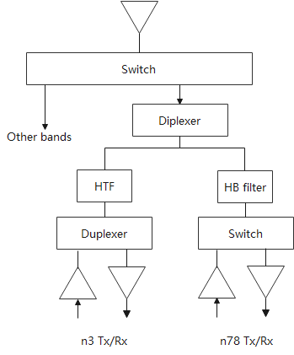

Figure 6.2.6-1: n3-n78 primarily Tx/Rx

And the general IPx RF parameters used in calculation are in Table 6.2.6-1.

Table 6.2.6-1: General IPx parameters

|  |  |  |  |  |
| --- | --- | --- | --- | --- |
| Component | IP2 (dBm) | IP3 (dBm) | IP4 (dBm) | IP5 (dBm) |
| Ant. Switch | 112 | 68 | 56 | 53 |
| Diplexer | 115 | 86 | 55 | 53 |
| Duplexer | 100 | 74 | 55 | 53 |
| Triplexer | 110 | 82 | 55 | 52 |
| Quadplexer | 113 | 74 | 55 | 50 |
| PA Forward | 27 | 32 | 31 | 28 |
| PA Reversed | 40 | 30 | 33 | 30 |
| LNA | 6 | -6 | -6 | -10 |

The IMD2/IMD4 values at the condition of PCB isolation=65dB and antenna isolation = 10dB are calculated as in Table 6.2.6-2 and 6.2.6-3.

Table 6.2.6-2: IMD2 MSD for n3-n78

|  |  |  |
| --- | --- | --- |
|  | Main path | Diversity path |
| IMD2 (without CF) (dBm) | -59.4 | -69.2 |
| Band n3 Thermal noise (dBm) | -94 | -94 |
| Total Noise (dBm) | -59.3 | -69.1 |
| After MRC sensitivity @ Ant (dBm) | -69.6 | |
| MSD (dB) | 27.4 | |

Table 6.2.6-3: IMD4 MSD for n3-n78

|  |  |  |
| --- | --- | --- |
|  | Main path | Diversity path |
| IMD2 (without CF) (dBm) | -80.1 | -90.1 |
| Band n3 Thermal noise (dBm) | -94 | -94 |
| Total Noise (dBm) | -79.9 | -88.6 |
| After MRC sensitivity @ Ant (dBm) | -89.1 | |
| MSD (dB) | 7.9 | |

With other PCB isolation and antenna isolation values, where the antenna isolation values are [10, 15, 20]dB, and the PCB isolation values are [60, 65, 70, 75, 80, 85, 90]dB, the IMD2/4 MSD values are summarized in Table 6.2.6-4.

Table 6.2.6-4: IMD2/4 MSD values with different antenna isolation, and different PCB isolation

(a). PC3(without CF)

|  |  |  |  |  |  |  |
| --- | --- | --- | --- | --- | --- | --- |
|  | Antenna iso.=10dB | | Antenna iso. =15dB | | Antenna iso. =20dB | |
|  | IMD2 | IMD4 | IMD2 | IMD4 | IMD2 | IMD4 |
| PCB iso. = 60dB | 31.9 | 10.4 | 27.1 | 7.0 | 22.2 | 4.7 |
| PCB iso. = 65dB | 27.4 | 7.9 | 22.6 | 5.2 | 17.8 | 3.8 |
| PCB iso. = 70dB | 23.8 | 6.5 | 18.9 | 4.4 | 14.1 | 3.4 |
| PCB iso. = 75dB | 21.5 | 6.0 | 16.5 | 4.1 | 11.8 | 3.2 |
| PCB iso. = 80dB | 20.4 | 5.8 | 15.3 | 4.0 | 10.7 | 3.2 |
| PCB iso. = 85dB | 20.0 | 5.7 | 14.8 | 3.9 | 10.3 | 3.1 |
| PCB iso. = 90dB | 19.8 | 5.7 | 14.7 | 3.9 | 10.1 | 3.1 |

(b). PC2 (without CF)

|  |  |  |  |  |  |  |
| --- | --- | --- | --- | --- | --- | --- |
|  | Antenna iso.=10dB | | Antenna iso. =15dB | | Antenna iso. =20dB | |
|  | IMD2 | IMD4 | IMD2 | IMD4 | IMD2 | IMD4 |
| PCB iso. = 60dB | 37.9 | 21.8 | 33.1 | 17.2 | 28.2 | 12.6 |
| PCB iso. = 65dB | 33.4 | 18.6 | 28.6 | 14.1 | 23.7 | 9.9 |
| PCB iso. = 70dB | 29.8 | 16.8 | 24.8 | 12.4 | 19.9 | 8.4 |
| PCB iso. = 75dB | 27.5 | 16.0 | 22.3 | 11.7 | 17.4 | 7.9 |
| PCB iso. = 80dB | 26.4 | 15.7 | 21.1 | 11.4 | 16.1 | 7.7 |
| PCB iso. = 85dB | 25.8 | 15.6 | 20.6 | 11.4 | 15.6 | 7.6 |
| PCB iso. = 90dB | 19.8 | 5.7 | 20.5 | 11.3 | 15.5 | 7.6 |

If considering CF, the MSD would be smaller than the values in table 6.2.6-4 due to the IMD2/4 product bandwidth will not occupy the whole IMD2/4 frequency range considering the UL/DL IMD MSD test point.

For n3-n78 IMD2/4 MSD, the PA non-linear factor is dominated factor when the PCB isolation is about 75dB. However, when PCB isolation is larger than 75dB, the other RF parameters like diplexer/LNA become the domination. So in this case, if PCB isolation continue to increase, the MSD improved is quite limited. It should be noted that the situations are similar for PC2.

H2 harmonic MSD

For H2 harmonic requirements, the MSD values at the condition of PCB isolation=65dB and antenna isolation = 10dB, and HTF isolation equals to 30dB are calculated as in table 6.2.6-5. Note that only MSD test points of channel bandwidth@n78=10MHz and channel bandwidth@n3 =5MHz is considered since it is the worst case compared to the other MSD test points of channel bandwidth@n78=100MHz and channel bandwidth@n3 =10MHz.

Table 6.2.6-5: H2 MSD for n3-n78

|  |  |  |
| --- | --- | --- |
|  | Main path | Diversity path |
| IMD2 (without CF) (dBm) | -67.1 | -70.4 |
| Band n78 Thermal noise@10MHz (dBm) | -92.3 | -92.3 |
| Total Noise (dBm) | -67.1 | -70.4 |
| After MRC sensitivity @ Ant (dBm) | -72.0 | |
| MSD (dB) | 23.3 | |

Similar as IMD2/4 MSD, using the combinations of different PCB isolation values and different antenna isolation values, the H2 MSD values are summarized in Table 6.2.6-6.

Table 6.2.6-6: H2 MSD values with different antenna isolation, and different PCB isolation (PC3 and PC2)(without CF)

|  |  |  |  |
| --- | --- | --- | --- |
|  | Antenna iso.=10dB | Antenna iso.=15dB | Antenna iso.=20dB |
| PCB iso. = 60dB | 27.2 | 27.1 | 27.1 |
| PCB iso. = 65dB | 23.3 | 23.0 | 22.9 |
| PCB iso. = 70dB | 20.0 | 19.2 | 18.8 |
| PCB iso. = 75dB | 17.7 | 15.8 | 14.8 |
| PCB iso. = 80dB | 16.5 | 13.4 | 11.4 |
| PCB iso. = 85dB | 16.0 | 12.1 | 9.3 |
| PCB iso. = 90dB | 15.8 | 11.7 | 8.2 |

Harmonic mixing MSD

In current 38.101-1 spec, there is no harmonic mixing MSD defined for PC3 n3-n78 inter-band CA but 8.1dB harmonic mixing MSD was defined for PC2 n3-n78 when aggressor UL is PC2 n78.

Noted that harmonic mixing MSD was defined for ENDC 3-n78, where 5.7dB is defined for 3@5MHz. Actually 5.7dB harmonic mixing MSD was the comprised value from references due to different parameters were used by different companies. Also, it can be found that this values were derided from antenna isolation is 10dB and PCB isolation is 70dB.

Ignoring the mistakes for PC3 n3-n78 harmonic mixing MSD, here we assume the same PC3 3\_n78 harmonic mixing MSD of 5.7dB was reused.

For harmonic mixing requirements, the MSD values at the condition of PCB isolation=70dB and antenna isolation = 10dB, are calculated as in Table 6.2.6-7.

Table 6.2.6-7: Harmonic mixing MSD for n3-n78 (PC3&PC2)

|  |  |  |  |  |
| --- | --- | --- | --- | --- |
|  | PC3 | | PC2 | |
|  | Main path | Div. path | Main path | Div. path |
| n78 Tx power at n3 LNA input (dBm) | -42.9 | -46.4 | -39.9 | -43.4 |
| After Rx harmonic rejection (referred to antenna) (dBm) | -87.9 | -91.4 | -84.9 | -88.4 |
| Band n3 Thermal noise (dBm) | -94 | -94 | -94 | -94 |
| Total Noise (dBm) | -86.9 | -89.5 | -84.4 | -87.3 |
| After MRC sensitivity @ Ant (dBm) | -91.4 | | -89.1 | |
| MSD (dB) | 5.6 | | 7.9 | |

Similar as above, different combination of antenna isolation and PCB isolation are used to see how much MSD can be improved, as summarized in Table 6.2.6-8.

Table 6.2.6-8: Harmonic mixing MSD values different antenna isolation, and different PCB isolation (PC3 and PC2)

|  |  |  |  |  |  |  |
| --- | --- | --- | --- | --- | --- | --- |
|  | Antenna iso.=10dB | | Antenna iso. =15dB | | Antenna iso. =20dB | |
|  | PC3 | PC2 | PC3 | PC2 | PC3 | PC2 |
| PCB iso. = 60dB | 12.6 | 15.5 | 12.6 | 15.4 | 12.6 | 15.4 |
| PCB iso. = 65dB | 8.6 | 11.3 | 8.5 | 11.2 | 8.5 | 11.2 |
| PCB iso. = 70dB | 5.6 | 7.9 | 5.4 | 7.7 | 5.4 | 7.6 |
| PCB iso. = 75dB | 3.9 | 5.7 | 3.6 | 5.2 | 3.4 | 5.0 |
| PCB iso. = 80dB | 3.1 | 4.5 | 2.7 | 3.8 | 2.5 | 3.5 |
| PCB iso. = 85dB | 2.8 | 4.0 | 2.3 | 3.2 | 2.2 | 2.9 |
| PCB iso. = 90dB | 2.7 | 3.9 | 2.2 | 3.0 | 2.1 | 2.6 |

In terms of the above, considering the existing MSD minimum requirements defined in the spec, we can observe:

**Observation 2. PCB isolation for harmonic/IMD and harmonic mixing are used to derive the corresponding MSD values are different.**

**Observation 3. For IMD2** **and H2 MSD, it is difficult to improve 20dB MSD by only increasing PCB isolation or antenna isolation.**

**Observation 4. For IMD2 and H2 MSD, to achieve ~10dB MSD value, the antenna isolation needs to better than 20dB associated with PCB isolation better than 85dB.**

**Observation 5. For IMD4, the improved MSD** **is less than 5dB when the antenna isolation is 20dB associated with PCB isolation is 85dB.**

**Observation 6. For IMD2/4, H2 and harmonic mixing MSD, the improved MSD is limited when PCB isolation >75dB for a certain antenna isolation.**

***CA\_n28-n40***

For n28-n40, harmonic mixing, i.e. n40 DL = 3\*n28 UL, should be considered. Actually, the harmonic mixing MSD value for ENDC 28-n40 and NR CA n28-n40 are reused from LTE CA 28-n40, while it seems the MSD value for LTE CA 28-40 are the leverage value from companies.

The RF architecture used in the calculation is shown below.

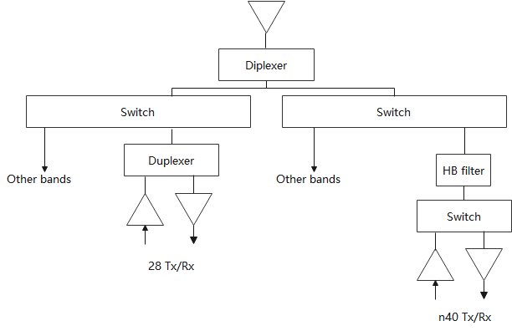

The Rx 3rd order harmonic rejection = 20dB and n28 Rx filter selectivity at B40 = 60dB, the MSD values at the condition of PCB isolation=70dB and antenna isolation = 10dB, are calculated as in Table 6.2.6-9.

Table 6.2.6-9: Harmonic mixing MSD for n28-n40(PC3)

|  |  |  |
| --- | --- | --- |
|  | Main path | Div. path |
| n40 Tx power at n28 LNA input (dBm) | -42.5 | -42.9 |
| After Rx harmonic rejection (referred to antenna) (dBm) | -58.5 | -58.9 |
| Band n28 Thermal noise (dBm) | -95.5 | -95.5 |
| Total Noise (dBm) | -58.5 | -58.9 |
| After MRC sensitivity @ Ant (dBm) | -61.7 | |
| MSD (dB) | 36.8 | |

Similar as above, using the combinations of different PCB isolation values and different antenna isolation values, the H2 MSD values are summarized in Table 6.2.6-10.

Table 6.2.6-10: Harmonic mixing MSD values with different antenna isolation, and different PCB isolation (PC3)(without CF)

|  |  |  |  |
| --- | --- | --- | --- |
|  | Antenna iso.=10dB | Antenna iso.=15dB | Antenna iso.=20dB |
| PCB iso. = 60dB | 46.5 | 46.5 | 46.5 |
| PCB iso. = 65dB | 41.6 | 41.6 | 41.6 |
| PCB iso. = 70dB | 36.8 | 36.8 | 36.8 |
| PCB iso. = 75dB | 32.3 | 32.2 | 32.2 |
| PCB iso. = 80dB | 28.3 | 28.0 | 28.0 |
| PCB iso. = 85dB | 24.9 | 24.2 | 23.9 |
| PCB iso. = 90dB | 22.4 | 20.6 | 19.8 |

The tendency is quite similar as n3-n78 harmonic mixing, where the MSD value is almost keep unchanged when the antenna isolation is increased up to 20dB as antenna isolation pay less role on improving the MSD.

For n28-n40 harmonic mixing, although PCB isolation is up to 90dB, the MSD would be still ‘high’. So to further improve the MSD value, some other method may need to be adopted.

**Observation 7. For n28-n40 harmonic mixing, some other method may need to be adopted to further improving the MSD value.**

For harmonic mixing, no matter for n3-n78 and n28-n40, the MSD value is almost keep unchanged when the antenna isolation is increased up to 20dB, that’s mainly because the aggressor PA output power appears at victim LNA input via PCB path is the dominated factor.

**Observation 8. For harmonic mixing MSD,** **antenna isolation play less role on improving the MSD.**

So far, there were no agreements on the antenna isolation and PCB isolation values. Some concerns from UE vendor that higher PCB isolation (>75dB?) is challenge in practice. So it would be better to discuss the achievable PCB isolation/antenna isolation values in practice when companies re-evaluate how much the MSD can be improved. Otherwise, the re-evaluated may big different among companies by using difference assumption.

### 6.2.7 Evaluation from LGE [14]

MSD values are analyzed for CA\_n1-n3 based on Table1 and Table2. Table 6.2.7-1 shows the component linearity parameter and Table 6.2.7-2 shows the isolation factor used in this analysis.

Table 6.2.7-1: Front-end component linearity parameter

|  |  |  |  |  |
| --- | --- | --- | --- | --- |
| Component | IP2 (dBm) | IP3 (dBm) | IP4 (dBm) | IP5 (dBm) |
| Ant. Switch | 112 | 68 | 55 | 55 |
| Duplexer | 100 | 75 | 55 | 53 |
| PA | 28.5 | 30 | 30 | 28 |
| LNA | 10 | 0 | 0 | -10 |

Table 6.2.7-2: Isolation factor

|  |  |  |
| --- | --- | --- |
| Isolation parameter | Case1 | Case2 |
| Antenna to antenna | 10 dB | 10 dB |
| PCB | 60 dB | 70 dB |

The MSD value for CA\_n1-n3 in TS 38.101-1is shown in Table 6.2.7-3, and the analyzed MSD values in this paper are shown in Table 6.2.7-4.

Table 6.2.7-3: 2DL/2UL interband Reference sensitivity QPSK PREFSENS and uplink/downlink configurations for PC3 CA [TS 38.101-1]

|  |  |  |  |  |  |  |  |  |
| --- | --- | --- | --- | --- | --- | --- | --- | --- |
| Band / Channel bandwidth / NRB / Duplex mode | | | | | | | | Source of IMD |
| NR CA band combination | NR band | UL Fc  (MHz) | UL/DL BW  (MHz) | UL  CLRB | DL Fc (MHz) | MSD  (dB) | Duplex mode |  |
| CA\_n1-n3 | n1 | 1950 | 5 | 25 | 2140 | 23 | FDD | IMD3 |
|  | n3 | 1760 | 5 | 25 | 1855 | N/A | TDD | N/A |

Table 6.2.7-4: Analyzed MSD values considering two types of PCB isolation

|  |  |
| --- | --- |
| **Isolation factor** | **MSD** |
| Case1 | 23.1 dB |
| Case2 | 5 dB |

In case 1, assuming PCB isolation of 60 dB, the MSD value is 23.1 dB, which is similar to the MSD value of TS38.101-1. In case 2, assuming PCB isolation of 70 dB, the MSD value is 5 dB, which is 18.1 dB lower than case 1.

**Observation1: In CA\_n1-n3, when the PCB isolation is 70 dB, it has a much lower MSD value than 60 dB PCB isolation. Further analysis is required for other combinations using 70 dB PCB isolation.**

### 6.2.8 Evaluation from Xiaomi [15]

#### 6.2.8.1 2nd harmonic MSD analysis for CA\_n3-n78

In order to evaluate the effect of improving PCB isolation as well as antenna isolation, the parameters for the MSD analysis list in the below.

Table 6.2.8.1-1, the parameters for the MSD analysis for CA\_n3-n78

|  |  |
| --- | --- |
|  | value |
| Band 3 PA | 27.8 dBm |
| Band 3 PA in H2 | -8 dBm |
| Band 3 duplexer in H2 | 25 dB |
| diplexer | 15 dB |
| Harmonic filter | 25 dB |
| Antenna isolation | 10 ~20 dB |
| PCB isolation | 60~100 dB |
| duplexer, switch, diplexer in H2 | -85dBc |

Based on above parameter, the MSD improvement over improving PCB isolation and antenna isolation could be illustrated in Figure 6.2.8.1-1.

Figure 6.2.8.1-1 MSD improvement over improving PCB isolation and antenna isolation

As seen from above figure 1, the following observations could be made for the harmonic MSD of band combination n3 and n78.

**Observation 1: improving the PCB isolation can reduce the MSD, but when PCB isolation is above 80dB, the impact becomes very small.**

**Observation 2: improving the antenna isolation can reduce the MSD, especially when PCB isolation is high.**

#### 6.2.8.2 IMD MSD analysis for CA\_n3-n78

According to the spec, there are IMD2 and IMD4 issues for CA\_n3-n78 due to 2UL. To assess the potential MSD improvement, the following parameters in table 6.2.8.2-1 and table 6.2.8.2-2 are assumed.

Table 6.2.8.2-1: RF-front component linearity IP2 and IP4 parameters

|  |  |  |
| --- | --- | --- |
|  | IP2 (dBm) | IP4 (dBm) |
| Ant. Switch | 112 | 56 |
| Diplexer | 115 | 55 |
| Duplexer | 100 | 55 |
| PA Forward | 27 | 32 |
| PA Reversed | 38 | 33 |
| LNA | 5 | -6 |

Table 6.2.8.2-2: the isolation parameters

|  |  |  |
| --- | --- | --- |
| Isolation Parameter | Value (dB) | Comment |
| Antenna to Antenna | 10~20 | Main antenna to diversity antenna |
| PA (out) to PA (in)  PA(out) to LNA (in) | 60~100 | PCB isolation (PA forward mixing and n78 PA leakage into B3 LNA |
| PA (out) to PA (out) | 60 | L-H/H-L cross-band (diplexer + duplexer) |
| PA (out) to LNA (in) | 50 | L-H/H-L cross-band (diplexer + filter @ n78) |
| Duplexer | 45 | Tx band rejection at Rx band |
| diplexer | 15 |  |

##### 6.2.8.2.1 IMD2 MSD

With above assumptions, we have made some calculations for IMD2, and the results for PC2 and PC3 are summarized in Figure 6.2.8.2.1-1 and Figure 6.2.8.2.1-2 separately.

Figure 6.2.8.2.1-1: IMD2 MSD improvement over improving PCB isolation and antenna isolation for PC2

Figure 6.2.8.2.1-2: IMD2 MSD improvement over improving PCB isolation and antenna isolation for PC3

As seen from above Figure 6.2.8.2.1-1 and Figure 6.2.8.2.1-2, the following observations could be made for the IMD2 MSD of the combination n3 and n78.

**Observation 1: improving the PCB isolation can reduce the MSD, but when PCB isolation is above 80dB, the impact becomes very small.**

**Observation 2: improving the antenna isolation can reduce the MSD, especially when PCB isolation is high.**

##### 6.2.8.2.2 IMD4 MSD

The similar calculations are also made for IMD4, and the results for PC2 and PC3 are summarized in Figure 6.2.8.2.2-1 and Figure 6.2.8.2.2-2 separately.

Figure 6.2.8.2.2-1: IMD4 MSD improvement over improving PCB isolation and antenna isolation for PC2

Figure 6.2.8.2.2-2: IMD4 MSD improvement over improving PCB isolation and antenna isolation for PC3

As seen from above figures, the following observations could be made for the IMD4 MSD of the combination n3 and n78.

**Observation 1: improving the PCB isolation can reduce the MSD, but when PCB isolation is above 80dB, the impact becomes very small.**

**Observation 2: improving the antenna isolation can reduce the MSD.**

#### 6.2.8.3 Comparison of MSD improvement for different MSD types

In order to compare with MSD improvement for different MSD types, we made the following table based on above calculations.

|  |  |  |  |
| --- | --- | --- | --- |
| **MSD types** | **MSD in current spec**  **(dB)** | **MSD improvement**  **when antenna isolation=20dB and PCB isolation=80dB** | **delta MSD value** |
| 2nd harmonic | 23.9 | 12.2 | 11.7 dB |
| IMD2 | PC2: 31.9  PC3: 26 | PC2: 16.7  PC3: 10.5 | PC2: 15.2 dB  PC3: 15.5 dB |
| IMD4 | PC2: 18.5  PC3: 8.0 | PC2: 7.3  PC3: 1.4 | PC2: 11.2 dB  PC3: 6.6 dB |

**Observation 3: even when antenna isolation is 20dB and PCB isolation is 80dB, the MSD value is still above 15dB for IMD2 for CA\_n3-n78**

**Observation 4: the delta MSD value due to MSD improvement for different MSD types is different. When the minimum requirement of MSD is high, the delta MSD value could be above 10 dB.**

#### 6.2.8.4 Cross band isolation for CA\_n1-n3 (R4-2219037)

According to the spec, there are IMD3 issues for CA\_n1-n3 due to 2UL. To assess the potential MSD improvement, the following parameters in table 6.2.8.4-1 and table 6.2.8.4-2 are assumed.

Table 6.2.8.4-1: RF-front component linearity IP3 parameters

|  |  |
| --- | --- |
| **RF component** | **IP2 (dBm)** |
| Ant. Switch | 68 |
| Quadplexer | 74 |
| PA Forward | 30 |
| PA Reversed | 28 |
| LNA | -6 |

Table 6.2.8.4-2: the isolation parameters

|  |  |  |
| --- | --- | --- |
| **Isolation Parameter** | **Value (dB)** | **Comment** |
| Antenna to Antenna | 10~20 | Main antenna to diversity antenna |
| PA (out) to PA (in)  PA(out) to LNA (in) | 60~100 | PCB isolation (PA forward mixing and n3 PA leakage into B1 LNA |
| PA (out) to PA (out) | 45 | cross-band (Quadplxer) |
| PA (out) to LNA (in) | 45 | cross-band (Quadplxer)) |

With above assumptions, we have made the calculations for IMD3, and the results for PC3 are summarized in figure 6.2.8.4-1.

[TBD]

Figure 6.2.8.4-1: MSD improvement over improving PCB isolation and antenna isolation

As seen from above figure, the following observations could be made for the IMD3 MSD of the combination n1 and n3. From the paper [15], these two observations are the same as those for CA\_n3-n78

**Observation 1: improving the PCB isolation can reduce the MSD, but when PCB isolation is above 80dB, the impact becomes very small.**

**Observation 2: improving the antenna isolation can reduce the MSD, especially when PCB isolation is high.**

### 6.2.9 Evaluation from Meta [16]

#### 6.2.9.1 MSD evaluation results by Harmonic problem

For CA\_n1-n3-n78, the 2nd harmonic from n3 UL will fall into n78 spectrum in DL slot. Based on the following RF parameters in Table 6.2.9.1-1, the expected MSD levels are evaluated in Table 6.2.9.1-2.

Table 6.2.9.1-1: NR CA\_n3A-n78A UE RF FE component isolation parameters

|  |  |
| --- | --- |
|  | **Attenuation Value** |
| n3 Tx in PA output | 28 |
| n3 PA H2 attenuation | 35/ 40 |
| n3 duplexer H2 attenuation | 32 |
| Harmonic filter | 20/25 |
| HB switch H2 | 110 |
| Diplexer attenuation | 25 |
| Antenna isolation | 10/15 |
| Diplexer pathloss | 0.7 |
| UHB switch attenuation | 0.7 |
| UHB switch | 130/110 (primary/secondary) |
| n78 Rx filter attenuation | 1.5 |
| n78 Rx filter | 110/110 (primary/secondary) |
| n3 PA to n78 LNA isolation | 70/75 |

The Table 6.2.9.1-2 is shown the expected MSD levels for NR CA\_n3A-n78A.

Table 6.2.9.1-2: Comparison of MSD of NR CA\_n3A-n78A with different RF components

|  |  |  |  |  |
| --- | --- | --- | --- | --- |
| **Parameter** | **Considering different Filter/isolation** | | | |
| **Primary** | | **Diversity** | |
| **Value** | **H2 level** | **Value** | **H2 level** |
| n3 Tx in PA output | 28 |  | 28 |  |
| n3 PA H2 attenuation | 35 | -7 | 35 | -7 |
| n3 duplexer H2 attenuation | 32 | -39 | 32 | -39 |
| Harmonic filter | 20/25 | -59 /-64 | 20/25 | -59 /-64 |
| HB switch H2 | -110 | -59/ -64 | -110 | -59/ -64 |
| Diplexer attenuation | 25 | -84/ -89 | 25 | -84/ -89 |
| Antenna isolation | 0 | -84/ -89 | 10/15 | -94/ -99 |
| Diplexer pathloss | 0.7 | -84.7/ -89.7 | 0.7 | -94.7/ -99.7 |
| UHB switch attenuation | 0.7 | -85.4/ -90.4 | 0.7 | -95.4/ -100.4 |
| UHB switch | -130 | -85.4/ -90.4 | -110 | -95.2/ -99.9 |
| n78 Rx filter attenuation | 1.5 | -86.9/ -91.9 | 1.5 | -96.7/ -101.4 |
| n78 Rx filter | -110 | -86.9/ -91.8 | -110 | -96.5/ -100.9 |
| n3 PA to n78 LNA isolation | 70/75 | -77/ -82 | 70/75 | -77/ -82 |
| Composite |  | **-76.85 –**  **-81.54** |  | **- 76.98 –**  **-81.93** |
| MSD (dB) | **18.5dB – 23.4dB** | | | |

**Observation #1: Antenna isolation, attenuation of harmonic filter and PA H2 performance improvement are not dominant factors for the 2nd harmonic product to reduce the MSD requirements.**

**Observation #2: The aggressor PA to victim LNA isolation improvement is a dominant factor due to the 2nd Harmonic product to improve MSD levels.**

#### 6.2.9.2 MSD evaluation results by cross band isolations

For CA\_n41-n77, expected MSD levels are evaluated in Table 6.2.9.2-2 based on the common RF parameters are in Table 6.2.9.2-1.

Table 6.2.9.2-1: Basic RF parameters for CA\_n41A\_n77A

|  |  |
| --- | --- |
| Band n77 PA noise @Band 41 Rx (dBm/Hz) | -115 |
| CBW at n77 for UL | 100MHz |
| n77 front end filter Loss (dB) | 4 |
| n41 front end filter Loss (dB) | 4 |
| PA to antenna and LNA to antenna IL (dB) | 4 |
| n41/n77 diplexer isolation (dB) | 10/15 |
| n77 filter attenuation @ B41 RX (dB) | 30 |
| Cross-band isolation (dB) (n77 Tx --> n41 Rx) | 40/45 |
| Rx Antenna isolation (dB) | 10/15 |

Table 6.2.9.2-2: Comparison of MSD of NR CA\_n41A-n77A with different RF components

|  |  |  |
| --- | --- | --- |
| Parameter | Primary | Diversity |
| Value | Value |
| Total noise at PA output (dBm/Hz) | -148 | -148 |
| Antenna isolation  (10dB/ 15dB) | -148 | -158 /-163 |
| Rx thermal noise @ LNA input (dBm) | -84 | -88.2 / -92.5 |
| Total Interference @ Rx | -82.4 | -87.0/-91.2 |
| MRC | -88.3 / -91.7 | |
| REFSENS at n41 (dBm/CBW) | -95.1 | |
| MSD (dB) | **3.4 – 6.8 dB** | |

**Observation #3: For the MSD improvement due to cross band isolation, a larger antenna isolation could improve a required MSD level, but this is difficult to achieve in a small form-factor and not verifiable by conducted tests.**

**Observation #4: An RB restriction (e.g., restriction of RB length or RB position) also could reduce MSD levels. A specific uplink configuration will improve MSD levels.**

#### 6.2.9.3 MSD evaluation results by dual uplink transmission

For CA\_n1-n3-n78, the 2nd & 4th IMDs products by 2UL\_CA\_n1-n3 are falling into n78 DL slot. Also 2nd IMD product by 2UL\_CA\_n3-n78 is falling into n3 Rx band. Therefore, we consider the specific RF component improvement to enhance the MSD requirements in Table 5 and Table 6.

Table 6.2.9.3-1 shows the RF component isolation parameters to derive MSD level for CA\_n1A-n3A-n78A.

Table 6.2.9.3-1: UE RF Front-end component parameters

|  |  |  |  |  |
| --- | --- | --- | --- | --- |
| UE ref. architecture  Component | Cascaded Diplexer-Duplexer  Architecture w/ single ant. or dual ant. | | | |
| CA\_n1A-n3A-n78A | | | |
| IP2 (dBm) | IP3 (dBm) | IP4 (dBm) | IP5 (dBm) |
| Ant. Switch | 110 | 65 | 55 | 45 |
| Triplexer | 110 | 72 | 55 | 45 |
| Diplexer | 112 | 85 | 55 | 45 |
| Duplexer | 95 | 75 | 55 | 45 |
| PA Forward | 27 | 30 | 28 | 27 |
| PA Reversed | 38 | 28 | 33 | 32 |
| LNA | 5 | -5 | -5 | -10 |

Table 6.2.9.3-2 shows the isolation levels based on the RF component in Table 6.2.9.3-1.

Table 6.2.9.3-2: UE RF Front-end component isolation parameters

|  |  |  |
| --- | --- | --- |
| Isolation Parameter | Value (dB) | Comment |
| Antenna to Antenna | 10/15 | Main antenna to diversity antenna |
| PA (out) to PA (in) | 60/70 | PCB isolation (PA forward mixing) |
| Triplexer | 20 | High/low band isolation |
| Diplexer | 25 | High/low band isolation |
| PA (out) to PA (out) | 60 | L-H/H-L cross-band |
| PA (out) to PA (out) | 50 | L-L/H-H cross-band |
| LNA (in) to PA (out) | 60 | L-H/H-L cross-band |
| LNA (in) to PA (out) | 50 | L-L/H-H cross-band |
| Duplexer | 50 | Tx band rejection at Rx band |
| Rx filter attenuation | 38 | n3 filter rejection over n78 |

Table 6.2.9.3-3: Comparison of MSD in n3 Rx band of NR CA\_n3A-n78A UE with different RF parameters

|  |  |  |  |  |  |
| --- | --- | --- | --- | --- | --- |
|  | Thermal | IMD w/ ant. ISO 10dB, PCB 60dB | IMD w/ ant. ISO 10dB, PCB 60dB | IMD w/ ant. ISO 10dB, PCB 70dB | IMD w/ ant. ISO 15dB, PCB 70dB |
| Main Path (dBm) | -93 | -57.2 | -57.2 | -59.8 | -59.8 |
| Diversity Path (dBm) | -93 | -67.1 | -71.9 | -69.4 | -74.1 |
| After MRC (dBm) | -96 | -67.5 | -72.0 | -69.8 | -74.2 |
| MSD (dB) |  | **28.5** | **24.0** | **26.2** | **21.8** |

Considering unit-to-unit variation in mass productions, it is necessary that more than 80 dB PCB isolation is supposed to be guaranteed, i.e., > 85 dB PCB isolation. In our view, it is excessive and overly tightens the implementation complexity.

**Observation #5: For the MSD improvement by dual uplink transmission, 10 dB or less improvements are feasible by enhancing antenna isolation and PCB isolation. However, 80 dB PCB isolation and 20 dB antenna isolation are quite challenging to achieve in a smart phone form-factor.**

## 6.3 Conclusion

According to the available evaluation from companies, it was concluded in RAN4#104-bis meeting that MSD improvement is feasible [7].

# 7 Study of signalling for improved lower MSD

## 7.1 Possible MSD reporting approaches

### 7.1.1 Candidate solution 1: MSD reporting depending on frequency region

On the way to feasibility study on how much MSD improvement to be expected, it was found that it is feasible to reduce drastically MSD, in some cases, it takes a cost, e.g., increasing PCB isolation alone may not be able to achieve MSD to be zero. With this outcome in mind, there were discussion on how many thresholds to be defined for reporting MSD as well as how reported lower MSD value(s) to be utilized by gNB. All the aforementioned discussion is based on MSD in Block A according to a specified test scenario as illustrated in top right in Figure 7.1.1-1, where RAN4 has selected a combination of an aggressor UE channel bandwidth (also # of RBs) and a victim channel bandwidth so as to enable 2nd order harmonic to hit the entire spectrum in Block A as well as most of the power to be contained in Block A.

Figure 7.1.1-1: MSD test condition for 2nd UL harmonic

It’s noted that with respect to 2nd order harmonic case for at least PC3, it is very likely that MSD in Block C would be zero if lower MSD capability is reported provided that specified MSD for this region would be a few dB. Still, however, MSD at least in Block B remains undefined or unpredicted. It is noted that MSD undefined region is undefined is wider than Block B. When the lower edge frequency of victim channel bandwidth of X MHz is larger than -20 – X/2 + 2\*f1 and the higher edge frequency of victim channel bandwidth is less than 20 + X/2 + 2\*f1, MSD is undefined, and the value is somewhere between MSD for near-miss and MSD for direct-hit. This is quite an unfortunate situation since even if a lower MSD, e.g., 15 dB is reported, if e.g., RSRP doesn’t reach a threshold, the network may avoid configuring the UE with CA, may try to configure the UE with CA using DL resource in Region C as shown in Case 1 in Figure 7.x.x-1, and/or may try to schedule UL resources in a way to minimize 2nd order harmonic impact on scheduled DL resources, but if there are other users in the same network, it may not be possible for the network to take any measures to the UE. If the network, however, clearly knows that e.g., Block B has no MSD, the UE might get higher possibility to configured with CA using DL resource in Block B and/or C as shown in Case 2 in Figure 7.1.1-1 since the network can have more flexibility in terms of available resources. Hence, clarifying MSD = 0 dB region gives network more flexibility in terms of resource allocation and UE higher possibility in terms of CA configuration as depicted in case 2 in Figure 7.1.1-1.

Observation 1: Reporting from where MSD = 0 dB with respect to the center of a victim channel bandwidth in the specification(s) provides a network more flexibility to decide CA configuration as well as frequency resource scheduling, and this would increase possibility for the UE to get CA configured with.

Another aspect would be there may be cases, e.g., an operator whose band doesn’t have MSD in a way that the entire channel bandwidth is impacted by an MSD root cause, but rather only an upper part of the channel has MSD as can be seen in Figure 7.1.1-2.

Figure 7.1.1-2: A case where a part of victim channel bandwidth is affected by MSD

Observation 2: Reporting MSD = 0 dB region can provide NW with more flexibility in terms of resource scheduling even if an operator has MSD in a limited part of their spectrum.

If a UE doesn’t have so-called lower MSD capability being discussed, a network may assume that the upper part of the channel bandwidth is affected by the specified MSD, e.g., 30 dB as the worst case. Even if a UE has the lower MSD capability of e.g., 15 dB, still network may consider that the upper part of the operator’s spectrum has 15 dB MSD as the worst case while actually, the UE may not have MSD in the upper part of the operator’s spectrum at all, i.e., MSD = 0 dB. If somehow this information is reported to the network, the operator’s network resource schedule can be released from a restriction due to MSD at least within MSD = 0 dB region.

Observation 3: Reporting MSD = 0 dB region can provide NW with more flexibility in terms of resource scheduling even if an operator has MSD in a limited part of their spectrum.

A question may arise that if a noise due to MSD root cause is actually not flat? Figure 7.1.1-3 shows 2nd order harmonic spectrum, where horizontal axis of -1 to +1 is corresponding to a victim channel bandwidth size. It can be seen that the noise due to 2nd order harmonic sharply decrease as the position becomes close to the channel edges from the center. Hence, it would be likely that a UE with lower MSD capability can have wider MSD zero region than the UE without lower MSD capability.

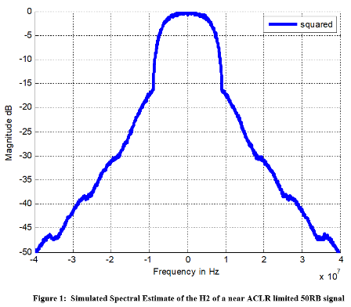

Figure 7.1.1-3: H2 spectral extracted from [3]

Hence, even if a UE cannot indicate MSD = 0 dB based on the existing MSD test condition, i.e., in the entire Block A in the top in Figure 7.1.1-4, some part of Block B may have MSD = 0 dB as shown in the middle in Figure 7.1.1-4. Or if a UE has better lower MSD capability, the UE may have MSD = 0 dB region even in inside Block A as shown in the bottom in Figure 7.1.1-4.

Figure 7.1.1-4: relationship of MSD existence region between specification and a UE with lower MSD

Observation 4: Even if a UE with better isolation still may have challenges in achieving MSD = 0 dB based on the existing MSD definition, i.e., Block A in Figure 7.1.1-4, but still the UE can extend MSD = 0 dB region with the same isolation.

The information that MSD is 0 dB can be easily treated by a network since as far as a network allocates frequency resources to MSD = 0 dB region in the victim channel bandwidth or adjacent channel bandwidth (if CA is possible) on the side of the victim channel bandwidth that is the farthest from MSD non-zero region, the resources are not affected by aggressor’ uplink power(s) in the UE.

With respect to test configurations, this approach does not require something special compared to the existing test configurations expect for the position of victim channel bandwidth. As can be seen in Figure 7.1.1-4, the victim channel bandwidth is placed just adjacent to MSD non-zero region (lower, higher or both sides). Under this condition, UE needs to meet reference sensitivity requirements with no MSD allowance.

Observation 5: The information on where MSD = 0 dB outside a victim channel bandwidth or even inside the victim channel bandwidth can be treated by a network since MSD in this region is not affected by aggressor’s power(s) in a UE.

Conclusion: Reporting distance between the centre of a defined victim channel bandwidth and a starting point of MSD = 0 dB region can be a possible way to enable network to utilize the reported information and to produce a complementary effect with a case that reported MSD is a non-zero value base on existing test configurations.

### 7.1.2 Candidate solution 2: MSD reporting for frequency regions affected by self-interference

#### 7.1.2.1 Basic MSD information unit

Based on the survey of the existing MSD specifications, the essential MSD information for a band combination includes: the cause of the MSD (such as harmonic interference, intermodulation, cross-band isolation and etc), the aggressor band(s), the victim band and the amount of MSD in dB.

The first three pieces of information are correlated. After reducing the redundancy, the basic MSD information unit can be escribed as a 3-tuple of <MSD value, MSD source, Victim band >.

The details of the basic MSD information unit are shown in Table 7.1.2.1-1 below. Note that MSD=0dB indicates no degradation of the receiver sensitivity.

**Table 7.1.2.1-1: Basic MSD Information Unit for a band combination**

|  |  |
| --- | --- |
| **MSD 3-tuple** | **<MSD value, MSD source, Victim band>** |
| **MSD Value** | The index within the set of {MSD=0dB, MSD≤Th1 dB, MSD≤Th2 dB, …, MSD≤Thi dB, …, MSD≤ThM-1 dB }, where M is the total number of thresholds |
| **MSD Source** | The index within the set of {Harmonic, Harmonic mixing, cross-band ISO, IMDn (n=2, …, K)}, where K is the highest IMD order up to 5 in Rel-18. [Handling of order for Harmonic and Harmonic mixing is FFS]. |
| **Victim Band** | Band number or the band index within the DL band combination |

More explicitly, as per the latest 3GPP specifications, the MSD sources can be summarised in Table 7.1.2.1-2 below. However, not all the details are to be reported in order to reduce the signalling overhead.

Table 7.1.2.1-2: MSD sources

|  |  |
| --- | --- |
| **Interference source** | **3GPP notations** |
| **UL harmonic** | UL2/DL1, UL3/DL1, UL4/DL1, UL5/DL1 (Only direct-hit is counted.) |
| **Harmonic mixing** | UL1/DL2, UL1/DL3, UL1/DL4, UL1/DL5, UL2/DL3, UL3/DL2, UL4/DL3 |
| **Intermodulation** | IMD2, IMD3, IMD4, IMD5, IMD7, IMD9 |
| **Cross-band Isolation** | ACLR1, ACLR2, >ACLR2 |

In the following, some examples are given to demonstrate the basic MSD information to be reported by a UE. For different types of MSD sources, the MSD information units to be reported are shown in Table 7.1.2.1-3.

Table 7.1.2.1-3: Examples of MSD information unit.

|  |  |
| --- | --- |
| MSD in TS 38.101-1 | MSD information unit |
|  | For CA\_n1-n3:  <MSD≤25, IMD3, n1>  For CA\_n1-n78:  <MSD≤10, IMD4, n1>  For CA\_n3-n78:  <MSD≤30, IMD2, n3>  <MSD≤10, IMD4, n3>  <MSD≤5, IMD7, n3> |
|  | For CA\_n1-n3-n78:  <MSD≤30, IMD2, n78>  <MSD≤15, IMD4, n78>  <MSD≤30, IMD2, n3> |
|  | For CA\_n3-n78:  <MSD≤25, Harmonic, n78> |
|  | For CA\_n1-n3:  <MSD≤20, Cross-band ISO, n3> |

Note that for the purpose of MSD improvement, a UE should perform better than the minimum requirement in order to claim the low-MSD capability. For example, if the minimum requirement falls into the interval of MSD≤Thi dB, the UE should be able to support at least one-level lower (e.g., MSD≤Thi-1 dB) in order to report the low-MSD capability. If the actual MSD is larger than the maximum threshold ThM-1 (i.e. out of range), the UE cannot report low-MSD capability for this REFSENS exception case

#### 7.1.2.2 Reporting of low-MSD information

##### 7.1.2.2.1 Aspect of higher order band combinations

When a UE supports higher order band combinations, 3GPP specifies ΔTIB,c to allow certain relaxation in Tx power requirements as well as ΔRIB,c for relaxation in Rx sensitivity. Both factors can contribute to the relaxation of the MSD requirements for higher order band combinations. Hence, it’s reasonable to assume that higher order band combinations supported by the UE can inherit the low-MSD capabilities from the fall-back band combinations. As a result, a UE only needs to report low-MSD information for the following types of band combinations as shown in Table 7.1.2.2.1-1.

Table 7.1.2.2.1-1: Band combinations targeted for reporting low-MSD information

|  |  |  |  |
| --- | --- | --- | --- |
| **MSD Source** | **Band combination type** | | |
| **1UL/2DL** | **2UL/2DL** | **2UL/3DL** |
| UL Harmonic | X |  |  |
| Harmonic mixing | X |  |  |
| Cross band isolation | X |  |  |
| IMD | X2 | X | X1 |
| NOTE 1: Only MSD caused by the dual-UL IMD on the third band is reported.  NOTE 2: IMD may occur for intra-band non-contiguous CA. | | | |

##### 7.1.2.2.2 Aspect of power classes

The Tx power can have significant effect on MSD, especially for that caused by high order IMD. Some examples are shown in Table 7.1.2.2.2-1. For example, regarding CA\_n1-n78, the MSD for IMD4 on band n1 deteriorates from 8.0dB to 17.8dB when the Tx power class is upgraded from PC3 to PC2.

Table 7.1.2.2.2-1: Example MSD requirements for different power classes

|  |  |
| --- | --- |
| MSD in TS 38.101-1 | Power Class |
|  | PC3 |
|  | PC2 |

One option is to report the low-MSD information for each power class, or for the power class requested by the network. Effectively, a UE may be requested to report low-MSD information for Tx power at 23dBm, 26dBm or 29dBm (i.e., PC3, PC2 or PC1.5).

Since each power class corresponds to one particular Tx power level, other options have been proposed to support wider range of Tx power. One option is to report the low-MSD information at a given Tx power level which is requested by the network. The Tx power level for the UE is predicted by the network using path loss estimate before a band combination is configured.

##### 7.1.2.2.3 Network query based reporting

A UE may support a large number of band combinations across a wide frequency range. However, a practical network uses pre-planned frequency resources and may be interested in a very limited number of band combinations. To reduce the unnecessary signalling overhead, one solution is for the network to specify certain filter conditions when enquiring the UE about its low-MSD information, for example via *UE-CapabilityReqeustFilterNR* or some similar mechanism. The filter conditions may include: frequency band(s), MSD source (such as IMD order), power class, frequency range, [minimum Lower MSD class] and etc.

The query of the UE low-MSD information could happen before a band combination is configured, which could help the network scheduler to optimise its resource allocation according to the reported UE capabilities.

UE

gNB

Enquiry on low-MSD information

With filter on e.g., band n3, n78, IMD4, PC3.

Response for low-MSD information

CA\_n3-n78:

<MSD≤10, IMD4, n3>

CA\_n1-n3-n78:

<MSD≤15, IMD4, n78>

Figure 7.1.2.2.3-1: Illustration of network query on low-MSD information

###### 7.1.2.2.3.1 Effect of introducing frequency range as one of the filtering conditions

When RAN4 discusses whether an MSD type like IMD falls into a victim band, RAN4 considers the respective bands’ entire UL and DL frequency range(s). More specifically, when IMD2 for CA\_n3A-n77A was studied, fn77 – fn3\_UL was calculated assuming that 3300 ≤ fn77 ≤ 4200 MHz, 1710 ≤ fn3\_UL ≤ 1785 MHz as UL frequency ranges by the two bands. Accordingly, 1515 ≤ fn77 – fn3\_UL ≤ 2490 MHz was derived. Since the frequency range of When RAN4 discusses whether an MSD type like IMD falls into a victim band, RAN4 considers the respective bands’ entire UL and DL frequency range(s). More specifically, when IMD2 for CA\_n3A-n77A was studied, fn77 – fn3\_UL was calculated assuming that 3300 ≤ fn77 ≤ 4200 MHz, 1710 ≤ fn3\_UL ≤ 1785 MHz as UL frequency ranges by two bands. Accordingly, 1515 ≤ fn77 – fn3\_UL ≤ 2490 MHz was derived. Since the frequency range overlaps with 1805 ≤ fn3\_DL ≤ 1880 MHz, MSD due to IMD2 was defined. Each operator, however, has limited frequency range(s) per operating band. Hence, MSD capabilities associated with MSD types and the associated orders that each operator is interested in may be very limited.

Assume that an operator has following frequency ranges in n3 and n77, respectively.

Table 7.1.2.2.3.1-1: Hypothetical frequency ranges for an operator with n3 and n77

|  |  |  |  |
| --- | --- | --- | --- |
|  | UL (MHz) | DL (MHz) | Width (MHz) |
| n3 | 1710 - 1730 | 1805 - 1825 | 20 x 2 |
| n77 | 3520 - 3560 | 3520 - 3560 | 40 |
| n77 | 3700 - 3800 | 3700 - 3800 | 100 |
| n77 | 4000 - 4100 | 4000 - 4100 | 100 |

As defined in 38.101-1, CA\_n3A-n77A has multiple MSD due to several MSD types and associated orders, i.e.,

- 2nd order harmonic:

- IMD2, IMD4 and IMD7

- Harmonic mixing (UL1/DL2)

However, both IMD7 (5\*fn3\_UL – 2\*fn77) and harmonic mixing (UL1/DL2) don’t hit n3 DL if the calculation is conducted with frequency ranges in Table 7.1.2.2.3.1-1.

For 2nd order harmonic and IMD2 and IMD4, according to below Figure 7.1.2.2.3.1-1, only IMD2 hits n3 DL. The frequency region to cause IMD2 is enclosed in red lines. It’s noted that 4100 – 4200 MHz is clearly irrelevant so that the range is omitted from the Figure 7.1.2.2.3.1-1. Hence, in the example with Table 7.1.2.2.3.1-1, MSD values and associated information that a UE needs to report can be reduced to only one (IMD2) from five specified MSDs for CA-n3A-n78 per power class.

Figure 7.1.2.2.3.1-1: Rough sketch of MSD regions for specific frequency ranges

###### 7.1.2.2.3.2 Effect of introducing network preferred minimum Lower MSD class as one of the filtering conditions

It has already been agreed that the following MSD thresholds would be defined as following in Table 7.1.2.2.3.2-1:

Table 7.1.2.2.3.2-1: Actual lower MSD capability signalling index

|  |  |  |  |
| --- | --- | --- | --- |
| Index | Maximum allowed actual MSD  (i.e. Thresholds) | Lower MSD  Capability classes | Note |
| 0 | 0dB | Ⅰ | No degradation |
| 1 | 3 dB | Ⅱ | Actual MSD ≤ 3dB |
| 2 | 6 dB | Ⅲ | Actual MSD ≤ 6dB |
| 3 | 9 dB | IV | Actual MSD ≤ 9dB |
| 4 | 12 dB | Ⅴ | Actual MSD ≤ 12dB |
| 5 | 15 dB | Ⅵ | Actual MSD ≤ 15dB |
| 6 | 18 dB | Ⅶ | Actual MSD ≤ 18dB |
| 7 | 22dB | Ⅷ | Actual MSD ≤ 22dB |

However, there are still views that this granularity is much finer than the network really needs, depending on how to use this capability by the network. For example, the network may simply use one MSD value as a threshold to set different scheduling method for a particular band / BC, and some minor refinements such as a few dB in relative higher region, e.g 18dB -> 15 or 12 dB, may not that meaningful for the network. In this case, even the UE may be qualified for “Lower MSD” in a certain scenario including band/MSD type etc, the network may simply treat this UE the same to a UE which only satisfy minimum MSD requirement, and the signalling of Lower MSD for this particular scenario, might actually not be needed by the network.

In another word, depending on how the network would utilize Lower MSD capability class, the lower MSD capable UE for a certain scenario may not be differentiated by the network with UE only satisfy minimum MSD requirements, particularly if the lower MSD capability class is relatively large.

Based on this condition, a network preferredminimum Lower MSD capability class can be considered as another filter parameter for reducing capability reporting. For example, if network would only consider a maximum allowed 6dB MSD for harmonic interference for n3-n78 harmonics interference for n78, it can consider using the lower MSD capability class as a filtering parameter, and set up the maximum allowed report class as III (index 2), which corresponds to a maximum allowed actual MSD of 6dB. In this case, the UE would report the lower MSD class for this scenario if it can satisfy class I or II or III. If the UE support lower MSD but can only achieve lower MSD class larger than III, the UE would not report the capability since anyway the network would treat it the same to UE only support minimum requirements.

In this way, the signalling overhead is saved based on network needs. Though the UE may lose the opportunity to report in the condition, those reporting would anyway be meaningless since network would no use it and explicitly indicted. Furthermore, the whole scheme is well controlled by the network.

### 7.1.3 Candidate solution 3: MSD reporting for frequency regions affected by self-interference

#### 7.1.3.1 Basic MSD information unit

Based on the survey of the existing MSD specifications, there are types of MSD mechanism includes: uplink(aggressor) harmonic, receiver harmonic mixing, cross-band isolation, intermodulation and etc. The aggressor power class also have direct impact on the victim band and the amount of MSD in dB.

The improved lower MSD capability signalling shall include its mechanism, aggressor order, aggressor power class and improved MSD values per victim band. The lower MSD capability signalling can be specified as per victim band per BC as a 2-tuple of < MSD mechanism/Aggressor power class and its order, MSD value >. This can save 1-tuple signaling overhead on adaptive network signalling approach comparing to 3-tuple signalling element.

Some examples are given below to demonstrate the improved MSD reporting information for different types of MSD mechanisms. Table 7.1.3.1-1 referred from [3] for ease of understanding. For one mechanism same aggressor power class, order and victim order, only the worst MSD value after improvement is reported to reduce unnecessary signalling overhead. All the MSD in existing specs are within the scope of lower MSD capability reporting. Further, if new MSD type is identified and specified by RAN4 in the future, the new MSD type can also be considered for indicating lower MSD capability

UE would not be allowed to report the lower MSD capability if there’s no improvement.

Table 7.1.3.1-1: Information element examples of improved MSD reporting per BC for non-threshold based approach

|  |  |
| --- | --- |
| MSD in TS 38.101-1 | MSD information unit |
|  | For CA\_n1-n3:  Victim n1: <PC3IMD3, 17>  For CA\_n1-n78:  Victim n1: <PC3IMD4, 4>  For CA\_n3-n78:  Victim n3: <PC3IMD2, 19>  Victim n3: <PC3IMD4, 4>  Victim n3: <PC3IMD7, 0> |
|  | For CA\_n1-n3-n78:  Victim n78: <PC3IMD2, 19>  Victim n78: <PC3IMD4, 6>  Victim n3: <PC3IMD2, 19> |
|  | For CA\_n3-n78:  Victim n78: <PC3UL2DL1, 17> |
|  | For CA\_n1-n3:  Victim n3: <PC3XB, 11> |

An alternative expression on the information element of low-MSD reporting can also be a few bits index that pointed to some actual MSD values like the examples below,

Table 7.1.3.1-2: Information element examples of improved MSD reporting per BC for threshold-based approach

|  |  |
| --- | --- |
| MSD in TS 38.101-1 | MSD information unit |
|  | For CA\_n1-n3:  Victim n1: <PC3IMD3, index 7>  For CA\_n1-n78:  Victim n1: <PC3IMD4, index 2>  For CA\_n3-n78:  Victim n3: <PC3IMD2, index 7>  Victim n3: <PC3IMD4, index 3>  Victim n3: <PC3IMD7, index 2> |
|  | For CA\_n1-n3-n78:  Victim n78: <PC3IMD2, index 7>  Victim n78: <PC3IMD4, index 2>  Victim n3: <PC3IMD2, index 7> |
|  | For CA\_n3-n78:  Victim n78: <PC3UL2DL1, index 6> |
|  | For CA\_n1-n3:  Victim n3: <PC3XB, index 4> |

where the reported index can be pointed to an agreed MSD values in Table 7.1.2.2.3.2-1.

#### 7.1.3.2 Reporting of low-MSD information

As for how to report the lower MSD capability, several promising options for allowing a UE to signal improved lower MSD performance have been discussed [R4-2306590]. It is also agreed that the MSD mechanisms, orders and values in existing specs shall all be considered as starting point. Considering there are many MSD mechanisms and the order of aggressor could be up to 9 in existing specs, if UE need to signal all improved MSD information, the signaling overhead might be quite large. One approach with signaling the essential information as well as the idea to reduce signaling overhead is network can require UE only to report the top K largest MSD values together with its mechanism indexing and improved MSD values. For example K = 1,

If K=1, Network scheduling with reference on top largest value of reported lower MSD

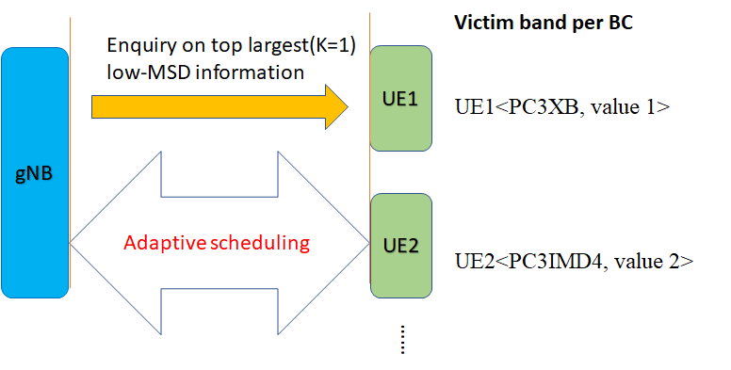

Figure 7.1.3.2-1 Example illustration of network query on low-MSD information, K=1

If K=2, Network scheduling with reference on top two largest value of reported lower MSD

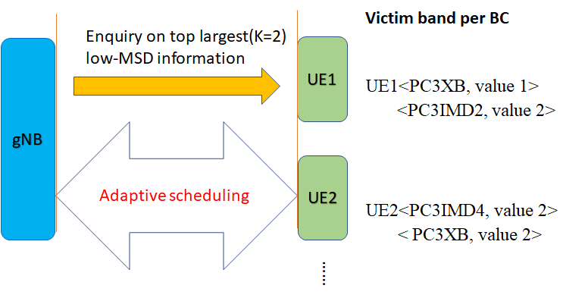

Figure 7.1.3.2-2 Example illustration of network query on low-MSD information, K=2

Or alternative low-MSD signaling expression:

If K=1, Network scheduling with reference on top largest value of reported lower MSD

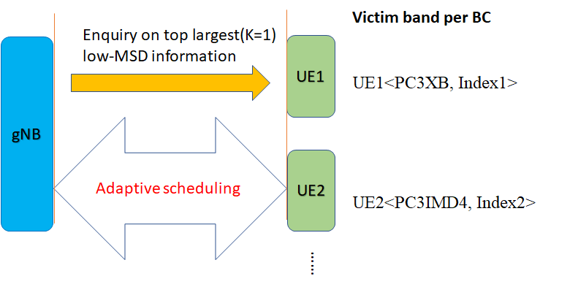

Figure 7.1.3.2-3 Example illustration of network query on low-MSD information, K=1

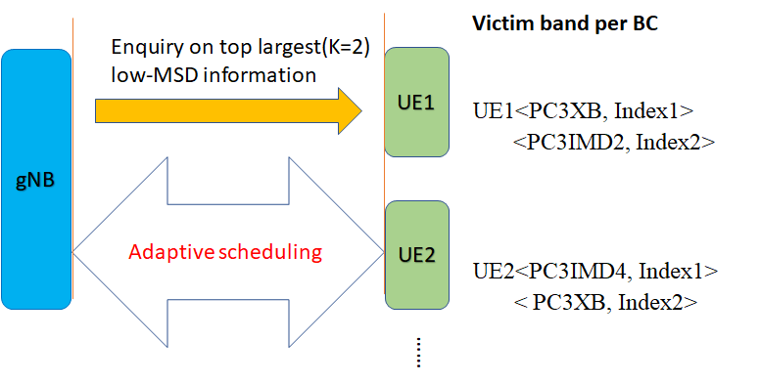

Figure 7.1.3.2-4 Example illustration of network query on low-MSD information, K=2

With such adaptive signalling approach, UE does not need to report all low-MSD information over all supported band combinations. UE may also not need to restore all improved low-MSD points, it only needs to restore top K largest low-MSD information which can save the size of UE memory to smaller one. Network also does not need to restore large amount of low-MSD information that only a few of them are interested band combinations.

## 7.2 Conclusion

With the conclusion that MSD improvement is feasible, RAN4 continues the study on approaches for a UE to indicate the improved lower MSD performance based on the progress of the study phase and reached the following agreements which could be utilized to specify the related signaling:

- Essential information considered by RAN4 for the capability

- Victim band

- MSD type (harmonic; harmonic mixing; cross band isolation; IMD) with orders

- MSD indication of corresponding threshold (or capability class)

- Power class

- MSD for different power classes

- UE reports the lower MSD capability class per MSD type for the highest supported power class for the band combination

- UE can additionally report lower MSD capability class per MSD type for other power classes if requested by the network/regulator

- MSD orders

- No need to report the order for harmonic/ harmonic mixing/cross band isolation MSD types

- Lower MSD capability class reported should apply for all specified orders of the MSD type

- IMD order is up to 5 in Rel-18

- MSD types

- The following MSD types/orders are agreed to be reported based on the existing spec

- Harmonic, harmonic mixing, crossband isolation, IMD with order=2/3/4/5

- It is agreed to add a new special lower MSD type as “ALL”, which means all above mentioned MSD types/orders could meet the reported lower MSD threshold/lower MSD capability class. “ALL” is defined per victim band per BC

- Type “ALL” denotes the actual MSD values for harmonic/harmonic mixing/cross band isolation/IMD2,3,4,5 if any existing are all under the reported lower MSD capability threshold for a victim band with a band combination

- It is noted that for a certain victim band per BC, additional MSD type(s) and/or new MSD types could be introduced in future releases.

- If UE reports “ALL” MSD type, it does not mean that UE always suffer from all MSD types included in the LS to RAN2 in R4-2310276. There is no change in the applicable MSD types for the “ALL” type as communicated to RAN2 previously.

- All above mentioned MSD types could be related to different UL configurations, e.g.

|  |  |  |
| --- | --- | --- |
| UL configuration | MSD type | Support of reporting  in Rel-18 |
| 1UL with 1CC in one aggressor band | UL harmonic, harmonic mixing and crossband isolation MSD | Yes |
| 1UL with 2CC in one aggressor band | IMD MSD by Intra-band UL CA | No |
| 2UL with 2CC in two aggressor bands | IMD MSD by Inter-band UL CA | Yes |
| 2UL with 3CC in two aggressor bands | Triple beat MSD | No |

It was agreed by RAN4 that MSD caused by triple beat and intra-band UL CA as well as UL configurations are not considered by RAN4 for lower MSD reporting in Rel-18, but some additional MSD types caused by different UL configurations may be considered in future release.

- Candidate MSD thresholds

- 3-bit signalling will be used for reporting thresholds

- The maximum value of threshold is 22 dB

- The minimum reporting value for threshold is 0 dB, i.e., no degradation relative to REFSENS

|  |  |  |  |
| --- | --- | --- | --- |
| Index | Maximum allowed actual MSD  (i.e. Thresholds) | Lower MSD  Capability classes | Note |
| 0 | 0 dB | I | No degradation |
| 1 | 3 dB | II | Actual MSD ≤ 3dB |
| 2 | 6 dB | III | Actual MSD ≤ 6dB |
| 3 | 9 dB | IV | Actual MSD ≤ 9dB |
| 4 | 12 dB | V | Actual MSD ≤ 12dB |
| 5 | 15 dB | VI | Actual MSD ≤ 15dB |
| 6 | 18 dB | VII | Actual MSD ≤ 18dB |
| 7 | 22 dB | VIII | Actual MSD ≤ 22dB |

- Lower MSD capability for higher order combination

- For 2-bands combination, the MSD indication of corresponding threshold (or capability class) are supposed to be reported separately as per victim band per MSD type per band combination

- For 3-bands combination, the MSD indication of corresponding threshold (or capability class) are only reported for IMD of dual UL falling into the third band DL whose UL band is not configured with, other kinds of Lower MSD capability (harmonic/ harmonic mixing/cross band isolation/IMD due to dual UL falling into own DL) could inherit from 2-band combinations with the same power class.

- For combination with more than 3 bands, no need to report the Lower MSD capability any more, the capability could inherit from the fallback combinations with the same power class.

- Others

- No dynamic signaling scheme will be introduced for lower MSD report in Rel-18

Apart from the above agreements reached in RAN4 to facilitate the lower MSD capability signaling design, RAN4 also had some discussion for the possible MSD reporting approaches, which can refer to clauses 7.1.1-7.1.3.

In addition, RAN4 had extensive discussion on signaling overhead reduction, which would be left to RAN2 for further consideration during the signaling design.

# Annex A (informative): Change history

|  |  |  |  |  |  |  |  |
| --- | --- | --- | --- | --- | --- | --- | --- |
| **Change history** | | | | | | | |
| **Date** | **Meeting** | **Tdoc** | **CR** | **Rev** | **Cat** | **Subject/Comment** | **New version** |
| 2022-08 | RAN4 #104-e | R4-2213728 |  |  |  | TR skeleton for lower MSD for inter-band CA/EN-DC/DC combinations | 0.0.1 |
| 2022-10 | RAN4 #104-bis-e | R4-2216675 |  |  |  | R4-2217724, TP for TR 38.881 Example band combinations for lower MSD | 0.1.0 |
| 2022-11 | RAN4 #105 | R4-2219568 |  |  |  | R4-2220513, TP for TR 38.881 Feasibility study for lower MSD improvement | 0.2.0 |
| 2023-02 | RAN4 #106 | R4-2302370 |  |  |  | R4-2301097, TP for 38.881 on feasible study  R4-2303520, TR handling and TP on possible Lower MSD signaling for TR 38.881 | 0.3.0 |
| 2023-04 | RAN4 #106-bis-e | R4-2305563 |  |  |  | R4-2306593, TP for TR38881 on the signalling design for low-MSD capability | 0.4.0 |
| 2023-05 | RAN4 #107 | R4-2307145 |  |  |  | R4-2307089, TP for TR 38.881 update of MSD 0 dB region approach  R4-2308926, TP for TR 38.881 on the signalling design for low-MSD capability | 0.5.0 |
| 2023-08 | RAN4 #108 | R4-2312246 |  |  |  | R4-2311054, TP for TR 38.881 on a possible signaling overhead reduction approach | 0.6.0 |
| 2023-10 | RAN4 #108bis | R4-2315237 |  |  |  | R4-2315833, TP for TR 38.881 on a possible scheme for signaling overhead reduction  R4-2315241, TP for TR 38.881: draft conclusion for lower MSD capability | 0.7.0 |
| 2023-11 | RAN4 #109 | R4-2319732 |  |  |  | R4-2318444, TP on TR38.881 to update contents based on agreements | 0.8.0 |
| 2023-12 | RAN#102 | RP-233187 |  |  |  | Presentation of TR 38.881 v1.0.0 to TSG RAN | 1.0.0 |

|  |  |  |  |  |  |  |  |
| --- | --- | --- | --- | --- | --- | --- | --- |
| **Change history** | | | | | | | |
| **Date** | **Meeting** | **TDoc** | **CR** | **Rev** | **Cat** | **Subject/Comment** | **New version** |
| 2023-12 | RAN#102 |  |  |  |  | Approved by plenary – Rel-18 spec under change control | 18.0.0 |