3GPP TR 38.872 V18.3.0 (2023-12)
Technical Report

3rd Generation Partnership Project;
Technical Specification Group Radio Access Network;
NR;
Study on enhancement for 700/800/900MHz band combinations
(Release 18)
The present document has been developed within the 3rd Generation Partnership Project (3GPP TM) and may be further elaborated for the purposes of 3GPP.
The present document has not been subject to any approval process by the 3GPP Organizational Partners and shall not be implemented.
This Specification is provided for future development work within 3GPP only. The Organizational Partners accept no liability for any use of this Specification.
Specifications and Reports for implementation of the 3GPP TM system should be obtained via the 3GPP Organizational Partners' Publications Offices.

3GPP
Postal address

3GPP support office address
650 Route des Lucioles - Sophia Antipolis
Valbonne - FRANCE
Tel.: +33 4 92 94 42 00 Fax: +33 4 93 65 47 16
Internet
http://www.3gpp.org

Copyright Notification
No part may be reproduced except as authorized by written permission.
The copyright and the foregoing restriction extend to reproduction in all media.

© 2023, 3GPP Organizational Partners (ARIB, ATIS, CCSA, ETSI, TSDSI, TTA, TTC).
All rights reserved.

UMTS™ is a Trade Mark of ETSI registered for the benefit of its members
3GPP™ is a Trade Mark of ETSI registered for the benefit of its Members and of the 3GPP Organizational Partners
LTE™ is a Trade Mark of ETSI registered for the benefit of its Members and of the 3GPP Organizational Partners
GSM® and the GSM logo are registered and owned by the GSM Association
Contents
Foreword 8
1 Scope 10
2 References 10
3 Definitions of terms, symbols and abbreviations 11
3.1 Terms 11
3.2 Symbols 11
3.3 Abbreviations 11
4 Background 11
4.1 TR Maintenance 13
5 Specific Band combinations 13
5.1 CA_n5-n8 13
5.1.0 General 13
5.1.1 UE RF architecture assumption 13
5.1.2 Common for 1 band UL and 2 bands UL of CA_n5-n8 18
5.1.2.1 Operating bands for CA 18
5.1.2.2 Channel bandwidths per operating band for CA 18
5.1.2.3 UE co-existence studies 18
5.1.2.4 ∆TIB,c and ∆RIB,c values 19
5.1.2.5 REFSENS evaluation 19
5.1.3 Specific for 2 bands UL of CA_n5-n8 20
5.1.3.0 General 20
5.1.3.1 Maximum output power for inter-band CA 20
5.1.3.2 UE co-existence studies 20
5.1.3.3 REFSENS evaluation 21
5.1.4 Feasible RF implementations 21
5.1.5 Output for 2UL/2DL CA_n5-n8 during the work item phase 22
5.2 CA_n5-n28 25
5.2.1 UE RF architecture assumption 25
5.2.1.1 UE RF architecture with two antennas 26
5.2.1.2 UE RF architecture with three antennas 27
5.2.2 Common for 1 band UL and 2 bands UL of CA_n5-n28 27
5.2.2.0 General 27
5.2.2.1 Operating bands for CA 27
5.2.2.2 Channel bandwidths per operating band for CA 27
5.2.2.3 UE co-existence studies 28
5.2.2.4 ∆TIB,c and ∆RIB,c values 28
5.2.2.5 REFSENS evaluation 28
5.2.3 Specific for 2 bands UL of fallback CA_n5-n28 29
5.2.3.1 Maximum output power for inter-band CA 29
5.2.3.2 UE co-existence studies 29
5.2.3.3 REFSENS evaluation 31
5.3 CA_n8-n20-n28 33
5.3.1 UE RF architecture assumption 33
5.3.1.0 General 33
5.3.1.1 UE RF architecture with three antennas 33
5.3.1.2 UE RF architecture with two antennas 34
5.3.1.3 UE RF architecture with four antennas 35
5.3.2 CA_n8-n20 36
5.3.2.0 General 36
5.3.2.1 Operating bands for CA 36
5.3.2.2 Channel bandwidths per operating band for CA 36
5.3.2.3 UE co-existence studies 36
5.3.2.4 ∆TIB,c and ∆RIB,c values 36
5.3.2.5 REFSENS requirements 36
5.3.2.6 Maximum output power for UL inter-band CA 36
5.3.2.7 UE co-existence studies for UL inter-band CA 36
5.3.2.8 REFSENS evaluation for UL inter-band CA 38
5.3.3 CA_n8-n28 38
5.3.3.0 General 38
5.3.3.1 Operating bands for CA 38
5.3.3.2 Channel bandwidths per operating band for CA 39
5.3.3.3 UE co-existence studies 39
5.3.3.4 ∆TIB,c and ∆RIB,c values 39
5.3.3.5 REFSENS requirements 39
5.3.3.6 Maximum output power for UL inter-band CA 39
5.3.3.7 UE co-existence studies for UL inter-band CA 39
5.3.3.8 REFSENS requirements for UL inter-band CA 41
5.3.4 CA_n20-n28 41
5.3.4.1 General 41
5.3.5 CA_n8-n20-n28 42
5.3.5.1 Operating bands for CA 42
5.3.5.2 Channel bandwidths per operating band for CA 42
5.3.5.3 ∆TIB,c and ∆RIB,c values 42
5.3.5.4 UE co-existence studies for UL inter-band CA 43
5.3.5.5 REFSENS evaluation 46
5.4 CA_n5-n105 47
5.4.1 General 47
5.4.2 UE RF architecture assumption 47
5.4.2.1 UE RF architecture with two antennas 47
5.4.2.2 UE RF architecture with three antennas 48
5.4.3 Common for 1 band UL and 2 bands UL of CA_n5-n105 49
5.4.3.1 Operating bands for CA 49
5.4.3.2 Channel bandwidths per operating band for CA 49
5.4.3.3 Identify the potential MSD issues due to harmonic/harmonic mixing/cross band isolation 49
5.4.3.4 ∆TIB,c and ∆RIB,c values 50
5.4.3.5 REFSENS exception evaluation for one UL band 50
5.4.4 Specific for 2 bands UL of CA_n5-n105 55
5.4.4.1 Maximum output power for inter-band CA 55
5.4.4.2 UE co-existence studies 55
5.4.4.3 REFSENS exception evaluation for two UL band 57
5.5 CA_n28-n105 57
5.5.1 General 57
5.5.2 UE RF architectures assumption 57
5.5.2.1 UE RF architectures with two antennas 57
5.5.2.2 UE RF architectures with three antennas 58
5.5.2.3 2UL IMD issue 59
5.5.2.4 Cross-band interference 59
5.5.3 Common for 1 band UL and 2 bands UL of CA_ n28-n105 60
5.5.3.0 General 60
5.5.3.1 Operating bands for CA 60
5.5.3.2 Channel bandwidths per operating band for CA 60
5.5.3.3 UE co-existence studies 60
5.5.3.4 ∆TIB,c and ∆RIB,c values 61
5.5.3.5 REFSENS evaluation 61
5.5.4 Specific for 2 bands UL of fallback CA_n28-n105 62
5.5.4.1 Maximum output power for inter-band CA 62
5.5.4.2 UE co-existence studies 62
5.5.4.3 REFSENS evaluation 63
5.6 CA_n26-n28 64
5.6.1 General 64
5.6.2 UE RF architecture assumption 65
5.6.2.1 UE RF architecture with lower 30MHz of n28 supporting 65
5.6.2.2 UE RF architecture with entire n28 frequency range supporting 66
5.6.3 Common for 1 band UL and 2 bands UL of CA_n26-n28 68
5.6.3.1 Operating bands for CA 68
5.6.3.2 Channel bandwidths per operating band for CA 68
5.6.3.3 Identify the potential MSD issues due to harmonic/harmonic mixing/cross band isolation 68
5.6.3.4 ∆TIB,c and ∆RIB,c values 69
5.6.3.5 REFSENS exception evaluation for one UL band 69
5.6.4 Specific for 2 bands UL of CA_n26-n28 78
5.6.4.1 Maximum output power for inter-band CA 78
5.6.4.2 UE co-existence studies 78
5.6.4.3 REFSENS exception evaluation for two UL band 80
5.7 CA_n5-n28-n105 83
5.7.1 UE RF architecture assumption 83
5.7.1.1 General 83
5.7.1.2 UE RF architecture with two antennas 83
5.7.1.3 UE RF architecture with three antennas 85
5.7.1.4 UE RF architecture with four antennas 87
5.7.2 Operating bands for CA 88
5.7.3 Channel bandwidths per operating band for CA 88
5.7.4 ∆T_{IB,c} and ∆R_{IB,c} values 88
5.7.5 UE co-existence studies for UL inter-band CA 89
5.7.6 REFSENS evaluation 91
Annex A: Change history 93

Foreword
This Technical Report has been produced by the 3rd Generation Partnership Project (3GPP).
The contents of the present document are subject to continuing work within the TSG and may change following formal TSG approval. Should the TSG modify the contents of the present document, it will be re-released by the TSG with an identifying change of release date and an increase in version number as follows:
Version x.y.z
where:
x the first digit:
1 presented to TSG for information;
2 presented to TSG for approval;
3 or greater indicates TSG approved document under change control.
y the second digit is incremented for all changes of substance, i.e. technical enhancements, corrections, updates, etc.
z the third digit is incremented when editorial only changes have been incorporated in the document.
In the present document, modal verbs have the following meanings:
shall indicates a mandatory requirement to do something
shall not indicates an interdiction (prohibition) to do something
The constructions "shall" and "shall not" are confined to the context of normative provisions, and do not appear in Technical Reports.
The constructions "must" and "must not" are not used as substitutes for "shall" and "shall not". Their use is avoided insofar as possible, and they are not used in a normative context except in a direct citation from an external, referenced, non-3GPP document, or so as to maintain continuity of style when extending or modifying the provisions of such a referenced document.
should indicates a recommendation to do something
should not indicates a recommendation not to do something
may indicates permission to do something
need not indicates permission not to do something
The construction "may not" is ambiguous and is not used in normative elements. The unambiguous constructions "might not" or "shall not" are used instead, depending upon the meaning intended.
can indicates that something is possible
cannot indicates that something is impossible
The constructions "can" and "cannot" are not substitutes for "may" and "need not".
will indicates that something is certain or expected to happen as a result of action taken by an agency the behaviour of which is outside the scope of the present document
will not indicates that something is certain or expected not to happen as a result of action taken by an agency the behaviour of which is outside the scope of the present document
might indicates a likelihood that something will happen as a result of action taken by some agency the behaviour of which is outside the scope of the present document
might not indicates a likelihood that something will not happen as a result of action taken by some agency the behaviour of which is outside the scope of the present document
In addition:
is (or any other verb in the indicative mood) indicates a statement of fact
is not (or any other negative verb in the indicative mood) indicates a statement of fact
The constructions "is" and "is not" do not indicate requirements.

1 Scope
The present document is the technical report for the study on enhancement for 700/800/900MHz band combinations [2] and sub-1GHz NR band combinations [5] under R18 time frame. The purpose is to gather the relevant background information and studies in order to address the study on enhancement for 600/700/800/900MHz band combinations in Table 1-1.
Table 1-1: Band combinations in the SI
Configuration | Uplink configuration
CA_n8-n20-n28 | CA_n8-n20, CA_n8-n28, CA_n20-n28
CA_n5-n8 | CA_n5-n8
CA_n5-n28 | CA_n5-n28
CA_n5A-n105A | CA_n5A-n105A
CA_n28A-n105A | single UL in either n28 or n105
CA_n26A-n28A | CA_n26A-n28A
CA_n5A-n28A-n105A | CA_n5A-n28A
CA_n5A-n28A-n105A | CA_n5A-n105A
CA_n5A-n28A-n105A | single UL in either n28 or n105

2 References
The following documents contain provisions which, through reference in this text, constitute provisions of the present document.
- References are either specific (identified by date of publication, edition number, version number, etc.) or non-specific.
- For a specific reference, subsequent revisions do not apply.
- For a non-specific reference, the latest version applies. In the case of a reference to a 3GPP document (including a GSM document), a non-specific reference implicitly refers to the latest version of that document in the same Release as the present document.
[1] 3GPP TR 21.905: "Vocabulary for 3GPP Specifications".
[2] RP-221464, “Revised SI: Study on enhancement for 700/800/900MHz band combinations for NR”, RAN#96
[3] TS 38.101-1
[4] TS 38.101-3
[5] RP-230789, “ Study on enhancement for sub-1Ghz NR band combinations”. RAN 99
[6] 3GPP TR 38 892 , APT 600 MHz NR band.
[7] R4-2308581, Discussion on RF architecture and potential MSD issues for CA_n5-n105, Huawei, HiSilicon, Spark NZ
[8] R4-2309299, Input on CA_n5-n105 cross-band MSD and DeltaT/R, Skyworks Solutions Inc.
[9] R4-2309356, Considerations on CA_n5-n105, Qualcomm France
[10] R4-2309358, Considerations on CA_n26-n28, Qualcomm France
[11] R4-2306468, WF on CA_n5-n28 and CA_n8-n20-n28, Huawei, HiSilicon
[12] R4-2308583, Discussion on RF architecture and potential MSD issues for CA_n26-n28, Huawei, HiSilicon
[13] R4-2307477, Input on CA_n26-n28 requirements, Skyworks Solutions Inc.
[14] R4-2306470, WF on RF architecture and critical issues for CA_n28-n105
[15] R4-2312979, Discussion on RF architecture and potential MSD issues for CA_n5-n28-n105
[16] R4-2311755, requirements for LBLBLB CA_n5-n28-n105
[17] R4-2303576 TP for CA_n26-n28, MediaTek Inc.
[18] R4-2311116 CA_n26-n28 cross band MSD based on measurements, Skyworks Solutions Inc.
[19] R4-2311753 MSD analysis for CA_n5-n105, CA_n28-n105, and CA_n26-n28, Apple Inc.
[20] R4-2313371 Considerations on CA_n26-n28, Qualcomm France

3 Definitions of terms, symbols and abbreviations

3.1 Terms
For the purposes of the present document, the terms given in TR 21.905 [1] and the following apply. A term defined in the present document takes precedence over the definition of the same term, if any, in TR 21.905 [1].

3.2 Symbols
For the purposes of the present document, the following symbols apply:
ΔR_{IB,c} Allowed reference sensitivity relaxation due to support for inter-band CA operation, for serving cell c
ΔT_{IB,c} Allowed maximum configured output power relaxation due to support for inter-band CA operation, inter-band NR-DC operation and due to support for SUL operations, for serving cell c

3.3 Abbreviations
For the purposes of the present document, the abbreviations given in TR 21.905 [1] and the following apply. An abbreviation defined in the present document takes precedence over the definition of the same abbreviation, if any, in TR 21.905 [1].
MRC Maximum Ratio Combining
MSD Maximum Sensitivity Degradation
RB Resource Block
UE User Equipment

4 Background
In RAN#95e, SI “enhancement for 700800900MHz band combinations” was approved. The objectives of SI are as follows:
1 Investigate the feasibility and solutions to enable simultaneous transmission on two UL bands and simultaneous reception on two or three bands for the band combination of 700, 800 and 900MHz spectrum for smart phone form factor
2 The following band combinations will be considered. And the feasibility study on three band combination will start after the completion of feasibility study of all the fallback band combinations.
- CA_n8-n20-n28 with uplink configurations of CA_n8-n20, CA_n8-n28, CA_n20-n28, and the fallback modes
- CA_n5-n8 with uplink configuration of CA_n5-n8, and the fallback modes
Note1: Spectrum restrictions should be studied to solve overlap of band n5 downlink and band n8 uplink
Note2: The current filter is used as the baseline. Further study whether or not to have new solutions.
- CA_n5-n28 (full range) with uplink configuration of CA_n5-n28.
In RAN 99 a new SI [5] was approved. This SI concerns the consideration of the APT 600 MHz band (n105) that has been recently has been introduced into 3GPP specifications [6]. After the completion of APT 600MHz band, operators have the further demands to combine this 600MHz band with other sub-1GHz bands together to achieve a good performance for the real deployment. However, some challenges were identified for a device with a smart phone form factor to support the combinations of those low bands including 600MHz band. For example, UE RF architecture need to be further studied due to larger antenna size for 600MHz band and some RF requirements need to be evaluated, e.g. MSD. The previous SI on Enhancement for 700/800/900MHz band combinations didn’t include the evaluation and studies for 600MHz band. Additionally band 26 is also considered.
Summary of band combinations considered in the SI
Configuration | Uplink configuration | Supported operators | The status of fallback mode
CA_n8-n20-n28 | CA_n8-n20, CA_n8-n28, CA_n20-n28 | Vodafone, Telecom Italia, Orange, Deutsche Telekom
CA_n5-n8 | CA_n5-n8 | China Telecom, Spark NZ, China Unicom
CA_n5-n28 | CA_n5-n28 | Spark NZ
CA_n5A-n105A | CA_n5A-n105A | Spark NZ | DL_n5A-n105A_UL_n5A_BCS0 (New)  DL_n5A-n105A_UL_n105A_BCS0 (New)
CA_n28A-n105A | CA_n28A-n105A | Spark NZ | DL_n28A-n105A_UL_n28A_BCS0 (New)  DL_n28A-n105A_UL_n105A_BCS0 (New)
CA_n26A-n28A | CA_n26A-n28A | Telstra | DL_n26A-n28A_UL_n28A_BCS0 (Completed in RAN4#106)  DL_n26A-n28A_UL_n26A_BCS0 (New)
CA_n5A-n28A-n105A¹ | CA_n5A-n28A | Spark NZ | DL_n5A-n28A_UL_n5A-n28A_BCS0 (Ongoing in a separate WI)  DL_n5A-n28A-n105A_UL_n5A_BCS0 (New)  DL_n5A-n28A-n105A_UL_n28A_BCS0 (New)
CA_n5A-n28A-n105A¹ | CA_n5A-n105A | Spark NZ | DL_n5A-n105A_UL_n5A-n105A_BCS0 (New)  DL_n5A-n28A-n105A_UL_n5A_BCS0 (New)  DL_n5A-n28A-n105A_UL_n105A_BCS0 (New)
CA_n5A-n28A-n105A¹ | CA_n28A-n105A | Spark NZ | DL_n28A-n105A_UL_n28A-n105A_BCS0 (New)  DL_n5A-n28A-n105A_UL_n28A_BCS0 (New)  DL_n5A-n28A-n105A_UL_n105A_BCS0 (New)

NOTE 1: The study of 3 band combination can only start after completion of 2 bands fallbacks
NOTE 2: Check at RAN4#107 whether CA_n5A-n28A-n105A could be included in the SI based on study progress for the fall back combinations listed in the above table.

The following aspects need be studied
- UE architecture including n-plexing, PA
- Study feasibility of low band wideband antenna
- Performance due to impacts including inter-modulation products
- Method to manage the inter-modulation product impacts
Note: Revisit in RAN#98 whether additional aspects need to be added.
Power class 3 (PC3) is considered in this study
3 Identify potential impacts to relevant RAN4 requirements.
The present document is the technical report for this Study Item.

4.1 TR Maintenance
A single company is responsible for introducing all approved TPs in the current TR, i.e. TR editor.

5 Specific Band combinations

5.1 CA_n5-n8

5.1.0 General
Generally, in this study item, some high level implementations were discussed and shown as below.
1) Full band n5 and n8 RF filters implementation with option 1 and option2:
- Option 1: Only support 1UL/2DL CA. Single UL in n5
- Option 2: Support both 1UL/2DL and 2UL/2DL CA. Non-concurrent n5 DL and n8 UL
Note: Potential impacts on RAN2 are observed
2) Dedicated RF filters implementation with partial frequency range
- Option 3: Support both 1UL/2DL and 2UL/2DL CA. Dedicated filter to allow simultaneous n5 DL and n8 UL

5.1.1 UE RF architecture assumption
The following UE RF architectures can be assumed in the future meetings’ analysis for CA_n5-n8: 2 antenna, 3 antenna. The antenna number is the total number of antennas to support Main UL/DL and diversity DL for all bands.
Due to the frequency range overlap between n5 DL and n8 UL, one possibility to enable CA_n5-n8 operation with 2-antenna implementation is to allow non-simultaneous Rx/Tx between n5 DL and n8 UL or single UL in n5 only to avoid n5 REFSENS impact due to n8 UL transmission. With that the filter isolation between n5 DL and n8 UL would no longer be needed and a triplexer can be used to provide the semi-full-duplex carrier aggregation to a single antenna in the main path, as is shown in Figure 5.1.1-1. On the other hand, since the triplexer center band range is over 5% bandwidth ratio (band range divided by center frequency) and the frequency gap between center band and n8 DL is only 10 MHz which may pose design challenge on achieving acceptable filter isolation and insertion loss, the feasibility of a single triplexer for CA_n5-n8 needs to be studied.

Figure 5.1.1-1 Possible CA_n5-n8 UE architecture and operation diagram for semi-full-duplex CA
Another architecture variant with 2-antenna implementation is to move n8 UL to the diversity path as is shown in Figure 5.1.1-2 which may potentially ease the triplexer design in the main TRx path owing to the narrower middle band range and wider frequency separation between n5 DL and n8 DL. The filter design challenge however would be shifted to the diversity TRx path duplexer due to the wider band range to cover n5 DL and n8 UL.
Figure 5.1.1-2 Possible CA_n5-n8 UE architecture based on 2-antenna implementation
For the 3-antenna implementation, the two of the three antenna are used in the main path to aggregate the n5 and n8 signals over the air, as shown in Figure 5.1.1-3. As n5 and n8 signals do not need to be combined through a multiplexer, there is no additional insertion loss in both n5 and n8 main signal paths as compared to single-band implementation.
Having two antenna in the main signal path not only avoids the more complicated multiplexer implementation and the associated additional insertion losses, but also allows narrower frequency coverage for each of the two antenna as compared to single-antenna implementation which can be up to 348 MHz (from n105 to n8) to support all the sub-1GHz bands above 600 MHz as defined in 3GPP. On the other hand, the additional antenna cannot be added without occupying more phone space. Therefore, the feasibility on placing more than two low-band antenna in a smartphone needs to be investigated with the concern of the expected narrower bandwidth and regressed radiating performance due to the limitation in form factor.
Figure 5.1.1-3 CA_n5-n8 UE architecture based on the 3-antenna implementation
Despite the 3-antenna implementation can help reduce n8 UL interfering n5 DL via antenna isolation which however is far from sufficient even under the restricted frequency ranges for CA operation where n8 UL does not overlap with n5 DL. Therefore, semi-full-duplex operation with non-simultaneous Rx/Tx between n5 DL and n8 UL as diagramed in Figure 5.1.1-1 is still required for the CA combination.
In consideration of the operation frequency ranges restriction for this specific band combination as is shown below,
- n5r: UL 824 - 835 MHz; DL 869 - 880 MHz
- n8r: UL 904 - 915 MHz; DL 949 - 960 MHz

Figure 5.1.1-4 CA_n5-n8 restricted spectrum range
Dedicated filter implementation may be considered to potentially enable 2UL/2DL simultaneous operation. Due to the frequency range restriction on the dedicated filters, additional full-band duplexers for either or both n5 and n8 would be required in order to support the single-band full-band operation. Figure 5.1.1-5 and Figure 5.1.1-6 show the architecture diagrams with dedicated quadplexer in main TRx path based on 2-antenna implementation where the former uses both partial ranges for n5 and n8 in the quadplexer and the latter uses partial range only for n8 UL in the quadplexer.

Figure 5.1.1-5 CA_n5-n8 architecture with dedicated quadplexer using partial ranges in both n5 and n8

Figure 5.1.1-6 CA_n5-n8 architecture with dedicated quadplexer using partial range in n8 UL only
Figure 5.1.1-7 and Figure 5.1.1-8 show the architecture diagrams with dedicated duplexers for both n5 and n8 and n8 UL only respectively in main TRx path based on 3-antenna implementation.
Dedicated filter based on specific frequency range restriction for operation bands usually is not a common practice in UE implementation as it adds additional cost and area to the devices.

Figure 5.1.1-7 CA_n5-n8 architecture using dedicated duplexers with partial ranges in both n5 and n8

Figure 5.1.1-8 CA_n5-n8 architecture using dedicated duplexers with partial range in n8 UL only
Figure 5.1.1-9 CA_n5-n8 architecture using dedicated triplexers with partial range in n8 and n5
In the architecture of Figure 5.1.1-9, dedicated triplexers are used. In this architecture, UL’s are transmitted from different antennas, which may help in optimizing the TRP for each of the UL’s resulting in better coverage.

5.1.2 Common for 1 band UL and 2 bands UL of CA_n5-n8

5.1.2.1 Operating bands for CA
UE should support the full range of spectrum for single band operations on both n5 and n8
Use the following frequency ranges for further discussion for spectrum restriction to support uplink CA_n5-n8.
Table 5.1.2.1-1: CA band combination of band n5+n8
 | UL | DL
Frequency 1 (800MHz) | 824MHz - 835MHz | 869MHz - 880MHz
Frequency 2 (900MHz) | 904MHz - 915MHz | 949MHz - 960MHz

The frequency relation between band n8 and n5 is shown below as UL band n8 is overlapping with DL band n5
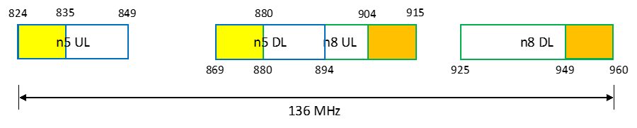
Figure 5.1.2.1-1: The frequency relation between band n8 and n5

5.1.2.2 Channel bandwidths per operating band for CA
Based on WF R4-2214445, BCS0 for CA_n5A-n8A can be specified as below.
Table 5.1.2.2-1: Supported bandwidths per CA band combination of band n5+n6
NR CA configuration | Uplink CA configuration or single uplink carrier | NR Band | Channel bandwidth (MHz) | Bandwidth combination set
CA_n5A-n8A | CA_n5A-n8A | n5 | 5, 10 | 0
CA_n5A-n8A | CA_n5A-n8A | n8 | 5, 10

5.1.2.3 UE co-existence studies
Table 5.1.2.3-1/2 summarizes frequency ranges where harmonics and/or harmonics mixing occur for CA_n5-n8.
Table 5.1.2.3-1: Impact of UL/DL Harmonic
 |  |  |  |  | 2nd Harmonic |  | 3rd Harmonic |  | 4th Harmonic |  | 5th Harmonic
Band | UL Low Band Edge | UL High Band Edge | DL Low Band Edge | DL High Band Edge | UL Low Band Edge | UL High Band Edge | UL Low Band Edge | UL High Band Edge | UL Low Band Edge | UL High Band Edge | UL Low Band Edge | UL High Band Edge
n5 | 824 | 849 | 869 | 894 | 1648 | 1698 | 2472 | 2547 | 3296 | 3396 | 4120 | 4245
n8 | 880 | 915 | 925 | 960 | 1760 | 1830 | 2640 | 2745 | 3520 | 3660 | 4400 | 4575

Table 5.1.2.3-2: Impact of UL/DL Harmonic mixing
 |  |  |  |  | 2nd Harmonic |  | 3rd Harmonic |  | 4th Harmonic |  | 5th Harmonic
Band | UL Low Band Edge | UL High Band Edge | DL Low Band Edge | DL High Band Edge | DL Low Band Edge | DL High Band Edge | DL Low Band Edge | DL High Band Edge | DL Low Band Edge | DL High Band Edge | DL Low Band Edge | DL High Band Edge
n5 | 824 | 849 | 869 | 894 | 1738 | 1788 | 2607 | 2682 | 3476 | 3576 | 4345 | 4470
n8 | 880 | 915 | 925 | 960 | 1850 | 1920 | 2775 | 2880 | 3700 | 3840 | 4625 | 4800

Based on the analysis above, there is no need to specify harmonics and harmonics mixing exception for CA_n5-n8 as we didn’t specify them in current spec.

5.1.2.4 ∆TIB,c and ∆RIB,c values
For CA_n5-n8, the ΔT_{IB,c} and ΔR_{IB,c} are given in the tables below considering both 2-antenna and 3–antenna implementations. If 3-antenna implementation is assumed, there isn’t any additional insertion loss observed for CA_n5-n8 compared with single carrier operation. If it’s assumed to derive the the delta Tib and Rib requirements for CA_n5-n8 based on 3–antenna implementation, all the values can be zero. If 2-antenna implementation is assumed to derive these values, the some delta Tib and Rib values for CA_n5-n8 are provided from interested companies as below.
Table 5.1.2.4-1: ΔT_{IB,c} for 2-antenna implementation
Inter-band CA Configuration | NR Band | Huawei | Skyworks | Qualcomm
CA_n5-n8 | n5 | 0.4 | 0.2 | 0.5
CA_n5-n8 | n8 | 0.4 | 0.4 | 0.5

Table 5.1.2.4-2: ΔR_{IB,c} for 2-antenna implementation
Inter-band CA Configuration | NR Band | Huawei | Skyworks | Qualcomm
CA_n5-n8 | n5 | 0 | 0.3 | 0.5
CA_n5-n8 | n8 | 0 | 0.2 | 0.5

5.1.2.5 REFSENS evaluation
For option 1 of full band n5 and n8 RF filters implementation, the scheduling is restricted as DL_n5-n8_UL_n5 and the concurrent operation between DL band n5 and UL band n8 can’t work. There may be some MSD for band n8 DL due to band n5 UL interference. Some legacy filters exhibit the flyback effect into n8 DL reducing the rejection of the n5 TX OOB leakage for no MSD
For option 3 of dedicated RF filters implementation with partial frequency range, the MSD test point and values due to cross band isolation between DL band n5 and UL band n8 in Table 5 are provided referring to R4-2300759.
Table 5.1.2.5-1: n8R UL cross band MSD in n5 for CA_n5-n8
UL band | DL band | UL F_{c} | UL BW | SCS of UL band | UL RB Allocation | DL F_{c} | DL BW | MSD | Cross-band  Interference  source
UL band | DL band | (MHz) | (MHz) | (kHz) | L_{CRB} | (MHz) | (MHz) | (dB) | Cross-band  Interference  source
n8 | n5 | 909 | 10 | 15 | 25 (RBstart=0) | 877.5 | 5 | [12.3] | ACLR2

5.1.3 Specific for 2 bands UL of CA_n5-n8

5.1.3.0 General
Option 2 full band n5 and n8 RF filters implementation can support both DL_n8_UL_n5-n8 and DL_n5-n8_UL_n5 features.
Option 3 dedicated RF filter(s) implementation with partial frequency range can support DL_n5-n8_UL_n5-n8 feature.
Thus, the following technical analysis in clause 5.1.3 is based on these kinds of candidate options and implementations.

5.1.3.1 Maximum output power for inter-band CA
Power class 3 is assumed for UL CA_n5-n8.

5.1.3.2 UE co-existence studies
Table 5.1.3.2-1 lists Band n5 + Band n8 2UL bands CA 2nd, 3rd, 4th and 5th order IMD for the UE-to-UE coexistence analysis.
Table 5.1.3.2-1: Band n5 and Band n8 UL IMD products with frequency range restriction
UE UL carriers | fx_low | fx_high | fy_low | fy_high
UL frequency (MHz) | 824 | 835 | 904 | 915
2nd order IMD products | |fy_low – fx_high| | |fy_high – fx_low| | |fy_low + fx_low| | |fy_high + fx_high|
IMD frequency limits (MHz) | 69 | 91 | 1728 | 1750
Two-tone 3rd order IMD products | |2*fx_low – fy_high| | |2*fx_high – fy_low| | |2*fy_low – fx_high| | |2*fy_high – fx_low|
IMD frequency limits (MHz) | 733 | 766 | 973 | 1006
Two-tone 3rd order IMD products | |2*fx_low + fy_low| | |2*fx_high + fy_high| | |2*fy_low + fx_low| | |2*fy_high + fx_high|
IMD frequency limits (MHz) | 2552 | 2585 | 2632 | 2665
Two-tone 4th order IMD products | |3*fx_low –1* fy_high| | |3*fx_high – 1*fy_low| | |3*fy_low – 1*fx_high| | |3*fy_high – 1*fx_low|
IMD frequency limits (MHz) | 1557 | 1601 | 1877 | 1921
Two-tone 4th order IMD products | |3*fx_low +1* fy_low| | |3*fx_high + 1*fy_high| | |3*fy_low + 1*fx_low| | |3*fy_high + 1*fx_high|
IMD frequency limits (MHz) | 3376 | 3420 | 3536 | 3580
Two-tone 4th order IMD products | |2*fx_low –2* fy_high| | |2*fx_high –2* fy_low| | |2*fx_low +2* fy_low| | |2*fx_high +2* fy_high|
IMD frequency limits (MHz) | 182 | 138 | 3456 | 3500
Two-tone 5th order IMD products | |fx_low – 4*fy_high| | |fx_high – 4*fy_low| | |fy_low – 4*fx_high| | |fy_high – 4*fx_low|
IMD frequency limits (MHz) | 2836 | 2781 | 2436 | 2381
Two-tone 5th order IMD products | |2*fx_low - 3*fy_high| | |2*fx_high - 3*fy_low| | |2*fy_low - 3*fx_high| | |2*fy_high -3*fx_low|
IMD frequency limits (MHz) | 1097 | 1042 | 697 | 642
Two-tone 5th order IMD products | |fx_low + 4*fy_low| | |fx_high + 4*fy_high| | |fy_low + 4*fx_low| | |fy_high + 4*fx_high|
IMD frequency limits (MHz) | 4440 | 4495 | 4200 | 4255
Two-tone 5th order IMD products | |2*fx_low + 3*fy_low| | |2*fx_high + 3*fy_high| | |2*fy_low + 3*fx_low| | |2*fy_high + 3*fx_high|
IMD frequency limits (MHz) | 4360 | 4415 | 4280 | 4335

Based on Table 5.1.3.2-1, there is no IMD issue for CA_n5-n8 with the following frequency range restriction.
n5 UL: 824 MHz – 835 MHz DL: 869 MHz – 880 MHz;
n8 UL: 904 MHz – 915 MHz DL: 949 MHz – 960 MHz.
Table 5.1.3.2-2 lists the protected bands required for the 2UL bands CA configuration.

Table 5.1.3.2-2: Protected bands for the 2UL bands CA configuration
NR CA Configuration | Spurious emission
NR CA Configuration | Protected band | Frequency range (MHz) |  |  | Maximum Level (dBm) | MBW (MHz) | NOTE
CA_n5-n8 | E-UTRA Band 1, 28, 31, 34, 38, 40, 45, 50, 51, 65, 73, 74 | F_{DL_low} | - | F_{DL_high} | -50 | 1
CA_n5-n8 | E-UTRA Band 3, 7, 41, 42, 43, 52  NR Band n77, n78, n79 | F_{DL_low} | - | F_{DL_high} | -50 | 1 | 2
CA_n5-n8 | E-UTRA Band 8 | F_{DL_low} | - | F_{DL_high} | -50 | 1 | 4
CA_n5-n8 | E-UTRA Band 11, 21 | F_{DL_low} | - | F_{DL_high} | -50 | 1
CA_n5-n8 | Frequency range | 1884.5 | - | 1915.7 | -41 | 0.3 | 3
NOTE 2: As exceptions, measurements with a level up to the applicable requirements defined in Table 6.5.3.1-2 are permitted for each assigned NR carrier used in the measurement due to 2nd, 3rd, 4th or 5th harmonic spurious emissions. Due to spreading of the harmonic emission the exception is also allowed for the first 1 MHz frequency range immediately outside the harmonic emission on both sides of the harmonic emission. This results in an overall exception interval centred at the harmonic emission of (2 MHz + N x L_{CRB} x 180kHz), where N is 2, 3, 4, 5 for the 2nd, 3rd, 4th or 5th harmonic respectively. The exception is allowed if the measurement bandwidth (MBW) totally or partially overlaps the overall exception interval.
NOTE 3: Applicable when co-existence with PHS system operating in 1884.5 -1915.7 MHz
NOTE 4: These requirements also apply for the frequency ranges that are less than F_{OOB} (MHz) in Table 6.5.3.1-1 from the edge of the channel bandwidth.

5.1.3.3 REFSENS evaluation
Based on the assumption of restricted frequency range for CA_n5-n8, there is no MSD issue due to intermodulation interference. 2UL Cross-band MSD may be needed.

5.1.4 Feasible RF implementations
Referring to clause 5.1.0 and 5.1.1 UE RF architecture assumption, it can be observed that two sets of different RF implementations are included currently:
One is full band n5 and n8 RF filters implementation.
Another one is dedicated RF filters implementation with partial frequency range.
These two implementation may have different RF requirements and scheduling restriction. In study phase, we list all the implementations on the table and further trade off each implementation as below.
Table 5.1.4-1: Trade-off between the feasible RF implementations
Type of implementation | Options | Pros | Cons
Full band n5 and n8 RF filters implementation | Option 1 | 1. Current RF components can be reused easily.  2. The same RF filters can support both single carrier operation and CA operation.  3. UE cost may not be improved too much. | 1. UL_n5-n8 can’t be supported. Only DL_n5-n8_UL_n5 can be supported.
Full band n5 and n8 RF filters implementation | Option 2 | 1. Current RF components can be reused.  2. The same RF filters can support both single carrier operation and CA operation.  3. Compared to option 1, DL_n8_UL_n5-n8 can be supported additionally. | 1. Non-concurrent n5 DL and n8 UL limiting DL throughput  2. At least one additional n8 RX filter is required compared to option 1  3. There may be RF additional performance impacts caused by managing the non-concurrency between n5DL and n8UL  4. Potential impacts on RAN2 are observed
Dedicated RF filters implementation with partial frequency range | Option 3 | 1. DL_n5-n8_UL_n5-n8 can be supported by UE within partial frequency range. Operators’ demands can be met.  2. There is no scheduling restriction for CA operation, but the specific partial frequency range. | 1. At least, but not necessary limited to one n8 UL dedicated filter with UL partial frequency range need to be developed for this specific CA operation.  2. n5 RX filtering may be impacted to avoid n8 UL at 904-914 blocking n5RX  3. Dedicated filter and full band filter need to be switched between single carrier operation and CA operation.

As all the implementations are not excluded and UE can support them optionally, a solution is needed to further distinguish these different implementations. The following options can be further discussed.
- Option 1: New bands would be required.
- Option 2: New bands would not be required. An optional signalling/capability solution can be designed for the BS and UE to distinguish these different implementations.
- Option 3: Other are not precluded.

5.1.5 Output for 2UL/2DL CA_n5-n8 during the work item phase
Three UE implementations for CA_n5-n8:
In the discussion for UE implementations for CA_n5-n8, there were three options from the SI phase:
1) Full band n5 and n8 RF filters implementation with option 1 and option2:
- Option 1: Only support 1UL/2DL CA. Single UL in n5
- Option 2: Support both 1UL/2DL and 2UL/2DL CA. Non-concurrent n5 DL and n8 UL
2) Dedicated RF filters implementation with partial frequency range
- Option 3: Support both 1UL/2DL and 2UL/2DL CA. Dedicated filter to allow simultaneous n5 DL and n8 UL
According to the updated WID for 700/800/900MHz band combinations in RAN#101, uplink is only in band n5 for CA_n5-n8. Thus, only Option 1 is specified in Rel-18 specification. However, if operator requests this 2UL/2DL CA_n5-n8 in futurte release, it should be further decided whether option 2, option 3 or both are specified.
If UE capabilities need to be updated or defined to distinguish different implementations, it’s encouraged to send LS to RAN2 for UE capabilities as soon as RAN4 has decided which options to specify.
CA_n5-n8 MSD values:
The following test configuration and MSD from n5 UL to n8 DL are agreed in Table 5.1.3.4-1 and the requirements are already specified in Rel-18 specification.
Table 5.1.3.4-1: CA_n5-n8 MSD value for 1U/2D n5UL/n8DL
UL band | DL band | UL F_{c} | UL BW | SCS of UL band | UL RB Allocation | DL F_{c} | DL BW | MSD | Cross-band  Interference  source
UL band | DL band | (MHz) | (MHz) | (kHz) | L_{CRB} | (MHz) | (MHz) | (dB) | Cross-band  Interference  source
n5 | n8 | 844 | 10 | 15 | 25 (RBstart=27) | 951.5 | 5 | 2.8 | >ACLR2

The following test configuration and MSD from n8 UL to n5 DL are agreed in Table 5.1.3.4-2 and the requirements apply if the Option 3 is specifed.

Table 5.1.3.4-2: CA_n5-n8 MSD value for 1U/2D n8UL/n5DL
UL band | DL band | UL F_{c} | UL BW | SCS of UL band | UL RB Allocation | DL F_{c} | DL BW | MSD | Cross-band  Interference  source
UL band | DL band | (MHz) | (MHz) | (kHz) | L_{CRB} | (MHz) | (MHz) | (dB) | Cross-band  Interference  source
n8 | n5 | 909 | 10 | 15 | 25 (RBstart=0) | 877.5 | 5 | 12.3 | >ACLR2

Clarification on the scenario:
The RAN4 discussion for the 2UL scenario for CA_n5-n8 with the scheduling restriction of non-concurrent n5 DL and n8 UL is based on the assumption that UE is configured by RRC with two UL and two DL, i.e. not two UL and one DL. Based on that assumption, RAN4 has the following answers for the questions in the LS R2-2306862.
Question 1: Does RAN4 see problem if cross carrier scheduling is used in this scenario i.e. PCell (n8) scheduling SCell (n5)?
Answer to Question 1:
Cross carrier scheduling is transparent from RAN4’s perspective. RAN4 didn’t see any impact to RAN4 specifications.
Question 2: What are RAN4 understanding regarding RRM measurements in this kind of scenario? Does UE need to measure the cell with UL only (n5) (e.g. for SCell addition/change/release purpose)?
Answer to Question 2:
RAN4 expects measurement of the SCell (n5) in this scenario is needed.
In RAN4 understanding, network would avoid the collision with the DL transmission of SCell (n5) when scheduling the UL in n8.
No impact to existing RRM specifications is seen from RAN4 perspective.
How to distinguish UE implementation for CA_n5-n8?

Situation 1: if Option 1 is supported in Rel-18, then
Implementation | Applicable RRC configuration | How to distinguish UE implementation
Full band n5 and n8 RF filters implementation:  Option 1: Only support 1UL/2DL CA. Single UL in n5 | (UL: n5, DL: n5+n8) | There is no need to indicate additional UE capability. UE just reports the applicable CA configuration.

In addition, one note can be added in RAN4 that band n8 can only be configured as DL Scell for band combinations including DL CA_n5-n8.

Situation 2: if Option 1 and option 2 are supported in Rel-18.
Implementation | Applicable RRC configuration | How to distinguish UE implementation
Full band n5 and n8 RF filters implementation:  Option 1: Only support 1UL/2DL CA. Single UL in n5 | (UL: n5, DL: n5+n8) | There is no need to indicate additional UE capability. UE just reports the applicable CA configuration.
Full band n5 and n8 RF filters implementation:  Option 2: Support both 1UL/2DL and 2UL/2DL CA. Non-concurrent n5 DL and n8 UL | (UL: n5, DL: n5+n8) | There is no need to indicate additional UE capability. UE just reports the applicable CA configuration.
 | (UL: n5+n8, DL: n5+n8) or potential (UL: n5+n8, DL: n5+n8+n78) in future | Alt1: One UE capability AA is needed to indicate that UE can’t support Non-concurrent n5 DL and n8 UL.  Alt2: No need to introduce UE capability. But it should be clarified that Non-concurrent n5 DL and n8 UL is supported by default in RAN4 general spec, only if UE reports UL CA_n5-n8.

Situation 3: if Option 1 and option 3 are supported in Rel-18.
Implementation | Applicable RRC configuration | How to distinguish UE implementation
Full band n5 and n8 RF filters implementation:  Option 1: Only support 1UL/2DL CA. Single UL in n5 | (UL: n5, DL: n5+n8) | There is no need to indicate additional UE capability. UE just reports the applicable CA configuration.
Dedicated RF filters implementation with partial frequency range  Option 3: Support both 1UL/2DL and 2UL/2DL CA. Dedicated filter to allow simultaneous n5 DL and n8 UL | (UL: n5, DL: n5+n8) | There is no need to indicate additional UE capability. UE can just report this applicable RRC configuration.
 | (UL: n8, DL: n5+n8) or (UL: n5+n8, DL: n5+n8) or potential (UL: n5+n8, DL: n5+n8+n78) in future | Alt1: One UE capability BB is needed to indicate that the UL frequency range of band n8 is restricted as 904~915 MHz.  Alt2: No need to introduce UE capability. But it should be clarified that UL frequency range of band n8 is restricted as 904~915 MHz is supported by default in RAN4 general spec only if UE report n5 DL and n8 UL in one Band combination simultaneously.  Alt3: One UE capability BB is introduced. The applicability of the UE capability in 38.306 refers to a NOTE in RAN4 spec to elaborate the UL frequency range of band n8 is restricted as 904~915 MHz and supported channel bandwidths.

Situation 4: if Option 1, option 2 and option 3 are supported in Rel-18.
Implementation | Applicable RRC configuration | How to distinguish UE implementation
Full band n5 and n8 RF filters implementationj:  Option 1: Only support 1UL/2DL CA. Single UL in n5 | (UL: n5, DL: n5+n8) | There is no need to indicate additional UE capability. UE just reports the applicable CA configuration.
Full band n5 and n8 RF filters implementation:  Option 2: Support both 1UL/2DL and 2UL/2DL CA. Non-concurrent n5 DL and n8 UL | (UL: n5, DL: n5+n8) | There is no need to indicate additional UE capability. UE just reports the applicable CA configuration.
 | (UL: n5+n8, DL: n5+n8) or potential (UL: n5+n8, DL: n5+n8+n78) in future | One UE capability AA is needed to indicate that UE can’t support Non-concurrent n5 DL and n8 UL.
Dedicated RF filters implementation with partial frequency range  Option 3: Support both 1UL/2DL and 2UL/2DL CA. Dedicated filter to allow simultaneous n5 DL and n8 UL | (UL: n5, DL: n5+n8) | There is no need to indicate additional UE capability. UE just reports the applicable CA configuration.
 | (UL: n8, DL: n5+n8) or (UL: n5+n8, DL: n5+n8) or potential (UL: n5+n8, DL: n5+n8+n78) in future | Alt 1: One UE capability BB is needed to indicate that the UL frequency range of band n8 is restricted as 904~915 MHz.  Alt 2: One UE capability AA is needed to indicate that UE can’t support Non-concurrent n5 DL and n8 UL, which means UE will support 2UL CA based on dedicated RF filters with band n8 restricted as 904~915 MHz.  Alt3: One UE capability BB is introduced. The applicability of the UE capability in 38.306 refers to a NOTE in RAN4 spec to elaborate the UL frequency range of band n8 is restricted as 904~915 MHz and supported channel bandwidths.  NOTE: Other options to distinguish between options are not precluded

5.2 CA_n5-n28

5.2.1 UE RF architecture assumption
The n5 filter parameter assumption in the analysis is based on without sharing path of band n26.
The UE RF architectures with 2 antenna and 3 antenna can be assumed in the feasibility study for CA_n5-n28.The antenna number is the total number of antennas to support Main UL/DL and diversity DL for all bands. Figure 5.2.1.0-1 shows the aggregated spectrum allocation for CA_n5-n28 where no frequency range restriction has been indicated for either of the constituent bands.

Figure 5.2.1.0-1 CA_n5-n28 aggregated spectrum allocation

5.2.1.1 UE RF architecture with two antennas
For CA_n5-n28 with 2-antenna implementation, there are two potential UE RF architectures as shown in Figure 5.2.1.1-1.

Figure 5.2.1.1-1 Potential UE architecture variants to support CA_n5-n28 with 2 antenna

The topology for 2 antenna architecture a is listed as below.
- 1) n28UL+n28DL+n5UL+n5DL quadplexer on antenna 1
- 2) n5DL+n28DL duplexer on antenna 2
The topology for 2 antenna architecture b is listed as below.
- 1) n5UL+n5DL+n28DL triplexer on antenna 1
- 2) n28UL+n28DL+n5DL triplexer on antenna 2
[Considering the maximum simultaneously covered spectrum range and closely spaced UL and DL bands, the following challenges and issues impacting UE RF performance for 2-antenna architecture variant (a) can be anticipated:
- The main antenna design needs to cover the entire spectrum range of 191 MHz simultaneously as shown in Figure 5.2.1-1, which is equivalent to a 24% bandwidth ratio and that would exceed the bandwidth ratio for a typical planar antenna design in a smartphone. As a result, the radiative performance for the combination likely would be compromised.
- The feasibility of a single quadplexer is questionable as n28 alone already requires a dual duplexer to reduce the band range to duplex gap ratio in order to achieve the acceptable filter isolation and insertion loss performance. Dual quadplexer has the implication on UE front-end design complexity, area, and cost impacts.
- REFSENS degradation (MSD) on n28 DL caused by frequency proximity between n5 UL and n28 DL and insufficient cross-band isolation.
For 2-antenna architecture variant (b), the following challenges and issues impacting UE RF performance can be anticipated:
- Compared to variant (a), though the main path frequency range is reduced from 191 MHz to 136 MHz, the diversity path frequency range however is increased from 136 MHz to 191 MHz. From antenna design perspective, the same challenge with 24% antenna bandwidth ratio as in variant (a) is expected.
- The feasibility of a single triplexer for diversity path is questionable as n28 alone already requires a dual duplexer to reduce the band range to duplex gap ratio in order to achieve the acceptable filter isolation and insertion loss performance. Dual triplexer in diversity path in conjunction with a single or dual triplexer in main path has the implication on UE front-end design complexity, area, and cost impacts.
- REFSENS degradation (MSD) on n28 DL caused by frequency proximity between n5 UL and n28 DL and insufficient cross-band isolation.]

5.2.1.2 UE RF architecture with three antennas
For CA_n5-n28 with 3-antenna implementation, the following UE RF architectures can be considered, as shown in Figure 5.2.1.2-1.
Figure 5.2.1.2-1 CA_n5-n28 UE architecture based on the 3-antenna implementation
The topology for the above 3 antenna architecture is listed as below:
1) n28UL+n28DL duplexer on antenna 1
2) n5UL+n5DL duplexer on antenna 2
3) n5DL+n28DL duplexer on antenna 3

5.2.2 Common for 1 band UL and 2 bands UL of CA_n5-n28

5.2.2.0 General
According to the current spec TS 38.101-1, DL CA_n5A-n28A_BCS0 has been specified. Thus, some of RF requirements can be reused as below.

5.2.2.1 Operating bands for CA
Table 5.2.2.1-1: CA band combination of band n5+n28
NR Band | Uplink (UL) band |  |  | Downlink (DL) band |  |  | Duplex  mode
NR Band | BS receive / UE transmit |  |  | BS transmit / UE receive |  |  | Duplex  mode
NR Band | F_{UL_low} – F_{UL_high} |  |  | F_{DL_low} – F_{DL_high} |  |  | Duplex  mode
n5 | 824 MHz | – | 849 MHz | 869 MHz | – | 894 MHz | FDD
n28 | 703 MHz | – | 748 MHz | 758 MHz | – | 803 MHz | FDD

5.2.2.2 Channel bandwidths per operating band for CA
Referring to table 5.5A.3.1-1e of TS 38.101-1, DL_n5A-n28A_BCS0 has been specified

5.2.2.3 UE co-existence studies
There is no need to specify harmonics and harmonics mixing exception for CA_n5-n28 as we didn’t specify them in current spec.

5.2.2.4 ∆TIB,c and ∆RIB,c values
For CA_n5-n28 with 2 antenna implementation, the ΔTIB,c and ΔRIB,c values has been specified in TS 38.101-1.
Referring to contribution R4-2300657, it is suggest to reuse the DC_28_n5 ΔTIB,c and ΔRIB,c values with an additional 0.2dB to all to enable the two-antenna n-plexers in the future and including the support of full band n28, which are shown below:
Table 5.2.2.4-0: ΔT_{IB,c}
Inter-band CA Configuration | NR Band | ΔT_{IB,c} [dB]
CA_n5A-n28A | n5 | 0.7
CA_n5A-n28A | n28 | 0.7

Table 5.2.2.4-0a: ΔR_{IB,c}
Inter-band CA Configuration | NR Band | ΔR_{IB,c} [dB]
CA_n5A-n28A | n5 | 0.2
CA_n5A-n28A | n28 | 0.2

For CA_n5-n28 with 3 antenna implementation, the ΔTIB,c and ΔRIB,c values are shown below.
Table 5.2.2.4-1: ΔT_{IB,c}
Inter-band CA Configuration | NR Band | ΔT_{IB,c} [dB]
CA_n5A-n28A | n5 | 0
CA_n5A-n28A | n28 | 0

Table 5.2.2.4-2: ΔR_{IB,c}
Inter-band CA Configuration | NR Band | ΔR_{IB,c} [dB]
CA_n5A-n28A | n5 | 0
CA_n5A-n28A | n28 | 0

5.2.2.5 REFSENS evaluation
For CA_n5-n28 with 2 antennas implementation, referring to contribution R4-2202036, the n28 MSD evaluation for CA_n5-n28 is shown as below.
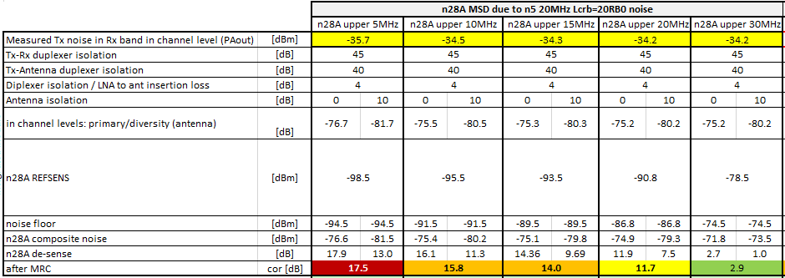
Figure 5.2.2.5-1 the n28 MSD evaluation for CA_n5-n28
Based on the agreed CR R4-2206134, one MSD test configuration (n28 30MHz) can be a reference considering the impacts from band n5 UL.
Table 5.2.2.5-1 MSD due to cross band isolation for CA_n5-n28
UL band | DL band | UL F_{c} | UL BW | SCS of UL band | UL RB Allocation | DL F_{c} | DL BW | MSD | Cross-band  Interference  source
UL band | DL band | (MHz) | (MHz) | (kHz) | L_{CRB} | (MHz) | (MHz) | (dB) | Cross-band  Interference  source
n5 | n28 | 834 | 20 | 15 | 20 (RBstart=0) | 800.5 | 5 | 17.5 | ACLR2

For CA_n5-n28 with 3 antennas implementation, referring to contribution R4-2301266, the n28 MSD evaluation on the same MSD test configuration (n28 30MHz) as 2 antennas implementation is shown as below.
Table 5.2.2.5-2 MSD due to cross band isolation for CA_n5-n28
UL band | DL band | UL F_{c} | UL BW | SCS of UL band | UL RB Allocation | DL F_{c} | DL BW | MSD | Cross-band  Interference  source
UL band | DL band | (MHz) | (MHz) | (kHz) | L_{CRB} | (MHz) | (MHz) | (dB) | Cross-band  Interference  source
n5 | n28 | 834 | 20 | 15 | 20 (RBstart=0) | 800.5 | 5 | 18.6 | ACLR2

5.2.3 Specific for 2 bands UL of fallback CA_n5-n28

5.2.3.1 Maximum output power for inter-band CA
Power class 3 is assumed for UL CA_n5-n28.

5.2.3.2 UE co-existence studies
Table 5.2.3.2-1 lists Band n5 + Band n28 2UL bands CA 2nd, 3rd, 4th and 5th order IMD for the UE-to-UE coexistence analysis.
Table 5.2.3.2-1: Band n5 and Band n28 UL IMD products
UE UL carriers | fx_low | fx_high | fy_low | fy_high
UL frequency (MHz) | 824 | 869 | 703 | 748
2nd order IMD products | |fy_low – fx_high| | |fy_high – fx_low| | |fy_low + fx_low| | |fy_high + fx_high|
IMD frequency limits (MHz) | 166 | 76 | 1527 | 1617
Two-tone 3rd order IMD products | |2*fx_low – fy_high| | |2*fx_high – fy_low| | |2*fy_low – fx_high| | |2*fy_high – fx_low|
IMD frequency limits (MHz) | 900 | 1035 | 537 | 672
Two-tone 3rd order IMD products | |2*fx_low + fy_low| | |2*fx_high + fy_high| | |2*fy_low + fx_low| | |2*fy_high + fx_high|
IMD frequency limits (MHz) | 2351 | 2486 | 2230 | 2365
Two-tone 4th order IMD products | |3*fx_low –1* fy_high| | |3*fx_high – 1*fy_low| | |3*fy_low – 1*fx_high| | |3*fy_high – 1*fx_low|
IMD frequency limits (MHz) | 1724 | 1904 | 1240 | 1420
Two-tone 4th order IMD products | |3*fx_low +1* fy_low| | |3*fx_high + 1*fy_high| | |3*fy_low + 1*fx_low| | |3*fy_high + 1*fx_high|
IMD frequency limits (MHz) | 3175 | 3355 | 2933 | 3113
Two-tone 4th order IMD products | |2*fx_low –2* fy_high| | |2*fx_high –2* fy_low| | |2*fx_low +2* fy_low| | |2*fx_high +2* fy_high|
IMD frequency limits (MHz) | 152 | 332 | 3054 | 3234
Two-tone 5th order IMD products | |fx_low – 4*fy_high| | |fx_high – 4*fy_low| | |fy_low – 4*fx_high| | |fy_high – 4*fx_low|
IMD frequency limits (MHz) | 2168 | 1943 | 2773 | 2548
Two-tone 5th order IMD products | |2*fx_low - 3*fy_high| | |2*fx_high - 3*fy_low| | |2*fy_low - 3*fx_high| | |2*fy_high -3*fx_low|
IMD frequency limits (MHz) | 596 | 371 | 1201 | 976
Two-tone 5th order IMD products | |fx_low + 4*fy_low| | |fx_high + 4*fy_high| | |fy_low + 4*fx_low| | |fy_high + 4*fx_high|
IMD frequency limits (MHz) | 3636 | 3861 | 3999 | 4224
Two-tone 5th order IMD products | |2*fx_low + 3*fy_low| | |2*fx_high + 3*fy_high| | |2*fy_low + 3*fx_low| | |2*fy_high + 3*fx_high|
IMD frequency limits (MHz) | 3757 | 3982 | 3878 | 4103

Based on Table 5.2.3.2-1, there is no IMD issue for CA_n5-n28.
Table 5.2.3.2-2 lists the protected bands required for the 2UL bands CA configuration.
Table 5.2.3.2-2: Protected bands for the 2UL bands CA configuration
NR CA Configuration | Spurious emission
NR CA Configuration | Protected band | Frequency range (MHz) |  |  | Maximum Level (dBm) | MBW (MHz) | NOTE
CA_n5-n28 | E-UTRA Band 2, 3, 5, 7, 8, 18, 19, 25, 26, 31, 34, 38, 40, 73  NR Band n79 | F_{DL_low} | - | F_{DL_high} | -50
CA_n5-n28 | E-UTRA Band 4, 41, 42, 43, 50, 51, 52, 65, 66, 74  NR Band n77, n78 | F_{DL_low} | - | F_{DL_high} | -50 | 1 | 2
CA_n5-n28 | E-UTRA Band 1 | F_{DL_low} | - | F_{DL_high} | -50 | 1 | 2, 11, 15
CA_n5-n28 | E-UTRA Band 11, 21 | F_{DL_low} | - | F_{DL_high} | -50 | 1 | 2, 11, 12
CA_n5-n28 | Frequency range | 1884.5 | - | 1915.7 | -41 | 0.3 | 3, 11
CA_n5-n28 | Frequency range | 470 | - | 694 | -42 | 8 | 4, 14
CA_n5-n28 | Frequency range | 470 | - | 710 | -26.2 | 6 | 13
CA_n5-n28 | Frequency range | 662 | - | 694 | -26.2 | 6 | 4
CA_n5-n28 | Frequency range | 758 | - | 773 | -32 | 1 | 4
CA_n5-n28 | Frequency range | 773 | - | 803 | -50 | 1
NOTE 2: As exceptions, measurements with a level up to the applicable requirements defined in Table 6.5.3.1-2 are permitted for each assigned NR carrier used in the measurement due to 2nd, 3rd, 4th or 5th harmonic spurious emissions. Due to spreading of the harmonic emission the exception is also allowed for the first 1 MHz frequency range immediately outside the harmonic emission on both sides of the harmonic emission. This results in an overall exception interval centred at the harmonic emission of (2 MHz + N x L_{CRB} x 180kHz), where N is 2, 3, 4, 5 for the 2nd, 3rd, 4th or 5th harmonic respectively. The exception is allowed if the measurement bandwidth (MBW) totally or partially overlaps the overall exception interval.
NOTE 3: Applicable when co-existence with PHS system operating in 1884.5 -1915.7 MHz
NOTE 4: These requirements also apply for the frequency ranges that are less than F_{OOB} (MHz) in Table 6.5.3.1-1 from the edge of the channel bandwidth.
NOTE 11: Applicable when the assigned NR carrier is confined within 718 MHz and 748 MHz and when the channel bandwidth used is 5 or 10 MHz.
NOTE 12: As exceptions, measurements with a level up to the applicable requirement of -38 dBm/MHz is permitted for each assigned NR carrier used in the measurement due to 2nd harmonic spurious emissions. An exception is allowed if there is at least one individual RB within the transmission bandwidth (see Figure 5.3.1-1) for which the 2nd harmonic totally or partially overlaps the measurement bandwidth (MBW).
NOTE 13: This requirement is applicable for 5 and 10 MHz NR channel bandwidth allocated within 718 - 728 MHz. For carriers of 10 MHz bandwidth, this requirement applies for an uplink transmission bandwidth less than or equal to 30 RB with RBstart > 1 and Rbstart < 48.
NOTE 14: This requirement is applicable in the case of a 10 MHz NR carrier confined within 703 MHz and 733 MHz, otherwise the requirement of -25 dBm with a measurement bandwidth of 8 MHz applies.
NOTE 15: As exceptions, measurements with a level up to the applicable requirement of -36 dBm/MHz is permitted for each assigned E-UTRA carrier used in the measurement due to 3rd harmonic spurious emissions. An exception is allowed if there is at least one individual RB within the transmission bandwidth (see Figure 5.6-1) for which the 3rd harmonic totally or partially overlaps the measurement bandwidth (MBW).

5.2.3.3 REFSENS evaluation
Since there is no two UL IMD issue for CA_n5-n28, no need to specify the MSD due to two UL IMD interference. The following reference exception can be further studied.
Referring to contribution R4-2300657, the estimation of the n5+n28 UL interference in band n28 DL versus n5 and n28 1UL case can be found in table 5.2.3.3-1.
Table 5.2.3.3-1: Estimation of the n5+n28 UL interference in band n28 DL versus n5 and n28 1UL case
n28DL CBW (MHz) at the top of band 28 | 5 |  | 15 | 20 | 25 | 30
n28 UL transmitter output noise at 23dBm (dBm) | -58.5 |  | -52.2 | -50.0 | -42.3 | -28.1
38.101-1 n28 REFSENS de-sense due to Tx (dB) | 0.0 |  | 0.0 | 1.4 | 7.0 | 11.9
n28 UL transmitter output noise at 20dBm (dBm) | -61.5 |  | -55.3 | -53.8 | -50.5 | -39.2
n5 UL transmitter output noise at 23dBm (dBm) | -45.2 |  | -41.1 | -41.0 | -40.8 | -40.7
n5 UL transmitter output noise at 20dBm (dBm) | -53.8 |  | -49.6 | -48.9 | -47.8 | -48.9
n28UL -> n28DL quadplexer isolation (dB) | 50 |  | 50 | 50 | 50 | 50
n5UL -> n28DL quadplexer isolation (dB) | 45 |  | 45 | 45 | 45 | 45
n28 transmitter output noise at 23dBm (dBm) at main LNA | -108.5 |  | -102.2 | -100.0 | -92.3 | -78.1
n5+n28 transmitter output noise at 23dBm (dBm) at main LNA | -90.4 |  | -94.8 | -94.1 | -93.3 | -88.0
delta n5+n28 vs n28 at 23dBm output noise at main LNA | 18.1 |  | 7.4 | 5.8 | -1.0 | -9.9

The resulting MSD (on top of n28 without self de-sense) with MRC calculations is provided in Table 5.2.3.3-1 to enable a two-antenna architecture in the long-term.
Table 5.2.3.3-2: 2UL cross band MSDs for CA_n5-n28
UL band | DL band | UL F_{c} | UL BW | SCS of UL band | UL RB Allocation | DL F_{c} | DL BW | MSD | Cross-band  Interference  source
UL band | DL band | (MHz) | (MHz) | (kHz) | L_{CRB} | (MHz) | (MHz) | (dB) | Cross-band  Interference  source
n5 | n28 | 834 | 20 | 15 | 20 (Rbstart=0) | 793 | 20 | [3.6] | ACLR2
n28 | n28 | 738 | 20 | 15 | 25 (Rbstart=81) | 793 | 20 | [3.6] | ACLR2

Referring to contribution R4-2302097, the relationship for n28 DL impacted by both band n5 UL and n28 UL is shown in figure 1, when both band n5 UL and n28 UL are configured for CA_n5-n28, band n28 DL receiver will be impacted by the leakage interference from band n5 UL and n28 UL.
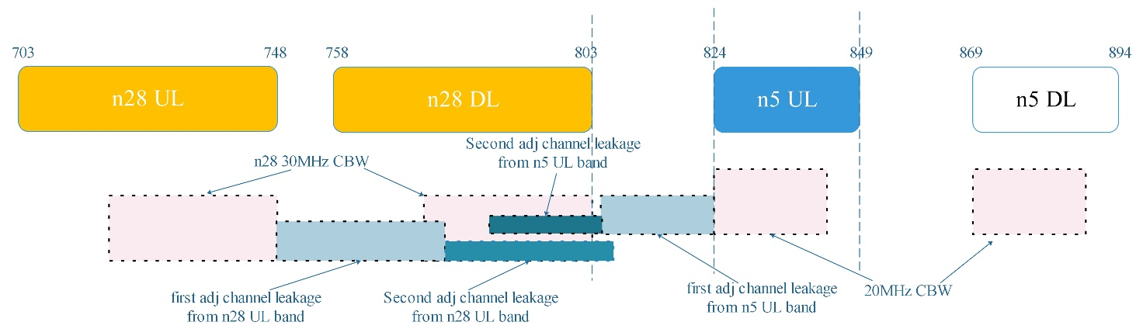
Figure 5.2.3.3-1 The relationship for band n28 DL impacted by both band n5 UL and n28 UL
Some measurement results were proposed in R4-2202036 for band n28 30MHz case. -32.4dBm Tx noise in n28 Rx band can be observed from band n5 PAout. Since 45dB Tx-Rx isolation between n5 UL band and n28 DL band was assumed, 2.9dB MSD can be observed based on n28 30MHz -78.5dBm REFSENS for 2 antenna implementation, which is shown in Table 5.2.3.3-3:
Table 5.2.3.3-3: 2UL cross band MSDs for CA_n5-n28
UL band | DL band | UL F_{c} | UL BW | SCS of UL band | UL RB Allocation | DL F_{c} | DL BW | MSD | Cross-band  Interference  source
UL band | DL band | (MHz) | (MHz) | (kHz) | L_{CRB} | (MHz) | (MHz) | (dB) | Cross-band  Interference  source
n5 | n28 | 834 | 20 | 15 | 20 (RBstart=0) | 788 | 30 | 2.9 | ACLR2 from n5 UL band  ACLR1+ACLR2 from n28 UL band
n28 | n28 | 733 | 30 | 15 | 25 (RBstart=135)

Referring to contribution R4-2302253, the most straightforward way would be to use the same test point for 2UL MSD due to Cross-Band Isolation as has been used for 1UL Cross-band Isolation for 2 antenna implementation, which is shown in Table 5.2.3.3-4:
Table 5.2.3.3-4: 2UL cross band MSDs for CA_n5-n28
UL band | DL band | UL F_{c} | UL BW | SCS of UL band | UL RB Allocation | DL F_{c} | DL BW | MSD | Cross-band  Interference  source
UL band | DL band | (MHz) | (MHz) | (kHz) | L_{CRB} | (MHz) | (MHz) | (dB) | Cross-band  Interference  source
n5 | n28 | 834 | 20 | 15 | 20 (Rbstart=0) | 800.5 | 5 | 17.5 | n5 ACLR2
n28 | n28 | 5 | 5 | 15 | 25 (Rbstart=0)

Referring to contribution R4-2218129, for 2UL MSD due to Cross-Band Isolation as has been used for 1UL Cross-band Isolation for 3 antenna implementation is shown in Table 5.2.3.3-5. It includes a legacy filter rejection for n5 TX OOB leakage in n28DL. The antenna isolation helps attenuate the TX leakage to give a similar MSD result specified in Table 5.2.3.3-3 for a 30MHz DL.
Table 5.2.3.3-5: 2UL cross band MSDs for CA_n5-n28
UL band | DL band | UL F_{c} | UL BW | SCS of UL band | UL RB Allocation | DL F_{c} | DL BW | MSD | Cross-band  Interference  source
UL band | DL band | (MHz) | (MHz) | (kHz) | L_{CRB} | (MHz) | (MHz) | (dB) | Cross-band  Interference  source
n5 | n28 | 834 | 20 | 15 | 20 (RBstart=0) | 788 | 30 | 4.5 | ACLR2 from n5 UL band  ACLR1+ACLR2 from n28 UL band
n28 | n28 | 733 | 30 | 15 | 25 (RBstart=135)

5.3 CA_n8-n20-n28

5.3.1 UE RF architecture assumption

5.3.1.0 General
The UE RF architectures with 2 antenna, 3 antenna, 4 antenna can be assumed to analyze and study for CA_n8-n20-n28.The antenna number is the total number of antennas to support Main UL/DL and diversity DL for all bands. UE RF architecture with three antennas for CA_n8-n20-n28 is used as baseline for evaluation. The UE RF architectures with two or four antennas are not precluded in the study item.

5.3.1.1 UE RF architecture with three antennas
The assumption 1A for UE RF architecture with three antennas for CA_n8-n20-n28 are shown as below.
1) n28UL/n20+n28DL/n20UL triplexer on antenna 1
2) n8UL/n8DL duplexer on antenna 2
3) n20+n28DL/n8DL duplexer on antenna 3
4) 10dB antenna isolation is used for MSD calculations
The assumption 1B for UE RF architecture with three antennas for CA_n8-n20-n28 are shown as below. Comparing to assumption 1a, n8UL/n8DL duplexer on antenna 2 was replaced by n8UL/n8DL/n20UL/n20DL quadplexer.
1) n28UL/n20+n28DL/n20UL triplexer on antenna 1
2) n8UL/n8DL/n20UL/n20DL quadplexer on antenna 2
3) n20+n28DL/n8DL duplexer on antenna 3
4) 10dB antenna isolation is used for MSD calculations
The assumption 1C for UE RF architecture with three antennas for CA_n8-n20-n28 are shown as Figure 5.3.1.1-1. These are two other variants based on assumption 1a. They may allow easier implementation of either triplexer or duplexer in main path owing to that the frequency separations between the sub-bands are wider than the architecture assumed for DC_8-20_n28. However, the downside with two variants is that the widest frequency range which needs to be covered by any of the antenna is still relatively wide at 212 MHz and 257 MHz respectively.

Figure 5.3.1.1-1 Potential UE architecture variants to support CA_n8-n20-n28 with 3 antenna

5.3.1.2 UE RF architecture with two antennas
The assumption 2A for UE RF architecture with two antennas for CA_n8-n20-n28 are shown as below. Pentaplexer design is considered.
1) n28UL/n20+n28DL/n20UL/n8UL/n8DL pentaplexer on antenna 1
2) n20+n28DL/n8DL duplexer on antenna 2
3) 10dB antenna isolation is used for MSD calculations
The assumption 2B for UE RF architecture with two antennas for CA_n8-n20-n28 are shown as below. Quadplexer design is considered.
1) n28UL/n20+n28DL/n20UL/n8DL quadplexer on antenna 1
2) n20+n28DL/n8UL/n8DL triplexer or n20+n28DL/n20UL/n8UL/n8DL quadplexer on antenna 2
3) 10dB antenna isolation is used for MSD calculations
There are two potential implementation challenges with 2-antenna architectures. The first challenge is that the antenna design needs to cover the entire spectrum range of 257 MHz simultaneously as shown in Figure 5.3.1-1 for either of the variants, which is equivalent to a 31% bandwidth ratio and that would far exceed the bandwidth ratio for a typical planar antenna design in a smartphone. As a result, the radiative performance for the combination is expected to be compromised.
The second challenge is on the feasibility of a pentaplexer design for variant (a) to aggregate five closely spaced spectrum ranges as shown in Figure 5.3.1-1, not only with sufficient filter isolation between self-band and cross-band but also with acceptable insertion loss. The variant (b) though avoids the use of pentaplexer, the design of the intended quadplexer is still relatively challenging considering the closely spaced spectrum ranges with nearly 8% bandwidth ratio for the n20/n28 combined DL range.

5.3.1.3 UE RF architecture with four antennas
The assumption 3A and 3B for UE RF architecture with four antennas for CA_n8-n20-n28 are shown as below.
Figure 5.3.1.3-1 The assumption 3A for UE RF architecture to support CA_n8-n20-n28 with 4 antenna

Figure 5.3.1.3-2 The assumption 3B for UE RF architecture to support CA_n8-n20-n28 with 4 antenna
For the 4-antenna implementation, the three of the four antenna are used in the main path to aggregate the n8, n20, and n28 signals over the air, as shown in Figures 5.3.1.3-1 and 5.3.1.3-2. As n8, n20, and n28 signals do not need to be combined through a multiplexer, there is no additional insertion loss in n8, n20, and n28 main signal paths as compared to single-band implementation.
Having 3 antenna in the main signal path not only avoids the more complicated multiplexer implementation and the associated additional insertion losses, but also allows narrower frequency coverage for each of the 3 antenna as compared to single-antenna implementation. However, the additional antenna cannot be added without occupying more phone space.

5.3.2 CA_n8-n20

5.3.2.0 General
According to the current spec TS 38.101-1, DL CA_n8A-n20A_BCS0 has been specified. Thus, some of RF requirements can be reused as below. Both DL_n8A-n20A_BCS0 and DL_n8A-n20A_UL_n8A-n20A are fallback CA band combinations of DL_n8A-n20A-n28A_UL_n8A-n20A.

5.3.2.1 Operating bands for CA
Table 5.3.2.1-1: CA band combination of band n8+n20
NR Band | Uplink (UL) band |  |  | Downlink (DL) band |  |  | Duplex  mode
NR Band | BS receive / UE transmit |  |  | BS transmit / UE receive |  |  | Duplex  mode
NR Band | F_{UL_low} – F_{UL_high} |  |  | F_{DL_low} – F_{DL_high} |  |  | Duplex  mode
n8 | 880 MHz | – | 915 MHz | 925 MHz | – | 960 MHz | FDD
n20 | 832 MHz | – | 862 MHz | 791 MHz | – | 821 MHz | FDD

5.3.2.2 Channel bandwidths per operating band for CA
Referring to table 5.5A.3.1-1e of TS 38.101-1, DL_n8A-n20A_BCS0 has been specified.

5.3.2.3 UE co-existence studies
There is no need to specify harmonics and harmonics mixing exception for CA_n8-n20 as we didn’t specify them in current spec.

5.3.2.4 ∆TIB,c and ∆RIB,c values
For CA_n8-n20, the ΔT_{IB,c} and ΔR_{IB,c} values have been specified in TS 38.101-1.

5.3.2.5 REFSENS requirements
As CA_n8-n20 has been specified into current spec TS 38.101-1, there is no harmonics, cross band isolation and harmonics mixing exception.

5.3.2.6 Maximum output power for UL inter-band CA
Power class 3 is assumed for UL CA_n8-n20.

5.3.2.7 UE co-existence studies for UL inter-band CA
Table 5.3.2.7-1 lists Band n8 + Band n20 2UL bands CA 2nd, 3rd, 4th and 5th order IMD for the UE-to-UE coexistence analysis.
Table 5.3.2.7-1: Band n8 and Band n20 UL IMD products
UE UL carriers | fx_low | fx_high | fy_low | fy_high
UL frequency (MHz) | 880 | 915 | 832 | 862
2nd order IMD products | |fy_low – fx_high| | |fy_high – fx_low| | |fy_low + fx_low| | |fy_high + fx_high|
IMD frequency limits (MHz) | 83 | 18 | 1712 | 1777
Two-tone 3rd order IMD products | |2*fx_low – fy_high| | |2*fx_high – fy_low| | |2*fy_low – fx_high| | |2*fy_high – fx_low|
IMD frequency limits (MHz) | 898 | 998 | 749 | 844
Two-tone 3rd order IMD products | |2*fx_low + fy_low| | |2*fx_high + fy_high| | |2*fy_low + fx_low| | |2*fy_high + fx_high|
IMD frequency limits (MHz) | 2592 | 2692 | 2544 | 2639
Two-tone 4th order IMD products | |3*fx_low –1* fy_high| | |3*fx_high – 1*fy_low| | |3*fy_low – 1*fx_high| | |3*fy_high – 1*fx_low|
IMD frequency limits (MHz) | 1778 | 1913 | 1581 | 1706
Two-tone 4th order IMD products | |3*fx_low +1* fy_low| | |3*fx_high + 1*fy_high| | |3*fy_low + 1*fx_low| | |3*fy_high + 1*fx_high|
IMD frequency limits (MHz) | 3472 | 3607 | 3376 | 3501
Two-tone 4th order IMD products | |2*fx_low –2* fy_high| | |2*fx_high –2* fy_low| | |2*fx_low +2* fy_low| | |2*fx_high +2* fy_high|
IMD frequency limits (MHz) | 36 | 166 | 3424 | 3554
Two-tone 5th order IMD products | |fx_low – 4*fy_high| | |fx_high – 4*fy_low| | |fy_low – 4*fx_high| | |fy_high – 4*fx_low|
IMD frequency limits (MHz) | 2568 | 2413 | 2828 | 2658
Two-tone 5th order IMD products | |2*fx_low - 3*fy_high| | |2*fx_high - 3*fy_low| | |2*fy_low - 3*fx_high| | |2*fy_high -3*fx_low|
IMD frequency limits (MHz) | 826 | 666 | 1081 | 916
Two-tone 5th order IMD products | |fx_low + 4*fy_low| | |fx_high + 4*fy_high| | |fy_low + 4*fx_low| | |fy_high + 4*fx_high|
IMD frequency limits (MHz) | 4208 | 4363 | 4352 | 4522
Two-tone 5th order IMD products | |2*fx_low + 3*fy_low| | |2*fx_high + 3*fy_high| | |2*fy_low + 3*fx_low| | |2*fy_high + 3*fx_high|
IMD frequency limits (MHz) | 4256 | 4416 | 4304 | 4469

Based on Table 5.3.2.6-1, 3rd and 5th order IMD may also fall into Rx frequencies of bands n8 or band n20.
Table 5.3.2.7-2 lists the protected bands required for the 2UL bands CA configuration.
Table 5.3.2.7-2: Protected bands for the 2UL bands CA configuration
NR CA Configuration | Spurious emission
NR CA Configuration | Protected band | Frequency range (MHz) |  |  | Maximum Level (dBm) | MBW (MHz) | NOTE
CA_n8-n20 | E-UTRA Band 1, 31, 32, 33, 34, 40, 50, 51, 65, 67, 68, 72, 74, 75, 76  NR Band n100, n104 | F_{DL_low} | - | F_{DL_high} | -50 | 1
CA_n8-n20 | E-UTRA Band 3, 7, 22, 38, 42, 43, 52, 69  NR band n77, n78 | F_{DL_low} | - | F_{DL_high} | -50 | 1 | 2
CA_n8-n20 | E-UTRA Band 8, 20 | F_{DL_low} | - | F_{DL_high} | -50 | 1 | 4
CA_n8-n20 | Frequency range | 758 | - | 788 | -50 | 1
NOTE 2: As exceptions, measurements with a level up to the applicable requirements defined in Table 6.5.3.1-2 are permitted for each assigned NR carrier used in the measurement due to 2nd, 3rd, 4th or 5th harmonic spurious emissions. Due to spreading of the harmonic emission the exception is also allowed for the first 1 MHz frequency range immediately outside the harmonic emission on both sides of the harmonic emission. This results in an overall exception interval centred at the harmonic emission of (2 MHz + N x L_{CRB} x 180kHz), where N is 2, 3, 4, 5 for the 2nd, 3rd, 4th or 5th harmonic respectively. The exception is allowed if the measurement bandwidth (MBW) totally or partially overlaps the overall exception interval.
NOTE 4: These requirements also apply for the frequency ranges that are less than F_{OOB} (MHz) in Table 6.5.3.1-1 from the edge of the channel bandwidth.

5.3.2.8 REFSENS evaluation for UL inter-band CA
IMD3 MSD of DC_20_n8A in band 20 and n8 specified in TS 38.101-3 is a good reference for CA_n8-n20 as below.

Table 5.3.2.8-1: REFSENS exceptions due to IMD interference for CA_n8-n20
Band / Channel bandwidth / N_{RB} / Duplex mode |  |  |  |  |  |  |  | Source of IMD
NR CA band combination | NR band | UL F_{c}  (MHz) | UL/DL BW  (MHz) | UL  L_{CRB} | DL F_{c} (MHz) | MSD  (dB) | Duplex mode
CA_n8-n20 | n8 | 892.5 | 5 | 25 | 937.5 | 25 | FDD | IMD3
CA_n8-n20 | n20 | 849.5 | 5 | 25 | 808.5 | 25 | FDD | IMD3

5.3.3 CA_n8-n28

5.3.3.0 General
According to the current spec TS 38.101-1, DL CA_n8A-n28A_BCS0 has been specified. Thus, some of RF requirements can be reused as below. Both DL_n8A-n28A_BCS0 and DL_n8A-n28A_UL_n8A-n28A are fallback CA band combinations of DL_n8A-n20A-n28A_UL_n8A-n28A.

5.3.3.1 Operating bands for CA
Table 5.3.3.1-1: CA band combination of band n8+n28
NR Band | Uplink (UL) band |  |  | Downlink (DL) band |  |  | Duplex  mode
NR Band | BS receive / UE transmit |  |  | BS transmit / UE receive |  |  | Duplex  mode
NR Band | F_{UL_low} – F_{UL_high} |  |  | F_{DL_low} – F_{DL_high} |  |  | Duplex  mode
n8 | 880 MHz | – | 915 MHz | 925 MHz | – | 960 MHz | FDD
n28 | 703 MHz | – | 748 MHz | 758 MHz | – | 803 MHz | FDD

5.3.3.2 Channel bandwidths per operating band for CA
Referring to table 5.5A.3.1-1e of TS 38.101-1, DL_n8A-n28A_BCS0 has been specified as below.
Table 5.3.3.2-1: Supported bandwidths per CA band combination of band n8+n28
NR CA configuration | Uplink CA configuration or single uplink carrier | NR Band | Channel bandwidth (MHz) | Bandwidth combination set
CA_n8A-n28A | CA_n8A-n28A | n8 | 5, 10, 15, 20 | 0
CA_n8A-n28A | CA_n8A-n28A | n28 | 5, 10, 15, 20, 30

5.3.3.3 UE co-existence studies
There is no need to specify harmonics and harmonics mixing exception for CA_n8-n28 as we didn’t specify them in current spec.

5.3.3.4 ∆TIB,c and ∆RIB,c values
For CA_n8-n28, the ΔT_{IB,c} and ΔR_{IB,c} values have been specified in TS 38.101-1.

5.3.3.5 REFSENS requirements
As CA_n8-n28 has been specified into current spec TS 38.101-1, there is no harmonics, cross band isolation and harmonics mixing exception.

5.3.3.6 Maximum output power for UL inter-band CA
Power class 3 is assumed for UL CA_n8-n28.

5.3.3.7 UE co-existence studies for UL inter-band CA
Table 5.3.3.7-1 lists Band n8 + Band n28 2UL bands CA 2nd, 3rd, 4th and 5th order IMD for the UE-to-UE coexistence analysis.
Table 5.3.3.7-1: Band n8 and Band n28 UL IMD products
UE UL carriers | fx_low | fx_high | fy_low | fy_high
UL frequency (MHz) | 880 | 915 | 703 | 748
2nd order IMD products | |fy_low – fx_high| | |fy_high – fx_low| | |fy_low + fx_low| | |fy_high + fx_high|
IMD frequency limits (MHz) | 212 | 132 | 1583 | 1663
Two-tone 3rd order IMD products | |2*fx_low – fy_high| | |2*fx_high – fy_low| | |2*fy_low – fx_high| | |2*fy_high – fx_low|
IMD frequency limits (MHz) | 1012 | 1127 | 491 | 616
Two-tone 3rd order IMD products | |2*fx_low + fy_low| | |2*fx_high + fy_high| | |2*fy_low + fx_low| | |2*fy_high + fx_high|
IMD frequency limits (MHz) | 2463 | 2578 | 2286 | 2411
Two-tone 4th order IMD products | |3*fx_low –1* fy_high| | |3*fx_high – 1*fy_low| | |3*fy_low – 1*fx_high| | |3*fy_high – 1*fx_low|
IMD frequency limits (MHz) | 1892 | 2042 | 1194 | 1364
Two-tone 4th order IMD products | |3*fx_low +1* fy_low| | |3*fx_high + 1*fy_high| | |3*fy_low + 1*fx_low| | |3*fy_high + 1*fx_high|
IMD frequency limits (MHz) | 3343 | 3493 | 2989 | 3159
Two-tone 4th order IMD products | |2*fx_low –2* fy_high| | |2*fx_high –2* fy_low| | |2*fx_low +2* fy_low| | |2*fx_high +2* fy_high|
IMD frequency limits (MHz) | 264 | 424 | 3166 | 3326
Two-tone 5th order IMD products | |fx_low – 4*fy_high| | |fx_high – 4*fy_low| | |fy_low – 4*fx_high| | |fy_high – 4*fx_low|
IMD frequency limits (MHz) | 2112 | 1897 | 2957 | 2772
Two-tone 5th order IMD products | |2*fx_low - 3*fy_high| | |2*fx_high - 3*fy_low| | |2*fy_low - 3*fx_high| | |2*fy_high -3*fx_low|
IMD frequency limits (MHz) | 484 | 279 | 1339 | 1144
Two-tone 5th order IMD products | |fx_low + 4*fy_low| | |fx_high + 4*fy_high| | |fy_low + 4*fx_low| | |fy_high + 4*fx_high|
IMD frequency limits (MHz) | 3692 | 3907 | 4223 | 4408
Two-tone 5th order IMD products | |2*fx_low + 3*fy_low| | |2*fx_high + 3*fy_high| | |2*fy_low + 3*fx_low| | |2*fy_high + 3*fx_high|
IMD frequency limits (MHz) | 3869 | 4074 | 4046 | 4241

Based on Table 5.3.3.7-1, there is no IMD issue for CA_n8-n28.
Table 5.3.3.7-2 lists the protected bands required for the 2UL bands CA configuration.
Table 5.3.3.7-2: Protected bands for the 2UL bands CA configuration
NR CA Configuration | Spurious emission
NR CA Configuration | Protected band | Frequency range (MHz) |  |  | Maximum Level (dBm) | MBW (MHz) | NOTE
CA_n8-n28 | E-UTRA Band 20, 31, 34, 38, 40, 72 | F_{DL_low} | - | F_{DL_high} | -50 | 1
CA_n8-n28 | E-UTRA band 3, 7, 22, 41, 42, 43, 50, 51, 65, 73, 74, 75, 76  NR Band n77, n78, n79, n100 | F_{DL_low} | - | F_{DL_high} | -50 | 1 | 2
CA_n8-n28 | E-UTRA Band 1 | F_{DL_low} | - | F_{DL_high} | -50 | 1 | 2, 11, 15
CA_n8-n28 | E-UTRA Band 8 | F_{DL_low} | - | F_{DL_high} | -50 | 1 | 4
CA_n8-n28 | E-UTRA Band 11, 21 | F_{DL_low} | - | F_{DL_high} | -50 | 1 | 11, 12
CA_n8-n28 | Frequency range | 470 | - | 694 | -42 | 8 | 4, 14
CA_n8-n28 | Frequency range | 470 | - | 710 | -26.2 | 6 | 13
CA_n8-n28 | Frequency range | 662 | - | 694 | -26.2 | 6 | 4
CA_n8-n28 | Frequency range | 758 | - | 773 | -32 | 1 | 4
CA_n8-n28 | Frequency range | 773 | - | 803 | -50 | 1
CA_n8-n28 | Frequency range | 1884.5 | - | 1915.7 | -41 | 0.3 | 3, 11
NOTE 2: As exceptions, measurements with a level up to the applicable requirements defined in Table 6.5.3.1-2 are permitted for each assigned NR carrier used in the measurement due to 2nd, 3rd, 4th or 5th harmonic spurious emissions. Due to spreading of the harmonic emission the exception is also allowed for the first 1 MHz frequency range immediately outside the harmonic emission on both sides of the harmonic emission. This results in an overall exception interval centred at the harmonic emission of (2 MHz + N x L_{CRB} x 180kHz), where N is 2, 3, 4, 5 for the 2nd, 3rd, 4th or 5th harmonic respectively. The exception is allowed if the measurement bandwidth (MBW) totally or partially overlaps the overall exception interval.
NOTE 3: Applicable when co-existence with PHS system operating in 1884.5 -1915.7 MHz
NOTE 4: These requirements also apply for the frequency ranges that are less than F_{OOB} (MHz) in Table 6.5.3.1-1 from the edge of the channel bandwidth.
NOTE 11: Applicable when the assigned NR carrier is confined within 718 MHz and 748 MHz and when the channel bandwidth used is 5 or 10 MHz.
NOTE 12: As exceptions, measurements with a level up to the applicable requirement of -38 dBm/MHz is permitted for each assigned NR carrier used in the measurement due to 2nd harmonic spurious emissions. An exception is allowed if there is at least one individual RB within the transmission bandwidth (see Figure 5.3.1-1) for which the 2nd harmonic totally or partially overlaps the measurement bandwidth (MBW).
NOTE 13: This requirement is applicable for 5 and 10 MHz NR channel bandwidth allocated within 718 - 728 MHz. For carriers of 10 MHz bandwidth, this requirement applies for an uplink transmission bandwidth less than or equal to 30 RB with RBstart > 1 and Rbstart < 48.
NOTE 14: This requirement is applicable in the case of a 10 MHz NR carrier confined within 703 MHz and 733 MHz, otherwise the requirement of -25 dBm with a measurement bandwidth of 8 MHz applies.
NOTE 15: As exceptions, measurements with a level up to the applicable requirement of -36 dBm/MHz is permitted for each assigned E-UTRA carrier used in the measurement due to 3rd harmonic spurious emissions. An exception is allowed if there is at least one individual RB within the transmission bandwidth (see Figure 5.6-1) for which the 3rd harmonic totally or partially overlaps the measurement bandwidth (MBW).

5.3.3.8 REFSENS requirements for UL inter-band CA
There is no REFSENS exception due to IMD interference for CA_n8A-n28A.

5.3.4 CA_n20-n28

5.3.4.1 General
According to the current spec TS 38.101-1, DL_n20A-n28A_UL_n20A-n28A_BCS0 and DL_n20A-n28A_UL_n20A-n28A_BCS1 have already been specified. Thus, all of the related RF requirements have been analysed in clause 6.31 from TR 38.716-02-00 and can be reused as below. Both DL_n20A-n28A_BCS0 and DL_n20A-n28A_UL_n20A-n28A_BCS0 are fallback CA band combinations of DL_n8A-n20A-n28A_UL_n20A-n28A.
1) The operating bands for CA_n20-n28 were specified in table 5.2A.2.1-1 from TS 38.101-1 with note 2 that The frequency range in band n28 is restricted for this band combination to 703-733 MHz for the UL and 758-788 MHz for the DL.
2) The UL/DL configurations and bandwidth combination sets for DL_n20A-n28A_UL_n20A-n28A_BCS0 and DL_n20A-n28A_UL_n20A-n28A_BCS1 were specified in table 5.5A.3.1-1g from TS 38.101-1.
3) 23dBm Power class 3 for UL CA_n20A-n28A was specified in Table 6.2A.1.3-1 from TS 38.101-1.
4) 0.5dB ΔT_{IB,c} for CA_n20-n28 was specified in Table 6.2A.4.2.3-1 from TS 38.101-1.
5) Spurious emissions for UE co-existence for Inter-band CA_n20-n28 were specified in Table 6.5A.3.2.3-1 from TS 38.101-1.
6) Referring to UE co-existence studies in clause 6.31.2.1 from TR 38.716-02-00, there are no harmonic/harmonic mixing or IMD issues affecting own Rx frequencies of either band n20 or n28. Therefore, there is no need to specify the additional REFSENS exceptions for CA_n20-n28.
7) 0dB ΔR_{IB,c} for CA_n20-n28 was specified in Table 6.31.1.4-2 from TR 38.716-02-00.

5.3.5 CA_n8-n20-n28

5.3.5.1 Operating bands for CA
Table 5.3.5.1-1: Inter-band CA operating bands involving FR1 (three bands)
NR Band | Uplink (UL) band |  |  | Downlink (DL) band |  |  | Duplex  mode
NR Band | BS receive / UE transmit |  |  | BS transmit / UE receive |  |  | Duplex  mode
NR Band | F_{UL_low} – F_{UL_high} |  |  | F_{DL_low} – F_{DL_high} |  |  | Duplex  mode
n8 | 880 MHz | – | 915 MHz | 925 MHz | – | 960 MHz | FDD
n20 | 832 MHz | – | 862 MHz | 791 MHz | – | 821 MHz | FDD
n28 | 703 MHz | – | 748 MHz | 758 MHz | – | 803 MHz | FDD

It’s noted that the following sentence was clarified in clause 5.5A.0 from TS 38.101-1.
“For a higher order band combination of which CA_n20-n28 is a subset, the frequency range in band n28 is restricted for the higher order band combination to 703-733 MHz for the UL and 758-788 MHz for the DL.”
Thus, this frequency range restriction is also applicable to CA_n8-n20-n28.

5.3.5.2 Channel bandwidths per operating band for CA
Table 5.3.5.2-1: Supported bandwidths per CA band combination of band n8+n20+n28
NR CA configuration | Uplink CA configuration or single uplink carrier | NR Band | Channel bandwidth (MHz) | Bandwidth combination set
CA_n8A-n20A-n28A | CA_n8A-n20A  CA_n8A-n28A  CA_n20A-n28A | n8 | 5, 10, 15, 20 | 0
CA_n8A-n20A-n28A | CA_n8A-n20A  CA_n8A-n28A  CA_n20A-n28A | n20 | 5, 10, 15, 20 | 0
CA_n8A-n20A-n28A | CA_n8A-n20A  CA_n8A-n28A  CA_n20A-n28A | n28 | 5, 10, 15, 20 | 0

5.3.5.3 ∆TIB,c and ∆RIB,c values
For CA_n8-n20-n28, the ΔT_{IB,c} and ΔR_{IB,c} values for 2-antenna and 3-antenna architectures are captured in this part. However, only one set of values will be defined in the specification in the follow-up WI allowing all possible UE RF architectures.
For CA_n8-n20-n28, the ΔT_{IB,c} and ΔR_{IB,c} values are derived from the existing CA_n8-n28 and CA_n20-n28 based on 3-antennas UE architecture as the baseline.
Table 5.3.5.3-1: ΔT_{IB,c}
Inter-band CA Configuration | NR Band | ΔT_{IB,c} (dB)
CA_n8-n20-n28 | n8 | 0.6
CA_n8-n20-n28 | n20 | 0.5
CA_n8-n20-n28 | n28 | 0.5

Table 5.3.5.3-2: ΔR_{IB,c}
Inter-band CA Configuration | NR Band | ΔR_{IB,c} (dB)
CA_n8-n20-n28 | n8 | 0.2
CA_n8-n20-n28 | n20 | 0
CA_n8-n20-n28 | n28 | 1
For CA_n8-n20-n28, the ΔT_{IB},_{c} and ΔR_{IB},_{c} values are derived in Table 5.3.5.3-3 and Table 5.3.5.3-4 and enable a two-antenna architecture in the long-term.
Table 5.3.5.3-3: ΔT_{IB,c}
Inter-band CA Configuration | NR Band | ΔT_{IB,c} (dB)
CA_n8-n20-n28 | n8 | 0.8
CA_n8-n20-n28 | n20 | 0.7
CA_n8-n20-n28 | n28 | 0.7

Table 5.3.5.3-4: ΔR_{IB,c}
Inter-band CA Configuration | NR Band | ΔR_{IB,c} (dB)
CA_n8-n20-n28 | n8 | 0.3
CA_n8-n20-n28 | n20 | 0.2
CA_n8-n20-n28 | n28 | 0.2

5.3.5.4 UE co-existence studies for UL inter-band CA
Table 5.3.5.4-1 lists Band n8 + Band n20 2UL bands CA 2nd, 3rd, 4th and 5th order IMD for the UE-to-UE coexistence analysis, which may fall into the Rx receiver of DL band n28.
Table 5.3.5.4-1: Band n8 and Band n20 UL IMD products
UE UL carriers | fx_low | fx_high | fy_low | fy_high
UL frequency (MHz) | 880 | 915 | 832 | 862
2nd order IMD products | |fy_low – fx_high| | |fy_high – fx_low| | |fy_low + fx_low| | |fy_high + fx_high|
IMD frequency limits (MHz) | 83 | 18 | 1712 | 1777
Two-tone 3rd order IMD products | |2*fx_low – fy_high| | |2*fx_high – fy_low| | |2*fy_low – fx_high| | |2*fy_high – fx_low|
IMD frequency limits (MHz) | 898 | 998 | 749 | 844
Two-tone 3rd order IMD products | |2*fx_low + fy_low| | |2*fx_high + fy_high| | |2*fy_low + fx_low| | |2*fy_high + fx_high|
IMD frequency limits (MHz) | 2592 | 2692 | 2544 | 2639
Two-tone 4th order IMD products | |3*fx_low –1* fy_high| | |3*fx_high – 1*fy_low| | |3*fy_low – 1*fx_high| | |3*fy_high – 1*fx_low|
IMD frequency limits (MHz) | 1778 | 1913 | 1581 | 1706
Two-tone 4th order IMD products | |3*fx_low +1* fy_low| | |3*fx_high + 1*fy_high| | |3*fy_low + 1*fx_low| | |3*fy_high + 1*fx_high|
IMD frequency limits (MHz) | 3472 | 3607 | 3376 | 3501
Two-tone 4th order IMD products | |2*fx_low –2* fy_high| | |2*fx_high –2* fy_low| | |2*fx_low +2* fy_low| | |2*fx_high +2* fy_high|
IMD frequency limits (MHz) | 36 | 166 | 3424 | 3554
Two-tone 5th order IMD products | |fx_low – 4*fy_high| | |fx_high – 4*fy_low| | |fy_low – 4*fx_high| | |fy_high – 4*fx_low|
IMD frequency limits (MHz) | 2568 | 2413 | 2828 | 2658
Two-tone 5th order IMD products | |2*fx_low - 3*fy_high| | |2*fx_high - 3*fy_low| | |2*fy_low - 3*fx_high| | |2*fy_high -3*fx_low|
IMD frequency limits (MHz) | 826 | 666 | 1081 | 916
Two-tone 5th order IMD products | |fx_low + 4*fy_low| | |fx_high + 4*fy_high| | |fy_low + 4*fx_low| | |fy_high + 4*fx_high|
IMD frequency limits (MHz) | 4208 | 4363 | 4352 | 4522
Two-tone 5th order IMD products | |2*fx_low + 3*fy_low| | |2*fx_high + 3*fy_high| | |2*fy_low + 3*fx_low| | |2*fy_high + 3*fx_high|
IMD frequency limits (MHz) | 4256 | 4416 | 4304 | 4469

Table 5.3.5.4-2 lists Band n8 + Band n28 2UL bands CA 2nd, 3rd, 4th and 5th order IMD for the UE-to-UE coexistence analysis, which may fall into the Rx receiver of DL band n20.
Table 5.3.5.4-2: Band n8 and Band n28 UL IMD products
UE UL carriers | fx_low | fx_high | fy_low | fy_high
UL frequency (MHz) | 880 | 915 | 703 | 748
2nd order IMD products | |fy_low – fx_high| | |fy_high – fx_low| | |fy_low + fx_low| | |fy_high + fx_high|
IMD frequency limits (MHz) | 212 | 132 | 1583 | 1663
Two-tone 3rd order IMD products | |2*fx_low – fy_high| | |2*fx_high – fy_low| | |2*fy_low – fx_high| | |2*fy_high – fx_low|
IMD frequency limits (MHz) | 1012 | 1127 | 491 | 616
Two-tone 3rd order IMD products | |2*fx_low + fy_low| | |2*fx_high + fy_high| | |2*fy_low + fx_low| | |2*fy_high + fx_high|
IMD frequency limits (MHz) | 2463 | 2578 | 2286 | 2411
Two-tone 4th order IMD products | |3*fx_low –1* fy_high| | |3*fx_high – 1*fy_low| | |3*fy_low – 1*fx_high| | |3*fy_high – 1*fx_low|
IMD frequency limits (MHz) | 1892 | 2042 | 1194 | 1364
Two-tone 4th order IMD products | |3*fx_low +1* fy_low| | |3*fx_high + 1*fy_high| | |3*fy_low + 1*fx_low| | |3*fy_high + 1*fx_high|
IMD frequency limits (MHz) | 3343 | 3493 | 2989 | 3159
Two-tone 4th order IMD products | |2*fx_low –2* fy_high| | |2*fx_high –2* fy_low| | |2*fx_low +2* fy_low| | |2*fx_high +2* fy_high|
IMD frequency limits (MHz) | 264 | 424 | 3166 | 3326
Two-tone 5th order IMD products | |fx_low – 4*fy_high| | |fx_high – 4*fy_low| | |fy_low – 4*fx_high| | |fy_high – 4*fx_low|
IMD frequency limits (MHz) | 2112 | 1897 | 2957 | 2772
Two-tone 5th order IMD products | |2*fx_low - 3*fy_high| | |2*fx_high - 3*fy_low| | |2*fy_low - 3*fx_high| | |2*fy_high -3*fx_low|
IMD frequency limits (MHz) | 484 | 279 | 1339 | 1144
Two-tone 5th order IMD products | |fx_low + 4*fy_low| | |fx_high + 4*fy_high| | |fy_low + 4*fx_low| | |fy_high + 4*fx_high|
IMD frequency limits (MHz) | 3692 | 3907 | 4223 | 4408
Two-tone 5th order IMD products | |2*fx_low + 3*fy_low| | |2*fx_high + 3*fy_high| | |2*fy_low + 3*fx_low| | |2*fy_high + 3*fx_high|
IMD frequency limits (MHz) | 3869 | 4074 | 4046 | 4241

Table 5.3.5.4-3 lists Band n20 + Band n28 2UL bands CA 2nd, 3rd, 4th and 5th order IMD for the UE-to-UE coexistence analysis, which may fall into the Rx receiver of DL band n8.
Table 5.3.5.4-3: Band n20 and Band n28 UL IMD products
UE UL carriers | fx_low | fx_high | fy_low | fy_high
UL frequency (MHz) | 832 | 862 | 703 | 733
2nd order IMD products | |fy_low – fx_high| | |fy_high – fx_low| | |fy_low + fx_low| | |fy_high + fx_high|
IMD frequency limits (MHz) | 159 | 99 | 1535 | 1595
Two-tone 3rd order IMD products | |2*fx_low – fy_high| | |2*fx_high – fy_low| | |2*fy_low – fx_high| | |2*fy_high – fx_low|
IMD frequency limits (MHz) | 931 | 1021 | 544 | 634
Two-tone 3rd order IMD products | |2*fx_low + fy_low| | |2*fx_high + fy_high| | |2*fy_low + fx_low| | |2*fy_high + fx_high|
IMD frequency limits (MHz) | 2367 | 2457 | 2238 | 2328
Two-tone 4th order IMD products | |3*fx_low –1* fy_high| | |3*fx_high – 1*fy_low| | |3*fy_low – 1*fx_high| | |3*fy_high – 1*fx_low|
IMD frequency limits (MHz) | 1763 | 1883 | 1247 | 1367
Two-tone 4th order IMD products | |3*fx_low +1* fy_low| | |3*fx_high + 1*fy_high| | |3*fy_low + 1*fx_low| | |3*fy_high + 1*fx_high|
IMD frequency limits (MHz) | 3199 | 3319 | 2941 | 3061
Two-tone 4th order IMD products | |2*fx_low –2* fy_high| | |2*fx_high –2* fy_low| | |2*fx_low +2* fy_low| | |2*fx_high +2* fy_high|
IMD frequency limits (MHz) | 198 | 318 | 3070 | 3190
Two-tone 5th order IMD products | |fx_low – 4*fy_high| | |fx_high – 4*fy_low| | |fy_low – 4*fx_high| | |fy_high – 4*fx_low|
IMD frequency limits (MHz) | 2100 | 1950 | 2745 | 2595
Two-tone 5th order IMD products | |2*fx_low - 3*fy_high| | |2*fx_high - 3*fy_low| | |2*fy_low - 3*fx_high| | |2*fy_high -3*fx_low|
IMD frequency limits (MHz) | 535 | 385 | 1180 | 1030
Two-tone 5th order IMD products | |fx_low + 4*fy_low| | |fx_high + 4*fy_high| | |fy_low + 4*fx_low| | |fy_high + 4*fx_high|
IMD frequency limits (MHz) | 3644 | 3794 | 4031 | 4181
Two-tone 5th order IMD products | |2*fx_low + 3*fy_low| | |2*fx_high + 3*fy_high| | |2*fy_low + 3*fx_low| | |2*fy_high + 3*fx_high|
IMD frequency limits (MHz) | 3773 | 3923 | 3902 | 4052

Based on Table 5.3.5.4-1, 3rd and 5th order IMD may also fall into Rx frequencies of third DL band n28 when CA_n8-n20 is the UL configuration.
Based on Table 5.3.5.4-2, there is no IMD interference which may also fall into Rx frequencies of third DL band n20 when CA_n8-n28 is the UL configuration.
Based on Table 5.3.5.4-3, 3rd order IMD may also fall into Rx frequencies of third DL band n8 when CA_n20-n28 is the UL configuration.

5.3.5.5 REFSENS evaluation
The MSD test configurations can be evaluated as below for band n8 MSD due to IMD3 of Tx band n20 + band n28 and band n28 MSD due to IMD3 of Tx band n8 + band n20.
Table 5.3.5.5-1: REFSENS exceptions due to IMD interference for CA_n8-n20-n28
Band / Channel bandwidth / N_{RB} / Duplex mode |  |  |  |  |  |  |  | Source of IMD
NR CA band combination | NR band | UL F_{c}  (MHz) | UL/DL BW  (MHz) | UL  C_{LRB} | DL F_{c} (MHz) | MSD  (dB) | Duplex mode
CA_n8-n20-n28 | n20 | 834.5 | 5 | 25 | 793.5 | N/A | FDD | N/A
 | n28 | 715.5 | 5 | 25 | 770.5 | N/A | FDD | N/A
 | n8 | 908.5 | 5 | 25 | 953.5 | 23.5 | FDD | IMD3
 | n8 | 887.5 | 5 | 25 | 932.5 | N/A | FDD | N/A
 | n20 | 834.5 | 5 | 25 | 793.5 | N/A | FDD | N/A
 | n28 | 726.5 | 5 | 25 | 781.5 | 23 | FDD | IMD3

CA_n8-n20-n28 2UL IMD3 MSDs are derived in Table 5.3.5.5-2 and enable a two-antenna architecture in the long-term.
Table 5.3.5.5-2: 3DL/2UL IMD3 MSDs for CA_n8-n20-n28
Band / Channel bandwidth / N_{RB} / Duplex mode |  |  |  |  |  |  |  | Source
NR CA band combination | NR band | UL F_{c} | UL/DL BW | UL | DL F_{c} (MHz) | MSD | Duplex mode | of IMD
NR CA band combination | NR band | (MHz) | (MHz) | C_{LRB} | DL F_{c} (MHz) | (dB) | Duplex mode | of IMD
CA_n8-n20-n28 | n8 | N/A | 5 | 25 | 951.5 | [25] | FDD | IMD3
 | n20 | 834.5 | 5 | 25 | 793.5 | N/A | FDD | N/A
 | n28 | 717.5 | 5 | 25 | 772.5 | N/A | FDD | N/A
 | n8 | 887.5 | 5 | 25 | 932.5 | N/A | FDD | N/A
 | n20 | 834.5 | 5 | 25 | 793.5 | N/A | FDD | N/A
 | n28 | N/A | 5 | 25 | 781.5 | [25] | FDD | IMD3

5.4 CA_n5-n105

5.4.1 General
In this configuration the uplink is also CA_n5A-n105A, but there are two fall back options:
DL_n5A-n105A_UL_n5A_BCS0
UL_n5A-n105A_UL_n105A_BCS0
The aggregated spectrum allocation for CA_n5A-n105A is illustrated in Figure 5.4.1-1.
Figure 5.4.1-1: Aggregated spectrum allocation for CA_n5A-n105A

5.4.2 UE RF architecture assumption
The UE RF architectures with 2 antenna and 3 antenna are assumed in the feasibility study for CA_n5-n105. The antenna number is the total number of antennas to support Main UL/DL and diversity DL for all bands.

5.4.2.1 UE RF architecture with two antennas
For CA_n5-n105 with 2-antenna implementation, there are two potential UE RF architectures as shown in Figure 5.4.2.1-1.
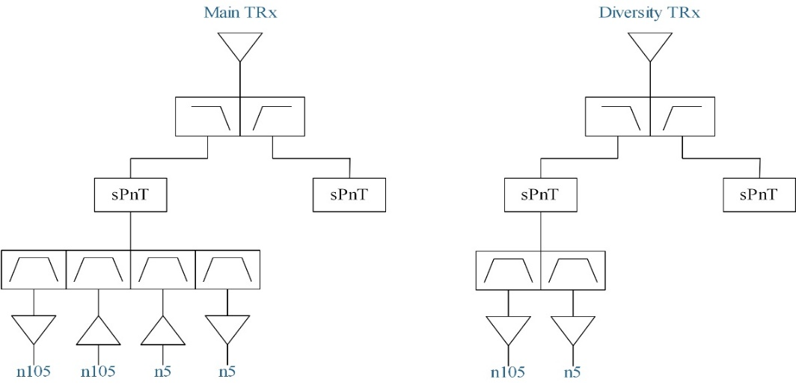
Figure 5.4.2.1-1a: Potential UE architecture with 2 antenna to support CA_n5-n105

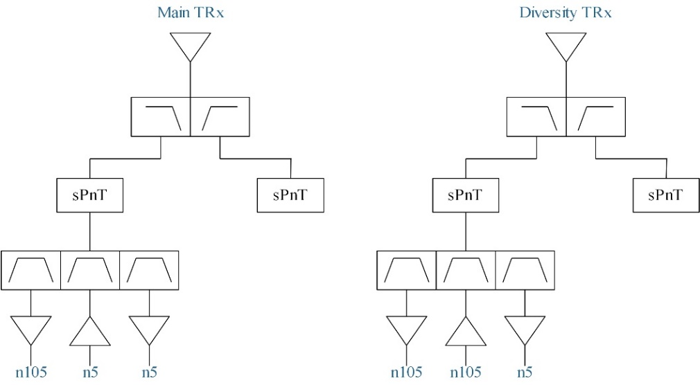
Figure 5.4.2.1-1b: Potential UE architecture with 2 antenna to support CA_n5-n105

The topology for 2-antenna architecture illustrated in Figure 5.4.2.1-1a is listed as below.
- 1) n105UL+n105DL+n5UL+n5DL quadplexer on antenna 1
- 2) n5DL+n105DL duplexer on antenna 2
The topology for 2-antenna architecture illustrated in Figure 5.4.2.1-1b is listed as below.
- 1) n5UL+n5DL+n105DL triplexer on antenna 1
- 2) n105UL+n105DL+n5DL triplexer on antenna 2

5.4.2.2 UE RF architecture with three antennas
Figure 5.4.2.2-1 illustrates the potential UE RF architecture for CA_n5-n105 with a 3-antenna implementation.
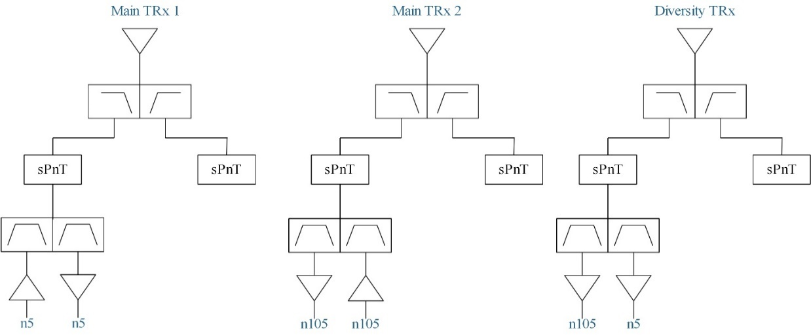
Figure 5.4.2.2-1: Potential UE architecture with 3 antenna to support CA_n5-n105

The topology for 3-antenna architecture illustrated in Figure 5.4.2.2-1 is listed as below:
1) n105UL+n105DL duplexer on antenna 1
2) n5UL+n5DL duplexer on antenna 2
3) n5DL+n105DL duplexer on antenna 3

5.4.3 Common for 1 band UL and 2 bands UL of CA_n5-n105

5.4.3.1 Operating bands for CA
The operating bands for CA_n5-n105 are provided in Table 5.4.3.1-1.
Table 5.4.3.1-1: CA band combination of band n5+n105
NR Band | Uplink (UL) band |  |  | Downlink (DL) band |  |  | Duplex  mode
NR Band | BS receive / UE transmit |  |  | BS transmit / UE receive |  |  | Duplex  mode
NR Band | F_{UL_low} – F_{UL_high} |  |  | F_{DL_low} – F_{DL_high} |  |  | Duplex  mode
n5 | 824 MHz | – | 849 MHz | 869 MHz | – | 894 MHz | FDD
n105 | 663 MHz | – | 703 MHz | 612 MHz | – | 652 MHz | FDD

5.4.3.2 Channel bandwidths per operating band for CA
The supported channel bandwidths for CA_n5-n105 are provided in Table 5.4.3.2-1.
Table 5.4.3.2-1: Supported bandwidths per CA band combination of band n5+n105
NR CA configuration | Uplink CA configuration or single uplink carrier | NR Band | Channel bandwidth (MHz) | Bandwidth combination set
CA_n5A-n105A | CA_n5A-n105A | n5 | 5, 10, 15, 20 | 0
CA_n5A-n105A | CA_n5A-n105A | n105 | 5, 10, 15, 20, 25, 30, 35 | 0

5.4.3.3 Identify the potential MSD issues due to harmonic/harmonic mixing/cross band isolation
Table 5.4.3.3-1/2 summarizes frequency ranges where harmonics/harmonics mixing occur for CA_n5-n105.
Table 5.4.3.3-1: Impact of UL/DL Harmonic
 |  |  |  |  | 2nd Harmonic |  | 3rd Harmonic |  | 4th Harmonic |  | 5th Harmonic
Band | UL Low Band Edge | UL High Band Edge | DL Low Band Edge | DL High Band Edge | UL Low Band Edge | UL High Band Edge | UL Low Band Edge | UL High Band Edge | UL Low Band Edge | UL High Band Edge | UL Low Band Edge | UL High Band Edge
n5 | 824 | 849 | 869 | 894 | 1648 | 1698 | 2472 | 2547 | 3296 | 3396 | 4120 | 4245
n105 | 663 | 703 | 612 | 652 | 1326 | 1406 | 1989 | 2109 | 2652 | 2812 | 3315 | 3515

Table 5.4.3.3-2: Impact of UL/DL Harmonic mixing
 |  |  |  |  | 2nd Harmonic |  | 3rd Harmonic |  | 4th Harmonic |  | 5th Harmonic
Band | UL Low Band Edge | UL High Band Edge | DL Low Band Edge | DL High Band Edge | DL Low Band Edge | DL High Band Edge | DL Low Band Edge | DL High Band Edge | DL Low Band Edge | DL High Band Edge | DL Low Band Edge | DL High Band Edge
n5 | 824 | 849 | 869 | 894 | 1738 | 1788 | 2607 | 2682 | 3476 | 3576 | 4345 | 4470
n105 | 663 | 703 | 612 | 652 | 1224 | 1304 | 1836 | 1956 | 2448 | 2608 | 3060 | 3260

Based on the above analysis, there is no need to study MSD due to harmonics and harmonics mixing for CA_n5-n105.

5.4.3.4 ∆TIB,c and ∆RIB,c values
Two-antenna architecture with dual triplexer can be used as a baseline to study ΔT_{IB,c} and ΔR_{IB,c}.By referring to contribution [7], it seems that two-antenna solutions with quadplexer or triplexer are not very challenging for CA_n5-n105 as the frequency gap between band n5 UL part and band n105 DL part is larger than 100MHz. Thus, general values for low band combinations can be used for Delta Tib and Rib.
Table 5.4.3.4-1: ΔT_{IB,c} for 2-antenna implementation
Inter-band CA Configuration | NR Band | ΔT_{IB,c} [dB]
CA_n5-n105 | n5 | 0.5
CA_n5-n105 | n105 | 0.5

Table 5.4.3.4-2: ΔR_{IB,c} for 2-antenna implementation
Inter-band CA Configuration | NR Band | ΔR_{IB,c} [dB]
CA_n5-n105 | n5 | 0
CA_n5-n105 | n105 | 0

By referring to contribution [8], the two antenna implementation should drive the ΔT_{IB,c} and ΔR_{IB,c} values for CA_n5-n105. Based on other LB-LB cases, and especially DC_5_n71, a Delta T of 0.5dB for both bands can be used. For Delta Rib, CA_n5-n12 values can be reused.
Table 5.4.3.4-3: ΔT_{IB,c} for 2-antenna implementation
Inter-band CA Configuration | NR Band | ΔT_{IB,c} [dB]
CA_n5-n105 | n5 | 0.5
CA_n5-n105 | n105 | 0.5

Table 5.4.3.4-4: ΔR_{IB,c} for 2-antenna implementation
Inter-band CA Configuration | NR Band | ΔR_{IB,c} [dB]
CA_n5-n105 | n5 | 0.5
CA_n5-n105 | n105 | 0.3

By referring to contribution [9], the following values are derived for ΔT_{IB,c} and ΔR_{IB,c}:
Table 5.4.3.4-5: ΔT_{IB,c} for 2-antenna implementation
Inter-band CA Configuration | NR Band | ΔT_{IB,c} [dB]
CA_n5-n105 | n5 | 0.5
CA_n5-n105 | n105 | 0.5

Table 5.4.3.4-6: ΔR_{IB,c} for 2-antenna implementation
Inter-band CA Configuration | NR Band | ΔR_{IB,c} [dB]
CA_n5-n105 | n5 | 0.2
CA_n5-n105 | n105 | 0.2

5.4.3.5 REFSENS exception evaluation for one UL band
By referring to contribution [7], the following evaluation for MSD due to cross band isolation is provided for CA_n5-n105.
Table 5.4.3.5-1 MSD due to Cross band isolation from n5 to n105
 | parameters | n105 main path | n105 diversity path
transmit power for n5, dBm |  | 23 | 23
Tx band n5 BW(MHz, Lcrb) | 20
RFFE loss, dB | 4
Diplexer isolation at n5 uplink freq，dB | 10
antenna isolation, dB | 10
n105 receiver signal at ANT port, dBm |  | 13 | 13
n105 filter rejection at 814~849MHz, dB | 40
signal After n105 filter, dBm |  | -31 | -31
Typical receiver IIP2, dB | 50
TX IM2 noise level refer to RX LNA input, dBm |  | -112 | -112
front-end loss | 4
TX IM2 noise level at ANT port, dBm |  | -108 | -108
noise figure dB | 11.8
Thermal noise at RX ant port(dBm/Hz) | -162.2
Rx band n105 BW(MHz, NRB) | 4.5
Thermal noise, dBm |  | -95.67 | -95.67
ACLR1, dB | 30
ACLR2, dB | 43
n5 PA leakage PSD at PA output port at 1st adjacent channel, dBm/MHz |  | -20.01
n5 PA leakage PSD at PA output port at 2nd adjacent channel, dBm/MHz |  | -33.01
n5 PA noise PSD at PA output port, dBm/Hz | -130
n5 PA noise PSD at PA output port, dBm/RxBW |  | -63.47
n5 Tx filter rejection at 612~652MHz, dB | 30
n5 PA noise power at Rx n105 ant port at 612~652MHz, dBm |  | -103.47 | -103.47
Total noise level at ANT port |  | -94.79 | -94.79
SNR requirement for QPSK | -1
REFSENSE (referred to antenna)(5MHz BW) |  | -95.79 | -95.79
Implementation Margin, dB | 2
combined REFSENS(5MHz BW), dBm | -96.80
MSD | 0.40

Table 5.4.3.5-2 MSD due to Cross band isolation from n105 to n5
 | parameters | n5 main path | n5 diversity path
transmit power for n105, dBm |  | 23 | 23
Tx band n105 BW(MHz, Lcrb) | 20
RFFE loss, dB | 4
Diplexer isolation at n105 uplink freq，dB | 10
antenna isolation, dB | 10
n5 receiver signal at ANT port, dBm |  | 13 | 13
n5 filter rejection at 663~703MHz, dB | 40
signal After n5 filter, dBm |  | -31 | -31
Typical receiver IIP2, dB | 50
TX IM2 noise level refer to RX LNA input, dBm |  | -112 | -112
front-end loss | 4
TX IM2 noise level at ANT port, dBm |  | -108 | -108
noise figure dB | 11
Thermal noise at RX ant port(dBm/Hz) | -163
Rx band n5 BW(MHz, NRB) | 4.5
Thermal noise, dBm |  | -96.47 | -96.47
ACLR1, dB | 30
ACLR2, dB | 43
n105 PA leakage PSD at PA output port at 1st adjacent channel, dBm/MHz |  | -20.01
n105 PA leakage PSD at PA output port at 2nd adjacent channel, dBm/MHz |  | -33.01
n105 PA noise PSD at PA output port, dBm/Hz | -130
n105 PA noise PSD at PA output port, dBm/RxBW |  | -63.47
n105 Tx filter rejection at 869~894MHz, dB | 30
n105 PA noise power at Rx n105 ant port at 869~894MHz, dBm |  | -103.47 | -103.47
Total noise level at ANT port |  | -95.43 | -95.43
SNR requirement for QPSK | -1
REFSENSE (referred to antenna)(5MHz BW) |  | -96.43 | -96.43
Implementation Margin, dB | 2
combined REFSENS(5MHz BW), dBm | -97.44
MSD | 0.56

Based on the above evaluation, the REFSENS degradation can be neglected. Thus, there is no need to specify MSD due to cross band isolation for CA_n5-n105.
By referring to contribution [8], the 1UL cross band interference is as follows for the IMD orders of the allocated UL Resource blocks (RBs) and its image:
For the n105 20MHz maximum UL CBW, the IMD interference order to n5 is >9 RBs
For the n5 20MHz maximum UL CBW, the IMD interference order to n105 is >9 RBs
Given this, there is no MSD due to IMDs. Nonetheless, the transmitter noise floor must be considered.
With the architecture aspects discussed above and the need to support multiple LBLB cases, conservative values should be considered:
45dB cross band Tx-Rx isolation for the triplexers
40dB Tx rejection in the other DL band
10dB antenna couplingf
4dB post PA losses
Transmitter noise floor of -125dBm/Hz.
Based on these assumptions, the MSD with MRC combining is calculated in Table 5.4.3.5-3.
Table 5.4.3.5-3: MRC calculations for band n5 and n105 Cross-band MSD.
 | band | n105 |  | n5
CBW/NRB | [MHz]/# | 5 | 25 | 5 | 25
transmitter noise floor | [dBm/CBW] | -58.5 |  | -58.5
5MHz CBW REFSENS | [dBm/CBW] | -97.2 |  | -98.0
RX noise floor wo Tx noise: Main/Div | [dBm/CBW] | -93.2 | -93.2 | -94.0 | -94.0
Tx-Rx / Tx-Ant duplexer isolation/rejection | [dB] | 45 | 40 | 45 | 40
LNA to antenna insertion loss | [dB] | 4 |  | 4
Antenna isolation | [dB] | 0 | 10 | 0 | 10
PC3 1Tx interference levels: Main/Div | [dBm/CBW] | -99.5 | -104.5 | -99.5 | -104.5
noise floor degradation due to Tx noise: Main/Div | [dB] | 0.9 | 0.3 | 1.1 | 0.4
noise floor degradation due to Tx noise: Main/Div | [lin] | 1.2 | 1.1 | 1.3 | 1.1
REFSENS degradation after MRC | uncor [dB] | 0.6 |  | 0.7
REFSENS degradation after MRC | cor [dB] | 1.1 |  | 1.3

1UL cross-band MSD for CA_n5-n105 is proposed in Table 5.4.3.5-4.
Table 5.4.3.5-4: CA_n5-n105 1UL cross-band MSD
UL band | DL band | UL F_{c} | UL BW | SCS of UL band | UL RB Allocation | DL F_{c} | DL BW | MSD | Cross-band  Interference  source
UL band | DL band | (MHz) | (MHz) | (kHz) | L_{CRB} | (MHz) | (MHz) | (dB) | Cross-band  Interference  source
n105 | n5 | 693 | 20 | 15 | 20 (RBstart=86) | 871.5 | 5 | 1.3 | >ACLR2
n5 | n105 | 834 | 20 | 15 | 20 (RBstart=0) | 649.5 | 5 | 1.1 | >ACLR2

By referring to contribution [9], one aspect that needs to be pointed out is that n105 is a recently standardised band, with very challenging frequency arrangements from RF filtering point of view. Hence, especially given the band is new and implementations are just under development, we don’t see it possible to optimize the CA characteristics at the expense of attenuation at US CH36 and n105 TX/RX isolations. Please note that the numbers are not derived from dedicated triplexers, but instead from what can be achieved by matching DPX and RX filters together, without optimizations which may offer improved performance over time.
The MSD with MRC combining is calculated in Table 5.4.3.5-5 and Table 5.4.3.5-6.

Table 5.4.3.5-5 MSD due to cross band isolation n105 to n5

Table 5.4.3.5-6 MSD due to cross band isolation n5 to n105

1UL cross-band MSD for CA_n5-n105 is proposed in Table 5.4.3.5-7.

Table 5.4.3.5-7: CA_n5-n105 1UL cross-band MSD
UL band | DL band | UL F_{c} | UL BW | SCS of UL band | UL RB Allocation | DL F_{c} | DL BW | MSD | Cross-band  Interference  source
UL band | DL band | (MHz) | (MHz) | (kHz) | L_{CRB} | (MHz) | (MHz) | (dB) | Cross-band  Interference  source
n105 | n5 | 693 | 20 | 15 | 20 (RBstart=86) | 871.5 | 5 | 2.6 | >ACLR2
n5 | n105 | 834 | 20 | 15 | 20 (RBstart=0) | 649.5 | 5 | 5.6 | >ACLR2

5.4.4 Specific for 2 bands UL of CA_n5-n105

5.4.4.1 Maximum output power for inter-band CA
Power class 3 is assumed for UL CA_n5-n105

5.4.4.2 UE co-existence studies
Table 5.4.4.2-1 lists Band n5 + Band n105 2UL bands CA 2nd, 3rd, 4th and 5th order IMD for the UE-to-UE coexistence analysis.
Table 5.4.4.2-1: Band n5 and Band n105 UL IMD products
UE UL carriers | fx_low | fx_high | fy_low | fy_high
UL frequency (MHz) | 663 | 703 | 824 | 849
2nd order IMD products | |fy_low – fx_high| | |fy_high – fx_low| | |fy_low + fx_low| | |fy_high + fx_high|
IMD frequency limits (MHz) | 121 | 186 | 1487 | 1552
Two-tone 3rd order IMD products | |2*fx_low – fy_high| | |2*fx_high – fy_low| | |2*fy_low – fx_high| | |2*fy_high – fx_low|
IMD frequency limits (MHz) | 477 | 582 | 945 | 1035
Two-tone 3rd order IMD products | |2*fx_low + fy_low| | |2*fx_high + fy_high| | |2*fy_low + fx_low| | |2*fy_high + fx_high|
IMD frequency limits (MHz) | 2150 | 2255 | 2311 | 2401
Two-tone 4th order IMD products | |3*fx_low –1* fy_high| | |3*fx_high – 1*fy_low| | |3*fy_low – 1*fx_high| | |3*fy_high – 1*fx_low|
IMD frequency limits (MHz) | 1140 | 1285 | 1769 | 1884
Two-tone 4th order IMD products | |3*fx_low +1* fy_low| | |3*fx_high + 1*fy_high| | |3*fy_low + 1*fx_low| | |3*fy_high + 1*fx_high|
IMD frequency limits (MHz) | 2813 | 2958 | 3135 | 3250
Two-tone 4th order IMD products | |2*fx_low –2* fy_high| | |2*fx_high –2* fy_low| | |2*fx_low +2* fy_low| | |2*fx_high +2* fy_high|
IMD frequency limits (MHz) | 372 | 242 | 2974 | 3104
Two-tone 5th order IMD products | |fx_low – 4*fy_high| | |fx_high – 4*fy_low| | |fy_low – 4*fx_high| | |fy_high – 4*fx_low|
IMD frequency limits (MHz) | 2733 | 2593 | 1988 | 1803
Two-tone 5th order IMD products | |2*fx_low - 3*fy_high| | |2*fx_high - 3*fy_low| | |2*fy_low - 3*fx_high| | |2*fy_high -3*fx_low|
IMD frequency limits (MHz) | 1221 | 1066 | 461 | 291
Two-tone 5th order IMD products | |fx_low + 4*fy_low| | |fx_high + 4*fy_high| | |fy_low + 4*fx_low| | |fy_high + 4*fx_high|
IMD frequency limits (MHz) | 3959 | 4099 | 3476 | 3661
Two-tone 5th order IMD products | |2*fx_low + 3*fy_low| | |2*fx_high + 3*fy_high| | |2*fy_low + 3*fx_low| | |2*fy_high + 3*fx_high|
IMD frequency limits (MHz) | 3798 | 3953 | 3637 | 3807

Based on the above analysis, there is no IMD issue for CA_n5-n105 with 2UL configuration.Table 5.4.4.2-2 lists the protected bands required for CA_n5-n105 with 2UL configuration.
Table 5.4.4.2-2: Band n5 and Band n105 UL IMD products
NR CA Configuration | Spurious emission
NR CA Configuration | Protected band | Frequency range (MHz) |  |  | Maximum Level (dBm) | MBW (MHz) | NOTE
CA_n5-n105 | E-UTRA Band 1, 3, 4, 5, 8, 11, 18, 19, 21, 26, 28, 31, 38, 40, 43, 50, 51, 65, 66, 73, 74  NR Band n79 | F_{DL_low} | - | F_{DL_high} | -50
CA_n5-n105 | E-UTRA Band 41, 52  NR Band n77, n78 | F_{DL_low} | - | F_{DL_high} | -50 | 1 | 2
CA_n5-n105 | Frequency range | 1884.5 | - | 1915.7 | -41 | 0.3 | 8
NOTE 2: As exceptions, measurements with a level up to the applicable requirements defined in Table 6.5.3.1-2 are permitted for each assigned NR carrier used in the measurement due to 2nd, 3rd, 4th or 5th harmonic spurious emissions. Due to spreading of the harmonic emission the exception is also allowed for the first 1 MHz frequency range immediately outside the harmonic emission on both sides of the harmonic emission. This results in an overall exception interval centred at the harmonic emission of (2 MHz + N x L_{CRB} x 180kHz), where N is 2, 3, 4, 5 for the 2nd, 3rd, 4th or 5th harmonic respectively. The exception is allowed if the measurement bandwidth (MBW) totally or partially overlaps the overall exception interval.
NOTE 8: Applicable when co-existence with PHS system operating in 1884.5 - 1915.7 MHz.

5.4.4.3 REFSENS exception evaluation for two UL band
It is not required to study the MSD due to two UL IMD interference since there is no two UL IMD issue for CA_n5-n105.

5.5 CA_n28-n105

5.5.1 General
Figure 5.5.1-1 shows the aggregated spectrum allocation for CA_n28A-n105A where no frequency range restriction has been indicated for either of the constituent bands.
Figure 5.5.1-1 CA_n28A-n105A spectrum allocation
In this study item, only a single UL configuration is considered for the combination due to the concern of 2UL IMD issue as described in sub-clause 5.5.2.3.

5.5.2 UE RF architectures assumption
Both 2-antenna and 3-antenna implementations are considered in the study item where the corresponding UE RF architectures are further detailed in the following sub-clauses.

5.5.2.1 UE RF architectures with two antennas
For CA_n28A-n105A with 2-antenna implementation, there can be two potential architecture variants, one with a triplexer and a quadplexer in the main signal path and a duplexer in the diversity signal path, as shown in Figure 5.5.2.1-1, the other is with dual triplexers in main signal path and a triplexer in diversity signal path, as shown in Figure 5.5.2.1-2.
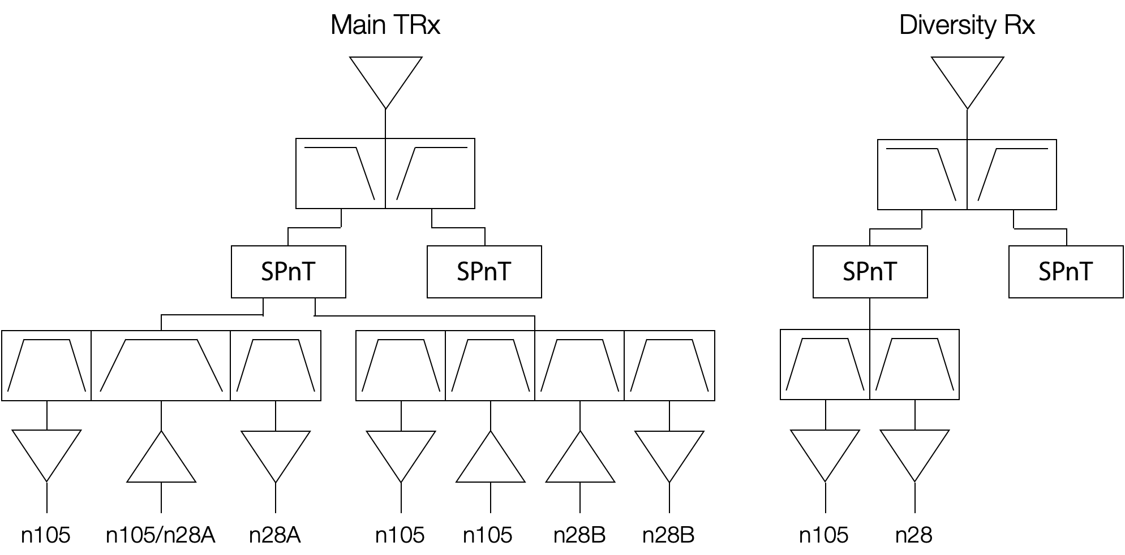
Figure 5.5.2.1-1 CA_n28A-n105A UE RF first architecture variant with 2-antenna implementation

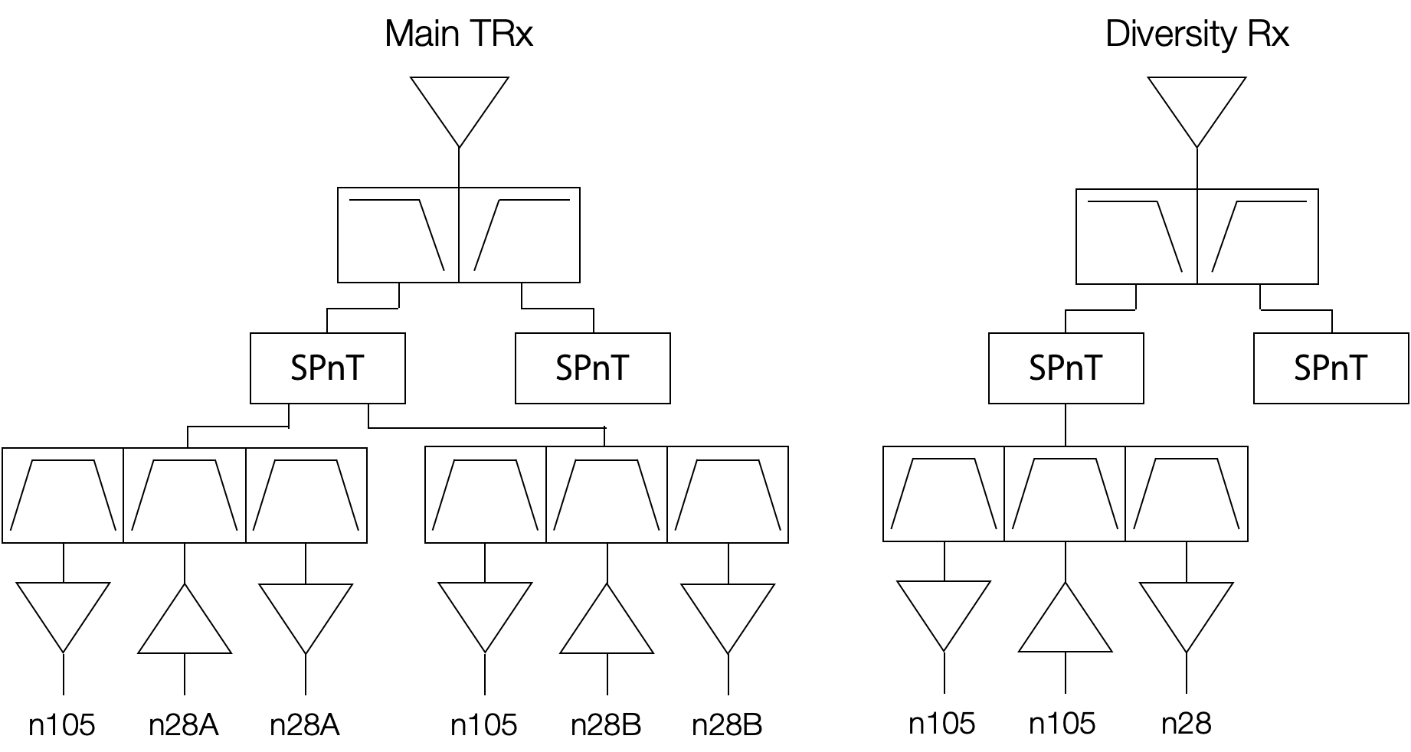
Figure 5.5.2.1-2 CA_n28A-n105A second architecture variant with 2-antenna implementation

The first architecture variant, due to the relatively wide frequency range (a single filter covering both n28 and n 105) in the middle sub-band for the main signal path triplexer, is considered rather challenging and impracticable for implementation and will not be further pursued in this study item.
For the second architecture variant, both the main antenna and diversity antenna design need to cover the entire spectrum range of 191 MHz simultaneously as shown in Figure 5.5.1-1, which is equivalent to a 27% bandwidth ratio and that would exceed the bandwidth ratio for a typical planar antenna design in a smartphone. As a result, the radiative performance for the combination likely would be compromised.

5.5.2.2 UE RF architectures with three antennas
For the 3-antenna implementation, the two of the three antennas are used in the main path to aggregate the n28 and n105 signals over the air, as shown in Figure 5.5.2.2-1. As n28 and n105 signals do not need to be combined through a multiplexer, there is no additional insertion loss in both n28 and n105 main signal paths as compared to the single-band implementation.
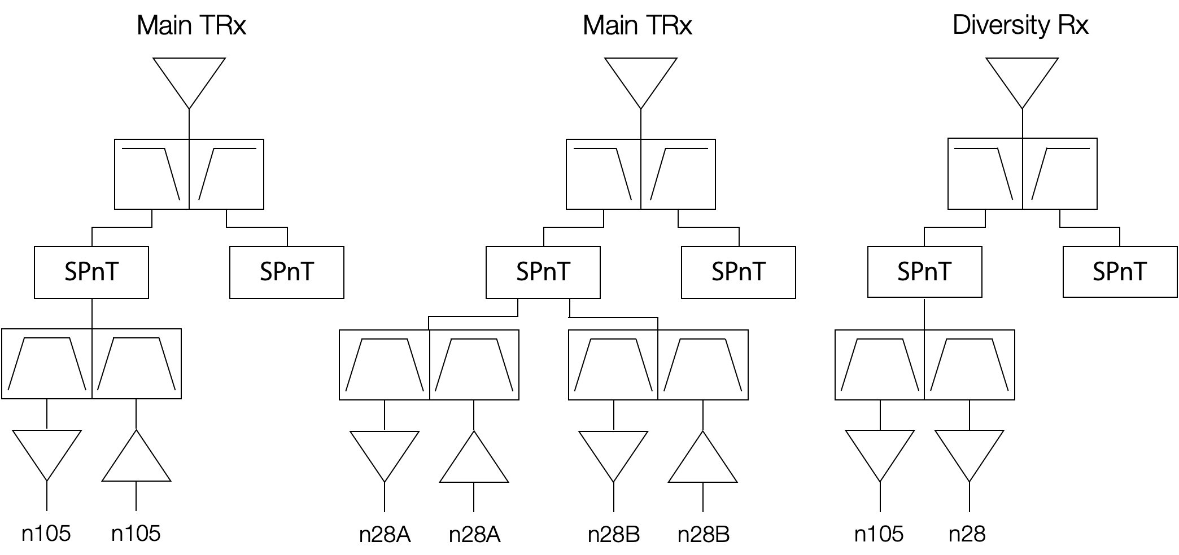
Figure 5.5.2.2-1 CA_n28A-n105A UE RF architecture with 3-antenna implementation
Having two antenna in the main signal path not only avoids the more complicated multiplexer implementation and the associated additional insertion losses, but also allows narrower frequency coverage for each of the two antennas as compared to single-antenna implementation. However, the additional antenna cannot be added without occupying more phone space. Therefore, the feasibility on placing more than two low-band antennas in a smartphone needs to be investigated, with narrower bandwidth and regressed radiating performance expected due to the limitation in form factor.

5.5.2.3 2UL IMD issue
2UL IMD3/IM5 may fall into either n105 DL or n28 DL or both DL bands simultaneously to cause REFSENS degradation (MSD), as conceptually illustrated in Figure 5.5.2.3-1.
Figure 5.5.2.3-1 Conceptual illustration on 2UL IMD3/IMD5 impact to DL bands for CA_n28A-n105A
For both 2-antenna and 3-antenna implementations, depending on the carrier allocation and Tx filter isolation on the two UL carriers, the MSD caused by two simultaneous up links (2UL) IMD3 to n105 DL carrier could potentially be higher than 30 dB; especially when the n28 UL carrier is close to n105 UL band where the n105 Tx filter does not provide any rejection to n28 UL carrier and the n105 PA reverse IMD would dominate the MSD. For carrier allocations where both Tx filters can provide sufficient isolation to the cross-band UL carriers, the MSD caused by 2UL IMD3 could still be around 20 dB to either or both of the DL carriers which would be dominated by PA forward IMD.
Due to the concern of the 2UL IMD issue, only single UL configuration is considered in this study item where UL can be in either n28 or n105.

5.5.2.4 Cross-band interference
Apart from the 2UL IMD concern, the combination may also be subject to cross-band UL to DL interference issue due to frequency proximity even under single UL operation where the REFSENS impact needs to be further analyzed.

5.5.3 Common for 1 band UL and 2 bands UL of CA_ n28-n105

5.5.3.0 General
This band combination is similar to the case of CA_n71-n85 with the two UL bandwidths having no frequency gap between them. CA_n71-n85 is being specified for 1UL only as 2 ULs showed significant MSD challenges.

5.5.3.1 Operating bands for CA
Table 5.5.3.1-1: CA band combination of band n28+n105
NR Band | Uplink (UL) band |  |  | Downlink (DL) band |  |  | Duplex  mode
NR Band | BS receive / UE transmit |  |  | BS transmit / UE receive |  |  | Duplex  mode
NR Band | F_{UL_low} – F_{UL_high} |  |  | F_{DL_low} – F_{DL_high} |  |  | Duplex  mode
n28 | 703 MHz | – | 748 MHz | 758 MHz | – | 803 MHz | FDD
n105 | 663 MHz | – | 703 MHz | 612 MHz | – | 652 MHz | FDD

5.5.3.2 Channel bandwidths per operating band for CA
Based on WF [14], it was agreed that only 1UL configuration will be supported, the 2UL issues will be described in section 5.5.4. Thus, BCS0 for CA_n28A-n105A can be specified as below.

Table 5.5.3.2-1: Supported bandwidths per CA band combination of band n28+n105
NR CA configuration | Uplink CA configuration or single uplink carrier | NR Band | Channel bandwidth (MHz) | Bandwidth combination set
CA_n28A-n105A | - | n28 | 5, 10, 15, 20, 25, 30 | 0
CA_n28A-n105A | - | n105 | 5, 10, 15, 20, 25¹, 30¹, 35¹
NOTE 1: These n105 channel bandwidths are valid in DL only

5.5.3.3 UE co-existence studies
Table 5.5.3.3-1/2 summarizes frequency ranges where UL harmonics and/or harmonic mixing occur for CA_n28-n105.
Table 5.5.3.3-1: Impact of UL/DL Harmonic
 |  |  |  |  | 2nd Harmonic |  | 3rd Harmonic |  | 4th Harmonic |  | 5th Harmonic
 | UL Low Band Edge | UL High Band Edge | DL Low Band Edge | DL High Band Edge | UL Low Band Edge | UL High Band Edge | UL Low Band Edge | UL High Band Edge | UL Low Band Edge | UL High Band Edge | UL Low Band Edge | UL High Band Edge
n28 | 703 | 748 | 758 | 803 | 1406 | 1496 | 2109 | 2244 | 2812 | 2992 | 3515 | 3740
n105 | 663 | 703 | 612 | 652 | 1326 | 1406 | 1989 | 2109 | 2652 | 2812 | 3315 | 3515

Based on the above table, there is no UL harmonic issue for CA_n28-n105.

Table 5.5.3.3-2: Impact of UL/DL Harmonic mixing
 |  |  |  |  | 2nd Harmonic |  | 3rd Harmonic |  | 4th Harmonic |  | 5th Harmonic
Band | UL Low Band Edge | UL High Band Edge | DL Low Band Edge | DL High Band Edge | DL Low Band Edge | DL High Band Edge | DL Low Band Edge | DL High Band Edge | DL Low Band Edge | DL High Band Edge | DL Low Band Edge | DL High Band Edge
n28 | 703 | 748 | 758 | 803 | 1516 | 1606 | 2274 | 2409 | 3032 | 3212 | 3790 | 4015
n105 | 663 | 703 | 612 | 652 | 1224 | 1304 | 1836 | 1956 | 2448 | 2608 | 3060 | 3260

Based on the above table, there is no harmonic mixing issue for CA_n28-n105.
Since the two bands are very close, cross-band isolation may be an issue as shown in Figure 5.5.3.3-3 below, the Table 5.5.3.3-4 provides the analysis for the potential IMD order of the UL configuration and its image for the largest channel bandwidths.
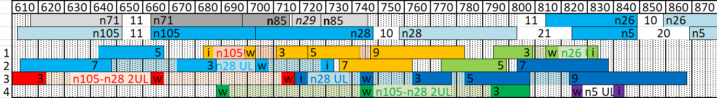
Figure 5.5.3.3-3: IMD landscape for 1UL and 2UL configurations of CA_n28-n105

Table 5.5.3.3-4: Cross band isolation issues
UL  Band | UL Low Band Edge | UL High Band Edge | DL  Band | DL Low Band Edge | DL High Band Edge | UL to DL distance | Maximum UL BW | Source of interference  (IMD order of UL RBs and their image)
n28 | 703 | 748 | n105 | 612 | 652 | 51 | 30 | ACLR2 (IMD5)
n105 | 663 | 703 | n28 | 758 | 803 | 55 | 20 | ACLR3 (IMD7)

As shown in the above Table 5.5.3.3-4, the band n28 30MHz CBW UL ACLR2 overlaps with the band n105 DL while the band n105 20MHz CBW UL ACLR3 overlaps with band n28 DL. Both MSDs need to be evaluated.

5.5.3.4 ∆TIB,c and ∆RIB,c values
For CA_n28-n105 the 2 antenna implementation should drive the ΔT_{IB,c} and ΔR_{IB,c} values, three companies provided input that is summarized in the two tbles below.
Table 5.5.3.4-1: ΔT_{IB,c} due to NR CA (two bands)
Inter-band CA combination | ΔT_{IB,c} for NR bands (dB)⁹
Inter-band CA combination | Component band in order of bands in configuration¹⁰  Proposed values by company A / B / C
CA_n28-n105 | 1.0 / 0.7 / 0.8 | 1.0 / 0.7 / 0.8
NOTE 9: “-” denotes ΔT_{IB,c} = 0.
NOTE 10: The component band order in the configuration should be listed by the order of NR bands, such as for CA_n1-n3 the band order from left to right is n1 and n3.

Table 5.5.3.4-2: ΔR_{IB,c} due to NR CA (two bands)
Inter-band CA combination | ΔR_{IB,c} for NR bands (dB)⁸
Inter-band CA combination | Component band in order of bands in configuration⁹  Proposed values by company A / B / C
CA_n28-n105 | 1.0 / 0.4 / 0.2 | 1.0 / 0.4 / 0.2
NOTE 8: “-” denotes ΔR_{IB,c} = 0.
NOTE 9: The component band order in the configuration should be listed by the order of NR bands, such as for CA_n1-n77 the band order from left to right is n1 and n77.

5.5.3.5 REFSENS evaluation
For CA_n28-n105, the 2 antennas implementation n28 and n105 MSDs related to cross band isolation described in Table 5.5.3.3-4 must be evaluated.
Three companies provided their evaluation for both cross band MSDs.
For n28 MSD due to n105 UL, one company suggested that no MSD was needed while the two other companies’ input can be found in Table 5.5.3.5-1a and b respectively.
Table 5.5.3.5-1a n28 MSD due to cross band isolation for CA_n28-n105 with n105 UL (company A)
UL band | DL band | UL F_{c} | UL BW | SCS of UL band | UL RB Allocation | DL F_{c} | DL BW | MSD | Cross-band  Interference  source
UL band | DL band | (MHz) | (MHz) | (kHz) | L_{CRB} | (MHz) | (MHz) | (dB) | Cross-band  Interference  source
n105 | n28 | 693 | 20 | 15 | 20 (RBstart=86) | 760.5 | 5 | 3.7 | >ACLR2

Table 5.5.3.5-1b n28 MSD due to cross band isolation for CA_n28-n105 with n105 UL (company B)
UL band | DL band | UL F_{c} | UL BW | SCS of UL band | UL RB Allocation | DL F_{c} | DL BW | MSD | Cross-band  Interference  source
UL band | DL band | (MHz) | (MHz) | (kHz) | L_{CRB} | (MHz) | (MHz) | (dB) | Cross-band  Interference  source
n105 | n28 | 693 | 20 | 15 | 20 (RBstart=86) | 760.5 | 5 | 10.8 | >ACLR2

Similarly, for n105 MSD due to n28 UL, the three companies’ input can be found in Table 5.5.3.5-1a, b and c.

Table 5.5.3.5-2a n105 MSD due to cross band isolation for CA_n28-n105 with n28 UL (company A)
UL band | DL band | UL F_{c} | UL BW | SCS of UL band | UL RB Allocation | DL F_{c} | DL BW | MSD | Cross-band  Interference  source
UL band | DL band | (MHz) | (MHz) | (kHz) | L_{CRB} | (MHz) | (MHz) | (dB) | Cross-band  Interference  source
n28 | n105 | 718 | 30 | 15 | 25 (RBstart=0) | 649.5 | 5 | 17 | ACLR2

Table 5.5.3.5-2b n105 MSD due to cross band isolation for CA_n28-n105 with n28 UL (company B)
UL band | DL band | UL F_{c} | UL BW | SCS of UL band | UL RB Allocation | DL F_{c} | DL BW | MSD | Cross-band  Interference  source
UL band | DL band | (MHz) | (MHz) | (kHz) | L_{CRB} | (MHz) | (MHz) | (dB) | Cross-band  Interference  source
n28 | n105 | 718 | 30 | 15 | 25 (RBstart=0) | 649.5 | 5 | 12.7 | ACLR2

Table 5.5.3.5-2c n105 MSD due to cross band isolation for CA_n28-n105 with n28 UL (company C)
UL band | DL band | UL F_{c} | UL BW | SCS of UL band | UL RB Allocation | DL F_{c} | DL BW | MSD | Cross-band  Interference  source
UL band | DL band | (MHz) | (MHz) | (kHz) | L_{CRB} | (MHz) | (MHz) | (dB) | Cross-band  Interference  source
n28 | n105 | 718 | 30 | 15 | 25 (RBstart=0) | 649.5 | 5 | 10.1 | ACLR2

5.5.4 Specific for 2 bands UL of fallback CA_n28-n105

5.5.4.1 Maximum output power for inter-band CA
Power class 3 was assumed for UL CA_n28-n105, but as discussed in the next clauses, it was decided that the two UL configuration will not be supported due to significant IMD3 MSD and potential co-existence issues with DTV channels.

5.5.4.2 UE co-existence studies
Table 5.5.4.2-1 lists Band n28 + Band n105 2UL bands CA 2nd, 3rd, 4th and 5th order IMD for the UE-to-UE coexistence analysis.
Table 5.5.4.2-1 IMD interference analysis for CA_n28-n105 with 2 ULs
UE UL carriers | fx_low | fx_high | fy_low | fy_high
UL frequency (MHz) | 663 | 703 | 703 | 748
2nd harmonics frequency limits | 2*fx_low | 2*fx_high | 2*fy_low | 2*fy_high
2nd harmonics frequency limits (MHz) | 1326 | 1406 | 1406 | 1496
3rd harmonics frequency limits | 3*fx_low | 3*fx_high | 3* fy_low | 3* fy_high
3rd harmonics frequency limits (MHz) | 1989 | 2109 | 2109 | 2244
4th harmonics frequency limits | 4*fx_low | 4*fx_high | 4* fy_low | 4* fy_high
4th harmonics frequency limits (MHz) | 2652 | 2812 | 2812 | 2992
5th harmonics frequency limits | 5*fx_low | 5*fx_high | 5* fy_low | 5* fy_high
5th harmonics frequency limits (MHz) | 3315 | 3515 | 3515 | 3740
6th harmonics frequency limits | 6*fx_low | 6*fx_high | 6* fy_low | 6* fy_high
6th harmonics frequency limits (MHz) | 3978 | 4218 | 4218 | 4488
7th harmonics frequency limits | 7*fx_low | 7*fx_high | 7* fy_low | 7* fy_high
7th harmonics frequency limits (MHz) | 4641 | 4921 | 4921 | 5236
2nd order IMD products | |fy_high – fx_low| | |fy_low – fx_high| | |fy_low + fx_low| | |fy_high + fx_high|
IMD frequency limits (MHz) | 85 | 0 | 1366 | 1451
3rd order IMD products | |fy_high – 2*fx_low| | |fy_low – 2*fx_high| | |2*fy_low – fx_high| | |2*fy_high – fx_low|
IMD frequency limits (MHz) | 578 | 703 | 703 | 833
3rd order IMD products | |2*fx_low + fy_low| | |2*fx_high + fy_high| | |2*fy_low + fx_low| | |2*fy_high + fx_high|
IMD frequency limits (MHz) | 2029 | 2154 | 2069 | 2199
Two-tone 4th order IMD products | |2*fx_low –2* fy_high| | |2*fx_high – 2*fy_low| | |2*fx_low +2* fy_low| | |2*fx_high +2* fy_high|
IMD frequency limits (MHz) | 170 | 0 | 2732 | 2902
Two-tone 4th order IMD products | |3*fx_low –1* fy_high| | |3*fx_high – 1*fy_low| | |3*fy_low – 1*fx_high| | |3*fy_high – 1*fx_low|
IMD frequency limits (MHz) | 1241 | 1406 | 1406 | 1581
Two-tone 4th order IMD products | |3*fx_low +1* fy_low| | |3*fx_high +1* fy_high| | |3*fy_low + 1*fx_low| | |3*fy_high + 1*fx_high|
IMD frequency limits (MHz) | 2692 | 2857 | 2772 | 2947
Two-tone 5th order IMD products | |fx_low – 4*fy_high| | |fx_high – 4*fy_low| | |fy_low – 4*fx_high| | |fy_high – 4*fx_low|
IMD frequency limits (MHz) | 2329 | 2109 | 2109 | 1904
Two-tone 5th order IMD products | |fx_low + 4*fy_low| | |fx_high + 4*fy_high| | |fy_low + 4*fx_low| | |fy_high + 4*fx_high|
IMD frequency limits (MHz) | 3475 | 3695 | 3355 | 3560
Two-tone 5th order IMD products | |2*fx_low – 3*fy_high| | |2*fx_high – 3*fy_low| | |2*fy_low – 3*fx_high| | |2*fy_high – 3*fx_low|
IMD frequency limits (MHz) | 918 | 703 | 703 | 493
Two-tone 5th order IMD products | |2*fx_low + 3*fy_low| | |2*fx_high + 3*fy_high| | |2*fy_low + 3*fx_low| | |2*fy_high + 3*fx_high|
IMD frequency limits (MHz) | 3435 | 3650 | 3395 | 3605

From the above table, it can be found that both n28 DL and n105 DL are subject to MSD due to dual-uplink IMD3 and IMD5 of 2UL CA_n28-n105 configuration. Furthermore, the DTV channels below 608 MHz are also victims of the CA_n28-n105 IMD3 and higher orders and thus the coexistence between UL CA_n28-n105 and DTV channels may be compromised.

5.5.4.3 REFSENS evaluation
Based on the above IMD analysis, the IMD3 and IMD5 MSD test points in Table 5.5.4.2-1 were discussed. Some estimations of the IMD3 MSD ranged between 25 dB and 44dB depending on the performance of the filters and antenna coupling assumptions. Based on this large MSD and the potential coexistence issue with (US) DTV channels, it was agreed together with the band combination proponent, that 2UL configuration will not be supported. This agreement is captured in way forward [14].
Table 5.5.4.3-1 potential MSD test points due to IMD3 and IMD5 if 2UL configuration would be specified.
Band / Channel bandwidth / N_{RB} / Duplex mode |  |  |  |  |  |  |  | Source of IMD
NR CA band combination | NR band | UL F_{c}  (MHz) | UL/DL BW  (MHz) | UL  C_{LRB} | DL F_{c} (MHz) | MSD  (dB) | Duplex mode | Source of IMD
CA_n28-n105 | n28 | 745.5 | 5 | 25 | 800.5 | 2UL not specified | FDD | IMD3
CA_n28-n105 | n105 | 690.5 | 5 | 25 | 639.5 | N/A | FDD | N/A
CA_n28-n105 | n28 | 745.5 | 5 | 25 | 800.5 | N/A | FDD | IMD3
CA_n28-n105 | n105 | 694.5 | 5 | 25 | 643.5 | 2UL not specified | FDD | N/A
CA_n28-n105 | n28 | 715 | 5 | 25 | 770 | 2UL not specified | FDD | IMD5
CA_n28-n105 | n105 | 687.5 | 5 | 25 | 636.5 | N/A | FDD | N/A
CA_n28-n105 | n28 | 715.5 | 5 | 25 | 770.5 | N/A | FDD | IMD5
CA_n28-n105 | n105 | 690 | 5 | 25 | 639 | 2UL not specified | FDD | N/A

5.6 CA_n26-n28

5.6.1 General
In this configuration the uplink is also CA_n26A-n28A, but there are two fall back options:
DL_n26A-n28A_UL_n28A_BCS0 (already completed)
UL_n26A-n28A_UL_n26A_BCS0
The implementation of the band n28 of CA_n26_n28 has been discussed, and the pros and cons of the following two cases can be further traded-off, whether and/or how to do the down-selection in the future is for further study.
Case 1: lower 30MHz of n28 (UL: 703~733MHz, DL: 758~788MHz) is supported.
Case 2: entire n28 frequency range (UL: 703~748MHz, DL: 758~803MHz) is supported.
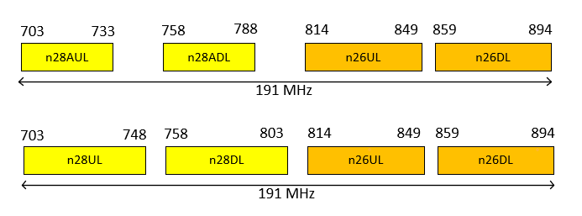
Figure 5.6.1-1 CA_n26-n28 frequency ranges
Besides, as a reference for further study, proponent operator provided some related information about the allocated spectrum in the 700MHz and extended 850 MHz bands as sketched in the following figure and table.
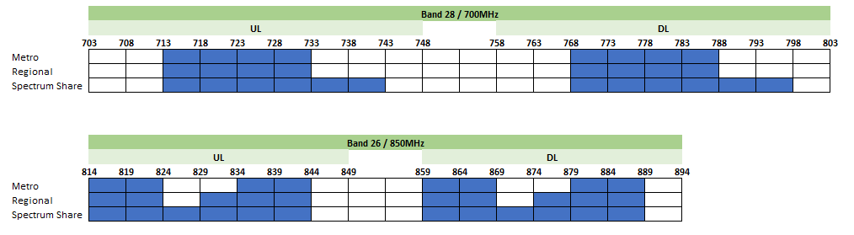
Figure 5.6.1-2 n26 and n28 spectrum allocation

Table 5.6.1-1 n26 and n28 spectrum allocation
 | Uplink | Downlink
n28 (national) | 713 MHz – 733 MHz | 768 MHz – 788 MHz
n26 (Metropolitan) | 814 MHz – 824 MHz  835 MHz – 845 MHz | 859 MHz – 869 MHz  880 MHz – 890 MHz
n26 (Regional) | 814 MHz – 824 MHz  830 MHz – 845 MHz | 859 MHz – 869 MHz  875 MHz – 890 MHz

5.6.2 UE RF architecture assumption
The potential UE RF architectures for CA_n26A-n28A case 1 and case 2 can be considered as shown below. Baseline architecture for UE RF requirements development will be further discussed. As the performance of band n26 is similar to band n28, after the development of CA_n5-n28, some architectures could be used as a reference to CA_n26-n28.

5.6.2.1 UE RF architecture with lower 30MHz of n28 supporting
Architecture of case 1 (lower 30MHz of n28 (UL: 703~733MHz, DL: 758~788MHz) is supported) is listed as below. Entire n28 presents a greater challenge to filter implementation, so further research on feasibility and applicable filtering techniques should be considered.
The topology for architecture 1 with 2 antenna, as shown in Figure 5.6.2.1-1:
1) antenna 1 with quadplexer supporting n26DL+n26UL+n28AUL+n28ADL
2) antenna 2 with duplexer supporting n26DL+n28ADL
The topology for architecture 2 with 2 antenna, as shown in Figure 5.6.2.1-2:
1) antenna 1 with triplexer supporting n26DL+n28AUL+n28ADL
2) antenna 2 with triplexer supporting n26DL+n26UL+n28ADL
The topology for architecture 3 with 3 antenna, as shown in Figure 5.6.2.1-3:
1) antenna 1 with duplexer supporting n28AUL+n28ADL
2) antenna 2 with duplexer supporting n26UL+n26DL
3) antenna 3 with duplexer supporting n26DL+n28ADL
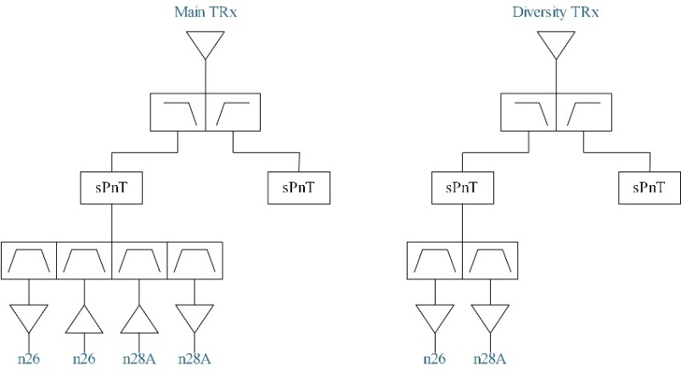
Figure 5.6.2.1-1 Architecture 1: Quadplexer solution for CA_n26-n28 with two antennas
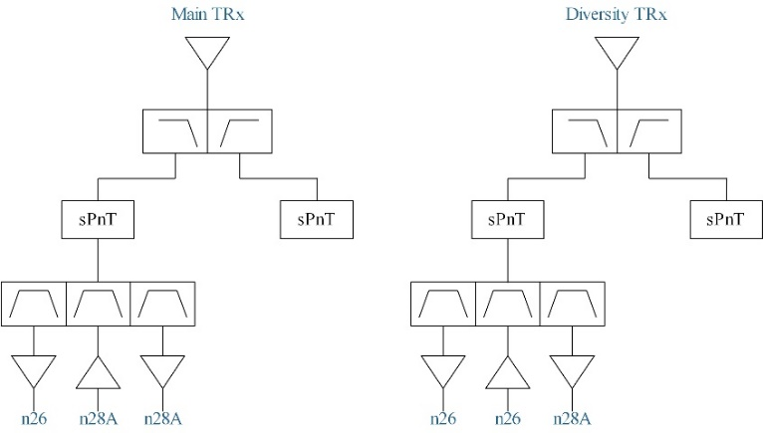
Figure 5.6.2.1-2 Architecture 2: Triplexer solution for CA_n26-n28 with two antennas
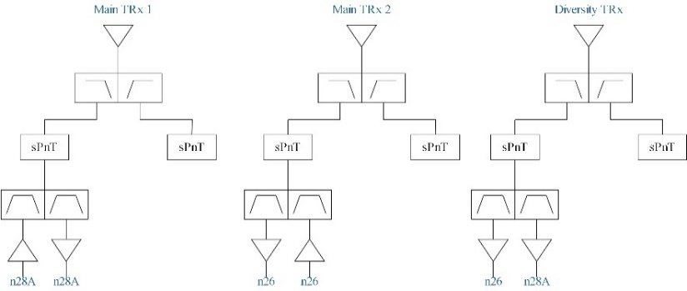
Figure 5.6.2.1-3 Architecture 3: Three-antenna solution for CA_n26-n28

5.6.2.2 UE RF architecture with entire n28 frequency range supporting
Architecture of case 2 (entire n28 frequency range (UL: 703~748MHz, DL: 758~803MHz) is supported) is listed as below.
The topology for architecture 4 with 2 antenna, as shown in Figure 5.6.2.2-1:
1) antenna 1 with dual-quadplexer supporting n26UL+ n26DL+ n28AUL+ n28ADL_ n26UL+ n26DL+ n28BUL+ n28BDL
2) antenna 2 with duplexer supporting n26DL+n28DL
The topology for architecture 5 with 2 antenna, as shown in Figure 5.6.2.2-2:
1) antenna 1 with dual-triplexer supporting n26DL+ n28AUL+n28ADL_ n26DL+ n28BUL+n28BDL
2) antenna 2 with triplexer supporting n26DL+n26UL+n28UL
The topology for architecture 6 with 3 antenna, as shown in Figure 5.6.2.2-3:
1) antenna 1 with dual-duplexer supporting n28AUL+n28ADL_ n28BUL+n28BDL
2) antenna 2 with duplexer supporting n26UL+n26DL
3) antenna 3 with duplexer supporting n26DL+n28ADL
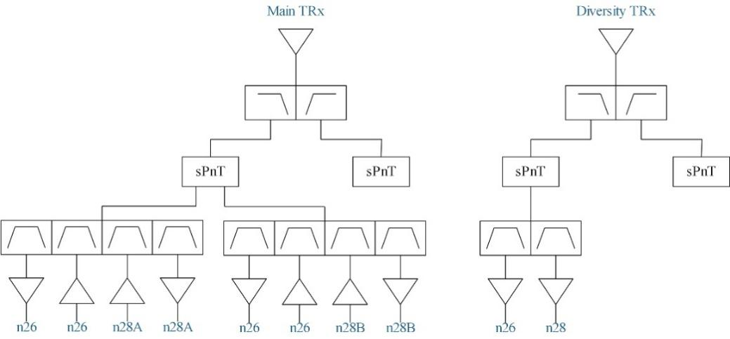
Figure 5.6.2.2-1 Architecture 4: Dual-quadplexer solution for CA_n26-n28 with two antennas
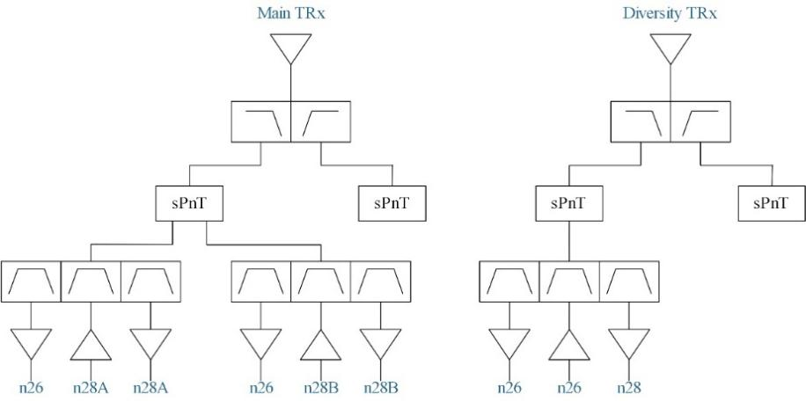
Figure 5.6.2.2-2 Architecture 5: Dual-triplexer solution for CA_n26-n28 with two antennas
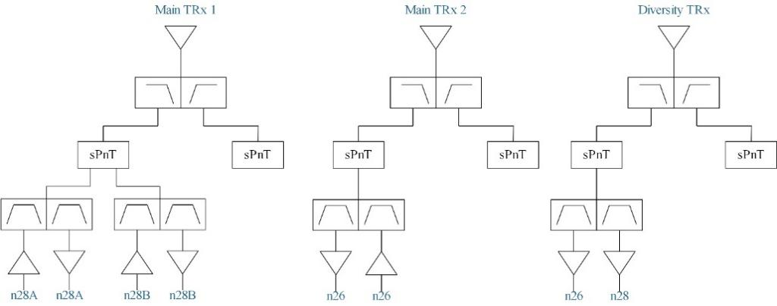
Figure 5.6.2.2-3 Architecture 6: Three-antenna solution for CA_n26-n28
For architecture 4 with 2 antenna, there are some potential implementation challenges:
- The main antenna should simultaneously cover the whole band from n28UL to n26DL with the length of 191MHz, the bandwidth ratio is as high as 23.9%, it would far exceed the bandwidth ratio for a typical planar antenna design in a smartphone, therefore the radiative performance for CA_n26A-n28A is expected to be compromised.
- The performance requirements of quadplexer such as filter isolation and insertion loss are strict, posing challenge to the implementation and cost of the UE front-end, and the feasibility of two quadplexers may need further study.
For architecture 5 with 2 antenna, there are some advantages and potential implementation challenges:
- A two-antenna architecture with three triplexers can be easier to design with proper delta T and delta R, so architecture 2 seems to be more feasible.
- The difficulties of triplexer implementation still remain with two gaps of 10MHz, n26 BW of 35MHz and n28DL of 45MHz.
For architecture 6 with 3 antenna, there are some advantages and potential implementation challenges:
- For the 3-antenna architecture, there are two antennas on the main signal path, which eases the difficulty of multiplexer design and implement. The frequency range for each main antenna is narrower compared with 2-antenna architecture, and the antenna BW ratios of the two antennas would be close to the current devices.
- 3 LB antennas present a greater challenge to the dimension of the mobile phone than 2-amtenna architecture.

5.6.3 Common for 1 band UL and 2 bands UL of CA_n26-n28

5.6.3.1 Operating bands for CA
Table 5.6.3.1-1: CA band combination of band n26+n28
NR Band | Uplink (UL) band |  |  | Downlink (DL) band |  |  | Duplex  mode
NR Band | BS receive / UE transmit |  |  | BS transmit / UE receive |  |  | Duplex  mode
NR Band | F_{UL_low} – F_{UL_high} |  |  | F_{DL_low} – F_{DL_high} |  |  | Duplex  mode
n26 | 814 MHz | – | 849 MHz | 859 MHz | – | 894 MHz | FDD
n28 | 703 MHz | – | 748 MHz | 758 MHz | – | 803 MHz | FDD

A note may be needed if case 1 is considered for CA_n26-n28, e.g. band n28 is restricted at lower 30MHz (UL: 703~733MHz, DL: 758~788MHz).
In addition, referring to the contribution [10], the following options about different frequency range restrictions are listed to trade-off the pros and cons. From a high level perspective, based on the proponent operator’s feedback, one possibility is that RAN4 move forward with option 4 (i.e. both options 1 and 3 being captured in the specification) which would allow maximum implementation flexibility.
Option 1 Keep current CA_n26A-n28A with entire n28 frequency range and specify n26 UL and UL CA support for entire frequency range
Option 2 Modify current CA_n26A-n28A to include only lower 30MHz of n28 and specify n26 UL and UL CA support for lower 30MHz frequency range
Option 3 Keep current CA_n26A-n28A with entire n28 frequency range and specify n26 UL and UL CA support for lower 30MHz frequency range
Option 4 Combination of options 1 and 3

5.6.3.2 Channel bandwidths per operating band for CA
Referring to table 5.5A.3.1-1h of TS 38.101-1, DL_n26A-n28A_BCS0 and BCS1 has been specified

5.6.3.3 Identify the potential MSD issues due to harmonic/harmonic mixing/cross band isolation
There is no need to specify harmonics and harmonics mixing exception for CA_n26-n28 as we didn’t specify them in current spec.
For cross band isolation issue:
Case 1: The 2nd adjacent channel leakage from band n26 may fall into band DL frequency range (774~788) when 20MHz UL CBW is assumed for band n26.
Case 2: the 1st adjacent channel leakage from band n26 may fall into n28 DL frequency range (796~803) when 20MHz UL CBW is assumed for band n26.

5.6.3.4 ∆TIB,c and ∆RIB,c values
Option 1 is proposed based on the agreed ΔT_{IB,c} and ΔR_{IB,c} values for CA_n5-n28 in WF [11] which can be reused for CA_n26-n28.
Option 2 is proposed in the contribution [10].
Table 5.6.3.4-1: ΔT_{IB,c}
Inter-band CA Configuration | NR Band | ΔT_{IB,c} [dB] option 1 | ΔT_{IB,c} [dB] option 2
CA_n26A-n28A | n26 | 0.7 | 0.5
 | n28 | 0.7 | 0.5
Table 5.6.3.4-2: ΔR_{IB,c}
Inter-band CA Configuration | NR Band | ΔR_{IB,c} [dB] option 1 | ΔR_{IB,c} [dB] option 2
CA_n26A-n28A | n26 | 0.2 | 0.3
 | n28 | 0.2 | 0.3

5.6.3.5 REFSENS exception evaluation for one UL band
1) Referring to the contribution [12], the following band n28A MSD evaluations, assuming 35dB and 45dB Tx filter rejection of band n26.
Table 5.6.3.5-1: band n28A MSD evaluations due to cross band isolation for CA_n26-n28
UL band | DL band | UL F_{c} | UL BW | SCS of UL band | UL RB Allocation | DL F_{c} | DL BW | MSD | Cross-band  Interference  source
UL band | DL band | (MHz) | (MHz) | (kHz) | L_{CRB} | (MHz) | (MHz) | (dB) | Cross-band  Interference  source
n26 | n28A | 824 | 20 | 15 | 25 (RBstart=0) | 785.5 | 5 | 25.6 | ACLR2
n26 | n28A | 824 | 20 | 15 | 25 (RBstart=0) | 785.5 | 5 | 15.9 | ACLR2

Referring to the contribution [12], we have the following band n28B MSD evaluations, assuming filter performance with set 1 and set 2 in Table 5.6.3.5-3.
Table 5.6.3.5-2: band n28B MSD evaluations due to cross band isolation for CA_n26-n28
UL band | DL band | UL F_{c} | UL BW | SCS of UL band | UL RB Allocation | DL F_{c} | DL BW | MSD | Cross-band  Interference  source
UL band | DL band | (MHz) | (MHz) | (kHz) | L_{CRB} | (MHz) | (MHz) | (dB) | Cross-band  Interference  source
n26 | n28B | 824 | 20 | 15 | 25 (RBstart=0) | 801.5 | 5 | 45.9 (Set 1) | ACLR1
n26 | n28B | 824 | 20 | 15 | 25 (RBstart=0) | 801.5 | 5 | 28.5 (Set 2) | ACLR1

Table 5.6.3.5-3: Filter performance assumption
 | Set 1 | Set 2
n28B Rx filter rejection at 814~849MHz | 12 dB | 33 dB
n26 Tx filter rejection at 773~803MHz | 35 dB | 45 dB

2) Referring to the contribution [13], the following analysis were provided.
To evaluate the potential 1UL and 2UL for CA_n26-n28 with band n28 full (n28F) or the lower 30MHz (n28A), it is useful to compare existing cases for CA_n5-n28F and CA_n18-n28F and CA_n18-n28A. This can be done by observing the IMD landscape provided in Figure 5.6.3.5-1, and the related wanted UL RB allocation and its image IMDs overlaps for 5MHz and 30MHz n28DL for n28F or n28A scenarios that are collected in Table 5.6.3.5-4.
In addition, 1UL cross band MSD for n28F and n28A were proposed in 1UL cross band MSD for n28F and n28A.

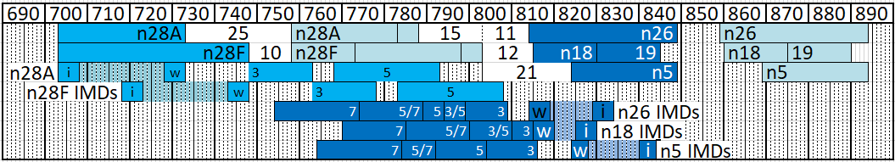
Figure 5.6.3.5-1: IMD landscape of n5, n18, n26 and n28 for n28F and n28A cases.

Table 5.6.3.5-4: Distance to n28 victim DL and IMD overlap for different UL and DL scenarios
Band | Max UL BW | #RB | Distance to (MHz) |  | IMD overlap
Band | Max UL BW | #RB | n28A | n28F | n28A 5MHz | n28F 5MHz | n28A 30MHz | n28F 30MHz
n26 | 20MHz | 25 | 26 | 11 | IMD5/7 | IMD3 | IMD5/7 | IMD3/5/7
n5 | 20MHz | 20 | 21 | 36 | IMD5/7 | IMD5 | IMD5/7 | IMD5/7
n18 | 15MHz | 25 | 17 | 12 | IMD5/7 | IMD3/5 | IMD5/7 | IMD3/5/7
n28A | 30MHz | 25 | 25 | na | na | na | IMD3/5 | na
n28F | 30MHz | 25 | na | 10 | na | na | na | IMD3/5

Table 5.6.3.5-5: 1UL cross band MSD for n28F and n28A
UL band | DL band | UL F_{c} | UL BW | SCS of UL band | UL RB Allocation | DL F_{c} | DL BW | MSD | Cross-band  Interference source
UL band | DL band | (MHz) | (MHz) | (kHz) | LCRB | (MHz) | (MHz) | (dB) | Cross-band  Interference source
n26 | n28 | 822.5 | 20 | 15 | 25 (RBstart=0) | 800.5 | 5 | [>30] | ACLR1
n26 | n28 | 822.5 | 20 | 15 | 25 (RBstart=0) | 785.5 | 5 | [18] | ACLR2

3) Referring to the contribution [10], the technical analysis for two cases (case 1: n28 Cross-band MSD for lower 30MHz of n28 / case 2: n28 Cross-band MSD for entire n28) are shown below.
Table 5.6.3.5-6: Cross-band MSD for lower 30MHz of n28
Table 5.6.3.5-7: n28 Cross-band MSD for entire n28
It’s observed that MSD is about 15-20dB higher if the entire n28 must be supported, compared to case when only lower 30MHz of n28 is supported.
Table 5.6.3.5-8: n28 Cross-band MSD test point for lower 30MHz of n28 and entire n28
UL band | DL band | UL F_{c} | UL BW | SCS of UL band | UL RB Allocation | DL F_{c} | DL BW | MSD | Cross-band  Interference  source
UL band | DL band | (MHz) | (MHz) | (kHz) | L_{CRB} | (MHz) | (MHz) | (dB) | Cross-band  Interference  source
n26 | n28 | 824 | 20 | 15 | 25 (RBstart=0) | 785.5 | 5 | 17.0 | ACLR2
n26 | n28 | 824 | 20 | 15 | 25 (RBstart=0) | 800.5 | 5 | 33.7 | ACLR

4) Referring to the contribution [17], the following analysis were provided.
The combo is a L-L band combination with small gap between uplink range of n26 and downlink range of n28. The maximum uplink bandwidth of n26 is up to 20MHz that its ACP1 would fall into DL range of n28 directly if uplink is allocated full RB. Below table lists our assumption for MSD characterization. Here we consider three-antenna implementation since the frequency gap between n26 uplink and n28 downlink is only 11MHz that we don’t think a low band diplexer is feasible with existing technology. Based on previous RAN4 agreement, there shall not be frequency range constraint on n28 thus MSD shall be characterized with full frequency range.
Table 5.6.3.5-9 Receiver performance parameters for MSD analysis
Parameter | Value | Unit
Antenna isolation | 10 | dB
n28 filter rejection at n26 UL range | 15 | dB
n26 ACP1 | -30 | dBc
n26 CIM3 | -60 | dBc
Front-end loss | 4 | dB
PCB isolation | 67 | dB
PA RXBN noise | -115 | dBm/Hz
Thermal noise at n28 RX ANT port | -165.5 | dBm/Hz
Transceiver effective phase noise | -144 | dBc/Hz
SNR requirement for QPSK | -1 | dB

With above parameters, we calculate MSD due to cross band isolation as below:
Table 5.6.3.5-10 Link analysis for Band 28 5MHz REFSENS calculation at fc = 800.5 MHz
Direct Signal Path
Parameter | Main | Diversity
n26 TX power at antenna port (Primary path) | 23 | 23 | dBm
n26PA output noise power at n28 LNA input port | -71.3 | -71.3 | dBm/5MHz
n28 LNA IM2 due to n26 uplink | -53 | -53 | dBm/5MHz
Thermal noise at RX ant port | -162.5 |  | dBm/Hz
CIM3 noise at n28 LNA input port | -55.8 | -55.8 | dBm
Total noise level refer to B28 LNA input port | -51.1 | -51.1
Combined
MSD (5MHz BW) | 47.4 |  | dB

Table 5.6.3.5-11: band n28B MSD evaluations due to cross band isolation for CA_n26-n28
UL band | DL band | UL F_{c} | UL BW | SCS of UL band | UL RB Allocation | DL F_{c} | DL BW | MSD | Cross-band  Interference  source
UL band | DL band | (MHz) | (MHz) | (kHz) | L_{CRB} | (MHz) | (MHz) | (dB) | Cross-band  Interference  source
n26 | n28B | 824 | 20 | 15 | 25 (RBstart=0) | 800.5 | 5 | 47.4 | ACLR1

5) Referring to the contribution [18], new evaluation based on measurements were provided compared to [13] which was based on extrapolated from similar combination:
- 20MHz band n26 output noise in n28A (first 30MHz of band n28) and n28B (last 30MHz of band n28) for:
- 5, 20, 25 and 30MHz band n28 CBW
- At 23dBm for 1UL and 20dBm for 2UL
- Band n28 self-desense for 5, 20, 25 and 30MHz band n28 CBW at 23dBm for 1UL and 20dBm for 2UL.
Based on the chosen architecture, the following RF front-end performance is assumed:
- Post PA and pre LNA losses = 4dB
- Antenna isolation 10dB
- Band n26 UL filter from n26UL/n26DL/n28DL triplexer performance:
- n26 UL to n28A DL T/R isolation = 38dB
- n26UL to n28A DL antenna rejection = 35dB
- n26 UL to n28A DL T/R isolation = 35dB (11MHz distance)
- n26UL to n28A DL antenna rejection = 32dB (11MHz distance)
- These performances are justified by the fact that band n26 is one of the most critical low band duplexers (35MHz BW with 10MHz duplex gap)
- Band n28 UL filter from n28AorBUL/n26DL/n28AorBDL triplexer performance
- n28 UL to n26 DL T/R isolation = 40dB
- n28 UL to n26 DL antenna rejection = 38dB
These performances are justified for a full band n28 design and the proximity of band n26.
For CA_n26-n28, the 1UL scenario is using the largest n28 and n26 UL CBW (respectively 30MHz and 20MHz) closest to the victim band with a 5MHz Rx CBW. Still, in previous meetings, there was discussion regarding whether the 30MHz lower band n28 or the full band n28 should be considered, for this we evaluated n28A and n28B (representative of full band) cases:
- n28B (upper 30MHz) is victim of IMD3 of band n26 UL wanted RBs and their image including its peak
- n28A (lower 30MHz) is victim of IMD5 of band n26 UL wanted RBs and their image including its peak
- n26 is victim of n28B IMD9 and n28A IMD11, at these high IMD offsets, the noise is dominated by the wideband transmitter white noise floor.
We performed measurements for both sub-band n28A and n28B cases and the MSD after MRC results are summarized in Table 3.
Table 5.6.3.5-12: Post MRC MSD calculations based on measured transmitter noise.
UL/BW/IM-DL |  | n26/20/5-n28A |  | n26/20/3-n28B |  | n28AB/30/9-n26
CBW/NRB | [MHz]/# | 5 | 25 | 5 | 25 | 5 | 25
Meas Tx noise / transmitter noise floor | [dBm/CBW] | -43.1 | -63.5 | -23.3 | -63.5 | -85.0 | -63.5
REFSENS | [dBm/CBW] | -98.5 |  | -98.5 |  | -97.5
RX noise floor wo Tx noise : Main/Div | [dBm/CBW] | -94.5 | -94.5 | -94.5 | -94.5 | -93.5 | -93.5
Tx-Rx / Tx-Ant duplexer isolation/rejection | [dB] | 38 | 35 | 35 | 32 | 37 | 34
LNA to antenna insertion loss | [dB] | 4 |  | 4 |  | 4
Antenna isolation | [dB] | 0 | 10 | 0 | 10 | 0 | 10
PC3 1Tx interference levels: Main/Div | [dBm/CBW] | -77.1 | -84.1 | -54.3 | -61.3 | -96.4 | -103.4
Noise degradation due to Tx noise : Main/Div | [dB] | 17.5 | 10.8 | 40.2 | 33.2 | 1.8 | 0.4
REFSENS degradation after MRC | cor [dB] | 15.3 |  | 37.8 |  | 1.7

Observations:
- With only the transmitter noise floor contributing, the band n26 MSD due to band n28 is small
- The MSD of band n28B victim of band n26 UL IMD3 is confirmed to be significantly above 30dB
- The MSD of band n28A victim of band n26 UL IMD5 is slightly lower than estimated in [2].
These observations lead to the following 1UL cross band isolation MSD proposals, which provides MSD for full band and lower 30MHz of band n28 as spectrum availability varies in different regions.

Table 5.6.3.5-13: 1UL cross band MSD for CA_n26-n28 accounting for both full band and lower 30MHz only of band n28.
UL band | DL band | UL F_{c} | UL BW | SCS of UL band | UL RB Allocation | DL F_{c} | DL BW | MSD | Cross-band  Interference source
UL band | DL band | (MHz) | (MHz) | (kHz) | LCRB | (MHz) | (MHz) | (dB) | Cross-band  Interference source
n26 | n28 | 824 | 20 | 15 | 25 (RBstart=0) | 800.5 | 5 | 37.8 | ACLR1
n26 | n28 | 824 | 20 | 15 | 25 (RBstart=0) | 785.5 | 5 | 15.3 | ACLR2
n28 | n26 | 733 | 30 | 15 | 25 (RBstart=135) | 861.5 | 5 | 1.7 | >ACLR2

6) Referring to the contribution [19], new evaluation for one uplink is provided:
During the study phase for the CA_n26-n28 band combination, there was no agreement on whether to consider only the lower 30MHz section of n28 or the entire band, as captured in the following WF:
- Case 1: lower 30MHz of n28 (UL: 703~733MHz, DL: 758~788MHz) is supported.
- Case 2: entire n28 frequency range (UL: 703~748MHz, DL: 758~803MHz) is supported.
As a consequence of this, we will do the MSD analysis and access the ∆TIB,c and ∆RIB,c for both cases. The corresponding aggregated spectrums are shown in Figures 2.3-1 and 2.3-2 below:

Figure 5.6.3.5-2: Aggregated spectrum allocation for the CA_n26-n28 combination (full n28 band)

Figure 5.6.3.5-3: Aggregated spectrum allocation for the CA_n26-n28 combination (lower 30MHz of n28 band)

The two-antenna architecture is captured in the following figure.
Figure 5.6.3.5-4: CA_n26-n28 RF front-end architecture based on 2 antennas and 2 triplexers

CA_n26-n28 MSD Analysis
As can be seen from the MSD contributor table below, for n28 UL n26 DL, there is more than 110MHz of spectrum gap. Therefore, the cross-band interference for that case will be minimum and so the MSD for n26 DL will be small. However, for the n26 UL n28 DL, there is only 11MHz of separation when the n28 full 45MHz band is considered and 26MMHz when the lower 30MHz of n28 (n28A) is assumed. Due to that small frequency separation, there is a strong cross-band interference that will affect the n28 DL. Next, we will examine the n28 DL MSD for both cases.

Table 5.6.3.5-14: CA_n26-n28 MSD cross-band interference sources
Interference Source | 1 Uplink (n26UL or n28UL) | 2 Uplinks (n26UL+n28UL)
Harmonic/harmonic mixing | No issue | No issue
Intermodulation | No issue | No significant issue
Cross-band isolation | Option # 1: Entire n28 band  Significant ACLR1 and cross band noise issue for n26ULn28DL case  Potential TX noise leakage issue  Option # 2: Lower 30MHz of 28 band  Significant ACLR2 and cross band noise issue for n26ULn28DL case  Potential TX noise leakage issue

For the n28 DL MSD analysis, we will use the following worst-case assumptions for the RF front-end performance parameters:
- n26 Tx filter rejection at n28 RX (758MHz-803MHz): 30dB
- Cross-band TX to RX isolation: 40dB
- ACLR2 sideband level: 30dBc
- ACLR3 sideband level: 30dBc
- Front-end insertion loss: 4.5dB
- Antenna coupling: 10dB
- RxBW: 4.5MHz
- Output Power at antenna: 23dBm
Given the assumptions above, the MSD analysis is summarized in the table below.

Table 5.6.3.5-15: CA_n26-n28 MSD analysis
MSD Source | Parameter | Unit | n26 Tx n28 RX Case 1 (Full 45MHz BW) |  | n26 Tx n28 RX Case 2 (Lower 30MHz BW only)
MSD Source | Parameter | Unit | n28 main path | n28 div. path | n28 main path | n28 div. path
PA noise  + ACLR | TX noise leakage at PA output due to ACLR2 (PC3) | dBm/RxBW | -14 |  | -39.5
PA noise  + ACLR | Total PA noise @ ANT | dBm/RXBW | -48.5 | -58.5 | -79 | -89
IIP2 effects | Typical Rx IIP2 | dBm | 54 | 54 | 54 | 54
IIP2 effects | TX IM2 noise level @ ANT | dBm | -98 | -108 | -98 | -108
Thermal Noise | 3GPP REFSENS | dBm | -98.5 | -98.5 | -98.5 | -98.5
Thermal Noise | SNR | dB | -1 | -1 | -1 | -1
Thermal Noise | Thermal noise | dBm | -97.5 | -97.5 | -97.5 | -97.5
Composite | Composite noise | dBm | -48.5 | -58.5 | -78.9 | -88.3
Composite | Composite noise after MRC | dBm | -65.7 |  | -88.7
MSD |  | dB | >31.0 |  | 8.7

CA_n26-n28 ∆TIB,c and ∆RIB,c Values
For CA_n26-n28, we can reuse the values already derived for the CA_n5-n28 as proposed in [10].

Table 5.6.3.5-16: ∆TIB,c for CA_n26-n28
Inter-band CA Configuration | NR Band | ΔT_{IB,c} [dB]
CA_n26-n28 | n26 | 0.7
CA_n26-n28 | n28 | 0.7

Table 5.6.3.5-17: ∆RIB,c for CA_n26-n28
Inter-band CA Configuration | NR Band | RI_{B,c} [dB]
CA_n26-n28 | n26 | 0.2
CA_n26-n28 | n28 | 0.2

7) Referring to the contribution [20], new evaluation for one uplink is provided:
We did further MSD analyses, resulting in slightly different MSD numbers.
Conventional 3GPP assumptions for the TX for the PA noise measurements were used, as well as in factoring the CIM3/CIM5 contributions:
- 20 MHz 100RB DFT-s-OFDM
- 30dBc ACLR
- 4dB Post-PA loss
- Image -28dB
- LO -28dBc
- CIM3 -60dBc
- CIM5 -70dBc

Figure 5.6.3.5-5 n28 Cross-band MSD for lower 30MHz of n28

Figure 5.6.3.5-5 n28 Cross-band MSD for entire n28

Table 5.6.3.5-17 MSD test points when deciding the specifications for CA_n26A-n28A
UL band | DL band | UL F_{c} | UL BW | SCS of UL band | UL RB Allocation | DL F_{c} | DL BW | MSD | Cross-band  Interference  source
UL band | DL band | (MHz) | (MHz) | (kHz) | L_{CRB} | (MHz) | (MHz) | (dB) | Cross-band  Interference  source
n26 | n28 | 824 | 20 | 15 | 25 (RBstart=0) | 785.5 | 5 | 17.1 | ACLR2
n26 | n28 | 824 | 20 | 15 | 25 (RBstart=0) | 800.5 | 5 | 31.4 | ACLR

5.6.4 Specific for 2 bands UL of CA_n26-n28

5.6.4.1 Maximum output power for inter-band CA
Power class 3 is assumed for UL CA_n26-n28

5.6.4.2 UE co-existence studies
Table 5.6.4.2-1 lists Band n26 + Band n28 2UL bands CA 2nd, 3rd, 4th and 5th order IMD for the UE-to-UE coexistence analysis.
Table 5.6.4.2-1: Band n26 and Band n28 UL IMD products
UE UL carriers | fx_low | fx_high | fy_low | fy_high
UL frequency (MHz) | 814 | 849 | 703 | 748
2nd order IMD products | |fy_low – fx_high| | |fy_high – fx_low| | |fy_low + fx_low| | |fy_high + fx_high|
IMD frequency limits (MHz) | 146 | 66 | 1517 | 1597
Two-tone 3rd order IMD products | |2*fx_low – fy_high| | |2*fx_high – fy_low| | |2*fy_low – fx_high| | |2*fy_high – fx_low|
IMD frequency limits (MHz) | 880 | 995 | 557 | 682
Two-tone 3rd order IMD products | |2*fx_low + fy_low| | |2*fx_high + fy_high| | |2*fy_low + fx_low| | |2*fy_high + fx_high|
IMD frequency limits (MHz) | 2331 | 2446 | 2220 | 2345
Two-tone 4th order IMD products | |3*fx_low –1* fy_high| | |3*fx_high – 1*fy_low| | |3*fy_low – 1*fx_high| | |3*fy_high – 1*fx_low|
IMD frequency limits (MHz) | 1694 | 1844 | 1260 | 1430
Two-tone 4th order IMD products | |3*fx_low +1* fy_low| | |3*fx_high + 1*fy_high| | |3*fy_low + 1*fx_low| | |3*fy_high + 1*fx_high|
IMD frequency limits (MHz) | 3145 | 3295 | 2923 | 3093
Two-tone 4th order IMD products | |2*fx_low –2* fy_high| | |2*fx_high –2* fy_low| | |2*fx_low +2* fy_low| | |2*fx_high +2* fy_high|
IMD frequency limits (MHz) | 132 | 292 | 3034 | 3194
Two-tone 5th order IMD products | |fx_low – 4*fy_high| | |fx_high – 4*fy_low| | |fy_low – 4*fx_high| | |fy_high – 4*fx_low|
IMD frequency limits (MHz) | 2178 | 1963 | 2693 | 2508
Two-tone 5th order IMD products | |2*fx_low - 3*fy_high| | |2*fx_high - 3*fy_low| | |2*fy_low - 3*fx_high| | |2*fy_high -3*fx_low|
IMD frequency limits (MHz) | 616 | 411 | 1141 | 946
Two-tone 5th order IMD products | |fx_low + 4*fy_low| | |fx_high + 4*fy_high| | |fy_low + 4*fx_low| | |fy_high + 4*fx_high|
IMD frequency limits (MHz) | 3626 | 3841 | 3959 | 4144
Two-tone 5th order IMD products | |2*fx_low + 3*fy_low| | |2*fx_high + 3*fy_high| | |2*fy_low + 3*fx_low| | |2*fy_high + 3*fx_high|
IMD frequency limits (MHz) | 3737 | 3942 | 3848 | 4043

3rd order IMD may also fall into Rx frequencies of bands n26 when both Band n26 and Band n28 transmit the UL signals.
Table 5.6.4.2-2: Protected bands for the 2UL bands CA configuration
NR CA Configuration | Spurious emission
NR CA Configuration | Protected band | Frequency range (MHz) |  |  | Maximum Level (dBm) | MBW (MHz) | NOTE
CA_n26-n28 | E-UTRA Band 2, 3, 5, 18, 19, 25, 26, 31, 34, 40, 73  NR Band n79 | F_{DL_low} | - | F_{DL_high} | -50
CA_n26-n28 | E-UTRA Band 4, 41, 42, 43, 50, 51, 52, 65, 66, 74  NR Band n77, n78, n79 | F_{DL_low} | - | F_{DL_high} | -50 | 1 | 2
CA_n26-n28 | E-UTRA Band 1 | F_{DL_low} | - | F_{DL_high} | -50 | 1 | 2, 11, 15
CA_n26-n28 | E-UTRA Band 11, 21 | F_{DL_low} | - | F_{DL_high} | -50 | 1 | 2, 11, 12
CA_n26-n28 | Frequency range | 1884.5 | - | 1915.7 | -41 | 0.3 | 3, 11
CA_n26-n28 | Frequency range | 470 | - | 694 | -42 | 8 | 4, 14
CA_n26-n28 | Frequency range | 470 | - | 710 | -26.2 | 6 | 13
CA_n26-n28 | Frequency range | 662 | - | 694 | -26.2 | 6 | 4
CA_n26-n28 | Frequency range | 758 | - | 773 | -32 | 1 | 4
CA_n26-n28 | Frequency range | 773 | - | 799 | -50 | 1
CA_n26-n28 | Frequency range | 799 | - | 803 | -40 | 1 | 4
CA_n26-n28 | Frequency range | 945 | - | 960 | -50 | 1
NOTE 2: As exceptions, measurements with a level up to the applicable requirements defined in Table 6.5.3.1-2 are permitted for each assigned NR carrier used in the measurement due to 2nd, 3rd, 4th or 5th harmonic spurious emissions. Due to spreading of the harmonic emission the exception is also allowed for the first 1 MHz frequency range immediately outside the harmonic emission on both sides of the harmonic emission. This results in an overall exception interval centred at the harmonic emission of (2 MHz + N x L_{CRB} x 180kHz), where N is 2, 3, 4, 5 for the 2nd, 3rd, 4th or 5th harmonic respectively. The exception is allowed if the measurement bandwidth (MBW) totally or partially overlaps the overall exception interval.
NOTE 3: Applicable when co-existence with PHS system operating in 1884.5 -1915.7 MHz
NOTE 4: These requirements also apply for the frequency ranges that are less than F_{OOB} (MHz) in Table 6.5.3.1-1 from the edge of the channel bandwidth.
NOTE 11: Applicable when the assigned NR carrier is confined within 718 MHz and 748 MHz and when the channel bandwidth used is 5 or 10 MHz.
NOTE 12: As exceptions, measurements with a level up to the applicable requirement of -38 dBm/MHz is permitted for each assigned NR carrier used in the measurement due to 2nd harmonic spurious emissions. An exception is allowed if there is at least one individual RB within the transmission bandwidth (see Figure 5.3.1-1) for which the 2nd harmonic totally or partially overlaps the measurement bandwidth (MBW).
NOTE 13: This requirement is applicable for 5 and 10 MHz NR channel bandwidth allocated within 718 - 728 MHz. For carriers of 10 MHz bandwidth, this requirement applies for an uplink transmission bandwidth less than or equal to 30 RB with RBstart > 1 and Rbstart < 48.
NOTE 14: This requirement is applicable in the case of a 10 MHz NR carrier confined within 703 MHz and 733 MHz, otherwise the requirement of -25 dBm with a measurement bandwidth of 8 MHz applies.
NOTE 15: As exceptions, measurements with a level up to the applicable requirement of -36 dBm/MHz is permitted for each assigned E-UTRA carrier used in the measurement due to 3rd harmonic spurious emissions. An exception is allowed if there is at least one individual RB within the transmission bandwidth (see Figure 5.6-1) for which the 3rd harmonic totally or partially overlaps the measurement bandwidth (MBW).

5.6.4.3 REFSENS exception evaluation for two UL band
1) MSD due to IMD
If the following test frequency range was assumed, we can calculate the frequency range which is hit by IMD3 from UL CA_n26-n28 as 880~895 MHz. It can be observed the IMD3 missed the DL channel of band n26 by 5MHz.
n26: UL 814~819 DL 859~864
n28: UL 743~748 DL 798~803
IMD3 range is 880~895 MHz
That means there is no direct test frequency point which can be found for IMD3 MSD definition.
2) MSD due to two UL cross band isolation
Even if the performance of duplexer/filter’s isolation can be guaranteed by one UL cross band isolation MSD, two PA linearity performance should be guaranteed simultaneously by two UL cross band isolation MSD requirements especially for the case that two 1st / 2nd adjacent channel interferences from two different UL aggressor bands hit the DL part of victim band. The following test points were proposed in contribution R4-2307477 for further discussion.
Table 5.6.4.3-1: 2UL cross band MSD for n28F and n28A
UL band | DL band | UL F_{c} | UL BW | SCS of UL band | UL RB Allocation | DL F_{c} | DL BW | MSD | Cross-band  Interference source
UL band | DL band | (MHz) | (MHz) | (kHz) | LCRB | (MHz) | (MHz) | (dB) | Cross-band  Interference source
n26 | n28 | 824 | 20 | 15 | 25 (RBstart=0) | 788 | 30 | [>6] | ACLR1 from n26 UL band and ACLR1+ACLR2 from n28 UL band
n28 | n28 | 733 | 30 | 15 | 25 (RBstart=135)
n26 | n28 | 824 | 20 | 15 | 25 (RBstart=0) | 773 | 30 | [3] | ACLR2 from n26 UL band and ACLR1+ACLR2 from n28 UL band
n28 | n28 | 718 | 30 | 15 | 25 (RBstart=135)

New evaluation based on measurement in [16] is also provided as below:
Since CA_n26-n28 UL configuration is also considered and, similar to the work performed for CA_n5-n28, the MSD due to the addition of the band n28 UL and band n26 UL noises must be evaluated. For this, we measured the noise levels at 20dBm for the band n26UL for 20/25/30MHz CBW of band n28 and again looking at the lower or upper 30MHz.
This time we had to measure the transmitter noise, evaluate the corresponding noise leaking to the receiver for each UL accounting for the front-end performance and assuming 3dB lower noise floor at 20dBm than 23dBm.
This resulted in the interference levels at the receiver in:
- Table 5.6.4.3-2 for 20dBm band n26 UL in band n28A which correspond to an IMD5 case (ACLR2)
- Table 5.6.4.3-3 for 20dBm band n26 UL in band n28B which correspond to an IMD3 case (ACLR1)
- Table 5.6.4.3-4 for the 20dBm band n28 UL self desense. It corresponds to an IMD5 case for 20 and 25MHz CBW and IMD3 case for 30MHz CBW.

Table 5.6.4.3-2: 20dBm band n26 UL noise in band n28A for 20/25/20MHz CBW.
UL/BW/IM-DL |  | n26/20/5-n28A |  | n26/20/5-n28A |  | n26/20/5-n28A
CBW/NRB | [MHz]/# | 20 | 106 | 25 | 133 | 30 | 160
Meas Tx noise / transmitter noise floor | [dBm/CBW] | -48.3 | -60.2 | -46.5 | -59.2 | -45.7 | -58.4
Tx-Rx / Tx-Ant duplexer isolation/rejection | [dB] | 38 | 35 | 38 | 35 | 38 | 35
LNA to antenna insertion loss | [dB] | 4 |  | 4 |  | 4
Antenna isolation | [dB] | 0 | 10 | 0 | 10 | 0 | 10
PC3 1Tx interference levels: Main/Div | [dBm/CBW] | -81.1 | -88.1 | -80.3 | -87.3 | -79.5 | -86.5

Table 5.6.4.3-3: 20dBm band n26 UL noise in band n28B for 20/25/20MHz CBW.
UL/BW/IM-DL |  | n26/20/3-n28B |  | n26/20/3-n28B |  | n26/20/3-n28B
CBW/NRB | [MHz]/# | 20 | 106 | 25 | 133 | 30 | 160
Meas Tx noise / transmitter noise floor | [dBm/CBW] | -33.4 | -60.2 | -28.8 | -59.2 | -28.2 | -58.4
Tx-Rx / Tx-Ant duplexer isolation/rejection | [dB] | 35 | 32 | 35 | 32 | 35 | 32
LNA to antenna insertion loss | [dB] | 4 |  | 4 |  | 4
Antenna isolation | [dB] | 0 | 10 | 0 | 10 | 0 | 10
PC3 1Tx interference levels: Main/Div | [dBm/CBW] | -64.4 | -71.4 | -59.8 | -66.8 | -59.2 | -66.2

Table 5.6.4.3-4: 20dBm band n28 UL noise for 20/25/20MHz CBW.
CBW/NRB | [MHz]/# | 20 | 106 | 25 | 133 | 30 | 160
Meas Tx noise / transmitter noise floor | [dBm/CBW] | -55.0 | -60.2 | -43.0 | -59.2 | -36.6 | -58.4
Tx-Rx / Tx-Ant duplexer isolation/rejection | [dB] | 50 | 46 | 50 | 46 | 50 | 46
LNA to antenna insertion loss | [dB] | 4 |  | 4 |  | 4
Antenna isolation | [dB] | 0 | 10 | 0 | 10 | 0 | 10
PC3 1Tx interference levels: Main/Div | [dBm/CBW] | -99.9 | -105.9 | -88.9 | -94.9 | -82.6 | -88.6

From the above, we can derive the MSD post MRC accounting for the addition of n26 and n28 UL noises, but also considering that the main and diversity antennas are swapped between the two bands in the proposed architecture. The calculations are provided for the three band n28 victim bandwidths in Table 5.6.4.3-5 for n28A and Table 5.6.4.3-6 for n28B.

Table 5.6.4.3-5: REFSENS degradation in n28A.
n28CBW | 20MHz n28A |  | 25MHz n28A |  | 30MHz n28A
antenna | main | div | main | div | main | div
n28 20dBm UL noise [dBm/CBW] | -99.9 | -105.9 | -88.9 | -94.9 | -82.6 | -88.6
n26 20dBm UL noise [dBm/CBW] | -89.0 | -82.0 | -87.3 | -80.3 | -86.5 | -79.5
n28 REFSENS [dBm/CBW] | -90.8 |  | -84.2 |  | -78.5
2UL interference levels [dBm/CBW] | -88.7 | -82.0 | -85.0 | -80.1 | -81.1 | -79.0
Noise degradation due to Tx noise [dB] | 2.7 | 6.1 | 3.3 | 3.5 | 3.6 | 2.1
REFSENS degradation after MRC [dB] | 5.4 |  | 3.3 |  | 1.9

Table 5.6.4.3-6: REFSENS degradation in n28B.
n28CBW | 20MHz n28B |  | 25MHz n28B |  | 30MHz n28B
antenna | main | div | main | div | main | div
n28 20dBm UL noise [dBm/CBW] | -99.9 | -105.9 | -88.9 | -94.9 | -82.6 | -88.6
n26 20dBm UL noise [dBm/CBW] | -71.4 | -64.4 | -66.8 | -59.8 | -66.2 | -59.2
n28 REFSENS [dBm/CBW] | -90.8 |  | -84.2 |  | -78.5
2UL interference levels [dBm/CBW] | -71.4 | -64.4 | -66.8 | -59.8 | -66.1 | -59.2
Noise degradation due to Tx noise [dB] | 15.5 | 22.4 | 13.6 | 20.4 | 9.0 | 15.4
REFSENS degradation after MRC [dB] | 20.1 |  | 18.2 |  | 13.5

Observations:
- Even in the n28A case, the 2UL noise is above the band n28 REFSENS levels that already suffers from IMD3 or IMD5 self-desense.
- In many n28A cases the band n26 UL noise dominates
- In the n28B case the band n26 noise dominates compared to band n28 self desense and although significantly lower than the n26 1UL case, it still results in significant MSD
- Given that it shows the contribution from both UL the 30MHz CBW for band n28 is preferred.
With the above, the following 2UL MSD is proposed considering both full band n28 and upper 30MHz cases as spectrum availability varies in different regions.

Table 5.6.4.3-7: 2UL cross band MSD for CA_n26-n28 accounting for both full band and lower 30MHz only of band n28.
UL band | DL band | UL F_{c} | UL BW | SCS of UL band | UL RB Allocation | DL F_{c} | DL BW | MSD | Cross-band  Interference source
UL band | DL band | (MHz) | (MHz) | (kHz) | LCRB | (MHz) | (MHz) | (dB) | Cross-band  Interference source
n26 | n28 | 824 | 20 | 15 | 25 (RBstart=0) | 788 | 30 | 13.5 | ACLR1 from n26 and n28
n28 | n28 | 733 | 30 | 15 | 25 (RBstart=135)
n26 | n28 | 824 | 20 | 15 | 25 (RBstart=0) | 773 | 30 | 1.9 | ACLR2 from n26 and ACLR1 from n28
n28 | n28 | 718 | 30 | 15 | 25 (RBstart=135)

5.7 CA_n5-n28-n105

5.7.1 UE RF architecture assumption

5.7.1.1 General
The UE RF architectures with 2 antenna, 3 antenna, 4 antenna can be assumed to analyze and study for CA_n5-n28-n105.The antenna number is the total number of antennas to support Main UL/DL and diversity DL for all bands. UE RF architecture with three antennas for CA_n5-n28-n105 is used as baseline for evaluation. The UE RF architectures with two or four antennas are not precluded in the study item. In addition, simultaneous 2-band transmission for UL CA_n28-n105 has been precluded in this combination which can be leveraged to potentially simplify the RF front-end architecture.

5.7.1.2 UE RF architecture with two antennas
For UE RF architecture with two antennas, three types (a) (b) and (c) are provided below for CA_n5-n28-n105.
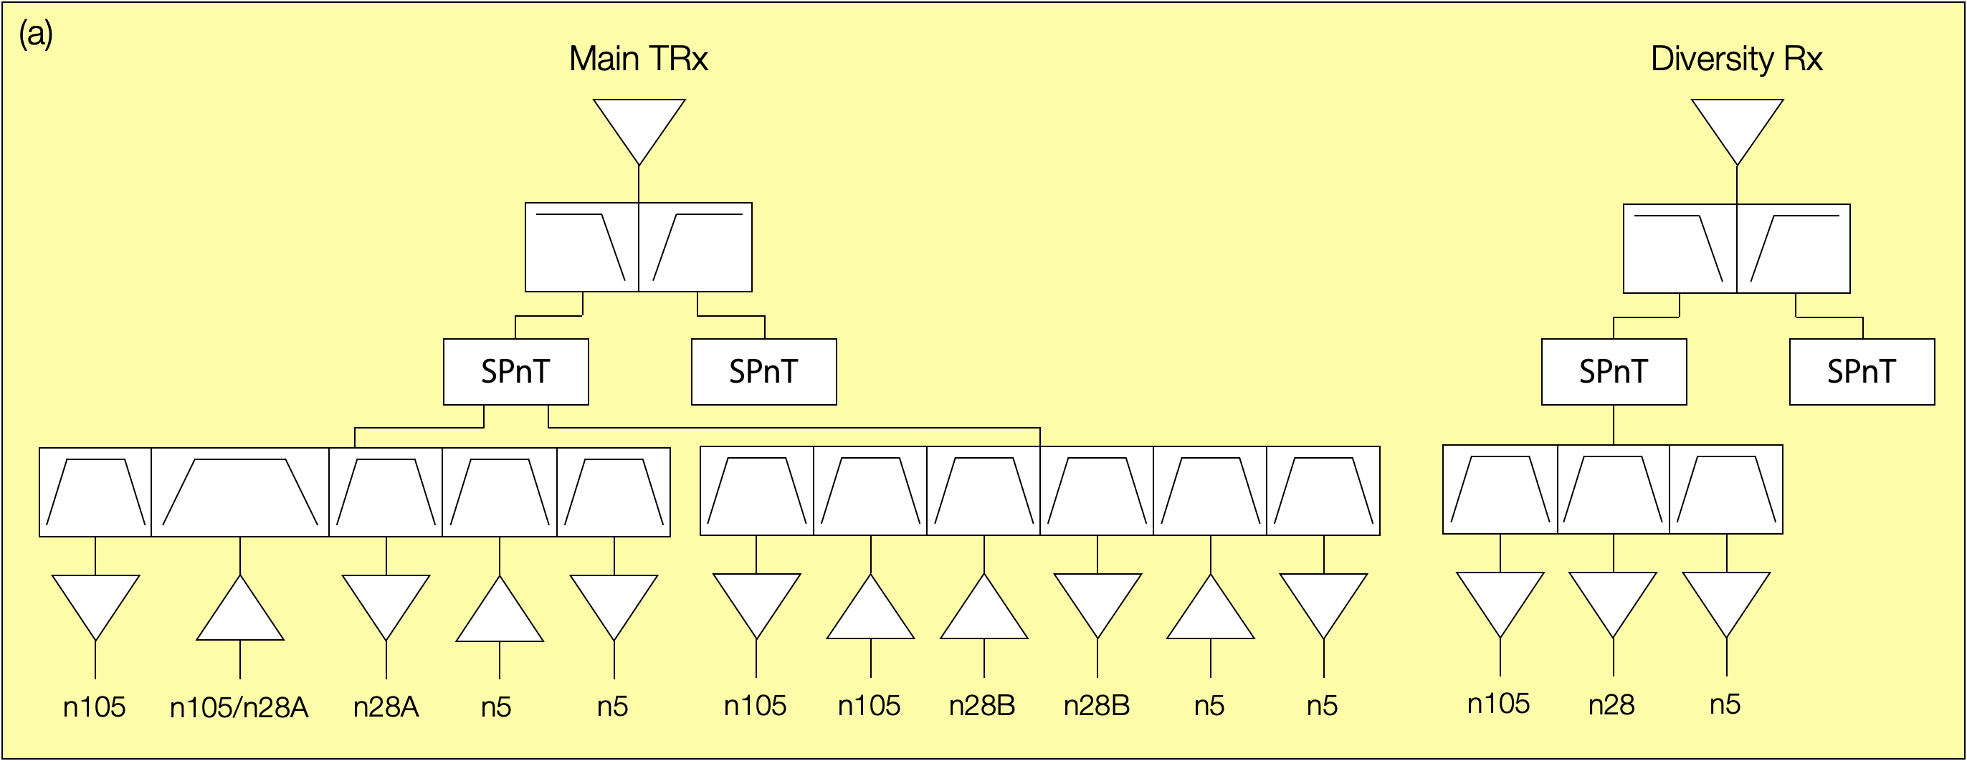
Figure 5.7.1.2-1 two-antenna RF architecture (a) for CA_n5-n28-n105
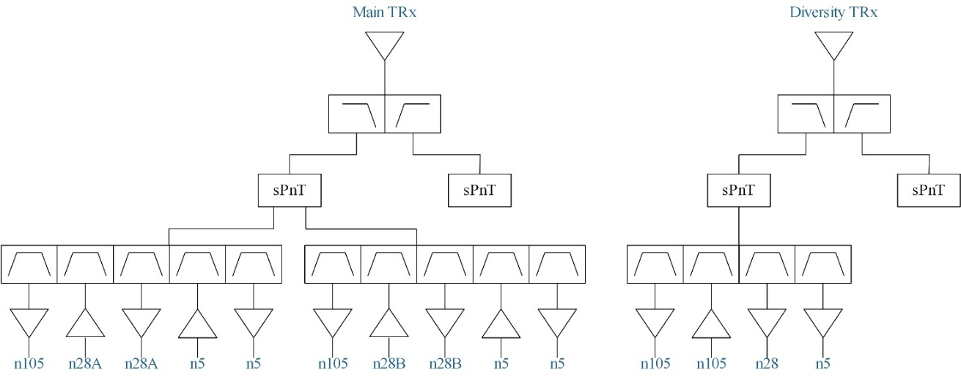
Figure 5.7.1.2-2 two-antenna RF architecture (b) for CA_n5-n28-n105

Figure 5.7.1.2-3 two-antenna RF architecture (c) for CA_n5-n28-n105
The antenna relative bandwidth ratio for two-antenna RF architecture (a), (b) and (c) is shown below.

Table 5.7.1.2-1: the antenna relative bandwidth ratio for two-antenna RF architecture (a), (b) and (c)
Antenna | The covered frequency range | Relative bandwidth ratio
Main TRx antenna | 612~894MHz | 37%
Diverstiy TRx antenna | 612~894MHz | 37%

For two-antenna UE RF architecture, although only two low band antennas are kept due to the compact size of smartphone, UE has to face the difficulties of wide bandwidth low-band antenna and complex multiplexer. Specifically,
1) For CA_n5A-n28A-n105A with 2-antenna implementation, the pentaplexer and hexaplexer with 5 and 6 closely spaced frequency ranges could be relatively challenging for filter implementation with acceptable insertion loss and isolation.
2) For CA_n5A-n28A-n105A with 2-antenna implementation, both main and diversity antennas need to cover the entire spectrum range of 282 MHz simultaneously, which is equivalent to a 37.5% bandwidth ratio and that would far exceed the bandwidth ratio for a typical planar antenna design in a smartphone. As a result, the radiative performance for the combination likely would be highly compromised.
In addition, the other difficulties can be observed, e.g.
- Uses the lower the entire band n28
- Need the two most critical low bands n28 and n105 in terms on BW and duplex gap
- No gap between n105 and n28
- No option for co-banding
- n5 very close to n28 (even more if implemented with a band 26 filter)

5.7.1.3 UE RF architecture with three antennas
For three-antenna RF architecture, three types (a) (b) and (c) are provided below for CA_n5-n28-n105.
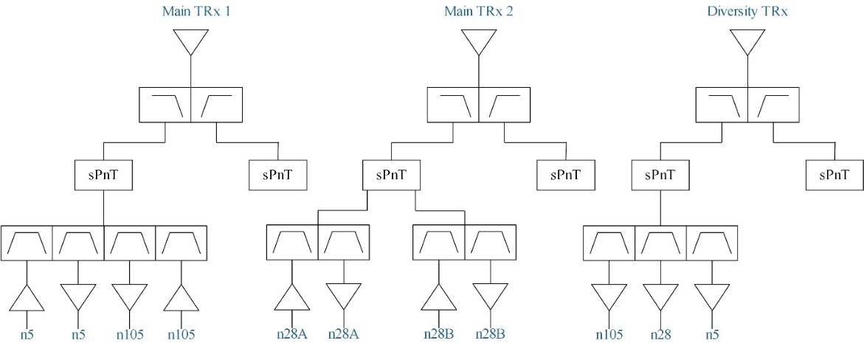
Figure 5.7.1.3-1 three-antenna RF architecture (a) for CA_n5-n28-n105
For a three-antenna RF architecture in Figure 5.7.1.3-1, the UE has also to implement a quadplexer (n5UL/n5DL/n105DL/n105UL). In addition, wide bandwidth antenna is another challenge for this type of UE RF architecture to cover frequency range from 612MHz to 894MHz. The antenna relative bandwidth ratio for three-antenna RF architecture (a) is shown Table 5.7.1.3-1.

Table 5.7.1.3-1 the antenna relative bandwidth ratio for three-antenna RF architecture (a)
Antenna | The covered frequency range | Relative bandwidth ratio
Main TRx antenna 1 | 612~894MHz | 37%
Main TRx antenna 2 | 703~803MHz | 13%
Diverstiy TRx antenna | 612~894MHz | 37%

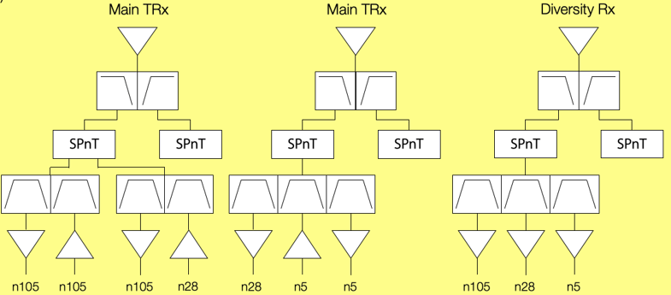
Figure 5.7.1.3-2 three-antenna RF architecture (b) for CA_n5-n28-n105
The three-antenna RF architecture (b) is shown in Figure 5.7.1.3-2. The antenna relative bandwidth ratio for three-antenna RF architecture (b) is shown in 5.7.1.3-2.

Table 5.7.1.3-2 the antenna relative bandwidth ratio for three-antenna RF architecture (b)
Antenna | The covered frequency range | Relative bandwidth ratio
Main TRx antenna 1 | 612~748MHz (UL band n28 is active)  612~703MHz (band n105 is active) | 20%  13.8%
Main TRx antenna 2 | 758~894MHz | 16.5%
Diverstiy TRx antenna | 612~894MHz | 37%

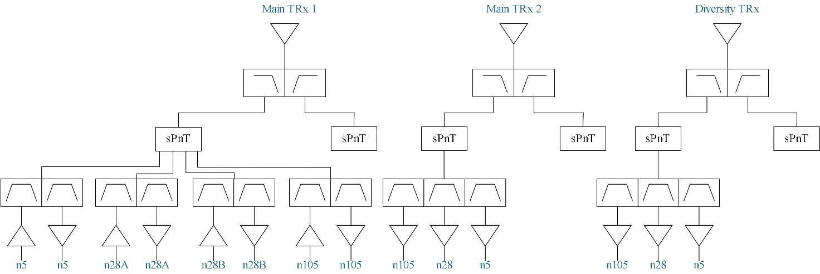
Figure 5.7.1.3-3 three-antenna RF architecture (c) for CA_n5-n28-n105
For three-antenna RF architecture Fig 5.7.1.3-3, only single UL is supported for CA_n5-n28-n105. Two Rx filter groups are considered and the antenna efficiency can be compromised for pure Rx wide bandwidth antenna. This kind of implementation can be achieved more easily to reuse the existing components as soon as possible. The antenna relative bandwidth ratio for three-antenna RF architecture (c) is shown in table 5.7.1.3-3.

Table 5.7.1.3-3 the antenna relative bandwidth ratio for three-antenna RF architecture (c)
Antenna | The covered frequency range | Relative bandwidth ratio
Main TRx antenna 1 | 824~894MHz (band n5 is active)  703~803MHz (band n28 is active)  612~703MHz (band n105 is active) | 8%  13%  13.8%
Main TRx antenna 2 | 612~894MHz | 37%
Diverstiy TRx antenna | 612~894MHz | 37%

Figure 5.7.1.3-4 three-antenna RF architecture (d) for CA_n5-n28-n105
The three-antenna RF architecture (d) is shown in Figure 5.7.1.3-4. The antenna relative bandwidth ratio for three-antenna RF architecture (d) is shown in 5.7.1.3-4.

Table 5.7.1.3-4 the antenna relative bandwidth ratio for three-antenna RF architecture (b)
Antenna | The covered frequency range | Relative bandwidth ratio
Main TRx antenna 1 | 612~849MHz | 32.4%
Main TRx antenna 2 | 663~894MHz | 29.7%
Diverstiy TRx antenna | 612~894MHz | 37%

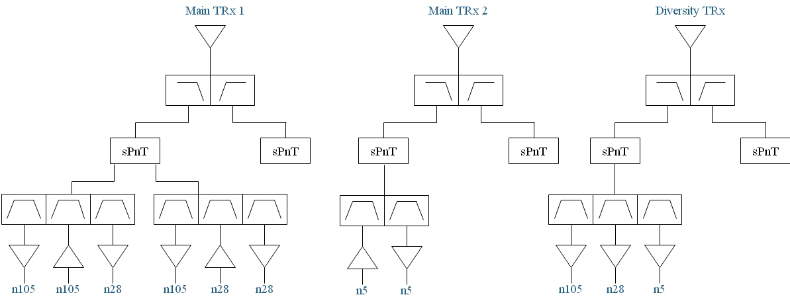
Figure 5.7.1.3-5 three-antenna RF architecture (e) for CA_n5-n28-n105
The three-antenna RF architecture (e) is shown in Figure 5.7.1.3-5. The antenna relative bandwidth ratio for three-antenna RF architecture (e) is shown in 5.7.1.3-5. On concept level, this is basically building on top of CA_n28-n105, by adding one new antenna (n5 Duplexer) and n5 DRX into n28-n105 DX antenna.

Table 5.7.1.3-5 the antenna relative bandwidth ratio for three-antenna RF architecture (b)
Antenna | The covered frequency range | Relative bandwidth ratio
Main TRx antenna 1 | 612~803MHz | 27%
Main TRx antenna 2 | 824~894MHz | 8.1%
Diverstiy TRx antenna | 612~894MHz | 37%

For three-antenna UE RF architecture, one more low-band antenna can help ease the design of wide bandwidth antenna and avoid to implement the most complicated multiplexer comparing to two-antenna UE RF architecture. For CA_n5A-n28A-n105A with 3-antenna implementation under architecture variant (b), the main TRx front-end design is eased by leveraging the non-concurrent UL transmission configuration between n28 and n105.

5.7.1.4 UE RF architecture with four antennas
UE RF architecture with four antennas for CA_n5-n28-n105 is shown below.
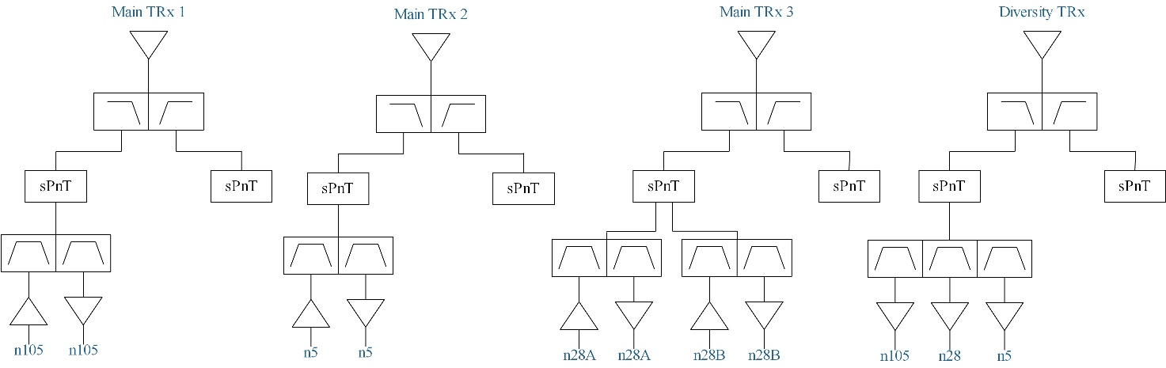
Figure 5.7.1.4-1 four-antenna RF architecture for CA_n5-n28-n105
The antenna relative bandwidth ratio for four-antenna RF architecture is shown below.

Table 5.7.1.4-1: the antenna relative bandwidth ratio for two-antenna RF architecture
Antenna | The covered frequency range | Relative bandwidth ratio
Main TRx antenna 1 | 612~703MHz (band n105 is active) | 13.8%
Main TRx antenna 2 | 824~894MHz (band n5 is active) | 8%
Main TRx antenna 3 | 703~803MHz (band n28 is active) | 13%
Diverstiy TRx antenna | 612~894MHz | 37%

For four-antenna UE RF architecture, even if UE can avoid implementing wide bandwidth low-band antenna and complex multiplexer, UE pays the price of space and antenna performance. Four-antenna RF architecture will not be used to specify the requirement for this band combination.

5.7.2 Operating bands for CA
Table 5.7.2-1: CA band combination of band n5+n28+n105
NR Band | Uplink (UL) band |  |  | Downlink (DL) band |  |  | Duplex  mode
NR Band | BS receive / UE transmit |  |  | BS transmit / UE receive |  |  | Duplex  mode
NR Band | F_{UL_low} – F_{UL_high} |  |  | F_{DL_low} – F_{DL_high} |  |  | Duplex  mode
n5 | 824 MHz | – | 849 MHz | 869 MHz | – | 894 MHz | FDD
n28 | 703 MHz | – | 748 MHz | 758 MHz | – | 803 MHz | FDD
n105 | 612 MHz | – | 652 MHz | 663 MHz | – | 703 MHz | FDD

5.7.3 Channel bandwidths per operating band for CA
Table 5.7.3-1: Supported bandwidths per CA band combination of band n8+n20+n28
NR CA configuration | Uplink CA configuration or single uplink carrier | NR Band | Channel bandwidth (MHz) | Bandwidth combination set
CA_n5A-n28A-n105A | CA_n5A-n105A  CA_n5A-n28A | n5 | 5, 10, 15, 20 | 0
CA_n5A-n28A-n105A | CA_n5A-n105A  CA_n5A-n28A | n28 | 5, 10, 15, 20, 25, 30 | 0
CA_n5A-n28A-n105A | CA_n5A-n105A  CA_n5A-n28A | n105 | 5, 10, 15, 20, 25, 30, 35 | 0

5.7.4 ∆T_{IB,c} and ∆R_{IB,c} values
For CA_n5-n28-n105, the ∆T_{IB,c} and ∆R_{IB,c} values are derived from the existing CA_n5-n28 and CA_n28-n105. The following ∆T_{IB,c} and ∆R_{IB,c} values for CA_n5-n28-n105 can be further considered referring to the contribution [15].
Table 5.7.4-1:ΔT_{IB,c} and ΔR_{IB,c} for CA_n5-n28-n105
Inter-band CA Configuration | NR Band | ΔT_{IB,c} [dB] | ΔR_{IB,c} [dB]
CA_n5A-n28A-n105A | n5 | 0.7 | 0.2
CA_n5A-n28A-n105A | n28 | Max(0.7, the value from CA_n28-n105) | Max(0.2, the value from CA_n28-n105)
CA_n5A-n28A-n105A | n105 | the value from CA_n28-n105 | the value from CA_n28-n105

Referring to the contribution [16], the following ∆T_{IB,c} and ∆R_{IB,c} values in table 5.7.4-2 were proposed after considering the factors:
- Co-banding of n5 with n26
- The critical design of the band n105, n28 and n26 duplexers to be further multiplexed in a LBLBLB configuration
- A two-antenna architecture in the future
- Potential split approach for band n28
- Existing Delta T and Delta R from 2 band fallbacks
Table 5.7.4-1:ΔT_{IB,c} and ΔR_{IB,c} for CA_n5-n28-n105
Inter-band CA  combination | ΔT_{IB,c} for NR bands (dB) |  |  | ΔR_{IB,c} for NR bands (dB)
Inter-band CA  combination | Component band in order of bands in configuration⁹
CA_ n5-n28-n105 | 0.7 | 1.1 | 1.1 | 0.5 | 0.7 | 0.7

5.7.5 UE co-existence studies for UL inter-band CA
Table 5.7.5-1 lists Band n5 + Band n105 2UL bands CA 2nd, 3rd, 4th and 5th order IMD for the UE-to-UE coexistence analysis, which may fall into the Rx receiver of DL band n28.
Table 5.7.5-1: UL CA_n5-n105 IMD product
UE UL carriers | fx_low | fx_high | fy_low | fy_high
UL frequency (MHz) | 663 | 703 | 824 | 849
2nd order IMD products | |fy_low – fx_high| | |fy_high – fx_low| | |fy_low + fx_low| | |fy_high + fx_high|
IMD frequency limits (MHz) | 121 | 186 | 1487 | 1552
Two-tone 3rd order IMD products | |2*fx_low – fy_high| | |2*fx_high – fy_low| | |2*fy_low – fx_high| | |2*fy_high – fx_low|
IMD frequency limits (MHz) | 477 | 582 | 945 | 1035
Two-tone 3rd order IMD products | |2*fx_low + fy_low| | |2*fx_high + fy_high| | |2*fy_low + fx_low| | |2*fy_high + fx_high|
IMD frequency limits (MHz) | 2150 | 2255 | 2311 | 2401
Two-tone 4th order IMD products | |3*fx_low –1* fy_high| | |3*fx_high – 1*fy_low| | |3*fy_low – 1*fx_high| | |3*fy_high – 1*fx_low|
IMD frequency limits (MHz) | 1140 | 1285 | 1769 | 1884
Two-tone 4th order IMD products | |3*fx_low +1* fy_low| | |3*fx_high + 1*fy_high| | |3*fy_low + 1*fx_low| | |3*fy_high + 1*fx_high|
IMD frequency limits (MHz) | 2813 | 2958 | 3135 | 3250
Two-tone 4th order IMD products | |2*fx_low –2* fy_high| | |2*fx_high –2* fy_low| | |2*fx_low +2* fy_low| | |2*fx_high +2* fy_high|
IMD frequency limits (MHz) | 372 | 242 | 2974 | 3104
Two-tone 5th order IMD products | |fx_low – 4*fy_high| | |fx_high – 4*fy_low| | |fy_low – 4*fx_high| | |fy_high – 4*fx_low|
IMD frequency limits (MHz) | 2733 | 2593 | 1988 | 1803
Two-tone 5th order IMD products | |2*fx_low - 3*fy_high| | |2*fx_high - 3*fy_low| | |2*fy_low - 3*fx_high| | |2*fy_high -3*fx_low|
IMD frequency limits (MHz) | 1221 | 1066 | 461 | 291
Two-tone 5th order IMD products | |fx_low + 4*fy_low| | |fx_high + 4*fy_high| | |fy_low + 4*fx_low| | |fy_high + 4*fx_high|
IMD frequency limits (MHz) | 3959 | 4099 | 3476 | 3661
Two-tone 5th order IMD products | |2*fx_low + 3*fy_low| | |2*fx_high + 3*fy_high| | |2*fy_low + 3*fx_low| | |2*fy_high + 3*fx_high|
IMD frequency limits (MHz) | 3798 | 3953 | 3637 | 3807

Table 5.7.5-2 lists Band n5 + Band n28 2UL bands CA 2nd, 3rd, 4th and 5th order IMD for the UE-to-UE coexistence analysis, which may fall into the Rx receiver of DL band n105.
Table 5.7.5-2: UL CA_n5-n28 IMD product
UE UL carriers | fx_low | fx_high | fy_low | fy_high
UL frequency (MHz) | 703 | 748 | 824 | 849
2nd order IMD products | |fy_low – fx_high| | |fy_high – fx_low| | |fy_low + fx_low| | |fy_high + fx_high|
IMD frequency limits (MHz) | 76 | 146 | 1527 | 1597
Two-tone 3rd order IMD products | |2*fx_low – fy_high| | |2*fx_high – fy_low| | |2*fy_low – fx_high| | |2*fy_high – fx_low|
IMD frequency limits (MHz) | 557 | 672 | 900 | 995
Two-tone 3rd order IMD products | |2*fx_low + fy_low| | |2*fx_high + fy_high| | |2*fy_low + fx_low| | |2*fy_high + fx_high|
IMD frequency limits (MHz) | 2230 | 2345 | 2351 | 2446
Two-tone 4th order IMD products | |3*fx_low –1* fy_high| | |3*fx_high – 1*fy_low| | |3*fy_low – 1*fx_high| | |3*fy_high – 1*fx_low|
IMD frequency limits (MHz) | 1260 | 1420 | 1724 | 1844
Two-tone 4th order IMD products | |3*fx_low +1* fy_low| | |3*fx_high + 1*fy_high| | |3*fy_low + 1*fx_low| | |3*fy_high + 1*fx_high|
IMD frequency limits (MHz) | 2933 | 3093 | 3175 | 3295
Two-tone 4th order IMD products | |2*fx_low –2* fy_high| | |2*fx_high –2* fy_low| | |2*fx_low +2* fy_low| | |2*fx_high +2* fy_high|
IMD frequency limits (MHz) | 292 | 152 | 3054 | 3194
Two-tone 5th order IMD products | |fx_low – 4*fy_high| | |fx_high – 4*fy_low| | |fy_low – 4*fx_high| | |fy_high – 4*fx_low|
IMD frequency limits (MHz) | 2693 | 2548 | 2168 | 1963
Two-tone 5th order IMD products | |2*fx_low - 3*fy_high| | |2*fx_high - 3*fy_low| | |2*fy_low - 3*fx_high| | |2*fy_high -3*fx_low|
IMD frequency limits (MHz) | 1141 | 976 | 596 | 411
Two-tone 5th order IMD products | |fx_low + 4*fy_low| | |fx_high + 4*fy_high| | |fy_low + 4*fx_low| | |fy_high + 4*fx_high|
IMD frequency limits (MHz) | 3999 | 4144 | 3636 | 3841
Two-tone 5th order IMD products | |2*fx_low + 3*fy_low| | |2*fx_high + 3*fy_high| | |2*fy_low + 3*fx_low| | |2*fy_high + 3*fx_high|
IMD frequency limits (MHz) | 3878 | 4043 | 3757 | 3942

There is no IMD interference which fall into Rx frequencies of third DL band n28 when CA_n5-n105 is the UL configuration.
3rd order IMD may also fall into Rx frequencies of third DL band n105 when CA_n5-n28 is the UL configuration.

5.7.6 REFSENS evaluation
For MSD due to cross band isolation, cross-band analysis done for 2-band cases are sufficient, and no new cross-band analysis are needed for 3-band case
For MSD due to IMD interference on 3rd band, the following inputs were provided.
1) The MSD test configurations were evaluated as below for band n105 MSD due to IMD3 of Tx band n5 + band n28 referring to contribution [15].
Table 5.7.6-1: REFSENS exceptions due to IMD interference for CA_n5-n28-n105Band / Channel bandwidth / N_{RB} / Duplex mode |  |  |  |  |  |  |  | Source of IMD
NR CA band combination | NR band | UL F_{c}  (MHz) | UL/DL BW  (MHz) | UL  C_{LRB} | DL F_{c} (MHz) | MSD  (dB) | Duplex mode
CA_n5-n28-n105 | n5 | 845 | 5 | 25 | 890 | N/A | FDD | N/A
 | n28 | 740 | 5 | 25 | 795 | N/A | FDD | N/A
 | n105 | 686 | 5 | 25 | 635 | 22.9 | FDD | IMD3

Generally, there are some network deployment methods to avoid the IMD product hitting the DL carrier directly. For example, if the UL carrier in band n28 is configured in 703~718MHz, no matter which UL frequency carrier in band n5 is configured, the IMD3 products will not hit the DL carrier in band n105 directly.
2) In addition, another contribution [16] proposed to derive the MSD due to IMD3 from CA_n8-n20-n28 with additional scaling factor. The scaling factor mainly consider the following reasons:
- n28 UL distance to n105 is smaller than n20 to n8
- n28 UL filter is more critical than band n20 and the lower side is more critical resulting in lower cross-band isolation
- The lower IMD3 is often higher since the PA has higher gain at lower frequencies.
It’s suggested to increase the MSD level by (6) dBs: 2dB for higher level lower IMD3 vs upper and 4dB for lower isolation compared with the MSD of CA_n8-n20-n28 as below.
Table 5.7.6-2: REFSENS exceptions due to IMD interference for CA_n5-n28-n105
Band / Channel bandwidth / N_{RB} / Duplex mode |  |  |  |  |  |  |  | Source of IMD
NR CA band combination | NR band | UL F_{c}  (MHz) | UL/DL BW  (MHz) | UL  C_{LRB} | DL F_{c} (MHz) | MSD  (dB) | Duplex mode
CA_n5-n28-n105 | n5 | 826.5 | 5 | 25 | 871.5 | N/A | FDD | N/A
 | n28 | 738.0 | 5 | 25 | 793 | N/A | FDD | N/A
 | n105 | N/A | 5 | 25 | 649.5 | 30.3 | FDD | IMD3

Annex A:
Change history
Change history
Date | Meeting | TDoc | CR | Rev | Cat | Subject/Comment | New version
2022-10 | RAN4#104be | R4-2217712 |  |  |  | TR skeleton | 0.1.0
2022-10 | RAN4#104be | R4-2217713 |  |  |  | TP and discussion on CA_n5-n28 | 0.2.0
2022-10 | RAN4#104be | R4-2217714 |  |  |  | TP and discussion on CA_n8-n20-n28 | 0.2.0
2022-10 | RAN4#104be | R4-2217715 |  |  |  | TP and discussion on CA_n5-n8 | 0.2.0
2022-11 | RAN4#105 | R4-2220504 |  |  |  | TP for TR 38.872 on CA_n5-n8 architectures | 0.3.0
2022-11 | RAN4#105 | R4-2220505 |  |  |  | TP on CA_n5-n28 | 0.3.0
2022-11 | RAN4#105 | R4-2220506 |  |  |  | TP for TR 38.872 to capture the RF architecture assumption and IMD evaluation for CA_n8-n20-n28 | 0.3.0
2023-03 | RAN4#106 | R4-2300560 |  |  |  | TP for TR 38.872: scope and references | 0.4.0
2023-03 | RAN4#106 | R4-2303544 |  |  |  | TP for TR 38.872 to complete the open issues for CA_n5-n8 | 0.4.0
2023-03 | RAN4#106 | R4-2303545 |  |  |  | TP for TR 38.872 to complete the open issues for CA_n5-n28 | 0.4.0
2023-03 | RAN4#106 | R4-2303546 |  |  |  | TP for TR 38.872 to complete the open issues for CA_n8-n20-n28 | 0.4.0
2023-03 | RAN#99 | RP-230425 |  |  |  | Editorial update for 1.0.0 version | 1.0.0

Change history
Date | Meeting | TDoc | CR | Rev | Cat | Subject/Comment | New version
2023-03 | RAN#99 |  |  |  |  | Approved by plenary – Rel-18 spec under change control | 18.0.0
2023-06 | RAN#100 | RP-231366 | 0001 |  | B | Big CR for TR 38.872 to introduce outcomes of CA_n5-n105 CA_n28-n105 CA_n26-n28 in sub-1GHz SI | 18.1.0
2023-09 | RAN#101 | RP-232512 | 0002 | 1 | F | CR for TR 38.872 to introduce some potential RF impacts for for CA_n26-n28 | 18.2.0
2023-09 | RAN#101 | RP-232512 | 0003 | 1 | B | CR for TR 38.872 to introduce some potential RF impacts for for CA_n5-n28-n105 | 18.2.0
2023-12 | RAN#102 | RP-233368 | 0004 | 1 | B | Draft CR for capturing the output for 2UL/2DL CA_n5-n8 | 18.3.0

