H-Craft Championship

User Manual

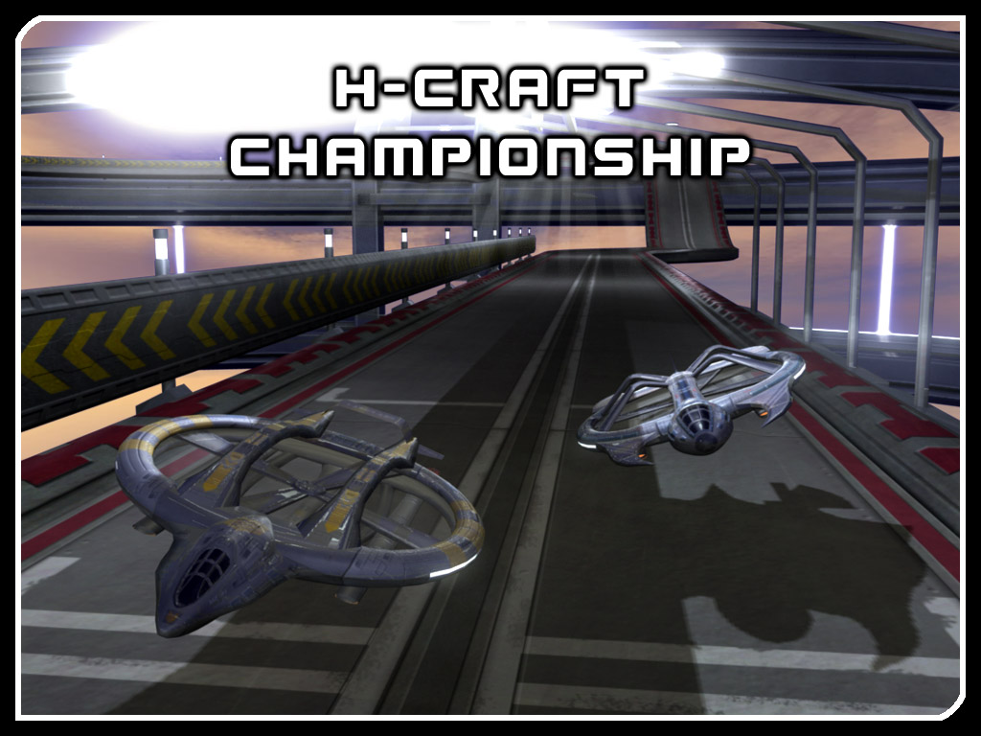

Index

Index ...page 1
Menus ...Page 2
Options ...Page 2
-Controller Setup ...Page 2
-Analog Setup ...Page 2
-Graphic Setup ...Page 3
Profiles ...Page 3
Unlocking Tracks and H-Crafts ...Page 3
Gamemodes ...Page 4
-Championship ...Page 4
-Arcade ...Page 4
-Timeattack ...Page 4
-Rivals ...Page 5
Gamedisplay ...Page 5
Select H-Craft ...Page 6
Highscores ...Page 6
Exporting Ghosts ...Page 6

-1-

Menus:

All menus can either be navigated by mouse or the arrow keys and the enter key on your keyboard.

Options:

At the Options screen you can set up your controls, adjust the volume for music and effects, and watch the credits.

Controller Setup:

Configure the controls to your taste by going to Options/Controller Setup.
The preset controls are as following:

Accelerate: Right Arrow
Brake: Down Arrow
Steer left: A
Steer right: S
Change camera: C
Pause game: P
Screenshot: F12 (can not be configured)
Show FPS: F11 (can not be configured)

Additionally you can choose to use an analog input devise such as a joypad for steering, accelerating and braking (recommended).

Analog Setup:

The analog setup (Options/Analog Setup) allows you to adjust your analog input device:

Deadzone:
The range you can move your stick or steeringwheel without taking effect.

Analog Range:
Defines the range you have to move your stick or steeeringwheel to take maximum effect.

Calibrate:
Click the calibrate button to reset your analog controller to its zero-positions.

-2-

Graphic Setup:

Screen Resolution:
Adjusts the resolution of the game. Lower settings make for a better performance. „Auto“ (preset) sets the game to use your desktop resolution.

Texture Filter:
Sets the filtering for textures. „Anisotropic“ (preset) gives you the best picture quality. „Bilinear“ and „Trilinear“ have lower quality, but speed up the game`s performance.

Antialiasing:
Adds to the picture quality, but has a high impact on the game`s performance (preset: off).

Particles:
Particles are used for many graphic features such as the H-Craft`s trails and weather effects.
Most likely the last graphic option to consider changing if you have performance issues. (preset: on)

Vsync:
Vsync gives you a more stable, steady picture, but can result in lags on low performance systems. Some graphic cards need to be set to "triple buffering" to run vsync properly.

Profiles:

Starting the game first time you will be asked to create a profile. Choose a name and click „accept“.
The profilename will be used to mark your highscores respectively the record times showing on the game screen. Ghosts (see chapter „Timeattack“) are also associated with your profile.

The configurations you do at the options screen, as well as the control setup, are saved to your profile too. This allows individual settings if two or more users want to play the game on the same system.

You can create additional profiles by choosing „Profiles“ from the mainmenu. Here you can also delete old profiles.

Unlocking Tracks and H-Crafts:

To unlock new tracks and H-Crafts you need to progress through the Championship mode. Every new track unlocked on the Championship gets available for all other game modes. New H-Crafts get available when you reach a given Level.

-3-

Gamemodes:

Championship:

The Championship is the main mode of the game. You go through three seasons with an increasing difficulty level. Not only do the tracks get constantly more challenging, your opponents get tougher as well.
Each Season is split into four quarters with a given level requirement. You need to fulfill this requirement to proceed.
You get 3 points for winning a race, 2 points for finishing second place, and 1 point for finishing third. These points are used to raise your level.

After finishing a Quarter „R-Buttons“ will show up for each single race of that quarter. You can use them to restart a single race and get a better score than on your initial try. Don't worry to lose points, worse results will be ignored.
Restarting a single race will not harm your progression in the championship. Clicking „Next Race“ will always start the most advanced race.
Your Championship progression gets automatically saved after finishing a race.

Arcade:

On the Arcade mode you can have single races fully configured to your taste. You can choose the track, the number of opponents, a difficulty level, and the number of laps.
The Trackfilter allows you to filter tracks by their difficulty. Set it to „All“ if you want to choose from all unlocked tracks. (Tracks get unlocked through progressing in the championship)

Timeattack:

The Timeattack mode is split into „Hotlap“ and „Timerace“. You can choose one of them through the „Racemode“ selector on the main Timeattack screen:

Hotlap:
You have an infinite amount of laps to set the lap record time. To quit this mode you have to pause the game and select „quit“.
Timerace:
Beat the Targettime on a track. The number of laps is set by the game and can't be changed.

The Trackfilter allows you to filter tracks by their difficulty.

You can choose to display a „Ghost“ on the track. On „Timeattack“ the ghost shows your best lap ever, on „Timerace“ it shows all laps of your best timerace. Ghosts display transparent and you can not collide with them.

-4-

Rivals:

Rivals is a competitive timerace mode for up to four players. You can choose to compete on a single race or on a series of random races. The trackfilter allows to filter which difficulty of tracks will be used. Each player can select his own profile, allowing to use individual controller setups.

Player 1 will set a first targettime and ghost for the session. Following players strive to beat the times and ghosts of their forerunners.

The player who scores the most points in all races wins the contest.

Gamedisplay:

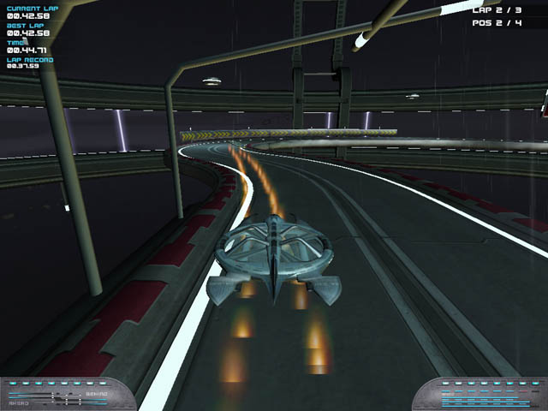

Current Lap: Shows your time on the current lap.
Best Lap: Shows the best lap you drove on the active session.
Time: Shows the total time the race is on.
Lap Record: Shows the alltime laprecord for the current track.
Trackrecord: Shows the record time for the track (Championship and Timerace only).

Lap: Shows the number of laps finished and the total number of laps.
Pos: Shows your current place in the race.
Targettime: The counter shows how much time you have left to beat the time on a timerace.

Position Indicator: Here you can see your position relatively to your opponents. White bars left from the middle indicate opponents ahead, white bars right from the middle indicate opponents behind.
Speed Indicator: Shows your current speed.

-5-

Select H-Craft:
Choose from three H-Crafts. When you begin the game two of them are locked. You have to earn Championship points to unlock them.

Highscores:

Go to Options/Highscores to see the record times for all tracks and modes.

Exporting Ghosts:

For direct competition with your friends the Timeattack modes allow you to export your Highscore Ghosts. Having a highscore set, simply click „export ghost“ on the timerace menu. The ghost is
now exported to the „ghosts“ folder in your game directory (eg. .../program files/hcraft/ghosts).
Ghosts for Hotlap and Timerace get exported separately, depending on the mode you have chosen. All exported ghosts in the ghosts folder can be selected by using the ghost on/off selector on the Timeattack menu. To make a ghost available to a friend, simply send him the exported file. As soon as he puts it into his own ghosts folder your ghost will show up for him in the game.

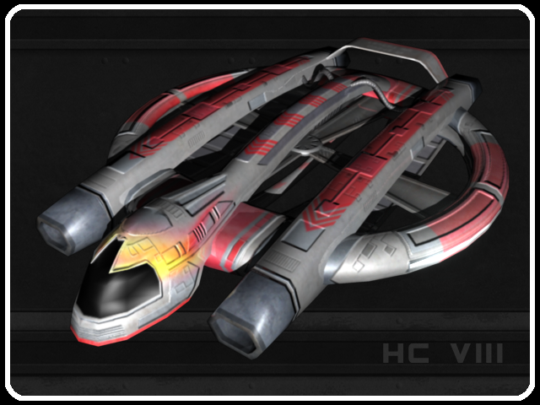

-6-

