|  |  |
| --- | --- |
| First Name: | Netra |
| Last Name: | Dahal |
| Student Number: | 9636138 |
| Supervisor: | Manoj Shrestha |

# **Abstract**

Main problem creates in house owner and tenants seem to grow due to the lack of communication, late rent payment, lack of water and some damage part of house (Like broken windows, non-functional electricity etc..) becomes a reason to break lease. All problem of both tenants and house owner solved only basic idea that is communication. House rental management system offers the solution by contribution the capacity to share issues between tenants and house owner. This web system is designed and developed to support both tenants and house owner by allowing both to document and repair communication issues, send auto rent date reminder and emergency information. This system also helps the tenants with making payment and house owner also track tenants’ issues post by tenants. Most important part of house owner are effectively resolving the issues to reduced exchange tenants continuously. This system also helps to rental stability by helping of initiating and documentation of communications and create a creative relationship with house owner.

# **Keywords**

Some keywords are data visualisation, data base design, graphics design etc..

Contents

**Abstract** 1

**Keywords** 1

**Introduction** 3

**Background** 3

**Problem of Statement** 3

**Aims** 4

**Objectives** 4

**Literature Review** 5

**Scope and Technical Challenges** 5

**Methodology** 6

**Fact Finding Techniques** 6

**System Development and Methodology** 6

**Waterfall Model** 6

**Tools and Technology** 7

**Deliverables** 8

**Timing** 8

**Project Plan** 8

**Conclusion** 9

**Appendices** 9

**SWOT Analysis** 9

**Use Case Diagram** 10

Figure 1waterfall model 7

Figure 2 Gantt Chart 8

Figure 3 SWOT Analysis 10

Figure 4 Use Case Diagram 11

# **Introduction**

Now a day one application support millions or billions of users at a one time and control as well as handle large volume of data. Database is a system which is control large amount of data at a one time. Database are mainly two types i.e. relational database (SQL) and Non-relational database (NoSQL). Relational database model has most complicated when control and handle of large amount of data. So, control of this limitation to the development of non-relational database. In this thesis, we are comparing the both SQL and NoSQL database. In the final which database is suitable for development of house rental management.

House is a essential parts of human being. So, Analysis of this importance to proposed of house rental system which is an essential factor in current or modern society. Hence, this thesis provides brief knowledge of background study of rental system, problem statement, project scope, objectives, project risk, justification and total budget and time.

## **Background**

A house is an essential and residence-place used as a permanent or semi-permanent residence for a human being. We charge a room in our house that is always existing for short term occupancy by paying customers. Home is a one of the must need of human being. If any people who have no home may stay through paying rent for other people who have more houses or more room in one house. In our environment there are many rented house and renter. All renter has different type of behaviour that show different character on rented people. Some renter has shown bad behaviour and some people show positive relationship on house owner or other tenants’ people. Renting system of home may contain advantage and disadvantage.

Some advantage of home renting system is:

* Lower housing costs for tenants.
* Income sources for house owner.
* Short term commitment
* No minimal repair costs and maintenance

Some disadvantage of house rental system is:

* No tax incentives
* No fixed room/housing costs
* Interior design may contain only owner concept.

## **Problem of Statement**

Kathmandu city does not have online house rental management system for who wants to rent home gets a lot of worry to find room or home even the home is available. If we are finding out the home or room in a rent but there is no proper communication in between home owner and tenant. Some problem found in the current system are:

* Owner records tenant’s data in paper
* Lack of database to store tenant’s data.
* No communication between owner and tenants
* Not a proper payment system.
* Lack of computer-based system.
* In manual process there is data security problem
* Not a proper documentation of owner and tenants so some time misunderstanding.

Minimize of above problem we try to developed house rental management system. After development of this system we consider owner and tenants have good communication, easy payment system and solved in another house problem.

# **Aims**

Main aim of this thesis is “Comparative analysis between SQL and NoSQL database and using appropriate database to create house rental management system”.

# **Objectives**

* To create House Rental system that allow to view tenants and owner send notification
* Prepared responsive an online home rental system.
* To develop a system that allows owner can delate, view, update, create tenants.
* To research, study and analyse current system and add some requirement to create a responsive House rental system
* Research about some existing system.
* To develop software documentation such as design documentation, research document etc...

# **Literature Review**

Thesis written by someone to consider the main points of current knowledge added substantive search as well as academic and working contribution to a particular topic are called as literature review. Main goals of literature reviews are known as situate the current study within the body of works and provides framework for the specific reader.

A variety of published and unpublished literatures produced by various government and non-government organizations and agencies were reviewed during the study period. Some of the major categories of the reviewed works were as follow;

According to Aquino (2005), important of computer are application are growths day to day. In the current times of the time winning organization are those which are ready to integrate business strategy and CIT results for them to be able to development of software efficient, reliable and secure. In a Nepal many places include computerize system such as school management system, hotel management system, rental system etc.

## **Scope and Technical Challenges**

The scope of this thesis defined the representation of the work that is required in handover the house rental management system. Some scope of work are given below during the create of this project

* Research, analysis, understand the thesis requirement
* Develop all type of system document which is necessary for software requirement such as design documentation, analysis documentation, planning documentation etc….

# **Methodology**

The method and process accepted by showing a research study are known as methodology. Methodology describe how data collect, describe suitable tools for collecting data, system architecture, system process, system output/input data, development tools. Also useful for how data collect from the user of the system. Some data collection technique given below

## **Fact Finding Techniques**

* Objectives: It will utilize this strategy to gather data about how the present framework works and its procedures. This includes deliberately watching and recording the conduct and qualities of activities and procedures. It gives progressively point by point and setting related data and can adjust to occasion as they happen anyway the technique might be tedious.
* Questionnaires: I will set up various surveys whereby I will submit them to house owner to get a more profound knowledge of how the system is getting down to business. I favour this strategy since it gives more data from different people and offers more prominent adaptability as the chance to rebuild questions. This procedure is favoured in light of the fact that it will give a closer contact between the clients and the engineer subsequently scattering the likelihood of the finished framework being rejected by user.
* Secondary Data Collection: in this method we are collected data from existing system such as books, internet, web etc... that system collected data from another researcher or analyst was done. It is from that data that I will then compare with the primary data and make a decision and conclusion.

## **System Development and Methodology**

The technique that is used to show how the proposed system will be developed is called system development methodology. In this thesis research, waterfall methodology model:

### **Waterfall Model**

It is a type of project management methodology which is based on sequential design process. In this model, one phase must be complete before the next phase. Water model has mainly 6 phases such as requirement analysis, design, implementation, verification, deployments and maintenance.

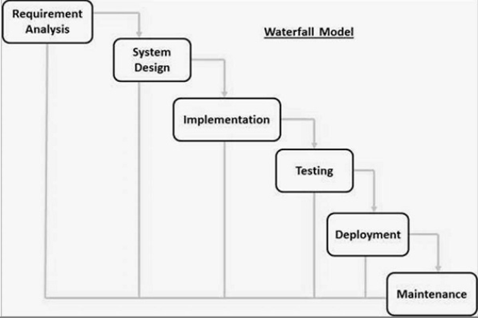

Figure 1waterfall model

# **Tools and Technology**

The flowing tools were used during the design phase of this project

* XAMPP
* Operating System
* Bootstrap/CSS
* HTML
* jQuery/Ajax
* JavaScript
* Nodejs
* Mongo dB (NoSQL)
* Microsoft Project
* Microsoft word (For documentation)
* Microsoft SQL
* Visual Studio Code, PhpMyAdmin

# **Deliverables**

Complete software system which is able to development in a user used is known as deliverables. After completion of software engineering we are include following documents

* Software proposed, condition and its description
* Software design documentation
* Software development process
* Develop documentation for software engineering.

# **Timing**

## **Project Plan**

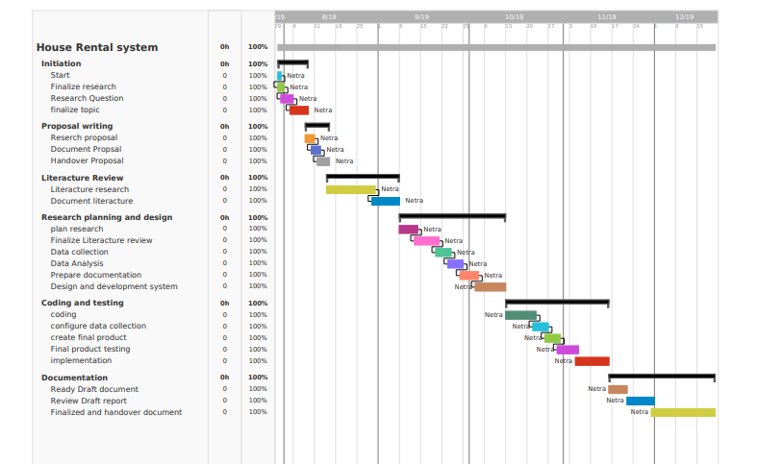

Figure 2 Gantt Chart

# **Conclusion**

In conclusion, according to literature review there are many benefits that increase from a smart house rental system. For example, there will be no duplication of records, sharing of information is made possible, reduces missing and misplaced records and also sort and sort any time. In order to continually improve the quality reliable system, Nepal need to put in place a smart house system backup with Suitable database (SQL or NoSQL) replacing all existing paper based rental system.

# **Bibliography**

Ambrose, P. and Barlow, J. (1987), Housing Provision and House Building in Western Europe: Increasing Expenditure, Declining Output, Housing Markets and Policies under Fiscal Austerity, London, Greenwood Press.

Erguden, S. (2001), Low cost housing policies and constraints in developing countries, International conference on spatial development for sustainable development, Nairobi.

Macoloo, G. (1994), The changing nature of financing low income urban housing development in Kenya, Housing Studies, vol. 9, Issue 2, pages 189-281.

Levin, K. (1999), Database Management Systems: How to use Relational Databases, vol. 2, no 4.

# **Appendices**

## **SWOT Analysis**

A SWOT analysis evaluates the internal strengths and weaknesses and the external opportunities and threats in an any type of research/ project. The internal analysis is used to identify, resources, capabilities, core competencies, environment etc... The external analysis identifies market opportunities and threats by looking at competitor’s resources, environment. SWOT analysis of smart rental system are given below

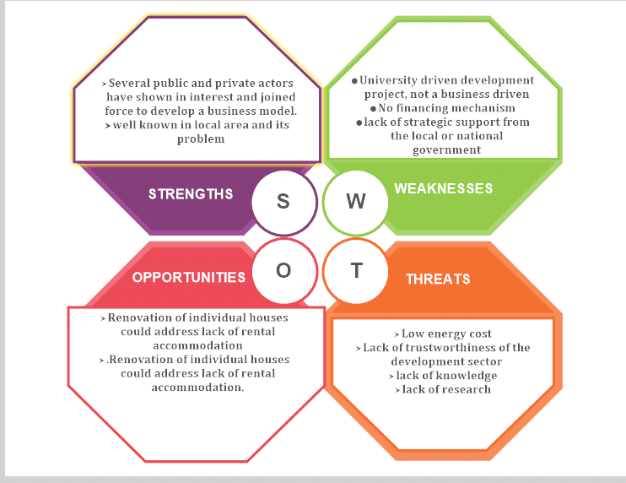

Figure 3 SWOT Analysis

## **Use Case Diagram**

It is a graphical representative diagram of the interconnection between the fundamentals of a proposed system. This system are used in a system analysis to determine, organize and summarize system requirement. In this methodology specific roles played by actors within or around the system. Use case diagram of house rental system are shown in below:

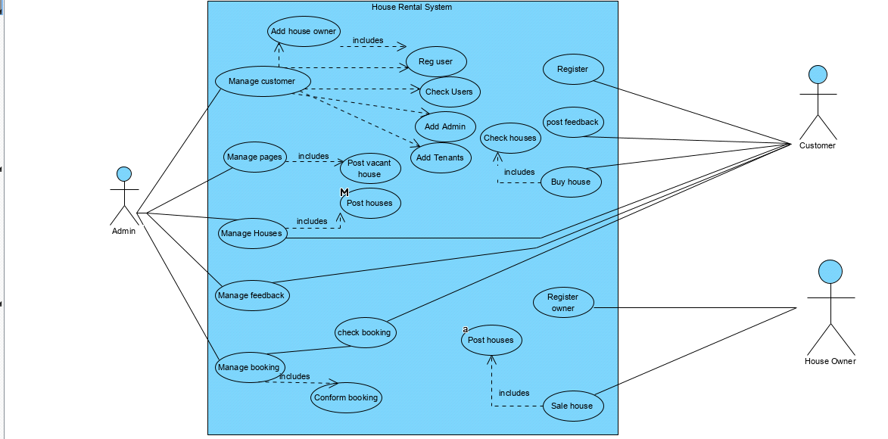

Figure 4 Use Case Diagram