System Security-Theoretic
Process Analysis
SSTPA
A methodology for asset protection and security
assurance in engineered systems
TECHNICAL WHITE PAPER
Version 17 | 4 October 2026

1 Abstract
System Security-Theoretic Process Analysis (SSTPA) is a human- and asset-centered systems security engineering methodology for specifying, evaluating, and sustaining protection of assets in complex engineered systems. It applies systems-theoretic reasoning to system behavior, control, feedback, and interactions, then connects the results to security requirements and evidence supporting acceptance decisions. Its objective is to preserve required security properties across the relevant environments, operating states, and transitions of the system lifecycle.
SSTPA uses a specific definition of Loss. A Loss is the effort an attacker needs to expend to violate one Assurance on one asset in one environment, modeled as an attack tree. The root specifies the violation; the branches explain the feasible attack strategies and their required effort and preconditions. This use of Loss expresses resistance to compromise, analogous in purpose to cryptographic work factor. It is distinct from STPA loss, which denotes an unacceptable stakeholder outcome [1, Chapter 2, “Identifying losses,” p. 16]. SSTPA retains stakeholder consequences as the basis for protection priorities and residual-risk decisions.
The methodology establishes a system model, analyzes use cases, functional and control behavior, states and environments, develops constraints and requirements, examines attacks and asset exposure, and evaluates Loss. It organizes verification and validation evidence into assurance cases expressed using Goal Structuring Notation (GSN). Asset identification and valuation are external inputs. Analysis is iterative and recursive across system tiers, with reassessment during integration and sustainment. Conclusions apply to the documented configuration, analysis scope, assumptions, and evidence; they do not establish universal resistance to every possible attack.

2 Introduction to SSTPA
Engineering security requires understanding how a system achieves its purpose and how its behavior can violate the protection needs of stakeholders. Correctly functioning elements can interact in ways that undermine security. A timely command in one operating mode may be hazardous in another; accurate feedback may arrive too late; authority granted during maintenance may persist into operation. Security analysis therefore addresses the behavior of the composed system as well as the properties of its elements [1].
SSTPA organizes protection around three connected concepts: the asset that has value, the criticality that relates system behavior to stakeholder consequences under a governing regime, and the Assurance that states a required protection property. These concepts establish the purpose and scope of analysis before controls or attack strategies are selected. The asset-protection perspective is consistent with NIST SP 800-160, Volume 1, Revision 1, Engineering Trustworthy Secure Systems, Sections 3.4 and 3.7 [2].
SSTPA is human centered because people establish value, specify acceptable behavior, evaluate evidence, and accept or reject residual risk under applicable regimes. It is asset centered because requirements and assurance claims are traced to the protection of identified assets. Its analysis follows assets through relevant functions, interfaces, states, and environments rather than assuming that protection follows automatically from a component label or catalog of controls.
The following subsections explain why SSTPA is needed, what it is for, and how it fits with other engineering activities. They then describe how assets and their protection needs are identified, how criticality is applied in the system model, and how each supported Assurance is defined and assessed. For every selected Assurance, the analyst specifies a violation criterion, applicable conditions, and evidence expectations. Criticality informs the consequences and rigor of protection; it does not replace an Assurance or its criterion. Capitalized Assurance identifies SSTPA's protection objective, while conventional assurance denotes justified confidence, as explained further in Section 3.8.
SSTPA supports the engineering of a security solution from concept through disposal. It can inform safety and mission assurance where asset protection and stakeholder consequences overlap, while retaining the analytical obligations of those disciplines. Its claimed contribution is the integration of established analysis and assurance practices within a common method. Adoption of its terminology or information model does not itself demonstrate effectiveness; project evidence and review establish whether the resulting security solution is adequate.

2.1 Why SSTPA
The systems-theoretic premise that security risks can arise from interactions as well as individual weaknesses has direct operational relevance. On 1 May 2026, cyber defense agencies from Australia, the United States, Canada, New Zealand, and the United Kingdom jointly issued Careful Adoption of Agentic AI Services. Their guidance describes agentic systems as interconnected arrangements of models, people, guardrails, data, tools, and hardware, whose combined behavior requires analysis across the architecture [3].
“Agentic AI systems are complex ecosystems of LLMs, humans, guardrails, datasets, tools and hardware, where security risks often emerge from interactions between components rather than isolated flaws. Traditional component-level analysis is insufficient and monitoring these systems is equally challenging due to blurred thresholds for decision-making, long reasoning chains and massive, often redundant logs. Localised logging methods rarely provide full visibility, making system-theoretic approaches essential for understanding and mitigating risks across the entire architecture.” [3, “Leverage system-theoretic approaches to analyse security”; emphasis added].
The advisory’s section “Leverage system-theoretic approaches to analyse security” explains why component checks and localized logs can miss risks produced by long reasoning chains, uncertain decision boundaries, and interacting components. It recommends system-theoretic approaches, explicitly including STPA and STPA-Sec for identifying security issues and informing mitigations, and CAST for investigating incidents. This is a joint recommendation by six authoring agencies from five countries [3].
SSTPA applies that general rationale through control structures, information flows, and asset exposure defined for particular system states and environments. It connects the resulting findings to countermeasures, security requirements, and verification and validation criteria. Its purpose is to make the reasoning about interactions usable throughout engineering and acceptance.

2.2 What SSTPA is for
SSTPA addresses a practical coordination gap between developing the functional capabilities that stakeholders fund and procure and assembling the evidence that an acceptance authority needs to judge residual risk. Systems engineering includes security responsibilities, but treating security only as late catalog conformance or a final documentation event can leave inadequate evidence and increase rework. SSTPA treats security as an engineered control problem: analysis follows assets and their protection needs, threats inform scenarios, Loss analysis evaluates resistance, and residual-vulnerability dispositions are supported by GSN assurance arguments as a product of the analysis [2, Ch. 1, “Engineering-Driven Solutions,” p. 6] [4, §3.6, pp. 69–75] [5, §§0:2–0:4, pp. 10–11].
The methodology adapts established systems security engineering practices: the STPA and STPA-Sec lineage [1, Ch. 1, p. 12] [6, §4]; Engineering Trustworthy Secure Systems, NIST SP 800-160, Volume 1, Revision 1 (2022) [2, §3.10, pp. 29–31]; Security and Privacy Controls for Information Systems and Organizations, NIST SP 800-53, Revision 5 (2020) [7]; and the Risk Management Framework in NIST SP 800-37, Revision 2 (2018) [4, Ch. 3]. It also draws on security categorization under CNSSI 1253 for national security systems, as identified in NIST’s “Security Categorization” glossary entry [8], or FIPS PUB 199 (2004), Standards for Security Categorization of Federal Information and Information Systems, where applicable [9]. Its assurance-case references are the Goal Structuring Notation Community Standard, Version 3 (SCSC-141C, May 2021) [5, Parts 0–1], and ISO/IEC/IEEE 15026-2:2022, Systems and software engineering — Systems and software assurance — Part 2: Assurance case, second edition [10]. SSTPA brings these contributions into a connected MBSE practice implemented on a graph database [11, “Introduction”].
Top-down capability decomposition applies whether a subsystem is developed internally or assigned to a supplier through a system specification and Statement of Work (SoW). The same analytical rigor applies at each tier: allocated protection needs, interfaces, assumptions, requirements, and evidence must be reconciled with the parent system as the design is refined and integrated [12].

2.3 What SSTPA is not for
SSTPA is not the primary method for developing functional capability. Enterprise engineering environments remain responsible for the program’s functional models, analyses, and configuration baselines. The following division of labor identifies the information SSTPA uses and the security work it adds; the program determines which repositories are authoritative.
Requirements configuration management covers the functional and contractual baseline in IBM Engineering Requirements Management DOORS or an equivalent requirements environment. SSTPA derives System Security Requirements and maintains their relationships to that baseline, the protected assets, and the verification evidence. Security requirements and approved changes remain subject to the program’s configuration-management responsibilities [13].
Functions, interfaces, components, use cases, and architectural trade studies are established in Dassault Systèmes’ Cameo Systems Modeler, another SysML MBSE environment, or the program’s selected architecture tool. SSTPA faithfully represents the approved architecture for its security analysis. Narrative descriptions can support critical-function and critical-component analysis where they state the relevant behavior precisely enough; required sequencing, timing, and control conditions remain explicit [14, 15].
Parametric models, algorithms, and performance analyses remain in MathWorks MATLAB or an equivalent specialist environment. They inform SSTPA functional-flow and protection analyses when resource limits, timing, numerical behavior, or algorithmic properties affect a security conclusion [16].
Asset identification remains an expert activity outside SSTPA. It includes assets with cross-program protection obligations, such as designated Critical Program Information, and assets valued for the local system’s purpose, such as critical enabling intellectual property. Flight-critical Vehicle Management System software and hardware may fall in either group according to the governing context. An Organic asset can also carry horizontal protection obligations; Horizontal asset classification depends on its value outside the local system of interest. Once stakeholders approve the assets and their protection needs, SSTPA records the applicable regimes and Assurances, which drive the subsequent security workflow. If analysis reveals another asset, the finding returns to the responsible identification process.
Within the agreed configuration-management arrangement, the SSTPA model is the working source of truth for the System Security Solution: the connected account of assets, regimes, Assurances, hazards, controls, attack and Loss analysis, requirements, and assurance evidence. It uses the authoritative enterprise inputs and returns proposed changes for engineering resolution. Its security focus complements the program’s functional, contractual, and performance responsibilities.

2.4 Asset
An asset is an item of value for which stakeholders establish protection needs and the consequences of compromise. NIST SP 800-160, Volume 1, Revision 1, Section 3.4, “The Concept of Assets,” recognizes both tangible and intangible assets [2, p. 16]. SSTPA makes those protection needs concrete by identifying what the system holds, transports, uses, or delivers and which Assurances must be preserved. Typical examples include executable software, firmware, hardware, data, credentials, intellectual property, and services. Thus, physical tangibility is not a necessary condition: a cryptographic key or an algorithm can be valuable even though its storage medium is replaceable. The asset is distinguished from the system elements that hold, transport, or use it, so that protection follows the valued item across architectural and operational changes.
Stakeholders and the applicable regime determine what merits protection. Customer objectives, mission needs, legislation, contractual commitments, certification obligations, and organizational policy provide the basis for identifying assets and assigning protection responsibilities. These decisions require domain knowledge and authority that a model cannot supply. Formal asset identification, valuation, and approval therefore remain outside SSTPA. The methodology receives the approved decisions, records their engineering implications, and supplies analysis that may reveal omissions or changed assumptions. A newly discovered dependency or exposure produces a candidate asset or a proposed revision for stakeholder review; it does not silently enlarge the approved asset baseline.
An asset description begins with a stable identity, a meaningful name, and sufficient explanation to distinguish its scope from similar items. Provenance and model-data ownership make the record accountable and maintainable. Version 7 of the SSTPA Tool Software Requirements Specification provides common identification, description, creator, owner, and change-tracking metadata, together with asset-specific classification, criticality descriptions and levels, and selected Assurance properties [17, §§3.3.9–3.3.9.1, 3.3.10.11]. Model-data ownership identifies responsibility for the record; the analyst must also establish the stakeholder or authority responsible for the actual protection decision. Governing regimes, source decisions, violation criteria, and supporting evidence complete the analysis context through the model and its referenced documentation. These associated decisions are not all direct properties of an Asset record.
The specified asset classifications describe why an item matters in the current system of interest. An Organic asset matters to that system in its own right. A Horizontal asset is carried or supported because it matters outside that system, even where it contributes no value to the local purpose. A Derived asset matters because of its relationship to a parent asset; its protection rationale must preserve that dependency. These are SSTPA modeling conventions specified in the Version 7 SRS Asset definition [17, §3.3.10.11]. They help expose cases in which a locally expendable item still carries a binding external obligation. They do not, by themselves, determine a statutory information category, establish a DoD CPI designation, or prove that the required protection has been achieved.
Critical Program Information (CPI) is one important asset category in U.S. Department of Defense acquisition. DoDI 5200.39, incorporating Change 3 (2020), defines CPI around U.S. capability elements that provide warfighters with a technical advantage and whose compromise would undermine U.S. military preeminence. Examples include software algorithms and particular hardware in operational, training, or maintenance equipment [18, Glossary, Part II, “CPI,” p. 11]. This is a specific policy designation, not a synonym for all valuable information or all critical system elements. SSTPA can represent designated CPI as an asset and carry its approved protection needs into the system analysis.
CPI identification and critical function or critical component analysis answer related but different questions. CPI concerns preserving a technological advantage against compromise. DoDI 5200.44 (16 February 2024) addresses protection of mission-critical functions and the information and communications technology components that implement or protect them, including components that can introduce vulnerabilities into those functions. Its criticality analysis decomposes missions into functions and traces those functions to implementing hardware, software, and firmware [19, Glossary, “critical component” and “criticality analysis,” p. 18]. A component can be critical to mission performance without containing designated CPI. Conversely, protection of a CPI asset can remain necessary in equipment that is not indispensable to the receiving system's immediate mission.
SSTPA supports the engineering contribution to asset identification by using this functional and architectural reasoning to expose candidates for review. Starting with the agreed purpose and use cases, analysts trace required functions to the components, interfaces, data, and services on which their behavior depends. They examine the effect of unavailable, altered, falsely represented, or otherwise compromised inputs and resources. This can reveal an overlooked calibration dataset, a shared timing source, or a credential whose compromise defeats an approved protection objective. The resulting trace and rationale give stakeholders a reviewable basis for confirming an asset, selecting its Assurances, or revising its criticality. This supporting analysis complements the externally governed identification and approval process.
The SSTPA asset concept also covers flight-critical software and hardware, as well as personal information, whether or not those items meet the DoD CPI criteria. Personally identifiable information (PII) is a principal example. NIST SP 800-122, Guide to Protecting the Confidentiality of Personally Identifiable Information (PII), Section 2.1, includes information that identifies or traces an individual and information linked or linkable to that individual, with contextual impact assessment addressed in Section 3.2 [20]. For example, a personnel record may require confidentiality and privacy, while an aircraft control-software image may require integrity, authenticity, and availability. Selection depends on the approved use and consequences of violation. The Privacy Assurance and its explicitly broader SSTPA interpretation are addressed in Section 2.6.
Horizontal protection addresses obligations that continue across program or system boundaries. DoDI 5200.39, paragraph 3.c, calls for equivalent CPI protections across programs, assessed against exposure, consequences of compromise, and threats; its definition includes consistent protection of similar CPI and inherited CPI [18, Glossary, Part II, “horizontal protection,” p. 11]. SSTPA applies the underlying protection principle more broadly: an asset protected in one system may require equivalent protection when transferred to, hosted by, or used in another. The receiving system must establish the applicable objective and acceptance basis. Equivalence concerns justified protection under the receiving conditions; it does not require copying a mechanism whose assumptions no longer hold.
For example, moving a protected software image from a development repository to embedded equipment changes access paths, operating states, and recovery options. The receiving analysis preserves the approved asset identity and protection obligation while examining those changed conditions. Asset traces connect that obligation to the relevant functions, interfaces, and components. The resulting protection requirements and evidence remain traceable to the asset and its selected Assurances. Each subsequent SSTPA Loss analysis concerns the attacker effort required to violate one Assurance on that asset in one environment. Criticality explains why the violation matters; Loss characterizes the resistance to achieving it.

2.5 Criticality
In SSTPA, criticality is a system property expressing the importance of required behavior and the consequences of its failure or compromise under an applicable regime. It directs attention to the behavior, dependencies, and protection obligations whose loss would matter most. NIST IR 8179, Criticality Analysis Process Model: Prioritizing Systems and Components (2018), similarly prioritizes systems and components according to their contribution to organizational goals and the effects of inadequate operation or loss [21, Abstract, p. ii]. SSTPA records that significance on assets and relevant entities in the system model so that engineering obligations can be traced through the architecture. Criticality is distinct from an Assurance, which identifies a property to preserve, and from SSTPA Loss, which measures attacker effort.
The model supports mission, safety, flight, and security criticality. These properties can coexist: one controller may support mission completion, prevent hazardous behavior, maintain safe flight, and enforce asset protection. Each designation must retain its governing regime, rationale, applicable design guidance, and interpretation of any assigned level. A level has meaning within its defined scale; the same numeral under another regime need not represent the same consequence or rigor. Criticality analysis therefore preserves the separate obligations and examines their interactions, including cases where a measure that improves one objective impairs another.
Mission Critical identifies required capability essential to mission success or continuation; NASA-STD-8739.8B, Software Assurance and Software Safety Standard, Section 3.2, provides this mission-capability basis [22, p. 14]. Safety Critical identifies behavior that can cause or contribute to serious harm, or whose correct performance controls an identified hazard [22, §3.2, p. 16]. The same standard’s Section 4.2 explicitly includes software hazard contributors, controls, and mitigations [22, p. 20], illustrating why protective functions can be as critical as the functions that create danger. SSTPA applies these concepts at system level under the actual mission and safety regimes; NASA's software-specific requirements do not automatically become universal requirements for every SSTPA application.
Flight Critical identifies behavior essential to safe flight and landing under the applicable airworthiness regime. FAA AC 25.1309-1B, System Design and Analysis (2024), Section 6.2, bases functional hazard assessment on failure conditions and their effects [23]; it does not establish one universal Flight Critical category. SSTPA uses the designation to retain the applicable airworthiness obligations while analyzing control actions, feedback, shared resources, and dependencies. Security Critical identifies behavior essential to enforcing required asset protection or preventing unacceptable security consequences. Its analysis identifies enforcement functions, trust relationships, and supporting dependencies, informed by the Domain Separation and Minimal Trusted Elements principles in NIST SP 800-160, Volume 1, Revision 1 [2, §§E.12, E.20].
Application to model entities follows the asset's actual relationships. The Version 7 SSTPA Tools SRS provides criticality flags, levels, and descriptions on assets [17, §3.3.10.11]. For components, system functions, and interfaces, it derives criticality and selected Assurance properties from current, state-scoped relationships identifying assets held, transported, or used. Connections receive corresponding properties through their participating interfaces. Where several assets contribute, the specified computation retains their applicable criticality dimensions and the maximum numeric level within each dimension [17, §3.3.4.6.2]. This propagation supports finding shared responsibilities and relevant boundaries; it requires compatible level conventions and does not establish an engineering severity classification merely by calculation.
Each criticality needs an explicitly examined boundary through the functions, interfaces, resources, and external dependencies necessary to satisfy its obligations. Those boundaries may overlap without being identical. In a flight controller, for example, a software-update interface may participate in a security boundary and also affect the flight-critical behavior enabled after startup. The model helps analysts inspect that intersection, allocate constraints and requirements, and identify the evidence needed to justify separation or controlled interaction. A criticality label does not enforce a boundary. Implemented controls, verified requirements, and validation of the resulting system behavior establish whether the protection is effective under the stated conditions.

2.6 Assurances and their protection criteria
Capitalized Assurance is SSTPA's model term for a required security property or protection objective on an asset. Conventional assurance concerns justified confidence that a claim is satisfied, supported by argument and evidence [2, Appendix B, assurance and assurance case entries, p. 50; 24, opening definition]. The seven supported Assurances distinguish established security meanings from SSTPA extensions. Each selected Assurance identifies the asset, applicable environment and states, protection obligation, violation criterion, and evidence expectations. A label alone is insufficient. Where deliberate compromise is analyzed, Loss remains the attacker effort needed to violate one Assurance on one asset in one environment, modeled as an attack tree. Consequence severity and confidence in the assessment remain separate considerations. The following examples illustrate how to make these objectives assessable; they do not prescribe identical controls for every asset.

2.6.1 Confidentiality
Confidentiality protects information against access or disclosure that violates applicable authorization rules. FIPS 200 defines confidentiality in terms of authorized restrictions on information access and disclosure [25, Appendix A, p. 6], and NIST SP 800-57 Part 1, Revision 5 describes encryption as one means of supporting it [26, §3.1, p. 22]. Confidentiality matters because disclosure of credentials, personal information, intellectual property, or mission plans can cause harm even when the information remains unchanged.
In SSTPA, define the protected information, permitted recipients and uses, release conditions, and duration of the protection obligation. Follow the asset through messages, copies, logs, temporary storage, backups, and disposal. A confidentiality claim covering an encrypted link also needs to address exposure before encryption, after decryption, and through access to keys. For example, a maintenance log containing a credential can create a disclosure route distinct from interception of the protected communication. The Loss tree evaluates feasible strategies against the stated disclosure criterion; encryption strength alone does not characterize every strategy.

2.6.2 Integrity
Integrity protects an asset against unauthorized alteration or destruction. This definition uses the narrower data-integrity meaning in NIST SP 800-57 Part 1, Revision 5, which includes insertion, deletion, and substitution [26, §3.2, p. 22]. FIPS 200 uses a broader integrity definition that also encompasses authenticity and non-repudiation [25, Appendix A, p. 7]. SSTPA distinguishes those objectives so that the analyst can state precisely what is being protected. Integrity does not establish that the original content was correct, its source was genuine, or its use was authorized.
Specify permitted transformations, responsible authorities, the accepted baseline, and conditions for detecting and responding to unauthorized changes. Examine storage, transfer, processing, update, and recovery, including the interval between a successful check and use of the checked asset. A verified boot image that can be modified before execution does not satisfy the intended protection. Cryptographic checking can detect modification under its assumptions; the system must also enforce an appropriate response. Verification therefore examines both the checking mechanism and the behavior that prevents unacceptable use.

2.6.3 Availability
Availability concerns timely, reliable access to and use of information or a service by authorized entities. NIST SP 800-160, Volume 1, Revision 1 defines availability in terms of accessibility and usability on demand by an authorized entity [2, Appendix B, p. 50]; NIST's CSRC Glossary indexes this same definition [27, Definitions, SP 800-160v1r1 entry]. The objective matters because protection has little operational value if legitimate users cannot obtain the needed function within its required time.
An SSTPA availability criterion identifies the authorized user or function, demand conditions, response bounds, permitted interruption, and recovery expectations. Analysis follows the complete service dependency chain, including resources, communications, supporting authorities, and state transitions. A running component is insufficient evidence if an unavailable authorization service blocks the function. Protective controls also receive scrutiny when lockout, inspection, or recovery behavior can obstruct legitimate operation. Distinguish a required safe shutdown from an unacceptable denial of service using the stated operating conditions. Attacker-induced denial supports Loss analysis; accidental outages retain their separate engineering evaluation.

2.6.4 Authenticity
Authenticity concerns genuine identity or claimed origin. NIST SP 800-38D defines data authenticity by its purported source [28, §4.1, p. 3]; FIPS 186-5 describes digital signatures as mechanisms supporting origin authentication and integrity [29, §2.1, digital signature entry, p. 3]. Integrity asks whether an asset has undergone an unauthorized change; authenticity asks whether its identity or provenance is genuine. Neither alone establishes semantic correctness or authority to use the asset. Freshness is also distinct: successful authentication does not inherently prevent replay [28, Appendix D, p. 30].
For deployed assets, SSTPA deliberately extends this meaning to include the creator's intent to deploy the asset for its stated use and the promises associated with the creator's testing and validation processes. This is an SSTPA interpretation, not an additional property proved by signature mathematics. Possession of a private signing key or verification of a signature does not establish that those commitments were fulfilled. Their upstream verification is outside SSTPA's scope; identified assumptions or accepted evidence enter the analysis with their source, applicability, and limitations recorded. SSTPA then examines preservation of authenticity during receipt, storage, selection, update, and execution, including substitution, replay, and mismatch between the accepted release and the operating configuration.

2.6.5 Non-repudiation
Non-repudiation supports resolution of a disputed claim that an identified entity performed a specified action. NIST SP 800-53, Revision 5, control AU-10, covers actions such as creating, sending, receiving, or approving information [7, AU-10, p. 76]; FIPS 186-5 explains how a signature can supply evidence to a third party [29, Announcement §7, p. ii]. This objective matters when accountability must remain supportable after the event.
In SSTPA, identify the action, actor or represented authority, evidence required, retention period, and conditions for evaluating that evidence. Analyze identity binding, signing-key control, timestamps where relevant, record integrity, custody, and later retrievability. A signed message does not itself demonstrate delivery, and signature verification does not automatically establish personal intent. NIST SP 800-57 Part 1, Revision 5 distinguishes cryptographic support from the wider determination of non-repudiation [26, §3.5, p. 23]. Consequently, evidence of origin, dispatch, receipt, and approval should support their respective claims. The analyst evaluates whether an attacker can defeat the defined accountability objective by exploiting gaps in this chain.

2.6.6 Trustworthy
SSTPA uses Trustworthy as an Assurance requiring justified confidence, supported by evidence, that an asset satisfies specified behavior under stated conditions. NIST SP 800-160, Volume 1, Revision 1 distinguishes the decision to trust from demonstrated trustworthiness [2, §2.3, pp. 10–11] and describes assurance cases that support specific claims through argument, evidence, and explicit assumptions [2, §4.3, pp. 35–36]. Authentic origin and unchanged contents are relevant evidence but do not establish that behavior is suitable or sufficiently protected.
The analyst identifies the applicable requirements, configuration, environment, assumptions, and evidence sufficient for the claim. Behavioral analysis, verification, validation, and supported attacker-effort assessments contribute to the argument. Contrary evidence and uncertainty remain visible; a favorable label cannot replace them. When Trustworthy is used in Loss analysis, the violation criterion identifies concrete attacker-induced defeat of the asset's specified behavior. Inadequate evidence is an assurance finding, not an attack with an invented effort value. Changes to configuration, dependencies, or operating conditions require reconsideration of the judgment and its supporting case.

2.6.7 Privacy
Privacy addresses effects of information processing on individuals. NISTIR 8062 explains that privacy problems can result from authorized processing as well as unauthorized access, so confidentiality alone cannot establish appropriate collection, use, retention, or disclosure [30, §§2.1–2.2, pp. 6–10]. SSTPA records the affected asset, processing context, applicable obligations, and explicit adverse outcome. Relevant individual rights and obligations remain visible even when access controls operate correctly.
SSTPA extends Privacy to protecting sensitive system characteristics and activities through operations security (OPSEC). This is a stated modeling extension, not a redefinition of individual privacy. OPSEC protects critical information and observable indicators from adversarial exploitation. Its importance to U.S. national security is reflected in DoDD 5205.02E, which requires OPSEC across DoD missions, functions, programs, and activities [31, §4 and ¶4.a, p. 1]. OPSEC examines how observations, including unclassified information, can be combined to reveal capabilities or intentions [31, Enclosure 2, ¶11.j–k, p. 7; 32, The OPSEC Cycle, p. 13]; its analysis connects critical information, threats, vulnerabilities, risk, and countermeasures [32, The OPSEC Cycle, p. 13].
For a system-level Privacy objective, specify what disclosure or inference would violate protection and under which observation conditions. A trace may reveal that maintenance activity and communication patterns jointly disclose readiness even where message contents remain protected. OPSEC supplies the analytical process supporting this Privacy objective. Deliberate disclosure or inference can support a scoped Loss tree; privacy harm from otherwise authorized processing also needs evaluation without assigning a fictional attacker effort.

3 Foundations and scope
Building on the purpose and protection concepts introduced in Section 2, this section develops SSTPA's systems-theoretic foundation and custom Loss measure. It distinguishes SSTPA from STPA and STPA-Sec, relates the methodology to systems engineering and MBSE, and defines its scope and terminology.

3.1 Systems Theory and STPA
System-Theoretic Process Analysis (STPA), developed at MIT by Nancy Leveson and John Thomas, builds on the System-Theoretic Accident Model and Processes (STAMP), as explained in their STPA Handbook (March 2018). Its founding insight is that losses in complex systems cannot be explained solely by component failures: accidents can also arise from unsafe interactions among components that have not failed. STPA therefore casts safety in systems-theoretic terms [1, Ch. 1, pp. 4, 10–12; Ch. 2, pp. 22–25, 34–35]:
• System behavior emerges from interactions among components and with the environment.
• Safety depends on enforcing constraints on that behavior.
• Control structures use control actions, feedback, and the process models held by controllers to enforce those constraints.
• Inadequate enforcement can permit unacceptable outcomes, including when control actions are missing, inappropriate, mistimed, applied for an unsuitable duration, or improperly coordinated.
Process analysis examines these dynamic control and feedback processes over time: how decision and control structures perform the mission, and how they adapt or fail to adapt. In “Systems Thinking for Safety and Security” (ACSAC 2013), Young and Leveson extend this thinking to security by shifting attention from threats alone to vulnerable system states and the system structures that permit a threat to cause harm. This emphasis on the conditions the system can control is a point of departure for SSTPA [6, §4, pp. 3–6].

3.2 What SSTPA Changes
System Security-Theoretic Process Analysis (SSTPA) carries this systems-theoretic viewpoint into an asset-centered, multi-regime security engineering workflow. It analyzes how adversarially influenced, degraded, or improperly controlled interactions and information flows undermine asset protection, violate security constraints, or compromise mission objectives. STPA itself can address security and other stakeholder concerns; SSTPA makes the asset, Assurance, environment, and regime explicit organizing dimensions of the analysis. The same asset may carry different Assurances and acceptance obligations under different regimes [1, Ch. 2, p. 14] [6, §4, pp. 3–6].
The pivotal change in terminology concerns Loss. In STPA, a loss is an unacceptable stakeholder outcome. SSTPA uses capitalized Loss as a technical performance measure: the effort an attacker must expend to violate one Assurance on one asset in one environment. It models that effort with an attack tree rooted at the specified violation. Alternative strategies and required combinations of subgoals identify the actions, preconditions, and effort needed for compromise. A tree is acyclic; an implementation that shares subgoals can use a directed acyclic graph with explicit treatment of those shared dependencies [1, 33, 34].
SSTPA is tailored to acceptance settings in which a responsible authority evaluates the vulnerabilities remaining after protection is applied [4, §3.6, Tasks R-2–R-4, pp. 71–74]. It records an accepted residual vulnerability as an Allowed Residual Vulnerability (ARV), with the associated risk, conditions, and authority decision made explicit. Closure requires a documented disposition for every identified finding: some strategies are eliminated or blocked, some residual vulnerabilities are accepted, and others remain unresolved. The intention is an inspectable acceptance decision, rather than an unsupported assertion that the system is invulnerable.

3.3 Systems theory and control
Systems theory considers a system as an interacting whole. Emergent properties depend on the organization and behavior of its parts, their relationships, and their environment. Decomposition remains useful for engineering, but separate evaluations of parts cannot establish every property of the assembled system. SSTPA consequently analyzes interactions both within a system of interest and across its boundaries [1, Ch. 1, “System Theory,” pp. 10–11].
STAMP, the System-Theoretic Accident Model and Processes, provides the causality foundation for STPA. It explains losses in terms of inadequate enforcement of constraints on system behavior, including cases where no component has failed. A control structure represents controllers, controlled processes, control actions, and feedback. Controllers use process models representing their understanding of relevant conditions. Incorrect beliefs, missing authority, delayed feedback, or conflicting actions can prevent constraints from being enforced [1, Ch. 1, “What is STAMP?”, p. 12; Ch. 2, pp. 22–25].
Control includes technical mechanisms and human or organizational decisions. A security architecture can therefore involve an authorization service, an operator, a maintenance organization, and an acceptance authority, each with different responsibilities and information needs. Representing these responsibilities makes assumptions about coordination and evidence visible. Dynamic analysis examines their behavior over time; an executable simulation is useful where warranted but is not a prerequisite for STPA [1, Ch. 2, “A control structure is not an executable model,” pp. 25–26].

3.4 SSTPA in relation to STPA and STPA Sec
STPA is a general method for identifying hazardous conditions, unsafe control actions, and causal scenarios that can produce unacceptable stakeholder losses. Although developed in system safety, its scope includes security, privacy, mission performance, and other properties. Chapter 2 of the STPA Handbook (March 2018) explicitly applies the same control-structure and control-action analysis to these concerns. SSTPA therefore builds on a method already capable of security analysis [1, Ch. 2, p. 14 and pp. 46, 48, 50–51].
STPA-Sec applies this systems-theoretic foundation to security. In “Systems Thinking for Safety and Security” (ACSAC 2013), Young and Leveson emphasize the vulnerable system states and control relationships that permit a threat to produce a loss, rather than treating the threat alone as the explanation. This supports examination of security requirements and architectural conditions before implementation detail is complete [6, §4, pp. 3–6]. Leveson’s chapter “Safety and Security Are Two Sides of the Same Coin,” in The Coupling of Safety and Security (2020), describes an integrated safety and security analysis in which adversarial interference is included in the causal scenarios for inadequate control or execution [35, §3.4, pp. 21–26].
SSTPA organizes this reasoning within a broader asset-centered engineering workflow. It relates each asset to its Assurances, operating environments, applicable regimes, architectural exposure, requirements, and evidence. It incorporates attack analysis and a custom Loss model measuring attacker effort, then uses the results to support assurance arguments and residual-risk decisions. These are choices about the organization and integration of engineering work, rather than a replacement causality theory.
The distinction in Loss is deliberate. STPA uses loss for the unacceptable consequence being prevented. SSTPA uses capitalized Loss for the attacker effort required to violate a specified protection objective, represented through an attack tree. Consequences remain recorded separately so that effort estimates inform, rather than substitute for, judgments about acceptability. A high-effort attack can still warrant treatment where consequences are severe or the relevant attacker has sufficient resources.
STPA and STPA-Sec can also contribute requirements and evidence to an assurance case. SSTPA's differentiator is its particular combination of asset and Assurance scoping, environment-specific attack trees, exposure traceability, recursive system analysis, and documented acceptance. No claim is made that each constituent technique is unique to SSTPA.

3.5 Purpose and engineering decisions
SSTPA supports decisions about which security properties are required, where protection is allocated, which behaviors and interactions can defeat it, and what evidence supports continued operation. Analysis can lead to architecture changes, requirements, countermeasures, operating restrictions, or a decision that the proposed solution is unacceptable. A catalog of controls can inform this work, but the architecture and behavior determine how a selected control contributes to protection.
The method keeps the purpose of protection visible. Stakeholder consequences establish priorities; hazardous conditions and causal scenarios identify control needs; Loss analysis evaluates the effort needed to overcome the resulting protections. An assurance case connects these results to claims about the realized system. Responsible authorities make acceptance decisions under the applicable regime, with conditions, limitations, and review triggers recorded [4, §3.6, Tasks R-2–R-4, pp. 71–74; Appendix F, “Authorization Decision Information,” p. 147].

3.6 Relationship to systems engineering and MBSE
SSTPA is a specialty engineering contribution within the wider systems engineering lifecycle. It uses the agreed system purpose, stakeholder needs, architecture, interfaces, and configuration baseline. Security analysis can expose deficiencies in that baseline and generate changes for resolution through the program's engineering and configuration-management processes. The security view must remain synchronized with authoritative engineering information [2, §3.10, pp. 29–31] [36] [37, “Engineered System-of-Interest”].
Model-based systems engineering (MBSE) supports this coordination through related representations of the system and its engineering evidence. A functional view describes what is done; a behavioral view describes sequencing and control conditions; a structural view identifies the elements and interfaces that realize the behavior. Timing and resource constraints qualify those views. SSTPA connects them to asset protection and assurance without prescribing a particular authoring environment [15, “Functional Architecture Model,” “Behavioral Architecture Model,” and “Temporal Architecture Model”].

3.7 Scope and applicability
Asset identification, valuation, and initial protection decisions are performed by stakeholders and domain specialists outside SSTPA. Their approved results enter the methodology. SSTPA can reveal an omitted or newly created asset, in which case it returns that finding to the responsible identification process rather than silently expanding the approved scope.
The method does not replace functional design, performance engineering, configuration management, or the authority responsible for certification or authorization. Its attack-tree Loss model addresses deliberate violation of Assurances. Non-adversarial failures and environmental disturbances remain relevant to systems-theoretic analysis and assurance, but they are not assigned a fictional attacker effort. Related scenarios are evaluated alongside the Loss model. Analysis is bounded by the declared environments, lifecycle conditions, attacker capabilities, and available evidence.

3.8 Terminology and assurance vocabulary
The following definitions distinguish conventional systems engineering usage from SSTPA-specific model terms. Capitalization of Loss and Assurance identifies the custom SSTPA meanings. Other engineering terms follow their stated SEBoK, STPA, or assurance references; using a graph representation does not change those meanings.
System and system of interest. A system is a set of interacting elements organized to achieve a purpose. The system of interest is the system selected for analysis at a particular level. Its boundary defines what is included, what is treated as external, and the interfaces through which interaction occurs. A subsystem can become the system of interest for a more detailed analysis [37, “Engineered System-of-Interest” and “Applying the System Context”].
System element and architecture. An element is a constituent of a system and can itself be considered as a system at another level. Elements may include hardware, software, people, procedures, and other resources appropriate to the system boundary. Architecture describes the organizing concepts and relationships through which the system fulfills its purpose. A decomposition hierarchy is one architectural view; it does not by itself represent effective behavior or control [15, “Functional Architecture Model”] [37, “Engineered System-of-Interest” and “Applying the System Context”].
Environment and context. The environment comprises relevant entities and conditions outside the selected system boundary that affect or are affected by the system. Context includes the purpose, stakeholders, external interactions, and conditions needed to interpret the analysis. An environment can include physical conditions, operational conditions, external services, and adversarial capabilities. A threat actor is not the environment as a whole [37, “Engineered System-of-Interest”].
Function and use case. A function describes a transformation or activity the system performs [15, “Functional Architecture Model”]. A use case describes interaction between actors and the system to achieve an intended result under specified conditions. Use cases establish behavioral situations for analysis; functional flow analysis identifies dependencies, sequencing, inputs, outputs, and control needed to realize them.
State and transition. A state represents a condition of the system using variables relevant to the analysis. A transition changes that condition in response to events and guards, with associated actions and timing. An SSTPA security state groups conditions relevant to asset exposure, authority, and protection. Constant Assurance labels do not imply constant protection or constant confidence. Transitions and temporary conditions are analyzed explicitly [15, “Behavioral Architecture Model,” especially “Operational Mode”].
System-theoretic process analysis. A structured, top-down, iterative analysis of how system behavior and interactions can produce unacceptable stakeholder losses through inadequate control or execution. It identifies losses, hazardous system conditions, constraints, control structures, unsafe control actions, and causal scenarios, then uses them to inform design and operating requirements. System-theoretic means grounded in systems theory; the process being analyzed includes technical, human, and organizational behavior [1, Ch. 1, p. 12; Ch. 2, pp. 14–15].
STAMP and STPA-Sec. STAMP is the causality model underlying STPA, not a procedure synonymous with STPA. STPA-Sec is the security application or adaptation of the STPA approach, with attention to vulnerable conditions and adversarial influences on the system and its control relationships [1, Ch. 1, “What is STAMP?”, p. 12] [6, §4, pp. 3–6].
Asset and criticality. An asset is an item of value for which stakeholders establish protection needs. Its criticality expresses the significance of compromise to specified objectives under an applicable classification or regime. The analysis traces protection obligations to elements, functions, and interfaces that hold, transport, or use the asset. Allocation is justified by exposure and responsibility; identical obligations do not automatically apply to every related element.
Assurance and assurance. Capitalized Assurance is SSTPA's model term for a required security property or protection objective on an asset, such as confidentiality or integrity. An attacker violates the condition specified by that Assurance. In conventional systems engineering, assurance concerns justified confidence that claims are satisfied, supported by argument and evidence. An assurance case addresses this confidence; it is not the property being attacked [24, definition; 5, §§0:2–0:4, pp. 10–11].
Loss in SSTPA. Loss is the effort an attacker needs to expend to violate one Assurance on one asset in one environment, modeled as an attack tree. Each Loss has exactly that asset–Assurance–environment scope. The root identifies the violation, and the attack strategies establish the preconditions, resources, access, knowledge, time, or computational work required to achieve it. Within a comparable effort measure, a larger Loss value represents greater resistance to compromise. The model, its assessed effort, and the evidence supporting that assessment are maintained together.
Loss in STPA. STPA uses loss to mean an unacceptable outcome affecting something stakeholders value, such as life, mission success, property, reputation, or sensitive information [1, pp. 16–17]. This differs from SSTPA Loss in both subject and direction: greater stakeholder loss means a more adverse outcome, whereas greater SSTPA Loss effort means a harder attack under the stated assumptions. The SSTPA definition is local to this methodology and is not attributed to STPA, SEBoK, or NIST.
Security strength and attacker effort. The analogy is cryptographic security strength, which relates resistance to the amount of work needed to break protection under specified assumptions [26, §2.1, “Security strength,” p. 17; §5.6.1, pp. 52–53]. SSTPA applies effort reasoning to a wider system. Computational operations, elapsed time, financial cost, expertise, and access are distinct dimensions. A bit-strength interpretation is appropriate only where a defined computational work measure supports it. The analogy does not establish a universal conversion of system security into bits.
Stakeholder consequence and risk. A consequence is an effect of an Assurance violation on stakeholder objectives. Risk concerns potential adverse consequences and uncertainty, evaluated under the applicable decision process. SSTPA Loss characterizes attack effort; it does not by itself supply consequence severity, attack probability, or a complete risk assessment. Acceptance records preserve these distinctions [4, §3.1, Task P-14, pp. 41–42; §3.6, Tasks R-2–R-4, pp. 71–74].
Hazard, threat, and attack. In STPA, a hazard is a system state or set of conditions that leads to stakeholder loss under a particular worst-case environment [1, pp. 17–20]. SSTPA retains this system-condition meaning when identifying hazards associated with Assurance violations. A threat is a potential source or cause of adverse effects. An attack is an intentional action or strategy directed toward violation. Threats and attacks can cause or exploit hazardous conditions; they are not synonyms for hazards.
Control structure and process model. A control structure represents responsibilities and interacting control loops. A controller selects control actions using a control algorithm or decision procedure and a process model of relevant conditions. Feedback informs that model. A process model is the controller's representation, which can disagree with reality; it is distinct from the analyst's overall system model [1, Ch. 2, pp. 22–25 and 45–48].
Unsafe control action and causal scenario. An unsafe control action contributes to a hazard in a specified context, including required action that is absent or action that is mistimed. A causal scenario explains how inadequate control or execution can occur and lead to the hazardous condition. Scenarios cover malicious and non-malicious causes as relevant to scope [1, Ch. 2, pp. 34–35 and 42–51].
Constraint, security control, and countermeasure. A constraint specifies a condition or behavior necessary to prevent a hazard or protect an Assurance. A security control is a measure or prescribed practice selected to enforce protection. A countermeasure is a concrete protective feature or action applied to an identified attack or weakness. An STPA control action is an action issued by a controller and is not synonymous with a catalog security control. A measure can serve several constraints and must be evaluated in its operational context.
Requirement and allocation. A requirement states an agreed obligation on a system or element to perform a function or possess a quality under specified conditions, with criteria that permit evaluation. Allocation assigns responsibility for satisfying it to a system or element. SSTPA uses MUST for a binding security condition whose realization is developed into specific requirements, and SHALL for concrete mandatory requirements with verification criteria. These are project conventions, not universal SEBoK definitions; a MUST condition is not merely aspirational. Derivation and allocation retain the rationale and trace to protection needs [38, “Principles and Concepts,” “Requirements At Levels Within the Hierarchy,” and “Traceability”].
Verification and validation. Verification establishes whether specified requirements are satisfied. Validation establishes whether the system fulfills intended use and stakeholder needs in its intended context. Both require planned criteria and evidence; inspection, analysis, demonstration, and testing are selected as appropriate. Validation is not satisfied solely by verifying individual countermeasure requirements [39, “Definition and Purpose” and “Methods and Techniques”] [40, “Definition and Purpose” and “Verification and Validation Level per Level”].
Residual vulnerability and Allowed Residual Vulnerability. A residual vulnerability is a weakness or enabling condition remaining after selected protections are considered. SSTPA records it with the attack strategy that can exploit it and the associated effort. Allowed Residual Vulnerability (ARV) is SSTPA's disposition for a residual vulnerability whose associated risk has been accepted by the responsible authority under documented conditions. It does not mean the vulnerability has been eliminated or that every regime uses this term.
Regime and assurance case. An SSTPA regime is the applicable framework of authorities, obligations, criteria, and practices governing protection and acceptance. An assurance case is a reasoned argument, supported by evidence and stated context, that identified claims are justified. GSN provides a notation for expressing this argument. The case supports an authority's decision; its existence is not itself acceptance [24, definition] [5, §§0:2–0:4, pp. 10–11].

4 System model and graph foundation

4.1 A connected model of the system security solution
The system model joins architecture, behavior, asset protection, and engineering evidence. It records the purpose and boundary of each system of interest, the elements and interfaces that realize it, and the functions, use cases, states, and transitions that describe its behavior. Environments identify external conditions relevant to those views. A stakeholder or acceptance authority can then understand where an asset is exposed, which Assurance applies, and what protection is expected in a particular situation.
Protection views associate assets with obligations, hazards, constraints, controls, requirements, and countermeasures. Analysis views record control structures, attacks, asset traces, and Loss trees. Evidence views connect the resulting claims to verification, validation, residual-vulnerability dispositions, and assurance arguments. These are complementary views of the same subject. A state model cannot substitute for an architecture, and an attack tree cannot by itself establish correct system behavior.
The model maintains identifiers, provenance, configuration baselines, assumptions, and ownership sufficient to manage change. Reference catalogs provide reusable information, while project-specific decisions state why a referenced item applies and how it is realized. Implementation bookkeeping and database schema are outside the scope of this methodology description.

4.2 Graph database and Cypher
SSTPA Tools implements the connected model in a Neo4j property graph. Neo4j’s Getting Started article “Graph Database Concepts” describes a property graph as representing information as nodes and directed, typed relationships, with properties describing both. This supports explicit connections among engineering objects instead of requiring the analyst to reconstruct their relationships from separate document locations [11, “Introduction,” “Relationship,” and “Properties”].
Cypher is Neo4j's declarative graph query language. An analyst or application specifies a graph pattern and conditions to match, and the database finds the corresponding nodes, relationships, and paths. In SSTPA, this supports questions such as which requirements protect an asset, which evidence supports a claim, and which analyses are affected by a changed interface. Query results support review; they do not establish that the underlying engineering assertions are true [41, introduction and “How does Cypher work?”].

4.3 Hierarchy and cross system relationships
Hierarchical system data maps naturally to parent and child relationships. The same pattern can describe a system, its constituent elements, and the more detailed systems used to realize those elements. Path queries can follow successive levels without defining a separate structural representation for each depth. Cross-system relationships can simultaneously preserve shared assets, interface dependencies, and evidence links that do not fit a simple tree [11, “Traversals and paths”; 42, “Quantified path patterns”].
This is useful because system decomposition is hierarchical while security dependencies often cross the hierarchy. The graph retains both views and supports tracing a change from one level into related analyses. Query bounds, indexing, modeling decisions, and data volume affect practical performance; the graph does not imply unlimited depth or guaranteed speed [11, 42]. Cyclic behavior belongs in appropriate behavioral relationships, while decomposition and requirement derivation are managed to avoid accidental circular ownership or justification.
The graph is an information foundation, not a simulation or proof engine. Dynamic conclusions require explicit states, guards, timing, dependencies, and control semantics, with analysis or executable models where necessary. A connected database improves access to those engineering relationships but cannot supply omitted scenarios or missing evidence.
Figure 1 shows the System and its immediate related model nodes. Each box names a node, identifies its relationship to the System, and summarizes its engineering meaning. These are relationships in the system model: an Environment describes context, whereas a Component or Element is a constituent part. The drawing stops at this first level and is not a database schema. SSTPA operates on lower-level nodes as the analysis is refined; an element can become the system of interest for a further application of the methodology.
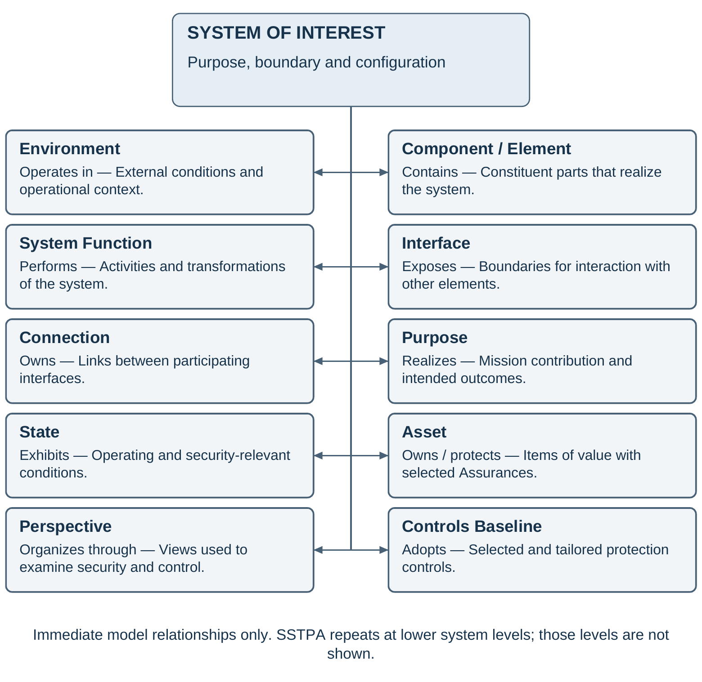
Figure 1. System of interest and its immediate model relationships

5 Methodology workflow
The workflow begins with externally established assets, stakeholder consequences, protection needs, and acceptance responsibilities. SSTPA records these inputs and establishes the system of interest and its baseline. Use case analysis explains intended interactions; functional and control analysis explains how those interactions are realized; state and environment analysis identifies the conditions under which behavior and protection change. Hazards and constraints are then refined in that context.
The analyst develops security requirements and countermeasures, examines feasible attacker behavior, and traces each asset through the functions, elements, interfaces, states, and transitions that expose it. Attack analysis and trace analysis inform each other. Their results populate the Loss attack tree for each selected asset, Assurance, and environment. Effort assessments and residual vulnerabilities are evaluated with the consequences of compromise. Verification and validation evidence then supports an assurance case and an acceptance decision.
The principal progression is:
• Receive approved asset and protection inputs from the external identification process.
• Define system purpose, boundary, architecture, and use cases.
• Analyze functions, control relationships, states, transitions, and environments.
• Identify hazardous conditions and derive constraints, controls, and requirements.
• Develop attack scenarios and trace state-dependent asset exposure.
• Construct and evaluate each scoped Loss attack tree and disposition residual vulnerabilities.
• Establish the assurance case, obtain and evaluate evidence, and support the responsible acceptance decision.
• Repeat the analysis at appropriate system tiers and maintain it through integration, operation, change, and disposal.
This sequence expresses dependencies rather than a one-pass lifecycle. Protection objectives and initial stakeholder consequences are established before threat catalogs are used to elaborate attack scenarios. Control analysis can reveal a missing environment or hazard; trace analysis can reveal an overlooked interface; an assurance argument can expose an unsupported assumption. The analyst returns to the earliest affected activity and updates downstream results. Functional and security engineering exchange these findings through the program's change process.
Two forms of repetition are essential. Iteration revisits a system's analysis when design, evidence, or acceptance is inadequate. Recursion applies the method to an element treated as a new system of interest. During integration, the composed system is reassessed for interactions that were absent from isolated subsystem analyses. Evidence from lower levels contributes to the parent case only within its stated assumptions and configuration.
Section 6 describes the activities in detail. Each activity produces reviewable engineering information and preserves its relationship to the asset protection objectives. Verification and validation planning and assurance-case development begin early and continue throughout the workflow, even though their consolidated treatment appears after Loss analysis.
Figure 2 restores the workflow presented as Figure 23 in version 14, redrawn with process names and legible engineering relationships. Enterprise models, customer obligations, and external asset identification feed the SSTPA analysis. Attack and trace results converge in Loss analysis, which supports the GSN assurance case. The return path highlights revision when the argument or evidence is inadequate. The arrows show principal dependencies; evidence planning and collection continue throughout the work.
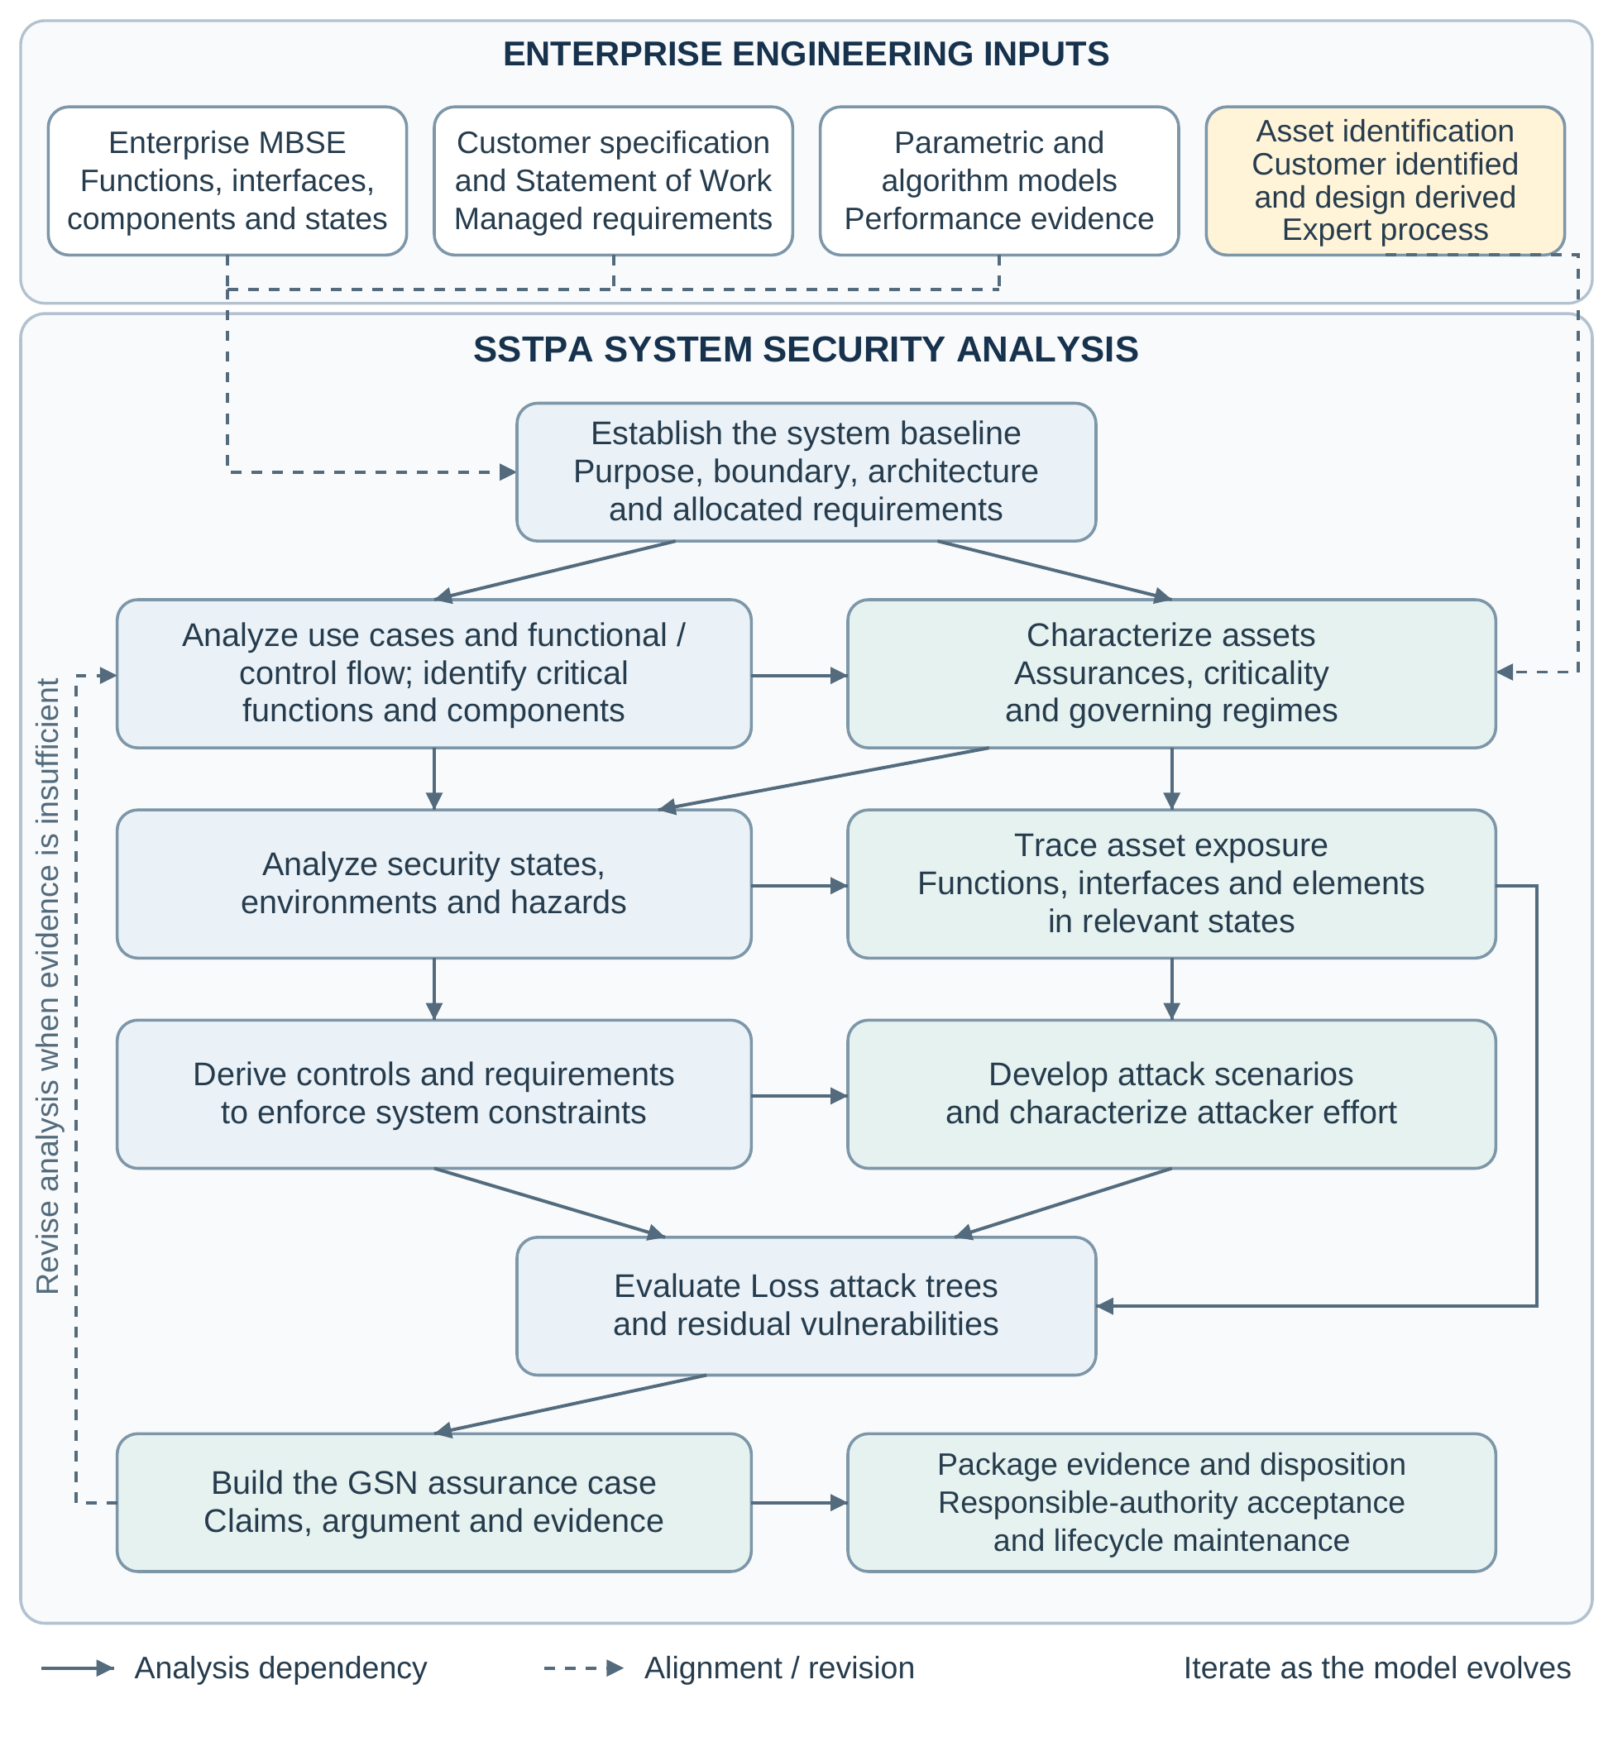
Figure 2. SSTPA methodology workflow, redrawn from version 14, Figure 23

6 Detailed methodology

6.1 Receive asset identification and protection decisions
Asset identification is outside the scope of SSTPA. Stakeholders and domain specialists identify items of value, establish the consequences of their compromise, and determine the initial protection needs. They distinguish assets required by the customer or governing regime from assets introduced by the proposed realization, such as credentials or enabling intellectual property. SSTPA receives the approved results, their ownership, and their rationale.
The analyst records each asset's meaning, boundaries, dependencies, applicable regimes, criticality, and selected Assurances. Each Assurance receives a violation criterion and operational context. The responsible authority identifies the acceptance criteria and evidence expectations. Conflicting obligations are resolved explicitly; a label such as mission critical is not sufficient to infer a particular control or assurance level.
The resulting asset and protection baseline supplies the scope for subsequent analysis. Discovery of a new credential, derived data product, or service dependency is referred back to the external identification process. Once accepted into scope, the asset is connected to the relevant architectural and behavioral views and its protection analysis is performed.

6.2 Define the system of interest and architecture
Define what the system is intended to accomplish, how it contributes to the larger capability, and which responsibilities fall within the analysis boundary. Identify external actors, neighboring systems, services, and environmental dependencies. Record constraints and assumptions about elements outside the designer's authority; external placement does not remove a dependency from the security analysis.
Establish the structural and functional baseline using the program's authoritative engineering information. Describe constituent elements, their responsibilities, interfaces, and connections. Include human and organizational elements where their decisions or actions affect protection. Allocate stakeholder and parent-system obligations at a level where responsibility can be understood and eventually verified. Use identifiers and configuration references to keep security views aligned with the broader architecture.
The model is an abstraction sufficient for the current decisions. Early analysis can use high-level descriptions; later decisions require more detail about implementation, timing, interfaces, or resource use. The required fidelity follows the security question. Missing detail is recorded as an assumption or open issue rather than treated as evidence of protection [43, “Abstraction”].

6.3 Analyze use cases and operational scenarios
Use case analysis establishes how actors interact with the system to achieve intended results. For each relevant use case, identify the actors, their authority, the initiating event, preconditions, normal progression, alternatives, exceptions, and expected outcome. Relate the interactions to the assets and Assurances they affect. Scenarios include operation, administration, maintenance, update, emergency response, recovery, and disposal where these are within the lifecycle scope.
Examine boundary interactions and authority changes. An operator allowed to load a configuration during maintenance may not be authorized to perform the same action during operation. A supporting service may return valid information too late to support the intended decision. These situations identify conditions for functional, state, and control analysis and expose assumptions about an actor's trustworthiness.
Use cases remain descriptions of intended interaction. Misuse and attack scenarios later challenge their assumptions. The output is a set of operational situations linked to functions, interfaces, assets, and expected protection conditions. Inconsistencies with stakeholder needs or the system boundary are resolved before these situations are used as the basis for detailed claims [44].

6.4 Analyze functional flow and control behavior
Functional flow analysis identifies the activities and transformations needed to realize each scenario. Follow information, material, or energy between functions and across interfaces; identify sequencing, concurrency, inputs, outputs, and dependencies. Allocate functions to the responsible elements and identify those whose behavior is critical to asset protection. Shared services, shared resources, and indirect dependencies receive the same attention as direct asset handling [15, “Functional Architecture Model” and “Behavioral Architecture Model”; 44, “Purpose” and “Application in practice”].
Figure 3 illustrates a linear functional flow: an input passes through successive functions to produce an output. This view explains transformation and sequence. It does not explicitly show an authority deciding whether the actions are appropriate, feedback about their effects, or a model of the controlled process. A larger system can contain this flow within a control loop even when the local flow drawing omits that loop.
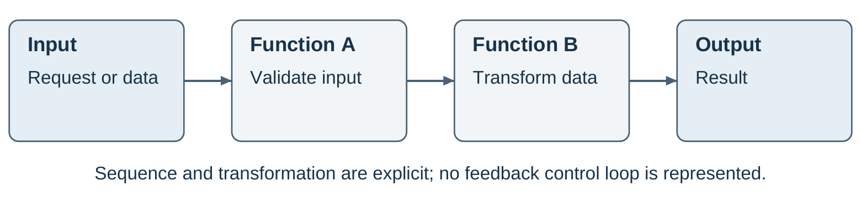
Figure 3. Linear functional flow from input through functions to output
The control-structure model in Leveson and Thomas’s STPA Handbook (March 2018), Chapter 2, adds the decision and feedback relationships needed to analyze control. Identify the controller, its authority and control algorithm, the controlled process, the control actions it can issue, and the feedback used to update its process model. The process model represents what the controller believes about the controlled process and relevant context; it may differ from the actual state. Feedback updates that model, and the model informs or tunes subsequent control decisions. This does not necessarily mean automatic adaptation of controller parameters. Include interactions among controllers and between organizational and technical levels [1, “Modeling the control structure,” pp. 22–25, Figure 2.6].
Figure 4 shows this feedback structure and names illustrative control-action and feedback messages. SetMode and EnableOutput represent commands to the controlled process; ModeStatus, IntegrityStatus, and HealthStatus provide observations used to update the process model. The diagram is an analytical view of responsibilities and information, so an implementation can distribute these responsibilities across several elements. Additional sensing, actuation, and communication detail is introduced when required by the analysis.
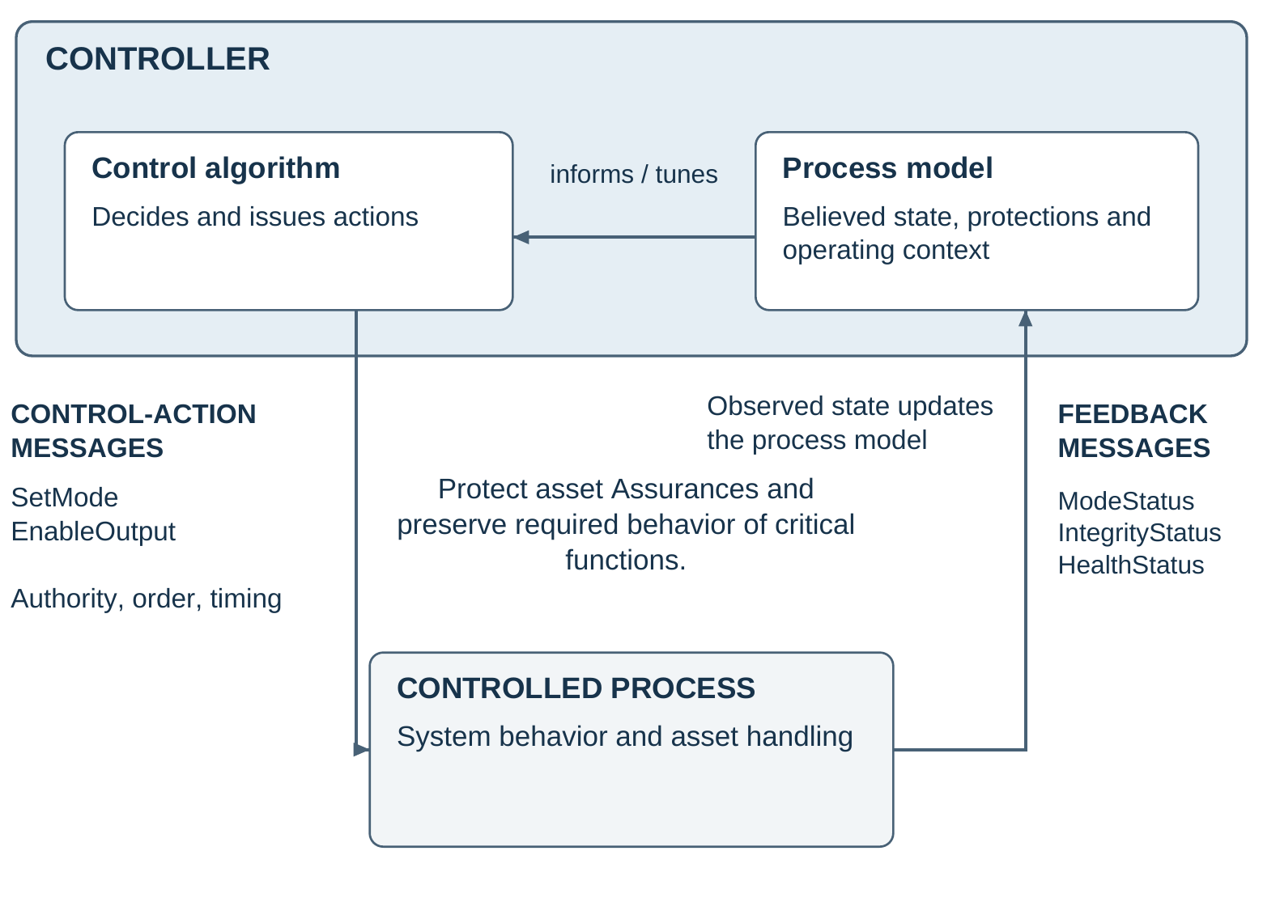
Figure 4. STPA feedback control structure with explicit control-action and feedback messages
Not every functional flow has the full feedback structure: a transformation pipeline or an open-loop activity may have no local feedback. SSTPA nevertheless recommends that secure systems employ the STPA control model for decisions that protect asset Assurances or govern critical functional flows, including flight-critical functions. Identify the appropriate enclosing control loop, or record and justify its absence. Criticality describes the consequences of inadequate behavior; the control loop preserves the required behavior of the critical function and the Assurances on affected assets.
Explicitly identify each control-action and feedback message, its sender and receiver, meaning, authority, triggering conditions, sequence, freshness, timing bounds, and expected response. Specify how authenticity and integrity are protected, how availability and confidentiality apply, and what happens when messages are missing, delayed, duplicated, replayed, or inconsistent. Feedback needs to establish the state relevant to the decision, rather than merely acknowledge receipt of a command. The existence of a loop alone does not establish that it is secure.
Apply STPA control-action analysis in the relevant contexts. Examine required actions that are not provided, actions whose provision creates a hazard, actions delivered too early or too late or in the wrong order, and continuous actions that persist too long or stop too soon. Record the action, responsible controller, contextual conditions, and linked hazard. An action name without context is not a complete unsafe-control-action statement [1, Chapter 2, “Identifying Unsafe Control Actions,” pp. 34–41].
Develop causal scenarios for inadequate control and for correct control actions that are not executed as intended, following the two scenario categories in the STPA Handbook [1, Chapter 2, “Identifying loss scenarios,” pp. 42–50]. Consider process-model errors, missing or misleading feedback, authority conflicts, implementation deficiencies, resource limitations, and adversarial interference. Derive constraints and requirements addressing the causes. Preliminary hazards are refined as this analysis proceeds; a drawing of a control loop alone does not complete the analysis.

6.5 Analyze security states and transitions
Define state variables relevant to protection, including operating mode, authorization status, asset location or representation, active protections, and dependencies. Group conditions into security states where this makes the model understandable, while preserving the distinctions needed to analyze control decisions and attacks. Align these states with the program's functional and operational models.
For each transition, specify the triggering event, guard conditions, actions, relevant timing, and resulting state. Examine interruptions, incomplete transitions, concurrent activity, stale information, and unexpected re-entry. A correct protection condition at each endpoint does not establish protection during the transition. Startup, update, maintenance, failover, degraded operation, recovery, and disposal often change both exposure and authority.
An embedded-system secure-boot example can use the formal subsystem states defined in the Open Mission Systems (OMS) Standard, Version 2.5 (OMSC-STD-001, Revision M, 22 January 2026): OFF, PRE_INITIALIZATION, INITIALIZATION, STANDBY, and OPERATE. In OMS, OFF means prime power is present but the subsystem is inactive; absence of electrical power is the distinct Unpowered condition. PRE_INITIALIZATION covers bootstrap and initial software loading, INITIALIZATION prepares the subsystem for mission use, and STANDBY precedes commanded operation. These are OMS subsystem states, not the separate OMS service-state vocabulary [45, §6.2.1, Table 6.2-1, pp. 38–40; §6.1.1, p. 27].
Figure 5 shows selected startup transitions from OFF to OPERATE and overlays illustrative SSTPA security guards. Boot-chain authentication gates progress into INITIALIZATION; accepted configuration, completed self-tests, and active protections gate STANDBY; an authorized command and confirmed readiness gate OPERATE. The state names and startup path follow OMS Standard Version 2.5 [45, §6.2.1, Figures 6.2-2–6.2-3, pp. 36–37], while these guards are proposed security design choices informed by NIST SP 800-193, Platform Firmware Resiliency Guidelines (May 2018) [46, §§4.1–4.4]. Failed checks inhibit entry into mission operation and invoke program-defined, authorized recovery. This is neither the complete OMS state machine nor a claim of OMS compliance.
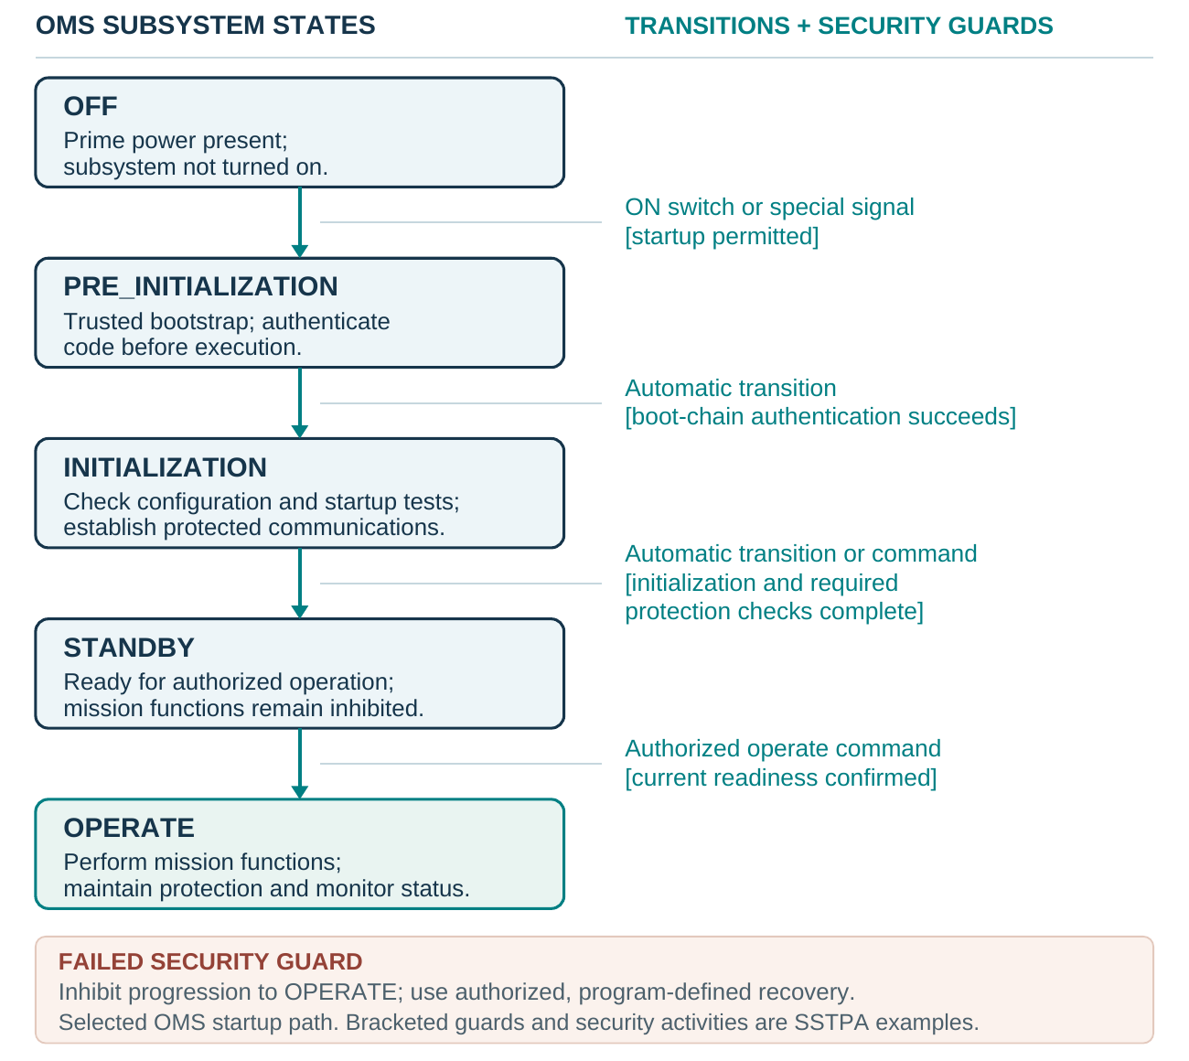
Figure 5. Illustrative secure boot using OMS subsystem states and SSTPA security guards
The security analysis follows the boot firmware asset and its integrity Assurance through loading, checking, handoff, and execution. It challenges the authenticity and protection of trust anchors, image and configuration acceptance, rollback policy, the interval between verification and use, and failure behavior. Feedback about boot status must reflect the current instance of startup; a stale ready indication cannot justify entry into OPERATE. Recovery paths receive the same scrutiny as the normal startup path [46, §§4.1, 4.2.1.3, 4.2.3, 4.3.1, and 4.4.1].
The resulting state model provides context for hazards, attack feasibility, asset traces, and evidence. It preserves security objectives while distinguishing actual protection from confidence in that protection. Timing and transition coverage are reviewed with the behavioral model [15, “Behavioral Architecture Model” and “Temporal Architecture Model”].

6.6 Define environments and attacker assumptions
Describe the environments in which the system is developed, deployed, operated, maintained, recovered, and retired as applicable to scope. Identify physical conditions, connectivity, external services, organizational arrangements, and relevant threat exposure. Establish which states and transitions are valid in each environment and which environmental changes require reanalysis.
Characterize attackers by capabilities and access relevant to the system. Record resources, knowledge, privileges, physical proximity, persistence, and opportunity where they affect feasibility or effort. A named threat category without these assumptions is insufficient for a reproducible Loss assessment. Distinguish facts supported by evidence from conservative assumptions and unresolved questions.
Each Loss retains one focal environment. Its attack tree can reference prerequisites established in another environment or earlier lifecycle stage, provided those dependencies and assumptions are explicit. For example, compromised maintenance credentials can persist into an operational environment. Analysts do not discard that history merely because the compromise objective is scoped to operation.

6.7 Identify hazards and derive security constraints
Starting from stakeholder consequences and asset protection objectives, identify system conditions that permit or lead to an Assurance violation. Express hazards as conditions of the system of interest, without prematurely limiting them to one exploit or failed component. Then identify the environmental circumstances in which the conditions produce the adverse outcome [1, Chapter 2, “Identifying system-level hazards,” pp. 17–20].
Keep threats, attacks, and hazards distinct. Replaying an obsolete authorization is an attack action; permitting commands on the basis of expired authority is a hazardous system condition. Threat catalogs can suggest how such a condition arises, but they do not replace the system-level reasoning that identifies what must be prevented.
Derive security constraints that prevent the condition or limit its consequences. Allocate responsibility for their enforcement and identify the information required to determine whether they hold. Constraints can address prevention, detection, containment, or recovery. Link them to hazards, Assurances, and stakeholder consequences so later design decisions remain traceable to purpose.
Non-adversarial causes identified here remain part of the engineering record. They can independently defeat protection or create preconditions an attacker exploits. Their evaluation is retained even where they are not themselves meaningful attack-tree branches with an attacker-effort value.

6.8 Develop controls and verifiable requirements
Controls must enforce system constraints. Select and tailor controls to prevent the hazardous conditions or limit the consequences identified in the system model. Relevant catalogs, regime obligations, and established engineering practices can supply candidates. Record why each control applies, which constraint it enforces, what responsibility it assigns, and any tailoring or exception. A catalog reference alone does not demonstrate implementation or effectiveness.
SSTPA promotes the imperative MUST for a parent control statement expressing a binding security condition. Specific implementing requirements use SHALL and trace to that parent. This distinction makes the required protection condition visible while allowing its realization to be allocated across systems, elements, procedures, and lifecycle activities. It is a proposed SSTPA authoring convention, not a universal systems-engineering distinction or a claim that MUST is intrinsically stronger than SHALL. Both impose mandatory obligations in this methodology.
Develop countermeasures as concrete protective behavior or features, then specify the SHALL requirements needed to realize them. Each requirement identifies a responsible subject, required behavior or property, relevant conditions, and objective verification criteria. Maintain its identifier, parent control, source, rationale, allocation, and planned verification method [38, “Transforming Needs to System Requirements” and “Use of Attributes”]. A single MUST control can require several coordinated SHALL requirements; their combined satisfaction and interactions must be shown to enforce the parent constraint across the relevant states and environments. Merely collecting individually verified requirements does not establish that the control is effective.
Requirements specify what is required at their architectural level. Implementation choices are introduced deliberately through design and allocation, and required behavior is stated without relying on unexplained terms such as secure or robust. Review the resulting constraint-to-control-to-requirement chain for missing responsibilities, incompatible assumptions, bypass paths, and failure behavior. Use system-level verification and validation evidence to assess whether the implemented controls achieve the intended protection [38, 39, 40].
Review interactions among measures. A protective mechanism can impair availability, obstruct recovery, or create a new control dependency. Trace each requirement to its source and maintain the relationship among constraints, countermeasures, verification plans, and the protection claim. Feed required architecture changes back into the program baseline rather than treating the security model as an independent design authority [38].

6.9 Analyze attacks and feasible strategies
Attack analysis challenges the modeled protection under the declared attacker and environmental assumptions. Identify entry points, trust boundaries, exposed interfaces, relevant functions, and control or feedback paths. Consider direct compromise, misuse of legitimate authority, spoofed or delayed information, denial of service, and bypass of protective mechanisms as applicable to the specific system.
For each candidate strategy, document prerequisites, attack actions, required access and resources, affected architecture, and the resulting condition. Connect the strategy to the Assurance violation it could achieve. Reference catalogs can suggest techniques, but local feasibility depends on the system state, actual exposure, and countermeasures. Preserve evidence provenance and the reason for including or excluding a candidate.
Develop alternatives that avoid the strongest protection as well as attacks against it. Compromising a key-handling process may require less effort than breaking the cryptographic algorithm. The analysis therefore evaluates complete system strategies rather than assigning the algorithm's strength to every route to the asset. Attack results remain provisional until checked against the asset traces and state conditions.

6.10 Trace asset exposure and protection
Trace where each asset is held, transported, or used across elements, functions, interfaces, states, and transitions. Include copies, derived representations, caches, logs, temporary storage, and trust-boundary crossings when relevant to the selected Assurance. Record dependencies on external services and on protections allocated to other system tiers.
For each exposure, identify the applicable protection obligation, enforcement responsibility, countermeasure, and supporting requirement. Compare the trace with the attack scenarios. An alleged attack route may be impossible in the stated state; an unexamined copy may reveal a new route. Update both analyses until the model presents a consistent account of exposure and feasible attack behavior.
Review gaps in terms of the approved scope. Missing traces, unallocated protection, unsupported assumptions, or absent transition coverage become explicit findings. The completed trace is the basis for constructing Loss trees and for determining which claims and evidence are affected by a change. It is not a claim that merely touching an asset imposes identical requirements on every element.

6.11 Construct and evaluate Loss attack trees
Create a separate Loss for each selected combination of one asset, one Assurance, and one environment. State the configuration, attacker assumptions, assessment date, and precise violation criterion. The attack tree is the model of the effort needed to achieve that violation. Stakeholder consequences and applicable acceptance criteria are linked to the Loss but are not substituted for its effort meaning.
Decompose the root objective into feasible attack strategies. OR relationships represent alternatives; AND relationships represent conditions or subgoals that must be achieved together. Identify the states, transitions, architecture exposures, and countermeasures relevant to each strategy. Leaves describe assessable actions or prerequisites with a stated evidence basis. A successful strategy through AND conditions can involve several branches, so an individual root-to-leaf path is not necessarily a complete attack [33, “Enter Attack Trees,” Figure 1 and accompanying text].
Assign effort using identified units and assumptions. Depending on the strategy, the assessment can involve computational work, time, cost, expertise, or access. Retain a vector or a justified qualitative scale where dimensions cannot be meaningfully combined. Define what each rating means and how reviewers can reproduce the judgment. For probabilistic attacks, state whether the estimate is expected effort to success or effort needed to reach a specified success probability, with the time horizon and assumptions about retries. Document uncertainty, evidence gaps, and changes in effort caused by countermeasures.
Where costs are comparable and additive, an OR choice is governed by the least costly feasible alternative, while an AND combination accounts for the required subgoals. These rules need qualification. Shared preparation, reusable credentials, parallel execution, repeated attempts, and ordering dependencies can invalidate a simple sum. A graph with shared subtrees requires explicit accounting for shared work; elapsed time and total work may aggregate differently [33, “Enter Attack Trees,” Figure 4 and accompanying text; 34, §§IV–V, Table II and Figure 3, pp. 4–6].
If a single effort result is reported, it characterizes the least demanding feasible modeled strategy under the chosen measure and assumptions. An expensive branch cannot conceal a cheaper bypass. If strategies are incomparable, report the alternatives and their different resource demands. Finding no feasible strategy establishes neither infinite resistance nor complete coverage. The analyst records the search scope and the unresolved limitations.
Preserve dynamic semantics when the tree is acyclic. Relevant sequences, transition conditions, time windows, and prior-environment prerequisites are recorded with the attack strategy or linked behavioral model. Repeated behavior can be represented with explicit bounds or evaluated in a supporting analysis. A graph path is accepted as an attack strategy only after feasibility has been established.
Identify residual vulnerabilities and their associated effort after the selected countermeasures are considered. Dispositions include eliminated, blocked under stated assumptions, accepted under documented conditions as an ARV, deferred, and unresolved. Only a responsible authority can accept the associated risk. Deferred or unresolved findings remain visible and cannot support an unconditional closure claim. Comparison between configurations uses equivalent scope and effort assumptions so changes in resistance can be interpreted.

6.12 Plan and obtain verification and validation evidence
Plan verification as requirements are developed. Identify the configuration, criteria, method, responsible party, and expected evidence for each protection obligation. Obtain results showing whether requirements and interfaces are satisfied, including relevant negative behavior, degraded conditions, and enforcement of state-transition constraints. Failed checks and unexplained deviations return to analysis and design [39, “Activities of the Process” and “Methods and Techniques”].
Plan validation against stakeholder protection needs and intended use in the stated environments. Evaluate whether the composed security solution is suitable for its purpose, including operator behavior, recovery, usability of security functions, and mission effects. Validation scenarios challenge assumptions that individual requirement checks may leave untested. Evidence can combine analysis, inspection, demonstration, and testing as appropriate to the claim [40, “Purpose and Principles of the Approach” and “Activities of the Process”].
Loss effort assessments need their own support. Record whether estimates arise from measured work, established cryptanalytic results, demonstrations, analytical models, or expert judgment, with applicable uncertainty. Planned checks are evidence of a plan, not evidence that the realized system has passed them. Maintain the distinction in both the model and the assurance case.

6.13 Generate and evaluate the assurance case using GSN
Develop the assurance case around bounded claims about asset protection and suitability for acceptance. State the configuration, asset scope, Assurances, environments, attacker assumptions, and applicable regime. The Goal Structuring Notation Community Standard, Version 3 (SCSC-141C, May 2021), defines GSN claims as goals, the reasoning used to organize them as strategies, relevant context and assumptions explicitly, and references to evidence as solutions. A GSN solution is an evidence reference, not a synonym for a security countermeasure [5, Part 1, §1:2.1, Tables 1:2-1–1:2-2, pp. 17–18].
Use the connected model to generate the initial argument structure and its evidence links. Supporting claims address the adequacy of the system model, coverage of hazardous and adversarial scenarios, enforcement of constraints, sufficiency of Loss effort assessments, and satisfaction of requirements and stakeholder needs. Organize the argument according to the actual reasoning; copying the system decomposition into a goal hierarchy does not automatically justify the claims.
For a Loss-related claim, explain why the modeled strategies and their assessed effort support the required level of resistance under the stated conditions. Relate this conclusion to stakeholder consequences and acceptance criteria. Address common assumptions and shared dependencies explicitly so that evidence reused across claims does not imply independence where none exists. Include non-adversarial scenarios through the relevant protection claims rather than forcing them into the custom Loss metric.
Review the argument's reasoning, evidence quality, configuration applicability, and unresolved findings. Retain contrary evidence and assumptions requiring operational monitoring. GSN makes the argument inspectable; its notation and automatic generation do not demonstrate that the argument is sound or sufficient [5, Part 2, §2:7, “Evaluating Goal Structures: A Step-by-Step Approach,” pp. 88–95]. If support is inadequate, revise the earliest affected analysis or design activity and regenerate the dependent portions of the case.
Figure 6 illustrates a GSN argument for one asset, one Assurance, and one environment: boot firmware integrity during embedded-system startup. Its strategy addresses image validation, preservation of the verified image until execution, and prevention of entry into OPERATE after a failed check. Solution nodes identify validation and rollback-test results, protected-handoff analysis and tests, and failure-injection and state-transition tests. The rectangles, parallelogram, context capsule, assumption oval, solution circles, and directed relationships follow GSN Community Standard Version 3 [5, Part 1, Tables 1:2-1–1:2-2, pp. 17–18]. Braces and hollow triangular decorators identify uninstantiated evidence references [5, Part 1, §1:3.3, Table 1:3-2, p. 28]; this example is not a completed assurance case.
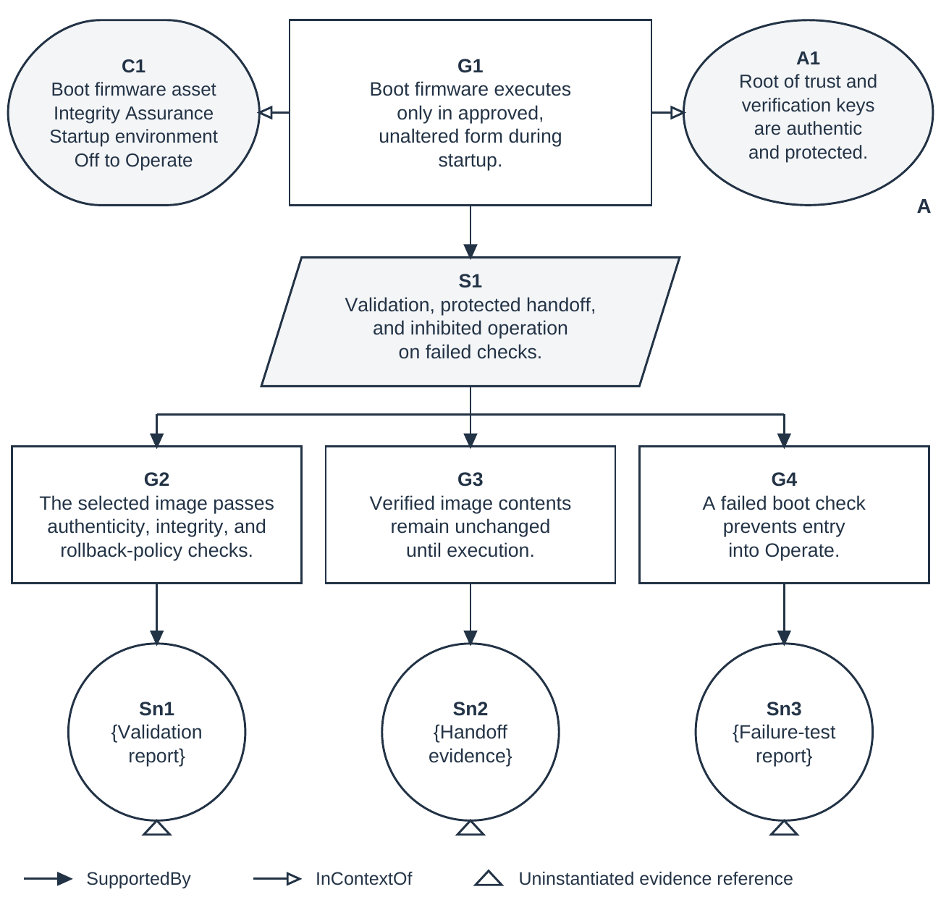
Figure 6. Illustrative GSN argument for boot firmware integrity
The responsible authority records acceptance or rejection, conditions of use, applicable obligations, affected configurations, and reassessment triggers. ARV decisions identify the residual vulnerability and associated risk being accepted. The assurance case supports this decision without replacing it [4, §3.6, Task R-4, pp. 73–74; Appendix F, p. 147].

6.14 Recurse integrate and sustain the analysis
At project inception, establish the capability context and the initial systems of interest. When an element requires more detailed realization, treat it as a new system of interest and repeat the applicable activities. Carry forward allocated requirements, related assets and Assurances, interface obligations, and assumptions. Record newly identified needs and resolve their relationship to the parent protection objectives. Re-establish exposure traces at the child level instead of assuming that the parent's view supplies the required detail.
During integration, evaluate the composed behavior. Shared resources, interacting controllers, interface timing, incompatible assumptions, and emergent attack routes can undermine protection even when individual elements meet their requirements. Reassess parent hazards and Loss trees using the realized composition and actual evidence. Child assurance cases contribute only within the conditions for which their claims are supported.
Maintain this process through operation, maintenance, upgrades, recovery, and disposal. Changes to architecture, environments, attacker capabilities, protection obligations, or evidence can affect the validity of a Loss assessment or acceptance decision. Trace the change to affected requirements, analyses, and claims; revise the relevant work; and obtain renewed decisions where required. Iteration, concurrent work, and recursion support this lifecycle rather than occurring only at the end of a fixed sequence, consistent with the SEBoK article “Process Concurrency, Iteration, and Recursion” (version 2.14) [12].

7 Engineering outputs and closure
The engineering product is a security solution whose rationale and evidence can be inspected. Its connected records include the approved asset and Assurance scope, relevant architecture and behavior, environments and attacker assumptions, hazards and constraints, allocated requirements and countermeasures, exposure traces, scoped Loss attack trees, verification and validation results, and the assurance case. Each record has an identifiable configuration and relationship to the protection need it addresses.
Closure is judged against approved coverage criteria. The analysis explains which states, transitions, environments, interactions, attack strategies, and non-adversarial scenarios have been examined and why that scope is adequate for the decision. Each identified residual vulnerability has a documented disposition. Unknowns and insufficient evidence remain findings, and any operating restriction or conditional acceptance is visible in the case. Acceptance does not convert an unresolved technical question into a demonstrated fact.
SSTPA Loss provides an explicit account of the effort required to violate an Assurance on an asset in an environment. Keeping that measure distinct from consequence and risk allows reviewers to assess both resistance and what is at stake. The graph model supports traceability; systems-theoretic analysis supplies behavioral reasoning; verification, validation, and GSN arguments support confidence. Continued adequacy depends on maintaining their consistency as the system and its context change.

8 References
STPA terminology and the basic method follow Leveson and Thomas’s STPA Handbook (March 2018), Chapter 2, “How to Do a Basic STPA Analysis” [1, pp. 14–53]. SSTPA-specific definitions, including Loss, Assurance, and ARV, are defined in this paper and are not presented as definitions adopted by the cited organizations. Online references were accessed on 4 October 2026.
[1] Leveson, Nancy G., and John P. Thomas. STPA Handbook. MIT Partnership for Systems Approaches to Safety and Security, March 2018. Chapter 2, “How to Do a Basic STPA Analysis,” pp. 14–53; definitions, pp. 16–21; control structure, pp. 22–34; unsafe control actions and controller constraints, pp. 34–41; loss scenarios, pp. 42⁠–⁠53. https://psas.scripts.mit.edu/home/get_file.php?name=STPA_handbook.pdf
[2] Ross, Ron, Mark Winstead, and Michael McEvilley. Engineering Trustworthy Secure Systems. NIST Special Publication 800-160, Volume 1, Revision 1, November 2022. Section 3.4, The Concept of Assets, p. 16; Section 3.7, Determining Protection Needs, pp. 25–27. https://doi.org/10.6028/NIST.SP.800-160v1r1
[3] Australian Signals Directorate’s Australian Cyber Security Centre; U.S. Cybersecurity and Infrastructure Security Agency and National Security Agency; Canadian Centre for Cyber Security; New Zealand National Cyber Security Centre; and United Kingdom National Cyber Security Centre. Careful Adoption of Agentic AI Services. 1 May 2026. Section ‘Leverage system-theoretic approaches to analyse security’. https://www.cyber.gov.au/business-government/secure-design/artificial-intelligence/careful-adoption-of-agentic-ai-services
[4] Joint Task Force. Risk Management Framework for Information Systems and Organizations: A System Life Cycle Approach for Security and Privacy. NIST Special Publication 800-37, Revision 2, December 2018. Section 3.6, Task R-4, pp. 73–74; Appendix F, “Authorization Decision Information,” p. 147. https://doi.org/10.6028/NIST.SP.800-37r2
[5] SCSC Assurance Case Working Group. Goal Structuring Notation Community Standard, Version 3. SCSC-141C. Safety-Critical Systems Club, May 2021. Part 1, §1:2.1, Tables 1:2-1–1:2-2, pp. 17–18; §1:3.3, Table 1:3-2, p. 28; Part 2, §2:7, pp. 88–95. https://scsc.uk/scsc-141c
[6] Young, William, and Nancy G. Leveson. Systems Thinking for Safety and Security. Proceedings of the 29th Annual Computer Security Applications Conference, 2013, pp. 1–8. DOI: 10.1145/2523649.2530277. Relevant discussion: §4, “Applying STPA to Security,” pp. 3–6. https://dspace.mit.edu/entities/publication/c43a36bd-46c9-4a85-8ffb-35d8764b57a3
[7] Joint Task Force. Security and Privacy Controls for Information Systems and Organizations. NIST Special Publication 800-53, Revision 5, September 2020, includes updates as of 10 December 2020. AU-10 Non-repudiation and enhancements (1)–(4), printed pp. 76–77. https://doi.org/10.6028/NIST.SP.800-53r5
[8] National Institute of Standards and Technology. Security Categorization. Computer Security Resource Center Glossary; sources include NIST SP 800-37 Revision 2 and NIST SP 800-53 Revision 5. https://csrc.nist.gov/glossary/term/security_categorization
[9] National Institute of Standards and Technology. Standards for Security Categorization of Federal Information and Information Systems. Federal Information Processing Standards Publication 199, February 2004. https://doi.org/10.6028/NIST.FIPS.199
[10] ISO/IEC/IEEE. Systems and Software Engineering — Systems and Software Assurance — Part 2: Assurance Case. ISO/IEC/IEEE 15026-2:2022, second edition, November 2022. https://www.iso.org/standard/80625.html
[11] Neo4j. Graph Database Concepts. Getting Started documentation. Accessed 4 October 2026. https://neo4j.com/docs/getting-started/appendix/graphdb-concepts/
[12] SEBoK Editorial Board. Process Concurrency, Iteration, and Recursion. SEBoK, version 2.14, 2026. https://sebokwiki.org/wiki/Process_Concurrency,_Iteration,_and_Recursion
[13] IBM. IBM Engineering Requirements Management. Product webpage, “Options: DOORS” and “Configuration and variant management.” Accessed 4 October 2026. https://www.ibm.com/products/requirements-management
[14] Dassault Systèmes. No Magic Cameo Systems Modeler. CATIA product documentation. Accessed 4 October 2026. https://www.3ds.com/products/catia/no-magic/cameo-systems-modeler
[15] SEBoK Editorial Board. Logical Architecture. SEBoK, version 2.14, 2026. https://sebokwiki.org/wiki/Logical_Architecture
[16] MathWorks. MATLAB. Product documentation. Accessed 4 October 2026. https://www.mathworks.com/products/matlab.html
[17] SSTPA Tools project, SSTPA Tool Software Requirements Specification, Version 7, unpublished project specification, undated; working copy consulted 4 October 2026. Sections 1.2.2.1 (external Tier-1 asset identification); 3.3.9–3.3.9.1 (common properties and data ownership); 3.3.10.11 (Asset); 3.3.4.11 (Asset and Regime relationships); 3.3.4.6.2–3.3.4.6.3 (state-scoped inheritance and protection requirements).
[18] U.S. Department of Defense, DoD Instruction 5200.39, Critical Program Information (CPI) Identification and Protection Within Research, Development, Test, and Evaluation (RDT&E), 28 May 2015, incorporating Change 3, 1 October 2020. Paragraphs 3.b–3.d; Glossary, Part II, CPI, horizontal identification, horizontal protection, and inherited CPI, p. 11. https://www.esd.whs.mil/Portals/54/Documents/DD/issuances/dodi/520039p.pdf
[19] U.S. Department of Defense, DoD Instruction 5200.44, Protection of Mission Critical Functions to Achieve Trusted Systems and Networks, 16 February 2024. Section 1.2; Glossary, critical component and criticality analysis, p. 18. https://www.esd.whs.mil/Portals/54/Documents/DD/issuances/dodi/520044p.pdf
[20] Erika McCallister, Tim Grance, and Karen Scarfone, NIST Special Publication 800-122, Guide to Protecting the Confidentiality of Personally Identifiable Information (PII), National Institute of Standards and Technology, April 2010. Section 2.1, Identifying PII, p. 2-1; Section 2.2, Examples of PII Data, p. 2-2; Section 3.2, Factors for Determining PII Confidentiality Impact Levels. https://doi.org/10.6028/NIST.SP.800-122
[21] Celia Paulsen, Jon Boyens, Nadya Bartol, and Kris Winkler, NIST Internal Report 8179, Criticality Analysis Process Model: Prioritizing Systems and Components, National Institute of Standards and Technology, April 2018. Abstract, p. ii; Sections 2–3, organizational goals, system dependencies, and the criticality analysis process. https://doi.org/10.6028/NIST.IR.8179
[22] National Aeronautics and Space Administration, NASA-STD-8739.8B, Software Assurance and Software Safety Standard, approved 8 September 2022. Section 3.2, Mission Critical and Safety-Critical definitions, pp. 14 and 16; Section 4.2, Safety-Critical Software Determination, p. 20. https://standards.nasa.gov/sites/default/files/standards/NASA/B/0/NASA-STD-87398-Revision-B.pdf
[23] Federal Aviation Administration, Advisory Circular 25.1309-1B, System Design and Analysis, 30 August 2024. Sections 1.2.2.11, 3.1, 6.2 (Functional Hazard Assessment), and 7.4. Advisory guidance describing an acceptable means of showing compliance. https://www.faa.gov/documentLibrary/media/Advisory_Circular/AC_25.1309-1B.pdf
[24] SEBoK Editorial Board. System Assurance (glossary). SEBoK, version 2.14, 2026. https://sebokwiki.org/wiki/System_Assurance_(glossary)
[25] National Institute of Standards and Technology. Minimum Security Requirements for Federal Information and Information Systems. FIPS PUB 200, March 2006. Appendix A: Confidentiality, p. 6; Integrity, p. 7. https://doi.org/10.6028/NIST.FIPS.200
[26] Barker, Elaine. Recommendation for Key Management: Part 1 — General. NIST Special Publication 800-57 Part 1, Revision 5, May 2020. Section 3, security services; §2.1, “Security strength,” p. 17; §5.6.1, pp. 52–53; Appendix A. https://doi.org/10.6028/NIST.SP.800-57pt1r5
[27] National Institute of Standards and Technology. CSRC Glossary: Availability. undated. Definitions from NIST SP 800-160 Vol. 1 Rev. 1, FIPS 200, and NIST SP 800-57 Part 1 Rev. 5. https://csrc.nist.gov/glossary/term/availability
[28] Dworkin, Morris. Recommendation for Block Cipher Modes of Operation: Galois/Counter Mode (GCM) and GMAC. NIST SP 800-38D, November 2007. §4.1, Authenticity definition, printed p. 3; Appendix D, Protection Against Replay of Messages, printed p. 30. https://doi.org/10.6028/NIST.SP.800-38D
[29] National Institute of Standards and Technology. Digital Signature Standard (DSS). FIPS 186-5, 3 February 2023. Announcement §7, p. ii; §2.1, Digital signature, p. 3, and Non-repudiation, p. 4. https://doi.org/10.6028/NIST.FIPS.186-5
[30] Brooks, Sean, Michael Garcia, Naomi Lefkovitz, Suzanne Lightman, and Ellen Nadeau. An Introduction to Privacy Engineering and Risk Management in Federal Systems. NISTIR 8062, January 2017. §§2.1–2.2, printed pp. 6–10; §3.2.2, privacy risk characteristics, p. 23. https://doi.org/10.6028/NIST.IR.8062
[31] U.S. Department of Defense. DoD Operations Security (OPSEC) Program. DoDD 5205.02E, 20 June 2012, incorporating Change 2, 20 August 2020. §4 and ¶4.a, Policy, p. 1; Enclosure 2, ¶11.j–k, unclassified information review and aggregation, p. 7. https://www.esd.whs.mil/Portals/54/Documents/DD/issuances/dodd/520502e.pdf
[32] U.S. Department of Defense, Center for Development of Security Excellence. OPSEC Fundamentals for OPSEC Practitioners Course: Student Guide, OP110. 2025. The OPSEC Cycle; Identification of CII, November 2025 edition, printed p. 13. https://www.cdse.edu/Portals/124/Documents/student-guides/OP110-guide.pdf
[33] Schneier, Bruce. Attack Trees. Dr. Dobb's Journal, December 1999. Author-hosted online text, “Enter Attack Trees,” Figures 1 and 4 and accompanying discussion; unpaginated. https://www.schneier.com/academic/archives/1999/12/attack_trees.html
[34] Budde, Carlos E., and Mariëlle Stoelinga. Efficient Algorithms for Quantitative Attack Tree Analysis. arXiv:2105.07511, version 2, 22 May 2021. Sections IV–V, Table II and Figure 3, pp. 4–6. https://arxiv.org/abs/2105.07511v2
[35] Leveson, Nancy. “Safety and Security Are Two Sides of the Same Coin.” In Corinne Bieder and Kenneth Pettersen Gould (eds.), The Coupling of Safety and Security: Exploring Interrelations in Theory and Practice. SpringerBriefs in Safety Management. Springer, Cham, 2020, pp. 17–27. §3.4, pp. 21–26. DOI: 10.1007/978-3-030-47229-0_3. https://doi.org/10.1007/978-3-030-47229-0_3
[36] SEBoK Editorial Board. Guide to the Systems Engineering Body of Knowledge (SEBoK), version 2.14, released 18 May 2026. N. Hutchison, Editor in Chief. The Trustees of the Stevens Institute of Technology. https://sebokwiki.org/wiki/Guide_to_the_Systems_Engineering_Body_of_Knowledge_(SEBoK)
[37] SEBoK Editorial Board. Engineered System Context. SEBoK, version 2.14, 2026. https://sebokwiki.org/wiki/Engineered_System_Context
[38] SEBoK Editorial Board. System Requirements Definition. SEBoK, version 2.14, 2026. https://sebokwiki.org/wiki/System_Requirements_Definition
[39] SEBoK Editorial Board. System Verification. SEBoK, version 2.14, 2026. https://sebokwiki.org/wiki/System_Verification
[40] SEBoK Editorial Board. System Validation. SEBoK, version 2.14, 2026. https://sebokwiki.org/wiki/System_Validation
[41] Neo4j. What Is Cypher? Getting Started documentation. Accessed 4 October 2026. https://neo4j.com/docs/getting-started/cypher/
[42] Neo4j. Variable-length Paths. Cypher Manual. Accessed 4 October 2026. https://neo4j.com/docs/cypher-manual/current/patterns/variable-length-paths/
[43] SEBoK Editorial Board. System Modeling Concepts. SEBoK, version 2.14, 2026. https://sebokwiki.org/wiki/System_Modeling_Concepts
[44] SEBoK Editorial Board. Functional Architecture. SEBoK, version 2.14, 2026. https://sebokwiki.org/wiki/Functional_Architecture
[45] Open Architecture Collaborative Working Group. Open Mission Systems (OMS) Standard, Version 2.5. OMSC-STD-001, Revision M, 22 January 2026, §6.2.1, Figures 6.2-2–6.2-3 and Table 6.2-1, pp. 36–42. https://guide.dafdto.com/wp-content/uploads/2026/03/02_OMSC-STD-001_RevM_OMS_Standard_DandD_v2_5.pdf
[46] Regenscheid, Andrew. Platform Firmware Resiliency Guidelines. NIST Special Publication 800-193, May 2018, §§4.1–4.4: Roots of Trust, Protection, Detection, and Recovery.
https://doi.org/10.6028/NIST.SP.800-193

