System Security-Theoretic
Process Analysis
SSTPA
A methodology for asset protection and security
assurance in engineered systems
TECHNICAL WHITE PAPER
Version 16 | 4 October 2026

1 Abstract
System Security-Theoretic Process Analysis (SSTPA) is a human- and asset-centered systems security engineering methodology for specifying, evaluating, and sustaining protection of assets in complex engineered systems. It applies systems-theoretic reasoning to system behavior, control, feedback, and interactions, then connects the results to security requirements and evidence supporting acceptance decisions. Its objective is to preserve required security properties across the relevant environments, operating states, and transitions of the system lifecycle.
SSTPA uses a specific definition of Loss. A Loss is the effort an attacker needs to expend to violate one Assurance on one asset in one environment, modeled as an attack tree. The root specifies the violation; the branches explain the feasible attack strategies and their required effort and preconditions. This use of Loss expresses resistance to compromise, analogous in purpose to cryptographic work factor. It is distinct from STPA loss, which denotes an unacceptable stakeholder outcome. SSTPA retains stakeholder consequences as the basis for protection priorities and residual-risk decisions.
The methodology establishes a system model, analyzes use cases, functional and control behavior, states and environments, develops constraints and requirements, examines attacks and asset exposure, and evaluates Loss. It organizes verification and validation evidence into assurance cases expressed using Goal Structuring Notation (GSN). Asset identification and valuation are external inputs. Analysis is iterative and recursive across system tiers, with reassessment during integration and sustainment. Conclusions apply to the documented configuration, analysis scope, assumptions, and evidence; they do not establish universal resistance to every possible attack.

2 Introduction to SSTPA
Engineering security requires understanding how a system achieves its purpose and how its behavior can violate the protection needs of stakeholders. Correctly functioning elements can interact in ways that undermine security. A timely command in one operating mode may be hazardous in another; accurate feedback may arrive too late; authority granted during maintenance may persist into operation. Security analysis therefore addresses the behavior of the composed system as well as the properties of its elements [1].
SSTPA organizes this work around assets and the Assurances required on them. An asset may be information, software, firmware, hardware, credentials, intellectual property, a service, or another item of value. The asset is distinguished from the system elements that hold, transport, or use it. Stakeholders establish why it matters, the consequences of compromise, and the authorities responsible for protection and acceptance decisions. This asset-protection perspective is compatible with systems security engineering as described by NIST [4].
SSTPA is human centered because people establish value, specify acceptable behavior, evaluate evidence, and accept or reject residual risk under applicable regimes. It is asset centered because requirements and assurance claims are traced to the protection of identified assets. Its analysis follows assets through relevant functions, interfaces, states, and environments rather than assuming that protection follows automatically from a component label or catalog of controls.
The methodology uses Assurance as a named protection objective. Common examples are confidentiality, integrity, availability, authenticity, and non-repudiation. Privacy objectives, trustworthiness, and certifiability can also be represented, but each needs criteria appropriate to its meaning. Confidentiality concerns permitted disclosure; integrity concerns permitted modification and preservation of required correctness; availability concerns authorized access or service when required. Authenticity concerns genuineness, and non-repudiation concerns evidence supporting attribution of an action or event. Privacy requires objectives addressing effects on individuals. Trustworthiness concerns justified reliance on required behavior. Certifiability is an SSTPA-defined objective concerning achievement and maintenance of certification under a specified regime [4].
For each selected Assurance, the analyst defines what counts as a violation, the applicable conditions, and the evidence needed to assess protection. Labels alone are insufficient. An availability objective, for example, needs a service, authorized users, demand conditions, and an acceptable interruption interval. Privacy and certifiability require explicit adverse outcomes; they cannot automatically be reduced to the same metric used for confidentiality. The distinction between the model label Assurance and conventional assurance is defined in Section 3.6.
SSTPA supports the engineering of a security solution from concept through disposal. It can inform safety and mission assurance where asset protection and stakeholder consequences overlap, while retaining the analytical obligations of those disciplines. Its claimed contribution is the integration of established analysis and assurance practices within a common method. Adoption of its terminology or information model does not itself demonstrate effectiveness; project evidence and review establish whether the resulting security solution is adequate.

3 Foundations and scope

3.1 Systems theory and control
Systems theory considers a system as an interacting whole. Emergent properties depend on the organization and behavior of its parts, their relationships, and their environment. Decomposition remains useful for engineering, but separate evaluations of parts cannot establish every property of the assembled system. SSTPA consequently analyzes interactions both within a system of interest and across its boundaries [1].
STAMP, the System-Theoretic Accident Model and Processes, provides the causality foundation for STPA. It explains losses in terms of inadequate enforcement of constraints on system behavior, including cases where no component has failed. A control structure represents controllers, controlled processes, control actions, and feedback. Controllers use process models representing their understanding of relevant conditions. Incorrect beliefs, missing authority, delayed feedback, or conflicting actions can prevent constraints from being enforced [1].
Control includes technical mechanisms and human or organizational decisions. A security architecture can therefore involve an authorization service, an operator, a maintenance organization, and an acceptance authority, each with different responsibilities and information needs. Representing these responsibilities makes assumptions about coordination and evidence visible. Dynamic analysis examines their behavior over time; an executable simulation is useful where warranted but is not a prerequisite for STPA.

3.2 SSTPA in relation to STPA and STPA Sec
STPA is a general method for identifying hazardous conditions, unsafe control actions, and causal scenarios that can produce unacceptable stakeholder losses. Although developed in system safety, its scope includes security, privacy, mission performance, and other properties. The STPA Handbook explicitly applies the same control-structure and control-action analysis to these concerns. SSTPA therefore builds on a method already capable of security analysis [1].
STPA-Sec applies this systems-theoretic foundation to security. Young and Leveson emphasize the vulnerable system states and control relationships that permit a threat to produce a loss, rather than treating the threat alone as the explanation. This supports examination of security requirements and architectural conditions before implementation detail is complete [2]. Leveson's later account describes an integrated safety and security analysis in which adversarial interference is included in the causal scenarios for inadequate control or execution [3].
SSTPA organizes this reasoning within a broader asset-centered engineering workflow. It relates each asset to its Assurances, operating environments, applicable regimes, architectural exposure, requirements, and evidence. It incorporates attack analysis and a custom Loss model measuring attacker effort, then uses the results to support assurance arguments and residual-risk decisions. These are choices about the organization and integration of engineering work, rather than a replacement causality theory.
The distinction in Loss is deliberate. STPA uses loss for the unacceptable consequence being prevented. SSTPA uses capitalized Loss for the attacker effort required to violate a specified protection objective, represented through an attack tree. Consequences remain recorded separately so that effort estimates inform, rather than substitute for, judgments about acceptability. A high-effort attack can still warrant treatment where consequences are severe or the relevant attacker has sufficient resources.
STPA and STPA-Sec can also contribute requirements and evidence to an assurance case. SSTPA's differentiator is its particular combination of asset and Assurance scoping, environment-specific attack trees, exposure traceability, recursive system analysis, and documented acceptance. No claim is made that each constituent technique is unique to SSTPA.

3.3 Purpose and engineering decisions
SSTPA supports decisions about which security properties are required, where protection is allocated, which behaviors and interactions can defeat it, and what evidence supports continued operation. Analysis can lead to architecture changes, requirements, countermeasures, operating restrictions, or a decision that the proposed solution is unacceptable. A catalog of controls can inform this work, but the architecture and behavior determine how a selected control contributes to protection.
The method keeps the purpose of protection visible. Stakeholder consequences establish priorities; hazardous conditions and causal scenarios identify control needs; Loss analysis evaluates the effort needed to overcome the resulting protections. An assurance case connects these results to claims about the realized system. Responsible authorities make acceptance decisions under the applicable regime, with conditions, limitations, and review triggers recorded [5].

3.4 Relationship to systems engineering and MBSE
SSTPA is a specialty engineering contribution within the wider systems engineering lifecycle. It uses the agreed system purpose, stakeholder needs, architecture, interfaces, and configuration baseline. Security analysis can expose deficiencies in that baseline and generate changes for resolution through the program's engineering and configuration-management processes. The security view must remain synchronized with authoritative engineering information [6,7].
Model-based systems engineering (MBSE) supports this coordination through related representations of the system and its engineering evidence. A functional view describes what is done; a behavioral view describes sequencing and control conditions; a structural view identifies the elements and interfaces that realize the behavior. Timing and resource constraints qualify those views. SSTPA connects them to asset protection and assurance without prescribing a particular authoring environment [8].

3.5 Scope and applicability
Asset identification, valuation, and initial protection decisions are performed by stakeholders and domain specialists outside SSTPA. Their approved results enter the methodology. SSTPA can reveal an omitted or newly created asset, in which case it returns that finding to the responsible identification process rather than silently expanding the approved scope.
The method does not replace functional design, performance engineering, configuration management, or the authority responsible for certification or authorization. Its attack-tree Loss model addresses deliberate violation of Assurances. Non-adversarial failures and environmental disturbances remain relevant to systems-theoretic analysis and assurance, but they are not assigned a fictional attacker effort. Related scenarios are evaluated alongside the Loss model. Analysis is bounded by the declared environments, lifecycle conditions, attacker capabilities, and available evidence.

3.6 Terminology and assurance vocabulary
The following definitions distinguish conventional systems engineering usage from SSTPA-specific model terms. Capitalization of Loss and Assurance identifies the custom SSTPA meanings. Other engineering terms follow their stated SEBoK, STPA, or assurance references; using a graph representation does not change those meanings.
System and system of interest. A system is a set of interacting elements organized to achieve a purpose. The system of interest is the system selected for analysis at a particular level. Its boundary defines what is included, what is treated as external, and the interfaces through which interaction occurs. A subsystem can become the system of interest for a more detailed analysis [7].
System element and architecture. An element is a constituent of a system and can itself be considered as a system at another level. Elements may include hardware, software, people, procedures, and other resources appropriate to the system boundary. Architecture describes the organizing concepts and relationships through which the system fulfills its purpose. A decomposition hierarchy is one architectural view; it does not by itself represent effective behavior or control [7,8].
Environment and context. The environment comprises relevant entities and conditions outside the selected system boundary that affect or are affected by the system. Context includes the purpose, stakeholders, external interactions, and conditions needed to interpret the analysis. An environment can include physical conditions, operational conditions, external services, and adversarial capabilities. A threat actor is not the environment as a whole [7].
Function and use case. A function describes a transformation or activity the system performs. A use case describes interaction between actors and the system to achieve an intended result under specified conditions. Use cases establish behavioral situations for analysis; functional flow analysis identifies dependencies, sequencing, inputs, outputs, and control needed to realize them [8].
State and transition. A state represents a condition of the system using variables relevant to the analysis. A transition changes that condition in response to events and guards, with associated actions and timing. An SSTPA security state groups conditions relevant to asset exposure, authority, and protection. Constant Assurance labels do not imply constant protection or constant confidence. Transitions and temporary conditions are analyzed explicitly [8].
System-theoretic process analysis. A structured, top-down, iterative analysis of how system behavior and interactions can produce unacceptable stakeholder losses through inadequate control or execution. It identifies losses, hazardous system conditions, constraints, control structures, unsafe control actions, and causal scenarios, then uses them to inform design and operating requirements. System-theoretic means grounded in systems theory; the process being analyzed includes technical, human, and organizational behavior [1].
STAMP and STPA-Sec. STAMP is the causality model underlying STPA, not a procedure synonymous with STPA. STPA-Sec is the security application or adaptation of the STPA approach, with attention to vulnerable conditions and adversarial influences on the system and its control relationships [1,2].
Asset and criticality. An asset is an item of value for which stakeholders establish protection needs. Its criticality expresses the significance of compromise to specified objectives under an applicable classification or regime. The analysis traces protection obligations to elements, functions, and interfaces that hold, transport, or use the asset. Allocation is justified by exposure and responsibility; identical obligations do not automatically apply to every related element.
Assurance and assurance. Capitalized Assurance is SSTPA's model term for a required security property or protection objective on an asset, such as confidentiality or integrity. An attacker violates the condition specified by that Assurance. In conventional systems engineering, assurance concerns justified confidence that claims are satisfied, supported by argument and evidence. An assurance case addresses this confidence; it is not the property being attacked [9].
Loss in SSTPA. Loss is the effort an attacker needs to expend to violate one Assurance on one asset in one environment, modeled as an attack tree. Each Loss has exactly that asset–Assurance–environment scope. The root identifies the violation, and the attack strategies establish the preconditions, resources, access, knowledge, time, or computational work required to achieve it. Within a comparable effort measure, a larger Loss value represents greater resistance to compromise. The model, its assessed effort, and the evidence supporting that assessment are maintained together.
Loss in STPA. STPA uses loss to mean an unacceptable outcome affecting something stakeholders value, such as life, mission success, property, reputation, or sensitive information [1, pp. 16–17]. This differs from SSTPA Loss in both subject and direction: greater stakeholder loss means a more adverse outcome, whereas greater SSTPA Loss effort means a harder attack under the stated assumptions. The SSTPA definition is local to this methodology and is not attributed to STPA, SEBoK, or NIST.
Security strength and attacker effort. The analogy is cryptographic security strength, which relates resistance to the amount of work needed to break protection under specified assumptions [10]. SSTPA applies effort reasoning to a wider system. Computational operations, elapsed time, financial cost, expertise, and access are distinct dimensions. A bit-strength interpretation is appropriate only where a defined computational work measure supports it. The analogy does not establish a universal conversion of system security into bits.
Stakeholder consequence and risk. A consequence is an effect of an Assurance violation on stakeholder objectives. Risk concerns potential adverse consequences and uncertainty, evaluated under the applicable decision process. SSTPA Loss characterizes attack effort; it does not by itself supply consequence severity, attack probability, or a complete risk assessment. Acceptance records preserve these distinctions [5].
Hazard, threat, and attack. In STPA, a hazard is a system state or set of conditions that leads to stakeholder loss under a particular worst-case environment [1, pp. 17–20]. SSTPA retains this system-condition meaning when identifying hazards associated with Assurance violations. A threat is a potential source or cause of adverse effects. An attack is an intentional action or strategy directed toward violation. Threats and attacks can cause or exploit hazardous conditions; they are not synonyms for hazards.
Control structure and process model. A control structure represents responsibilities and interacting control loops. A controller selects control actions using a control algorithm or decision procedure and a process model of relevant conditions. Feedback informs that model. A process model is the controller's representation, which can disagree with reality; it is distinct from the analyst's overall system model [1].
Unsafe control action and causal scenario. An unsafe control action contributes to a hazard in a specified context, including required action that is absent or action that is mistimed. A causal scenario explains how inadequate control or execution can occur and lead to the hazardous condition. Scenarios cover malicious and non-malicious causes as relevant to scope [1].
Constraint, security control, and countermeasure. A constraint specifies a condition or behavior necessary to prevent a hazard or protect an Assurance. A security control is a measure or prescribed practice selected to enforce protection. A countermeasure is a concrete protective feature or action applied to an identified attack or weakness. An STPA control action is an action issued by a controller and is not synonymous with a catalog security control. A measure can serve several constraints and must be evaluated in its operational context.
Requirement and allocation. A requirement states an agreed obligation on a system or element to perform a function or possess a quality under specified conditions, with criteria that permit evaluation. Allocation assigns responsibility for satisfying it to a system or element. SSTPA uses MUST for a binding security condition whose realization is developed into specific requirements, and SHALL for concrete mandatory requirements with verification criteria. These are project conventions, not universal SEBoK definitions; a MUST condition is not merely aspirational. Derivation and allocation retain the rationale and trace to protection needs [11].
Verification and validation. Verification establishes whether specified requirements are satisfied. Validation establishes whether the system fulfills intended use and stakeholder needs in its intended context. Both require planned criteria and evidence; inspection, analysis, demonstration, and testing are selected as appropriate. Validation is not satisfied solely by verifying individual countermeasure requirements [12,13].
Residual vulnerability and Allowed Residual Vulnerability. A residual vulnerability is a weakness or enabling condition remaining after selected protections are considered. SSTPA records it with the attack strategy that can exploit it and the associated effort. Allowed Residual Vulnerability (ARV) is SSTPA's disposition for a residual vulnerability whose associated risk has been accepted by the responsible authority under documented conditions. It does not mean the vulnerability has been eliminated or that every regime uses this term.
Regime and assurance case. An SSTPA regime is the applicable framework of authorities, obligations, criteria, and practices governing protection and acceptance. An assurance case is a reasoned argument, supported by evidence and stated context, that identified claims are justified. GSN provides a notation for expressing this argument. The case supports an authority's decision; its existence is not itself acceptance [9,14].

4 System model and graph foundation

4.1 A connected model of the system security solution
The system model joins architecture, behavior, asset protection, and engineering evidence. It records the purpose and boundary of each system of interest, the elements and interfaces that realize it, and the functions, use cases, states, and transitions that describe its behavior. Environments identify external conditions relevant to those views. A stakeholder or acceptance authority can then understand where an asset is exposed, which Assurance applies, and what protection is expected in a particular situation.
Protection views associate assets with obligations, hazards, constraints, controls, requirements, and countermeasures. Analysis views record control structures, attacks, asset traces, and Loss trees. Evidence views connect the resulting claims to verification, validation, residual-vulnerability dispositions, and assurance arguments. These are complementary views of the same subject. A state model cannot substitute for an architecture, and an attack tree cannot by itself establish correct system behavior.
The model maintains identifiers, provenance, configuration baselines, assumptions, and ownership sufficient to manage change. Reference catalogs provide reusable information, while project-specific decisions state why a referenced item applies and how it is realized. Implementation bookkeeping and database schema are outside the scope of this methodology description.

4.2 Graph database and Cypher
SSTPA Tools implements the connected model in a Neo4j property graph. A property graph represents information as nodes and directed, typed relationships, with properties describing both. This supports explicit connections among engineering objects instead of requiring the analyst to reconstruct their relationships from separate document locations [15].
Cypher is Neo4j's declarative graph query language. An analyst or application specifies a graph pattern and conditions to match, and the database finds the corresponding nodes, relationships, and paths. In SSTPA, this supports questions such as which requirements protect an asset, which evidence supports a claim, and which analyses are affected by a changed interface. Query results support review; they do not establish that the underlying engineering assertions are true [16].

4.3 Hierarchy and cross system relationships
Hierarchical system data maps naturally to parent and child relationships. The same pattern can describe a system, its constituent elements, and the more detailed systems used to realize those elements. Path queries can follow successive levels without defining a separate structural representation for each depth. Cross-system relationships can simultaneously preserve shared assets, interface dependencies, and evidence links that do not fit a simple tree [15–17].
This is useful because system decomposition is hierarchical while security dependencies often cross the hierarchy. The graph retains both views and supports tracing a change from one level into related analyses. Query bounds, indexing, modeling decisions, and data volume affect practical performance; the graph does not imply unlimited depth or guaranteed speed. Cyclic behavior belongs in appropriate behavioral relationships, while decomposition and requirement derivation are managed to avoid accidental circular ownership or justification.
The graph is an information foundation, not a simulation or proof engine. Dynamic conclusions require explicit states, guards, timing, dependencies, and control semantics, with analysis or executable models where necessary. A connected database improves access to those engineering relationships but cannot supply omitted scenarios or missing evidence.
Figure 1 shows the System and its immediate related model nodes. Each box names a node, identifies its relationship to the System, and summarizes its engineering meaning. These are relationships in the system model: an Environment describes context, whereas a Component or Element is a constituent part. The drawing stops at this first level and is not a database schema. SSTPA operates on lower-level nodes as the analysis is refined; an element can become the system of interest for a further application of the methodology.
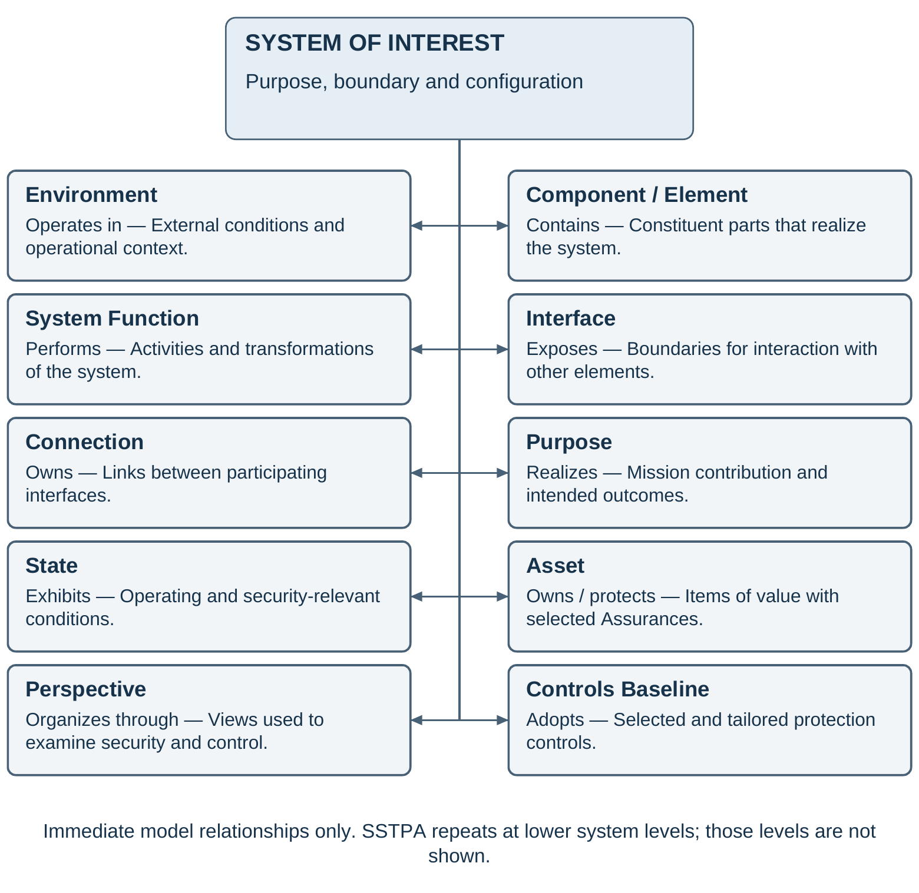
Figure 1. System of interest and its immediate model relationships

5 Methodology workflow
The workflow begins with externally established assets, stakeholder consequences, protection needs, and acceptance responsibilities. SSTPA records these inputs and establishes the system of interest and its baseline. Use case analysis explains intended interactions; functional and control analysis explains how those interactions are realized; state and environment analysis identifies the conditions under which behavior and protection change. Hazards and constraints are then refined in that context.
The analyst develops security requirements and countermeasures, examines feasible attacker behavior, and traces each asset through the functions, elements, interfaces, states, and transitions that expose it. Attack analysis and trace analysis inform each other. Their results populate the Loss attack tree for each selected asset, Assurance, and environment. Effort assessments and residual vulnerabilities are evaluated with the consequences of compromise. Verification and validation evidence then supports an assurance case and an acceptance decision.
The principal progression is:
• Receive approved asset and protection inputs from the external identification process.
• Define system purpose, boundary, architecture, and use cases.
• Analyze functions, control relationships, states, transitions, and environments.
• Identify hazardous conditions and derive constraints, controls, and requirements.
• Develop attack scenarios and trace state-dependent asset exposure.
• Construct and evaluate each scoped Loss attack tree and disposition residual vulnerabilities.
• Establish the assurance case, obtain and evaluate evidence, and support the responsible acceptance decision.
• Repeat the analysis at appropriate system tiers and maintain it through integration, operation, change, and disposal.
This sequence expresses dependencies rather than a one-pass lifecycle. Protection objectives and initial stakeholder consequences are established before threat catalogs are used to elaborate attack scenarios. Control analysis can reveal a missing environment or hazard; trace analysis can reveal an overlooked interface; an assurance argument can expose an unsupported assumption. The analyst returns to the earliest affected activity and updates downstream results. Functional and security engineering exchange these findings through the program's change process.
Two forms of repetition are essential. Iteration revisits a system's analysis when design, evidence, or acceptance is inadequate. Recursion applies the method to an element treated as a new system of interest. During integration, the composed system is reassessed for interactions that were absent from isolated subsystem analyses. Evidence from lower levels contributes to the parent case only within its stated assumptions and configuration.
Section 6 describes the activities in detail. Each activity produces reviewable engineering information and preserves its relationship to the asset protection objectives. Verification and validation planning and assurance-case development begin early and continue throughout the workflow, even though their consolidated treatment appears after Loss analysis.
Figure 2 restores the workflow presented as Figure 23 in version 14, redrawn with process names and legible engineering relationships. Enterprise models, customer obligations, and external asset identification feed the SSTPA analysis. Attack and trace results converge in Loss analysis, which supports the GSN assurance case. The return path highlights revision when the argument or evidence is inadequate. The arrows show principal dependencies; evidence planning and collection continue throughout the work.
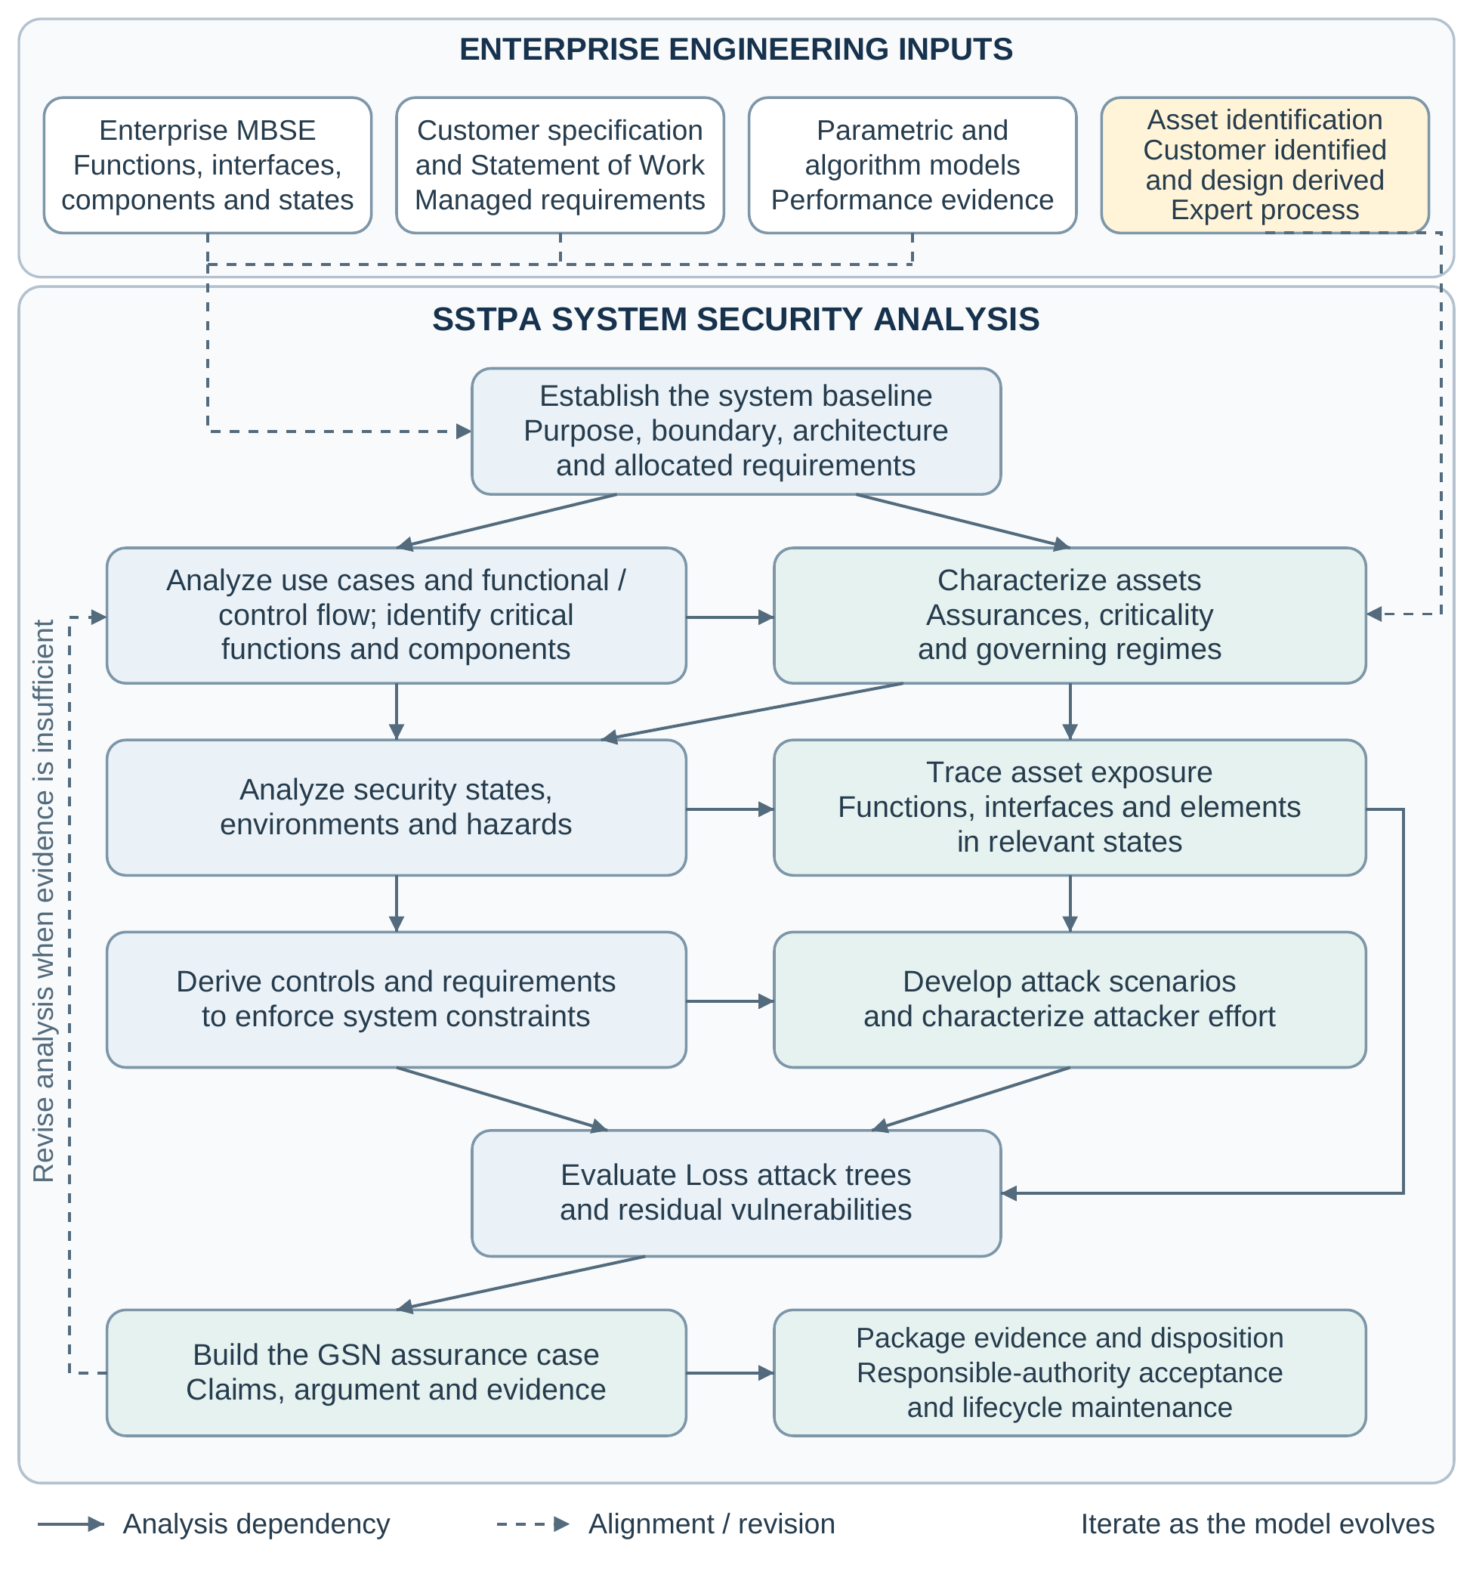
Figure 2. SSTPA methodology workflow, redrawn from version 14, Figure 23

6 Detailed methodology

6.1 Receive asset identification and protection decisions
Asset identification is outside the scope of SSTPA. Stakeholders and domain specialists identify items of value, establish the consequences of their compromise, and determine the initial protection needs. They distinguish assets required by the customer or governing regime from assets introduced by the proposed realization, such as credentials or enabling intellectual property. SSTPA receives the approved results, their ownership, and their rationale.
The analyst records each asset's meaning, boundaries, dependencies, applicable regimes, criticality, and selected Assurances. Each Assurance receives a violation criterion and operational context. The responsible authority identifies the acceptance criteria and evidence expectations. Conflicting obligations are resolved explicitly; a label such as mission critical is not sufficient to infer a particular control or assurance level.
The resulting asset and protection baseline supplies the scope for subsequent analysis. Discovery of a new credential, derived data product, or service dependency is referred back to the external identification process. Once accepted into scope, the asset is connected to the relevant architectural and behavioral views and its protection analysis is performed.

6.2 Define the system of interest and architecture
Define what the system is intended to accomplish, how it contributes to the larger capability, and which responsibilities fall within the analysis boundary. Identify external actors, neighboring systems, services, and environmental dependencies. Record constraints and assumptions about elements outside the designer's authority; external placement does not remove a dependency from the security analysis.
Establish the structural and functional baseline using the program's authoritative engineering information. Describe constituent elements, their responsibilities, interfaces, and connections. Include human and organizational elements where their decisions or actions affect protection. Allocate stakeholder and parent-system obligations at a level where responsibility can be understood and eventually verified. Use identifiers and configuration references to keep security views aligned with the broader architecture.
The model is an abstraction sufficient for the current decisions. Early analysis can use high-level descriptions; later decisions require more detail about implementation, timing, interfaces, or resource use. The required fidelity follows the security question. Missing detail is recorded as an assumption or open issue rather than treated as evidence of protection [21].

6.3 Analyze use cases and operational scenarios
Use case analysis establishes how actors interact with the system to achieve intended results. For each relevant use case, identify the actors, their authority, the initiating event, preconditions, normal progression, alternatives, exceptions, and expected outcome. Relate the interactions to the assets and Assurances they affect. Scenarios include operation, administration, maintenance, update, emergency response, recovery, and disposal where these are within the lifecycle scope.
Examine boundary interactions and authority changes. An operator allowed to load a configuration during maintenance may not be authorized to perform the same action during operation. A supporting service may return valid information too late to support the intended decision. These situations identify conditions for functional, state, and control analysis and expose assumptions about an actor's trustworthiness.
Use cases remain descriptions of intended interaction. Misuse and attack scenarios later challenge their assumptions. The output is a set of operational situations linked to functions, interfaces, assets, and expected protection conditions. Inconsistencies with stakeholder needs or the system boundary are resolved before these situations are used as the basis for detailed claims [22].

6.4 Analyze functional flow and control behavior
Functional flow analysis identifies the activities and transformations needed to realize each scenario. Follow information, material, or energy between functions and across interfaces; identify sequencing, concurrency, inputs, outputs, and dependencies. Allocate functions to the responsible elements and identify those whose behavior is critical to asset protection. Shared services, shared resources, and indirect dependencies receive the same attention as direct asset handling [8,22].
Figure 3 illustrates a linear functional flow: an input passes through successive functions to produce an output. This view explains transformation and sequence. It does not explicitly show an authority deciding whether the actions are appropriate, feedback about their effects, or a model of the controlled process. A larger system can contain this flow within a control loop even when the local flow drawing omits that loop.
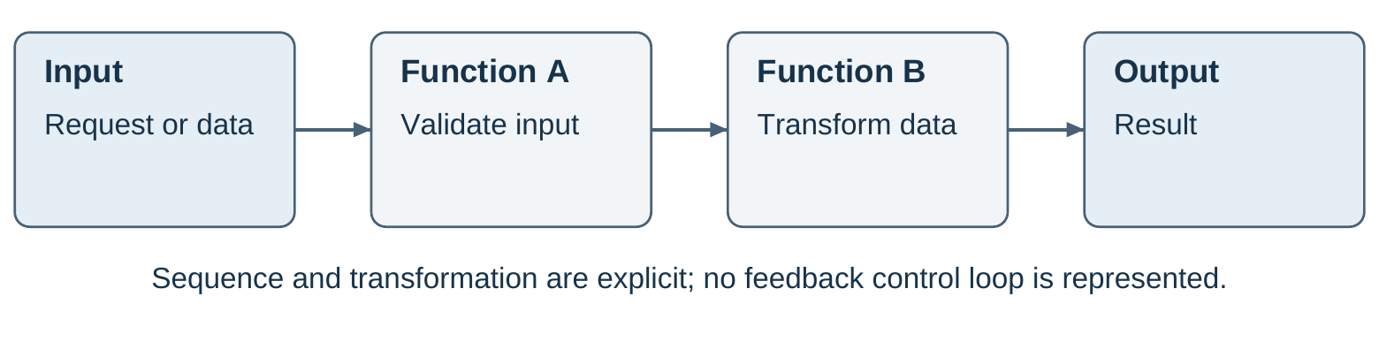
Figure 3. Linear functional flow from input through functions to output
The STPA control structure adds the decision and feedback relationships needed to analyze control. Identify the controller, its authority and control algorithm, the controlled process, the control actions it can issue, and the feedback used to update its process model. The process model represents what the controller believes about the controlled process and relevant context; it may differ from the actual state. Feedback updates that model, and the model informs or tunes subsequent control decisions. This does not necessarily mean automatic adaptation of controller parameters. Include interactions among controllers and between organizational and technical levels [1].
Figure 4 shows this feedback structure and names illustrative control-action and feedback messages. SetMode and EnableOutput represent commands to the controlled process; ModeStatus, IntegrityStatus, and HealthStatus provide observations used to update the process model. The diagram is an analytical view of responsibilities and information, so an implementation can distribute these responsibilities across several elements. Additional sensing, actuation, and communication detail is introduced when required by the analysis.
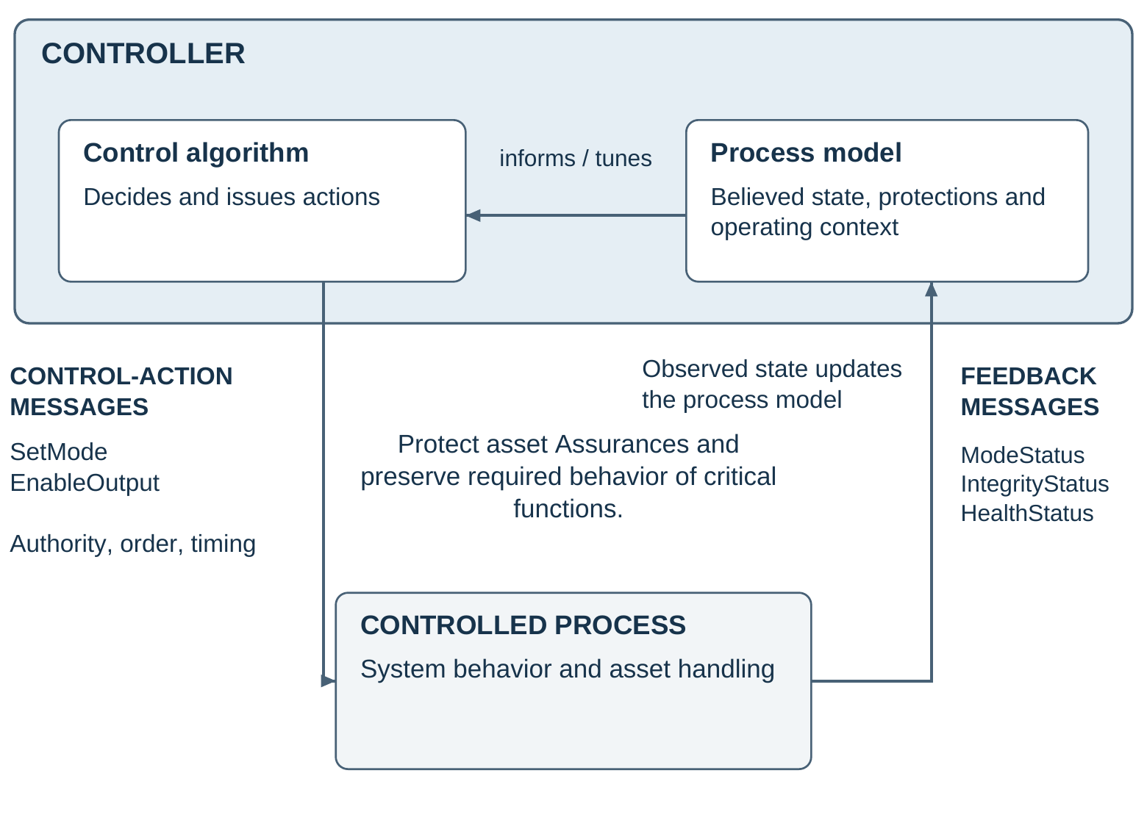
Figure 4. STPA feedback control structure with explicit control-action and feedback messages
Not every functional flow has the full feedback structure: a transformation pipeline or an open-loop activity may have no local feedback. SSTPA nevertheless recommends that secure systems employ the STPA control model for decisions that protect asset Assurances or govern critical functional flows, including flight-critical functions. Identify the appropriate enclosing control loop, or record and justify its absence. Criticality describes the consequences of inadequate behavior; the control loop preserves the required behavior of the critical function and the Assurances on affected assets.
Explicitly identify each control-action and feedback message, its sender and receiver, meaning, authority, triggering conditions, sequence, freshness, timing bounds, and expected response. Specify how authenticity and integrity are protected, how availability and confidentiality apply, and what happens when messages are missing, delayed, duplicated, replayed, or inconsistent. Feedback needs to establish the state relevant to the decision, rather than merely acknowledge receipt of a command. The existence of a loop alone does not establish that it is secure.
Apply STPA control-action analysis in the relevant contexts. Examine required actions that are not provided, actions whose provision creates a hazard, actions delivered too early or too late or in the wrong order, and continuous actions that persist too long or stop too soon. Record the action, responsible controller, contextual conditions, and linked hazard. An action name without context is not a complete unsafe-control-action statement [1, pp. 35–41].
Develop causal scenarios for inadequate control and for correct control actions that are not executed as intended. Consider process-model errors, missing or misleading feedback, authority conflicts, implementation deficiencies, resource limitations, and adversarial interference. Derive constraints and requirements addressing the causes. Preliminary hazards are refined as this analysis proceeds; a drawing of a control loop alone does not complete the analysis.

6.5 Analyze security states and transitions
Define state variables relevant to protection, including operating mode, authorization status, asset location or representation, active protections, and dependencies. Group conditions into security states where this makes the model understandable, while preserving the distinctions needed to analyze control decisions and attacks. Align these states with the program's functional and operational models.
For each transition, specify the triggering event, guard conditions, actions, relevant timing, and resulting state. Examine interruptions, incomplete transitions, concurrent activity, stale information, and unexpected re-entry. A correct protection condition at each endpoint does not establish protection during the transition. Startup, update, maintenance, failover, degraded operation, recovery, and disposal often change both exposure and authority.
An embedded-system secure-boot example can use the formal Open Mission Systems (OMS) subsystem states OFF, PRE_INITIALIZATION, INITIALIZATION, STANDBY, and OPERATE. In OMS, OFF means prime power is present but the subsystem is inactive; absence of electrical power is the distinct Unpowered condition. PRE_INITIALIZATION covers bootstrap and initial software loading, INITIALIZATION prepares the subsystem for mission use, and STANDBY precedes commanded operation. These are OMS subsystem states, not the separate OMS service-state vocabulary [23, §6.2.1].
Figure 5 shows selected startup transitions from OFF to OPERATE and overlays illustrative SSTPA security guards. Boot-chain authentication gates progress into INITIALIZATION; accepted configuration, completed self-tests, and active protections gate STANDBY; an authorized command and confirmed readiness gate OPERATE. The state names and startup path follow OMS, while these guards are proposed security design choices informed by firmware protection and recovery principles [23,24]. Failed checks inhibit entry into mission operation and invoke program-defined, authorized recovery. This is neither the complete OMS state machine nor a claim of OMS compliance.
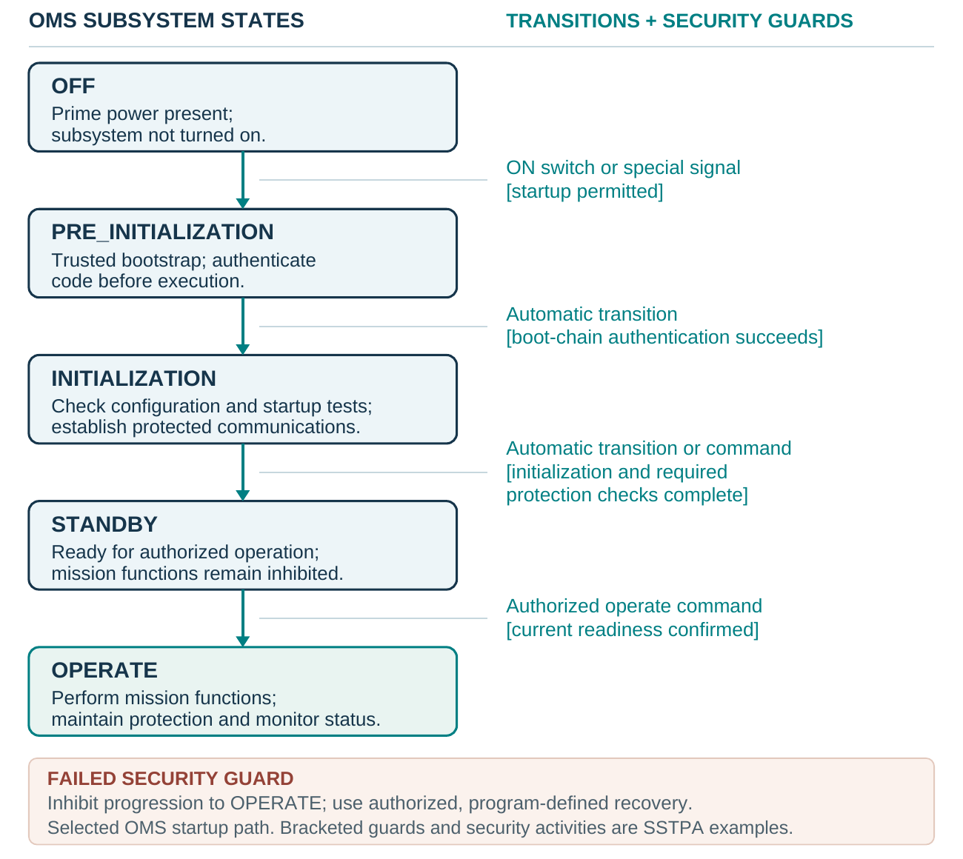
Figure 5. Illustrative secure boot using OMS subsystem states and SSTPA security guards
The security analysis follows the boot firmware asset and its integrity Assurance through loading, checking, handoff, and execution. It challenges the authenticity and protection of trust anchors, image and configuration acceptance, rollback policy, the interval between verification and use, and failure behavior. Feedback about boot status must reflect the current instance of startup; a stale ready indication cannot justify entry into OPERATE. Recovery paths receive the same scrutiny as the normal startup path [24].
The resulting state model provides context for hazards, attack feasibility, asset traces, and evidence. It preserves security objectives while distinguishing actual protection from confidence in that protection. Timing and transition coverage are reviewed with the behavioral model [8].

6.6 Define environments and attacker assumptions
Describe the environments in which the system is developed, deployed, operated, maintained, recovered, and retired as applicable to scope. Identify physical conditions, connectivity, external services, organizational arrangements, and relevant threat exposure. Establish which states and transitions are valid in each environment and which environmental changes require reanalysis.
Characterize attackers by capabilities and access relevant to the system. Record resources, knowledge, privileges, physical proximity, persistence, and opportunity where they affect feasibility or effort. A named threat category without these assumptions is insufficient for a reproducible Loss assessment. Distinguish facts supported by evidence from conservative assumptions and unresolved questions.
Each Loss retains one focal environment. Its attack tree can reference prerequisites established in another environment or earlier lifecycle stage, provided those dependencies and assumptions are explicit. For example, compromised maintenance credentials can persist into an operational environment. Analysts do not discard that history merely because the compromise objective is scoped to operation.

6.7 Identify hazards and derive security constraints
Starting from stakeholder consequences and asset protection objectives, identify system conditions that permit or lead to an Assurance violation. Express hazards as conditions of the system of interest, without prematurely limiting them to one exploit or failed component. Then identify the environmental circumstances in which the conditions produce the adverse outcome [1, pp. 17–20].
Keep threats, attacks, and hazards distinct. Replaying an obsolete authorization is an attack action; permitting commands on the basis of expired authority is a hazardous system condition. Threat catalogs can suggest how such a condition arises, but they do not replace the system-level reasoning that identifies what must be prevented.
Derive security constraints that prevent the condition or limit its consequences. Allocate responsibility for their enforcement and identify the information required to determine whether they hold. Constraints can address prevention, detection, containment, or recovery. Link them to hazards, Assurances, and stakeholder consequences so later design decisions remain traceable to purpose.
Non-adversarial causes identified here remain part of the engineering record. They can independently defeat protection or create preconditions an attacker exploits. Their evaluation is retained even where they are not themselves meaningful attack-tree branches with an attacker-effort value.

6.8 Develop controls and verifiable requirements
Controls must enforce system constraints. Select and tailor controls to prevent the hazardous conditions or limit the consequences identified in the system model. Relevant catalogs, regime obligations, and established engineering practices can supply candidates. Record why each control applies, which constraint it enforces, what responsibility it assigns, and any tailoring or exception. A catalog reference alone does not demonstrate implementation or effectiveness.
SSTPA promotes the imperative MUST for a parent control statement expressing a binding security condition. Specific implementing requirements use SHALL and trace to that parent. This distinction makes the required protection condition visible while allowing its realization to be allocated across systems, elements, procedures, and lifecycle activities. It is a proposed SSTPA authoring convention, not a universal systems-engineering distinction or a claim that MUST is intrinsically stronger than SHALL. Both impose mandatory obligations in this methodology [11].
Develop countermeasures as concrete protective behavior or features, then specify the SHALL requirements needed to realize them. Each requirement identifies a responsible subject, required behavior or property, relevant conditions, and objective verification criteria. Maintain its identifier, parent control, source, rationale, allocation, and planned verification method. A single MUST control can require several coordinated SHALL requirements; their combined satisfaction and interactions must be shown to enforce the parent constraint across the relevant states and environments. Merely collecting individually verified requirements does not establish that the control is effective.
Requirements specify what is required at their architectural level. Implementation choices are introduced deliberately through design and allocation, and required behavior is stated without relying on unexplained terms such as secure or robust. Review the resulting constraint-to-control-to-requirement chain for missing responsibilities, incompatible assumptions, bypass paths, and failure behavior. Use system-level verification and validation evidence to assess whether the implemented controls achieve the intended protection [11–13].
Review interactions among measures. A protective mechanism can impair availability, obstruct recovery, or create a new control dependency. Trace each requirement to its source and maintain the relationship among constraints, countermeasures, verification plans, and the protection claim. Feed required architecture changes back into the program baseline rather than treating the security model as an independent design authority [11].

6.9 Analyze attacks and feasible strategies
Attack analysis challenges the modeled protection under the declared attacker and environmental assumptions. Identify entry points, trust boundaries, exposed interfaces, relevant functions, and control or feedback paths. Consider direct compromise, misuse of legitimate authority, spoofed or delayed information, denial of service, and bypass of protective mechanisms as applicable to the specific system.
For each candidate strategy, document prerequisites, attack actions, required access and resources, affected architecture, and the resulting condition. Connect the strategy to the Assurance violation it could achieve. Reference catalogs can suggest techniques, but local feasibility depends on the system state, actual exposure, and countermeasures. Preserve evidence provenance and the reason for including or excluding a candidate.
Develop alternatives that avoid the strongest protection as well as attacks against it. Compromising a key-handling process may require less effort than breaking the cryptographic algorithm. The analysis therefore evaluates complete system strategies rather than assigning the algorithm's strength to every route to the asset. Attack results remain provisional until checked against the asset traces and state conditions.

6.10 Trace asset exposure and protection
Trace where each asset is held, transported, or used across elements, functions, interfaces, states, and transitions. Include copies, derived representations, caches, logs, temporary storage, and trust-boundary crossings when relevant to the selected Assurance. Record dependencies on external services and on protections allocated to other system tiers.
For each exposure, identify the applicable protection obligation, enforcement responsibility, countermeasure, and supporting requirement. Compare the trace with the attack scenarios. An alleged attack route may be impossible in the stated state; an unexamined copy may reveal a new route. Update both analyses until the model presents a consistent account of exposure and feasible attack behavior.
Review gaps in terms of the approved scope. Missing traces, unallocated protection, unsupported assumptions, or absent transition coverage become explicit findings. The completed trace is the basis for constructing Loss trees and for determining which claims and evidence are affected by a change. It is not a claim that merely touching an asset imposes identical requirements on every element.

6.11 Construct and evaluate Loss attack trees
Create a separate Loss for each selected combination of one asset, one Assurance, and one environment. State the configuration, attacker assumptions, assessment date, and precise violation criterion. The attack tree is the model of the effort needed to achieve that violation. Stakeholder consequences and applicable acceptance criteria are linked to the Loss but are not substituted for its effort meaning.
Decompose the root objective into feasible attack strategies. OR relationships represent alternatives; AND relationships represent conditions or subgoals that must be achieved together. Identify the states, transitions, architecture exposures, and countermeasures relevant to each strategy. Leaves describe assessable actions or prerequisites with a stated evidence basis. A successful strategy through AND conditions can involve several branches, so an individual root-to-leaf path is not necessarily a complete attack [18].
Assign effort using identified units and assumptions. Depending on the strategy, the assessment can involve computational work, time, cost, expertise, or access. Retain a vector or a justified qualitative scale where dimensions cannot be meaningfully combined. Define what each rating means and how reviewers can reproduce the judgment. For probabilistic attacks, state whether the estimate is expected effort to success or effort needed to reach a specified success probability, with the time horizon and assumptions about retries. Document uncertainty, evidence gaps, and changes in effort caused by countermeasures.
Where costs are comparable and additive, an OR choice is governed by the least costly feasible alternative, while an AND combination accounts for the required subgoals. These rules need qualification. Shared preparation, reusable credentials, parallel execution, repeated attempts, and ordering dependencies can invalidate a simple sum. A graph with shared subtrees requires explicit accounting for shared work; elapsed time and total work may aggregate differently [18,19].
If a single effort result is reported, it characterizes the least demanding feasible modeled strategy under the chosen measure and assumptions. An expensive branch cannot conceal a cheaper bypass. If strategies are incomparable, report the alternatives and their different resource demands. Finding no feasible strategy establishes neither infinite resistance nor complete coverage. The analyst records the search scope and the unresolved limitations.
Preserve dynamic semantics when the tree is acyclic. Relevant sequences, transition conditions, time windows, and prior-environment prerequisites are recorded with the attack strategy or linked behavioral model. Repeated behavior can be represented with explicit bounds or evaluated in a supporting analysis. A graph path is accepted as an attack strategy only after feasibility has been established.
Identify residual vulnerabilities and their associated effort after the selected countermeasures are considered. Dispositions include eliminated, blocked under stated assumptions, accepted under documented conditions as an ARV, deferred, and unresolved. Only a responsible authority can accept the associated risk. Deferred or unresolved findings remain visible and cannot support an unconditional closure claim. Comparison between configurations uses equivalent scope and effort assumptions so changes in resistance can be interpreted.

6.12 Plan and obtain verification and validation evidence
Plan verification as requirements are developed. Identify the configuration, criteria, method, responsible party, and expected evidence for each protection obligation. Obtain results showing whether requirements and interfaces are satisfied, including relevant negative behavior, degraded conditions, and enforcement of state-transition constraints. Failed checks and unexplained deviations return to analysis and design [12].
Plan validation against stakeholder protection needs and intended use in the stated environments. Evaluate whether the composed security solution is suitable for its purpose, including operator behavior, recovery, usability of security functions, and mission effects. Validation scenarios challenge assumptions that individual requirement checks may leave untested. Evidence can combine analysis, inspection, demonstration, and testing as appropriate to the claim [13].
Loss effort assessments need their own support. Record whether estimates arise from measured work, established cryptanalytic results, demonstrations, analytical models, or expert judgment, with applicable uncertainty. Planned checks are evidence of a plan, not evidence that the realized system has passed them. Maintain the distinction in both the model and the assurance case.

6.13 Generate and evaluate the assurance case using GSN
Develop the assurance case around bounded claims about asset protection and suitability for acceptance. State the configuration, asset scope, Assurances, environments, attacker assumptions, and applicable regime. GSN expresses claims as goals, the reasoning used to organize them as strategies, relevant context and assumptions explicitly, and references to evidence as solutions. A GSN solution is an evidence reference, not a synonym for a security countermeasure [14].
Use the connected model to generate the initial argument structure and its evidence links. Supporting claims address the adequacy of the system model, coverage of hazardous and adversarial scenarios, enforcement of constraints, sufficiency of Loss effort assessments, and satisfaction of requirements and stakeholder needs. Organize the argument according to the actual reasoning; copying the system decomposition into a goal hierarchy does not automatically justify the claims.
For a Loss-related claim, explain why the modeled strategies and their assessed effort support the required level of resistance under the stated conditions. Relate this conclusion to stakeholder consequences and acceptance criteria. Address common assumptions and shared dependencies explicitly so that evidence reused across claims does not imply independence where none exists. Include non-adversarial scenarios through the relevant protection claims rather than forcing them into the custom Loss metric.
Review the argument's reasoning, evidence quality, configuration applicability, and unresolved findings. Retain contrary evidence and assumptions requiring operational monitoring. GSN makes the argument inspectable; its notation and automatic generation do not demonstrate that the argument is sound or sufficient [14]. If support is inadequate, revise the earliest affected analysis or design activity and regenerate the dependent portions of the case.
Figure 6 illustrates a GSN argument for one asset, one Assurance, and one environment: boot firmware integrity during embedded-system startup. Its strategy addresses image validation, preservation of the verified image until execution, and prevention of entry into OPERATE after a failed check. Solution nodes identify validation and rollback-test results, protected-handoff analysis and tests, and failure-injection and state-transition tests. The rectangles, parallelogram, context capsule, assumption oval, solution circles, and directed relationships follow the GSN Community Standard [14]. Braces and hollow triangular decorators identify uninstantiated evidence references; this example is not a completed assurance case.
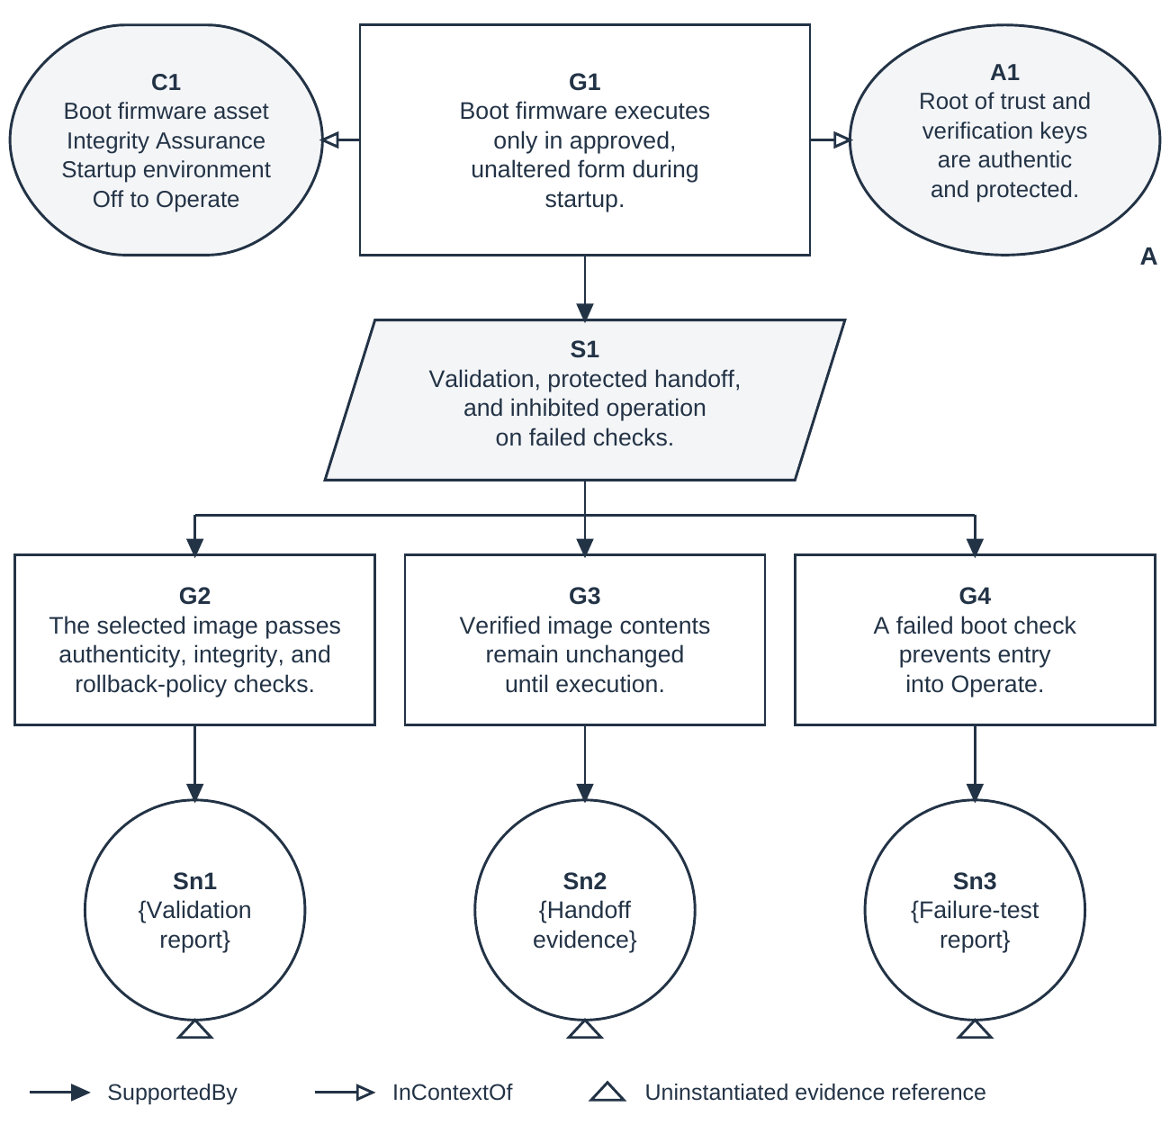
Figure 6. Illustrative GSN argument for boot firmware integrity
The responsible authority records acceptance or rejection, conditions of use, applicable obligations, affected configurations, and reassessment triggers. ARV decisions identify the residual vulnerability and associated risk being accepted. The assurance case supports this decision without replacing it [5].

6.14 Recurse integrate and sustain the analysis
At project inception, establish the capability context and the initial systems of interest. When an element requires more detailed realization, treat it as a new system of interest and repeat the applicable activities. Carry forward allocated requirements, related assets and Assurances, interface obligations, and assumptions. Record newly identified needs and resolve their relationship to the parent protection objectives. Re-establish exposure traces at the child level instead of assuming that the parent's view supplies the required detail.
During integration, evaluate the composed behavior. Shared resources, interacting controllers, interface timing, incompatible assumptions, and emergent attack routes can undermine protection even when individual elements meet their requirements. Reassess parent hazards and Loss trees using the realized composition and actual evidence. Child assurance cases contribute only within the conditions for which their claims are supported.
Maintain this process through operation, maintenance, upgrades, recovery, and disposal. Changes to architecture, environments, attacker capabilities, protection obligations, or evidence can affect the validity of a Loss assessment or acceptance decision. Trace the change to affected requirements, analyses, and claims; revise the relevant work; and obtain renewed decisions where required. Iteration, concurrent work, and recursion support this lifecycle rather than occurring only at the end of a fixed sequence [20].

7 Engineering outputs and closure
The engineering product is a security solution whose rationale and evidence can be inspected. Its connected records include the approved asset and Assurance scope, relevant architecture and behavior, environments and attacker assumptions, hazards and constraints, allocated requirements and countermeasures, exposure traces, scoped Loss attack trees, verification and validation results, and the assurance case. Each record has an identifiable configuration and relationship to the protection need it addresses.
Closure is judged against approved coverage criteria. The analysis explains which states, transitions, environments, interactions, attack strategies, and non-adversarial scenarios have been examined and why that scope is adequate for the decision. Each identified residual vulnerability has a documented disposition. Unknowns and insufficient evidence remain findings, and any operating restriction or conditional acceptance is visible in the case. Acceptance does not convert an unresolved technical question into a demonstrated fact.
SSTPA Loss provides an explicit account of the effort required to violate an Assurance on an asset in an environment. Keeping that measure distinct from consequence and risk allows reviewers to assess both resistance and what is at stake. The graph model supports traceability; systems-theoretic analysis supplies behavioral reasoning; verification, validation, and GSN arguments support confidence. Continued adequacy depends on maintaining their consistency as the system and its context change.

8 References
STPA terminology and method follow the handbook [1]. SSTPA-specific definitions, including Loss, Assurance, and ARV, are defined in this paper and are not presented as definitions adopted by the cited organizations. Online references were accessed on 4 October 2026.
[1] Leveson, Nancy G., and John P. Thomas. STPA Handbook. MIT Partnership for Systems Approaches to Safety and Security, March 2018. https://psas.scripts.mit.edu/home/get_file.php?name=STPA_handbook.pdf
[2] Young, William, and Nancy G. Leveson. Systems Thinking for Safety and Security. Proceedings of the 29th Annual Computer Security Applications Conference, 2013, pp. 1–8. DOI: 10.1145/2523649.2530277. https://dspace.mit.edu/entities/publication/c43a36bd-46c9-4a85-8ffb-35d8764b57a3
[3] Leveson, Nancy. Safety and Security Are Two Sides of the Same Coin. In The Coupling of Safety and Security, Springer, 2020. https://doi.org/10.1007/978-3-030-47229-0_3
[4] Ross, Ron, Mark Winstead, and Michael McEvilley. Engineering Trustworthy Secure Systems. NIST Special Publication 800-160, Volume 1, Revision 1, November 2022. https://doi.org/10.6028/NIST.SP.800-160v1r1
[5] Joint Task Force. Risk Management Framework for Information Systems and Organizations: A System Life Cycle Approach for Security and Privacy. NIST Special Publication 800-37, Revision 2, December 2018. https://doi.org/10.6028/NIST.SP.800-37r2
[6] SEBoK Editorial Board. Guide to the Systems Engineering Body of Knowledge (SEBoK), version 2.14, released 18 May 2026. N. Hutchison, Editor in Chief. The Trustees of the Stevens Institute of Technology. https://sebokwiki.org/wiki/Guide_to_the_Systems_Engineering_Body_of_Knowledge_(SEBoK)
[7] SEBoK Editorial Board. Engineered System Context. SEBoK, version 2.14, 2026. https://sebokwiki.org/wiki/Engineered_System_Context
[8] SEBoK Editorial Board. Logical Architecture. SEBoK, version 2.14, 2026. https://sebokwiki.org/wiki/Logical_Architecture
[9] SEBoK Editorial Board. System Assurance (glossary). SEBoK, version 2.14, 2026. https://sebokwiki.org/wiki/System_Assurance_(glossary)
[10] Barker, Elaine. Recommendation for Key Management: Part 1 — General. NIST Special Publication 800-57 Part 1, Revision 5, May 2020, Section 5.6. https://doi.org/10.6028/NIST.SP.800-57pt1r5
[11] SEBoK Editorial Board. System Requirements Definition. SEBoK, version 2.14, 2026. https://sebokwiki.org/wiki/System_Requirements_Definition
[12] SEBoK Editorial Board. System Verification. SEBoK, version 2.14, 2026. https://sebokwiki.org/wiki/System_Verification
[13] SEBoK Editorial Board. System Validation. SEBoK, version 2.14, 2026. https://sebokwiki.org/wiki/System_Validation
[14] SCSC Assurance Case Working Group. Goal Structuring Notation Community Standard, Version 3. SCSC-141C. Safety-Critical Systems Club, May 2021. https://scsc.uk/scsc-141c
[15] Neo4j. Graph Database Concepts. Getting Started documentation. https://neo4j.com/docs/getting-started/appendix/graphdb-concepts/
[16] Neo4j. What Is Cypher? Getting Started documentation. https://neo4j.com/docs/getting-started/cypher/
[17] Neo4j. Variable-length Paths. Cypher Manual. https://neo4j.com/docs/cypher-manual/current/patterns/variable-length-paths/
[18] Schneier, Bruce. Attack Trees. Dr. Dobb's Journal, December 1999. https://www.schneier.com/academic/archives/1999/12/attack_trees.html
[19] Budde, Carlos E., and Mariëlle Stoelinga. Efficient Algorithms for Quantitative Attack Tree Analysis. arXiv:2105.07511, version 2, 22 May 2021. https://arxiv.org/abs/2105.07511
[20] SEBoK Editorial Board. Process Concurrency, Iteration, and Recursion. SEBoK, version 2.14, 2026. https://sebokwiki.org/wiki/Process_Concurrency,_Iteration,_and_Recursion
[21] SEBoK Editorial Board. System Modeling Concepts. SEBoK, version 2.14, 2026. https://sebokwiki.org/wiki/System_Modeling_Concepts
[22] SEBoK Editorial Board. Functional Architecture. SEBoK, version 2.14, 2026. https://sebokwiki.org/wiki/Functional_Architecture
[23] Open Architecture Collaborative Working Group. Open Mission Systems (OMS) Standard, Version 2.5. OMSC-STD-001, Revision M, 22 January 2026, §6.2.1, Figures 6.2-2–6.2-3 and Table 6.2-1, pp. 36–42. https://guide.dafdto.com/wp-content/uploads/2026/03/02_OMSC-STD-001_RevM_OMS_Standard_DandD_v2_5.pdf
[24] Regenscheid, Andrew. Platform Firmware Resiliency Guidelines. NIST Special Publication 800-193, May 2018, §§4.1, 4.3–4.4. https://doi.org/10.6028/NIST.SP.800-193

