System Security-Theoretic Process Analysis
(SSTPA)
A Systems-Theoretic Methodology for the Specification of Complex Engineered Systems Requiring Security Assurances

TECHNICAL WHITE PAPER
Version 13 | 13 September 2026

1. Abstract
System Security-Theoretic Process Analysis (SSTPA) is a human- and asset-centered systems security engineering methodology for developing secure complex hierarchical engineered systems so they can support certification and authorization decisions under applicable regimes (for example aviation software assurance [22] and product cybersecurity obligations [23] as illustrative regime contexts). Under SSTPA, Loss is defined as the compromise of a security attribute on an asset, and analysis is disciplined into verifiable security requirements, residual-vulnerability disposition, and Goal Structuring Notation (GSN) assurance arguments [12]. SSTPA Tools implement the methodology as a Model-Based Systems Engineering (MBSE) environment on a graph database: Add-on Tools decompose and analyze each System of Interest (SoI), create security controls and countermeasure requirements, and capture verification and validation (V&V) evidence during integration so GSN arguments can be evidence-backed.
SSTPA does not replace enterprise tools for functional capability development. In a traditional program environment, DOORS (or equivalent) [24] owns requirements configuration management, Cameo (or equivalent SysML MBSE) [25] is the source of truth for functions, interfaces, and components, and MATLAB (or equivalent) [26] owns parametric and algorithmic models. The SSTPA analyst faithfully copies that functional architecture into SSTPA and concentrates on the System Security Solution—assets, regimes, assurances, hazards, controls, attacks, loss trees, and assurance arguments—from project inception through sustainment to end of life.
This white paper introduces SSTPA’s human- and asset-centered framing and security attributes, then specifies the methodology workflow and the Add-on Tools used to execute it. It situates SSTPA in the surrounding enterprise tool-chain, explains the graph-model foundation [10] and the System Model layer by layer, presents project-inception and recursive Tier-n patterns, catalogs the Add-on Tools in rough order of use, details the fourteen execution steps (including the Step 13→7 revision loop and the Step 14 hierarchical recursion), and closes with the step–tool matrix and the path from analysis to evidence packages.
Keywords: systems security engineering; STPA; STPA-Sec; MBSE; Neo4j; SysML 2; KerML; asset assurance; attack trees; Goal Structuring Notation; certification; System Model

2. Introduction to SSTPA
Engineering security for complex systems requires reasoning about interactions among technical elements, people, operational processes, and adversaries. Protection can be weakened by feedback, shared resources, changing operating conditions, and combinations of behavior that are not apparent when components are assessed individually [2][4]. Security analysis must therefore address the system’s composition and operating context, as well as the properties of its individual elements [3]. System Security-Theoretic Process Analysis (SSTPA) is a human- and asset-centered methodology for the development of secure engineered systems and their assured realization and life-cycle sustainment. SSTPA organizes this analysis around assets and protection objectives, connecting identified loss scenarios to security requirements, verification and validation evidence, and decisions by the responsible acceptance authorities. It supports a structured assessment within an explicit scope and set of assumptions; it does not establish that every possible attack has been identified.
The methodology is human centered because its central product is validatable systems with verifiable security requirements and comprehensive risk assessments that SSTPA defines as “Loss.” Under applicable regimes, only the responsible authorizing officials (or equivalent acceptance authorities) can accept the residual risk of loss [17]. It is that risk of loss that ultimately drives security requirements.
The methodology is asset centric because SSTPA defines “Loss” as the compromise of a security attribute on an asset. Under SSTPA’s modeling choice, assets are items of value requiring protection—including software, logic-ware, hardware, and data—whose security-attribute compromise would cause harm to system stakeholders [4]. Under SSTPA, all security requirements, verification of those requirements, and validation of the security solution for the component system must be traceable to protection objectives on specific assets.
By extending the concept of “asset” and security attributes beyond that traditionally used for cyber-security, the SSTPA methodology becomes applicable to more domains such as safety and surety (proposed applicability). The security attributes used by SSTPA include:
- Confidentiality – accessible only to authorized parties [21].
- Integrity – protected from unauthorized modification or destruction [21].
- Availability – usable on demand by authorized entities [21].
- Authenticity – genuine and able to be verified (including digital-identity contexts [6]).
- Non-Repudiation – evidence of origin or occurrence of actions can be established under stated assumptions [7].
- Privacy – individuals’ privacy risks managed in accordance with applicable privacy objectives [19].
- Trustworthiness – worthy of confidence that required behavior is met [4].
Certifiability – under SSTPA, defined as the ability to achieve and maintain certification in its regime (SSTPA-defined protection objective).

The body of this work describes the SSTPA methodology but as introduction it can be thought of as a linear process (the loops and external relationships shown in Figure 23 are omitted). Conceptually, the process goes as follows:
- Identify, characterize and approve Assets to include assignment of security assurance requirements
- Describe system architecture through decomposition into Elements, Functions and Interfaces
- Perform Critical Function / Critical Component analysis to map functional flow around the Asset
- Allocate security assurance requirements to System Elements, Functions and Interfaces
- Define System Security State behavior to include states and state transition criteria and align to system functional states
- Define the system Environment and align with System Security States
- Identify Hazards (threats) in each Environment and capture their Tactics, Techniques and Procedures (TTPs) in addition to their capabilities and limitations in the Environments
- Develop Controls to mitigate the Hazards in each Environments
- Develop security features to implement those controls and define with Requirements
- Trace dynamic behavior of Assets through Elements and Security States
- For each Asset Assurance in a single Environment, Perform Loss Analysis to define Residual Vulnerabilities (RV) (The RV is a path a valid threat actor would need to take in the environment to compromise the security assurance on the Asset)
- For each Loss, develop a structured argument to accept the risk associated with the RV
- If the responsible acceptance authority under the Asset’s Security Regime finds the residual risk acceptable (with any stated conditions), SSTPA records the residual vulnerability with disposition Allowed Residual Vulnerability (ARV)—SSTPA’s term for an accepted residual vulnerability under documented conditions [17]. Other SSTPA dispositions include eliminated, blocked under stated assumptions, accepted with conditions, deferred pending evidence, or unresolved. If residual risk remains unacceptable or evidence is insufficient, cycle back and revise until each identified scenario has a documented disposition consistent with the approved analysis scope—or escalate for redesign when acceptable risk cannot be achieved.
The SSTPA Methodology is neither new nor unique. It combines established methods: its language borrows from STPA (described below) and incorporates STPA analysis in functional flow analysis. The body of this work describes the implementation of the SSTPA methodology using the software application SSTPA Tools. Many key aspects of SSTPA cannot be done using any tool. These include Asset identification and risk acceptance by the responsible authorities under one or more regimes [17]. Likewise, SSTPA Tools provides configuration management for the system security solution but like all configuration management tools it must be attended to throughout the life-cycle of the system.

3. Purpose and positioning in the MBSE ecosystem

3.1 Systems Theory and STPA
System-Theoretic Process Analysis (STPA) was developed at MIT by Nancy Leveson and John Thomas from the System-Theoretic Accident Model and Processes (STAMP) [1][2]. Its founding insight is that in complex systems, losses are not merely the sum of component failures: accidents also arise from unsafe interactions among components, none of which may have failed. STPA therefore casts safety in systems-theoretic terms:
- system behavior emerges from interactions between components;
- safety is enforced through constraints on that behavior;
- constraints are regulated by control loops — control actions, feedback, and the process models controllers hold; and
- loss arises from inadequate enforcement of constraints — control actions that are missing, mistimed, or improperly coordinated.
Process analysis is the analysis of these dynamic control and feedback processes over time: how the system’s decision and control structures perform the mission, and how they adapt — or fail to. Leveson and Young extended this thinking toward security, observing that security analysis should focus on controlling vulnerabilities rather than solely on avoiding threats [3]. That observation is the point of departure for SSTPA.

3.2 What SSTPA Changes
System Security-Theoretic Process Analysis (SSTPA) carries the systems-theoretic viewpoint into security engineering [1][2][3], analyzing how adversarially influenced, degraded, or improperly controlled interactions and information flows reduce asset protection, violate security constraints, or compromise mission objectives. STPA already addresses stakeholder losses beyond a single notion of safety [2]. SSTPA’s differentiator is its particular combination of asset-, property-, and regime-organized analysis, traceability, attack modeling, and acceptance workflow: under SSTPA, a loss occurs when a security attribute on an asset is compromised, and the same asset may carry different protection objectives under different regimes.
The pivotal theoretical change concerns Loss itself. In STPA, loss is the condition to be avoided [1][2]. SSTPA is tailored to certification and authorization regimes in which responsible authorities decide which residual vulnerabilities are acceptable under stated conditions [17]. Under SSTPA, Allowed Residual Vulnerability (ARV) is SSTPA’s disposition term for a residual vulnerability accepted under documented conditions—not a claim that ARV is a universal official term of every regime. Concretely, a Loss in SSTPA is analyzed as a directed acyclic graph of system behavior — an attack tree [15] — rooted at the compromise of a single security attribute, on a single asset, in a single environment. Each branch of the tree is a path by which the compromise could occur; each path terminates in the effort and preconditions the threat requires. Analysis closure is assessed against the approved asset scope, architecture baseline, operating environments, threat assumptions, and coverage criteria: each identified scenario receives a documented SSTPA disposition (for example eliminated, blocked under assumptions, accepted with conditions as an ARV, deferred, or unresolved) and supporting rationale. Scenarios that remain unacceptable or lack sufficient evidence prevent closure [17].

3.3 Why SSTPA
The systems-theoretic premise that both component weaknesses and interactions matter—and that interaction-related losses are easily missed when parts are assessed only in isolation—is no longer an academic position [2][3]. In a 2026 joint advisory on agentic AI, the cyber defense agencies of Australia, the United States, Canada, New Zealand, and the United Kingdom put it plainly:
“Agentic AI systems are complex ecosystems of LLMs, humans, guardrails, datasets, tools and hardware, where security risks often emerge from interactions between components rather than isolated flaws. Traditional component-level analysis is insufficient and monitoring these systems is equally challenging due to blurred thresholds for decision-making, long reasoning chains and massive, often redundant logs. Localised logging methods rarely provide full visibility, making system-theoretic approaches essential for understanding and mitigating risks across the entire architecture.” [11]
The joint guidance on agentic AI recommends systems-theoretic analysis, including STPA and STPA-Sec, to address risks arising across interacting components [11]. SSTPA seeks to operationalize compatible reasoning through state-scoped asset exposure, control analysis, requirements traceability, and assurance arguments. The guidance supports this general direction; it does not endorse SSTPA. Evaluation of SSTPA itself requires separate evidence of analytical coverage, usability, and results.

3.4 What SSTPA is for
SSTPA addresses the gap between conventional systems engineering—optimized for primary behaviors that stakeholders fund and procure—and the evidence a trust authority needs in order to accept residual risk. Security that enters late, as catalog conformance, or as a terminal documentation event struggles to demonstrate that a complex system is sufficiently secure for authorization. SSTPA treats security as an engineered control problem: analysis is asset- and loss-centric; threats are inputs to scenario construction; and each Loss is dispositioned under SSTPA (including to Allowed Residual Vulnerabilities where accepted) and argued in GSN [12] as a native product of the analysis.
The methodology is not brand-new invention. It adapts existing system security engineering processes—STPA and STPA-Sec lineage [1][2][3], NIST SP 800-160 / 800-53 / RMF practice [4][5][17], CNSSI categorization [18][21], and assurance-case standards [12][14]—into an MBSE practice executed on a graph database [10]. Top-down capability decomposition applies whether subsystems are outsourced via system specification and Statement of Work (SoW) or developed internally; the same rigor applies at every tier.

3.5 What SSTPA is not for
SSTPA is not the focus for developing functional capability. Enterprise tools are better suited to modeling, analysis, and configuration management of functional systems:
Table 1. Division of labor between enterprise tools and SSTPA Tools.
Concern | Typical enterprise source of truth | SSTPA role
Requirements CM (functional and contractual) | DOORS (or equivalent) | Align; when SSTPA says Requirements, it means System Security Requirements
Functions, interfaces, components, use cases, trade studies | Cameo / SysML MBSE | Faithfully copy; narrative descriptions often suffice for critical-function / critical-component analysis
Parametric models, algorithms, performance | MATLAB (or equivalent) | Outside SSTPA; informs Flow analysis when needed
Horizontal / organic asset identification | Expert process, largely outside SSTPA today | Seed Asset Manager; regimes and assurances follow
System Security Solution | — | SSTPA Tools are the source of truth
Asset identification remains a key early step and is largely performed outside SSTPA today: horizontal assets (for example Critical Program Information expectations, flight-critical Vehicle Management System expectations) versus organic assets (critical enabling intellectual property) discovered through critical analysis. Once assets are identified, regimes and assurances are recorded in SSTPA and drive the remainder of the security workflow.

3.6 The Vocabulary of Assurance
Because SSTPA follows an architectural approach to security rather than a compliance model, its terms deserve precise definition. These terms are used consistently throughout this paper and throughout the application. SSTPA distinguishes a security attribute, such as confidentiality or integrity, from assurance: the justified confidence that the required property holds. A Loss specifies an adverse outcome affecting an asset’s protection objective. Loss Analysis records the modeled scenarios that could produce that outcome. A residual vulnerability is a remaining weakness or enabling condition after the selected protections are considered. The responsible authority determines whether the associated residual risk is acceptable within the stated operational scope and applicable obligations [4][17]. SSTPA records that decision and its conditions; it does not equate the existence of an argument with acceptance.
Asset. Under SSTPA, an item of value requiring protection to prevent harm to stakeholders (tangible or intangible—software, data, credentials, functions, intellectual property, and similar). The protected asset is distinct from any hosting Component.
Security attribute (protection objective). A protective property required on an asset. Definitions are grounded in established standards where applicable: Confidentiality, Integrity, and Availability (FIPS 199 [21]); Authenticity (including digital-identity guidance in NIST SP 800-63 [6]); Non-Repudiation (ISO/IEC 27000 [7]); Trustworthiness (NIST SP 800-160 [4]); and Privacy (NIST Privacy Framework [19]). Certifiability is SSTPA-defined: the ability to achieve and maintain certification within its regime. (Schema fields may still use a legacy label such as “Assurance” for these attributes; in prose, “assurance” means justified confidence that a required property holds.)
Criticality. A property derived from an asset, measured in type, regime, and degree. Because an asset carries a criticality, every element hosting it and every function and interface using it inherits that criticality — and with it, inherited design and development obligations. SSTPA Tools currently supports the following criticalities: Flight, Safety, Mission, Security, and Nuclear. Other criticalities will be added in the future.
Constraint vs. Control vs. Countermeasure. In this paper, constraint is reserved for general system constraints (“the system SHALL weigh 35 kg or less”). Controls are aspirational statements to mitigate Hazards using the imperative “Must” rather than the requirement imperative “Shall”. Countermeasures are derived system features — behaviors stakeholders are willing to pay for, on equal footing with functional features. Countermeasures are defined by requirements using the imperative “Shall”.
Regime. The socio-technical system that grants certification. From political science, a regime comprises the rulers who create and enforce rules and judge compliance; the relationship between rulers and ruled; and the documented and tribal knowledge of acceptable behavior. Every regime has its own appetite for risk and its own weighting between compliance frameworks and analyzed risk.
Verification and Validation. Verification confirms a requirement was implemented correctly (“was it built right?”). Validation confirms the realized system fulfills its purpose (“was the right thing built?”). All requirements have Verification whose criteria “shall” be met by Inspection, Demonstration, Analysis or Test. All Systems have Validation which must be tested prior to that system’s integration into a lower tier (up the right side of the Systems engineering Vee diagram [13][20]).

3.7 Add-on Tools and order of operations
Add-on Tools operate independently on a selected System of Interest. They enrich and manipulate nodes and relationships in an MBSE environment aligned with SysML 2.0 concepts [8] where applicable and mapped to KerML 1.0 concepts [9] otherwise; this paper does not claim full language conformance unless separately demonstrated. The methodology implies an order of operations; the tools themselves do not enforce that order. Expert use requires knowing the proper methodology tool sequence rather than any internal listing order.
Admin Tool and Message Center belong to installation, account stewardship, and data-ownership messaging. They are out of scope for the methodology execution workflow described here.

4. Graph-model foundation and System Model
SSTPA as a methodology is tool agnaustic but it does rest on specific model of the “System”. This begins with the concept of a “Capability” developed and realized by a “Project”. Neither are themselves treated as systems. The methodology posits systems decomposed in tiers implementing the capability. All systems have the same rich model structure and can be decomposed through their elements to any depth.
This section describes the system model used by the SSTPA Tools application to implement the methodology.

which implements the SSTPA Methodology manages the hirarchical arangemnt of systems using a graph database

Graph database foundation
SSTPA Tools store the system security model in a Neo4j graph database [10] rather than in a relational (SQL) schema of joined tables. In a graph:
- Data are nodes and relationships, each carrying key–value properties.
- Queries use Cypher, a human-readable language whose patterns resemble the model itself (for example a Component that parents a System).
- Hierarchical systems map naturally to parent/child and allocation relationships; practical depth is limited by memory and query time, not by fixed schema join depth.
This organization supports indefinite recursive decomposition of a Capability into Tier-1 … Tier-n Systems: each Component designated as a new System receives a subordinate SoI sub-graph of the same form.
Naming note. In systems engineering, Element is the proper term [20] for a constituent of a system. KerML 1.0 [9] defines an Element metamodel concept; Element is not presented here as a KerML reserved word. SSTPA’s naming choice is to label that constituent Component to avoid conceptual ambiguity with KerML’s Element. Throughout this paper, Component means the SSTPA schema label for what SE practice calls an element; Element may appear in prose as the SE concept.
The remainder of this section walks the System Model layer by layer in plain language. For each layer, a short narrative introduces the relationship table and diagram. Relationship type names appear in the tables for precision; the narrative uses ordinary verbs such as owns, contains, and connects.

Bookkeeping and partitions
Every engineering node carries light bookkeeping—display name, hierarchical identifier, unique id, type, owner and creator, timestamps, and schema version—so stewardship and traceability stay with the data. The model is partitioned into three areas: Core (the editable SoI engineering graph), Reference (read-only imported catalogs that are cloned into Core when selected), and User (people, mailboxes, and messages that support ownership and collaboration).
Table 2. Common bookkeeping properties on Core nodes.
Property | Role
Name | display name
HID | hierarchical identifier
uuid | unique identifier
TypeName | canonical node type
Owner / OwnerEmail | data owner (transferable)
Creator / CreatorEmail | immutable creator
Created / LastTouch | timestamps
VersionID | data schema version
Table 3. Data partitions: Core, Reference, and User.
Partition | Contents | Mutability
Core | SoI engineering graph under Project/Sandbox | editable under ownership and SoI rules
Reference (REF) | imported catalogs (ATT&CK, ATLAS, NIST SP 800-53, EMB3D, …) | read-only; selected items are cloned into Core
User | users, mailboxes, messages; ownership metadata on Core | messaging supports stewardship, not the engineering export set

4.1 Project / Capability
A project—also called a Capability in SSTPA—is the top of the model. It holds the customer’s overall requirements and owns the Tier-1 systems that make up the architecture. From here, work is allocated downward into each system. A Sandbox is a disposable Project owned by a specific user and can be used for out of band development and tutorials.
Figure 1 and Table 4 show how a Project (or Sandbox) owns Tier-1 Systems and capability-level requirements.
Table 4. Project / Capability.
Type | Source → Target | Meaning
HAS_SYSTEM | Project → System | project/capability owns Tier-1 Systems
HAS_SYSTEM | Sandbox → System | sandbox owns Systems (separate from project lineage)
HAS_REQUIREMENT | Project → Requirement | capability-level requirements
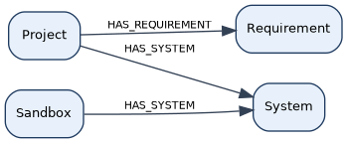
Figure 1. Project / Capability relationships: ownership of Tier-1 Systems and capability-level requirements.

4.2 System
A System is the unit of analysis—the System of Interest. It brings together what the system is for, what it contains, what it does, how it connects to others, how it behaves over time, what must be protected, and which security baseline applies. Everything else in the security model hangs from this system view.
Figure 2 and Table 5 summarize the System’s principal relationships to its environment, parts, functions, interfaces, connections, purpose, states, assets, perspective, and controls baseline.
Table 5. System layer.
Type | Source → Target | Meaning
ACTS_IN | System → Environment | System operates in Environment (one or more)
HAS_ELEMENT | System → Component | Contains parts (structural decomposition)
HAS_FUNCTION | System → SystemFunction | exhibits a Function
HAS_INTERFACE | System → Interface | exposes an Interface
HAS_CONNECTION | System → Connection | owns a Connection (one owner System)
REALIZES | System → Purpose | realizes a Purpose (one or more; default on create)
EXHIBITS | System → State | exhibits a State (one or more)
HAS_ASSET | System → Asset | owns an Asset in this SoI
HAS_PERSPECTIVE | System → Perspective | has a Perspective (normally one)
HAS_CONTROLS_BASELINE | System → ControlsBaseline | attaches a controls baseline
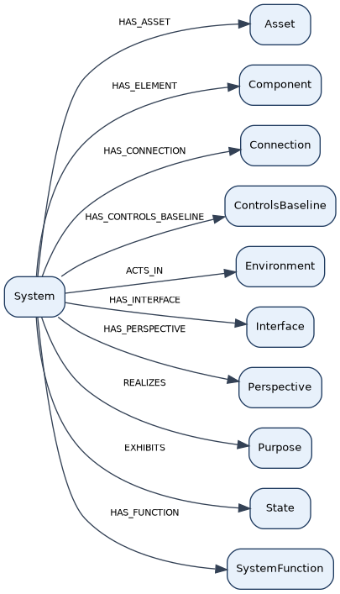
Figure 2. System layer: the System of Interest and its principal owned and related objects.

4.3 Component (Element)
Components are the parts of a system. In ordinary systems engineering they are called elements; SSTPA uses “Component” as its naming choice to avoid ambiguity with KerML’s Element concept [9]. A component can be refined into a child system of its own, which is how the hierarchy grows Tier by Tier.
Figure 3 and Table 6 show how Components relate to child Systems, assets (hold / transport / use), requirements, and attack-tree participation.
Table 6. Component (Element) relationships, including optional parenting of a child System.
Type | Source → Target | Meaning
PARENTS | Component → System | component may parent a child System (optional; hierarchy)
HOLDS | Component → Asset | holds an Asset (trace; exclusive with transports/uses)
TRANSPORTS | Component → Asset | transports an Asset
USES | Component → Asset | uses an Asset
HAS_REQUIREMENT | Component → Requirement | component-borne requirements
AT_RELATES_TO | Component → Attack | participates in an attack tree for a Loss
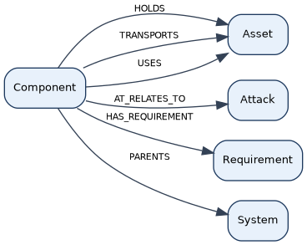
Figure 3. Component (Element) relationships, including optional parenting of a child System.

4.4 System Function
Functions describe what the system does. They are linked to the parts that perform them, to the interfaces they use, to requirements they must meet, and to assets they hold, move, or use. Security analysis often starts by asking which functions are critical.
Figure 4 and Table 7 cover functional chaining, allocation to Components, asset exposure, requirements, attack-tree participation, and STPA role bindings.
Table 7. SystemFunction relationships for flow, allocation, trace, and STPA bindings.
Type | Source → Target | Meaning
FLOWS_TO_FUNCTION | SystemFunction → SystemFunction | functional chaining (same SoI; cycles allowed within bounds)
FLOWS_TO_INTERFACE | SystemFunction → Interface | flow ends at an Interface (same SoI)
ALLOCATED_TO | SystemFunction → Component | function realized by a Component
HOLDS / TRANSPORTS / USES | SystemFunction → Asset | trace exposure (one of holds/transports/uses)
HAS_REQUIREMENT | SystemFunction → Requirement | function requirements
AT_RELATES_TO | SystemFunction → Attack | participates in an attack tree
IMPLEMENTS | SystemFunction → ControlAlgorithm | binds to an STPA control algorithm (at most one role)
IMPLEMENTS | SystemFunction → ControlledProcess | binds to a controlled process
IMPLEMENTS | SystemFunction → ProcessModel | binds to a process model
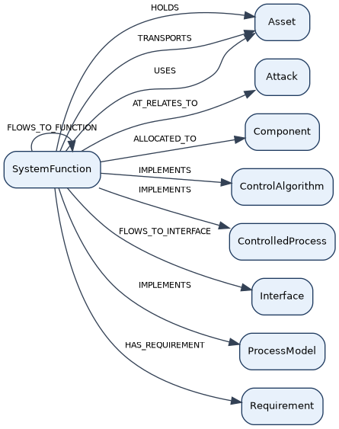
Figure 4. SystemFunction relationships for flow, allocation, trace, and STPA bindings.

4.5 Interface
Interfaces are the system’s doors and windows—where it interacts with the outside or with sibling systems. Requirements, assets, and attacks often concentrate here because exposure concentrates here.
Figure 5 and Table 8 show how Interfaces join Connections, bind to Functions and Components, carry requirements and asset exposure, and participate in attack trees and STPA roles.
Table 8. Interface.
Type | Source → Target | Meaning
PARTICIPATES_IN | Interface → Connection | joins a Connection (two or more Interfaces; may cross SoI)
CONNECTS | Interface → SystemFunction | interface bound to a Function
ALLOCATED_TO | Interface → Component | interface realized by a Component
HOLDS / TRANSPORTS / USES | Interface → Asset | trace exposure
HAS_REQUIREMENT | Interface → Requirement | interface requirements
AT_RELATES_TO | Interface → Attack | participates in an attack tree
IMPLEMENTS | Interface → ControlAlgorithm | STPA role binding (at most one)
IMPLEMENTS | Interface → ControlledProcess | STPA role binding
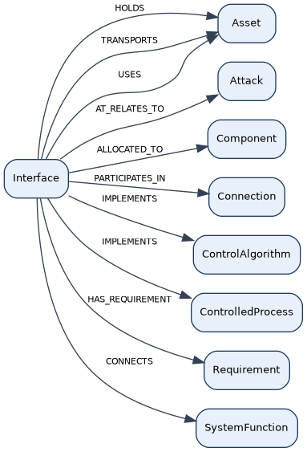
Figure 5. Interface relationships: participation, allocation, exposure, and STPA bindings.

4.6 Connection
A Connection is the shared link between systems through their interfaces. It carries the agreement about how they interact and can itself own security requirements when integrity, authenticity, or confidentiality matter on the link.
Figure 6 and Table 9 show Interface participation in a Connection and the requirements that may attach to the connection or its interfaces.
Table 9. Connection relationships among participating Interfaces and requirements.
Type | Source → Target | Meaning
PARTICIPATES_IN | Interface → Connection | Participants (may be from another SoI)
HAS_REQUIREMENT | Connection → Requirement | connection/ICD requirements (owning SoI)
HAS_REQUIREMENT | Interface → Requirement | interface requirements (context)
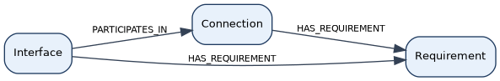
Figure 6. Connection relationships among participating Interfaces and requirements.

4.7 Purpose
Purpose captures why the system exists and anchors use cases, constraints, validation criteria, and related analysis containers. It is the mission lens for the System of Interest.
Figure 7 and Table 10 show Purpose ownership of requirements, validations, constraints, use cases, control structures, and functional flows.
Table 10. Purpose.
Type | Source → Target | Meaning
HAS_REQUIREMENT | Purpose → Requirement | purpose owns requirements
HAS_VALIDATION | Purpose → Validation | purpose owns validations
HAS_CONSTRAINT | Purpose → Constraint | purpose owns constraints
HAS_USECASE | Purpose → UseCase | purpose owns use cases
HAS_CONTROL_STRUCTURE | Purpose → ControlStructure | purpose motivates an STPA control structure
HAS_FUNCTIONAL_FLOW | Purpose → FunctionalFlow | purpose owns a functional flow
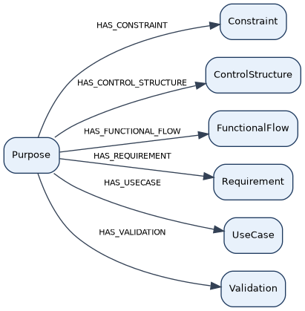
Figure 7. Purpose relationships: mission lens for requirements, validation, use cases, and analysis views.

4.8 Requirement and Verification
Requirements state what must be true; verifications say how that will be checked. In SSTPA these are primarily system security requirements. They can be parented into hierarchies and attached to the architecture pieces that must satisfy them.
Figure 8 and Table 11 show where requirements attach (Purpose, Project, architecture, controls, countermeasures), how they flow down, and how they link to Verification.
Table 11. Requirement and Verification relationships across the SoI and capability.
Type | Source → Target | Meaning
HAS_REQUIREMENT | Purpose → Requirement | purpose/system requirements
HAS_REQUIREMENT | Project → Requirement | Capability requirements
HAS_REQUIREMENT | Constraint → Requirement | constraint-derived requirements
HAS_REQUIREMENT | Connection → Requirement | connection requirements
HAS_REQUIREMENT | Interface → Requirement | interface requirements
HAS_REQUIREMENT | SystemFunction → Requirement | function requirements
HAS_REQUIREMENT | Component → Requirement | component requirements
HAS_REQUIREMENT | Countermeasure → Requirement | countermeasure realization requirements
HAS_REQUIREMENT | SecurityControl → Requirement | control realization requirements
PARENTS | Requirement → Requirement | derivation / flow-down (may cross SoI; acyclic)
VERIFIED_BY | Requirement → Verification | verification link
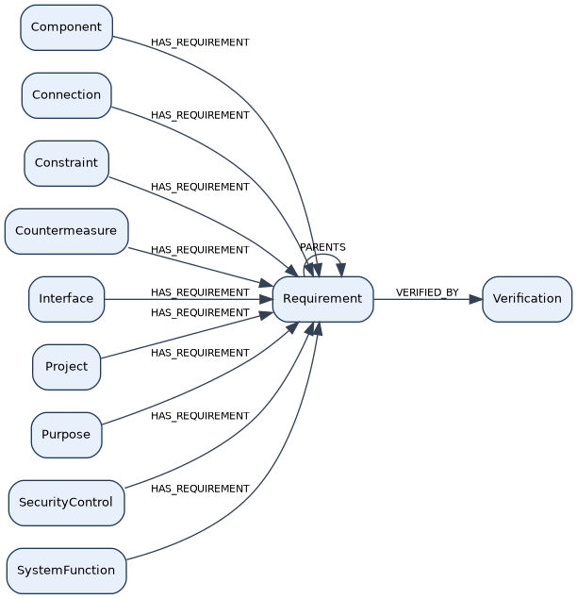
Figure 8. Requirement and Verification relationships across the SoI and capability.

4.9 State and Environment
States describe conditions of the system; the environment describes the world it operates in. SSTPA emphasizes system security states: periods where the assurances on assets stay the same. When an assurance changes, the security state has changed. Hazards live in this picture as well.
Figure 9 and Table 12 relate Systems to Environments and States, state transitions, environment validity, hazards, asset traces, and Loss-scoped attack-tree edges.
Table 12. State and Environment relationships, including hazards and state-scoped traces.
Type | Source → Target | Meaning
ACTS_IN | System → Environment | operating context (one or more)
EXHIBITS | System → State | modes / states (one or more)
HAS_HAZARD | Environment → Hazard | environment-scoped hazard
HAS_HAZARD | State → Hazard | state-scoped hazard
TRANSITIONS_TO | State → State | state transition (cycles allowed within bounds)
HOLDS / TRANSPORTS / USES | State → Asset | state-scoped traces
VALID_IN | State → Environment | state valid in an Environment (same SoI)
HAS_ENVIRONMENT | Loss → Environment | Exactly one Environment per Loss
AT_RELATES_TO | Loss → Environment | attack-tree edge
AT_RELATES_TO | Loss → State | attack-tree edge
AT_RELATES_TO | State → Interface | attack-tree traversal
AT_RELATES_TO | State → SystemFunction | attack-tree traversal
AT_RELATES_TO | State → Component | attack-tree traversal
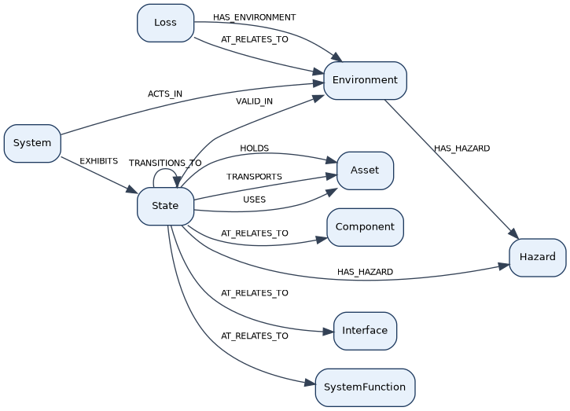
Figure 9. State and Environment relationships, including hazards and state-scoped traces.

4.10 Asset
Assets are what must be protected—intellectual property, credentials, flight-critical functions, and similar. They link to governing regimes and to losses if protection fails. Other parts of the model show where an asset is held, transported, or used.
Figure 10 and Table 13 show Asset ownership by the SoI, linkage to Loss, GSN goals, and Regimes, derivation among assets, and hold / transport / use traces from architecture and state.
Table 13. Asset.
Type | Source → Target | Meaning
HAS_ASSET | System → Asset | SoI owns an Asset
HAS_LOSS | Asset → Loss | asset owns a Loss
HAS_GOAL | Asset → GsnGoal | asset owns a top GSN goal
HAS_REGIME | Asset → Regime | asset under a certification Regime
DERIVED_FROM | Asset → Asset | derived asset inherits from a primary asset
DERIVED_FROM | DerivedAsset → Asset | explicit derived-asset link
HOLDS / TRANSPORTS / USES | State → Asset | state-scoped traces
HOLDS / TRANSPORTS / USES | SystemFunction → Asset | function traces
HOLDS / TRANSPORTS / USES | Interface → Asset | interface traces
HOLDS / TRANSPORTS / USES | Component → Asset | component traces
CONTAINS | FunctionalFlow → Asset | viewpoint containment
THREATENS | Hazard → Asset | hazard threatens an Asset
AT_RELATES_TO | Countermeasure → Asset | participates in an attack tree
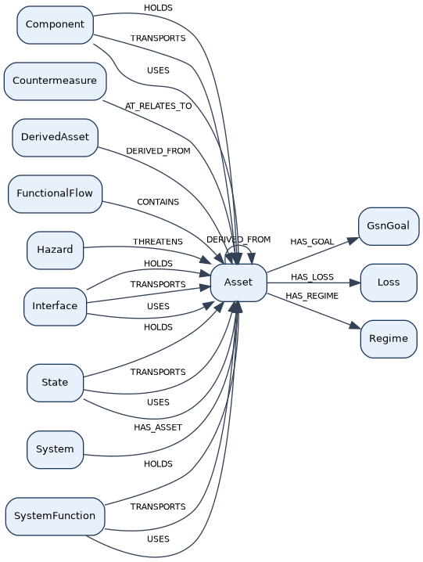
Figure 10. Asset relationships: regimes, losses, goals, derivation, and exposure traces.

4.11 Hazard
A hazard is a condition that can lead to loss of an asset’s required protection. Hazards threaten assets, may violate constraints, and are tied to the attacks that could realize them.
Figure 11 and Table 14 place Hazards under Environment or State, show mitigation by SecurityControls, and relate hazards to Constraints, Assets, Attacks, and unsafe control actions.
Table 14. Hazard relationships to environment, state, assets, controls, and attacks.
Type | Source → Target | Meaning
HAS_HAZARD | Environment → Hazard | environment-scoped hazard
HAS_HAZARD | State → Hazard | state-scoped hazard
MITIGATES | SecurityControl → Hazard | control mitigates a hazard
VIOLATES | Hazard → Constraint | hazard violates a Constraint
THREATENS | Hazard → Asset | hazard threatens an Asset
USES_ATTACK | Hazard → Attack | hazard employs an Attack
CAUSES | ControlAction → Hazard | unsafe control action leads to a Hazard
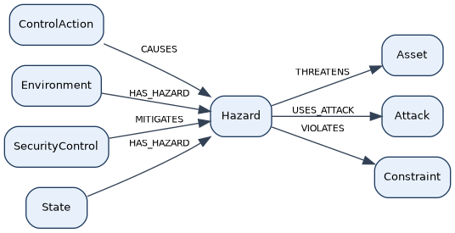
Figure 11. Hazard relationships to environment, state, assets, controls, and attacks.

4.12 Loss
A loss is the failure of an assurance on an asset that matters to a regime. Loss analysis organizes how that failure could occur [15] and feeds the assurance argument.
Figure 12 and Table 15 show how an Asset owns a Loss, how Attacks may target it, how it is scoped to one Environment, and how GSN Solutions cite Loss evidence.
Table 15. Loss.
Type | Source → Target | Meaning
HAS_LOSS | Asset → Loss | asset owns a Loss (one Asset owns each Loss)
TARGETS_LOSS | Attack → Loss | attack scoped to a Loss
HAS_ENVIRONMENT | Loss → Environment | Exactly one Environment
AT_RELATES_TO | Loss → Environment | attack-tree root edge
AT_RELATES_TO | Loss → State | attack-tree root edge
HAS_LOSS | GsnSolution → Loss | solution cites a Loss
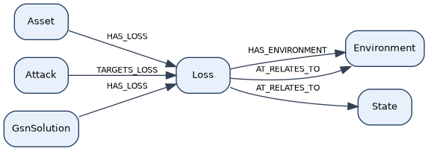
Figure 12. Loss relationships: asset ownership, environment scope, attacks, and GSN evidence.

4.13 Attack
Attacks are the ways an adversary (or adverse condition) can exploit parts of the system. They can be drawn from reference catalogs [16] and structured into hierarchies for deeper analysis.
Figure 13 and Table 16 cover attack hierarchies, exploitation of Components, Interfaces, and Functions, blocking and defeat relative to Countermeasures, and attack-tree edges.
Table 16. Attack.
Type | Source → Target | Meaning
BLOCKS | Countermeasure → Attack | countermeasure blocks an Attack
USES_ATTACK | Hazard → Attack | hazard employs an Attack
SUBORDINATE_TO | Attack → Attack | strategy → tactic → procedure (acyclic)
EXPLOITS | Attack → Component | attack acts on a Component
EXPLOITS | Attack → Interface | attack acts on an Interface
EXPLOITS | Attack → SystemFunction | attack acts on a Function
DEFEATS | Attack → Countermeasure | attack defeats a Countermeasure
TARGETS_LOSS | Attack → Loss | optional Loss scoping
AT_RELATES_TO | Interface / SystemFunction / Component → Attack | attack-tree edges
AT_RELATES_TO | Attack → Attack | attack-tree edges
AT_RELATES_TO | Attack ↔ Countermeasure | attack-tree edges
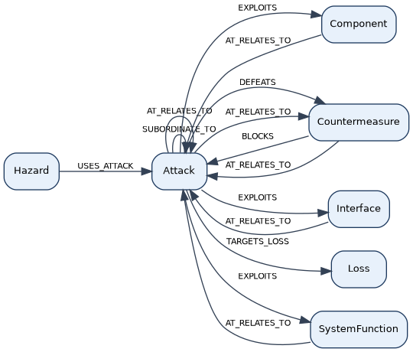
Figure 13. Attack relationships: hierarchies, exploitation targets, and countermeasure interplay.

4.14 SecurityControl
Security controls are the chosen protective measures (often from a standard catalog [5]). They mitigate hazards, enforce constraints, and give rise to security requirements.
Figure 14 and Table 17 show SecurityControls in the Security package, realizing requirements, mitigation and enforcement links, and satisfaction by Countermeasures.
Table 17. SecurityControl.
Type | Source → Target | Meaning
HAS_CONTROL | Security → SecurityControl | package owns catalog controls
HAS_REQUIREMENT | SecurityControl → Requirement | realization requirements
ENFORCES | SecurityControl → Constraint | control enforces a Constraint
MITIGATES | SecurityControl → Hazard | control mitigates a Hazard
SATISFIES | Countermeasure → SecurityControl | countermeasure realizes an abstract control
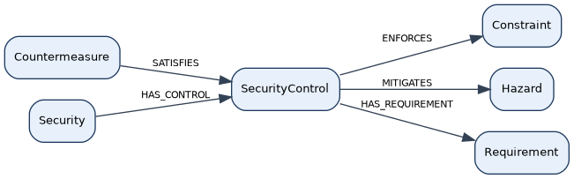
Figure 14. SecurityControl relationships: realization, mitigation, enforcement, and satisfaction.

4.15 Countermeasure
Countermeasures are concrete mitigations applied to specific functions, interfaces, parts, or states. They block or reduce attacks and should satisfy the controls they implement.
Figure 15 and Table 18 show Countermeasure placement, blocking of Attacks, satisfaction of SecurityControls, realizing requirements, and attack-tree participation.
Table 18. Countermeasure.
Type | Source → Target | Meaning
HAS_COUNTERMEASURE | Security → Countermeasure | package owns countermeasures
HAS_REQUIREMENT | Countermeasure → Requirement | realization requirements
SATISFIES | Countermeasure → SecurityControl | countermeasure satisfies an abstract control
APPLIES_TO_FUNCTION | Countermeasure → SystemFunction | countermeasure placement
APPLIES_TO_INTERFACE | Countermeasure → Interface | countermeasure placement
APPLIES_TO_ELEMENT | Countermeasure → Component | countermeasure placement
APPLIES_TO_STATE | Countermeasure → State | countermeasure placement
APPLIES_TO_FEEDBACK | Countermeasure → Feedback | countermeasure placement
BLOCKS | Countermeasure → Attack | blocks an attack
DEFEATS | Attack → Countermeasure | attack defeats a Countermeasure
AT_RELATES_TO | Attack ↔ Countermeasure / Countermeasure → Asset | participates in an attack tree
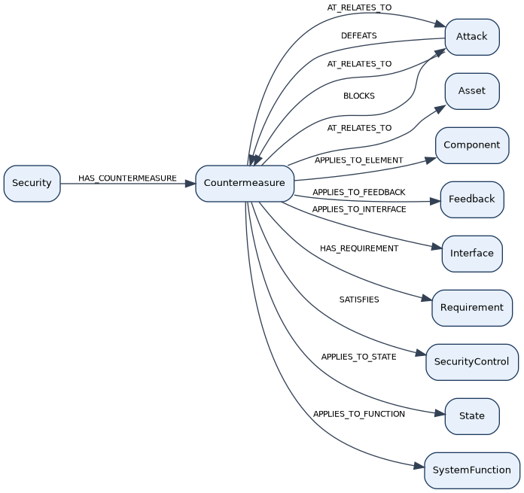
Figure 15. Countermeasure relationships: placement, blocking, and control satisfaction.

4.16 GSN (assurance argument)
Goal Structuring Notation [12][14] records the assurance case: claims that assets are adequately protected, strategies for arguing those claims, and solutions backed by evidence such as verification and validation results.
Figure 16 and Table 19 show how an Asset owns a top GsnGoal, how goals and strategies support one another, and how Solutions cite Validation, Verification, and Loss.
Table 19. GSN assurance-argument relationships among goals, strategies, solutions, and evidence.
Type | Source → Target | Meaning
HAS_GOAL | Asset → GsnGoal | asset’s top goal
SUPPORTED_BY | GsnGoal → GsnGoal / GsnStrategy / GsnSolution | goal support (acyclic hierarchy)
SUPPORTED_BY | GsnStrategy → GsnGoal / GsnSolution | strategy support
IN_CONTEXT_OF | GsnGoal / GsnStrategy → GsnContext / GsnJustification / GsnAssumption | context links
HAS_ENVIRONMENT | GsnContext → Environment | context cites an Environment
HAS_VALIDATION | GsnSolution → Validation | solution cites Validation
HAS_VERIFICATION | GsnSolution → Verification | solution cites Verification
HAS_LOSS | GsnSolution → Loss | solution cites a Loss
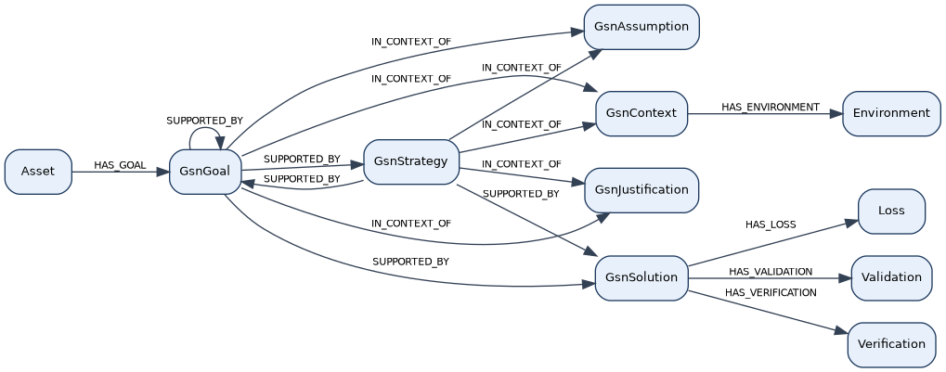
Figure 16. GSN assurance-argument relationships among goals, strategies, solutions, and evidence.

4.17 ControlStructure
The control structure shows how the system is controlled—controllers, controlled processes, and the loops between them—supporting STPA-style security analysis [1][2].
Figure 17 and Table 20 show ControlStructure ownership under Purpose and Perspective, and ownership of control-loop parts.
Table 20. ControlStructure containment under Purpose/Perspective and owned STPA parts.
Type | Source → Target | Meaning
HAS_CONTROL_STRUCTURE | Purpose → ControlStructure | purpose motivates a control structure
HAS_CONTROL_STRUCTURE | Perspective → ControlStructure | perspective contains a control structure
HAS_SECURITY | Perspective → Security | perspective contains a Security package
HAS_CONTROL_ALGORITHM | ControlStructure → ControlAlgorithm | control structure owns a control algorithm
HAS_PROCESS_MODEL | ControlStructure → ProcessModel | control structure owns a process model
HAS_CONTROLLED_PROCESS | ControlStructure → ControlledProcess | control structure owns a controlled process
HAS_CONTROL_ACTION | ControlStructure → ControlAction | control structure owns a control action
HAS_FEEDBACK | ControlStructure → Feedback | control structure owns feedback
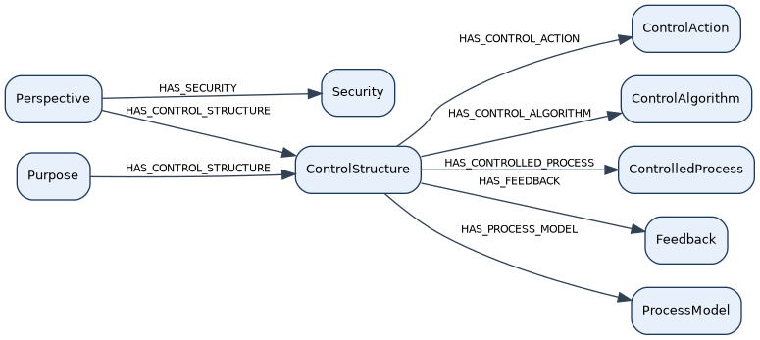
Figure 17. ControlStructure containment under Purpose/Perspective and owned STPA parts.

4.18 STPA parts
Control actions, feedback, process models, and related pieces flesh out the control loops so unsafe or insecure control can be analyzed systematically [2].
Figure 18 and Table 21 detail the STPA loop: control algorithm, control action, controlled process, feedback, and process model, including hazard causation and countermeasure placement on feedback.
Table 21. STPA control-loop part relationships (algorithm, action, process, feedback, model).
Type | Source → Target | Meaning
HAS_* | ControlStructure → CAL / PM / CP / ACT / FB | owns loop roles
IMPLEMENTS | Interface → ControlAlgorithm / ControlledProcess | STPA binding (at most one)
IMPLEMENTS | SystemFunction → ControlAlgorithm / ControlledProcess / ProcessModel | STPA binding (at most one)
GENERATES | ControlAlgorithm → ControlAction | control algorithm generates a control action
COMMANDS | ControlAction → ControlledProcess | control action commands a controlled process
CAUSES | ControlAction → Hazard | unsafe control action leads to a Hazard
PRODUCES | ControlledProcess → Feedback | controlled process produces feedback
INFORMS | Feedback → ProcessModel | feedback informs a process model
TUNES | ProcessModel → ControlAlgorithm | process model tunes a control algorithm
APPLIES_TO_FEEDBACK | Countermeasure → Feedback | countermeasure on feedback
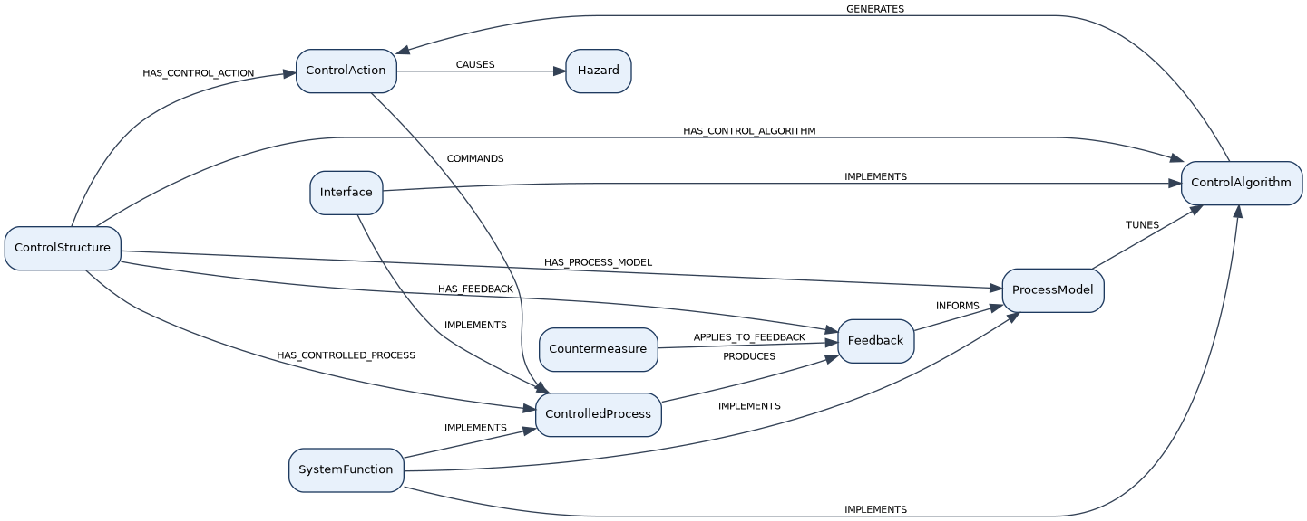
Figure 18. STPA control-loop part relationships (algorithm, action, process, feedback, model).

4.19 FunctionalFlow
Functional flow shows how activity moves through functions, interfaces, connections, and parts. It supports critical-function and critical-component thinking without requiring a full design toolset inside SSTPA.
Figure 19 and Table 22 show Purpose ownership of a FunctionalFlow viewpoint and membership of functions, interfaces, connections, components, and assets in that view.
Table 22. FunctionalFlow viewpoint relationships and contained members.
Type | Source → Target | Meaning
HAS_FUNCTIONAL_FLOW | Purpose → FunctionalFlow | purpose owns a functional flow
CONTAINS | FunctionalFlow → SystemFunction | viewpoint membership
CONTAINS | FunctionalFlow → Interface | viewpoint membership
CONTAINS | FunctionalFlow → Connection | viewpoint membership
CONTAINS | FunctionalFlow → Component | viewpoint membership
CONTAINS | FunctionalFlow → Asset | viewpoint membership
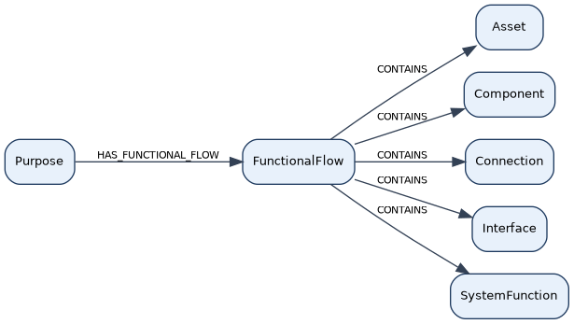
Figure 19. FunctionalFlow viewpoint relationships and contained members.

4.20 UseCase
Use cases describe how actors interact with the system through interfaces and functions. They help users faithfully capture structure that often originates in an enterprise MBSE tool.
Figure 20 and Table 23 show UseCases under Purpose, inclusion of Functions, involvement of Interfaces, and composition among use cases.
Table 23. UseCase relationships under Purpose.
Type | Source → Target | Meaning
HAS_USECASE | Purpose → UseCase | purpose owns use cases
INCLUDES | UseCase → SystemFunction | use case includes a Function
INVOLVES | UseCase → Interface | use case involves an Interface
EXTENDS | UseCase → UseCase | use-case extend (acyclic hierarchy)
INCLUDES_UC | UseCase → UseCase | SysML-style include between use cases (acyclic hierarchy)
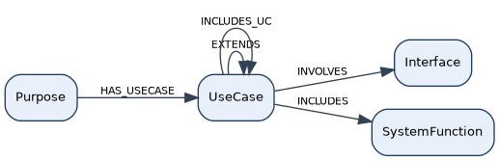
Figure 20. UseCase relationships under Purpose.

4.21 Reference Data application
Reference data are curated catalogs (such as ATT&CK [16] or NIST controls [5]) kept separate from the project model. Analysts browse them and clone or link selected items into the system security model so standards inform the design without rewriting the catalogs by hand.
Figure 21 and Table 24 summarize how reference content is applied in Core—cloned controls and attacks, annotations, baselines, and regime linkage—without treating the catalogs themselves as editable project data.
Table 24. Reference-data application mechanisms in the Core SoI model.
Mechanism | Core effect
Clone SecurityControl | places a catalog control in the Core Security package
Clone Attack / Hazard | creates threat/hazard nodes with reference provenance
[:REFERENCES] annotation | annotation carrying framework name, external ID, and source URI
ControlsBaseline | selects/overlays catalog controls on a System
SATISFIES | countermeasure binds to a cloned SecurityControl
MITIGATES / ENFORCES | SecurityControl relates to Hazard / Constraint
HAS_REGIME | asset under a Regime (certification context)
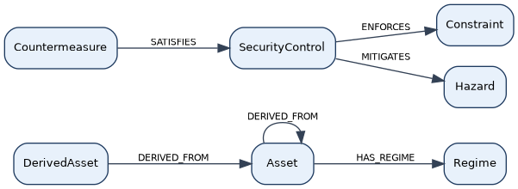
Figure 21. Reference-data application mechanisms in the Core SoI model.

4.22 User Data
User data covers people, messaging, and ownership context around the model—who owns what, and how collaboration notices are delivered. It supports stewardship of the model rather than the security analysis itself.
Figure 22 and Table 25 show Users, Mailboxes, and Messages, and the ownership context that ties people to Core hierarchy roots.
Table 25. User Data.
Type | Source → Target | Meaning
OWNS_MAILBOX | User → Mailbox | user owns a notification mailbox
HAS_MESSAGE | Mailbox → Message | mailbox contains a message
RELATES_TO | Message → * (any Core node) | message references a Core node
REPLY_TO | Message → Message | reply threading
HAS_SYSTEM | Project / Sandbox → System | hierarchy roots (context)
HAS_REQUIREMENT | Project → Requirement | Capability requirements (context)
HAS_SECURITY | Perspective → Security | Security package (context)
HAS_CONTROL_STRUCTURE | Perspective → ControlStructure | control-structure package (context)
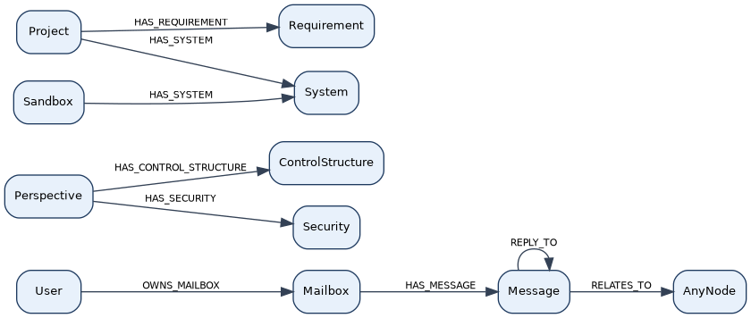
Figure 22. User Data: users, mailboxes, messages, and ownership context.

5. SSTPA Workflow — what SSTPA Tools supports versus outside
Figure 23 summarizes the division of labor. Outside SSTPA Tools, the customer System Spec and SoW, DOORS [24], Cameo [25], MATLAB [26], and expert asset identification supply functional architecture and seeding inputs. Inside SSTPA Tools, the Add-on Tools build and sustain the System Security Solution for each SoI, ending in GSN arguments and evidence packaging.
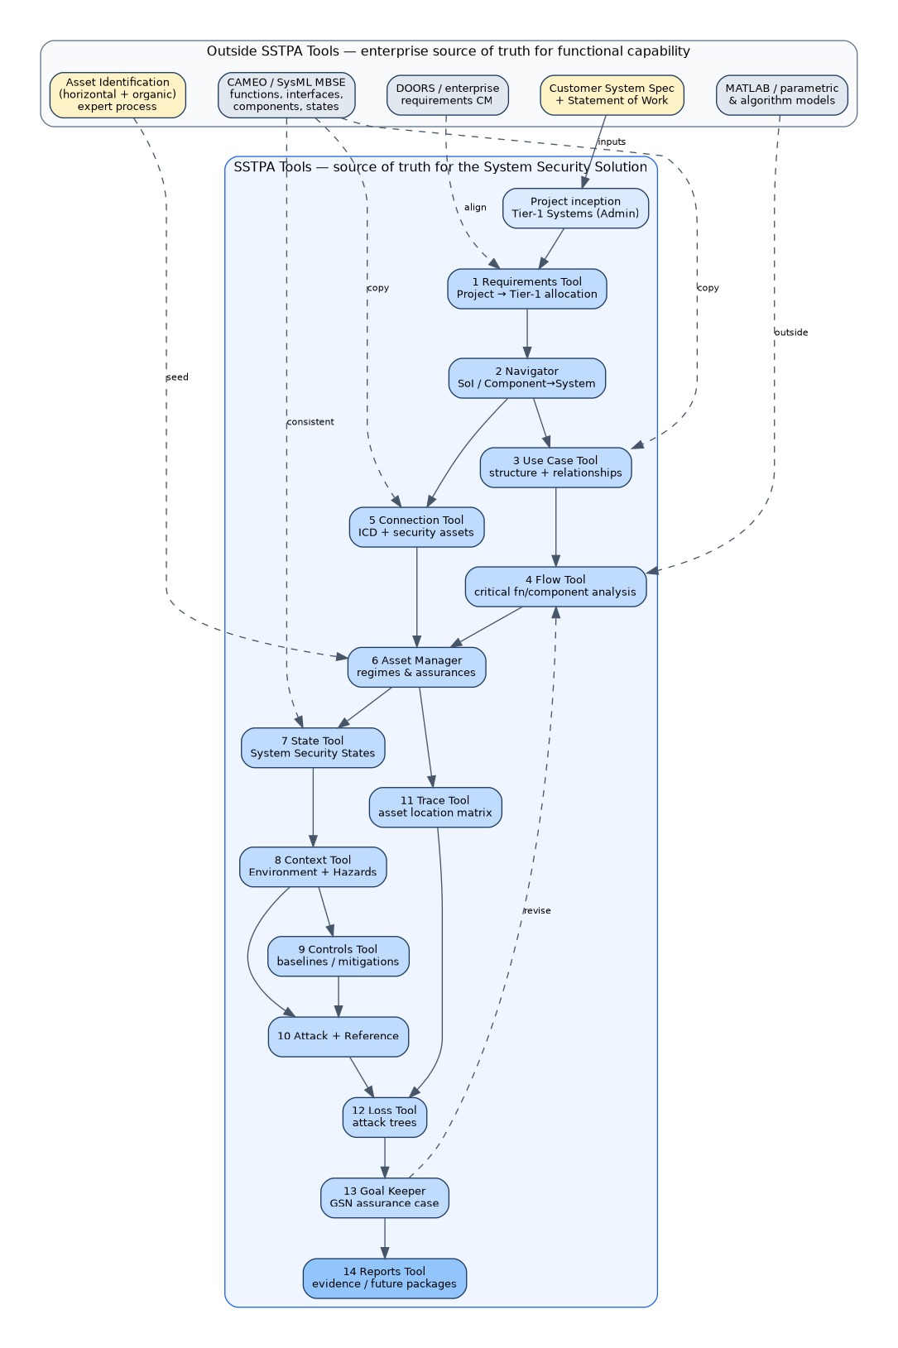
Figure 23. SSTPA Workflow: enterprise tools remain source of truth for functional capability; SSTPA Tools are source of truth for the System Security Solution. Dashed edges indicate alignment or faithful copy; the dashed revise edge from Goal Keeper back to Flow is the Step 13→7 inner loop.
Figure 24 shows the rough order of Add-on Tool use (methodology order, not catalog listing order).
Figure 24. Rough order of Add-on Tool use for expert execution of the SSTPA methodology.

6. Project inception versus recursive Tier-n pattern

6.1 Project inception (exception)
At project inception, an administrator creates the Project from the external System Spec and SoW. Tier-1 Systems are related according to the customer architecture. The Project receives capability-level requirements. The analyst then allocates Project requirements to Tier-1 Systems via the Requirements Tool and establishes the Connections that bind the Tier-1 architecture. Thereafter, Tier-1 through Tier-n follow the same recursive pattern.

6.2 Recursive pattern (Navigator Component → System)
After inception, the workflow start for each new SoI is: define a unique System by deriving it from a parent Component. Using the Navigator (and the SSTPA Tools GUI Main Panel / Data Drawer), the analyst designates a Component as parent of a new System. System Creation Behavior instantiates a subordinate System model and auto-allocates the Component’s requirements (and related Function/Interface requirements) to the new System’s Purpose; related Assets are cloned; new Loss and GSN root structures are prepared. The user then defines interfaces, functions, and components for that SoI—typically by faithful copy from Cameo [25]—and proceeds through the security analysis steps.
All requirements ultimately parent to Tier-1. All Assets ultimately derive parentage to Tier-1 Assets. Trace relationships are not copied into the child; the Trace Tool is re-run in each child SoI.

6.3 Outsourcing and internal development
Subsystems may be outsourced under a system specification and SoW, or developed internally. The same SSTPA rigor applies: each Tier is an SoI with the same model shape, the same security-requirements discipline, and the same path to V&V evidence and GSN argument.

7. Add-on Tools catalog (rough order of use)
The following catalog lists methodology Add-on Tools in rough order of use. Admin Tool and Message Center are omitted from the execution sequence (out of scope). Use Case Tool is included as early structural capture; Reports Tool is included as evidence packaging (with intended future regime-configurable certification packages). Tools do not enforce this order. Table 26 identifies tools by catalog order; the step–tool matrix in Section 8 maps execution steps to primary tools.
Table 26. Add-on Tools catalog in rough methodology order.
# | Tool | Purpose | When used | Primary inputs | Primary outputs | Notes
1 | Requirements Tool | Create, allocate, parent, and manage Requirement and Verification; SysML 2 requirement diagrams; orphan/barren gap resolution | Throughout; especially Project→Tier-1 allocation, Interface/Function/Component allocation, control- and countermeasure-realizing requirements | Capability / parent requirements; SoI Purpose | Allocated System Security Requirements; Verification criteria; healthy parentage | In SSTPA, Requirements means System Security Requirements
2 | Navigator Tool | Traverse hierarchy; select current SoI; clone nodes (optionally with requirements); associate Interface to foreign Connection | Before every SoI-scoped step; Component→System creation support; cross-SoI association | Project / System hierarchy | Current SoI selection; cloned subgraphs; association commits | Prerequisite: every SoI-scoped step assumes Navigator selection
3 | Use Case Tool | SysML 2 use-case diagrams; mission threads; assign Function and Interface to use cases | Early structural capture after architecture copy; supports critical-function / critical-component analysis | Copied architecture; Purpose | Use-case model and documented relationships | Adjacent to early steps; helps generate/document relationships
4 | Flow Tool | Functional Flow (SysML 2 activity) and STPA Control Flow; ControlAction / Feedback / ProcessModel; create Function, Interface, Requirement, Countermeasure | Critical function/component analysis; STPA-derived security requirements; re-entry of Step 13→7 loop | Functions, Interfaces, Hazards; prior Countermeasures on revise | Functional / STPA flows; STPA-derived requirements and Countermeasures | Narrative descriptions of functions often suffice because SSTPA focuses on security
5 | Connection Tool | Create and visualize Connection between Systems via Interfaces; ownership; participation; relate requirements | Tier-1 architecture binding; ICD capture; ongoing interface security concerns | Interfaces (often copied from Cameo) | Connections with participants; connection-related requirements | SSTPA owns security concerns on connections; organic assets on Interfaces inherit protection requirements
6 | Asset Manager Tool | Create and analyze Asset; manage Regime; Criticality and Assurance; Organic / Horizontal / Derived parentage | After architecture and critical analysis seed assets; before State/Context/Trace/Loss | Seeded asset list; customer criticality / certification needs | Assets with Regime, Criticality, Assurance, parentage | Asset identification largely outside SSTPA; tool records and organizes results
7 | State Tool | SysML 2–aligned state-transition diagrams; associate Hazard / Countermeasure / Requirement | After Assets; keep consistent with Cameo functional states | SoI lifecycle; Cameo state model | System Security States and transitions | Distinguish functional states from System Security States
8 | Context Tool | Authoritative Environment; State↔Environment validity; Hazard; Loss allocation to (Asset, Criticality, Assurance, Environment) | After State; environment and hazard analysis; Loss dimensioning | States; Assets; threat frameworks | Environments, Hazards, dimensioned Losses | Context = environment + hazards; Controls later mitigate hazards
9 | Controls Tool | Develop, tailor, trace Security Controls Baseline; map to SecurityControl; realizing Requirements; SatisfactionStatement | After Hazards / STPA flow; baseline categorization and mitigation | Hazards; Regimes; NIST / CNSSI / CSA / resiliency references | Tailored baseline; mitigating SecurityControls; realizing requirements | Parallel with Reference Tool for catalog content
10 | Attack Tool / Reference Tool | Attack: associate Attack to Interface / Function / Component; hierarchies and metrics. Reference: browse ATT&CK, ATLAS, EMB3D, NIST SP 800-53, CNSSI 1253, overlays, CSA/resiliency; clone/assign | Threat identification (early) and actionable attacks (after Trace); controls reference in parallel | Trace susceptibility; Environment threats; reference corpora | SoI Attacks; cloned reference bindings | Reference Tool runs in parallel throughout; Attack Tool is prerequisite for Loss
11 | Trace Tool | State-scoped hold / transport / use matrix for each Asset vs Interface / SystemFunction / Component | After Assets and States; before Attack refinement and Loss | Assets, Assurances, States, architecture entities | Trace matrix; inherited Criticality/Assurance; Loss-Tool readiness | Asset location in state/component feeds Loss analysis
12 | Loss Tool | Structured Attack Trees per Loss; residual vulnerabilities; inline Countermeasure | After Trace and Attacks; parallel with Goal Keeper evidence needs | Dimensioned Loss; Trace; Attacks; State | Attack trees; ARV dispositions; Countermeasures; GSN evidence | Completeness when every branch resolves to an ARV
13 | Goal Keeper Tool | GSN Community Standard Version 3 assurance argument for an Asset Loss; Solutions reference Validation, Verification, Loss | After Loss analysis; acceptance gate per Regime | Loss trees; Validation / Verification criteria | Regime-acceptable GSN argument—or revision package re-entering Flow (Step 7) | Inner loop Step 13→7 is part of the methodology
14 | Reports Tool | General text output (System Description, System Specification, requirement-traceability gap analysis); other tools produce specialized reports | Evidence packaging throughout and at certification milestones | SoI model; gap flags; specialized tool reports | Documents and gap analyses; intended future configurable packages per customer certification regime | Regime-configurable certification packages are a planned direction, not a claim of present capability
SSTPA Tools GUI (not an Add-on). The Main Panel and Data Drawer create and edit architecture nodes (System, Component, SystemFunction, Interface, Purpose, Asset properties, Purpose-level Validation) when no dedicated Add-on owns the mutation. System Creation Behavior (Component parents System) lives on this surface.

8. Detailed workflow steps
The fourteen execution steps below are the authoritative SSTPA execution workflow. They are not merged, split, or reordered. Two control structures are part of the methodology: the Step 13 → Step 7 revision loop, and the Step 14 hierarchical recurse. Use Case Tool work is adjacent to Steps 1–2 (early structural capture). Reports Tool work is evidence packaging across analysis milestones and is represented in the step–tool matrix (Section 8.2).

Step 1 — Tier-1 system architecture
Purpose. Perform Tier-1 system architecture by decomposing Capability-level requirements from the customer and allocating them to Tier-1 systems with defined connections.
Inputs. Customer Capability description; Capability specification (Capability-level requirements); SoW / certification needs; Tier-1 architecture as defined outside (typically in Cameo [25]) and prepared for faithful copy.
Actions. Create Capability and Tier-1 System nodes. Allocate Capability requirements to each Tier-1 System’s Purpose. Create and visualize Connection nodes that bind the Tier-1 architecture. Capture Components, SystemFunctions, and Interfaces (narrative descriptions acceptable where full functional fidelity lives in Cameo).
Add-on Tools. Requirements Tool (primary); Connection Tool (primary); Navigator Tool (primary); SSTPA Tools GUI (architecture node creation). Use Case Tool may begin structural capture in parallel.
Outputs. Tier-1 Systems with allocated Capability requirements and defined Connections.

Step 2 — Allocate requirements; join Interfaces to Connections
Purpose. Allocate and decompose System Security Requirements to Tier-1 Interfaces, Functions, and Components. Join Interfaces to Connections.
Inputs. Step 1 architecture; Capability requirements on each System Purpose.
Actions. Decompose and allocate Requirement to Interface, SystemFunction, and Component. Join each Interface as participant on its Connection (including cross-SoI Connections via Navigator Association Selection Mode). Continue Use Case relationship documentation as needed.
Add-on Tools. Requirements Tool (primary); Connection Tool (primary); Navigator Tool (supporting); Flow Tool (supporting for Interface–Connection association while building flow); Use Case Tool (supporting).
Outputs. Requirements allocated to Interface, Function, and Component; Interfaces joined to Connections.

Step 3 — Tier-1 Asset identification (record in SSTPA)
Purpose. Record Tier-1 Assets and, for each, define Regime, Criticality [18][21], and Assurance (security attributes).
Inputs. Tier-1 architecture; customer criticality / certification needs; asset identification results from the largely external expert process (horizontal and organic assets).
Actions. Create Asset nodes; relate to Regime; set Criticality (Safety, Mission, Flight, Security and levels) and Assurance (Confidentiality, Availability, Authenticity, Non-Repudiation, Certifiable, Privacy, Trust, and related flags); record AssetType (Organic, Horizontal, Derived) and parentage; relate Assets to Component, Function, and Interface as known. Organic assets discovered on Interfaces during Connection work (credentials, tokens, keys) are included and inherit protection requirements.
Add-on Tools. Asset Manager Tool (primary); SSTPA Tools GUI (supporting for property edit).
Outputs. Tier-1 Assets with Regime, Criticality, and Assurance defined.

Step 4 — Tier-1 System Security State behavior
Purpose. Define Tier-1 System Security State behavior, kept consistent with functional states in Cameo.
Inputs. SoI architecture; intended lifecycle; Cameo state model for alignment.
Actions. Create State nodes and transitions; set transition properties; assign sequence; relate states to Environments in which they are analytically valid. Treat System Security States as regimes of constant asset assurances; a change of assurance posture implies a transition.
Add-on Tools. State Tool (primary); Context Tool (supporting for environment validity).
Outputs. SoI security state model (states, transitions, sequence, environment validity).

Step 5 — Relevant environment and threats
Purpose. Define the relevant environment, including identification of threats in that environment.
Inputs. SoI; Asset set; intended operating contexts; external threat frameworks.
Actions. Create and edit Environment nodes; assign which States are valid in each Environment; research and prepare reference technique / vulnerability nodes for later Hazard and Attack work.
Add-on Tools. Context Tool (primary); Reference Tool (primary for research).
Outputs. Environment set with valid States; threat corpus available to clone into the SoI.

Step 6 — Hazard analysis from the threat environment
Purpose. Perform Hazard analysis from the threat environment. Controls will later mitigate these hazards.
Inputs. Environments; Assets; States; reference threat corpus.
Actions. Create Hazard nodes; associate to Environment and State; clone hazards from reference data as appropriate; relate Hazard to Asset (threatens) and Constraint (violates) as the model requires.
Add-on Tools. Context Tool (primary); Reference Tool (supporting).
Outputs. Hazards grounded in the threat environment, associated to Environment, State, and threatened Assets.

Step 7 — Functional Flow and STPA-derived security requirements
Purpose. Perform Functional Flow Analysis and develop feedback or process-model requirements derived from STPA analysis [1][2]. This step is the re-entry point of the Step 13 → Step 7 revision loop.
Inputs. Allocated Functions and Interfaces; Connections; Hazards; existing Countermeasures if entering from Step 13.
Actions. Model Functional Flow; cast selected flows as STPA Control Flow (ControlAction, Feedback, ProcessModel, ControlAlgorithm); derive Requirement and, as needed, Countermeasure from that analysis. Because SSTPA focuses on system security, narrative descriptions of functions and interfaces are often sufficient for critical-component / critical-function analysis.
Add-on Tools. Flow Tool (primary); Requirements Tool (supporting).
Outputs. Functional Flow and STPA Control Flow; feedback / process-model security requirements and any STPA-derived Countermeasures.

Step 8 — Controls to mitigate Hazards
Purpose. Develop Controls to mitigate Hazards [5][17][18].
Inputs. Hazards; Assets and Regimes; STPA Control Flow; NIST / CNSSI / resiliency reference data.
Actions. Categorize the SoI; select, overlay, expand, and tailor the Security Controls Baseline; map to Core Data SecurityControl; relate controls to Hazard (mitigates) and Constraint (enforces); create realizing Requirement nodes.
Add-on Tools. Controls Tool (primary); Reference Tool (supporting); SSTPA Tools GUI (supporting for Security view inspection).
Outputs. Tailored Controls Baseline; SecurityControls that mitigate Hazards; control-realizing requirements.

Step 9 — System Security Validation criteria
Purpose. Define System Security Validation criteria as demonstration of satisfaction of the “must” statements of the Controls.
Inputs. SecurityControl statements / SatisfactionStatement; control-realizing requirements.
Actions. Record SatisfactionStatement intent; create or relate realizing Requirements and Verification; record system-level Validation against Purpose (realized System satisfies intended Purpose in intended Environment).
Add-on Tools. Controls Tool (primary); Requirements Tool (primary); SSTPA Tools GUI (Purpose Data Drawer for Validation); Reports Tool (supporting for packaging).
Outputs. Purpose-level Validation criteria and Verification criteria on control-realizing requirements.

Step 10 — State-Trace Analysis for each Asset Assurance
Purpose. Perform State-Trace Analysis for each Asset Assurance (asset location in state and component).
Inputs. Assets and Assurances; States; Interface, SystemFunction, and Component of the SoI.
Actions. For each Asset, build the trace matrix (States as columns; Interface, SystemFunction, Component as rows); assign state-scoped hold, transport, or use; commit Criticality/Assurance inheritance; confirm Loss-Tool readiness.
Add-on Tools. Trace Tool (primary); State Tool (supporting); Asset Manager Tool (supporting).
Outputs. State-scoped Asset–entity traces; inherited Criticality/Assurance on entities; input to Attack and Loss analysis.

Step 11 — Actionable Attacks
Purpose. Develop actionable Attacks based on Trace results, Environment threats, and susceptibility of entities containing Assets [16].
Inputs. Trace results; Environment threats; Hazards; ATT&CK / ATLAS / EMB3D reference data.
Actions. Associate Attack to Interface, SystemFunction, and Component that hold, transport, or use Assets; clone from Reference Data or create SoI-specific Attacks; build Strategy → Tactic → Procedure hierarchies; assign leaf metrics; optionally scope to a Loss; create a new Hazard when an Attack represents a new threatening condition.
Add-on Tools. Attack Tool (primary); Reference Tool (supporting); Trace Tool (upstream susceptibility only).
Outputs. Actionable Attack population; hierarchies and metrics ready for Attack Trees.

Step 12 — Loss analysis (Attack Tree) for each Asset Assurance
Purpose. Perform Loss analysis (Attack Tree [15]) for each Asset Assurance. Runs in analytical parallel with Goal Keeper GSN construction needs.
Inputs. Fully dimensioned Loss (Asset × Criticality × Assurance × Environment); Trace coverage; Attacks; State model.
Actions. Auto-build and tailor a Structured Attack Tree per Loss; enumerate paths; identify Residual Vulnerabilities; associate or create Countermeasures; assign each identified scenario a documented SSTPA disposition (eliminated, blocked under assumptions, accepted with conditions as an ARV, deferred, or unresolved) with supporting rationale.
Add-on Tools. Loss Tool (primary); Context Tool (prerequisite Loss–Environment allocation); Trace / Attack / State Tools (upstream only); Reports Tool (supporting).
Outputs. Attack Tree and residual-vulnerability dispositions per Loss; Countermeasures; evidence for the GSN argument.

Step 13 — GSN Assurance argument; revise until credible
Purpose. Develop a GSN-based assurance argument for each Asset protection objective [12][14]. If not credible, develop countermeasures and countermeasure requirements and verification criteria; return to Step 7 and revise. Analysis closure for Steps 12–13 is assessed against the approved asset scope, architecture baseline, operating environments, threat assumptions, and coverage criteria: each identified scenario must have a documented disposition and rationale; scenarios that remain unacceptable or lack sufficient evidence prevent closure. Risk-acceptance records identify the deciding authority, affected configuration, applicable regime, conditions, review date, and change triggers [17]. A completed analysis remains subject to revision when evidence, architecture, operating conditions, or threat knowledge changes.
Inputs. Loss analysis; Validation and Verification criteria; Root GsnGoal associated with Asset/Loss.
Actions. Construct the GSN argument; terminate in Solution nodes referencing Validation, Verification, and Loss; validate the argument; if not credible for the Regime, strengthen Countermeasures and requirements and re-enter Step 7, refreshing Controls, Validation criteria, Trace, Attack, and Loss as products change.
Add-on Tools. Goal Keeper Tool (primary); Loss Tool, Requirements Tool, and Flow Tool support when the inner loop fires; Reports Tool (supporting).
Outputs. Regime-reviewed GSN argument per Asset protection objective—or a defined revision package that re-enters Step 7—together with dispositioned residual-vulnerability records.
Inner loop: Step 13 → Step 7 → … → Step 13. This loop is the methodology.

Step 14 — Hierarchical decomposition (Tier-2 and below)
Purpose. Decompose Tier-1 Components into Tier-2 Systems that inherit Component-allocated requirements. Repeat Steps 1–13 for each child System to the required granularity. Capture V&V evidence during integration system-by-system so GSN arguments remain evidence-backed.
Inputs. Tier-1 Components with allocated requirements and related Assets (current hold/transport/use).
Actions. Declare Component parents System; System Creation Behavior instantiates the child SoI (default Purpose, Environment, State; cloned requirements under child Purpose; cloned Assets; new Loss and GsnGoal; traces not copied). Select the child as current SoI via Navigator. Repeat Steps 1–13. Maintain requirement parentage to Tier-1 and Asset parentage to Tier-1 Assets. Recurse until realization grain is reached. During ascending integration, accumulate V&V evidence against the security requirements and feed Goal Keeper Solutions.
Add-on Tools. SSTPA Tools GUI (Component→System); Navigator Tool; Requirements Tool; Asset Manager Tool; Reports Tool (supporting).
Outputs. Child SoI subgraphs at Tier-2 and below; each child executes Steps 1–13. Outer recurse continues until realization grain is reached.
Outer loop: Step 14 → Steps 1–13 for each child System → Step 14 again. This loop is the methodology.

8.1 Recursion and inheritance (summary)
- Inner loop (13→7). The GSN argument is the acceptance gate for a given Asset Assurance in a given Regime. Failure of credibility does not invent a parallel process; it returns to Flow/STPA (Step 7) and refreshes downstream products.
- Outer loop (14). Each Component realized as a child System becomes a new SoI of identical form; Steps 1–13 repeat to realization grain.
- Requirement parentage. All requirements parent to Tier-1; Capability-level requirements remain the root of allocation.
- Asset parentage. All Assets ultimately derive to Tier-1 Assets; Derived Assets must have at least one parent; traces are re-established in each child.

8.2 Step–tool matrix
Table 27. Execution step × primary tool (methodology order). Use Case supports early architecture capture; Reports packages outputs throughout; Reference research is cross-cutting. The normal revision path is Step 13→7; child recursion is Step 14.

Execution step | Activity | Primary tool or surface
1 | Establish architecture and allocate capability requirements | Requirements, Connection, Navigator, GUI
2 | Allocate requirements and join interfaces | Requirements, Connection, Navigator
3 | Record assets and protection obligations | Asset Manager
4 | Define security states | State
5 | Define environments and research threats | Context, Reference
6 | Analyze hazardous conditions | Context
7 | Analyze functional and STPA control behavior | Flow, Requirements
8 | Select and tailor controls | Controls, Reference
9 | Define validation and verification criteria | Controls, Requirements, GUI
10 | Record state-scoped asset exposure | Trace
11 | Refine actionable attacks | Attack, Reference
12 | Analyze losses and residual vulnerabilities | Loss
13 | Construct and review the assurance argument | Goal Keeper
14 | Decompose and later integrate child systems | GUI, Navigator; applicable analysis tools at each tier

9. Integration, evidence, GSN, and future Reports packages
SSTPA’s analytic product is not a findings list. It is a set of effective System Security Requirements and an evidence-backed assurance argument [12][14]:
- Countermeasure requirements specifying protective features that block failing attack paths, each with verification criteria.
- Protection requirements generated on every entity that holds, transports, or uses an asset.
- Control-realization requirements recording how selected catalog controls are realized by the architecture, with tailoring decisions and justifications.
- Validation criteria attached to every Purpose of every System in the hierarchy, including security purposes.
Loss trees with documented residual-vulnerability dispositions (including ARVs where accepted), together with GSN arguments [12][14] whose Solutions reference Validation, Verification, and Loss evidence, are what a trust authority needs in order to assess residual risk with inspectable evidence. During integration, V&V evidence is captured system-by-system so that ascending tiers do not reconstruct arguments under terminal pressure.
The Reports Tool today produces general text outputs (System Description, System Specification, requirement-traceability gap analysis); other Add-on Tools produce specialized reports (for example residual-vulnerability reports from the Loss Tool). Intended direction: Reports Tool packages configurable for customer certification regimes, so that a program can assemble regime-specific evidence bundles from the same underlying SoI model without re-authoring the security solution.
Through sustainment to end of life, SSTPA Tools remain the source of truth for the System Security Solution: changes to architecture, threat landscape, or regime rules re-enter the appropriate workflow steps; affected Losses, ARV dispositions, and GSN arguments are re-evaluated rather than abandoned.

10. Closing and References
System Security-Theoretic Process Analysis extends systems-theoretic process analysis [1][2] from a primarily safety-oriented control problem to a multi-asset, multi-attribute, multi-regime security and certification problem. It preserves STPA’s core insight—that losses arise from inadequate constraint enforcement in hierarchical control structures—while treating Loss, under SSTPA, as a dispositionable analytic product whose attack-tree expansion [15] characterizes the effort and path required to violate a security attribute on an asset. Dispositioned residual vulnerabilities, argued in Goal Structuring Notation [12], support the residual-risk judgment a certification or authorizing authority is asked to make [17].
SSTPA Tools implement the methodology as graph-based MBSE [10] Add-on Tools that operate on a System of Interest without enforcing order—expert practice supplies the order documented here. Enterprise tools remain authoritative for functional capability [24][25][26]; SSTPA Tools remain authoritative for the System Security Solution. SSTPA is intended to make security reasoning and supporting evidence traceable throughout the system lifecycle, helping the responsible authorities assess whether the proposed security solution satisfies applicable obligations and whether its residual risk is acceptable.

References
[1] Nancy G. Leveson, Engineering a Safer World: Systems Thinking Applied to Safety. Cambridge, MA: MIT Press, 2011.

[2] Nancy G. Leveson and John P. Thomas, STPA Handbook. MIT Partnership for Systems Approaches to Safety and Security, March 2018.

[3] William Young and Nancy G. Leveson, “Systems Thinking for Safety and Security,” Proceedings of the 29th Annual Computer Security Applications Conference (ACSAC 2013), ACM, New York, 2013, pp. 1–8.

[4] Ron Ross, Mark Winstead, and Michael McEvilley, NIST Special Publication 800-160 Volume 1 Revision 1: Engineering Trustworthy Secure Systems, National Institute of Standards and Technology, November 2022, DOI 10.6028/NIST.SP.800-160v1r1.

[5] National Institute of Standards and Technology, NIST Special Publication 800-53 Revision 5: Security and Privacy Controls for Information Systems and Organizations, 2020.

[6] National Institute of Standards and Technology, NIST Special Publication 800-63-4: Digital Identity Guidelines, July 2025, DOI 10.6028/NIST.SP.800-63-4.

[7] ISO/IEC 27000:2018, Information technology — Security techniques — Information security management systems — Overview and vocabulary.

[8] Object Management Group, Systems Modeling Language (SysML) Version 2.0 specification suite.

[9] Object Management Group, Kernel Modeling Language (KerML) Version 1.0.

[10] Neo4j, Inc., “Graph database concepts,” Getting Started documentation, accessed 13 September 2026.

[11] Australian Signals Directorate’s Australian Cyber Security Centre (ASD’s ACSC), U.S. Cybersecurity and Infrastructure Security Agency (CISA), U.S. National Security Agency (NSA), Canadian Centre for Cyber Security, New Zealand National Cyber Security Centre (NCSC-NZ), and United Kingdom National Cyber Security Centre (NCSC-UK), Careful Adoption of Agentic AI Services, Commonwealth of Australia, 2026.

[12] The Assurance Case Working Group, Goal Structuring Notation Community Standard, Version 3, 2021.

[13] ISO/IEC/IEEE 15288:2023, Systems and software engineering — System life cycle processes.

[14] ISO/IEC/IEEE 15026-1:2019, Systems and software engineering — Systems and software assurance — Part 1: Concepts and vocabulary (and Part 2: Assurance case).

[15] Bruce Schneier, “Attack Trees: Modeling Security Threats,” Dr. Dobb’s Journal, December 1999.

[16] The MITRE Corporation, MITRE ATT&CK®, MITRE ATLAS™, and EMB3D (named adversary / embedded-device knowledge frameworks).

[17] National Institute of Standards and Technology, NIST Special Publication 800-37 Revision 2: Risk Management Framework for Information Systems and Organizations: A System Life Cycle Approach for Security and Privacy, December 2018, DOI 10.6028/NIST.SP.800-37r2.

[18] Committee on National Security Systems, CNSSI No. 1253: Security Categorization and Control Selection for National Security Systems.

[19] National Institute of Standards and Technology, NIST Privacy Framework: A Tool for Improving Privacy through Enterprise Risk Management, Version 1.0, January 2020.

[20] INCOSE, Systems Engineering Handbook: A Guide for System Life Cycle Processes and Activities, Fifth Edition. Hoboken, NJ: John Wiley & Sons, 2023.

[21] Federal Information Processing Standards Publication 199, Standards for Security Categorization of Federal Information and Information Systems, National Institute of Standards and Technology, 2004.

[22] RTCA DO-178C (2011) / EUROCAE ED-12C (January 2012), Software Considerations in Airborne Systems and Equipment Certification.

[23] Regulation (EU) 2024/2847 of the European Parliament and of the Council on horizontal cybersecurity requirements for products with digital elements (Cyber Resilience Act), Official Journal of the European Union, 20 November 2024.

[24] IBM Engineering Requirements Management DOORS (and equivalent requirements CM products) — product class for functional/contractual requirements configuration management.

[25] Dassault Systèmes Cameo Systems Modeler / MagicDraw (and equivalent SysML MBSE products) — product class for functional architecture modeling.

[26] MathWorks MATLAB (and equivalent parametric/algorithmic modeling products) — product class for performance and algorithmic models.

Document control: SSTPA Methodology White Paper Version 13 | Methodology Workflow, System Model, and Add-on Tools | 13 September 2026

