**How to conduct Cisco Virtual meetings**

This document contains:

1. Quick guide on joining through browser
2. Quick guide on joining through phone
3. Quick guide on creating the virtual meeting rooms

Press the links to jump to the relevant part of the guide.

**Quick guide: Joining through browser**

Browse to <https://join.video.nets.eu/>  
(Supported Browsers are: Edge Chromium, Firefox, Safari and Chrome)

You will be presented with a log-in prompt, where you can type in the meeting ID and pin. The meeting information is given in the virtual meeting room information:

Meeting50 join.nets@video.nets.eu +4722790011 IP 91.102.25.124 call ID **50**# PIN **123456**# (example)

The ID in this example is: 50

The PIN in this example is: 123456.



You can then input your name and press “join meeting”.

You have now joined the meeting.

**Quick guide: Joining through phone**

Call one of our access numbers:

* +47 22790011 in Norway
* +45 44880011 in Denmark
* +46 86099511 in Sweden
* +49 69 7922 6910 in Germany

(If you are calling from outside the above countries, you can choose any one of them to call)

You will be presented with a log-in prompt, where you can type in the meeting ID and pin. The meeting information is given in the virtual meeting room information:

Meeting50 join.nets@video.nets.eu +4722790011 IP 91.102.25.124 call ID **50**# PIN **123456**# (example)

The ID in this example is: 50

The PIN in this example is: 123456.

You have now joined the meeting.

**Quick guide: Creating the virtual meeting rooms**

**Booking a virtual meeting room in Nets**

In Nets all virtual meeting rooms are available for booking through Pronestor – which is an add-on to Outlook.

**Booking a virtual meeting room in Concardis**

Currently we have three public Nets meeting rooms available.



You can book these public rooms and you can see the status of the rooms like our own meeting rooms.

**Booking a virtual meeting room in Mercury**

MPSI has 5 virtual meeting rooms are available for booking from Outlook room list:

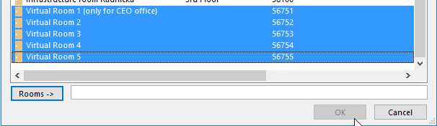

In the meeting request you will find info on how to connect :

For example:

