**How to conduct Microsoft Teams meetings**(In Nets Nordics we additionally have the option of Skype. The setup and usage are similar as for Microsoft Teams, but the sound quality is better in Teams)

**Please read the instructions carefully**

This document contains:

1. Quick guide on inviting for Microsoft Teams meetings
2. Quick guide on joining Microsoft Teams meetings
3. Detailed guide on joining via web browser or the app

Press the links to jump to the relevant part of the guide.

**Quick Guide: Inviting for Microsoft Teams meeting**

If you have Teams installed on your PC you can invite for a Microsoft Teams meeting, by going into your outlook calendar the same way you would normally do when booking a meeting.

When creating the meeting, notice that an option to add a Teams meeting occurs in the top action bar. When pressing this button, the location will be added as “Microsoft Team Meeting”, and the link to join the meeting will be added at the bottom of the invitation.

(As shown on the picture, the process is the same for Skype Meeting, you simply press the skype button instead)

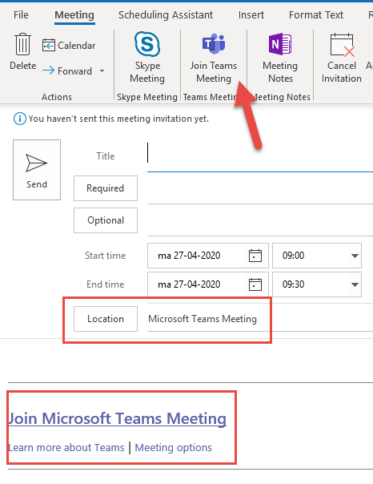

**Quick guide: Joining a Microsoft Teams meeting**

**Disclaimer: Please test this in due time before your first meeting**

**If you have the Teams client installed:**

To join a Microsoft Teams meeting, simply press the link in the invitation. If you have the Teams client installed, you will automatically be launched into the meeting by pressing “Join now”.

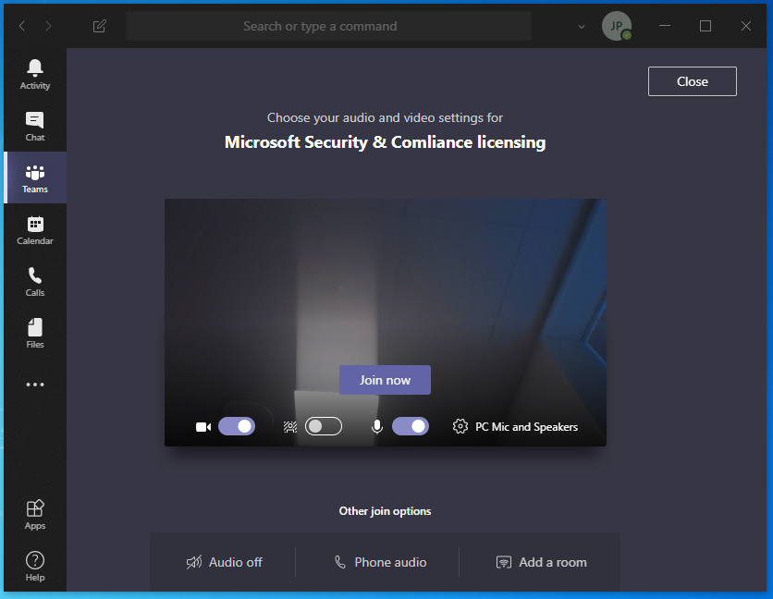

**If you do not have the client installed:**Your browser will instead open, and you can conduct the videocall like you normally would through the browser interface by pressing “Join on the web instead” (Supported Browsers are: Edge Chromium, Firefox, Safari and Chrome)

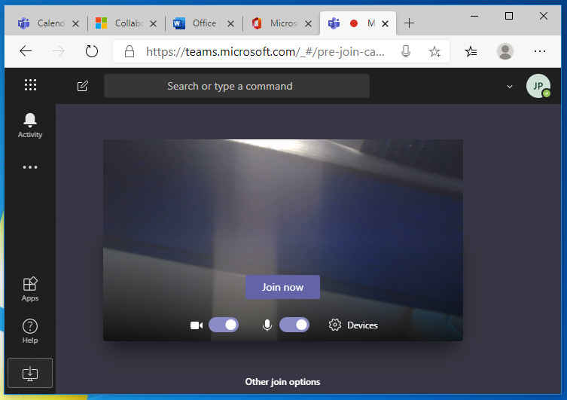

(Notice the small cogwheel allowing you to change the devices you are using for the call)

You have now joined the virtual meeting room. Your camera and microphone can be switched either on or off through the two buttons below the “join now” button.

**Detailed guide: Joining a Microsoft Teams meeting via web browser**

**1. Get the link**

If you've been invited to a Teams meeting you have probably received a link to connect to it. Check your meeting invitation and click the link.

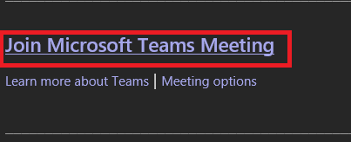

If you do not see the link, please contact the organiser and kindly ask them for a link to connect to the meeting.

**2. Connect to a meeting**

There are two ways of connecting to a Teams meeting:

1. Connect via Web browser – preferred way for all users without Nets user account (MPSI, Concardis)
2. Connect via Teams application

**3. Connecting via web browser**

Click the link from your meeting invitation.

If you see this notification, click “Cancel”:

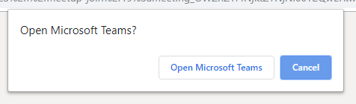

Click “Join on the web instead”

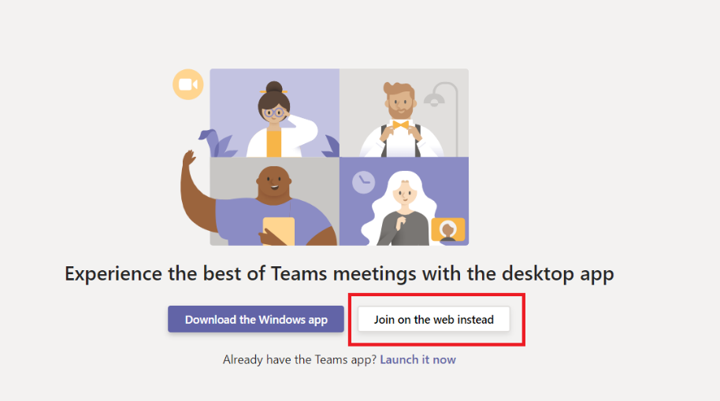

This is the first screen where you enter your name:

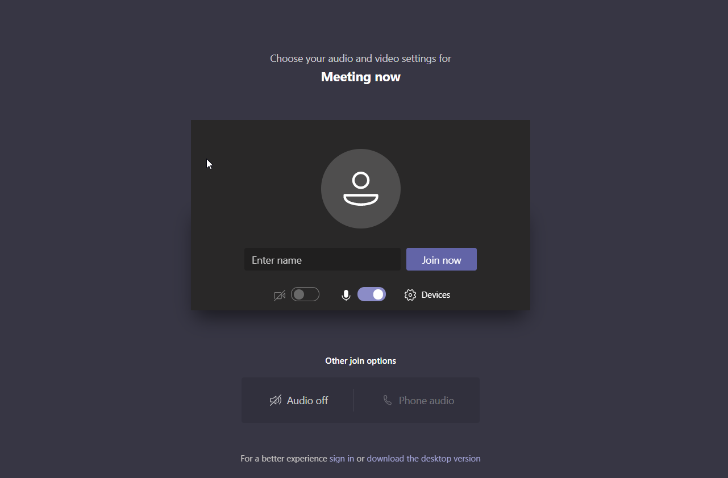

Below the name, you can choose if you want to turn on your camera and mic for the meeting. There are also some advanced features you can choose for your audio device.

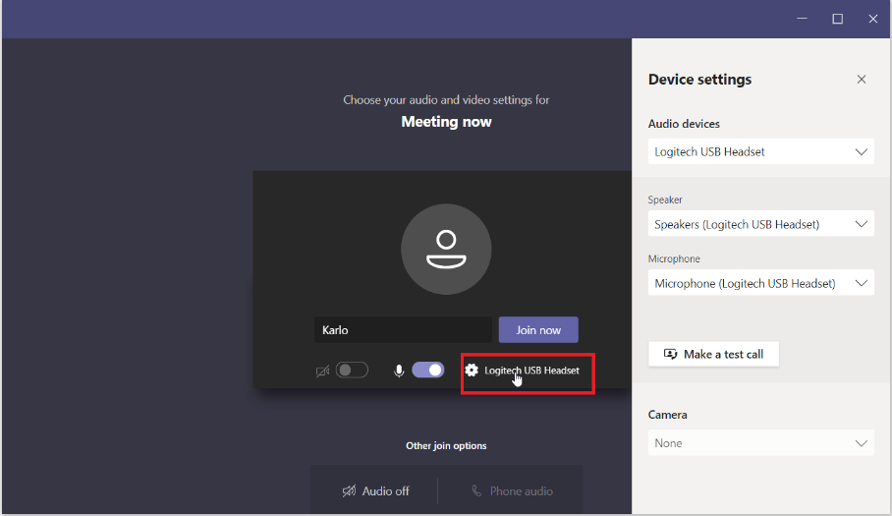

When you are ready, click **“Join now“**. There is a possibility you will then see a message as shown below.

**I case you are a guest to a Teams meeting**

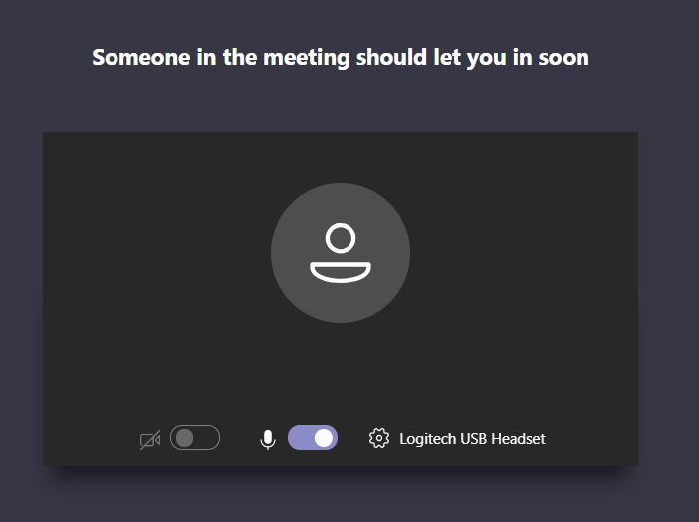

That happens in case a meeting is private and since you are a guest user, someone must approve your request to join the meeting.

**Admit participants to your Teams meeting**

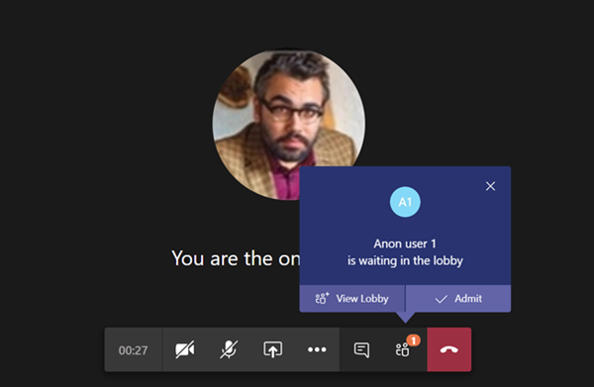

I case you are hosting a meeting with guest please ensure to admit them to the meeting by pressing the “Admit” button.

So, all you have to do now is wait until someone lets you in. And that's it! Have a good meeting!

**4.** **Connecting through Teams app**

Click the link you got in the meeting invitation.

If you see this notification, click “Open Microsoft Teams”:



If the app is installed on your PC and you choose to join through it, you will first see the app opening.



When the app is up and running, there are a few things you can set up (beware that after you join, you will not be able to change these settings).

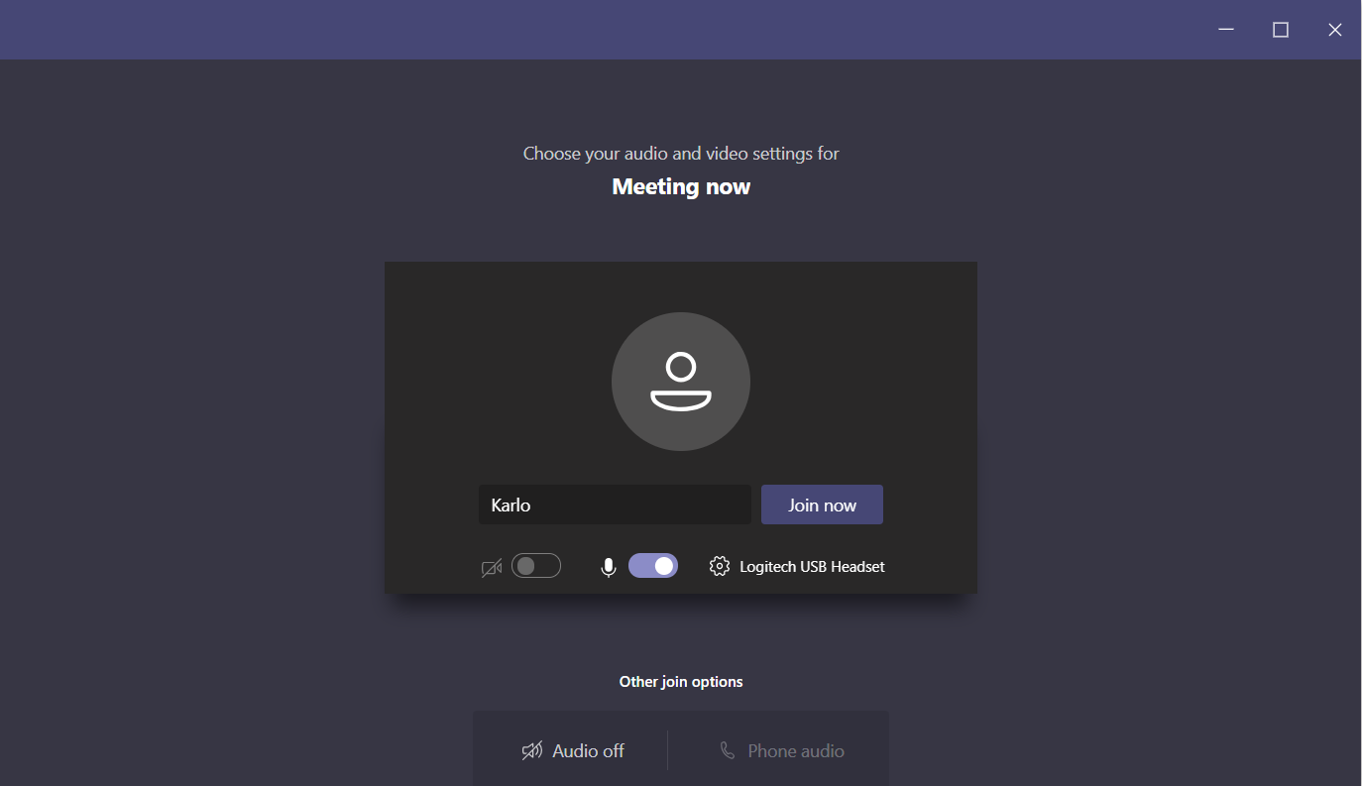

First, you have to enter your name by which other participants will recognise you.

Below the name you can choose if you want to turn on your camera and mic for the meeting. There are also some advanced features you can choose for your audio device.

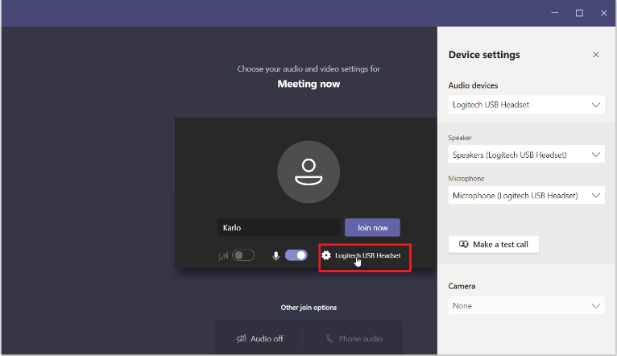

When you're ready, you can choose “Join now“. There is a possibility you will then see a message as shown below.

**I case you are a guest to a Teams meeting**



That happens in case a meeting is private and since you are a guest user, someone must approve your request to join the meeting.

**Admit participants to your teams meeting**



I case you are hosting a meeting with guest please ensure to admit them to the meeting by pressing the “Admit” button.

So, all you have to do now is wait until someone lets you in. And that's it! Have a good meeting!