**How to use the Office365 collaboration universe in browser**You can access the online Office365 collaboration universe through your browser and your Office365 account. It offers all the same functionalities as the desktop version.

**Please read the instructions carefully**

1. To access these functionalities, go to the following web-page:

<https://www.office.com/>

2. And press the sign-in button:



3. When signing in, use the address that you normally use to access your Office365:

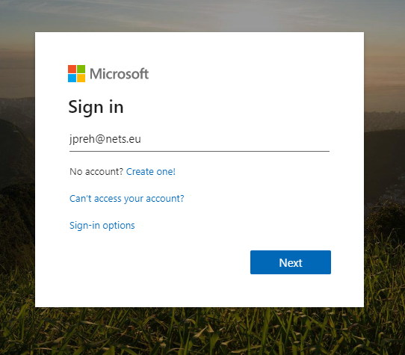

4. You will then be presented with the option of using any of the Office365 tools currently available: 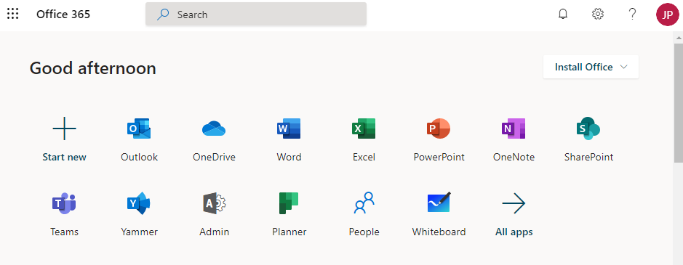

5. The tools function looks almost exactly like on your desktop, with the only notable exception being the meeting booking functionality in Outlook.

To add participants please search for them by typing their names in the attendee list. If you do not find the person you were looking for first hand, please use the “search” function highlighted below.

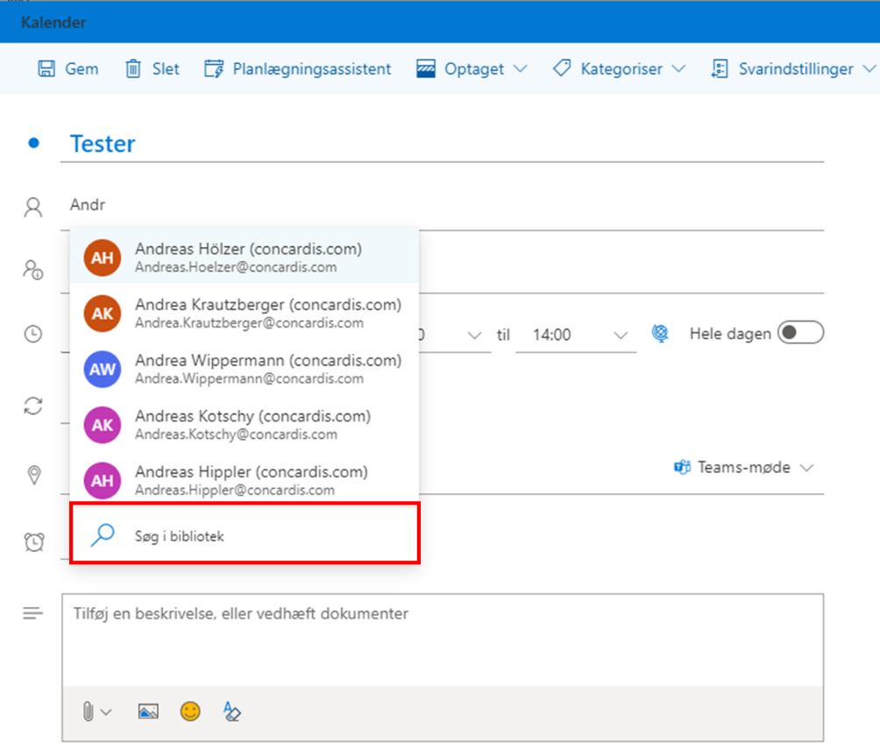

Notice that you must press the “add online meeting” button to add the Teams meeting option. After pressing this button, the meeting will contain a link for the Teams meeting, allowing all your attendees to join either through their Teams client, or through a web browser.

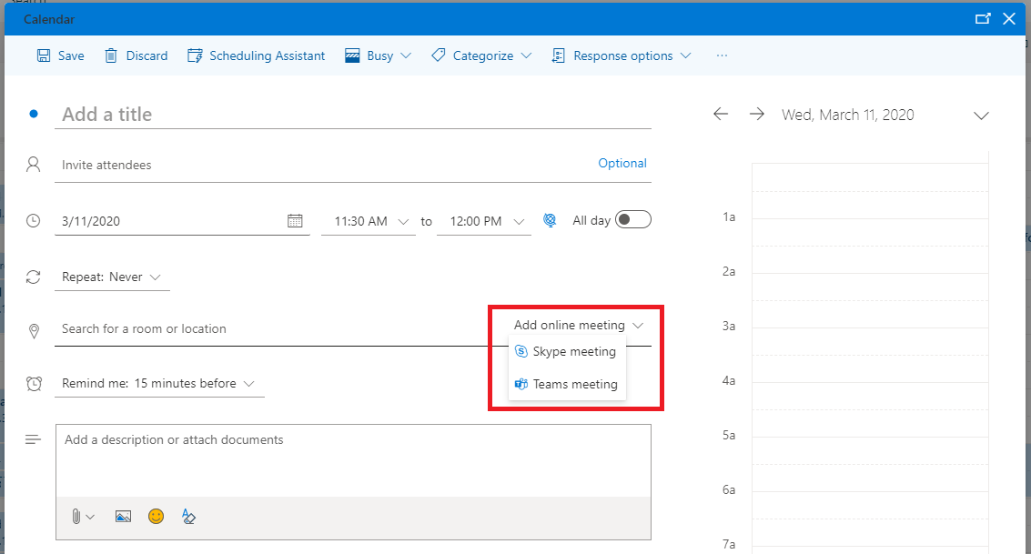

Once meeting has been scheduled you can join the online meeting directly by pressing the meeting in outlook calendar.

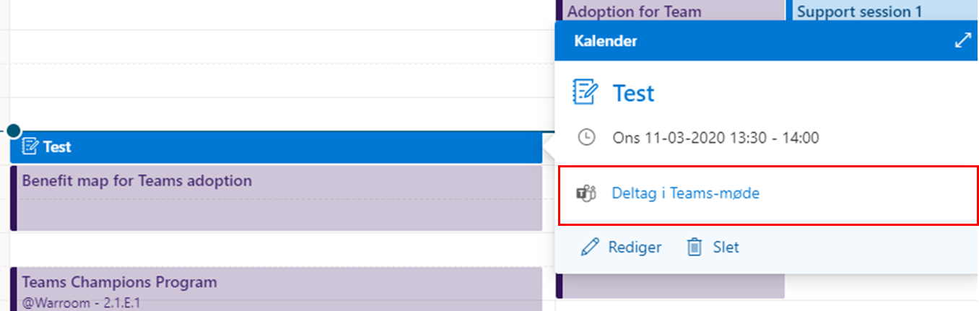

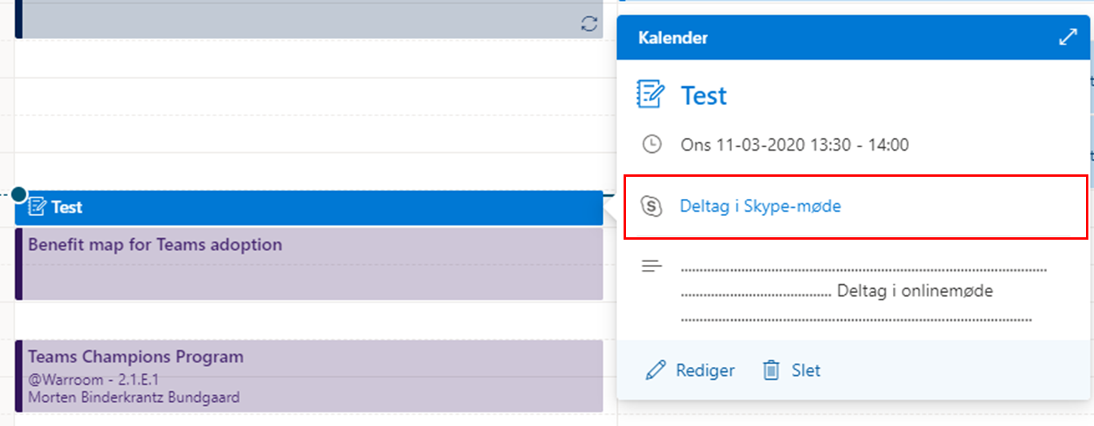

**IMPORTANT NOTICE**: If you use Skype as the online meeting channel, please not that you may be prompted for an installation. Please consider this before joining your meeting as it my take 2-3 minutes before it is completed.

6. Easy access to the most frequently used Office365 functions can be had by putting the name of the function in front of the address:

<http://www.teams.office.com/>

<http://www.outlook.office.com/>

<http://www.powerpoint.office.com/>