Laravel Sanctum

**MAKE API LOGIN WITH SANCTUM**

**# PRACTICE 1**

* **I want to login with column email and password**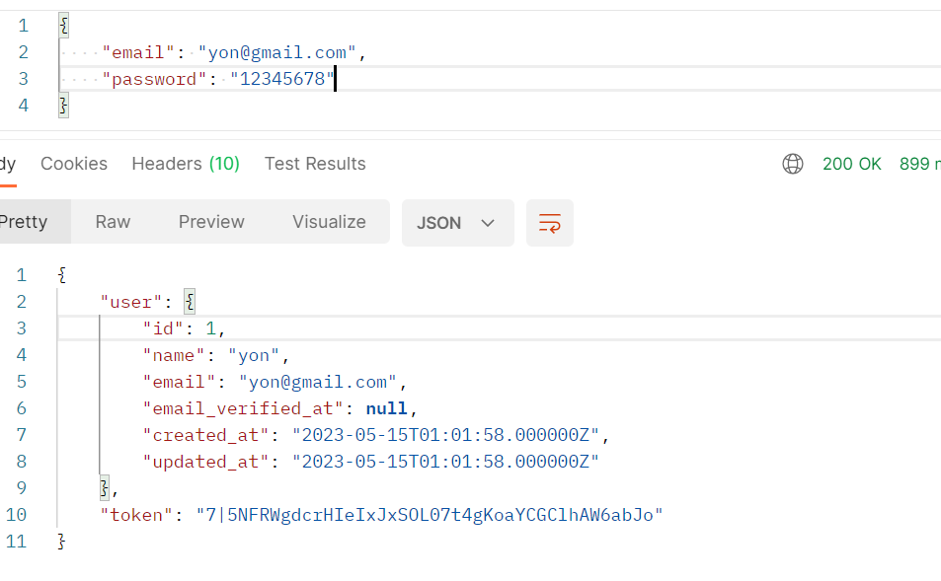
* **Step1: Install Laravel Sanctum**  
  **composer require laravel/sanctum**
* **Step2:** Next, you should publish the Sanctum configuration  
  php artisan vendor:publish --provider="Laravel\Sanctum\SanctumServiceProvider"
* **Step3: Run migration  
  php artisan migrate**
* **Step4: Add Sanctum Middleware  
  open** app/Http/Kernel.php file with the following:  
  \Laravel\Sanctum\Http\Middleware\EnsureFrontendRequestsAreStateful::class,  
    
  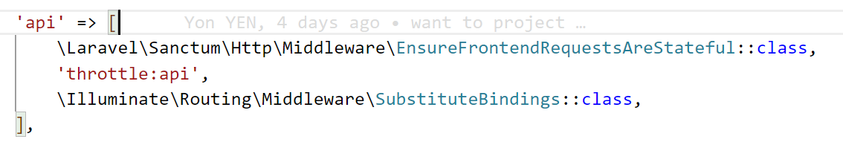
* Need to register user

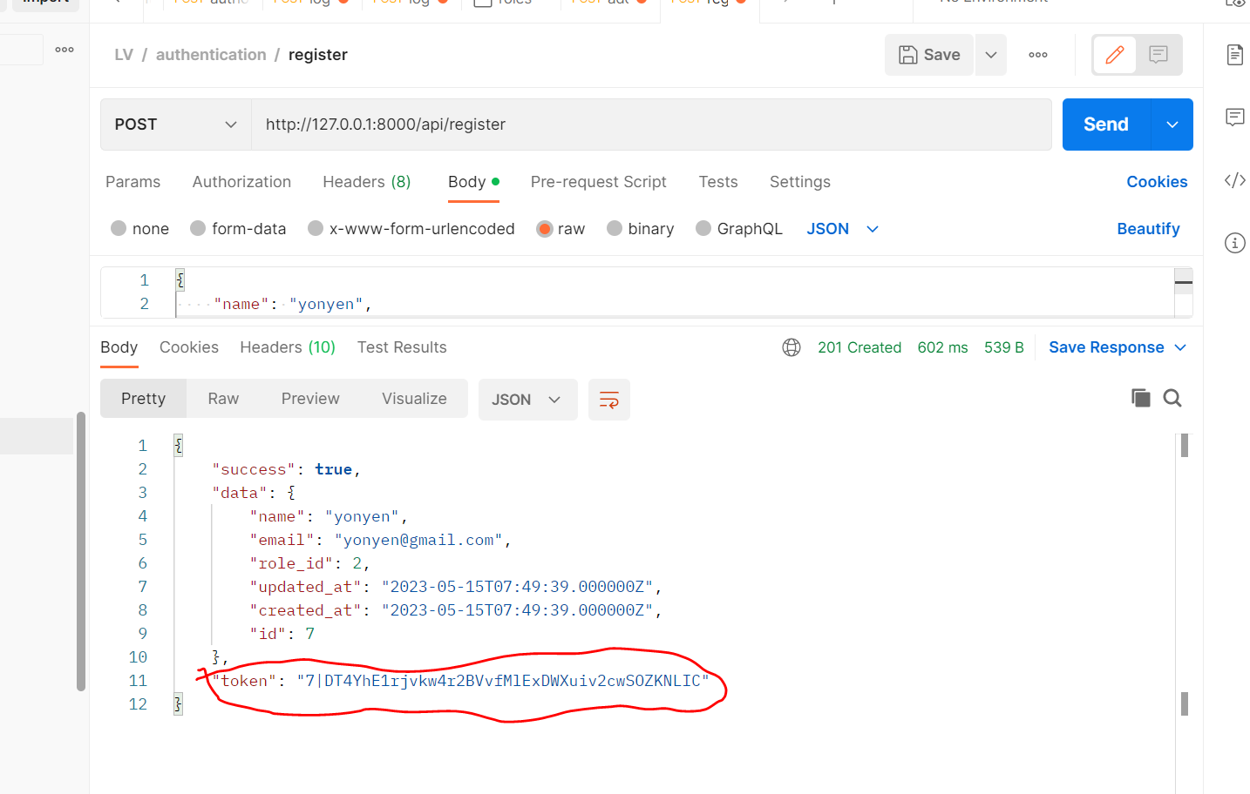

* **Make route for login**



* **Make function login in AuthenticationController**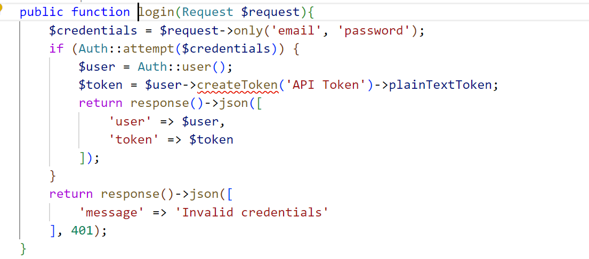
* **Now you can start to test with email and password**

**You will see the token**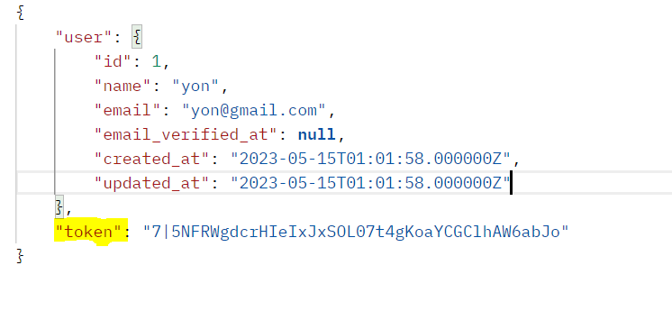

**NOTE: Not Only use sanctum to do api login we have many way to do.**