Signature Flooding Prevention in SCION

Overview

Denial-of-service, or DOS, attacks are a prevalent problem in today’s internet, with many research efforts being made to discover effective ways to both detect and respond to said attacks. DOS attacks occur when a malicious user attempts to make a certain service unavailable to legitimate users in a network. This is achieved by overwhelming a system with specially crafted requests to either congest the network traffic, or use up all of a specific resource such as memory or cpu time. One particular problem that makes denial of service attacks hard to combat is the inability to locate the source of the attack. Since, in the current internet, attackers are able to spoof their source addresses, they are able to act like a set of users, and, with adequate sending bandwidth, make their false requests seemingly indistinguishable from real traffic. There have been many attempts in developing systems to counteract denial of service attacks, one of which includes using signatures to verify legitimacy of requests. However, signatures themselves propose a certain computational burden, which, if exposed, could lead to a certain category of DOS attacks called signature flooding. Since it takes time to verify signatures, an attacker could perform a denial-of-service attack by sending a number of forged signatures to a service forcing the service to perform verification, ultimately wasting cpu time. Since SCION uses signatures and verification in a number of services to ensure authenticity, in this module we will be exploring signature flooding attacks and walking through two methods to mitigate this problem using SCION.

Testing Environment Setup and the Basic Case

In order to ensure we have a grasp of the situation as well as to aid future development, it would be helpful to create a sort of testing environment of the standard case. In the future, we may add to this to implement the various defence mechanisms. In this testing environment, we understand that we must have some sort of service receiving requests and some number of users (both malicious and legitimate) creating and sending requests. In order to simulate a real DOS attack, we would send the illegitimate requests (the ones with fake signatures) at a higher rate than the rest. Since the server may only complete its function after verifying that the sender’s signature is correct, the illegitimate request can use up all cpu time for this signature verification. In order to fluidly determine this saturation point, it would be important to have a variable sending rate for the attacker. This rate may be selected directly or some scaled multiple of the legitimate senders’ rates. But when and how exactly can one deem a request unservable? One viable metric could be time - if the request is not serviced within n seconds, it is considered “lost”. Therefore, we could measure how this number of “lost” packets changes as we increase the attacker’s bandwidth and compare this across mitigation methods. Excellent!

Task 1: Implement client and server applications according to the specifications above. The client is responsible for acting as both the real and malicious users, while the server is responsible for signature verification. You may assume the time it takes to deliver a packet is negligible so timestamps can be made on either side. Make use of rsa with 2048 bit keys for signatures.
- If desired, may utilize file “keygen.go” in appendix below that shows how to create an RSA keypair, sign messages, verify messages, write important RSA information to file (so that client and server use the same keys and hashes), and read again from said files.

Binning

One method to try to lessen the effects of an attacker conducting a denial-of-service is to effectively rate limit the attacker’s efforts through a method called binning. Binning essentially divides the incoming requests into buckets and only services some subset of the total requests in a way that ensures legitimate users will have their requests handled if they put in a certain level of effort (for example, send a certain number of copies) whilst an attackers attack bandwidth will be cut by a factor determined by the binning parameters. For more information on different binning methods and how they work, one may read Gunter 2004, Gunter 2005, or search online.

In SCION, we are able to adapt this binning method to counteract denial-of-service attacks by adding an extra component to our strategy at the AS level. In today’s internet, a large barrier to effective DOS protection is source address spoofing; however, in scion this is only possible in some cases. In order to forward a packet between ASes, the border routers at an AS inspect the AS’s respective hop field in the packet header and only forwards messages along the legitimate paths, until the packet reaches its destination. As a result, anything from the source to destination can only be forwarded if correct and only ASes prior can be spoofed. Therefore, if you imagine a scenario with only a single attacker and large available bandwidth, in today’s internet the attacker could masquerade behind a number of IP addresses, but in SCION every spoofed path would have at least one common node - the AS of the attacker.

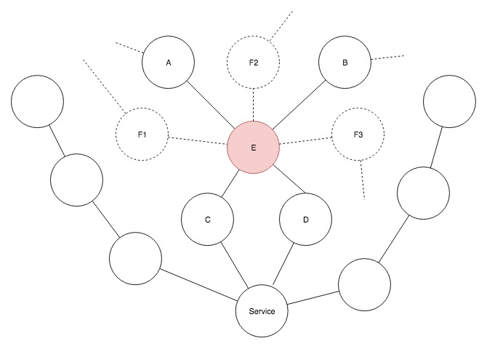
In the image above, the attacker, has the option of using an arbitrary number of spoofing paths by using a combination of different fake ASes and paths (indicated by dotted lines) along with legitimate ones (indicated by solid lines).

Normally you would serve requests based on these bins; however, for simplification of the problem, we are focused more on identifying we are in an attacked state and finding who is most likely the attacker.

Task 2: Append to your client application the ability to send the “path” a packet took to a destination for the binning case. In the server, implement a function that takes in a request (containing the “path” the packet took to reach the service), keeps track of the network state, and determines the attacker(s) if under attack. You may simply print “system under attack by AS <AS Number>” when found. In a real setting, this information would be used to adjust your binning rule.

Although you have free reign for what determines an “attack”, for better accuracy, your function should not only track the most recent state but also include assumptions about the number of attackers, percentage threshold of what constitutes an attack, and any other helpful parameters.

- One helpful way to begin is to design a topology similar to the figure above and create a set of “real” and “fake” paths to be associated with each client request. From there, you can keep state after every request the server receives and make decisions with that information.

Follow Up Questions:

- How may this helpful design detail about spoofing, as well as the binning method in general, aid in detecting and lessening the effect of a Denial of Service attack?
- What design choices did you make to give better accuracy as well as performance?

PISKES

*TODO: Talk about what PISKES is and how it solves DOS issues*

Conclusion

*TODO: Write after PISKES to wrap up document*

