The SCION Homeworks
The SCION homeworks are a set of homework assignments aimed at teaching users general networking problems and concepts, as well as introducing the structure and advantages of the SCION internet architecture and allowing them to build real SCION applications. Each assignment is aimed at a certain relevant topic in networking and are in the form of coding and conceptual walkthroughs.
In order to complete the assignments, students will need a working SCIONLab environment [7] which can be set up as a Virtual Machine or dedicated host, some familiarity with the Go programming language, as well as some linux tools to solve a series of networking problems/challenges. By following the SCION tutorials on how to set up a SCIONLab AS, you will have all these dependencies necessary to complete the homeworks ready in the machine.
The Go library source code [2] as well as SCIONLab sample applications [6] may prove helpful from time to time when searching for an API or examples. In addition, the appendix section contains several helpful debugging tips as well as sample outputs and results. At the end of the homeworks, users should be able to identify the topic of focus, the general approach at a solution, as well as SCION-specific advantages to said approach.

SCIONLab

SCIONLab is a contained, real networking environment in which you can create code for the SCION architecture and test how it would actually run in the network. Users may create autonomous systems (ASes), configure network parameters, and communicate over the SCION network. Each autonomous system comes with the development libraries and also with a set of services essential to SCION such as the border routers, beacon servers, path servers, etc. [4] , and are all available for interaction either in the environment or through the available APIs.
To use SCIONLab it is needed to register [5] and then configure a new AS following the guidelines explained in the tutorials [7].
Although extremely simple, this step is fundamental to be able to build and later test any code written in the assignments.

More information about the SCION architecture including news, updates, source code and a link to the book are available through the SCION website. [8]

STEPS:
- [10 min] Register to SCIONLab
- [40 min] Read the tutorial on how to create your AS VM. Create it in SCIONLab.
- [10 min] Using the tutorial check that the AS is working correctly.
- [30 min] Read exercise 1 and code an initial version.
- [1 hour] Build your code inside your SCIONLab machine, run it, debug it and improve it.
- [1 hour] Repeat steps 4 and 5 for exercise 2.
- [2 hours] Repeat steps 4 and 5 for exercise 3.

Bottleneck Bandwidth Estimation in SCION

Overview

The Bottleneck Bandwidth is the limiting rate of transfer available between two nodes of a connection on a specific path. This bottleneck can be caused by physical properties of a link such as its physical bandwidth or even the forwarding mechanisms of a router such as the time it takes to determine where to forward a packet to. No matter what the cause, the bottleneck bandwidth determines the maximum rate at which data can be forwarded from source to destination because all traffic must go through this path and data can only be pushed out as fast as this rate. Consequently, since future forwarding nodes can only maximally send out as much as they receive, the final received rate becomes that of this bottleneck.

In this module, we will use golang in order create a simple bottleneck bandwidth estimator in SCION. More specifically, we will implement the packet pair technique. This technique uses the difference in arrival times between two successive packets of the same size in order to provide an estimate of the bandwidth of the connection. If a source sends two packets of size s, initially with time interval t₀ between them, there are two possibilities of outcomes at the i’th link after, r_{i}. The following is the algorithm outlines these possibilities and is used to determine the received time interval at a destination. Keep in mind that bandwidth = s / t_{i}

t_{max} = t₀
While r_{i} := next_link():
if r_{i} >= (s / t_{max}):
/* The two packets will never queue because by the time the second packet is
ready to be transmitted, the first has already completed so does not change. */
t_{max} = t_{max}
Else:
/* The second packet is ready at the link while the first is being still being
transmitted because of smaller link rate, thus there is queuing. */
t_{max} = s / r_{i}

More intuitively –see Illustration 1– if two packets of size s are sent close enough together in time to cause the packets to queue at the bottleneck link with rate r, since both packets are waiting and this link can only push out these packets at rate r, the link services the second immediately after the first and thus there will be a difference of time t = s / r between the two packets. This difference will exist until the packets reach the receiver.

As a result, the destination receives these two packets with an interval t_{f} = max(t₀, s/r_{bottleneck}) between them. If t_{f} = t₀ = s/r₀ , this means the initial bandwidth is the bottleneck. Therefore, by rearranging the equation, we know the final time can be used to solve for the bottleneck link.
r_{bottleneck} = s/t_{f}.

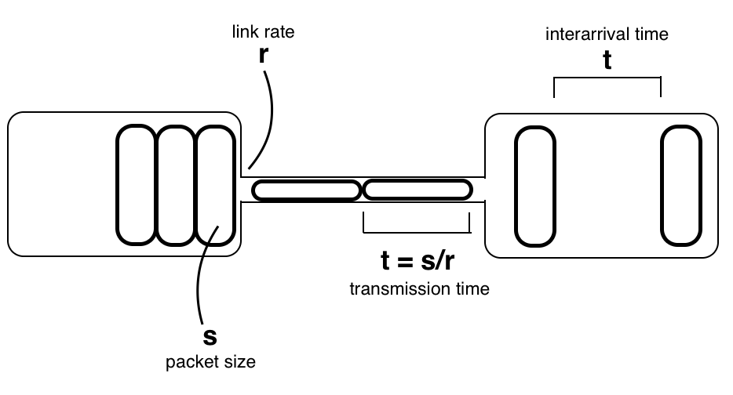
Illustration 1: Packets being transmitted (from left to right)

Implementation

So we have the basic idea but now need the implementation. Similar to the latency walkthrough, our implementation is going to consist of a sender and a dedicated receiver. Let’s think of all the factors our estimation relies on and what we’re trying to find. We need s, which is the size of the packet (chosen by us), we need t_{f} which we can find, and we use both to compute r_{bottleneck}.

In order to find t_{f}, we know that we need to send a sequence of packets, keeping track of when each was received at the receiver. In addition, we also want to make sure we know which packets are actually part of the test. This lets us know that there is some type of combination of IDs and timestamps necessary.

Task 1: Implement server and client bottleneck bandwidth estimators used the packet pair technique. You may use any of the suggested implementations below or come up with your own solution. Use the bottleneck bandwidth equation above.

Implementation Proposal 1: One possible implementation proposes that each packet is sent on an interval, with its own unique identifier, timestamped at the receiver who then returns the timestamp and the identifier for verification. In this way, all calculations and logic can be performed at the source and the server just receives and responds to requests.

Implementation Proposal 2: Another possible implementation idea could be to utilize the idea of sessions. A client could try to establish a session with a server, after which the server will only handle connections from said client for a specific amount of time. State can be kept at either side of this connection, making it possible to do calculations at one or both of the nodes.

Since there exists a bandwidth estimator implemented (see reference [1]) for SCION, you can use it to first estimate the bandwidth and check your results. Also, even though that implementation uses a different approach and cannot be used as an implementation reference, it could be helpful to discover the relevant library calls.

Packet Pair Evaluation

You may notice that results may vary and many may not even make sense, such as if you receive a bandwidth greater than the one that you sent out. These could be because of a number of reasons about how the code is being run and processed, the path the packets take, as well as some key assumptions made about our simplified packet pair technique.
- What assumptions are made when implementing the packet pair technique make that could alter the results? Hint: Think of packet queuing, processing, and potential network errors.

Other assumptions, as well as some filtering techniques, can be found here as well as by searching online. You are encouraged, but not required, to try to explore how you may adjust these parameters, estimations, and assumptions in order to get more accurate and consistent bw estimation results.

Expansion - SCION’s Impact

Although SCION’s impact on bottleneck bandwidth estimation does not solve the problems introduced by the assumptions above, it can indeed give more insight into the available rate between two nodes through forwarding path control. Since the desired AS-level path is encoded directly into the packet, one would be able to estimate the bottleneck for each path taken, and moreover, under the assumption that all experiments ran under the same conditions, determine the path with the smallest bandwidth and also estimate the bottlenecks on each independent node. More concretely, bw(path) = min(bw(node₀), bw(node₁), ... , bw(node_{N})) for a given path. Thus we could find which node is triggering the minimum either by enumerating the paths and using the intersections as an estimation. This is definitely something you cannot achieve using only IP.

Task 2: Expand your previous server and client bottleneck bandwidth estimators to not only report the bottleneck bandwidth but the specific path(s) and the node/link causing this bottleneck.

Conclusion

Overall, in this module we have used the Packet Pair technique to implement bottleneck bandwidth estimator applications in SCION that are able to not only report the bottleneck bandwidth between two nodes, but also the paths and nodes that have this bottleneck. We have discussed how SCION is advantageous in this application due to its transparency and control over forwarding paths. In addition, we also discussed the limitations of the Packet Pair technique and the assumptions for its execution. Steps for extension of these applications would be the implementation of filtering techniques to eliminate noisy measurements.

References

[1] SCION bwtester: https://netsec-ethz.github.io/scion-tutorials/sample_projects/bwtester/
[2] Go library code: https://github.com/netsec-ethz/netsec-scion/tree/scionlab/go/lib
[3] SCION protocol dissector: https://netsec-ethz.github.io/scion-tutorials/scion_tricks/wireshark/
[4] SCION Book (PDF version): https://www.scion-architecture.net/pdf/SCION-book.pdf
[5] SCIONLab: https://www.scionlab.org
[6] SCIONLab Sample Applications: https://github.com/perrig/scionlab/tree/master/
[7] SCIONLab Tutorials: https://netsec-ethz.github.io/scion-tutorials/
[8] SCION Architecture homepage: https://www.scion-architecture.net/

