Netskope DLP On Demand ↔ Databricks
Quickstart Deployment Guide
A condensed, step-by-step version of the full solutions guide — use this if you already know the architecture and just need the checklist. See Netskope-DLPoD-Databricks-Solutions-Guide.docx for full explanations, troubleshooting, and the API reference.

Prerequisites
- A Netskope tenant with DLP On Demand (DLPoD) enabled.
- If you want DLP on images (screenshots pasted into chat, etc.), ask your Netskope account team to enable the backend feature flag DLP_DLPAAS_FEATURE_ENABLE_OCR for your tenant — it is off by default. Text-only DLP works without it.
- A Netskope DLPoD appliance already deployed and tethered to your tenant — see https://github.com/sandiegojenkins/netskope-dlpod-standalone. (This guide covers only the Databricks-side adapter, not the appliance itself.)
- At least one DLP profile configured in your Netskope tenant that you want to enforce (custom or predefined) — you’ll need its exact name.
- A Databricks workspace with Unity Catalog and AI Gateway enabled, including the External Policies (Direct HTTP API) feature — confirm with your Databricks account team if you’re not sure it’s available.
- Permission in Databricks to create a Unity Catalog connection (CREATE CONNECTION or metastore admin) and MANAGE on the schema of the service you want to govern.
- AWS CLI access to the account/region where the DLPoD appliance runs, with permission to deploy a CloudFormation stack.

Steps

Step 1 — Deploy the AWS Netskope DLPoD Adapter
Get the deployment package (this repo), then:
cp .env.example .env # fill in VPC_ID, LAMBDA_SUBNET_IDS
./deploy-databricks-adapter.ps1

- VPC_ID and LAMBDA_SUBNET_IDS must be in the same VPC as the DLPoD appliance’s internal load balancer — the Lambda needs no internet/NAT access, only VPC-local reachability.
IMPORTANT: The script prints the OAuth Client Secret once, at the very end — copy it into a password manager immediately. It can be retrieved again later with aws cognito-idp describe-user-pool-client if needed (see README).
From the stack outputs, record: Host, Client ID, Client Secret, Token endpoint, and OAuth scope. You’ll enter these into Databricks in Step 2.

Step 2 — Configure Databricks
- Go to Catalog → gear icon (top of the Catalog panel) → Connections → Create connection.
- Set connection type to HTTP and authentication type to OAuth M2M.
- Fill in Host / Client ID / Client Secret / Token endpoint / OAuth scope from Step 1. Leave the API path blank.
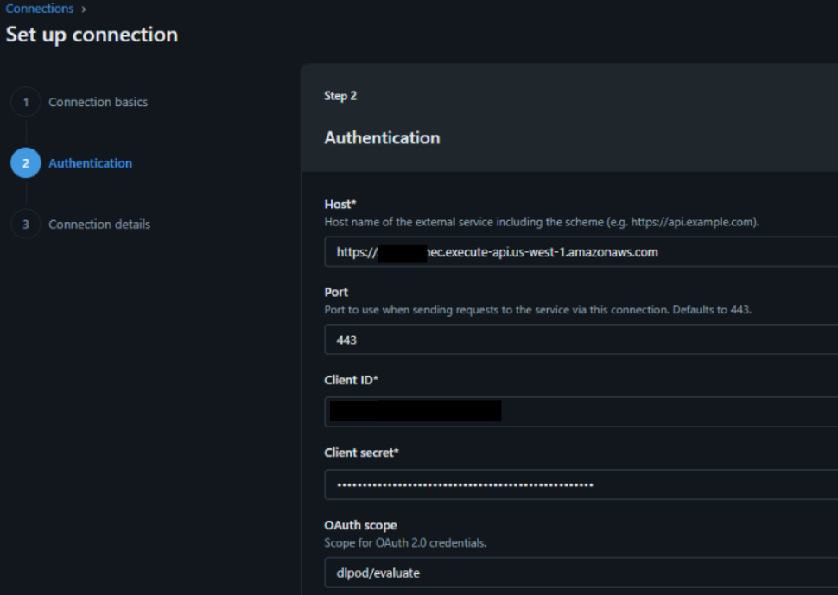
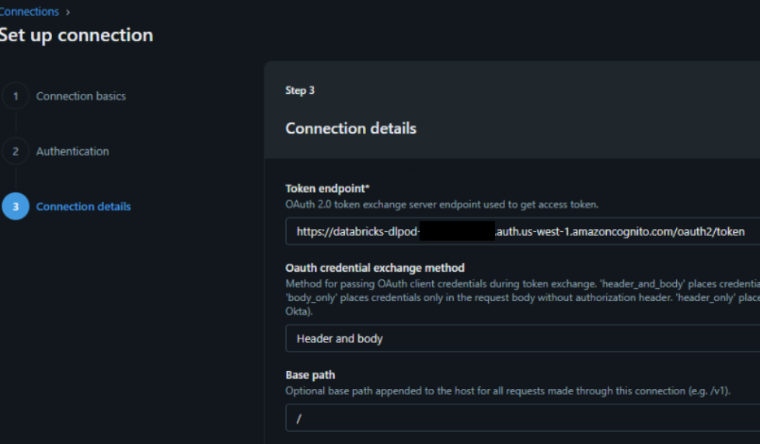
- Add the LLM service you want to govern.
- This is the model, model-provider, or MCP service whose traffic should be checked for DLP — e.g. an AI Gateway serving endpoint or a provider you’ve registered under AI Gateway → Providers.
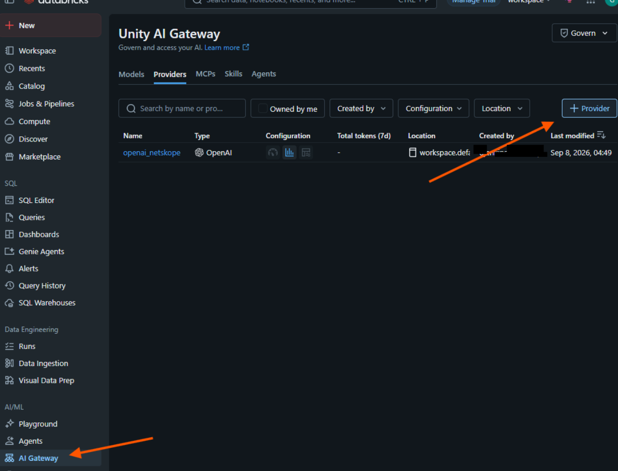
- Add the Netskope DLPoD External Policy to that service.
- On the service’s Policies tab (Beta): New policy → Service policy → Guardrail type: External → select the connection from step 1 above.
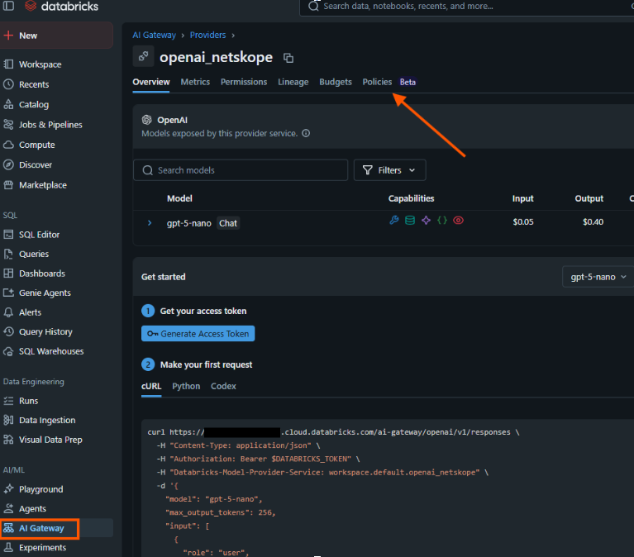
- Set Policy configuration (policy_config) to your DLP profile name(s), for example:
{ "profiles": ["Block SSN GenAI"] }

- Choose Phase (input, output, or both) and start in Log mode to validate before enforcing.
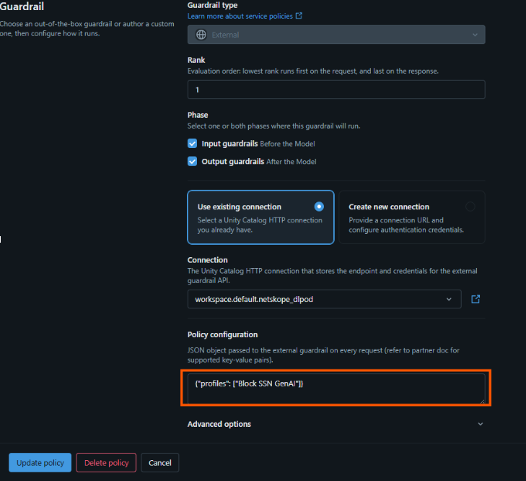
NOTE: Wait 60–90 seconds after saving a policy before testing — changes propagate through a configuration cache, and testing immediately is the most common reason people conclude a policy isn’t working when it actually is.

- Test with “Try in Browser.”
- On the governed service’s Overview page, use the Try in Browser button (more reliable than picking a model in Playground’s dropdown, which can silently call the wrong endpoint).
- Send a benign prompt first — it should complete normally.
- Then send a prompt containing something your DLP profile should catch (e.g. a realistic-looking SSN) — it should be blocked, with a reason mentioning the matched DLP profile.
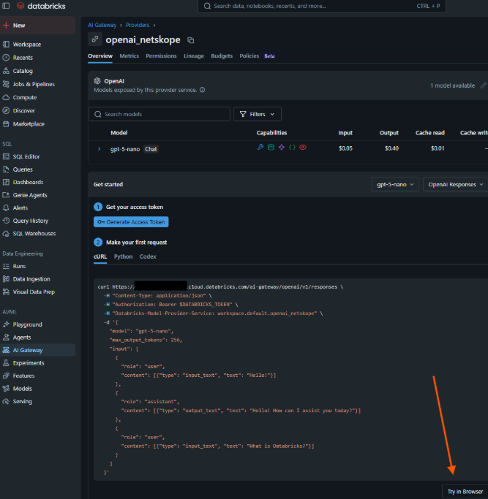

Step 3 — Set Up the DLP Policy in Netskope
In the Netskope UI, confirm the DLP profile you referenced in Step 2 exists and is configured the way you expect (Policies → DLP, or wherever your tenant’s DLP profile management lives). If you want image/OCR-based DLP, this is also where you’d confirm the DLP_DLPAAS_FEATURE_ENABLE_OCR flag has taken effect for your tenant.
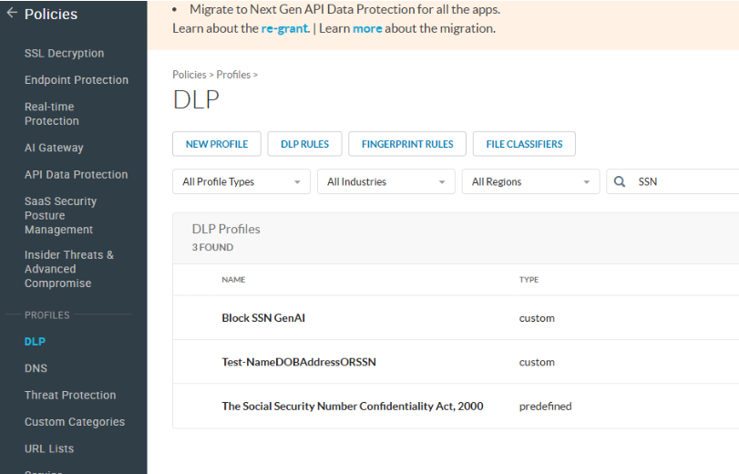
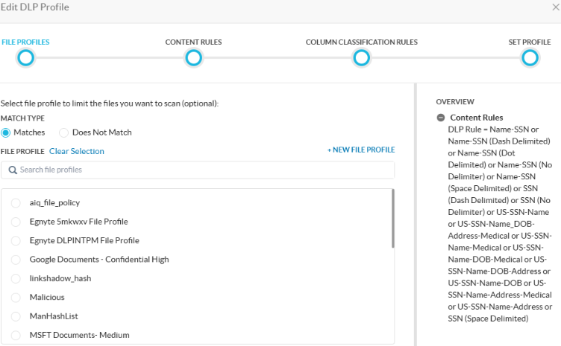

Step 4 — Confirm Alerts in SkopeIT
After the blocked test in Step 2, check SkopeIT (Skope IT → Alerts) for a new alert. This confirms the whole path end to end — not just that Databricks blocked the request, but that Netskope actually logged the match. Look for:
- Alert Name: DLP On Demand
- Application: DatabricksAIGateway
- DLP Profile / DLP Rule matching what you configured
NOTE: If Databricks blocked the request but no alert shows up in SkopeIT, the adapter’s GenerateIncidents setting was likely overridden to false at deploy time (it defaults to true). See docs/databricks-adapter.md.

Once Steps 1–4 all check out, switch the policy from Log to Enforce mode for production use.

