Netskope AI Gateway on Google Cloud
Deployment guide: Terraform, run locally
This guide explains how to deploy the Terraform from a copy of the repository on your own computer. It builds the AI Gateway tier on Google Cloud, then walks through the manual enrollment step, verification, and teardown. An optional section adds the TPU AI Guardrails tier.
Audience | Engineers who will run this Terraform from their own computer to deploy the AI Gateway on Google Cloud.
Estimated time | About two hours for the AI Gateway tier, including waiting for the instance group and load balancer and the manual enrollment. The TPU tier adds quota approval time, which can take hours or days.
Status | The AI Gateway tier was tested end to end. The TPU tier is tested through the endpoint and model upload.
Version | 1.1, November 2026

Contents
1. Overview
2. Before you start
3. Connect to the gateway without a public IP
4. Prepare the configuration
5. Run Terraform (AI Gateway tier)
6. Enroll the gateway (manual, AIG-CLI)
7. Verify the deployment
8. Optional: TPU guardrails tier
9. Scale the gateway
10. Teardown
11. Troubleshooting
Appendix A. Variable reference
Appendix B. Output reference

1. Overview
One Terraform run builds the network, the AI Gateway instance group, the autoscaler, and a public HTTPS load balancer. Terraform does not enroll the gateway. You do that once per instance with the AI Gateway Configuration Wizard, using a token from the Netskope portal.

What Terraform creates
- A VPC with a private subnet, a proxy-only subnet for the load balancer, Cloud NAT, and two firewall rules.
- A service account for the gateway instances, with logging and metrics writer roles only.
- A regional managed instance group of n2-standard-16 VMs across two zones, with no external IP addresses.
- An autoscaler: minimum 1, maximum 4, CPU target 70 percent, scale-out only.
- A global external HTTPS load balancer with a static IP and a self-signed certificate (replace it for production, see section 4).
- Optional, when enable_tpu_tier is true: the TPU tier resources in section 8.

How traffic flows
Clients connect to the load balancer's static IP on 443. The load balancer forwards to a gateway VM on 443. Gateway VMs reach Netskope and LLM providers through Cloud NAT. Administrators reach a VM's SSH port through Google Identity-Aware Proxy (IAP), described in section 3.
Note: Cloud NAT gives the VMs outbound access only. Nothing on the internet can reach a VM directly.

2. Before you start
You need | Details
Repository access | The private GitHub repository, netskope-aig-gcp-terraform. Clone it with git clone, using the URL you were given. Access is by GitHub account.
Google Cloud project | A project with billing enabled. Use your own project ID. Replace the placeholder your-project-id wherever it appears.
Google Cloud CLI (gcloud) | Installed and signed in with gcloud auth login. Install with winget install Google.CloudSDK.
Application Default Credentials | Set with gcloud auth application-default login. Terraform uses these, not your gcloud login.
Terraform 1.14 or later | Tested with 1.14.8. Install with winget install Hashicorp.Terraform. The Google and TLS providers download on first terraform init.
Git | Installed, for cloning the repository.
AI Gateway image | Access to an AI Gateway boot image in your project. The default is set by aig_image. Confirm it is visible (section 4).
Netskope tenant admin login | Needed to generate the registration token in the portal (section 6).
SSH key pair | An OpenSSH key pair on your computer. Ed25519 is recommended. The public key goes into your configuration.
PowerShell 5.1 or later or a Mac | The commands in this guide are for PowerShell. PowerShell 7 and Git Bash also work with the same gcloud and terraform commands.

Permissions your account needs
Owner on the project is the simplest option and covers everything in this guide. Editor is not enough: Terraform creates project IAM bindings for the gateway service account, which requires permission to set the project IAM policy.
Purpose | Role
Create the network, load balancer, instance group, and service account | Owner, or Editor plus Project IAM Admin
Connect to VMs through IAP (section 3) | roles/iap.tunnelResourceAccessor
SSH to a VM with gcloud compute ssh | roles/compute.instanceAdmin.v1

Enable the APIs
Terraform enables the APIs for the AI Gateway tier as needed. You can enable the core ones yourself first, so the first plan is clean:
gcloud services enable compute.googleapis.com iam.googleapis.com logging.googleapis.com monitoring.googleapis.com cloudresourcemanager.googleapis.com --project=your-project-id

Set up your computer
- Sign in to gcloud and set the project:
gcloud auth login
gcloud auth application-default login
gcloud config set project <your-project-id>
- Create an SSH key if you do not have one. Press Enter to accept the default file path:
ssh-keygen -t ed25519 -C "you@example.com"
Just hit enter when asked ‘Enter file in which to save the key’
- Print the public key. You will paste this one line into the configuration:
Get-Content $HOME\.ssh\id_ed25519.pub

3. Connect to the gateway without a public IP
Note: You can’t do this until step 6. Come back to it when told

The gateway VMs have no public IP address. You use Google Identity-Aware Proxy (IAP) instead. gcloud opens a tunnel through Google to port 22 on the VM. The tunnel works only for identities that have the IAP role, and only to VMs in the same VPC that the firewall allows.

Use your own terminal
Claude does not provide a shell that can reach your VPC, so do not use Claude to connect. Run the SSH command from a terminal on your computer. Two options work:
- Windows PowerShell or Windows Terminal on your computer, after gcloud auth login.
- The Terminal panel in the Claude desktop app. It is a PowerShell on your computer, so it uses the same gcloud login.

How it works
Terraform creates a firewall rule named aigw-allow-iap-ssh. It allows TCP port 22 from Google's IAP range, 35.235.240.0/20, to VMs tagged aig-gateway. When you run gcloud compute ssh --tunnel-through-iap, gcloud connects to IAP using your login. IAP checks that you have the IAP tunnel role, then forwards the connection to the VM's port 22.

Connect
- List the gateway instances and note the name and zone of one that is RUNNING:
Note: replace <your-project-id> with yours on both of these snipat
gcloud compute instances list --project <your-project-id> --filter="name~^aigw-aig" --format="table(name,zone,status,networkInterfaces[0].networkIP)"
- Connect as nsadmin, the AIG-CLI account. Replace INSTANCE_NAME and ZONE:
gcloud compute ssh nsadmin@INSTANCE_NAME --zone=ZONE --project=your-project-id --tunnel-through-iap
Note: The first connection asks you to accept the host key. Check the fingerprint shown matches the one the console shows for the instance, then answer yes.
Note: Terraform installs your key in instance metadata. You do not need to add it to Compute Engine by hand, and project-wide keys are blocked.

4. Prepare the configuration
Clone the repository, then create your own terraform.tfvars from the example. The file is git-ignored, so your key and settings stay on your computer. Do not commit it.
- Clone the repository and open the Terraform folder:
git clone <repository-url> netskope-aig-gcp-terraform
cd netskope-aig-gcp-terraform
- Create your variables file from the example, then edit it:
Copy-Item terraform.tfvars.example terraform.tfvars
Set at least the values below. Everything else has a working default. Appendix A lists every variable.
Variable | What to set
project_id | Your project ID. The repository has no default, so this is required.
region and zones | A region and two zones inside it, for example us-east1 with us-east1-b and us-east1-c. The machine type must be available in both zones.
name_prefix | A short unique prefix, for example aigw-alice. If two people share a project, each needs a different prefix.
aig_hostname | The hostname you will enter in the portal. Point a DNS record at the load balancer IP later, or use a hosts file entry for testing.
ssh_public_key | One line from the public key file you printed in section 2. It must start with ssh-rsa, ssh-ed25519, or ecdsa.
owner | Your owner label, for example jsmith. The repository has a placeholder (your-username). Set your own value here, or the label will show the placeholder.
cost_center, stage | Labels for cost tracking. Use lowercase letters, digits, dashes, or underscores only.
aig_image | Leave the default unless your account cannot see it. Confirm it with the command below.

Confirm your account can see the default image:
gcloud compute images describe ai-gateway-v1-9-63 --project=<your-project-id> --format="value(name,status)"
Warning: The default aig_image is a placeholder, so set it to the project that holds your image. If the command says the image is not found, your project does not have access. Subscribe to Netskope One AI Gateway in the Google Cloud Marketplace, or ask Netskope which image to use, then set aig_image.
Note: Terraform creates a self-signed certificate for the load balancer. Browsers and API clients must trust it or skip verification. For production, issue a certificate from your certificate authority or use Certificate Manager. This version of the Terraform does not import a certificate you provide, so that must be added before production use.

5. Run Terraform (AI Gateway tier)
Run these commands from the Terraform folder. Do not skip the plan, so you can review what will be created.
- Download the providers:
terraform init
- Check formatting and syntax:
terraform fmt -check
terraform validate
- Create a plan and save it to a file:
terraform plan -out aig.tfplan
A first run with the default values should show 22 to add, 0 to change, 0 to destroy. Read the list before you continue. If you see changes or deletions, stop and check your variables. If the plan asks you for project_id, your terraform.tfvars is missing or incomplete.
- Apply the saved plan:
terraform apply aig.tfplan
Terraform reports when it finishes. The instance group and load balancer can take several more minutes to become ready. The gateway is not usable until you enroll it in section 6.
Warning: The state file terraform.tfstate contains the private key for the self-signed certificate. Keep the folder private. Do not commit the state file or share it. It is git-ignored.
Warning: Terraform state is per folder. If you run the same configuration from a second folder, it has no record of resources the first folder created, and an apply can try to create duplicates. Keep one folder as the owner of each deployment.

6. Enroll the gateway (manual, AIG-CLI)
Enrollment has two parts: a registration token from the Netskope portal, and the AI Gateway Configuration Wizard on the VM. The token expires 24 hours after it is generated. Generate it immediately before you start this section.

Generate the registration token
- Sign in to your Netskope tenant and go to Settings > Security Cloud Platform > VM Onboarding.
- Click Deploy VM, then Register VM.
- In Step 1 (Configure), set VM Name (AI Gateway) to your name_prefix. Set Hostname to the aig_hostname value from your configuration. Choose the HTTPS and HTTP protocol and port settings.
Note: These fields can be found in your terraform.tfvars file.
- Click Continue. In Step 2 (Register), click Copy or Download to save the token. Then click Finish.

Connect and configure the gateway
- Connect to the instance over IAP, as in section 3.
- Open the AI Gateway Configuration Wizard from the CLI. The Netskope docs do not show the exact command, so confirm it on first login.
- Select Network Configuration. Netskope's docs say CLI network configuration is supported only on ESXi, so on GCP leave DHCP in place and check that the wizard lets you continue.
- Select Enroll this AI Gateway. Pre-enrollment takes a few minutes.
- When prompted, paste the registration token on the AI Gateway Enrollment page.
- Note the Gateway ID shown in the CLI when enrollment succeeds.

Confirm enrollment
- In the CLI, check the enrollment status shows success.
- In the portal, go to Settings > Security Cloud Platform > VM Onboarding. A green icon next to the VM name means it registered.
Note: If the token has expired, generate a new one in the portal and run the wizard again. Do not reuse an old token.

Install the SSL certificate
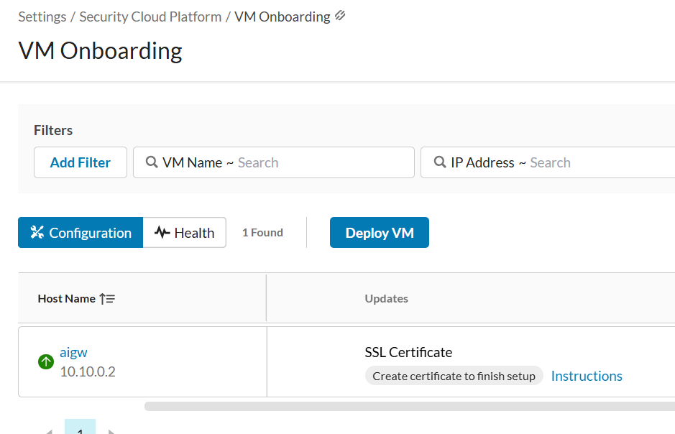
After enrollment, VM Onboarding shows "Create certificate to finish setup" next to the VM. Until you finish this step the load balancer backend stays UNHEALTHY. The Instructions link in the portal has the exact steps. The steps below use a throwaway lab certificate authority.
These steps are done in the tunneled connection to the AI Gateway connected in step 3.
- In the portal, click Instructions next to the SSL Certificate entry and follow them to generate a certificate signing request (CSR) on the gateway. Use an RSA key (2048 bits). Set the common name to the aig_hostname value.
- Copy the CSR to your computer and save it as aig.csr. In PuTTY, select text with the mouse to copy it and right-click to paste. Do not press Ctrl+C, which interrupts the session.
- On your computer, create a lab CA and sign the CSR. This uses the OpenSSL that comes with Git for Windows. Run it in a new empty folder:
$ssl = "C:\Program Files\Git\usr\bin\openssl.exe"
& $ssl genrsa -out lab-ca.key 4096
& $ssl req -x509 -new -key lab-ca.key -sha256 -days 825 -subj "/O=Netskope lab/CN=aigw" -out lab-ca.pem
"subjectAltName=DNS:aig.aigw.internal`nbasicConstraints=CA:FALSE`nextendedKeyUsage=serverAuth" | Set-Content -Encoding ascii ext.cnf
& $ssl x509 -req -in aig.csr -CA lab-ca.pem -CAkey lab-ca.key -CAcreateserial -days 365 -sha256 -extfile ext.cnf -out aig-server.pem
- Install aig-server.pem on the gateway as the portal Instructions describe. If the wizard also asks for a CA certificate, use lab-ca.pem. The certificate status shows Active.
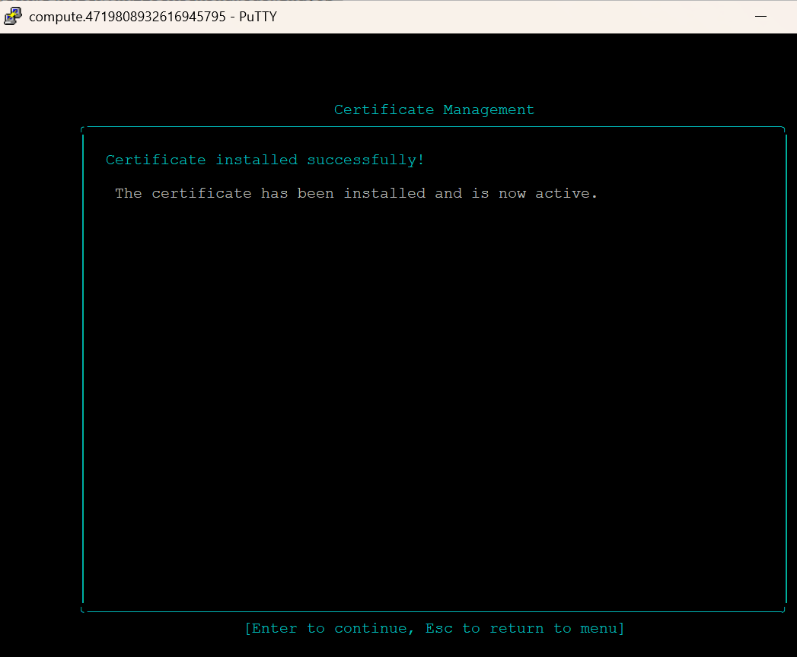
- In the portal, refresh VM Onboarding. The "Create certificate to finish setup" entry clears. After a few minutes the backend shows HEALTHY (section 7).
Note: Keep lab-ca.key private. Anyone who has it can issue certificates your clients would trust. For anything beyond a lab, send the CSR to your company CA instead.
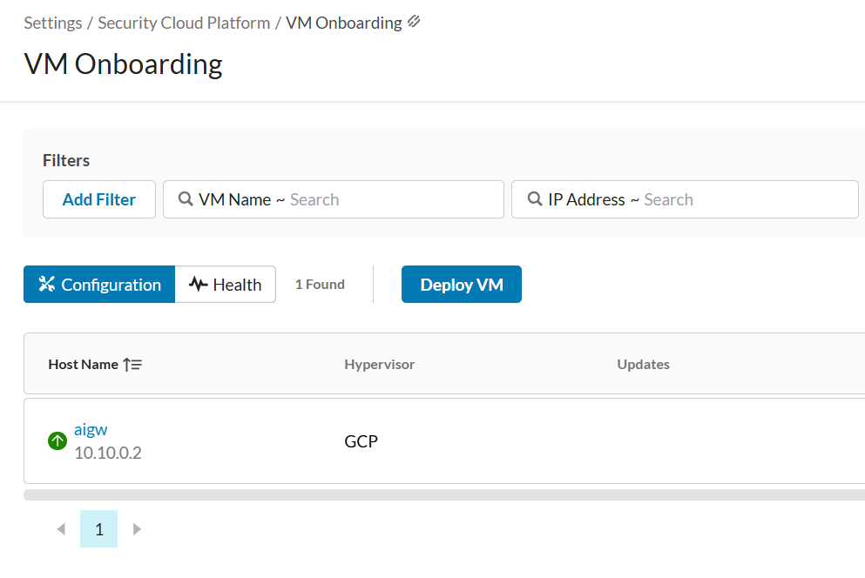

7. Verify the deployment
Check | Command or location | Expected result
Instances are running | gcloud compute instances list (section 3) | One or more instances with status RUNNING.
Load balancer backends | gcloud compute backend-services get-health aigw-aig-backend --global --project=your-project-id (use your name_prefix) | HEALTHY after enrollment. Expect UNHEALTHY until then.
HTTPS reachable | curl.exe -k -I https://LOAD_BALANCER_IP/ (run terraform output aig_load_balancer_ip) | An HTTP response. The -k flag skips the self-signed certificate check.
Portal registration | Settings > Security Cloud Platform > VM Onboarding | Green icon next to the VM name.

Note: The health check passes only on HTTP 200, and GCP does not accept other response codes. If the backend stays UNHEALTHY after enrollment and the gateway responds with 401 or 403 on /, set health_check_path in your configuration to a path that returns 200, then run terraform plan and terraform apply again.

8. Optional: TPU guardrails tier
The TPU tier runs the AI Guardrails model on a Vertex AI endpoint using TPU v5e. It is off by default. Turn it on with enable_tpu_tier = true in your terraform.tfvars. Terraform creates the APIs, the Artifact Registry repository, the Vertex AI endpoint, and, once you set the variables, the Cloud Run proxy. The model is uploaded and deployed with gcloud, because the Google provider cannot deploy a model to an endpoint and has no API Gateway resources.

8.1 Request TPU quota first
The endpoint cannot deploy a model until your project has TPU v5e quota. Request it before anything else. This is the most likely cause of delay.
- Open IAM & Admin > Quotas for your project.
- Filter: Service = Agent Platform API, Dimensions (location) = your region (for example us-east1), and search for TPU V5e.
- Tick Custom model serving TPU V5e cores per region, then click Edit Quotas.
- Request 8 cores. A ct5lp-hightpu-1t replica uses 1 core, so 8 leaves room for several replicas.
- Enter a justification and contact email, then submit. In our test the request was approved the same day, in about three hours. Your request may take longer.
Note: Check the Increase Requests tab for an earlier request before you submit, so you don't file a duplicate. Once the quota is approved, leave tpu_quota_id and tpu_quota_contact_email empty. Setting them submits a second request.

8.2 Get the image into your project
The AI Guardrails TPU image from Netskope is an OCI image layout in a .tgz file, not a docker save archive. Do not use docker load on it. Push it directly with crane (Google's go-containerregistry tool). crane reads the layout without the Docker daemon.
- Check the archive contents. You should see index.json, oci-layout, and a blobs\sha256 folder. Replace the file name with the one you downloaded:
tar -tzf aisecurity-llm-tpu.tgz
- Extract it to a folder, then install crane:
go install github.com/google/go-containerregistry/cmd/crane@latest
- Sign in to Artifact Registry so crane can push:
gcloud auth configure-docker us-east1-docker.pkg.dev
- Create the repository. Terraform can manage it later, but it must exist before the push. If you create it here, import it into Terraform in step 8.4:
gcloud artifacts repositories create aisecurity-tpu --repository-format=docker --location=us-east1 --project=your-project-id
- Push the image. Use the folder you extracted to:
crane push --index C:\path\to\aisecurity-llm-tpu us-east1-docker.pkg.dev/your-project-id/aisecurity-tpu/llm-tpu:v1
Note: Run crane push --help first to confirm the --index flag on your version. If the push fails on the attestation entry, push only the linux/amd64 manifest. The push takes a while because the image is large. Do not close the terminal while it runs.

8.3 Upload the model to Vertex AI
Uploading the model does not use TPU quota, so you can do it before the quota is approved.
- Upload the model:
gcloud ai models upload --region=us-east1 --display-name=aisecurity-llm --container-image-uri=us-east1-docker.pkg.dev/your-project-id/aisecurity-tpu/llm-tpu:v1 --container-predict-route=/predict --container-health-route=/health --project=your-project-id
- Get the numeric model ID. You need it for tpu_model_id:
gcloud ai models list --region=us-east1 --project=your-project-id --filter="displayName=aisecurity-llm" --format="value(name)"
Note: The container must listen on port 8080, which is the Vertex AI default. The Netskope guide does not say this, so confirm it with Netskope if the deploy fails.

8.4 Turn on the TPU tier with Terraform
- If you created the repository by hand in 8.2, import it so Terraform manages it instead of creating it again:
terraform import -var enable_tpu_tier=true 'google_artifact_registry_repository.tpu[0]' projects/your-project-id/locations/us-east1/repositories/aisecurity-tpu
- In terraform.tfvars, set these values. Leave the quota variables empty:
enable_tpu_tier = true
tpu_model_id = "MODEL_ID_FROM_8.3"
- Plan and review. With the tier on, the plan adds the APIs, the repository (if not imported), and the endpoint. It also includes the AI Gateway resources, so expect the full set:
terraform plan -out aig.tfplan
terraform apply aig.tfplan
Warning: Applying with the tier on also creates the AI Gateway instance group, which runs one n2-standard-16 VM. The VM bills while it runs.

8.5 Deploy the model to the endpoint
This step starts the TPU, and the TPU is the expensive part. A deployed endpoint bills every hour, even when idle. Deploy only when you are ready to test, and undeploy when you finish.
- Get the endpoint ID and the deploy command from the outputs:
terraform output tpu_endpoint_name
terraform output tpu_deploy_model_command
- Run the deploy command. Replace project id, MODEL_ID, and ENDPOINT_ID with the last part of the endpoint name:
gcloud ai endpoints deploy-model ENDPOINT_ID --region=us-east1 --model=MODEL_ID --display-name=aisecurity-tpu --machine-type=ct5lp-hightpu-1t --min-replica-count=1 --max-replica-count=1 --project=your-project-id
This is what mine looked like
gcloud ai endpoints deploy-model aisecurity-tpu-endpoint --region=us-east1 --model=243463xxxxxxxxxx140 --display-name=aisecurity-tpu --machine-type=ct5lp-hightpu-1t --min-replica-count=1 --max-replica-count=1 --project=netskope-gcp

- Confirm the deployment and note the deployed model ID for teardown:
gcloud ai endpoints describe ENDPOINT_ID --region=us-east1 --project=your-project-id
Note: If the deploy fails with a quota error, check that the TPU quota shows as approved for us-east1 in the Quotas page.

8.6 Cloud Run proxy and API Gateway (not yet tested)
Terraform creates the Cloud Run proxy only when tpu_proxy_image is set, and the guide does not name an image for it. This step is not yet tested. The API Gateway has no Terraform resource in this provider, so it needs gcloud. The Netskope guide contains some inconsistent names, so check each one before use: the proxy service account name, the Artifact Registry repository name, and the OpenAPI address line. The client service account is referenced but never created.

8.7 Check the TPU tier
Until the proxy and API Gateway are tested, check only that the model is deployed and the endpoint responds. Full inference testing waits for those steps.

8.8 Send test prompts to the model
These tests send three prompts directly to the deployed model: a normal question, a prompt-injection attempt, and a prompt that contains sensitive data. They test the model on the Vertex AI endpoint, not the gateway. Testing through the gateway waits for section 8.6.
The request files are in the tests folder of this repository. This guide does not document the request format for the model, so the files use an instances list with a prompt field. If the endpoint returns a schema error, read the error text and confirm the expected format with Netskope.
Run all three tests from the repository root in PowerShell:
.\tests\Test-TpuEndpoint.ps1 -ProjectId your-project-id
To run one test, send a single request file:
gcloud ai endpoints predict aisecurity-tpu-endpoint --region=us-east1 --project=your-project-id --json-request=tests\tpu-test-1-normal.json
Expected results: a normal response returns a JSON object with a predictions field. This guide does not document how the model reports a block or a sensitive-data detection. Compare the three responses, and confirm the verdict format with Netskope before you treat a result as a pass or fail.
When you finish testing, undeploy the model (section 10) so the TPU stops billing.

9. Scale the gateway
The autoscaler adds an instance when average CPU across the group stays above the threshold (70 percent by default) for the cooldown window. It never scales in. Each new instance needs its own registration token and manual enrollment, as in section 6. Until you enroll it, the new instance does not serve traffic.
To change the limits, edit max_capacity or cpu_scale_out_threshold in terraform.tfvars, then run terraform plan and terraform apply.

10. Teardown
Teardown removes everything Terraform created. If the TPU tier is on, undeploy the model first. Terraform cannot remove an endpoint that still has a deployed model.
- If the TPU tier is on, undeploy the model from the endpoint. Get the deployed model ID from the describe output in 8.5:
gcloud ai endpoints undeploy-model ENDPOINT_ID --region=us-east1 --deployed-model-id=DEPLOYED_MODEL_ID --project=your-project-id
- Destroy the deployment:
terraform destroy
- Delete the uploaded model, which Terraform does not manage:
gcloud ai models delete MODEL_ID --region=us-east1 --project=your-project-id
- Open VM Onboarding in the Netskope portal and remove the registration if it remains. The docs do not say whether the registration is removed automatically.
- Confirm nothing with your name prefix is left:
gcloud compute instances list --project=your-project-id --filter="name~aigw"
gcloud compute networks list --project=your-project-id --filter="name~aigw"
Note: Each command should return Listed 0 items.. Keep the Terraform folder's state file until the destroy has finished, then delete it.

11. Troubleshooting
Symptom | Likely cause | Fix
could not find default credentials during plan or apply | Application Default Credentials are missing or expired. | Run gcloud auth application-default login.
Plan asks for project_id | terraform.tfvars is missing or does not set it. | Create it from the example and set project_id.
Permission denied or setIamPolicy error during apply | The account is Editor, not Owner. | Use an account with Owner, or grant Project IAM Admin.
Permission 'iap.tunnels.create' denied on SSH | Your account lacks the IAP tunnel role. | Grant roles/iap.tunnelResourceAccessor on the project.
SSH fails with failed to connect to backend or times out | The instance is not running, or the IAP firewall rule is missing. | Check the instance status. Confirm the allow-iap-ssh rule exists in the VPC.
Backend stays UNHEALTHY | Enrollment is not finished, or the health check path does not return HTTP 200. | Finish enrollment first. Then adjust health_check_path (see section 7).
Enrollment token rejected | The token expired after 24 hours, or was generated for a different hostname. | Generate a new token with the same hostname as aig_hostname.
Plan shows repository already exists on apply | The Artifact Registry repository was created by hand and is not in Terraform state. | Import it (step 8.4), then plan again.
image not found during plan | Your project cannot see the AI Gateway image. | Set aig_image to an image you can see, or subscribe in the Marketplace (section 4).
Deploy fails with a quota error | TPU v5e quota is not approved for the region. | Check the Quotas page for us-east1. Wait for approval (section 8.1).
crane push fails with NAME_UNKNOWN | The repository does not exist yet. | Create it (step 8.2), then push again.
zone or machine type error | A zone is not in the region, or n2-standard-16 is not offered in a zone. | Pick two zones in your region that offer n2-standard-16.
ssh_public_key validation error | The key is not a single OpenSSH public key line. | Paste the whole .pub file contents on one line. Do not paste the private key.

Appendix A. Variable reference
Variable | Default | Purpose
project_id | (none, required) | Project to deploy into.
region | us-east1 | Region for all regional resources.
zones | us-east1-b, us-east1-c | Zones the instance group spans.
name_prefix | aigw | Prefix for every resource name. Max 21 characters.
aig_image | projects/your-image-project-id/global/images/ai-gateway-v1-9-63 | AI Gateway boot image self link. Set to the project that holds your image.
machine_type | n2-standard-16 | Gateway VM size (16 vCPU, 64 GB).
boot_disk_size_gb | 400 | Boot disk size.
boot_disk_type | pd-balanced | Boot disk type.
desired_capacity | 1 | Instances at deploy time (1 to 4).
max_capacity | 4 | Maximum instances. Minimum is fixed at 1.
cpu_scale_out_threshold | 70 | Average CPU percent that adds an instance (scale-out only).
aig_hostname | aig.aigw.internal | Hostname for the portal token and the certificate.
health_check_path | / | HTTPS path probed on 443. Only HTTP 200 counts as healthy.
ssh_public_key | (none, required) | Public key installed for nsadmin and nsdebug.
owner, project_type, cost_center, stage, sensitivity | placeholder, dati, bd-15-1, prod, none | Labels applied to supported resources. Set owner to your own value.
enable_tpu_tier | false | Turns on the TPU tier resources (section 8).
tpu_model_id | (empty) | Numeric model ID from gcloud ai models list. Used in the deploy command.
tpu_proxy_image | (empty) | Container image for the Cloud Run proxy. Leave empty to skip the proxy.
tpu_quota_id, tpu_quota_contact_email | (empty) | Only for a new quota request. Leave empty once the quota is approved.

Appendix B. Output reference
Output | Use
aig_load_balancer_ip | The public IP. Point the DNS record for aig_hostname here.
aig_url | The HTTPS endpoint. It uses the certificate Terraform creates; see the certificate note in section 4.
aig_hostname | The hostname to enter in the portal registration.
aig_certificate_pem | The self-signed certificate. Import it into clients that must trust the gateway.
aig_instance_group | Name of the regional managed instance group.
list_instances_command | The command that lists gateway instances (section 3).
ssh_command_template | The IAP SSH command with placeholders (section 3).
network_name | Name of the VPC.
tpu_endpoint_name | Full name of the Vertex AI endpoint. Empty until the TPU tier is on.
tpu_deploy_model_command | The gcloud command that deploys the model to the endpoint (section 8.5).
tpu_api_gateway_note | Reminder of the gcloud steps for the API Gateway (section 8.6).

