NEF Sample Books Application
Tutorial

Palmer Business Park
4550 Forbes Blvd, Suite 320
Lanham, MD 20706
(301) 879-3321
http://www.netspective.com
info@netspective.com
Copyright
Copyright © 1997-2004 Netspective Communications LLC. All Rights Reserved. Netspective, the Netspective logo, Sparx, and the Sparx logo, ACE, and the ACE logo are trademarks of Netspective, and may be registered in some jurisdictions.
Disclaimer and limitation of liability
Netspective and its suppliers assume no responsibility for any damage or loss resulting from the use of this tutorial. Netspective and its suppliers assume no responsibility for any loss or claims by third parties that may arise through the use of this software or documentation.
Customer Support
Customer support is available through e-mail via support@netspective.com

Books Application Tutorial
Table of Contents
1. Objectives 5
1.1. Learning Objectives Checklist 5
2. Assumptions 5
2.1. Downloading Java Developer's Kit (JDK) 5
2.2. Application Server (Servlet Container) 5
3. Setting up the Starter Application 6
3.1. Downloading the Starter Application 6
3.2. Setting up the Starter Application (Using Application Server) 6
3.2.1. Auto Deploying the Starter Application (Using Application Server) 6
3.2.2. Setting up the Starter Application Manually 6
3.3. Testing the Starter Application in a Browser 7
3.4. Verifying the Console 8
4. Key Concepts 8
4.1. The NEF Application Directory Structure 8
4.2. The NEF Project File (project.xml) 10
4.3. web.xml 10
5. Functionality 10
6. Design 11
6.1. Application Design 11
6.2. Database Design 11
7. Renaming the Starter Application 11
8. The NEF Project File (project.xml) 11
8.1. Dissecting the project.xml 11
9. Creating the Data Layer 12
9.1. Setting up the Data Source 12
9.1.1. Unit Testing the Data Source 13
9.2. Creating the Schema 13
9.2.1. Unit Testing the Schema 15
9.3. Generating Data Definition Language (DDL) 16
9.3.1. Using the Ant Build in Console 16
9.3.2. Automating the HSQL Database Generation 17
9.3.3. Populating the HSQL Database with Test Data 18
9.3.4. DDL and HSQL Database Files 20
9.3.5. Unit Testing the HSQL Database 20
9.4. Creating the Data Management Layer 20
9.4.1. Declaring a Static Query 21
9.4.2. Presenting the Results of a Static Query 21
9.4.3. Unit Testing a Static SQL 22
9.4.4. Declaring a Dynamic Query (Query Definition) 23
9.4.5. Presenting the Results of a Dynamic Query (Query Definition) 24
9.4.6. Unit Testing a Query Definition 26
10. Creating the Presentation Layer 27
10.1. Creating the Home Page 27
10.2. Creating the Add Book Page 28
10.3. Creating the Edit Book Page 28
10.4. Creating the Delete Book Page 29
10.5. Creating the Search Books Page 29
10.6. Creating the Console Page 29
10.7. Creating the Sample Apps Home Page 30
10.8. Custom-Handling of Dialog's Next Action 30
10.9. Testing the Books Application 31
11. Moving to Another Database 35
12. Conclusion 36

1. Objectives
The Books Application is a project meant to get you familiar with the NEF development by creating a simple but complete and functional real world application. The Books Application deals with the user interface as well as the back end part of the application. This involves the database access and the implementation of business logic. The Books Application will lead you through everything it takes to get an actual application up and running with special focus on developing the SQL and data management layers of your application.

1.1. Learning Objectives Checklist
At the end of this tutorial, you should be able to understand:
- the NEF Application Directory Structure
- the NEF Project File
- how to set up the sample application
- use of NEF Starter Application
- creation and testing of Data Layer
- creation and testing of Presentation Layer

2. Assumptions
For the purpose of this tutorial, we will be assuming that you installed the following:
- Java Developer's Kit (JDK) 1.2, 1.3 or 1.4 See Section 2.1, “Downloading Java Developer's Kit (JDK)”
- An Application Server (servlet container) supporting the Servlet 2.2 or higher specification See Section 2.2, “Application Server (Servlet Container)”
We assume that you are using the default port 8080 for your web server. If you chose different values for the installation path and the port number, you should substitute the paths and the URLs in our example with your values as needed. This tutorial also assumes your familiarity with XML, SQL, Java, Servlets and JDBC.

2.1. Downloading Java Developer's Kit (JDK)
Since NEFS comprises Java libraries, a fundamental requirement to develop applications with it is a Java SDK (the full SDK is required, the JRE will not be enough). You can obtain Sun’s official Java SDK from its Java web site at http://java.sun.com/j2se/1.4/download.html. This is a link to the Java 1.4 SDK but Java 1.2 and 1.3 will also work.

2.2. Application Server (Servlet Container)
Since Sparx works with standard J2EE application servers, a Servlet container is required if you're going to use Sparx. Both Axiom and Commons work in web-based or non-web-based applications but Sparx is a web application development library so an application server with a Servlet 2.2 or better container is necessary. Sparx-based applications have been tested on the following application servers:
- Apache Tomcat[2] (free)
- Caucho Resin[3] (free for development, commercial license required for deployment)
- BEA WebLogic[4] (commercial)
- IBM WebSphere[5] (commercial)
- ORACLE Application Server[6] (commercial)
- Macromedia JRun[7] (commercial)
Note
We recommend the Caucho Resin[8] application server if you're not familiar with other Servlet containers or if you're new to Java/J2EE application servers. It's an easy to install, easy to use, and fast Servlet container with advanced features that rival other more expensive application servers such as WebLogic and WebSphere. Resin is free for development use but requires a paid license before putting your application into production use. Rest assured though that all Sparx-based applications you write, even on Resin, will remain app-server neutral.

3. Setting up the Starter Application
For creation of a new NEF based application, you will need to download the Starter Application. The starter application is just an empty application that contains the minimal set of files required for NEF web applications. It doesn't do anything particularly useful but you can use this sample as your template for the new project.

3.1. Downloading the Starter Application
You can download the NEF Starter Application file from http://www.netspective.com/corp/downloads/frameworks/samples
Important
Depending upon the operating system and browser you're using, the downloaded file may be saved as a zip file (nefs-starter-empty.war.zip). In that case, rename the file as nefs-starter-empty.war after it is downloaded successfully.

3.2. Setting up the Starter Application (Using Application Server)

3.2.1. Auto Deploying the Starter Application (Using Application Server)
Copy the downloaded nefs-starter-empty.war file to the webapps folder of your servlet container (application server) and run (or restart) the application server. This creates an Application Directory Structure (see Section 4.1, “The NEF Application Directory Structure”), containing the necessary NEF files and sub-folders, under the webapps folder of the application server.

3.2.2. Setting up the Starter Application Manually
Some servlet containers (application servers) may not auto deploy the war files. In such cases you need to manually set up your starter application using the following steps:
- Create a new folder in the webapps folder of your application server. Change this folder's name to nefs-starter-empty
Figure 1. Creating a New Folder for NEFS Starter Application
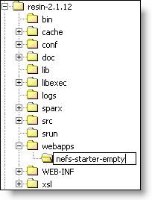
- Extract the contents of nefs-starter-empty.war file into this newly created folder. You may use any ZIP file extraction utility, such as WinZip[10] or WinRAR[11], for this purpose.
Figure 2. Extracting nefs-starter-app.war File
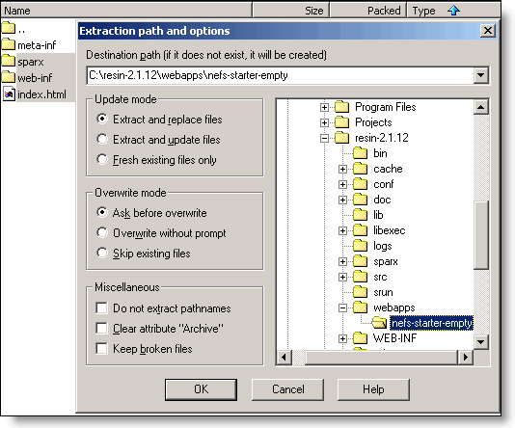
This creates an Application Directory Structure (see Section 4.1, “The NEF Application Directory Structure”), containing the necessary NEF files and sub-folders, within the nefs-starter-empty folder.

3.3. Testing the Starter Application in a Browser
Use a web browser to access the root of the starter application using the URL of the form http://host:port/nefs-starter-empty. If everything worked as it should, you will see the Starter Application Welcome Page.
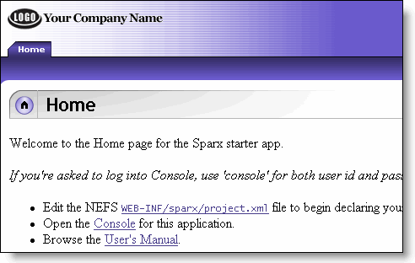

3.4. Verifying the Console
Use a browser to access the Console of the Starter Application. This will ensure not just the proper configuration of the application but also its proper configuration in relax to Sparx. In a web browser, we can go to the following URL: http://host:port/nefs-starter-empty/console. If everything is working, you will see the application Console login screen.
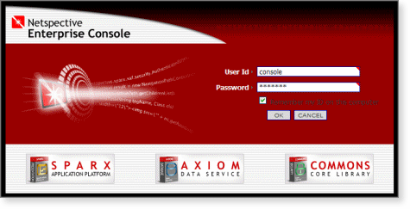
Congratulations! You now have an empty application upon which you can build. You can log in to your application's Console. The Console's default User Id is 'console' and the default Password is 'console'(each without quotes). Unless otherwise specified, that is the User Id and Password combination you should use if the Console prompts you to login.

4. Key Concepts
This section outlines some of the important, global concepts that you should be familiar with before embarking on developing your own applications.

4.1. The NEF Application Directory Structure
Every NEF application shares the benefit of a standard directory structure. To see the structure of the empty application (one with only the basic files required for all applications), view the Project | Project Folders tab of the Starter Application using the URL of the form http://host:port/appName/console The appName will be nefs-starter-empty in this case.
Figure 3. NEF Standard Project Directory Structure
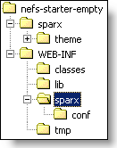
APP_ROOT The root directory (in this case nefs-starter-empty) contains all the browser-accessible files for the application. This is commonly referred to as the Document Root for a website because it is the root directory visible to web browsers. It also contains a private directory, called WEB-INF, for the application to store NEF and Java servlet related files (it's called private because none of its contents will ever be served to end users). As already mentioned, all files in the application's root directory are accessible through a web browser. All subdirectories in the application root other than WEB-INF will also be directly accessible through a browser. Therefore, if you put an index.jsp file in this directory, you should be able to access it using a URL of the form http://host:port/appName/index.jsp.
APP_ROOT/resources If present this directory tree contains all of the application's shared files that need to be served to end users of your applications. Web browser resources that your application needs such as images and scripts are placed here and will be served to your end users by their browser.
APP_ROOT/sparx This directory tree contains all of the Sparx shared files that need to be served to end users of your applications. Web browser resources that Sparx needs such as style sheets, JavaScript sources, images, and Console files are placed here and will be served to your end users by their browser. You should not modify files in this directory because it does not contain any programmer-modifiable files.
APP_ROOT/resources/sparx This directory tree (which is not present in the starter application or the diagram above) contains optional Sparx shared files and resources that usually belong in APP_ROOT/sparx but are being overridden by your application. For example, if you have your own stylesheets or images that need to replace something in Sparx, they would be placed in this directory. Because the APP_ROOT/sparx directory contents should never be modified, the APP_ROOT/resources/sparx directory gives you the opportunity to override Sparx resources without worrying about files being overwritten when Sparx is upgrade.
APP_ROOT/WEB-INF The WEB-INF directory is required by the J2EE Servlet Specification. It contains all files private to the application, meaning none of the files in this directory will be accessible to an end-user's web-browser (except through the Netspective Console which optionally allows secure browsing of source files in WEB-INF). The APP_ROOT/WEB-INF/web.xml file configures your application for your J2EE Servlet container and you should refer to your application server's documentation for how to configure the contents of that file.
WEB-INF/classes This directory, which is a part of the J2EE Servlet Specification, holds all the custom Java source code written for the application. After the application is built, each Java source file in this directory contains a corresponding compiled version in the same location as the source. All Java classes in WEB-INF/classes are automatically included in the classpath of the application. Therefore, if you have declared a dialog (in the project.xml file) to have a custom Java handler for complete or partial dialog processing, the Java source and compiled versions should be located somewhere in this directory structure. Any auxiliary Java classes that you might need should also be placed here. By default, you should place all of your Java classes in the directory WEB-INF/classes/app (or another appropriate subdirectory) because certain application servers will not work with Java classes that are not in a package.
WEB-INF/classes/auto Although this directory is not found in the starter package, it is automatically created by NEF when it generates classes for use by your application. It is called auto because the classes in there are auto-generated and should not be modified.
WEB-INF/lib This directory, which is a part of the J2EE Servlet Specification, holds all the Java Archive (JAR) files needed by your application. These include not only JAR files needed for Sparx but also extra JAR files needed by your own Java classes.
WEB-INF/sparx Sparx uses the WEB-INF/sparx directory to store its project component descriptors. There is usually at least one project.xml file and may contain subdirectories if you wish to split up your application component declarations. The APP_ROOT/WEB-INF/sparx/project.xml is the file that drives all of the Sparx functionality in your application.
WEB-INF/sparx/conf This directory contains contains sample web.xml configuration files for different application servers like WebLogic, WebSphere, Resin and Tomcat. It also contains Ant build files for compiling your application's classes.

4.2. The NEF Project File (project.xml)
All of the NEF (Sparx, Axiom, and Commons) components are declared in an input source file known as the Project File. The Project File may be either a single file with all components or may be broken up into multiple files and pulled into the main Project File by using <xdm:include> tags.
The default Project File is APP_ROOT/WEB-INF/sparx/project.xml but may be configured to be a different file. Although you may choose an alternate location for the Project File, the remainder of this document assumes that the Project File is APP_ROOT/WEB-INF/sparx/project.xml

4.3. web.xml
This file, which is a requirement of the Java Servlet Specification¹, contains information specific to the application server under which the application si running. As an example, it might contain a mapping of URLs to specific servlets that should handle those URLs. It might also contain references to data sources (i.e. database handles) referenced in the main application server's configuration. For application servers that run according to a standards compliant servlet specification, this file is necessary.

5. Functionality
The NEF Books Application is a small application meant to be used for a personal library of books. It allows you to track the books you have and add more books to your collection or edit information stored about existing books. It also allows you to search your collection for a particular book based on your own custom search criteria.
The overall functionality of the application is limited but complete. As such it demonstrates a few of the main types of data manipulation that developers need to take care of in every application. In the end, the goal is to show you just how much power can be wielded with just a few lines of XML and Java code when armed with the strength of Sparx.

6. Design

6.1. Application Design
The Books Application is designed around the basic Sparx components. It will use static SQL and associated reports to help you track the books stored in the application. Searches, on the other hand, require a dynamically generated SQL in the form of a Query Definition.
The last aspect to take care of is the data storage. It is possible to use expensive abd overkill (in all certainty) database like Oracle for this application. Instead, the data storage of choice is the Java-based embedded database that is included in the Sparx Starter Application: HypersonicSQL™². All the application components are included in the project.xml file for the Books Application.

6.2. Database Design
The Books Application deals with books and only books. Therefore, the information that needs to be stored in the database will be about books. The four pieces of information that the Books Application will store for this example are its ID, name, author, genre and ISBN. Of these, the genre is the only one that can be common across multiple books. In database language, the genre (book type) has a one-to-many relationship with the books.
Figure 4. Basic E-R Diagram for Books Application Database
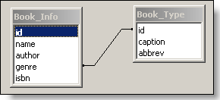
The figure shows the entity-relationship diagram for the data we will be using. The database for the Books Application will be designed to store each entity (and its attributes) in a separate table. As with the application design, the database design will become clearer when it is implemented later in this tutorial.

7. Renaming the Starter Application
You can now build your Books Application upon the Starter Application's directory structure. Rename the Starter Application's root folder (nefs-starter-empty) to your application's name. This tutorial uses nefs-sample-books as the root folder name for the Books Application.

8. The NEF Project File (project.xml)

8.1. Dissecting the project.xml
Example 1. Project File of Starter Application
<?xml version="1.0"?>
<project xmlns:xdm="http://www.netspective.org/Framework/Commons/XMLDataModel">
<xdm:include resource="com/netspective/commons/conf/commons.xml"/>
<xdm:include resource="com/netspective/axiom/conf/axiom.xml"/>
<xdm:include resource="com/netspective/sparx/conf/sparx.xml"/>
<xdm:include resource="com/netspective/sparx/conf/console.xml"/>
<!-- Your application tags go here. -->
<xdm:include file="your/own/file.xml"/>
<!-- Your other application tags go here. -->
</project>
The root tag is called project and should use the provided xdm namespace.
Include the Netspective Commons default component declarations. It uses the resource attribute so it will be located by searching the classpath and will usually find the file in the JAR file and directly read it from there.
Include the Netspective Axiom default component declarations and factory registrations. It uses the resource attribute so it will be located by searching the classpath and will usually find the file in the JAR file and directly read it from there.
Include the Netspective Sparx default component declarations and factory registrations. It uses the resource attribute so it will be located by searching the classpath and will usually find the file in the JAR file and directly read it from there.
Include the Netspective Enterprise Console servlet declarations and application components. If you are turning off the Console in your applications you may leave this line out.
This is the location where your component declarations will be done. Unless otherwise specified, all the components are declared right under the project tag.
This line demonstrates how you can include your own XML files using the file attribute. In this example, because the file is not absolute it will be treated as relative to the calling file. The xdm:include tag may be included anywhere in the file and simply takes items from the included file and places them into the calling file while parsing.

9. Creating the Data Layer
With the empty (Starter) application successfully created and running, it is time to work on the backbone of the Books Application: the database.

9.1. Setting up the Data Source
To set up the Books Application database, you need to have a database connection (data source) pointing towards your database. This is accomplished by using the connection-provider tag in the Project File (project.xml).
Example 2. Setting up the Data Source for Books Application
<project xmlns:xdm="http://www.netspective.org/Framework/Commons/XMLDataModel">
...
<connection-provider
class="com.netspective.axiom.connection.JakartaCommonsDbcpConnectionProvider">
<data-source name="jdbc/default">
<driver-class>org.hsqldb.jdbcDriver</driver-class>
<url>vs-expr:jdbc:hsqldb:${servlet-context-path:/WEB-INF/database/instance/db}</url>
<user>sa</user>
<password></password>
</data-source>
</connection-provider>
A connection-provider tag is used to declare the connection to your application's database.
Note
Note that data sources specified under this connection provider will be managed by the Jakarta Commons DBCP. If you wish to use JNDI, you simply have to specify the resource according to the server you're using.
Each connection-provider tag may contain one or more data-source tags. The data-source tag is used to specify the data source for the application. Any data source called 'jdbc/default' is automatically used as the default JDBC data source. That is why the name of the data source in the above example code is set to "jdbc/default".
Note
If you wish to change the name of the default data source, you may specify it in project.xml using the default-data-source tag.
The driver-class tag is used to provide the driver to be used for the specified database. Since the Books Application uses HSQL database, our sample code specifies the appropriate JDBC driver.
The url is the JDBC URL used to connect to the database. The JDBC driver uses it to point to a specific database on a specific server. The URL has three parts which are separated by a colon ":". The first part is always "jdbc" and the second part is usually the name of the driver. In the example code, hsqldb is the name of the driver that is used to connect to your HypersonicSQL™ database. The third part is the name of the database.
It is important to note the servlet-context-path value source. Value sources allow dynamic data to be included in XML without creating a programming language inside XML. In the example code, the servlet-context-path value source creates the database named 'db' in WEB-INF/database/instance folder.
The user tag defines a default user to log in to the database. The example code specifies 'sa' which is the default user for System Administrator.
The password tag is used to provide the password for the log in user. The default 'sa' user has no password.
Note
Please see the NEF User's Manual or review Tag Documentation in the Console to get further details on the each tag.
The above sample code declares a data source for the Books Application database.

9.1.1. Unit Testing the Data Source
You may test the data source by using Data Management | Data Sources section in the Console of your Books Application.
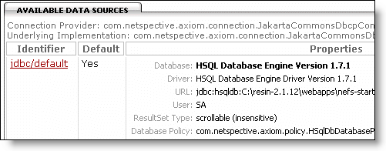

9.2. Creating the Schema
After analyzing the information that needs to be stored in the database and judging from the E-R diagram shown earlier, you can derive the database schema that is necessary for the Books Application. It is a very simple schema consisting of only two tables:
- Book Type: This table is used to store information aboout the different genres (types) of books.
- Book Info: This table stores all the attributes of the books.
The two tables are 1:n related by the genre (in Book Info) and type (in Book Type) fields. Once entered as XML, this schema is available for platform-independent database access from your application.
Note
The entire schema, and the other larger and more complex ones that you might develop for enterprise applications, can be represented entirely in project.xml file of your application.
Following is the code that creates the Books Application schema:
Example 3. Creating the Books Application Schema
<schema name="db">
<xdm:include resource="com/netspective/axiom/conf/schema.xml"/>
<table name="Book_Info" abbrev="bkI" type="Presentation">
<column name="id" type="text" size="10" primary-key="yes"
descr="Unique ID for every book in the database"/>
<column name="name" type="text" size="64" descr="Name of the book"/>
<column name="author" type="text" size="64" descr="Name of the author(s)"/>
<column name="genre" lookup-ref="Book_Type"/>
<column name="isbn" type="text" size="10"
unique="yes" descr="The 10 digit ISBN number"/>
</table>
<table name="Book_Type" abbrev="bkT" type="Enumeration">
<enumerations>
<enum>Science Fiction</enum>
<enum>Mystery</enum>
<enum>Business</enum>
<enum>Information Technology</enum>
<enum>Nuclear Physics</enum>
<enum>Chemistry</enum>
</enumerations>
</table>
</schema>
All schemas are declared using the <schema> tag and are uniquely identified with a name (db in this case). You may define multiple schemas within the same project.
The default com/netspective/axiom/conf/schema.xml resource file contains dozens of built-in data types and table types that may be extended or just used. Types such as text, integer, float, currency, date, and even composite types such as duration are built-into Axiom.
Each schema may contain one or more table tags to define database tables. Each table has a name and abbrev(iation) attribute associated with it. The table also has a type attribute. Axiom supplies various built-in table types. The type attribute for the Book_Info table is set to 'presentation' which gives it a default dialog.
The column tag is used to define a field (column) in the table. Each column has name, type, size and descr(iption) attributes associated with it. To specify a field as the primary key of the table, set the primary-key attribute's value to 'yes'.
The lookup-ref attribute specifies a general foreign key relationship. The format is Table_X.Column_Y. This creates a 1:1 or 1:N relationship from the defining column which references the foreign Column_Y of Table_X. The example code only specifies the table name (Book_Type) for the lookup-ref attribute. This defines the foreign key relationship between the referncing column (genre in this case) and the primary key column (type in this case) of the referenced (Book_Type) table.
Note
If you use this attribute, the type attribute is not required. It is set to the same type as the referenced column.
The unique attribute specifies whether the column's values should be unique. This means that no two rows should share the same valuefor this column. When this value is set to 'yes', this attribute creates a unique index based on this single column.
Note
If more than one column need to be unique (as a composite), use the index child element of the table element to create a unique index based on multiple columns.
The second table tag block is used to define the Book Type table. This table is defined as an Enumeration. An Enumeration is a special type of table that is generated by Sparx. It consists of the following three fields per record:
- id: contains a unique value which is used to relate the enumeration table in a 1:n manner with other tables
- caption: contains non-null value that is used to to provide a short description of each value in the enumeration
- abbrev: an optional field containing the abbreviation for the caption.
The syntax of an enumeration table is unlike that of regular tables. However, once parsed and interpreted, enumeration tables are translated into a set of regular tables for relational integrity purposes.
Note
An enumeration table is used to established a 1:n relationship between an attribute of an object (e.g. genre of the book in this case) and the object itself (the book in this case). It does this by letting the id field of the attribute enumeration table be inserted as a foreign key in the table containing records for the object. In this particular scenario, the lookup-ref attribute of the genre field in the Book_Info table makes that happen.
Each enumeration type table contains an enumerations tag. The values for the enumeration table (book types in this case) are specified with the help of enum tag. Each value is enclose within enum and /enum tag.

9.2.1. Unit Testing the Schema
You may view the newly defined schema by using Data Management | Schemas section in the Console of your Books Application.
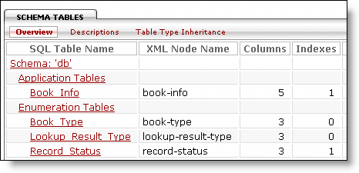
There is a list of all the tables contained in the schema. It should list a total of 4 tables, of which the most important to you are the ones you explicitly created: Book_Info and Book_Type. Click on the Book_Info table to see more details about it.
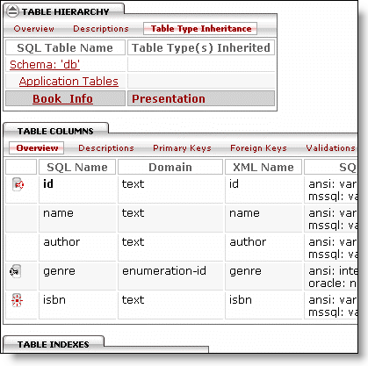
As you can see, the detailed view of the Book_Info tables gives a lot of information about the table and the information stored in it. For each field in the table, you can see its name, data type, actual SQL data type it was created as, whether it is a field referencing other fields (e.g. genre field in the Book _Info table) abd the index(es) deined on this table.
You can view the details for the Book_Info and other tables in the same manner.

9.3. Generating Data Definition Language (DDL)
The DDL representation of your schema consists of the actual commands that you need to issue to a database to create the tables you specified in the schema and to populate them with any static data (such as the one stored in enumeration tables) if necessary. These commands are DBMS-specific.

9.3.1. Using the Ant Build in Console
To create the HSQL database and its DDL, you can use the Project | Ant Build section in the Console. In order to create the HSQL database, you must run the "create-database-hsqldb" target.
Note
Please note that you need the initial-and-test-data.xml file in order to create the HSQL database using the Ant Build Script. See Section 9.3.3, “Populating the HSQL Database with Test Data”.
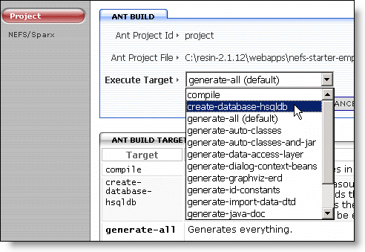
This erases the existing default datasource (Hypersonic database), generates the SQL DDL for the default schema, loads the SQL DDL (effectively creating the Hypersonic SQL database) and finally loads the 'starter' from XML files using Sparx import from XML feature. The Console displays differemt messages during the HSQL database creation (as show below):
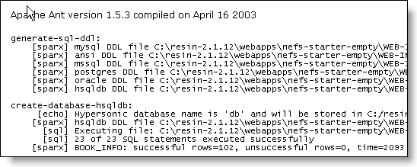
Note
Please note that this target should be executed anytime the default schema is modified.
With this final step completed, you should be ready to add, update, delete and query data from the database using the Sparx Library. To do that, however, you need a user interface that will allow you to manipulate data as well as query what is stored in the database.

9.3.2. Automating the HSQL Database Generation
You may also edit the web.xml file to automatically create the database each time the servlet is run for the first time. to do this, you need to add a --init-first-time-using-ant servlet option in the Sparx navigation controller using the following steps:
- Open the APP_ROOT/WEB-INF/web.xml file and look for the following Code:
<servlet>
<servlet-name>SparxNavigationController</servlet-name>
<servlet-class>
com.netspective.sparx.navigate.NavigationControllerServlet
</servlet-class>
</servlet>
- Add the init-param tag to the above block of code. The resulting code will look like this:
<servlet>
<servlet-name>SparxNavigationController</servlet-name>
<servlet-class>
com.netspective.sparx.navigate.NavigationControllerServlet
</servlet-class>
<init-param>
<param-name>com.netspective.sparx.navigate.CONTROLLER_SERVLET_OPTIONS</param-name>
<param-value>
--init-first-time-using-ant=/WEB-INF/sparx/conf/ant-build-project.xml:create-database-hsqldb
</param-value>
</init-param>
</servlet>
The above approach works because when the navigation controller runs, it creates a file called APP_ROOT/WEB-INF/sparx/conf/execution.properties. This properties file contains the execution count of the servlet. If the execution count is less than one, the Ant file (ant-build-project.xml) and the target you requested (create-database-hsqldb) will be run.
Note
This is the best method to create databases because it automatically creates the database the very first time the servlet is run. And, if you ever want the database recreated, you can simply erase the execution.properties file.

9.3.3. Populating the HSQL Database with Test Data
You will need some test data to be stored in the Books Application database. This will provide you with some initial data to test your application with. You can load this test data using the WEB-INF/database/data/initial-and-test-data.xml and initial-and-test-data.xsl files.
Important
The initial-and-test-data.xml file is necessary to create the HSQL database.
Example 4. Loading Initial Test Data into Book_Info Table
<!DOCTYPE dal SYSTEM "../defn/db-import.dtd">
<dal>
<book-info
id="test-001" name="Book 001"
author="Smith, James R." genre="Science Fiction" isbn="test001"/>
<book-info
id="test-002" name="Book 002"
author="Jones, Rober. J." genre="Mystery" isbn="test002"/>
</dal>
The db-import.dtd is the DTD that is automatically created (by the Ant Build) based on the schema that is provided by the schema tag. The DTD is always called dbname-import.dtd, where dbname is the name specified in the schema tag.
The root tag for the initial-and-test-data.xml is dal.
The root dal tag may contain one or more tags named as table-name (book-info in this case). Note that the underscore "_" in the original table name "book_info" (specified by schema tag in the project file) is replaced with a hyphen "-". The table field names become the attributes for the table-name tag (id, name, author, genre and isbn in this case). The values you provide for these fields are stored in the corresponding hsql table.
You may optionally use XSL to automate the creation of a large number of test data.
Example 5. Using XSL to Generate Test Data
<xsl:stylesheet xmlns:xsl="http://www.w3.org/1999/XSL/Transform" version="1.0"
xmlns:dal="http://www.netspective.org/Framework/Axiom/DataAccessLayer">
<xsl:output method="xml" indent="yes"/>
<xsl:template match="*">
<xsl:copy>
<xsl:copy-of select="attribute::*[. != '']"/>
<xsl:apply-templates/>
</xsl:copy>
</xsl:template>
<xsl:template match="generate-book-info-records">
<xsl:call-template name="iterate-one">
<xsl:with-param name="x"><xsl:value-of select="@count"/></xsl:with-param>
</xsl:call-template>
</xsl:template>
<xsl:template name="iterate-one">
<xsl:param name="x"/>
<book-info>
<xsl:attribute name="id">BOOK_<xsl:value-of select="$x"/></xsl:attribute>
<xsl:attribute name="name">Book <xsl:value-of select="$x"/></xsl:attribute>
<xsl:attribute name="author">Author <xsl:value-of select="$x"/></xsl:attribute>
<xsl:attribute name="genre">Science Fiction</xsl:attribute>
<xsl:attribute name="isbn">ISBN <xsl:value-of select="$x"/></xsl:attribute>
</book-info>
<xsl:if test="$x > 1">
<xsl:call-template name="iterate-one">
<xsl:with-param name="x" select="$x - 1"/>
</xsl:call-template>
</xsl:if>
</xsl:template>
</xsl:stylesheet>
Defining the Axiom Data Access Layer namespace prefix dal.
Defines the output of the XSL (XML in this case).
Defines the default template.
The template that you will use in your XML file. This template receives, through the parameter count, the number of records to be added. It calls another custom template named "iterate-one". The value of count parameter is also sent to the called template.
This is the iterate-one template which is called by the generate-info-records template. It generates the values for all the fields of Book_Info table.
The book-info XML records are generated using the value of parameter x, which changes on every iteration of the iterate-one template.
This tag is responsible for recursively calling the iterate-one template. It checks the value of the parameter x and, if it is greater than 1, decreases it by one to call the iterate-one template with this new value.
This XSL can be incorporated in your XML file using the following code:
Example 6. Incorporating XSL in the Test Data XSL
<?transform --xslt initial-and-test-data.xsl?>
<!DOCTYPE dal SYSTEM "../defn/db-import.dtd">
<dal>
<generate-book-info-records count="100"/>
</dal>
The xdm-transform processing instruction tells Sparx to filter special tags through the XSLT before processing.
Calling the the template from XSL to generate 100 test records for Book_Info table.
Note
The XSL is optional. It is merely a way of automating the creation of lots of test data. You can manually create the XML and leave out the XSL.

9.3.4. DDL and HSQL Database Files
The DDL generation process creates the WEB-INF/database folder. This folder contains further sub-folders: defn and instance.
defn This folder contains the SQL files containing DBMS-specific database creation scripts.
instance This folder contains the HSQL database files: db.properties, db.script, db.data and db.backup.

9.3.5. Unit Testing the HSQL Database
You may test the newly created HSQL database through Data Management | Data Sources | SQL Explorer option in the Console. Enter a SQL query for the Book_Info table in the SQL Editor.
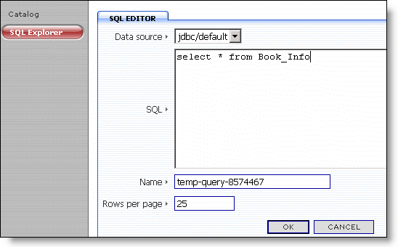
To execute the test query, click the OK button. This displays the query result form (as shown below):
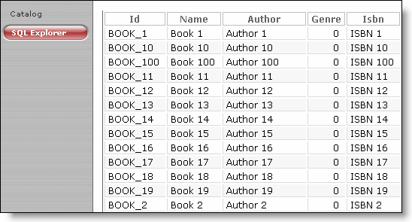

9.4. Creating the Data Management Layer
The Books Application uses two types of queries for data management:
Static SQL A static SQL statement is merely an encapsulation of a regular SQL statement within the XML definition required by Sparx to interpret it. Once defined, a single or multiple SQL statements may be used in reports, dialogs (forms), Servlets, templates, or JSP-pages. All the static SQL statements with the bind parameters are declared in the Books Application Project File.
Dynamic SQL (Query-Defn) One of Axiom's powerful features is to generate dynamic SQL statements based upon user input. The dynamic SQL generator can also generate different output formats such as pageable HTML reports with configurable rows per page or comma separated value (CSV) reports. The main component of the dynamic queries is the query definition dialog which is used to define bind parameters of the dynamic SQL statement. Thus, the dynamic query generator can be thought of as a combination of Dialog and Static Query features.
Note
All the static and dynamic SQL statements are declared in the Books Application Project File (project.xml)

9.4.1. Declaring a Static Query
The Books Application uses a simple join query to get information about all the books and their genres. Following is the xml declaration that performs this task:
Example 7. Declaring a Static Query
<queries package="books">
<query name="get-all-books">
select id, name, author, book_type.caption, isbn
from book_info, book_type
where genre = book_type.id
</query>
</queries>
All the static in Axiom must belong to a statement package represented by queries XML tag. The statement package is identified by its name (books in the above example). You can define multiple packages within your application's project.xml file.
A static query is defined (with or without bind parameters) by using the query tag. Each query is identified by its name (get-all-books in the above example).
Note
The namespace of a query is always queryPkg.queryName. This means you can have more than one queries with same name if each of them belongs to a different query package.
The static SQL (with or without bind parameters) is declared under the query tag. The query in this example declares a join on the Book_Type and Book_Info tables using the genre (from Book_Info) and id (from Book_Type) fields.

9.4.2. Presenting the Results of a Static Query
The next step is to define the customized way of displaying the result of your get-all-books query.
Example 8. Presenting the Results of a Static Query
<queries package="books">
<query name="get-all-books">
select id, name, author, book_type.caption, isbn
from book_info, book_type
where genre = book_type.id
<presentation>
<panel name="main" height="300">
<frame heading="static:All available books"/>
<report>
<actions>
<action type="add" caption="Add Book" redirect="page-id:/add"/>
<action type="edit" redirect="page-id:/edit?id=${0}"/>
<action type="delete" redirect="page-id:/delete?id=${0}"/>
</actions>
<column heading="ID" format="plain" redirect="page-id:/edit?id=${0}"/>
<column heading="Name" />
<column heading="Author"/>
<column heading="Genre"/>
<column heading="ISBN"/>
</report>
</panel>
</presentation>
</query>
</queries>
Each query tag contains a presentation tag associated with it. This tag defines presentation aspects of the query.
The panel tag is used to display a panel of given height. This panel serves as a container for the displayed query result.
The frame tag defines a frame to be drawn around the query result. The heading attribute is assigned a value using static value source.
A report is a way to customize the output of a SQL statement on the page.
Note
Each SQL statement may have any number of report tags as necessary. That way, a single statement can be viewed differently depending upon what context it’s being called in.
You can declare a set of actions for your query's result. This is done using the actions tag. These actions provide a way to perform different functions on the displayed query result. Sparx has pre-defined action types for performing add, edit and delete operations on the selected record within your query result.
The action tag is used to define individual actions (add in this case). The action tag may specify a redirect attribute to automatically redirect to another page whenever it is chosen. The name of the redirect page is supplied using the page-id value source.
Declaring edit action. You may also supply parameters and their values within the redirect URL (selected record's id field in this case).
Any ${XXX} specifies a dynamic replacement. Usually, value sources are used within the brackets but when the dynamic replacement definition is used within a report definition (declared using report tag), you can insert a number within the brackets to indicate the column index of the report. In the above example, ${0} is used to indicate that it should be replaced with the value of the first column of current row.
Declaring the delete action with redirect attribute pointing to the delete page.
Every SQL report contains column tags that are used to customize the appearance of a particular column or, more accurately, a particular field. You may also specify a redirect page URL (edit page in this case).

9.4.3. Unit Testing a Static SQL
To test your newly defined static query, go to the Data Management | Static Queries section in the Console. This displays all the Static SQL statements defined in your project.xml file.
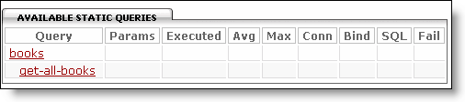
Click on the get-all-books query to see the SQL statement.

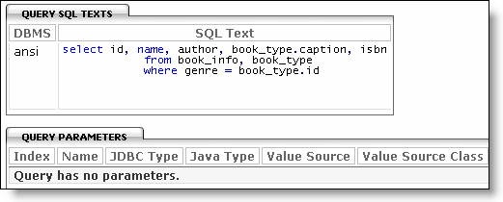
Click on the Unit Test option in the left menu bar. The unit test page is displayed containing a form/dialog for specifying the number of record rows to be displayed per page. By default, the number of records displayed per page is 10 records per page. Enter the new value in this field if you want to change the number of records displayed per page. Click the OK button. The query is executed and its result is displayed (as shown below):
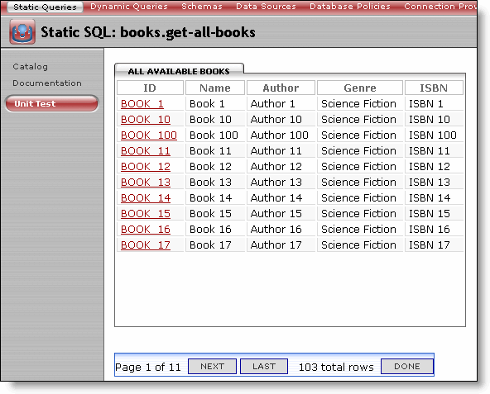

9.4.4. Declaring a Dynamic Query (Query Definition)
Query definitions are one of the most powerful features that Sparx provides developers. Using query definitions a developer wields extreme flexibility and power with an ease rivaled by few, if any, other components of Sparx.
The Books Application will make use of the following query definition:
Example 9. Declaring a Dynamic Query (query Definition)
<query-defn name="books">
<field name="book_id" caption="Book ID" join="BookInfo" column="id"/>
<field name="name" caption="Name" join="BookInfo" column="name"/>
<field name="author" caption="Author" join="BookInfo" column="author"/>
<field name="genre_id" caption="Genre ID" join="BookInfo" column="genre"/>
<field name="genre_caption" caption="Genre" join="BookType" column="caption"/>
<field name="isbn" caption="ISBN" join="BookInfo" column="isbn"/>
<join name="BookInfo" table="book_info"/>
<join name="BookType" table="book_type" condition="BookType.id = BookInfo.genre"/>
</query-defn>
All query definitions are declared using the query-defn tag and are uniquely identified with a name (books in this case).
Each query definition contains one ore more field tags that declare the selectable fields. The field tags are specified so that Axiom knows what fields the user should be allowed to select. Query definition fields may come from a mix of tables so long as they have appropriately defined join attribute values. The value of the join attribute is a reference to a join tag later on in the query definition (BookInfo and bookType in this case).
Note
In the context of the final SQL statement that Sparx generates, the field tags become a part of the select clause. i.e. the part of a select statement that determines which fields need to be returned.
The column attribute of field tag contains the field name (name in this case) as defined in the schema table (Book_Info in this case). The name attribute is used to define a different name for the schema table field (genre_id and genre, respectively, in this case).
The join tag is used to let the query definition know of the list of tables and joins. This is necessary to be able to get all the fields that are a part of the query definition. Each join tag is uniquely identified through its name. The table attribute contains the schema table name whereas the condition attribute defines the join condition.
Note
In the context of the final SQL statement that Sparx generates, the join tags become a part of the where clause to signify the relationships between tables (if any exists).

9.4.5. Presenting the Results of a Dynamic Query (Query Definition)
After defining the basic join on Books Application tables, the next step is to define the search dialog and the presentation of the search result. This is handled through the use of presentation tag and its child tags under query-defn tag.
Example 10. Declaring the Search Dialog and Query Result Presentation
<query-defn name="books">
<presentation>
<select-dialog name="searchBooksDialog" allow-debug="yes"
hide-output-dests="no" hide-readonly-hints="yes" >
<frame heading="Search for Books" />
<field type="text" name="book_id" caption="Book ID" />
<field type="text" name="name" caption="Book Name"/>
<field type="text" name="author" caption="Author"/>
<field type="text" name="isbn" caption="ISBN"/>
<field type="select" style="list" name="genre"
caption="Genre" choices="schema-enum:Book_Type"/>
<select name="test">
<display field="book_id"/>
<display field="name"/>
<display field="author"/>
<display field="genre_caption"/>
<display field="isbn"/>
<condition field="book_id" allow-null="no" comparison="equals"
value="field:book_id" connector="and"/>
<condition field="name" allow-null="no" comparison="starts-with"
value="field:name" connector="and"/>
<condition field="author" allow-null="no" comparison="equals"
value="field:author" connector="and"/>
<condition field="genre_id" allow-null="no" comparison="equals"
value="field:genre" connector="and"/>
<presentation>
<panel name="report">
<frame heading="static:Book Search Results"/>
<report>
<column heading="ID" format="plain" redirect="page-id:/edit?id=${0}"/>
<column heading="Name" />
<column heading="Author"/>
<column heading="Genre"/>
<column heading="ISBN"/>
</report>
</panel>
</presentation>
</select>
</select-dialog>
</presentation>
</query-defn>
The search dialog and search field results are declared under a presentation tag in the query-defn hierarchy.
The select-dialog tag is essentially a dialog embedded inside a query definition. The purpose of this dialog is to provide a user interface for the query definition. Each select-dialog is uniquely identified through its name.
Note
One query definition can have multiple select-dialogs declarations.
The allow-debug attribute of select-dialog tag is used to specify the query debug option. If it is set to "yes" (as in this example), a debug check box is displayed (with the caption View Generated SQL). When this checkbox is checked and the dialog is submitted, the generated SQL with its bind parameters is displayed for debugging purposes instead of execution of the generated SQL
The hide-output-dests attribute is used to give the user several output options: HTML output (pageable report and row count per page), CSV output format, tab delimited format. This is done by setting the value of this attribute to "no". The hide-readonly-hints attribute is used to show or hide the field hints (as is the case in this example).
The frame tag is used to draw a frame, with appropriate heading, around the search dialog.
The first part of a select-dialog is a declaration of all the fields (and their corresponding UI representations) that the select-dialog will use for user input. Each field has associated name and caption attributes. The genre field is declared to be a "select". The choices for this field are populated with the values from Book_Type table using schema-enum value source.
The second part of a select-dialog is a select section which has two parts in itself. The select component is what determines which of the select-dialog’s declared fields are actually displayed in the dialog for this select-dialog. It also determines how each field will be interpreted by the query definition engine once the dialog is submitted. The select tag is uniquely identified through its name (test in this case).
The display tags have one attribute, field, which points to the name of a field declared in the main query definition.
The condition tags determine how the data input from the select-dialog will be interpreted by the query definition engine. Basically, it defines the search criteria.
Each condition tag represents a condition on a field specified by the field attribute. The allow-null attribute of the condition tag determines the behavior of the query definition engine if this field is left empty when the dialog is submitted. The value of this attribute is set to “no” in this case. That is why the select generated will omit the field if the corresponding dialog field happens to be empty. The comparison attribute of the condition tag describes the relational operator to use ("equals" in this case).
The value attribute of the condition tag describes the field from the main query definition (book_id in this case) with which this select-dialog field (book_id in this case) is to be compared. The select-dialog field is mentioned using the field value source.
The connector attribute determines how many field criteria each record in the database has to match before it is selected. In this example, all the fields have a connector value of “and” thus specifying that a record would have to match all the field criteria to be selected in the final result.
The result of this dynamically generated and executed query can be configured in different ways using presentation tag hierarchy.
The report tag customizes the displayed query result fields.
Each report tag contains column tags to customize the display of individual query result fields. You may also provide a redirect URL which a column through the redirect attribute. In this example, the ID field of the book record in the displayed result points to the Edit Book page. Clicking on this link will open the Edit Book page with the dialog fields populated with the selected book's information.

9.4.6. Unit Testing a Query Definition
To test your newly defined static query, go to the Data Management | Dynamic Queries section in the Console. This displays all the Dynamic SQL statements defined in your project.xml file.
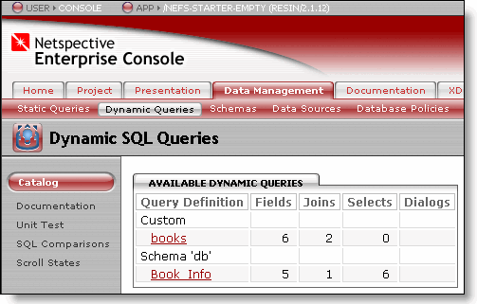
Click on the books query to see the details of the query in a tabular form.
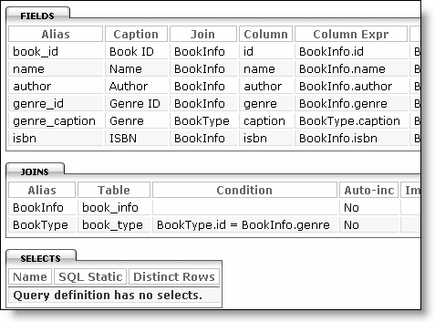
Click on the Unit Test option in the left menu bar. [TODO: Documentation to be made available when the Dynamic Query Unit Test option is functional]

10. Creating the Presentation Layer
The presentation layer of your Books Application comprises the following pages:
- Home Page
- Add Books Page
- Edit Books Page
- Delete Books Page
- Search Books Page
- Console Page
- NEFS Sample Apps Home Page

10.1. Creating the Home Page
Your Books Application Home page will display list of all the books. It will also provide Edit and Delete options for each of the displayed books.
Sparx handles the pages that an end user sees and the transfer of control from one page to another using URIs and URLs. This is called navigation. Once declared using XML, Sparx can automatically manage the visual and operational end-user control of the navigation from one area of your application to another. You simply define the rules for what happens when a user visits a page and Sparx takes care of the rest.
Following is the XML declaration for your Books Application navigation:
Example 11. Creating "Home" Page
<project xmlns:xdm="http://www.netspective.org/Framework/Commons/XMLDataModel">
...
<navigation-tree name="app" default="yes">
<page name="home" default="yes" caption="Home"
command="query,books.get-all-books,-,-,-,record-editor-compressed"/>
</navigation-tree>
...
The navigation-tree tag starts out the definition and appears as a child of the project tag. Each tree has a name (app in this case). The name attribute is required and must be unique across all navigation trees. The caption attribute is a value source and is always required. A tree may be marked with default=yes if it is to be the default tree. Which tree is actually used by the application may be specfied as a servet parameter or chosen dynamically at runtime based on some processing rules. There is only one instance of each navigation tree that you define and the definition is shared across all users and threads.
Note
You may declare as many navigation trees as your application needs.
The page tag begins a definition of a single page and appears under the navigation-tree tag. Each page has a name (home in this case). The name attribute is required and must be unique within the navigation tree in which it is defined. A tree may be marked with default=yes if it is to be the default tree. Which page is actually used by the application may be specfied as a servlet parameter or chosen dynamically at runtime based on some processing rules. There is only one instance of each page that you define and the definition is shared across all users and threads.
Note
You may declare as many pages under a navigation-tree as your application needs.
The page command attribute calls execute() on an instance of the com.netspective.sparx.command.Command interface and includes the content of the execution as the content of the page. The command attribute in this example executes the query get-all-books from the query package named books (see Section 9.4.1, “Declaring a Static Query”). It also specifies one of the pre-defined report skins (record-editor-compressed in this case) for the displayed report.

10.2. Creating the Add Book Page
The next step is to create a page for adding books information to your database. This is achieved through the following XML declaration:
Example 12. Creating "Add Book" Page
<navigation-tree name="app" default="yes">
<page name="add" caption="Add Book" command="dialog,schema.db.Book_Info,add"/>
<navigation-tree>
The page tag in the example code defines Books Application's Add Book page. The command attribute in this example displays and executes a dialog box for Book Info table using the "add" perspective.

10.3. Creating the Edit Book Page
Your books application requires a way to edit the book information already stored in the database. For that, you will need an Edit Book page. This is achieved through the following XML declaration::
Example 13. Creating "Edit Book" Page
<navigation-tree name="app" default="yes">
<page name="edit" caption="Edit Book" command="dialog,schema.db.Book_Info,edit"
require-request-param="id"
retain-params="id">
<missing-params-body>
Please choose a book to edit from the &lt;a href='home'&gt; books list&lt;/a&gt;.
</missing-params-body>
</page>
</navigation-tree>
The page tag declares the Edit Book page. The command attribute displays and execute a dialog box for Book Info table using the "edit" perspective.
The require-request-parameter attribute specifies id as the required request parameter. The id parameter contains unique identifier for the book record that is being edited.
The retain-params attribute allows you to carry parameters from one page to another. In this example, the "id" parameter's value will be sent to anothe page (tab) when that tab/page is clicked.
The missing-params-body tag is used to optionally produce automatic error message when required request parameter ('id' in this case) is not provided.

10.4. Creating the Delete Book Page
The Delete Book page is declared through the following XML:
Example 14. Creating "Delete Book" Page
<navigation-tree name="app" default="yes">
<page name="delete" caption="Delete Book"
command="dialog,schema.db.Book_Info,delete"
require-request-param="id"
retain-params="id">
<missing-params-body>
Please choose a book to delete from the &lt;a href='home'&gt; books list&lt;/a&gt;.
</missing-params-body>
</page>
</navigation-tree>
The page tag declares the Delete Book page. The command attribute displays and execute a dialog box for Book Info table using the "delete" perspective.
The require-request-parameter attribute specifies id as the required request parameter. The id parameter contains unique identifier for the book record that is being deleted.
The retain-params attribute allows you to carry parameters from one page to another. In this example, the "id" parameter's value will be sent to anothe page (tab) when that tab/page is clicked.
The missing-params-body tag is used to optionally produce automatic error message when required request parameter ('id' in this case) is not provided.

10.5. Creating the Search Books Page
The Books Application has, at the moment, most of the functionality originally intended for it. The only bit of functionality that is left is that of being able to search for books matching any criteria the user chooses. For a small collection, the result of the get-all-books query is small enough to browse manually for the information pertaining to a book. For larger numbers of books, the power of a query definition can come in very handy to search the database for all books matching any criteria specified by the end user.
The following XML declaration defines the Search Books page:
Example 15. Creating "Search Books" Page
<navigation-tree name="app" default="yes">
<page name="search" caption="Search Books"
command="query-defn, books, test, searchBooksDialog"/>
</navigation-tree>
The page tag is used to declare the Search Books page. The command attribute uses the "query-defn" value source to display the search dialog and the query results. The example declaration specifies the query-defn named books. The select statement being used for creating the search criteria is test while the customization of query result is done by the select-dialog named searchBooksDialog.

10.6. Creating the Console Page
Like every other Sparx application, your Books Application also has an associated Console. You may provide the access to this Console using the following XML declaration:
Example 16. Linking to the Books Application Console
<navigation-tree name="app" default="yes">
<page name="console" caption="Console" redirect="servlet-context-uri:/console"/>
</navigation-tree>
The page tag declares Cosole page for the Books Application. The redirect attribute is set (using the servlet-context-uri value source) to automatically redirect to the application Console.

10.7. Creating the Sample Apps Home Page
As a last step to the creation of your Books Application, you will add a Sample Apps Home page using the following XML declaration:
Example 17. Creating Sample Apps Home Page for Books Application
<navigation-tree name="app" default="yes">
<page name="sample-apps-home" caption="Sample Apps Home"
redirect="netspective-url:nefs-sample-apps-home"/>
</navigation-tree>
The page tag declares the Sample Apps Home page. The redirect attribute specifies the URL of the Netspective Sample Apps page using the netspective-url value source.

10.8. Custom-Handling of Dialog's Next Action
You may implement the Sparx DialogNextActionProvider interface to customize what happens after your Books Application's dialogs (forms) are submitted. In this example, you will try to send the dialogs (forms) back to the Books Application Home page. Following is the Java class (Util.java) that provides this functionality. This Java file will be saved in the WEB-INF/classes/app folder along with its class file.
Example 18. Class for Custom-Handling of Dialog's Next Action
package app;
import com.netspective.sparx.form.handler.DialogNextActionProvider;
import com.netspective.sparx.form.DialogContext;
public class Util implements DialogNextActionProvider
{
public String getDialogNextActionUrl(DialogContext dc, String defaultUrl)
{
return dc.getServletRootUrl();
}
}
Defines the package for this class (app in this case)
Importing the required classes
The class Util Implements the Sparx DialogNextActionProvider interface.
Implementing the method that gets the URL for the dialog's next action.
Returns the root URL of the current dialog context. The URL in this case will be the one for the Books Application Home page.
To compile the Util.java, go to Project | Ant Build section in Console and execute the Compile target.
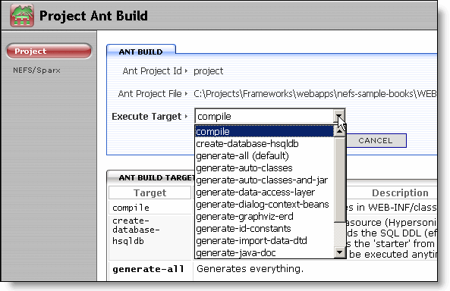
The Util.java file is compiled and a compile message is displayed.
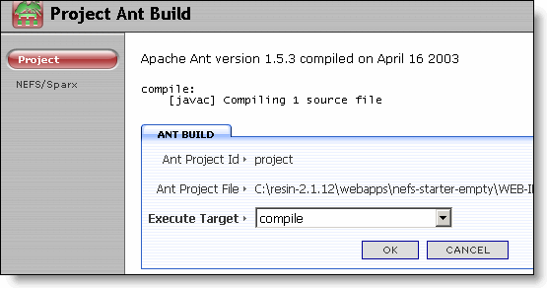
You can define the custom class, for handling the next action of your dialogs (forms), using the following XML declaration:
Example 19. Declaring Custom-Class for Dialog's Next Action Provider
<navigation-tree>
<dialog-next-action-provider class="app.Util"/>
</navigation-tree>
Declaring custom class (app.Util in this case) for custom-handling of dialog's next action. The class name is fully qualified.

10.9. Testing the Books Application
Congratulations! The Books Application is complete. Now you should open up your browser window and go to the Book Application’s main page using the URL: http://host:port/appName. Assuming you are using localhost and port 8080 for your Resin server and nefs-sample-books as your application's name, the URL for Books Application Home Page becomes: http://localhost:8080/nefs-sample-books
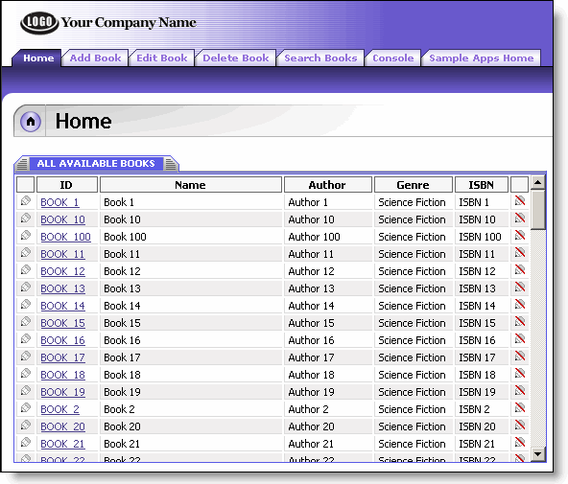
The Home page lists all the books available in your Books Application database along with the Edit and Delete buttons. Try adding a new book from the Add Book section.
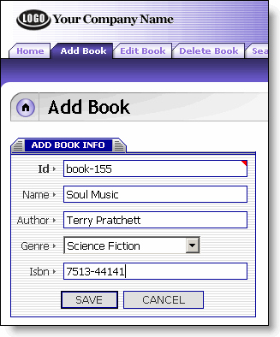
Enter the book information and click the OK button. You can see the newly added book in the list available on the Home page.
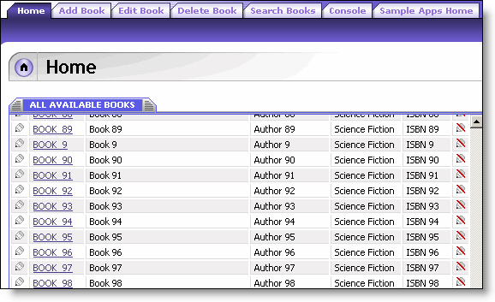
Try editing the record of the book. Select the book from the list by clicking on its name. The Edit Book page is displayed containing the selected book's information.
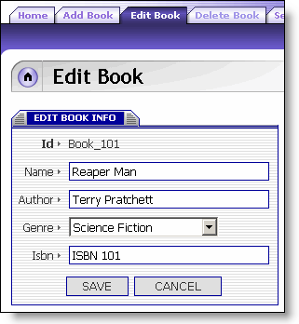
Try searching for books by genre or name, or any other field for that matter, by using the Search Books page.
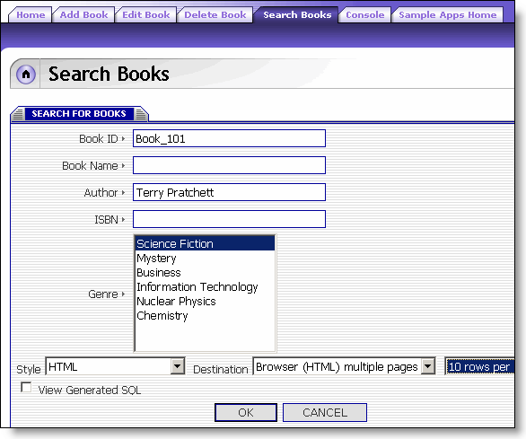
The result of the search is displayed in tabular form.
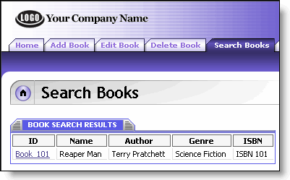
You may see the SQL statement corresponding to a search criteria by clicking on the View Generated SQL check box on the Search Books page. The SQL statement is displayed along with the bind parameters and their values.
Note
You may turn this option off in the production application by setting the allow-debug attribute of select-dialog tag within the corresponding query definition. See Section 9.4.5, “Presenting the Results of a Dynamic Query (Query Definition)”
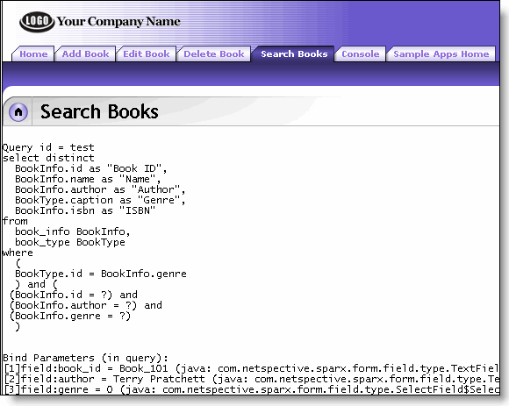
Go to Home page and select the book to delete. The Delete Book page is displayed containing the selected book's information. Click on the Delete button to delete the selected book's record.
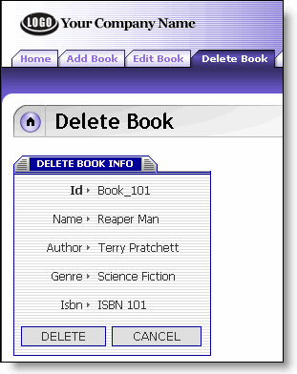
You may access the Books Application Console through the Console page. Use 'console' and 'console' (without quotes) for Console's User Id and Password.
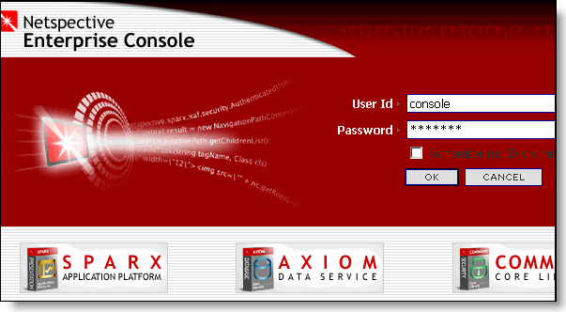
Try the Sample Apps Home page to see the NEFS Sample Apps Home Page loaded from the netspective web site.
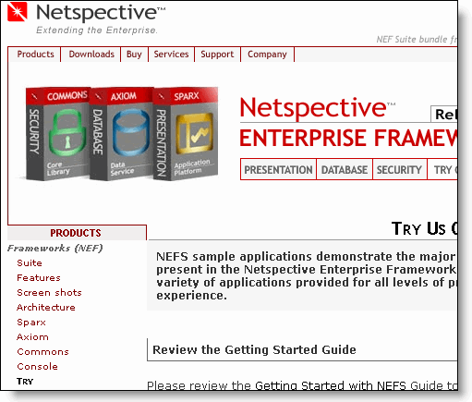

11. Moving to Another Database
Because NEFS Axiom supports multiple databases right out of the box, when you generate the SQL DDL from either Console | Project | Ant Build or from an automated run of the Ant Build file you will have the following files (assuming you have <schema name="db"> in your project.xml):

APP_ROOT/WEB-INF/database/defn
- db-ansi.sql (general ANSI DDL)
- db-erd.dot (GraphViz ERD diagram file)
- db-hsqldb.sql (HSQLDB DDL)
- db-mssql.sql (MS SQL Server DDL)
- db-mysql.sql (MySQL DDL)
- db-oracle.sql (ORACLE DDL)
- db-postgres.sql (PostgreSQL DDL)

Each database SQL file (for DDL and for DML) uses its own database policy class. The database policy is responsible for taking the db-independent <project>, <schema>, <table>, <column>, etc tags and converting them into database-specific DDL and DML calls.
If you want to manually take a DDL file and construct your database then all you need to do is
- use the generated SQL file and use your database's SQL import method to create the database.
- change the <data-source> in the project.xml file's <connection-provider> tag.
If you want to automatically create a database within the Ant file the same way the create-database-hsqldb target works, you should add the following target to the APP_ROOT/WEB-INF/sparx/conf/ant-build-projet.xml file:
<target name="create-database-XXXXX" depends=".init" description="...">
<property name="jdbc.driver" value="XXXX.jdbcDriver"/>
<property name="jdbc.url" value="jdbc:whatever"/>
<property name="jdbc.userid" value="xxxxx"/>
<property name="jdbc.password" value="xxxxx"/>
<!-- run some initialization script that will create a user/db/etc -->
<sql src="init-XXXX.sql"
driver="${jdbc.driver}" url="${jdbc.url}" userid="${jdbc.userid}" password=""/>
<!-- generate only the your XXXX DDL file -->
<sparx action="generate-ddl" projectFile="${app.sparx.project.file}"
destDir="${app.database.defn.path}"
ddl="/^mssql/"/> <!-- use oracle, mssql, mysql, postres, ansi -->
<property name="app.database.schema.ddl.loader.file"
value="${app.database.defn.path}/${app.database.default-schema-name}-mssql.sql"/>
<!-- load the DDL into the database -->
<sql src="${app.database.schema.ddl.loader.file}"
driver="${jdbc.driver}" url="${jdbc.url}" userid="${jdbc.userid}" password=""/>
<!-- import the "starter" data into the database (assuming you have any) -->
<sparx action="import-data"
projectFile="${app.sparx.project.file}"
import="${app.database.home}/data/initial-and-test-data.xml"
driver="${jdbc.driver}" url="${jdbc.url}" userid="${jdbc.userid}" password="" />
</target>

12. Conclusion
Your first Sparx application that does something meaningful is complete and you have gone through the shallowest parts of almost everything Sparx has to offer. You can now continue to improve the Books Application with newer ideas, delving deeper into Sparx or you can start a new application and use what you learned here to see how fast you can have a running system.

][2] http://jakarta.apache.org/tomcat
][3] http://www.caucho.com
][4] http://www.bea.com/framework.jsp?CNT=index.htm&FP=/content/products/server
][5] http://www.ibm.com/websphere
][6] http://www.oracle.com/appserver/
][7] http://www.macromedia.com/software/jrun/
][8] http://www.caucho.com
][10] http://www.winzip.com/downwz.htm
][11] http://www.rarsoft.com/download.htm
1You can get a copy of the Java Servlet Specification directly from Sun Microsystems' web site at the following URL: http://java.sun.com/products/servlet/download.html
2To learn more about HypersonicSQL, please go to http://hsqldb.sourceforge.net/™

