NEF Sample Library Application
Tutorial

Palmer Business Park
4550 Forbes Blvd, Suite 320
Lanham, MD 20706
(301) 879-3321
http://www.netspective.com
info@netspective.com
Copyright
Copyright © 1997-2004 Netspective Communications LLC. All Rights Reserved. Netspective, the Netspective logo, Sparx, and the Sparx logo, ACE, and the ACE logo are trademarks of Netspective, and may be registered in some jurisdictions.
Disclaimer and limitation of liability
Netspective and its suppliers assume no responsibility for any damage or loss resulting from the use of this tutorial. Netspective and its suppliers assume no responsibility for any loss or claims by third parties that may arise through the use of this software or documentation.
Customer Support
Customer support is available through e-mail via support@netspective.com

Library Application Tutorial
Table of Contents
1. Objectives 5
2. Assumptions 5
2.1. Downloading Java Developer's Kit (JDK) 5
2.2. Application Server (Servlet Container) 5
3. Setting up the Starter Application 6
3.1. Downloading the Starter Application 6
3.2. Setting up the Starter Application (Using Application Server) 6
3.2.1. Auto Deploying the Starter Application (Using Application Server) 6
3.2.2. Setting up the Starter Application Manually 6
3.3. Testing the Starter Application in a Browser 7
3.4. Verifying the Console 7
4. Key Concepts 8
4.1. The NEF Application Directory Structure 8
5. Functionality 9
6. Design 10
6.1. Application Design 10
6.2. Database Design 10
7. Renaming the Starter Application 10
8. The NEF Project File (project.xml) 10
8.1. Dissecting the project.xml 10
9. Creating the Data Layer 11
9.1. Setting up the Data Source 11
9.1.1. Unit Testing the Data Source 12
9.2. Creating the Schema 12
9.2.1. Unit Testing the Schema 14
9.3. Generating Data Definition Language (DDL) 15
9.3.1. Using the Ant Build in Console 15
9.3.2. Populating the HSQL Database with Test Data 16
9.3.3. Unit Testing the HSQL Database 17
9.4. Creating the Data Management Layer 18
9.4.1. Declaring Queries 18
9.4.2. Unit Testing a Static SQL 21
10. Creating the Presentation Layer 22
10.1. Creating the Home Page 22
10.2. Creating the Assets Page 23
10.3. Creating the Borrowers Page 24
10.4. Creating the Loans Page 25
10.5. Creating the Console Page 26
10.6. Creating the Sample Apps Home Page 26
10.7. Testing the Library Application 27
10.7.1. Assets Page 27
10.7.2. Borrowers Page 29
10.7.3. Loans Page 30
10.7.4. Console Page 32
10.7.5. Sample Apps Home Page 32
11. Conclusion 33

1. Objectives
The Library Application is a project meant to get you familiar with more features of NEF by creating a complete library management application.

2. Assumptions
For the purpose of this tutorial, we will be assuming that you installed the following:
- Java Developer's Kit (JDK) 1.2, 1.3 or 1.4 See Section 2.1, “Downloading Java Developer's Kit (JDK)”
- An Application Server (servlet container) supporting the Servlet 2.2 or higher specification See Section 2.2, “Application Server (Servlet Container)”
We assume that you are using the default port 8080 for your web server. If you chose different values for the installation path and the port number, you should substitute the paths and the URLs in our example with your values as needed. This tutorial also assumes your familiarity with XML, SQL, Java, Servlets and JDBC.

2.1. Downloading Java Developer's Kit (JDK)
Since NEFS comprises Java libraries, a fundamental requirement to develop applications with it is a Java SDK (the full SDK is required, the JRE will not be enough). You can obtain Sun’s official Java SDK from its Java web site at http://java.sun.com/j2se/1.4/download.html. This is a link to the Java 1.4 SDK but Java 1.2 and 1.3 will also work.

2.2. Application Server (Servlet Container)
Since Sparx works with standard J2EE application servers, a Servlet container is required if you're going to use Sparx. Both Axiom and Commons work in web-based or non-web-based applications but Sparx is a web application development library so an application server with a Servlet 2.2 or better container is necessary. Sparx-based applications have been tested on the following application servers:
- Apache Tomcat[2] (free)
- Caucho Resin[3] (free for development, commercial license required for deployment)
- BEA WebLogic[4] (commercial)
- IBM WebSphere[5] (commercial)
- ORACLE Application Server[6] (commercial)
- Macromedia JRun[7] (commercial)
Note
We recommend the Caucho Resin[8] application server if you're not familiar with other Servlet containers or if you're new to Java/J2EE application servers. It's an easy to install, easy to use, and fast Servlet container with advanced features that rival other more expensive application servers such as WebLogic and WebSphere. Resin is free for development use but requires a paid license before putting your application into production use. Rest assured though that all Sparx-based applications you write, even on Resin, will remain app-server neutral.

3. Setting up the Starter Application
For creation of a new NEF based application, you will need to download the Starter Application. The starter application is just an empty application that contains the minimal set of files required for NEF web applications. It doesn't do anything particularly useful but you can use this sample as your template for the new project.

3.1. Downloading the Starter Application
You can download the NEF Starter Application file from http://www.netspective.com/corp/downloads/frameworks/samples
Important
Depending upon the operating system and browser you're using, the downloaded file may be saved as a zip file (nefs-starter-empty.war.zip). In that case, rename the file as nefs-starter-empty.war after it is downloaded successfully.

3.2. Setting up the Starter Application (Using Application Server)

3.2.1. Auto Deploying the Starter Application (Using Application Server)
Copy the downloaded nefs-starter-empty.war file to the webapps folder of your servlet container (application server) and run (or restart) the application server. This creates an Application Directory Structure (see Section 4.1, “The NEF Application Directory Structure”), containing the necessary NEF files and sub-folders, under the webapps folder of the application server.

3.2.2. Setting up the Starter Application Manually
Some servlet containers (application servers) may not auto deploy the war files. In such cases you need to manually set up your starter application using the following steps:
- Create a new folder in the webapps folder of your application server. Change this folder's name to nefs-starter-empty
Figure 1. Creating a New Folder for NEFS Starter Application
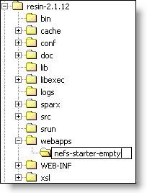
- Extract the contents of nefs-starter-empty.war file into this newly created folder. You may use any ZIP file extraction utility, such as WinZip[10] or WinRAR[11], for this purpose.
Figure 2. Extracting nefs-starter-app.war File
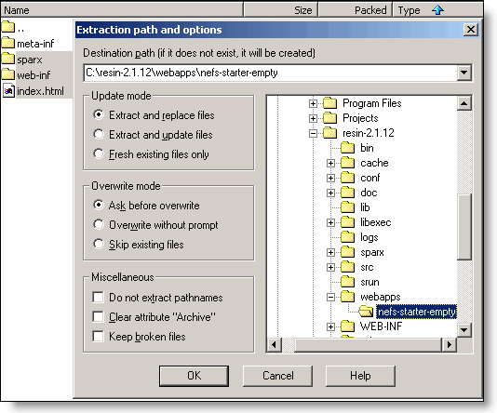
This creates an Application Directory Structure (see Section 4.1, “The NEF Application Directory Structure”), containing the necessary NEF files and sub-folders, within the nefs-starter-empty folder.

3.3. Testing the Starter Application in a Browser
Use a web browser to access the root of the starter application using the URL of the form http://host:port/nefs-starter-empty. If everything worked as it should, you will see the Starter Application Welcome Page.
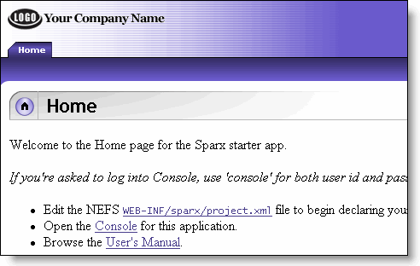

3.4. Verifying the Console
Use a browser to access the Console of the Starter Application. This will ensure not just the proper configuration of the application but also its proper configuration in relax to Sparx. In a web browser, we can go to the following URL: http://host:port/nefs-starter-empty/console. If everything is working, you will see the application Console login screen.
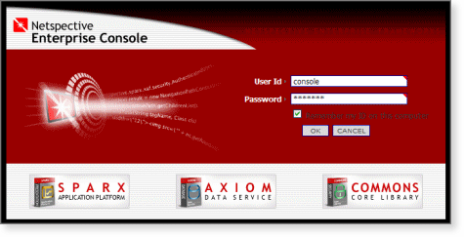
Congratulations! You now have an empty application upon which you can build. You can log in to your application's Console. The Console's default User Id is 'console' and the default Password is 'console'(each without quotes). Unless otherwise specified, that is the User Id and Password combination you should use if the Console prompts you to login.

4. Key Concepts
This section outlines some of the important, global concepts that you should be familiar with before embarking on developing your own applications.

4.1. The NEF Application Directory Structure
Every NEF application shares the benefit of a standard directory structure. To see the structure of the empty application (one with only the basic files required for all applications), view the Project | Project Folders tab of the Starter Application using the URL of the form http://host:port/appName/console The appName will be nefs-starter-empty in this case.
Figure 3. NEF Standard Project Directory Structure
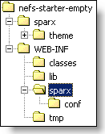
APP_ROOT The root directory (in this case nefs-starter-empty) contains all the browser-accessible files for the application. This is commonly referred to as the Document Root for a website because it is the root directory visible to web browsers. It also contains a private directory, called WEB-INF, for the application to store NEF and Java servlet related files (it's called private because none of its contents will ever be served to end users). As already mentioned, all files in the application's root directory are accessible through a web browser. All subdirectories in the application root other than WEB-INF will also be directly accessible through a browser. Therefore, if you put an index.jsp file in this directory, you should be able to access it using a URL of the form http://host:port/appName/index.jsp.
APP_ROOT/resources If present this directory tree contains all of the application's shared files that need to be served to end users of your applications. Web browser resources that your application needs such as images and scripts are placed here and will be served to your end users by their browser.
APP_ROOT/sparx This directory tree contains all of the Sparx shared files that need to be served to end users of your applications. Web browser resources that Sparx needs such as style sheets, JavaScript sources, images, and Console files are placed here and will be served to your end users by their browser. You should not modify files in this directory because it does not contain any programmer-modifiable files.
APP_ROOT/resources/sparx This directory tree (which is not present in the starter application or the diagram above) contains optional Sparx shared files and resources that usually belong in APP_ROOT/sparx but are being overridden by your application. For example, if you have your own stylesheets or images that need to replace something in Sparx, they would be placed in this directory. Because the APP_ROOT/sparx directory contents should never be modified, the APP_ROOT/resources/sparx directory gives you the opportunity to override Sparx resources without worrying about files being overwritten when Sparx is upgrade.
APP_ROOT/WEB-INF The WEB-INF directory is required by the J2EE Servlet Specification. It contains all files private to the application, meaning none of the files in this directory will be accessible to an end-user's web-browser (except through the Netspective Console which optionally allows secure browsing of source files in WEB-INF). The APP_ROOT/WEB-INF/web.xml file configures your application for your J2EE Servlet container and you should refer to your application server's documentation for how to configure the contents of that file.
WEB-INF/classes This directory, which is a part of the J2EE Servlet Specification, holds all the custom Java source code written for the application. After the application is built, each Java source file in this directory contains a corresponding compiled version in the same location as the source. All Java classes in WEB-INF/classes are automatically included in the classpath of the application. Therefore, if you have declared a dialog (in the project.xml file) to have a custom Java handler for complete or partial dialog processing, the Java source and compiled versions should be located somewhere in this directory structure. Any auxiliary Java classes that you might need should also be placed here. By default, you should place all of your Java classes in the directory WEB-INF/classes/app (or another appropriate subdirectory) because certain application servers will not work with Java classes that are not in a package.
WEB-INF/classes/auto Although this directory is not found in the starter package, it is automatically created by NEF when it generates classes for use by your application. It is called auto because the classes in there are auto-generated and should not be modified.
WEB-INF/lib This directory, which is a part of the J2EE Servlet Specification, holds all the Java Archive (JAR) files needed by your application. These include not only JAR files needed for Sparx but also extra JAR files needed by your own Java classes.
WEB-INF/sparx Sparx uses the WEB-INF/sparx directory to store its project component descriptors. There is usually at least one project.xml file and may contain subdirectories if you wish to split up your application component declarations. The APP_ROOT/WEB-INF/sparx/project.xml is the file that drives all of the Sparx functionality in your application.
WEB-INF/sparx/conf This directory contains sample web.xml configuration files for different application servers like WebLogic, WebSphere, Resin and Tomcat. It also contains Ant build files for compiling your application's classes.

5. Functionality
The NEF Library Application is an application meant to be used for a library of books. It allows you to track the books within a library and maintain the loan records for these library books. Assets, borrowers and loan information can be added and edited using the various management interfaces provided by the Library Application.

6. Design

6.1. Application Design
The Library Application is designed around the basic Sparx components. It will use static SQL and associated reports to help you track the assets, borrowers and loan information. The library contains certain assets (books, journals, etc.) which the borrowers can loan for a specified period.
The data storage of choice is the Java-based embedded database that is included in the Sparx Starter Application: HypersonicSQL™¹. All the application components are included in the project.xml file for the Library Application.

6.2. Database Design
The Library Application stores the information about library assets, borrowers and loans. Each borrower can loan an asset belonging to the library. There are different types of assets belonging to the library (e.g. software, periodical). Each asset can be loaned either for a short term or long term. This is represented by the Loan Type.
Figure 4. Basic E-R Diagram for Library Application Database [to be inserted]

The figure shows the entity-relationship diagram for the data we will be using. The database for the Library Application will be designed to store each entity (and its attributes) in a separate table. As with the application design, the database design will become clearer when it is implemented later in this tutorial.

7. Renaming the Starter Application
You can now build your Books Application upon the Starter Application's directory structure. Rename the Starter Application's root folder (nefs-starter-empty) to your application's name. This tutorial uses nefs-sample-library as the root folder name for the Library Application.

8. The NEF Project File (project.xml)

8.1. Dissecting the project.xml
Example 1. Project File of Starter Application
<?xml version="1.0"?>
<project xmlns:xdm="http://www.netspective.org/Framework/Commons/XMLDataModel">
<xdm:include resource="com/netspective/commons/conf/commons.xml"/>
<xdm:include resource="com/netspective/axiom/conf/axiom.xml"/>
<xdm:include resource="com/netspective/sparx/conf/sparx.xml"/>
<xdm:include resource="com/netspective/sparx/conf/console.xml"/>
<!-- Your application tags go here. -->
<xdm:include file="your/own/file.xml"/>
<!-- Your other application tags go here. -->
</project>
The root tag is called project and should use the provided xdm namespace.
Include the Netspective Commons default component declarations. It uses the resource attribute so it will be located by searching the classpath and will usually find the file in the JAR file and directly read it from there.
Include the Netspective Axiom default component declarations and factory registrations. It uses the resource attribute so it will be located by searching the classpath and will usually find the file in the JAR file and directly read it from there.
Include the Netspective Sparx default component declarations and factory registrations. It uses the resource attribute so it will be located by searching the classpath and will usually find the file in the JAR file and directly read it from there.
Include the Netspective Enterprise Console servlet declarations and application components. If you are turning off the Console in your applications you may leave this line out.
This is the location where your component declarations will be done. Unless otherwise specified, all the components are declared right under the project tag.
This line demonstrates how you can include your own XML files using the file attribute. In this example, because the file is not absolute it will be treated as relative to the calling file. The xdm:include tag may be included anywhere in the file and simply takes items from the included file and places them into the calling file while parsing.

9. Creating the Data Layer
With the empty (Starter) application successfully created and running, it is time to work on the backbone of the Library Application: the database.

9.1. Setting up the Data Source
To set up the Library Application database, you need to have a database connection (data source) pointing towards your database. This is accomplished by using the connection-provider tag in the Project File (project.xml).
Example 2. Setting up the Data Source for Library Application
<project xmlns:xdm="http://www.netspective.org/Framework/Commons/XMLDataModel">
...
<connection-provider
class="com.netspective.axiom.connection.JakartaCommonsDbcpConnectionProvider">
<data-source name="jdbc/default">
<driver-class>org.hsqldb.jdbcDriver</driver-class>
<url>vs-expr:jdbc:hsqldb:${servlet-context-path:/WEB-INF/database/instance/db}</url>
<user>sa</user>
<password></password>
</data-source>
</connection-provider>
A connection-provider tag is used to declare the connection to your application's database.
Note
Note that data sources specified under this connection provider will be managed by the Jakarta Commons DBCP. If you wish to use JNDI, you simply have to specify the resource according to the server you're using.
Each connection-provider tag may contain one or more data-source tags. The data-source tag is used to specify the data source for the application. Any data source called 'jdbc/default' is automatically used as the default JDBC data source. That is why the name of the data source in the above example code is set to "jdbc/default".
Note
If you wish to change the name of the default data source, you may specify it in project.xml using the default-data-source tag.
The driver-class tag is used to provide the driver to be used for the specified database. Since the Library Application uses HSQL database, our sample code specifies the appropriate JDBC driver.
The url is the JDBC URL used to connect to the database. The JDBC driver uses it to point to a specific database on a specific server. The URL has three parts which are separated by a colon ":". The first part is always "jdbc" and the second part is usually the name of the driver. In the example code, hsqldb is the name of the driver that is used to connect to your HypersonicSQL™ database. The third part is the name of the database.
It is important to note the servlet-context-path value source. Value sources allow dynamic data to be included in XML without creating a programming language inside XML. In the example code, the servlet-context-path value source creates the database named 'db' in WEB-INF/database/instance folder.
The user tag defines a default user to log in to the database. The example code specifies 'sa' which is the default user for System Administrator.
The password tag is used to provide the password for the log in user. The default 'sa' user has no password.
The above sample code declares a data source for the Library Application database.

9.1.1. Unit Testing the Data Source
You may test the data source by using Data Management | Data Sources section in the Console of your Library Application.
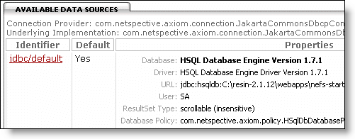

9.2. Creating the Schema
After analyzing the information that needs to be stored in the database and judging from the E-R diagram shown earlier, you can derive the database schema that is necessary for the Library Application. This schema consists of the following five tables:
- Asset_Type: used to store information about the different types of assets.
- Asset: stores the information about different library assets.
- Borrower: stores the information about the borrowers.
- Loan_Type: stores the allowed loan types.
- Asset_Loan: stores information about a loan.
The Asset_Type and Asset tables are 1:n related by the type (in Asset_Type) and type (in Asset) fields. The Asset and Asset_Loan tables are 1:n related by ID (in Asset) and asset_id (in Asset_Loan) fields. Similarly, Borrower and Asset_Loan tables are 1:n related by ID (in Borrower) and borrower_id (in Asset_Loan) fields. The Loan_Type and Asset_Loan tables are 1:n related by type (in Loan_Type) and loan_type (in Asset_Loan) fields.
Once entered as XML, this schema is available for platform-independent database access from your application.
Following is the code that creates the table types within Library Application schema:
Example 3. Creating table types for Library Application
<schema name="db">
<xdm:include resource="com/netspective/axiom/conf/schema.xml"/>
<table-type name="Entity">
<column name="${owner.name.toLowerCase()}_id" type="auto-inc" primary-key="yes"
descr="Unique identifier for ${owner.name}">
<presentation>
<field name="${column.name}" type="integer" caption="ID" primary-key-generated="yes"/>
</presentation>
</column>
</table-type>
<table-type name="Person" type="Entity">
<column name="first_name" type="text" size="64" descr="The person's first name"/>
<column name="last_name" type="text" size="64" descr="The person's last name"/>
</table-type>
Defining a table type named Entity.
The column element in the table-type elements creates actual columns derived from a particular data-type. The column elements will automatically maintain all type definitions and links to foreign keys. The name attribute represents the column name. Each column is usually named as a singular noun in all lower case with each word inside a name separated by underscores. Since this is a table template, the actual column name of the table that uses this table type will replace ${owner.name.toLowerCase()} to form the actual column name.
The type attribute represents the name of data-type to inherit. All of the attributes and elements from the other data-type will be inherited and any attributes and elements defined in this data-type will override those values. The primary-key attribute specifies whether or not this column is a primary key.
Defining the presentation for the column. This defines how the column data will be displayed.
Inheriting a new table type from the Entity table type defined in steps 1 through 3.
Specifying columns for the newly defined table type. The Person table type will consist of 3 columns - person_id, first_name, last_name.
Following is the code that creates the tables within Library Application schema:
Example 4. Creating tables for Library Application
<table name="Asset_Type" abbrev="atype" type="Enumeration">
<enumerations>
<enum>Other</enum>
<enum>Software</enum>
<enum>Periodical</enum>
<enum>Book</enum>
</enumerations>
</table>
<table name="Loan_Type" abbrev="ltype" type="Enumeration">
<enumerations>
<enum>Short term</enum>
<enum>Long term</enum>
</enumerations>
</table>
<table name="Asset" abbrev="asset" type="Entity,Presentation">
<column name="type" lookup-ref="Asset_Type" required="yes" descr="The type of asset"/>
<column name="name" type="text" size="64" required="yes" descr="Name of the asset"/>
<column name="quantity" type="integer" required="yes"
descr="Count of number of assets available to loan"/>
</table>
<table name="Borrower" type="Person,Presentation">
</table>
<table name="Asset_Loan" abbrev="asloan" type="Entity,Presentation">
<column name="asset_id" parent-ref="Asset.asset_id"
descr="The asset that was borrowed (a loan is owned by the Asset so
it's a parent reference)">
<presentation>
<field name="${column.name}" type="select" caption="Asset"
choices="query:library.asset-names-for-select-field-choices"/>
</presentation>
</column>
<column name="borrower_id" lookup-ref="Borrower.borrower_id" descr="The person
that borrowed the asset">
<presentation>
<field name="${column.name}" type="select" caption="Borrower"
choices="query:library.borrower-names-for-select-field-choices"/>
</presentation>
</column>
<column name="loan_type" lookup-ref="Loan_Type" descr="The type of loan"/>
<column name="loan" type="duration" required="yes" descr="The duration of the loan"/>
<column name="returned" type="boolean" descr="Whether the asset has been returned or not"/>
</table>
Defining an enumeration containing available asset types.
Defining an enumeration containing available loan types.
Defining Asset table using the Entity table type defined previously.
Adding more columns to the Asset table. The lookup-ref attribute specifies a general foreign key relationship from this column which references the foreign field type in table Asset_Type. This creates a 1:N relationship between the Asset_Type and Asset tables.
Defining Borrower table using the Person table type defined previously. No columns are being added.
Defining the field which represents the asset to which the loan belongs. The parent-ref attribute specifies a parent/child foreign key relationship which indicates that Asset table is the parent of the asset_id column (creates a 1:N relationship between Asset table and the asset_id column).
Defines presentation for the asset_id field. The available assets will be displayed as a select option. The choices attribute is used to fill the select with available assets. This definition uses the query asset-names-for-select-field-choices to obtain the assets.
Defining the field which represents the borrower taking the loan. The lookup-ref attribute specifies a general foreign key relationship from this column which references the foreign field borrower_id in table Borrower. This creates a 1:N relationship between the Borrower and Asset_Loan tables.
Defines presentation for the borrower_id field. The available borrowers will be displayed as a select option. The choices attribute is used to fill the select with available borrowers. This definition uses the query borrower-names-for-select-field-choices to obtain the borrower names.
Defining the field which represents the loan type. The lookup-ref attribute specifies a general foreign key relationship from this column which references the foreign field typein table Loan_Type. This creates a 1:N relationship between the Loan_Type and Asset_Loan tables.

9.2.1. Unit Testing the Schema
You may view the newly defined schema by using Data Management | Schemas section in the Console of your Library Application.
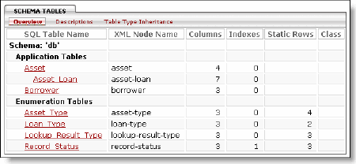
There is a list of all the tables contained in the schema. It should list a total of 5 tables, of which the most important to you are the ones you explicitly created: Asset, Borrower and Asset_Loan. You can view the details for the schema tables from this section of the Console.

9.3. Generating Data Definition Language (DDL)
The DDL representation of your schema consists of the actual commands that you need to issue to a database to create the tables you specified in the schema and to populate them with any static data (such as the one stored in enumeration tables) if necessary. These commands are DBMS-specific.

9.3.1. Using the Ant Build in Console
To create the HSQL database and its DDL, you can use the Project | Ant Build section in the Console. In order to create the HSQL database, you must run the "create-database-hsqldb" target.
Note
Please note that you need the initial-and-test-data.xml file in order to create the HSQL database using the Ant Build Script. See Section 9.3.2, “Populating the HSQL Database with Test Data”
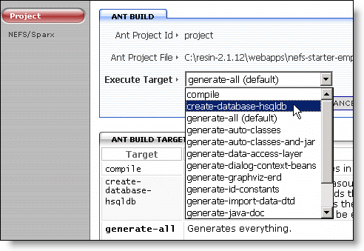
This erases the existing default datasource (Hypersonic database), generates the SQL DDL for the default schema, loads the SQL DDL (effectively creating the Hypersonic SQL database) and finally loads the 'starter' from XML files using Sparx import from XML feature. The Console displays different messages during the HSQL database creation (as show below):
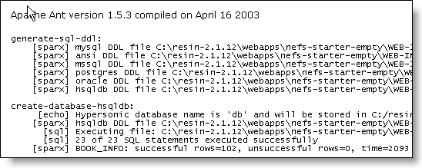
Note
Please note that this target should be executed anytime the default schema is modified.
With this final step completed, you should be ready to add, update, delete and query data from the database using the Sparx Library. To do that, however, you need a user interface that will allow you to manipulate data as well as query what is stored in the database.

9.3.2. Populating the HSQL Database with Test Data
You will need some test data to be stored in the Library Application database. This will provide you with some initial data to test your application with. You can load this test data using the WEB-INF/database/data/initial-and-test-data.xml and initial-and-test-data.xsl files.
Important
The initial-and-test-data.xml file is necessary to create the HSQL database.
Example 5. Loading Initial Test Data into Asset and Borrower Tables
<?transform --xslt initial-and-test-data.xsl?>
<!DOCTYPE dal SYSTEM "../defn/db-import.dtd">
<dal>
<generate-asset-records count="35"/>
<borrower last-name="Doe" first-name="John"/>
<borrower last-name="Doe" first-name="Jane"/>
</dal>
The xdm-transform processing instruction tells Sparx to filter special tags through the XSLT before processing.
The db-import.dtd is the DTD that is automatically created (by the Ant Build) based on the schema that is provided by the schema tag. The DTD is always called dbname-import.dtd, where dbname is the name specified in the schema tag.
The root tag for the initial-and-test-data.xml is dal.
Setting the value for the number of asset records to be generated automatically by the XSL.
Adding the test record in the Borrower table.
You may optionally use XSL to automate the creation of a large number of test data.
Example 6. Using XSL to Generate Test Data
<xsl:stylesheet xmlns:xsl="http://www.w3.org/1999/XSL/Transform" version="1.0"
xmlns:dal="http://www.netspective.org/Framework/Axiom/DataAccessLayer">
<xsl:output method="xml" indent="yes"/>
<xsl:template match="*">
<xsl:copy>
<xsl:copy-of select="attribute::*[. != '']"/>
<xsl:apply-templates/>
</xsl:copy>
</xsl:template>
<xsl:template match="generate-asset-records">
<xsl:call-template name="iterate-one">
<xsl:with-param name="x">0</xsl:with-param>
<xsl:with-param name="count"><xsl:value-of select="@count"/></xsl:with-param>
</xsl:call-template>
</xsl:template>
<xsl:template name="iterate-one">
<xsl:param name="x"/>
<xsl:param name="count"/>
<asset>
<xsl:attribute name="name">Item <xsl:value-of select="$x"/></xsl:attribute>
<xsl:attribute name="type">Book</xsl:attribute>
<xsl:attribute name="quantity">5</xsl:attribute>
</asset>
<xsl:if test="$x &lt; $count">
<xsl:call-template name="iterate-one">
<xsl:with-param name="x" select="$x + 1"/>
<xsl:with-param name="count"><xsl:value-of select="$count"/></xsl:with-param>
</xsl:call-template>
</xsl:if>
</xsl:template>
</xsl:stylesheet>
Defining the Axiom Data Access Layer namespace prefix dal.
Defines the output of the XSL (XML in this case).
Defines the default template.
The template that you will use in your XML file. This template receives, through the parameter count, the number of records to be added. It calls another custom template named "iterate-one". The value of count parameter is also sent to the called template.
This is the iterate-one template which is called by the generate-asset-records template. It generates the values for all the fields of Asset table.
The Asset XML records are generated using the value of parameter x, which changes on every iteration of the iterate-one template.
This tag is responsible for recursively calling the iterate-one template. It checks the value of the parameter x and, if it is less than count, increases it by one to call the iterate-one template with this new value.

9.3.3. Unit Testing the HSQL Database
You may test the newly created HSQL database through Data Management | Data Sources | SQL Explorer option in the Console. Enter a SQL query for the Asset table in the SQL Editor.
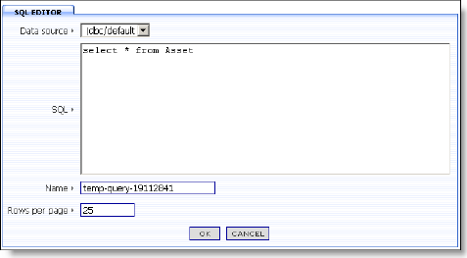
To execute the test query, click the OK button. This displays the query result form (as shown below):
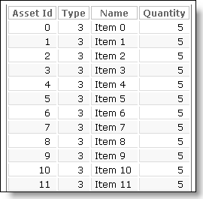

9.4. Creating the Data Management Layer

9.4.1. Declaring Queries
The Library Application uses different queries to retrieve required information from the library database.
Example 7. Static query to get all the library assets
<queries package="library">
<query name="get-all-assets">
select asset_id, name, Asset_Type.caption, quantity,
(select count(*) from Asset_Loan where Asset_Loan.asset_id = asset_id),
(select count(*) from Asset_Loan where Asset_Loan.asset_id = asset_id
and Asset_Loan.returned = 0)
from Asset, Asset_Type
where Asset.type = Asset_Type.id
order by name;
<presentation>
<panel name="main" height="300">
<frame heading="static:All available assets"/>
<report>
<actions>
<action type="add" caption="Add Asset" redirect="page-id:/asset/add"/>
<action type="edit" redirect="page-id:/asset/edit?asset_id=${0}"/>
<action type="delete" redirect="page-id:/asset/delete?asset_id=${0}"/>
</actions>
<column heading="ID" format="plain" redirect="page-id:/asset/edit?asset_id=${0}"/>
<column heading="Name" />
<column heading="Type"/>
<column heading="Quantity" align="right"/>
<column heading="Total Loans" align="right"/>
<column heading="Currently Out" align="right"/>
</report>
</panel>
</presentation>
</query>
All the static queries in Axiom must belong to a statement package represented by queries XML tag. The statement package is identified by its name (library in the above example). You can define multiple packages within your application's project.xml file.
The static query is defined (with or without bind parameters) by using the query tag. Each query is identified by its name (get-all-assets in the above example).
The static SQL (with or without bind parameters) is declared under the query tag. The query in this example declares a join on the Asset and Asset_Type tables using the type (from Asset) and id (from Asset_Type) fields.
Defining the presentation for displaying the query result. Each query tag contains a presentationtag associated with it. This tag defines presentation aspects of the query.
You can declare a set of actions for your query's result. These actions provide a way to perform different functions on the displayed query result. Sparx has pre-defined action types for performing add, edit and delete operations on the selected record within your query result.
The action tag is used to define individual actions (add in this case). The action tag may specify a redirect attribute to automatically redirect to another page whenever it is chosen. The name of the redirect page is supplied using the page-id value source.
Declaring edit action. You may also supply parameters and their values within the redirect URL (selected record's id field in this case). ${XXX} specifies a dynamic replacement. In the above example, ${0} is used to indicate that it should be replaced with the value of the first column of current row.
Every SQL report contains column tags that are used to customize the appearance of a particular column or, more accurately, a particular field. You may also specify a redirect page URL (edit page in this case).
Example 8. Static query to get all the loans
<query name="get-all-asset-loans">
select asset_loan_id, Asset.name, last_name + ', ' + first_name,
Loan_Type.caption, loan_begin_date, loan_end_date, returned
from Asset, Asset_Loan, Loan_Type, Borrower
where Asset.asset_id = Asset_Loan.asset_id and loan_type = Loan_Type.id and
Asset_Loan.borrower_id = Borrower.borrower_id
order by loan_begin_date desc
<presentation>
<panel name="main">
<frame heading="static:Loans for Asset"/>
<report>
<actions>
<action type="edit" redirect="page-id:/loan/edit?asset_loan_id=${0}"/>
<action type="delete" redirect="page-id:/loan/delete?asset_loan_id=${0}"/>
</actions>
<column heading="ID" format="plain"
redirect="page-id:/loan/edit?asset_loan_id=${0}"/>
<column heading="Asset"/>
<column heading="Borrower"/>
<column heading="Type"/>
<column heading="Begin"/>
<column heading="End"/>
<column heading="Returned"/>
</report>
</panel>
</presentation>
</query>
Defining query to retrieve 'all' the asset loans from the database.
The query declares a join on the Asset, Asset_Loan, Loan_Type and Borrower tables.
Defining the presentation for displaying the query result.
Defining edit action for the asset loan. The action tag specifies a redirect attribute to automatically redirect to edit page.
Defining delete action for the asset loan. The action tag specifies a redirect attribute to automatically redirect to delete page.
Every SQL report contains column tags that are used to customize the appearance of a particular column or, more accurately, a particular field. You may also specify a redirect page URL (edit page in this case). The format attribute specifies the format (plain in the above example) to be used to display the column data.
Example 9. Static query to retrieve a specific loan
<query name="get-asset-loans">
select
asset_loan_id, last_name + ', ' + first_name, Loan_Type.caption,
loan_begin_date, loan_end_date, returned
from
Asset_Loan, Loan_Type, Borrower
where
loan_type = Loan_Type.id and
Asset_Loan.borrower_id = Borrower.borrower_id and
Asset_Loan.asset_id = ?
order
by loan_begin_date desc
<params>
<param value="request:asset_id"/>
</params>
<presentation>
<panel name="main">
<frame heading="static:Loans for Asset"/>
<report>
<actions>
<action type="add" caption="Add Loan"
redirect="page-id:/loan/add?simple-expr:asset_id=${request:asset_id}"/>
<action type="edit" redirect="page-id:/loan/edit?asset_loan_id=${0}"/>
<action type="delete" redirect="page-id:/loan/delete?asset_loan_id=${0}"/>
</actions>
<column heading="ID" format="plain"
redirect="page-id:/loan/edit?asset_loan_id=${0}"/>
<column heading="Borrower"/>
<column heading="Type"/>
<column heading="Begin"/>
<column heading="End"/>
<column heading="Returned"/>
</report>
</panel>
</presentation>
</query>
Defining query to retrieve a specific loan from the database.
The ID for the specific asset to be retrieved will be replaced with the selected value dynamically.
Defining bound parameter for the query. This parameter represents the asset_id for the asset whose information is to be retrieved. The asset ID is retrieved from the request parameter named asset_id.
Defining add action for the asset loan. The action tag specifies a redirect attribute to automatically redirect to add page. The asset ID is retrieved from request parameter named asset_id. This asset ID is in turn passed to the add page as the request parameter.
Example 10. Static query to retrieve all loans of a borrower
<query name="get-borrower-loans">
select
asset_loan_id, Asset.name, Loan_Type.caption, loan_begin_date,
loan_end_date, returned
from
Asset, Asset_Loan, Loan_Type
where
loan_type = Loan_Type.id and
Asset_Loan.asset_id = Asset.asset_id and
Asset_Loan.borrower_id = ?
order by
loan_begin_date desc
<params>
<param value="request:borrower_id"/>
</params>
<presentation>
<panel name="main">
<frame heading="static:Loans for Borrower"/>
<report>
<actions>
<action type="edit" redirect="page-id:/loan/edit?asset_loan_id=${0}"/>
<action type="delete" redirect="page-id:/loan/delete?asset_loan_id=${0}"/>
</actions>
<column heading="ID" format="plain"
redirect="page-id:/loan/edit?asset_loan_id=${0}"/>
<column heading="Asset"/>
<column heading="Type"/>
<column heading="Begin"/>
<column heading="End"/>
<column heading="Returned"/>
</report>
</panel>
</presentation>
</query>
Defining query to retrieve all loans of a specific borrower.
The ID for the specific borrower whose loans are to be retrieved. The value will be replaced with the selected value dynamically.
Defining bound parameter for the query. This parameter represents the borrower_id for the borrower whose loan information is to be retrieved. The borrower ID is retrieved from the request parameter named borrower_id.
Example 11. Static query to retrieve all the borrowers
<query name="get-all-borrowers">
select borrower_id, last_name, first_name,
(select count(*) from Asset_Loan where Asset_Loan.borrower_id = borrower_id),
(select count(*) from Asset_Loan where Asset_Loan.borrower_id = borrower_id
and Asset_Loan.returned = 0)
from Borrower
order by last_name, first_name
<presentation>
<panel name="main">
<frame heading="static:All available borrowers"/>
<report>
<actions>
<action type="add" caption="Add Borrower" redirect="page-id:/borrower/add"/>
<action type="edit" redirect="page-id:/borrower/edit?borrower_id=${0}"/>
<action type="delete" redirect="page-id:/borrower/delete?borrower_id=${0}"/>
</actions>
<column heading="ID" format="plain"
redirect="page-id:/borrower/edit?borrower_id=${0}"/>
<column heading="Last Name" />
<column heading="First Name"/>
<column heading="Borrowed" align="right"/>
<column heading="Unreturned" align="right"/>
</report>
</panel>
</presentation>
</query>
Defining query to retrieve all the borrowers.
Defining edit action for the borrowers. The action tag specifies a redirect attribute to automatically redirect to edit page.
Specifying the redirect page URL (edit page in this case). The selected borrower's ID is also passed to the redirected page.
Example 12. Static queries to get all the assets and borrowers (to fill the select fields)
<query name="asset-names-for-select-field-choices">
select name, asset_id
from Asset
</query>
<query name="borrower-names-for-select-field-choices">
select (last_name + ', ' + first_name) as "Name", borrower_id
from Borrower
</query>
Defining the query to retrieve all the assets. This information is used to fill the select fields displaying the Assets.
Defining the query to retrieve all the borrowers. This information is used to fill the select fields displaying the Borrowers.

9.4.2. Unit Testing a Static SQL
To test your newly defined static query, go to the Data Management | Static Queries section in the Console. This displays all the Static SQL statements defined in your project.xml file.
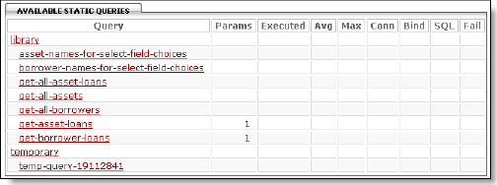
Click on the asset-names-for-select-field-choices query to see the SQL statement.
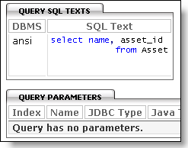
Click on the Unit Test option in the left menu bar. The unit test page is displayed containing a form/dialog for specifying the number of record rows to be displayed per page. By default, the number of records displayed per page is 10 records per page. Enter the new value in this field if you want to change the number of records displayed per page. Click the OK button. The query is executed and its result is displayed (as shown below):
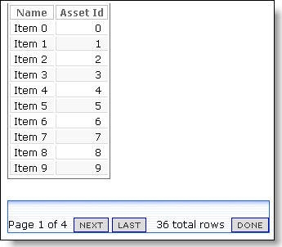

10. Creating the Presentation Layer
The presentation layer of your Library Application comprises the following pages:
- Home Page
- Assets Page
- Borrowers Page
- Loans Page
- Console Page
- NEFS Sample Apps Home Page

10.1. Creating the Home Page
Your Library Application Home page will display list of all the assets and the borrowers. These lists will be displayed in two separate panels. Both the lists will also have Add, Edit and Delete options.
Sparx handles the pages that an end user sees and the transfer of control from one page to another using URIs and URLs. This is called navigation. Once declared using XML, Sparx can automatically manage the visual and operational end-user control of the navigation from one area of your application to another. You simply define the rules for what happens when a user visits a page and Sparx takes care of the rest.
Following is the XML declaration for your Library Application navigation:
Example 13. Creating "Home" Page
<navigation-tree name="app" default="yes">
<page name="home" default="yes" caption="Home">
<panels style="horizontal">
<panel type="command"
command="query,library.get-all-assets,-,-,-,record-manager-compressed"/>
<panel type="command"
command="query,library.get-all-borrowers,-,-,-,record-manager-compressed"/>
</panels>
</page>
</navigation-tree>
The navigation-tree tag starts out the definition of the navigation tree. Each tree has a name (app in this case). The name attribute is required and must be unique across all navigation trees. The caption attribute is a value source and is always required. A tree may be marked with default=yes if it is to be the default tree. Which tree is actually used by the application may be specified as a server parameter or chosen dynamically at runtime based on some processing rules.
The page tag begins a definition of a single page and appears under the navigation-tree tag. The name attribute is required and must be unique within the navigation tree in which it is defined. A page may be marked with default=yes if it is to be the default page. Which page is actually used by the application may be specified as a servlet parameter or chosen dynamically at runtime based on some processing rules.
The panels tag starts a definition of a page body and appears under the page tag. Its contents are handled by Sparx by laying out pre-defined panels similar to the way portals lay out their content. The panels tag ends up as an instance of the com.netspective.sparx.panel.HtmlLayoutPanel class. The style attribute specifies how the panels will be arranged. In the above example, the panels will be arranged horizontally.
Declaring the panel containing the list of all assets. The value of type attribute is set to 'command' which specifies that the panels will be displaying the result of a command's execution.
The command attribute calls execute() on an instance of the com.netspective.sparx.command.Command interface and includes the content of the execution as the content of the page. The command attribute in this example executes the query get-all-asset from the query package named library (see Section 9.4.1, “Declaring Queries”). It also specifies one of the pre-defined report skins (record-manager-compressed in this case) for the displayed report.
Declaring the panel containing the list of all borrowers. The value of type attribute is again set to 'command'. The command attribute in this example executes the query get-all-borrowers from the query package named library (see Section 9.4.1, “Declaring Queries”). The record-manager-compressed skin is used for displaying the report.

10.2. Creating the Assets Page
The next step is to create a page for managing library assets. The Assets management page will contains links to pages for viewing, adding, editing and deleting the assets. Sparx allows creation of nested pages. i.e. pages that contain further pages. The following XML declaration creates the Assets management page:
Example 14. Creating "Assets" Page
<page name="asset" caption="Assets" dialog-next-action-url="page-id:/asset/view">
<page name="view" caption="View Assets"
command="query,library.get-all-assets,-,-,-,record-manager-compressed"/>
<page name="add" caption="Add Asset" command="dialog,schema.db.Asset,add"/>
<page name="edit" caption="Edit Asset"
require-request-param="asset_id" retain-params="asset_id">
<missing-params-body>
Please choose an asset to edit from the &lt;a href='view'&gt; assets
list&lt;/a&gt;.
</missing-params-body>
<panels style="horizontal">
<panel type="command" command="dialog,schema.db.Asset,edit"/>
<panel type="command"
command="query,library.get-asset-loans,-,-,-,record-manager-compressed"/>
</panels>
</page>
<page name="delete" caption="Delete Asset" command="dialog,schema.db.Asset,delete"
require-request-param="asset_id" retain-params="asset_id">
<missing-params-body>
Please choose an asset to delete from the &lt;a href='view'&gt; assets
list&lt;/a&gt;.
</missing-params-body>
</page>
</page>
The page tag in the example code defines Library Application's Assets page. The name of the page is set to asset and the caption for the page is 'Assets'. The dialog-next-action-url attribute sets the next action URL (to be used instead of a next action provider) for this particular page. This example sets the 'View Assets' page as the page to be called after execution of an action on any page within this page tree.
Declaring the 'View Assets' page within the Assets page tree. The command attribute executes the query get-all-assets to display a list of all the assets of the library.
Declaring the 'Add Assets' page within the Assets page tree. The command attribute displays and executes a dialog box for Asset table using the "add" perspective.
Declaring the Edit Asset page. The require-request-parameter attribute specifies asset_id as the required request parameter. The asset_id parameter contains unique identifier for the asset record that is being edited. The retain-params attribute specifies that the "asset_id" parameter's value will be sent to another page (tab) when that tab/page is clicked.
The missing-params-body tag is used to optionally produce automatic error message when required request parameter ('asset_id' in this case) is not provided.
Declaring the panels for Edit Asset page. The panels will be arranged horizontally.
The panels is used to display and execute a dialog box for Asset table using the "edit" perspective.
Declaring the panel containing the list of all loans associated with the selected asset. The value of type attribute is again set to 'command'. The command attribute in this example executes the query get-asset-loans. The record-manager-compressed skin is used for displaying the report.
Declaring the Delete Asset page. The require-request-parameter attribute specifies asset_id as the required request parameter. The asset_id parameter contains unique identifier for the asset record that is being edited. The retain-params attribute specifies that the "asset_id" parameter's value will be sent to another page (tab) when that tab/page is clicked. The command attribute displays and executes a dialog box for Asset table using the "delete" perspective.
The missing-params-body tag is used to optionally produce automatic error message when required request parameter ('asset_id' in this case) is not provided.

10.3. Creating the Borrowers Page
The next step is to create a page for managing the borrowers. The Borrowers management page will contains links to pages for viewing, adding, editing and deleting the borrowers. The following XML declaration creates the Borrowers management page:
Example 15. Creating "Borrowers" Page
<page name="borrower" caption="Borrowers" dialog-next-action-url="page-id:/borrower/view">
<page name="view" caption="View Borrowers"
command="query,library.get-all-borrowers,-,-,-,record-manager-compressed"/
<page name="add" caption="Add Borrower" command="dialog,schema.db.borrower,add"/>
<page name="edit" caption="Edit Borrower" command="dialog,schema.db.borrower,edit"
require-request-param="borrower_id" retain-params="borrower_id">
<missing-params-body>
Please choose a borrower to edit from the &lt;a href='view'&gt; borrowers
list&lt;/a&gt;.
</missing-params-body>
<panels style="horizontal">
<panel type="command" command="dialog,schema.db.Borrower,edit"/>
<panel type="command"
command="query,library.get-borrower-loans,-,-,-,record-manager-compressed"/>
</panels>
</page>
<page name="delete" caption="Delete Borrower" command="dialog,schema.db.borrower,delete"
require-request-param="borrower_id" retain-params="borrower_id">
<missing-params-body>
Please choose a borrower to delete from the &lt;a href='view'&gt; borrowers
list&lt;/a&gt;.
</missing-params-body>
</page>
</page>
The page tag defines Library Application's Borrowers page. The name of the page is set to borrower and the caption for the page is 'Borrowers'. The dialog-next-action-url attribute sets the 'View Borrowers' page as the page to be called after execution of an action on any page within this page tree.
Declaring the 'View Borrowers' page within the Borrowers page tree. The command attribute executes the query get-all-borrowers to display a list of all the borrowers.
Declaring the 'Add Borrowers' page within the Borrowers page tree. The command attribute displays and executes a dialog box for Borrower table using the "add" perspective.
Declaring the Edit Borrower page. The require-request-parameter attribute specifies borrower_id as the required request parameter. The borrower_id parameter contains unique identifier for the borrower record that is being edited. The retain-params attribute specifies that the "borrower_id" parameter's value will be sent to another page (tab) when that tab/page is clicked.
The missing-params-body tag is used to optionally produce automatic error message when required request parameter ('borrower_id' in this case) is not provided.
Declaring the panels for Edit Borrower page. The panels will be arranged horizontally.
The panels is used to display and execute a dialog box for Borrower table using the "edit" perspective.
Declaring the panel containing the list of all loans taken by the selected borrower. The command attribute in this example executes the query get-borrower-loans. The record-manager-compressed skin is used for displaying the report.
Declaring the Delete Borrower page. The require-request-parameter attribute specifies borrower_id as the required request parameter. The borrower_id parameter contains unique identifier for the borrower record that is being edited. The retain-params attribute specifies that the "borrower_id" parameter's value will be sent to another page (tab) when that tab/page is clicked. The command attribute displays and executes a dialog box for Borrower table using the "delete" perspective.
The missing-params-body tag is used to optionally produce automatic error message when required request parameter ('borrower_id' in this case) is not provided.

10.4. Creating the Loans Page
The next step is to create a page for managing the loans. The Loans management page will contains links to pages for viewing, adding, editing and deleting the loans. The following XML declaration creates the Loans management page:
Example 16. Creating "Loans" Page
<page name="loan" caption="Loans" dialog-next-action-url="page-id:/loan/view">
<page name="view" caption="View Loans"
command="query,library.get-all-asset-loans,-,-,-,record-manager-compressed"/>
<page name="add" caption="Add Loan" command="dialog,schema.db.Asset_Loan,add"/>
<page name="edit" caption="Edit Loan" command="dialog,schema.db.Asset_Loan,edit"
require-request-param="asset_loan_id" retain-params="asset_loan_id">
<missing-params-body>
Please choose an asset and select a loan from the &lt;a
href='../asset/view'&gt;asset list&lt;/a&gt;.
</missing-params-body>
</page>
<page name="delete" caption="Delete loan" command="dialog,schema.db.Asset_Loan,delete"
require-request-param="asset_loan_id" retain-params="asset_loan_id">
<missing-params-body>
Please choose an asset and select a loan from the
&lt;a href='../asset/view'&gt;asset list&lt;/a&gt;.
</missing-params-body>
</page>
</page>
The page tag defines Library Application's Loans page. The name of the page is set to loan and the caption for the page is 'Loans'. The dialog-next-action-url attribute sets the 'View Loans' page as the page to be called after execution of an action on any page within this page tree.
Declaring the 'View Loans' page within the Loans page tree. The command attribute executes the query get-all-asset-loans to display a list of all the loans.
Declaring the 'Add Loans' page within the Loans page tree. The command attribute displays and executes a dialog box for Asset_Loan table using the "add" perspective.
Declaring the Edit Loan page. The require-request-parameter attribute specifies asset_loan_id as the required request parameter. The asset_loan_id parameter contains unique identifier for the asset loan record that is being edited. The retain-params attribute specifies that the "asset_loan_id" parameter's value will be sent to another page (tab) when that tab/page is clicked.
The missing-params-body tag is used to optionally produce automatic error message when required request parameter ('asset_loan_id' in this case) is not provided.
Declaring the Delete Loan page. The require-request-parameter attribute specifies asset_loan_id as the required request parameter. The asset_loan_id parameter contains unique identifier for the asset loan record that is being edited. The retain-params attribute specifies that the "asset_loan_id" parameter's value will be sent to another page (tab) when that tab/page is clicked. The command attribute displays and executes a dialog box for Asset_Loan table using the "delete" perspective.
The missing-params-body tag is used to optionally produce automatic error message when required request parameter ('asset_loan_id' in this case) is not provided.

10.5. Creating the Console Page
Like every other Sparx application, your Library Application also has an associated Console. You may provide the access to this Console using the following XML declaration:
Example 17. Linking to the Library Application Console
<navigation-tree name="app" default="yes">
<page name="console" caption="Console" redirect="servlet-context-uri:/console"/>
</navigation-tree>
The page tag declares Console page for the Library Application. The redirect attribute is set (using the servlet-context-uri value source) to automatically redirect to the application Console.

10.6. Creating the Sample Apps Home Page
As a last step to the creation of your Library Application, you will add a Sample Apps Home page using the following XML declaration:
Example 18. Creating Sample Apps Home Page for Library Application
<navigation-tree name="app" default="yes">
<page name="sample-apps-home" caption="Sample Apps Home"
redirect="netspective-url:nefs-sample-apps-home"/>
</navigation-tree>
The page tag declares the Sample Apps Home page. The redirect attribute specifies the URL of the Netspective Sample Apps page using the netspective-url value source.

10.7. Testing the Library Application
Congratulations! The Library Application is complete. Now you should open up your browser window and go to the Library Application’s main page using the URL: http://host:port/appName. Assuming you are using localhost and port 8080 for your Resin server and nefs-sample-library as your application's name, the URL for Library Application Home Page becomes: http://localhost:8080/nefs-sample-library[13]
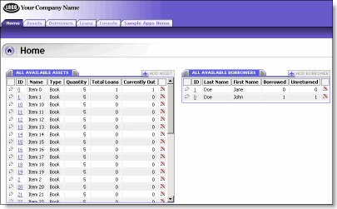

10.7.1. Assets Page
The Home page lists all the assets available in your Library Application database along with the available borrowers. Explore the Assets tab which contains View Assets, Add Asset, Edit Asset and Delete Asset pages. Use the View Assets page to view a list of all the available assets.
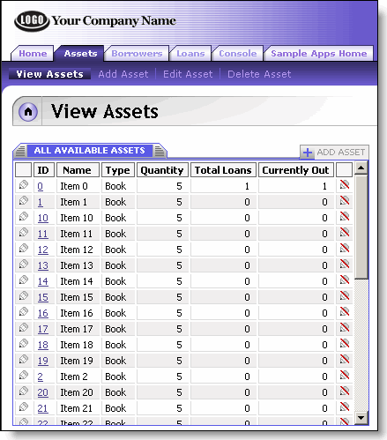
Use the Add Asset page to add an asset.
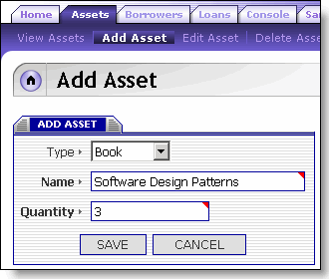
Enter the asset information and click the Save button. You can see the newly added asset in the list available on the Home or View Assets pages. You may also edit an existing asset's information by selecting it from the list of Assets using the Edit icon. This opens the Edit Assets page:
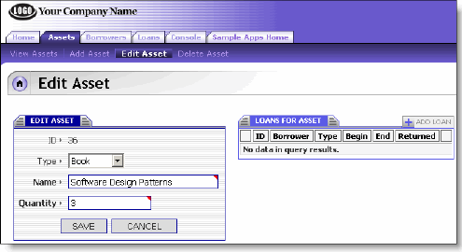
Try editing the details of the asset. Select the asset from the Asset List by clicking on its ID. The Edit Asset page is displayed containing the selected asset's information. The associated loan records are also shown in a separate panel on the same page.
Go to Home page and select the asset to delete. The Delete Asset page is displayed containing the selected asset's information. Click on the Delete button to delete the selected asset's record.
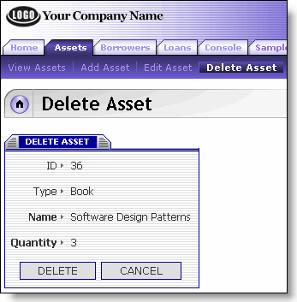

10.7.2. Borrowers Page
Explore the Borrowers tab which contains View Borrowers, Add Borrower, Edit Borrower and Delete Borrower pages. Use the View Borrowers page to view a list of all the available borrowers.

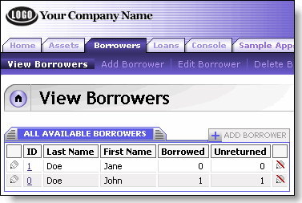
Use the Add Borrower page to add a borrower.
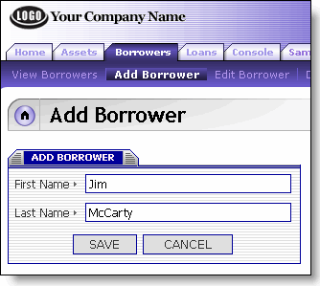
Enter the borrower information and click the Save button. You can see the newly added borrower in the list available on the Home or View Borrowers pages. You may also edit an existing borrower's information by selecting it from the list of Borrowers using the Edit icon. This opens the Edit Borrowers page:
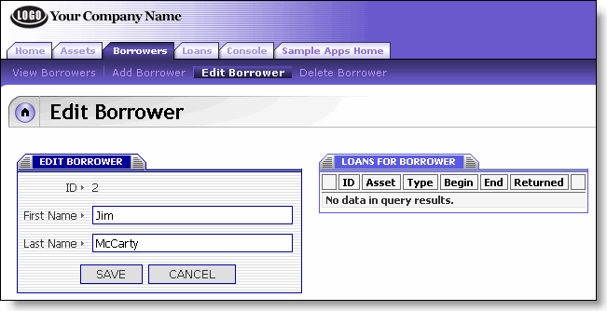
Try editing the details of the borrower. Select the borrower from the Borrowers List by clicking on the borrower's ID. The Edit Borrower page is displayed containing the selected borrower's information. The associated loan records are also shown in a separate panel on the same page.
Go to Home page and select the borrower to delete. The Delete Borrower page is displayed containing the selected borrower's information. Click on the Delete button to delete the selected borrower's record.
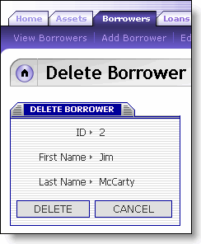

10.7.3. Loans Page
Explore the Loans tab which contains View Loans, Add Loan, Edit Loan and Delete Loan pages. Use the View Loans page to view a list of all the loans.
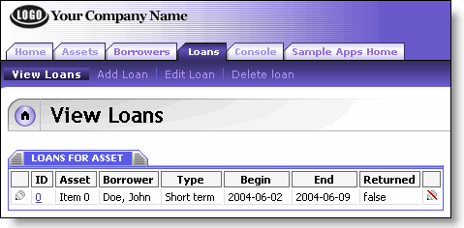
Use the Add Loan page to add a loan.
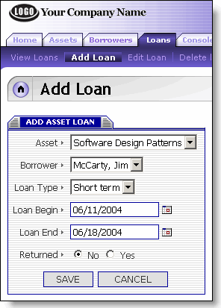
Enter the loan information and click the Save button. You can see the newly added loan in the list available on the View Loans pages. You may also edit an existing loan's information by selecting it from the list of Loans using the Edit icon. This opens the Edit Loan page:
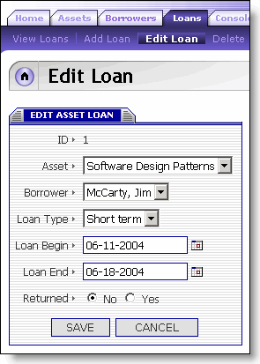
Try editing the details of the loan. Select the loan from the Loans List by clicking on the loan's ID. The Edit Loan page is displayed containing the selected loan's information.
Go to View Loans page and select the loan to delete. The Delete Loan page is displayed containing the selected loan's information. Click on the Delete button to delete the selected loan's record.
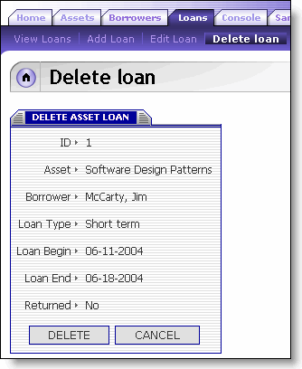

10.7.4. Console Page
You may access the Library Application Console through the Console page. Use 'console' and 'console' (without quotes) for Console's User Id and Password.
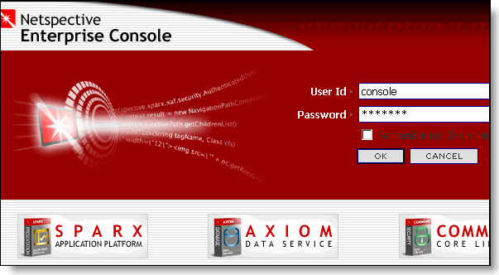

10.7.5. Sample Apps Home Page
Try the Sample Apps Home page to see the NEFS Sample Apps Home Page loaded from the netspective web site.
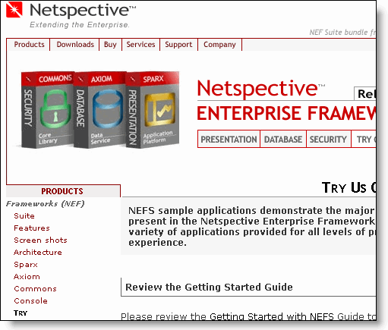

11. Conclusion
Congratulations! Your Library application is now complete. This application is relatively more complex in its use of nested pages and multiple panels per page. You can now move on to more complex sample applications provided by Netspective Enterprise Suite to help you learn more features provided by NEFS.

][2] http://jakarta.apache.org/tomcat
][3] http://www.caucho.com
][4] http://www.bea.com/framework.jsp?CNT=index.htm&FP=/content/products/server
][5] http://www.ibm.com/websphere
][6] http://www.oracle.com/appserver/
][7] http://www.macromedia.com/software/jrun/
][8] http://www.caucho.com
][10] http://www.winzip.com/downwz.htm
][11] http://www.rarsoft.com/download.htm
1To learn more about HypersonicSQL, please go to http://hsqldb.sourceforge.net/§™
][13] http://localhost:8080/nefs-sample-books

