Netspective Enterprise Frameworks Suite
Getting Started

Palmer Business Park
4550 Forbes Blvd, Suite 320
Lanham, MD 20706
(301) 879-3321
http://www.netspective.com
info@netspective.com
Copyright
Copyright © 1997-2004 Netspective Communications LLC. All Rights Reserved. Netspective, the Netspective logo, Sparx, and the Sparx logo, ACE, and the ACE logo are trademarks of Netspective, and may be registered in some jurisdictions.
Disclaimer and limitation of liability
Netspective and its suppliers assume no responsibility for any damage or loss resulting from the use of this tutorial. Netspective and its suppliers assume no responsibility for any loss or claims by third parties that may arise through the use of this software or documentation.
Customer Support
Customer support is available through e-mail via support@netspective.com

Netspective Enterprise Frameworks Suite: Getting Started
Table of Contents
1. NEFS Learning Map 4
2. Methods of Evaluating NEFS 5
3. Sampling the NEFS Online 5
3.1. Running the Sample Applications Online 6
3.2. Viewing XML Source Code in the Sampler 6
3.3. Viewing Other Source Code and Application Files in a Browser 6
3.4. Accessing XDM Tag Documentation 8
3.5. Accessing Command and Value Source Documentation 8
3.5.1. Accessing Commands 8
3.5.2. Accessing Value Sources 9
4. Using your own App Server to Sample the NEFS on your Workstation 9
4.1. Make sure you have a Java Developer's Kit (JDK) 9
4.2. Make sure you have an Application Server (Servlet Container) 9
4.3. Use an Integrated Development Environment (IDE) 10
4.4. Evaluating NEFS Using the Sample Applications 10
4.4.1. Evaluating NEFS Sample Applications on Caucho Resin 10

1. NEFS Learning Map
To facilitate your learning process, Netspective proposes the following learning map:
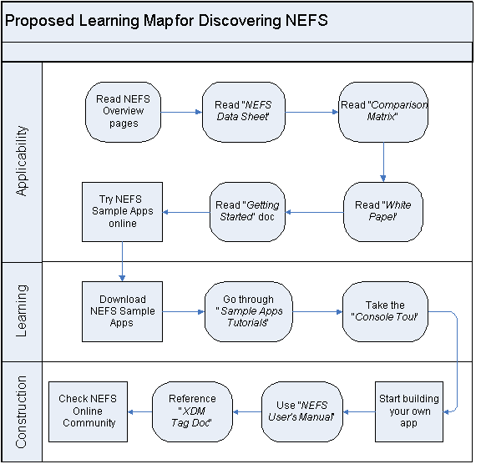
Table 1. NEFS Documentation

Document | Purpose
NEFS Data Sheet[1] | The NEFS Data Sheet is a comprehensive document containing details of the Netspective Enterprise Frameworks. It provides a quick overview of the NEFS architecture. Also, highlights the major features of each framework.
Comparison Matrix | The NEFS Comparison Matrix provides a comparative analysis of NEFS with various other frameworks.
White Paper | The NEFS White Paper presents the ideology behind NEFS and the technical details of its frameworks, proposing NEFS as a feasible solution for faster development of J2EE applications.
Getting Started Doc[2] | The NEFS Getting Started doc provides instructions for how to evaluate the Netspective Enterprise Frameworks Suite. It contains guidelines on how to Sample NEF online as well as through your own application server.
Sample Apps Tutorials[3] | Each of the NEFS Sample Apps comes with a tutorial. The tutorials provide step-by-step instructions for how to build the sample applications using NEFS.
Console Tour | The Console Tour is aimed at familiarizing you with different sections of the Console. It takes you through each section describing different subsections and their usage.
NEFS User's Manual[4] | The NEFS User's Manual is the core technical document for NEF. It is a complete technical reference for all the frameworks. It provides instructions for how to use the NEFS to build your own applications.
XDM Tag Documentation | The XDM Tag Documentation, accessible through the Console, serves as a reference doc for the XDM tags that you will use to build your applications. It lists all the XDM tags in an XML tree format describing their attributes and child elements.

2. Methods of Evaluating NEFS
The quickest way to evaluate the NEFS is to view all the documentation online and follow along with the online versions of the sample applications. Since all you need is a web browser, you can start learning about NEFS immediately. Because the applications are online, you will also be introduced to NEF's built-in remote development and team programming capabilities by seeing for yourself how you can review code and applications remotely. The sole disadvantage of the online evaluation is that you will not have the ability to dabble in or change the application code yourself.
The recommended method of evaluating the NEF is to download sample applications and install them in your own application server. Each of the downloadable sample applications are provided as app-server-independent .war files. Each sample app's .war file contains everything you need, including all of the NEFS binaries, third-party libraries, and resources, to start using NEFS immediately. Once you have downloaded any .war file from our website, you have everything you need to start modifying and adding to the app. There is even a special sample application called the NEFS Starter that allows you to start writing your own applications using an empty template app.

3. Sampling the NEFS Online
The Enterprise Sampler application, available at http://www.netspective.com (by clicking the Try Online link), is the first NEFS sample application that you should try because it's designed to help sample important components of the presentation and user interfaces features of our Frameworks. The application contains complete instructions on what's available to sample and links to important features.

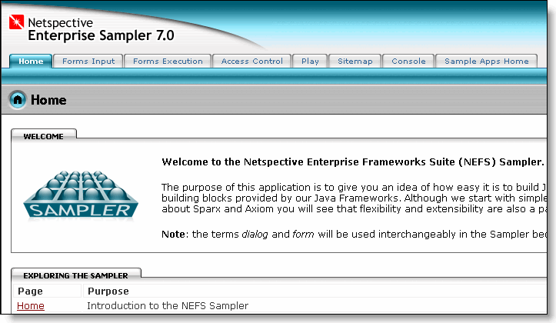

3.1. Running the Sample Applications Online
All of the NEFS sample application are available at http://www.netspective.com (by clicking the Try It Online link from the Home page). Each of the sample applications have two links: one is a link to the application itself and the other is a link to it's Console Servlet.

3.2. Viewing XML Source Code in the Sampler
The NEFS uses simple XML tags as its object construction and declaration language. The Enterprise Sampler application provides links on every page that allow you to learn how a few simple lines of XML can produce sophisticated web based applications.

3.3. Viewing Other Source Code and Application Files in a Browser
The Netspective administration console, called the Enterprise Console, provides a complete file browser with color syntax highlighting for XML, JSP, Java, JavaScript, and SQL files – this file browser allows you to review source code for online sample applications or locally if you downloaded the sample applications.
The Enterprise Console is a special Sparx Servlet that provides a browser-based administrative interface to all of the dynamic components and objects that NEFS produces. The Enterprise Console is automatically available to all NEF-based applications during development and each NEFS application has a private instance of the Console available at http://[server]/[appName]/console. When you log into the Console for Application X (.../appX/console) versus Y (.../appY/console) you will only see components for the appropriate application.
Important
Each sample app features its own Console Servlet and the default login user name is 'console' and the default login password is 'console'.

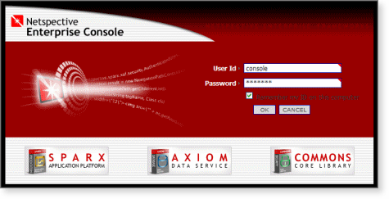
Once you have logged into the Console for any particular application, all of the source files and folders are available for viewing. Simply click on the Project tab and then click Project Folders to view all of the folders contained in the application and Project Files to navigate all the directories and look at the project files. The first time you enter the Project Files section, you should see a list of all the directories that exist in the application’s root directory. You can click on any directory to navigate to it and view the list of files and sub-directories inside it.

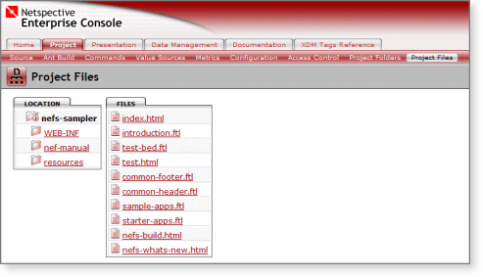
If you click on any XML, JSP or Java source file, you should also be able to see the source for those files directly from the browser.

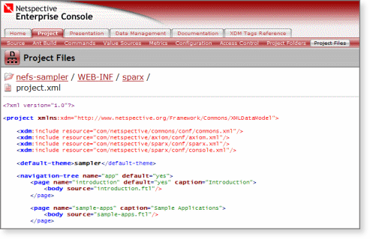

3.4. Accessing XDM Tag Documentation
NEFS Enterprise Console contains complete documentation for the XDM tags that are used to create NEFS applications. To access this documentation, login to the Enterprise Console and click the XDM Tags Reference tab. It displays the documentation for the Project tag along with a list of its attributes and all the children elements.
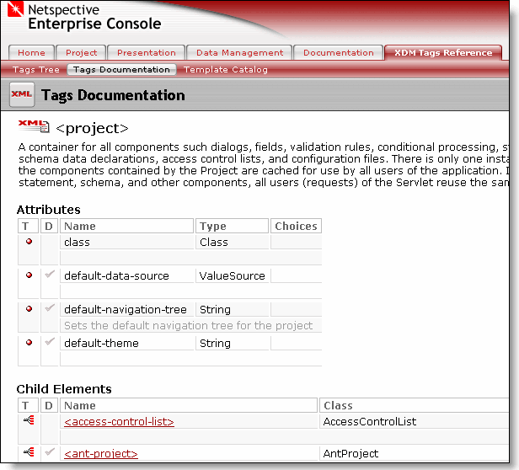
Click on a child element to view the corresponding tag documentation.

3.5. Accessing Command and Value Source Documentation
The NEF ships with many built-in Commands and Value Sources. You can view a complete list of the available commands and value sources through the Enterprise Console.

3.5.1. Accessing Commands
Login to the Enterprise Console. Click on the Project tab and then click the Commands submenu to view the list of all the available Commands.
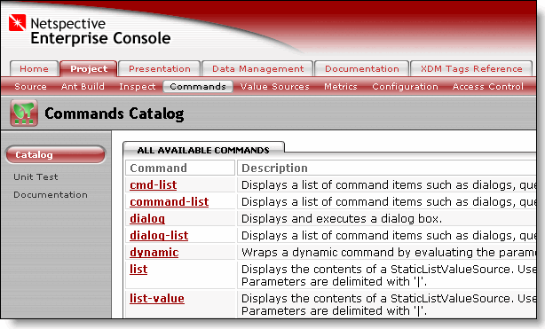

3.5.2. Accessing Value Sources
To view a list of all the value sources available to your project (including all built-in value sources and your own custom value sources) click on the Project tab in the Enterprise Console. Then click the Value Sources submenu and view the list of all the available Value Sources.
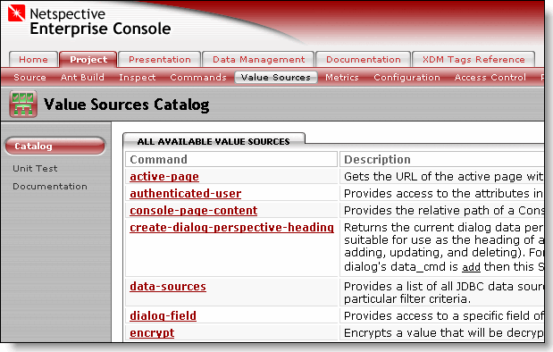

4. Using your own App Server to Sample the NEFS on your Workstation
In order to sample the true power of the NEF, you should try the samples on your own workstation or server. This section describes the prerequisites you need to sample NEFS locally:
- Java Developers Kit (JDK) 1.2, 1.3, or 1.4
- A Servlet Container (application server) supporting the Servlet 2.2 or higher specification

4.1. Make sure you have a Java Developer's Kit (JDK)
Since NEFS comprises Java libraries, a fundamental requirement to develop applications with it is a Java SDK (the full SDK is required, the JRE will not be enough). You can obtain Sun’s official Java SDK from its Java web site at http://java.sun.com/j2se/1.4/download.html. This is a link to the Java 1.4 SDK but Java 1.2 and 1.3 will also work.

4.2. Make sure you have an Application Server (Servlet Container)
Since Sparx works with standard J2EE application servers, a Servlet container is required if you're going to use Sparx. Both Axiom and Commons work in web-based or non-web-based applications but Sparx is a web application development library so an application server with a Servlet 2.2 or better container is necessary. Sparx-based applications have been tested on the following application servers:
- Apache Tomcat[4] (free)
- Caucho Resin[5] (free for development, commercial license required for deployment)
- BEA WebLogic[6] (commercial)
- IBM WebSphere[7] (commercial)
- ORACLE Application Server[8] (commercial)
- Macromedia JRun[9] (commercial)
Note
We recommend the Caucho Resin[10] application server if you're not familiar with other Servlet containers or if you're new to Java/J2EE application servers. It's an easy to install, easy to use, and fast Servlet container with advanced features that rival other more expensive application servers such as WebLogic and WebSphere. Resin is free for development use but requires a paid license before putting your application into production use. Rest assured though that all Sparx-based applications you write, even on Resin, will remain app-server neutral.

4.3. Use an Integrated Development Environment (IDE)
You can also optionally install a Java integrated development environment (IDE) for developing NEFS applications. The Netspective Frameworks do not require any particular Java IDE and if you prefer to use simple text editors like vi, emacs, or TextPad[11] those will work just as well. We recommend the free Eclipse[12] IDE or very affordable and useful JetBrain’s IDEA[13] for those who are not already familiar with other IDEs.

4.4. Evaluating NEFS Using the Sample Applications
To keep things simple, there's no special "evaluation kit" for NEFS -- instead you just download a sample application from http://www.netspective.com (click "Downloads" at the top of the page then pick "Sample Applications" from the Downloads page). Once you download an application, just drop it into your favorite Servlet container (application server) and you'll be ready for the evaluation. Each of the sample applications are provided as app-server-independent .war files and each sample app's .war file includes all of the NEFS binary files, resources, etc. you need to use NEF. Once you have downloaded any .war file, you have everything you need to start modifying and adding to the app. The typical procedure is:
- Download and install an application server (Servlet container).
- Go to http://www.netspective.com (click "Downloads" at the top of the page then pick "Sample Applications" from the Downloads page) and pick any application you're interested in evaluating.
- Download the .war file and place it into the app server's web applications directory.
- Start (or restart) the application server.
- Use your browser to point to http://localhost:port/appName to run the application or http://localhost:port/appName/console to run the application's Console servlet.

4.4.1. Evaluating NEFS Sample Applications on Caucho Resin
This section provides an overview of how to obtain, install, and start the Caucho Resin[16] application server and the NEFS Enterprise Sampler sample application. See the Resin QuickStart[17] document for the most up-to-date information.
- Install JDK 1.3 or later if you're using Resin 2.1 or above. JDK 1.4 or later if you're using Resin 3.0 or above. On Unix, set the JAVA_HOME variable or link /usr/java to the Java home. On Windows, check to make sure the JDK installation set JAVA_HOME correctly.
- Download[18] the latest Resin release (something like resin-x.y.z.zip, e.g. resin-3.0.4.zip or resin-3.0.4.tar.gz).
- Uncompress (unzip/untar) the package into resin-x.y.z, e.g. C:\resin-3.0.4, or other directory.
- Click here[19] to download the Sampler sample application and save it in resin-x.y.z\webapps.
- Start resin-x.y.z/bin/httpd.sh on Unix or resin-x.y.z/bin/httpd.exe on Win32. This will start up a local web server and the application server at the same time.
- Browse http://localhost:8080 to make sure Resin is working properly. If you do not see the Resin welcome page, please see the Resin Installation[21] document for appropriate help. If Resin is not working properly, Sparx will not be able to run either.
- Browse http://localhost:8080/nefs-sampler to run the application or http://localhost:8080/nefs-sampler/console to run the Console servlet.

][1] http://www.netspective.com/corp/resources/nefs-fact-sheet.pdf
][2] http://www.netspective.com/corp/resources/support/docs/nef-articles/getting-started.html
][3] http://www.netspective.com/corp/support/documentation
][4] http://www.netspective.com/corp/resources/support/docs/nef-manual/index.html
][4] http://jakarta.apache.org/tomcat
][5] http://www.caucho.com
][6] http://www.bea.com/framework.jsp?CNT=index.htm&FP=/content/products/server
][7] http://www.ibm.com/websphere
][8] http://www.oracle.com/appserver/
][9] http://www.macromedia.com/software/jrun/
][10] http://www.caucho.com
][11] http://www.textpad.com
][12] http://www.eclipse.org
][13] http://www.intellij.org
][16] http://www.caucho.com
][17] http://www.caucho.com/resin-3.0/install/install.xtp#quickstart
][18] http://www.caucho.com/download/
][19] http://www.netspective.com/resources/downloads/nefs-sampler.war
][21] http://www.caucho.com/resin-3.0/install/index.xtp

