Department

Functionality: These are a series of screens that group information in an efficient manner for the user. Only items that are added in Add a Department and other Organizations that are directly linked to the department are included on these tabs. It also allows the user to edit these fields from these pages. The tabs are Summary, and Organizations. Along with the Tabs, there is Profile line displaying continuously on each page.
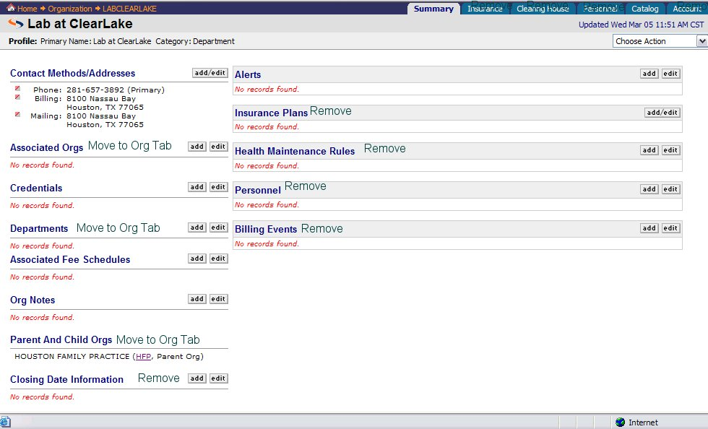

Profile Line
The profile line displays basic information about an Org. This information is entered from the Add-a-Department dialogue. The user can edit this information from the choose action drop down on the Summary Page. The only choice needed in the Choose action is the Edit Profile item. When the user clicks “Edit Profile”→application takes user to Edit Profile dialogue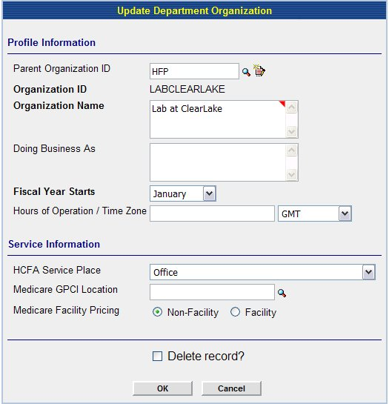
User updates information→User clicks [OK]→application acknowledges update→application takes user back to Summary Page. ***Delete is an issue that depends on what can happen. I don’t think anything should be permanently deleted—perhaps stored on a back burner with a user interface so that the user can view this information.

Summary Page

Contact Methods
This tab consists of basic information that is directly related to the Main Org. On this page the user should be able to view/add/edit the following Categories: Contact Methods/addresses, Credentials, Associated Fee Schedules, Org Notes, and Alerts

This tab is an overview of information entered in Add a Department Org dialogue. The users can add/edit information on this screen. The screen in Physia handles the majority of this but the following Categories should be removed or moved to another tab:

Remove:
Closing Date Information
Insurance Plans
Health Maintenance Rules
Billing Events
Personnel

Move
Departments to Organizations Tab
Associated Orgs to Organization Tab

Category: Contact Methods/Addresses
This category includes all information needed to contact the Org.

Add/Edit Function

Functionality: The user has the ability to add or edit any entry from the summary page and other tabs within the Org. The add/edit function should function the same for each category on the summary page.

Add:
The user is able to add new information to a sub category by clicking the Add/Edit button near the category. In Physia, it is a Hyperlink on the word Add/Edit. If the user does not see the information in the sub category and wishes to add it, then they click the hyperlink→application takes user to add/edit dialogue→
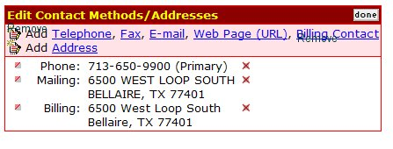
**Note: Remove the Add icons , because it is redundant. Remove billing contact because it is no longer used.

The user clicks the item to add. (In this example it is Telephone) →Application takes user to dialogue for add telephone→
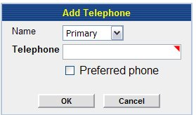

The user has the ability to choose which type of phone number they want to enter. This is in the form of a drop down box. 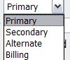. User enters required information
(Again marked with a required field indicator) →User clicks [OK]→application shows new information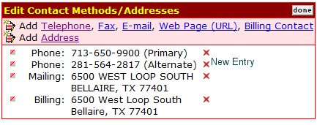

The user clicks [done]→ application acknowledges change→application takes user back to summary page.

If the user chooses to edit an existing item, at this point, they may choose the to the left of the item and the following dialogue on using the will begin.

Edit: The user can edit from a couple of ways. They can do the short cut and use the edit button in front of the existing item they wish to edit. (In Physia this is the .) Or the user can click the add/edit button on the category box. .

Takes the user directly to the edit dialogue for the item chosen. For example if the user chooses to edit the mailing address the following screen is displayed.
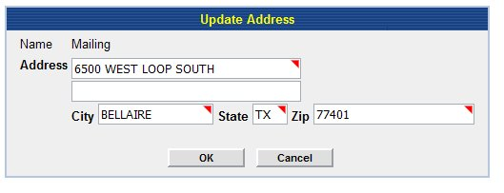
All the information is auto filled. The user simply uses the mouse to move the cursor to the correct box and enters the new information.→User clicks [OK]→application takes user to a screen that displays the edited information and a notification that update complete: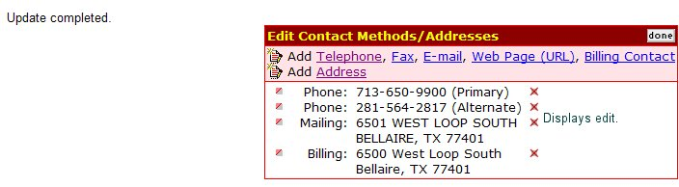

User clicks [done] →Application takes user back to Summary Page.
If user clicks in front of another entry→application takes user to edit dialogue for the chosen item→application continues loop until user clicks [done].

The application should follow the same line of actions for each item in a category. Any differences will be noted within the category below.

This is generally used for adding new items but the user is taken to the add/edit dialogue and has to click the icon in order to edit a field. Once they click the , the user is taken through the actions described above for the . This is a longer process but since the Add dialogue takes you to the same screen and a user can edit an existing item when there, it makes since to keep it. However, the user will be trained in the most efficient way to edit an item.

Credentials
This tab displays all credentials entered specifically for this organization. A user can add/or edit these with the same guidelines as above to contacts and address.

Add
A user can add a credential by clicking the Add button in the category. The user clicks the add button→application takes user to Add Credential Dialogue 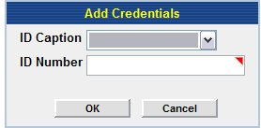 user chooses which type of credential (Employer, State, Medicaid, Workers Compensation, Blue Cross Blue Shield, Medicare and CLIA) and enters id→user clicks [OK] to save→application acknowledges add → application takes user back to summary page.

Edit
The user can edit an existing recording by clicking the to go to the edit dialogue screen→ 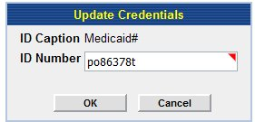→application auto fills existing information→User changes information→User clicks [OK] to save→application acknowledges edit→application takes user back to Summary Tab.

Associated Fee Schedules
Associated Fee Schedules are fee schedules that are assigned to a Department. The user should be able to view, add or remove a fee schedule from this screen.

Add
The user can add a fee schedule by clicking the add button. When the user clicks the add button→application takes user to search engine for fee schedules→ This look up takes user to a search engine for an existing Fee schedule. The user should be able to pull up using the following criteria:
Fee Schedule Name, Fee Schedule ID, Description, Physicians linked to Fee Schedule, Locations linked to Fee schedule
Fee Schedule Name
Fee Schedule ID | **User enters ID
Description
Associated Physicians | **User enters ID(s)
Associated Site Organizations | **User enters ID(s)

Once user clicks [OK]→application pulls up results:
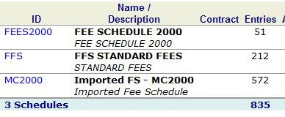
- User clicks look up→application takes user to search engine→if the user wants to see details of Fee Schedule→user clicks Name/Description (Fee Schedule 2000)→application takes user to details of fee schedule
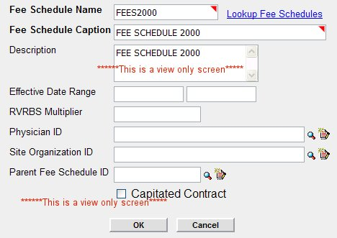
This is a view only screen. User closes screen→application takes user back to results→ if user sees the fee schedule , user clicks Fee Schedule ID→ Application pulls Fee Schedule ID into field for Fee Schedule ID.

Or
User clicks look up→application takes user to search engine→user does not see desired results and closes results window→application takes user back to look up for Fee schedule.

If Fee Schedule is found and user picks it→Application goes back to Add Fee Schedule dialogue and auto fills user’s choice→User clicks [OK]→application acknowledges add and takes user back to Summary Page ***Is it possible to put the date this change was made-next to the Fee Schedule ID on the Summary Page. ***The Application should place the Department ID into correct field in the Fee Schedule’s dialogue.

A user should only be able to add existing Fee Schedules to the Department.

Edit
Any changes to the Fee schedule in itself, should be done from the Catalog area in the Main Org.

Remove
A user can remove a fee schedule from a Department clicking the in front of the Fee Schedule Id→The application takes user to Remove Fee Schedule Dialogue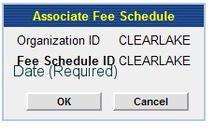the user must add a End date for Fee Schedule→user clicks [OK]→application acknowledges deletion→Application takes user to Summary Page→Fee schedule should show with the word “inactive” next to the name and the date.

Org Notes Not a Priority 5 will discuss in later documentation
These are organizational notes that are specific for this given Org.

Alerts Not a Priority 5 will discuss in later documentation
These are alerts with rankings from High to Low that are Department specific.

Associate Orgs Tab Not a Priority 5 will discuss in later documentation

Parent Org
Child Departments
Child Associate Orgs

