Schema Untitled1.xsd

Elements | Complex types
cache | columnType
description | dataType
parent | dbmscustomType
schema | enumType
 | paramType
 | tableType
 | transformType
 | validateType

element cache
diagram
type | xsd:string
used by
  element | schema/datatype
  complexType | columnType

element description
diagram
type | xsd:string
used by
  elements | schema/datatype schema/tabletype
  complexTypes | columnType tableType

element parent
diagram
type | xsd:string
used by
  element | schema/tabletype
  complexType | tableType

element schema
diagram | 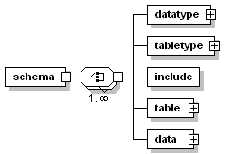
children | datatype tabletype include table data
attributes
  Name | Type | Use | Value
  name | xsd:string | required

element schema/datatype
diagram | 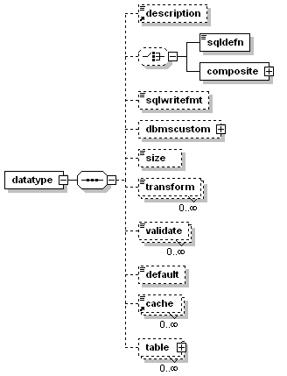
children | description sqldefn composite sqlwritefmt dbmscustom size transform validate default cache table
attributes
  Name | Type | Use | Value
  name | xsd:string | required
  type | xsd:string
  parentref | xsd:string
  selfref | xsd:string
  lookupref | xsd:string
  required | xsd:NMTOKEN | default | no
  calc | xsd:NMTOKEN | default | no
  unique | xsd:NMTOKEN | default | no
  indexed | xsd:NMTOKEN | default | no
  primarykey | xsd:NMTOKEN | default | no
  group | xsd:string
  abbrev | xsd:string
  sqldefn | xsd:string
  sqlwritefmt | xsd:string
  size | xsd:string
  default | xsd:string
  cache | xsd:string
  textsearch | xsd:string

element schema/datatype/sqldefn
diagram
type | xsd:string

element schema/datatype/composite
diagram | 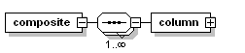
children | column

element schema/datatype/composite/column
diagram | 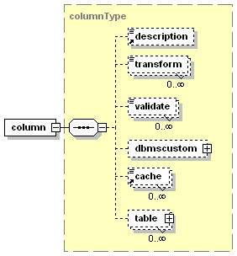
type | columnType
children | description transform validate dbmscustom cache table
attributes
  Name | Type | Use | Value
  name | xsd:string | required
  type | xsd:string | default | text
  parentref | xsd:string
  selfref | xsd:string
  lookupref | xsd:string
  size | xsd:string
  primarykey | xsd:NMTOKEN | default | no
  required | xsd:NMTOKEN | default | no
  calc | xsd:NMTOKEN | default | no
  unique | xsd:NMTOKEN | default | no
  uniquegrp | xsd:string
  uniquegrppos | xsd:string
  indexed | xsd:NMTOKEN | default | no
  indexgrp | xsd:string
  indexgrppos | xsd:string
  descr | xsd:string
  default | xsd:string
  group | xsd:string
  abbrev | xsd:string
  cache | xsd:string
  caption | xsd:string
  textsearch | xsd:string

element schema/datatype/sqlwritefmt
diagram
type | xsd:string

element schema/datatype/dbmscustom
diagram | 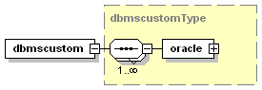
type | dbmscustomType
children | oracle

element schema/datatype/size
diagram
type | xsd:string

element schema/datatype/transform
diagram
type | transformType
attributes
  Name | Type | Use | Value
  method | xsd:NMTOKEN | required

element schema/datatype/validate
diagram
type | validateType
attributes
  Name | Type | Use | Value
  method | xsd:NMTOKEN | required
  type | xsd:NMTOKEN | required
  set | xsd:string | required
  setdelim | xsd:string | default | ,

element schema/datatype/default
diagram
type | xsd:string

element schema/datatype/table
diagram | 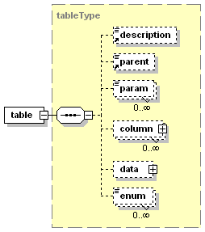
type | tableType
children | description parent param column data enum
attributes
  Name | Type | Use | Value
  name | xsd:string | required
  abbrev | xsd:string
  type | xsd:string
  parent | xsd:string
  group | xsd:string

element schema/tabletype
diagram | 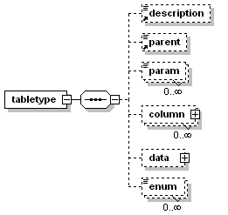
children | description parent param column data enum
attributes
  Name | Type | Use | Value
  name | xsd:string | required
  abbrev | xsd:string
  type | xsd:string
  parent | xsd:string
  group | xsd:string

element schema/tabletype/param
diagram
type | paramType
attributes
  Name | Type | Use | Value
  name | xsd:string | required

element schema/tabletype/column
diagram
type | columnType
children | description transform validate dbmscustom cache table
attributes
  Name | Type | Use | Value
  name | xsd:string | required
  type | xsd:string | default | text
  parentref | xsd:string
  selfref | xsd:string
  lookupref | xsd:string
  size | xsd:string
  primarykey | xsd:NMTOKEN | default | no
  required | xsd:NMTOKEN | default | no
  calc | xsd:NMTOKEN | default | no
  unique | xsd:NMTOKEN | default | no
  uniquegrp | xsd:string
  uniquegrppos | xsd:string
  indexed | xsd:NMTOKEN | default | no
  indexgrp | xsd:string
  indexgrppos | xsd:string
  descr | xsd:string
  default | xsd:string
  group | xsd:string
  abbrev | xsd:string
  cache | xsd:string
  caption | xsd:string
  textsearch | xsd:string

element schema/tabletype/data
diagram | 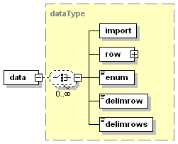
type | dataType
children | import row enum delimrow delimrows
attributes
  Name | Type | Use | Value
  table | xsd:string
  delim | xsd:string | default | ,
  blanks | xsd:NMTOKEN | default | ignore

element schema/tabletype/enum
diagram
type | enumType
attributes
  Name | Type | Use | Value
  id | xsd:string
  abbrev | xsd:string

element schema/include
diagram
attributes
  Name | Type | Use | Value
  file | xsd:string | required
  ifdefined | xsd:string
  ifnotdefined | xsd:string

element schema/table
diagram
type | tableType
children | description parent param column data enum
attributes
  Name | Type | Use | Value
  name | xsd:string | required
  abbrev | xsd:string
  type | xsd:string
  parent | xsd:string
  group | xsd:string

element schema/data
diagram
type | dataType
children | import row enum delimrow delimrows
attributes
  Name | Type | Use | Value
  table | xsd:string
  delim | xsd:string | default | ,
  blanks | xsd:NMTOKEN | default | ignore

complexType columnType
diagram | 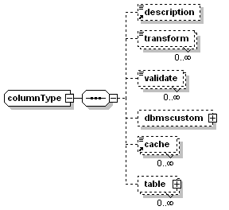
children | description transform validate dbmscustom cache table
used by
  elements | schema/datatype/composite/column schema/tabletype/column tableType/column
attributes
  Name | Type | Use | Value
  name | xsd:string | required
  type | xsd:string | default | text
  parentref | xsd:string
  selfref | xsd:string
  lookupref | xsd:string
  size | xsd:string
  primarykey | xsd:NMTOKEN | default | no
  required | xsd:NMTOKEN | default | no
  calc | xsd:NMTOKEN | default | no
  unique | xsd:NMTOKEN | default | no
  uniquegrp | xsd:string
  uniquegrppos | xsd:string
  indexed | xsd:NMTOKEN | default | no
  indexgrp | xsd:string
  indexgrppos | xsd:string
  descr | xsd:string
  default | xsd:string
  group | xsd:string
  abbrev | xsd:string
  cache | xsd:string
  caption | xsd:string
  textsearch | xsd:string

element columnType/transform
diagram
type | transformType
attributes
  Name | Type | Use | Value
  method | xsd:NMTOKEN | required

element columnType/validate
diagram
type | validateType
attributes
  Name | Type | Use | Value
  method | xsd:NMTOKEN | required
  type | xsd:NMTOKEN | required
  set | xsd:string | required
  setdelim | xsd:string | default | ,

element columnType/dbmscustom
diagram
type | dbmscustomType
children | oracle

element columnType/table
diagram
type | tableType
children | description parent param column data enum
attributes
  Name | Type | Use | Value
  name | xsd:string | required
  abbrev | xsd:string
  type | xsd:string
  parent | xsd:string
  group | xsd:string

complexType dataType
diagram | 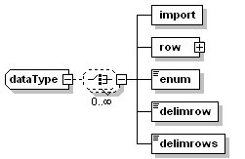
children | import row enum delimrow delimrows
used by
  elements | schema/tabletype/data schema/data tableType/data
attributes
  Name | Type | Use | Value
  table | xsd:string
  delim | xsd:string | default | ,
  blanks | xsd:NMTOKEN | default | ignore

element dataType/import
diagram
attributes
  Name | Type | Use | Value
  method | xsd:NMTOKEN | required
  src | xsd:string | required

element dataType/row
diagram | 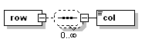
children | col

element dataType/row/col
diagram
type | restriction of xsd:string

element dataType/enum
diagram
type | enumType
attributes
  Name | Type | Use | Value
  id | xsd:string
  abbrev | xsd:string

element dataType/delimrow
diagram
type | xsd:string

element dataType/delimrows
diagram
type | xsd:string

complexType dbmscustomType
diagram | 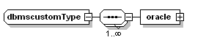
children | oracle
used by
  elements | schema/datatype/dbmscustom columnType/dbmscustom

element dbmscustomType/oracle
diagram
children | ctldatatype

element dbmscustomType/oracle/ctldatatype
diagram
type | xsd:string

complexType enumType
diagram
type | restriction of xsd:string
used by
  elements | schema/tabletype/enum dataType/enum tableType/enum

complexType paramType
diagram
type | restriction of xsd:string
used by
  elements | schema/tabletype/param tableType/param

complexType tableType
diagram | 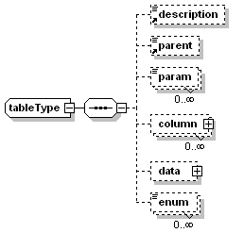
children | description parent param column data enum
used by
  elements | schema/datatype/table schema/table columnType/table
attributes
  Name | Type | Use | Value
  name | xsd:string | required
  abbrev | xsd:string
  type | xsd:string
  parent | xsd:string
  group | xsd:string

element tableType/param
diagram
type | paramType
attributes
  Name | Type | Use | Value
  name | xsd:string | required

element tableType/column
diagram
type | columnType
children | description transform validate dbmscustom cache table
attributes
  Name | Type | Use | Value
  name | xsd:string | required
  type | xsd:string | default | text
  parentref | xsd:string
  selfref | xsd:string
  lookupref | xsd:string
  size | xsd:string
  primarykey | xsd:NMTOKEN | default | no
  required | xsd:NMTOKEN | default | no
  calc | xsd:NMTOKEN | default | no
  unique | xsd:NMTOKEN | default | no
  uniquegrp | xsd:string
  uniquegrppos | xsd:string
  indexed | xsd:NMTOKEN | default | no
  indexgrp | xsd:string
  indexgrppos | xsd:string
  descr | xsd:string
  default | xsd:string
  group | xsd:string
  abbrev | xsd:string
  cache | xsd:string
  caption | xsd:string
  textsearch | xsd:string

element tableType/data
diagram
type | dataType
children | import row enum delimrow delimrows
attributes
  Name | Type | Use | Value
  table | xsd:string
  delim | xsd:string | default | ,
  blanks | xsd:NMTOKEN | default | ignore

element tableType/enum
diagram
type | enumType
attributes
  Name | Type | Use | Value
  id | xsd:string
  abbrev | xsd:string

complexType transformType
diagram
type | restriction of xsd:string
used by
  elements | schema/datatype/transform columnType/transform

complexType validateType
diagram
type | restriction of xsd:string
used by
  elements | schema/datatype/validate columnType/validate

XML Schema documentation generated with XML Spy Schema Editor www.xmlspy.com

