CD4/Viral Load References

# Laeyendecker - Multi-Algorithm Assay

Laeyendecker O, Brookmeyer R, Cousins MM, Mullis CE, Konikoff J, Donnell D, et al. HIV incidence determination in the United States: a multiassay approach. J Infect Dis. 2013 Jan 15;207(2):232–9.

## Abstract

**Background**. Accurate testing algorithms are needed for estimating human immunodeficiency virus (HIV) incidence from cross-sectional surveys.

**Methods**. We developed a multiassay algorithm (MAA) for HIV incidence that includes the BED capture enzyme immunoassay (BED-CEIA), an antibody avidity assay, HIV load, and CD4+ T-cell count. We analyzed 1782 samples from 709 individuals in the United States who had a known duration of HIV infection (range, 0 to >8 years). Logistic regression with cubic splines was used to compare the performance of the MAA to the BED- CEIA and to determine the window period of the MAA. We compared the annual incidence estimated with the MAA to the annual incidence based on HIV seroconversion in a longitudinal cohort.

**Results**. The MAA had a window period of 141 days (95% confidence interval [CI], 94–150) and a very low false-recent misclassification rate (only 0.4% of 1474 samples from subjects infected for >1 year were misclassified as indicative of recent infection). In a cohort study, annual incidence based on HIV seroconversion was 1.04% (95% CI, .70%–1.55%). The incidence estimate obtained using the MAA was essentially identical: 0.97% (95% CI, .51%–1.71%).

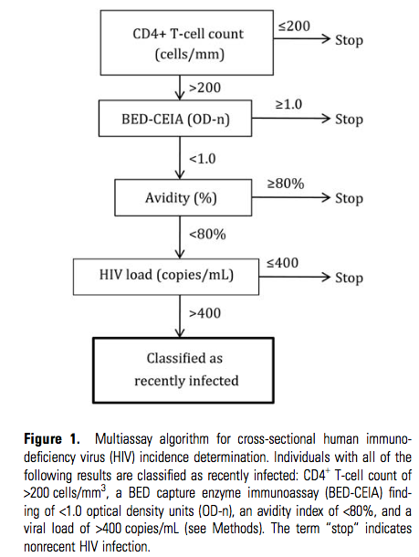**Conclusions**. The MAA is as sensitive for detecting recent HIV infection as the BED-CEIA and has a very low rate of false-recent misclassification. It provides a powerful tool for cross-sectional HIV incidence determination.

## Notes

* “The MAA combines 2 serological assays with CD4+ T-cell count and HIV load. The serological assays are used to cast a wide net to identify individuals who may have recent HIV infection. HIV load and CD4+ T-cell count are used to exclude individuals who, because of advanced HIV disease (indicated by low CD4+ T-cell count) or natural- or antiretroviral- induced viral suppression (indicated by low HIV load), may be misclassified by serologic assays as recently infected.” (p233)
* Provides some simple cutoffs for CD4 and VL, but they are for ruling out recent infections. Provides no guidance for identifying recent infections in the absence of a serologic assay like BED or an avidity assay
* A note about BED: “To address the issue of false-recent misclassification, the CDC recommended excluding persons with AIDS and persons receiving antiretroviral treatment from being counted as having recent infection, regardless of their BED- CEIA test results.”

# Lodi – CASCADE cohort

Lodi S, Phillips A, Touloumi G, Geskus R, Meyer L, Thiébaut R, et al. Time from human immunodeficiency virus seroconversion to reaching CD4+ cell count thresholds <200, <350, and <500 Cells/mm3: assessment of need following changes in treatment guidelines. Clin Infect Dis. 2011 Oct;53(8):817–25.

## Abstract

**BACKGROUND**: Recent updates of human immunodeficiency virus (HIV) treatment guidelines have raised the CD4+ cell count thresholds for antiretroviral therapy initiation from 350 to 500 cells/mm(3) in the United States and from 200 to 350 cells/mm³ in mid- and low-income countries. Robust data of time from HIV seroconversion to CD4+ cell counts of 200, 350, and 500 cells/mm³ are lacking but are needed to inform health care planners of the likely impact and cost effectiveness of these and possible future changes in CD4+ cell count initiation threshold.

**METHODS**: Using Concerted Action on Seroconversion to AIDS and Death in Europe data from individuals with well-estimated dates of HIV seroconversion, we fitted mixed models on the square root of CD4+ cell counts measured before combined antiretroviral therapy (cART) initiation. Restricting analyses to adults (age >16 years), we predicted time between seroconversion and CD4+ cell count <200, <350, and <500 cells/mm³ as well as CD4+ cell count distribution and proportions reaching these thresholds at 1, 2, and 5 years after seroconversion.

**RESULTS**: Median (interquartile range [IQR]) follow-up for the 18495 eligible individuals from seroconversion while cART-free was 3.7 years (1.5, 7). Most of the subjects were male (78%), had a median age at seroconversion of 30 years (IQR, 25-37 years), and were infected through sex between men (55%). Estimated median times (95% confidence interval [CI]) from seroconversion to CD4+ cell count <500, <350, and <200 cells/mm(3) were 1.19 (95% CI, 1.12-1.26), 4.19 (95% CI, 4.09-4.28), and 7.93 (95% CI, 7.76-8.09) years, respectively. Almost half of infected individuals would require treatment within 1 year of seroconversion for guidelines recommending its initiation at 500 cells/mm³, compared with 26% and 9% for guidelines recommending initiation at 350 and 200 cells/mm³, respectively.

**CONCLUSIONS**: These data suggest substantial increases in the number of individuals who require treatment and call for early HIV testing.

## Notes

Could use the proportions in the following table to inform an assumption for the No’s that is similar to what Josh did (random between 0-18 yrs) but more data driven: if CD4>500, ~50% get a 1.5 year window or random (0-1.5 yr), and the other 50% rest get random (1.5-18 yrs) or could split them up into 25% get (2-5) and 25% get (5-18)

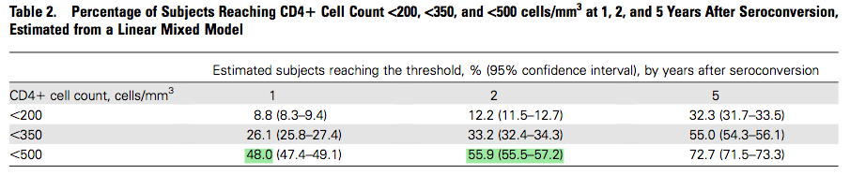

“Using a large dataset of 18,495 individuals with well-estimated dates of HIV seroconversion, we estimated that CD4 cell counts of 500, 350, and 200 cells/mm3 are reached, on average, at approximately 1, 4, and 8 years, respectively.”

# Cori – ATHENA Cohort

## Abstract

**BACKGROUND**: CD4 cell count is a key measure of HIV disease progression, and the basis of successive international guidelines for treatment initiation. CD4 cell dynamics are used in mathematical and econometric models for evaluating public health need and interventions. Here, we estimate rates of CD4 decline, stratified by relevant covariates, in a form that is clinically transparent and can be directly used in such models.

**METHODS**: We analyse the AIDS Therapy Evaluation in the Netherlands cohort, including individuals with date of seroconversion estimated to be within 1 year and with intensive clinical follow-up prior to treatment initiation. Owing to the fact that CD4 cell counts are intrinsically noisy, we separate the analysis into long-term trends of smoothed CD4 cell counts and an observation model relating actual CD4 measurements to the underlying smoothed counts. We use a monotonic spline smoothing model to describe the decline of smoothed CD4 cell counts through categories CD4 above 500, 350-500, 200-350 and 200 cells/μl or less. We estimate the proportion of individuals starting in each category after seroconversion and the average time spent in each category. We examine individual-level cofactors which influence these parameters.

**RESULTS**: Among untreated individuals, the time spent in each compartment was 3.32, 2.70, 5.50 and 5.06 years. Only 76% started in the CD4 cell count above 500 cells/μl compartment after seroconversion. Set-point viral load (SPVL) was an important factor: individuals with at least 5 log10 copies/ml took 5.37 years to reach CD4 cell count less than 200 cells/μl compared with 15.76 years for SPVL less than 4 log10 copies/ml.

**CONCLUSION**: Many individuals already have CD4 cell count below 500 cells/μl after seroconversion. SPVL strongly influences the rate of CD4 decline. Treatment guidelines should consider measuring SPVL, whereas mathematical models should incorporate SPVL stratification.

## Notes

* Ok so Lodi’s results are probably a function of the distribution of SPVLs in the population. Here, about a quarter of subjects had their CD4 below 500 at the estimated time of seroconversion, so very early. The (unstratified) average time to <500 was 3.32 years (Table 2). From Figure 2, it looks like the unstratified median time to <500 was maybe 2 yrs This is close to what Lodi found. Perhaps we could use 2 years as a more conservative window estimate for 50% of No’s with CD4>500, compared to 1-1.5 yrs from Lodi.
* Not sure what to do with the CD4 200-500 crew…
* And what about using the median time to CD4<200 to give 50% of the No’s with CD4<200 an LNT that’s random (2yr-median yr), and the rest random (median yr-18 yrs)? – how does this compare to the Base Case, since that distributes probability uniformly? It’s very similar, since 9.5 yrs is close to the median of 18. But that means that the median time for CD4=200-500 should be less.
  + “Gras et al. [19] found a similar estimate of over 4 years from seroconversion to a CD4þ cell count 350 cells/ml for individuals seroconverting before 1996, but a shorter estimate of 2.7 years from seroconversion to CD4þ cell count 350cells/ml for those seroconverting after 2002.”
  + “A number of other studies have reported the median time from estimated date of seroconversion to a a CD4þ cell count cell count below 200 cells/ml. Kilmarx et al. [20] reported 6.9 years among Thai female sex workers, whereas Wandel et al. [21] used cohorts from Uganda, Thailand and Coˆte d’Ivoire and estimated a median of 6.1 years to CD4þ cell count below 200 cells/ ml based on a Weibull survival model, with a shorter duration among the Thai cohorts than the Africans. The difference between our estimates and those of these other studies may be partly explained by their use of the median time. Motivated by the fact that the median time of an exponential process is lower than the mean time, we conducted numerical experiments, and we found a median time of 9.5 years given our model of disease progression.”

Using waiting times from the model and translating means to exponential medians,

|  |  |  |  |  |  |
| --- | --- | --- | --- | --- | --- |
|  |  |  |  |  |  |
| CD4 | 1/q | q | median | median total | approximate |
| >500 | 3.32 | 0.301204819 | 2.301248639 | 2.301248639 | 2 |
| 350-500 | 2.7 | 0.37037037 | 1.871497388 | 4.172746027 | 4 |
| 200-350 | 5.5 | 0.181818182 | 3.812309493 | 7.98505552 | 8 |
| <200 | 5 | 0.2 | 3.465735903 | 11.45079142 | 11.5 |
|  |  |  |  |  |  |