Identifying HIV Infections and the BED Assay

# Summary

1. We are at the beginning of a transition to a different testing algorithm in the US, with Western blots and IFAs being replaced by combination antigen-antibody testing. This transition is also decreasing the use of the BED assay; however, the new algorithm does include nucleic acid testing intended to identify early HIV infections that are in the acute stage.
   1. The acute stage is a much shorter period than the “recent infection” stage identified by the BED assay, approximately 24 days with a reported range of 10-50 days
   2. The recent infection stage refers to the window period between a positive test on a more sensitive HIV test and a positive test on a less sensitive HIV test, typically on the order of 5-6 months
2. The first STARHS algorithm to identify recent infections for incidence estimation came out in 1998 by Janssen et al. It did use a “detuned ELISA” approach in which the 2nd, less sensitive test was an EIA that measured quantity of the antibody response just like the 1st test, but with lower sensitivity
   1. BED, however, is not a detuned ELISA; instead, it measures the proportion of HIV IgG to total IgG, and a threshold of optical density units <0.8 is considered to indicate recent infection
   2. Note that development of “incidence assays” – ones intended to be used as a 2nd, less sensitive test to support incidence estimation – is still an active area of research. New contenders include the LAg assay that measures avidity.
      1. Several assay-development studies I encountered used testing histories as a mechanism for determining point of seroconversion, begging the question whether using the results of an incidence assay in combination with testing history is a bit circular!
3. The overestimation of recent infection by the BED test is a well-established concept in HIV incidence measurement in the global context. In 2007, the CDC issued a point-by-point defense of the use of BED in the US, given that several factors leading to false recent results are rare in the US setting. Part of this defense was that those simultaneously diagnosed with HIV and AIDS are considered false recents (specific definition of “simultaneous” not provided).
4. Because the BED results are not highly impactful, I’m not sure how precise we care to be or how much we will pursue using the results. However, my impression is that it would not be received well if we were to consider all individuals with close HIV and AIDS diagnoses who are BED+ to have correct BED results.

# Phases of HIV Infection

|  |  |  |  |
| --- | --- | --- | --- |
| Term | Description | Duration | Reference |
| Eclipse phase | HIV infection has occurred but is not detectable in the plasma | Approximately 11 days | Suthar 2015 (1), Rosenberg 2015 (2) |
| Acute infection (AHI) | Time from human immunodeficiency virus (HIV) infection to the presence of HIV-specific antibodies; characterized by a rapid rise in the viremia. HIV RNA and p24 antigen are detectable (7-10 days and + another 5-7 days, respectively) but the antibody response is not. Duration depends on the design and sensitivity of the immunoassays | Approximately 24 days | Suthar 2015, Rosenberg 2015, CDC 2014 (3) |
| Early infection (EHI) | Time from HIV infection to a viremic steady state or set point, i.e. chronic infection; characterized by replication of the virus and the development of the immune response during which there is a decline in the CD4+ T-cell counts. In 2014, the CDC issued a new surveillance case definition of “Stage 0” that refers to this stage (Rosenberg 2015). | Approximately 52 days | Suthar 2015, Rosenberg 2015 |
| Recent infection | State that begins when the biological process of HIV infection is first initiated; when HIV antibodies are detectable by sensitive diagnostic assays, but the immune response is immature. This term is used primarily in the context of measuring HIV incidence | 6 mos (Rosenberg); 2 years (the most recent WHO definition, designed to lower the false-recency rates) | Suthar 2015, Rosenberg 2015, WHO Technical Update 2015 (4) |
| Chronic infection | For people not receiving antiretroviral therapy: fairly constant viremia, steady declines in CD4+ T-cell counts, and increasing rates of opportunistic infections. For people receiving antiretroviral therapy: suppressed viral loads, increases in CD4+ T-cell counts, and reducing rates of opportunistic infections | Approximately 10 yrs (range 2-20 yrs after infection for people not receiving ART or nearly lifelong for people receiving effective ART) | Suthar 2015 |
| Late-stage infection | CD4+ T-cell levels decline to very low levels, rapid rises in viremia, and death if infection is left untreated | Approximately 1 yr if untreated | Suthar 2015 |

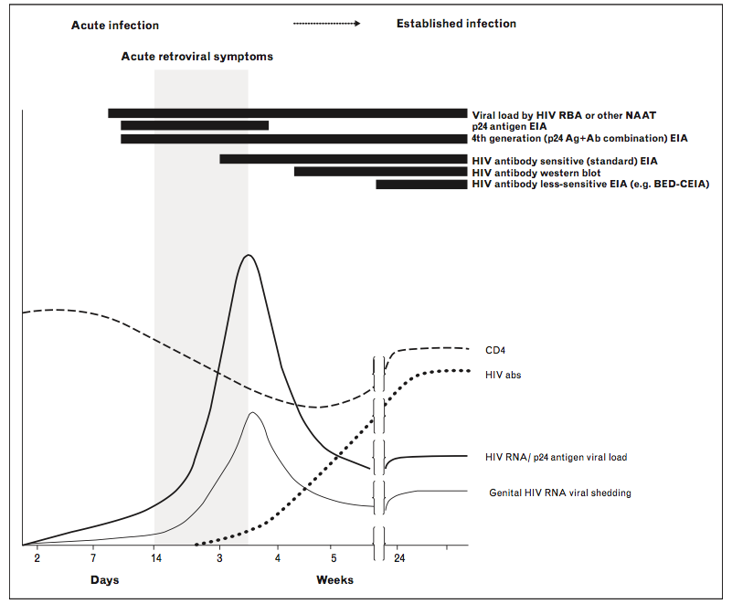

Figure 1. Timing of early HIV infection biomarkers and symptoms, from Rosenberg 2015

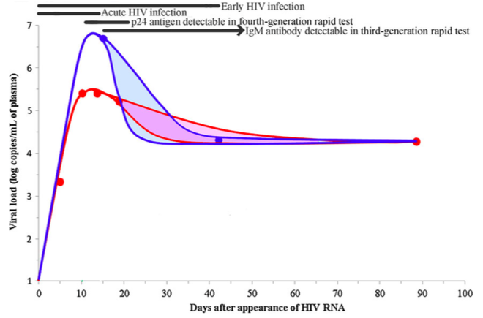

Figure 2. Appearance of diagnostic and viral markers during acute and early HIV infection, from Suthar 2015. Pairs of lines indicate ranges consistent with published data for Kenya/Uganda/Tanzania/Thailand (Blue) and the US (Red). Eclipse period not shown.

Figure . From the 2014 CDC testing guidelines update

# 

# Tests for Early Infection

## Antibody-Testing Approaches or “Incidence Assays”

Measure the antibody response with respect to

1. Quantity
   1. (Original?) STARHS – “detuned” serologic assay, Janssen 1998 (5)
      1. Depended on the maturity of the antibody response, which is unreliable across HIV subtypes
      2. Janssen *et al*. [8] reported the application of an alternative biomarker test designed for estimating HIV incidence in the United States. Their biomarker test distinguishes recent from long-standing infections later in the course of infection than the standard HIV test. The initial HIV biomarker test was a modification of the standard HIV enzyme immunoassay (EIA) [8, 9]. Currently, CDC uses the BED (named for the three HIV subtypes that constitute the polypeptide) capture EIA [10], with a mean window period of 156 days, as the HIV biomarker test…” (6) – see Figure 3.

Figure . From Karon 2008

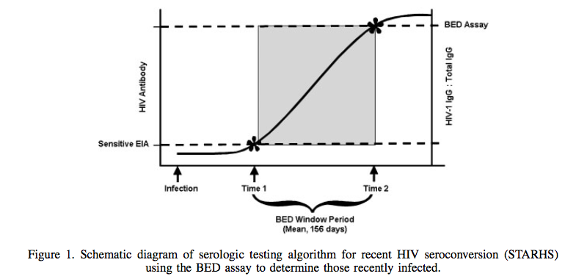

1. Proportion
   1. BED capture enzyme immunoassay (BED-EIA or BED-CEIA)
      1. Proportion of anti-HIV IgG to total IgG, or “the proportion of antibodies that binds to an HIV peptide” (7); results are reported as normalized optical density units (OD- n). The OD-n increases as a function of time since infection, and specimens with OD-n above a certain threshold are classified as not recently infected.
      2. Mean window period: the mean length of time individuals remain classified as “recently infected”
         1. Requires a calibration cohort study with frequent follow-up of individuals whose date of infection is approximately known (8).
         2. 2011 study: 176 days (linear regression) or 162 days (nonparametric survival method) – 162 days recommended for subtype B, as in the US (9)
         3. Unlike the original detuned assay by Janssen, the mean window period is similar across subtypes B and AE – so that’s the major improvement? (9)
      3. Misclassifies those with advanced disease and immunosuppression as early infections.
         1. “The BED assay cannot be used if a person has AIDS or is taking antiretroviral therapy at the time of HIV diagnosis, as the test can produce false-recent results among such persons even if not recently infected.” (6)
         2. “…it was discovered that the BED assay is an imperfect test, misclassifying some proportion of nonrecently infected individuals as recent” (8) (no reference). “This misclassification effect is particularly severe in settings with high HIV prevalence and may vary by HIV-1 subtype” (10). This comes from a CDC report that refers to the UNAIDS statement which reads as follows and includes no citations:
            1. “The comparison of BED-assay derived measures of incidence with directly measured prevalence and with estimates of incidence based on different methods consistently suggests that the current BED-based method overestimates incidence. Several studies show BED-derived incidence of a third to half the prevalence. This is inconsistent with the pattern of growth of the epidemic and data about survival of people infected with HIV-1. In studies that compare different measures of incidence, BED-assay derived incidence appears 2-3 times higher than that found using other methods (e.g. HIV-1 incidence measured directly in prospective studies, or derived from prevalence surveys in young people [15-24 years old] by single year of age or modelling using the Estimation and Projection Package and Spectrum or the Asian Epidemic Model). There is evidence that the above discrepancies arise because the BED-assay captures not only recent infections, but also late stage HIV infection (with or without antiretroviral therapy) when the levels of antibodies fall. Additionally, there may be an impact of sample storage conditions on assay results. There is evidence that assay characteristics vary by HIV-1 subtype. Based on the above-summarised evidence, the Reference Group recommends that at present the BED-assay not be used for routine surveillance applications, neither for absolute incidence estimates, nor for monitoring trends. In addition, the BED-assay should not be applied in national surveys, and sample sizes of planned national surveys should not be increased solely for the application of the BED-assay.” (11)
         3. The CDC report (10) points out that misclassification will be higher in populations with high ART use if ART users are not excluded – highlights the difference btwn developed and developing countries, since BED at time of dx, pre-ART, is more controlled.
         4. Assay characteristics may vary by men vs women due to differences in the immune response. Laeyendecker analyzed MACS data from men with LNT-to-Dx of 1 year and assumed seroconversion at the midpoint. Then they analyzed samples 2-4 yrs after seroconversion and 6-8 yrs after. They found a misclassification rate of 15% (7). But in a study using 5 African cohorts it was 7.6% (12).
            1. Initiating ART within 1 yr of seroconversion was highly associated with false recent results in the later samples. Misclassification rate dropped to 6.5% when men with CD4<200 and/or viral load <400 were excluded, i.e. assumed to be non-recent (7).
            2. Explanation: production of anti-HIV antibodies falls when the virus is suppressed by the immune system OR by ART, so low viral load -> false recent result. Anti-HIV antibody production also falls when the immune system collapses, hence false recency among those with low CD4.

Their 2013 paper is a MAA follow-up formalizing the addition of the CD4 and viral load info (13)

* + - * 1. Apparently the BED-CEIA package insert says the false recency rate is 3%.
      1. Adjustment approaches:
         1. Correct false-recents using ART utilization, AIDS diagnosis and/or conflicting previous HIV test results
         2. Use incidence estimators that account for imperfect specificity – plenty of references in (8)
      2. Several papers refer to a CDC report that is no longer up: <http://www.cdc.gov/hiv/topics/%20surveillance/resources/factsheets/BED.htm>. It’s possible that this report is the same one that is now located here: <http://www.cdc.gov/hiv/pdf/library_factsheet_HIV_usingTheBed_HIV-1_2007.pdf> (14)
         1. This report contrasts the use of the BED assay in the US to its use globally and argues in favor of its use in the US. It explains that:
         2. The UNAIDS recommendation against the use of BED was in response to incidence estimates for Africa and Thailand from models and prospective cohort studies that suggested BED estimates were too high.
         3. Several of the situations leading to false recent results in international settings do not apply in the US: confirmation by Western blot or IFA, poor specimen handling, chronic co-infection leading to high IgG not due to HIV, subtype heterogeneity in window periods, false + due to advanced HIV (those with AIDS are considered not recent in STARHS), false + due to ART initiated in last 6 mos
    1. Currently the most widely used commercially available assay for detecting recent HIV infection

1. Avidity
   1. Limiting-antigen avidity assay (LAg)
      1. Measures the avidity of antibody binding to low concentrations of a multisubtype peptide derived from an immunodominant region of gp41
      2. Similar challenges of misclassifying persons with advanced HIV disease, elite controllers, and persons with viral suppression and partial seroreversion following ART as having early infection
2. Isotope

## Multi-assay Algorithms (MAAs)

MAAs apply a sequential, hierarchical set of assays to classify confirmed seropositive samples into recent versus long-standing infection categories.

* The optimal MAA depends on the setting, due to differences in assay performance across HIV subtypes.
* MAAs are evaluated by systematically applying various algorithms to the same group of samples in different orders using a range of cutpoints. The samples have a “known” incidence duration, typically using LNT to 1st positive test. The precise definition of the known incidence duration depends on the study:
  + A new BED-based MAA was evaluated using LNT to 1st positive results from the ALIVE, MACS, and HIVNET 001 cohorts in the US (13). “The date of HIV sero-conversion was estimated for each individual as the midpoint between the last HIV-negative test result and the first HIV- positive test result except if acute infection was documented (ie, a sample was HIV RNA positive and HIV antibody negative), in which case the date of HIV seroconversion was estimated as 2 weeks after the study visit in which acute infection was documented.”
  + 403 MAAs were evaluated against LNTs to 1st positives from 7 African cohorts from an RCT evaluating integrated behavioral interventions. But LNT was not always known—if so, it was imputed as age 14 and true date of infection was simulated uniformly between LNT and first positive or, in some cases, a Weibull… (15)

### Issues with the use of BED-CEIA within a MAA (am I understanding that correctly?)

Two factors that have been associated with false-recent misclassification by the BED-CEIA are low CD4+ T-cell count and low HIV load (7). Some studies have suggested using a mathematical approach to adjust results obtained with these assays, to improve the precision of HIV incidence estimates [17]. However, that approach has limitations, such as requiring precise estimates of additional input adjustment factors [18–21]. Working groups have been assembled to harmonize the terminology used in this field, to facilitate collaboration among investigators, to share the findings of new research, and to focus research efforts [22]. In this report, we describe a multiassay algorithm (MAA) for identifying recent infections that can be used to determine population HIV incidence rates. This approach overcomes limitations of previous approaches developed for estimating HIV incidence that are based on cross-sectional sampling, because all individuals stop appearing to be recently infected and do not regress back to appearing to be recently infected. The MAA combines 2 serological assays with CD4+ T-cell count and HIV load. The serological assays are used to cast a wide net to identify individuals who may have recent HIV infection. HIV load and CD4+ T-cell count are used to exclude individuals who, because of advanced HIV disease (indicated by low CD4+ T-cell count) or natural- or antiretroviral- induced viral suppression (indicated by low HIV load), may be misclassified by serologic assays as recently infected. (13)

## STARHS

“The combination of the standard EIA test and the BED assay is also known as serologic testing algorithm for recent HIV seroconversion (STARHS); a person who is HIV positive on the diagnostic HIV test and recent on the BED test is classified as BED or STARHS recent; see Figure 1. The critical value for classifying a BED result as recent was chosen so that the probability of having a BED window period longer than 1 year is small [10].” (6)

# 2014 Updated Testing Guidelines from the CDC

<http://www.cdc.gov/hiv/pdf/hivtestingalgorithmrecommendation-final.pdf>

* Shift away from antibody testing alone to inclusion of antigen and nucleic acid testing. HIV-1 Western blot and HIV-1 IFA are no longer recommended.
* Begin with combo immunoassay that detects HIV-1 and HIV-2 antibodies as well as p24 antigen. If reactive but nonreactive/indeterminate on the antibody differentiation assay, proceed to nucleic acide testing (NAT).

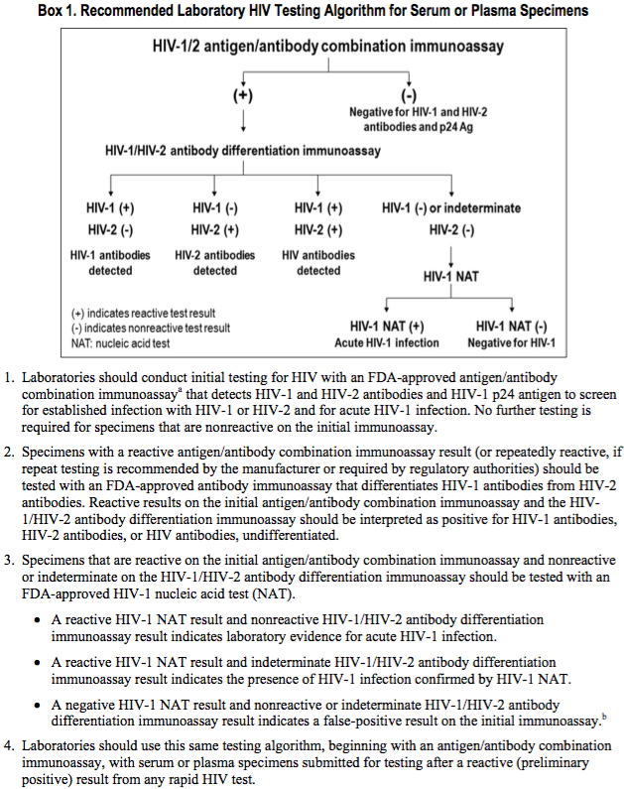

# References

1. Suthar AB, Granich RM, Kato M, Nsanzimana S, Montaner JSG, Williams BG. Programmatic Implications of Acute and Early HIV Infection. J Infect Dis. 2015 Nov 1;212(9):1351–60.

2. Rosenberg NE, Pilcher CD, Busch MP, Cohen MS. How can we better identify early HIV infections? Curr Opin HIV AIDS. 2015 Jan;10(1):61–8.

3. Centers for Disease Control. Laboratory Testing for the Diagnosis of HIV Infection: Updated Recommendations [Internet]. 2014 [cited 2016 Feb 16]. Available from: http://www.cdc.gov/hiv/pdf/hivtestingalgorithmrecommendation-final.pdf

4. World Health Organization. Technical update on HIV incidence assays for surveillance and monitoring purposes [Internet]. 2015 [cited 2016 Jan 22]. Available from: http://www.unaids.org/sites/default/files/media_asset/HIVincidenceassayssurveillancemonitoring_en.pdf

5. Janssen RS, Satten GA, Stramer SL, Rawal BD, O’Brien TR, Weiblen BJ, et al. New testing strategy to detect early HIV-1 infection for use in incidence estimates and for clinical and prevention purposes. JAMA. 1998 Jul 1;280(1):42–8.

6. Karon JM, Song R, Brookmeyer R, Kaplan EH, Hall HI. Estimating HIV incidence in the United States from HIV/AIDS surveillance data and biomarker HIV test results. Stat Med. 2008 Oct 15;27(23):4617–33.

7. Laeyendecker O, Brookmeyer R, Oliver AE, Mullis CE, Eaton KP, Mueller AC, et al. Factors associated with incorrect identification of recent HIV infection using the BED capture immunoassay. AIDS Res Hum Retroviruses. 2012 Aug;28(8):816–22.

8. Bärnighausen T, McWalter TA, Rosner Z, Newell M-L, Welte A. HIV incidence estimation using the BED capture enzyme immunoassay: systematic review and sensitivity analysis. Epidemiol Camb Mass. 2010 Sep;21(5):685–97.

9. Parekh BS, Hanson DL, Hargrove J, Branson B, Green T, Dobbs T, et al. Determination of mean recency period for estimation of HIV type 1 Incidence with the BED-capture EIA in persons infected with diverse subtypes. AIDS Res Hum Retroviruses. 2011 Mar;27(3):265–73.

10. Surveillance and Survey and the Laboratory working groups,Centers for Disease Control. Interim recommendations for the use of the BED capture enzyme immunoassay for incidence estimation and surveillance [Internet]. 2006 Nov [cited 2016 Jan 22]. Available from: http://www.cdc.gov/globalAIDS/docs/surveillance/Interim%20Recommendations%20for%20the%20use%20of%20the%20BED%20capture%20enzyme%20immunoassay%20for%20incidence%20estimation%20and%20surveillance%20Approved%20November%2021%202006%20(2).pdf

11. UNAIDS. Statement on the use of the BED-assay for the estimation of HIV-1 incidence for surveillance or epidemic monitoring: Report of a meeting of the UNAIDS Reference Group for Estimates, Modelling and Projections [Internet]. Athens, Greece; 2005 Dec. Available from: http://www.epidem.org/sites/default/files/content/resources/attachments/BED%20statement.pdf

12. Laeyendecker O, Brookmeyer R, Mullis CE, Donnell D, Lingappa J, Celum C, et al. Specificity of four laboratory approaches for cross-sectional HIV incidence determination: analysis of samples from adults with known nonrecent HIV infection from five African countries. AIDS Res Hum Retroviruses. 2012 Oct;28(10):1177–83.

13. Laeyendecker O, Brookmeyer R, Cousins MM, Mullis CE, Konikoff J, Donnell D, et al. HIV incidence determination in the United States: a multiassay approach. J Infect Dis. 2013 Jan 15;207(2):232–9.

14. Centers for Disease Control. Using the BED HIV-1 Capture EIA Assay to Estimate Incidence Using STARHS in the Context of Surveillance in the United States [Internet]. 2007 Oct [cited 2016 Feb 16]. Available from: http://www.cdc.gov/hiv/pdf/library_factsheet_HIV_usingTheBed_HIV-1_2007.pdf

15. Laeyendecker O, Kulich M, Donnell D, Komárek A, Omelka M, Mullis CE, et al. Development of methods for cross-sectional HIV incidence estimation in a large, community randomized trial. PloS One. 2013;8(11):e78818.

# 