Natural History of HIV/AIDS

# **Major untreated cohorts**

See <https://www.ncbi.nlm.nih.gov/pubmed?linkname=pubmed_pubmed&from_uid=2669471> - “similar articles” for the Munoz 1989 article

|  |  |  |  |  |
| --- | --- | --- | --- | --- |
| Name (References) | N | Years/FU | Seroconversion Date | Description |
| MACS: Multicenter AIDS Cohort Study (1,2) | 4954 | 4y (Taylor) |  |  |
| CASCADE: Concerted Action on Seroconversion to AIDS and Death in Europe (3,4) | 21,240 |  | Various; 89% midpoint btwn LNT and dx (max of 3 years); 8% lab evidence, 2% seroconversion illness, 1% hemophiliac infusion | 25 cohorts of persons with well-estimated dates of HIV seroconversion from Europe, Australia, Canada, and sub-Saharan Africa |
| ATHENA: AIDS Therapy Evaluation in the Netherlands (5) | 21,999 |  |  |  |

# **Time to CD4/VL thresholds**

## To Do

* Summarize the papers in Natural History – CD4/VL?

## Summary/Suggestions

* Investigate a simple restriction that is consistent across the major cohort studies and SPVL, e.g., a CD4 count >500 means at least a 50% chance that seroconversion was <= 2 years ago
* Ask for repeated measures in order to estimate SPVL better

## CD4

## VL

# **Time to AIDS**

## To Do

1. ~~Extract info from abstracts~~
2. ~~Extract info from pdf~~
   1. Flag discussion points: Matt was getting that 10% of recent infections are fast progressors; we also want to know the whole incubation distribution
   2. How much do the details matter – how they determined seroconversion, how they defined the AIDS endpoint, what the max follow-up time was, if there was any treatment, % and N developing AIDS, selection process (e.g. selected based on developing AIDS?)
3. Graph distributions overlayed with data points and compare percentiles from the distributions
   1. PDF and CDF, since some stats are reported as cumulative incidence. But be careful, CI is a crude measure. Were there deaths from other causes?
4. **Papers from Sarah** 
   1. **The specific papers refer to viral load, but they could lead to time-to-AIDS descriptions from these untreated cohorts**
   2. **Frasier 2007, “Variation in HIV-1 set-point viral load: Epidemiological analysis and an evolutionary hypothesis”**
   3. **Cori and Pickles [http://www.ncbi.nlm.nih.gov/pubmed/26558543](http://www.ncbi.nlm.nih.gov/pubmed/26558543" \t "_blank)**
   4. **MACS – not sure what the primary time-to-AIDS papers are, from MACS**

## Summary/Suggestions

1. We are looking for data to inform the entire AIDS incubation distribution as well as the proportion of patients who are naturally “rapid progressors.” I looked into Matt’s references, the CDC’s reference, our reference, and one clinical review paper that I came across.
2. Matt’s references are mostly small cohort studies of primarily hemophiliacs. There are hundreds of these out there, all with varying results, and for what we are looking for, there doesn’t seem to be any particular reason to focus on the studies he selected. The Rosenberg paper has the largest cohort and had MSM, not just hemophiliacs. However the focus of the paper is the effect of age on progression, so the results reported are age-specific.
3. The CDC’s reference for the AIDS incubation distribution is a Markov model developed from a large dataset. While I cannot completely vouch for the paper, the approach and data source have a lot more face validity than the small cohort studies. Length bias is an important issue in the hemophiliac cohort studies and this paper specifically calls out the Lui paper that we referenced as an insufficient attempt to use hemophiliac data but correct for length bias.
4. The Lui paper that we/Ian referenced attempts to correct for length bias by assuming that the incubation distribution is Weibully-distributed and then finding the best-fit Weibull for the data. It is difficult to compare the resulting distribution with the one from the CDC reference and say with certainty that one is more correct. However, I would be more inclined to go with the CDC reference given that disease progression is believed to be slower in hemophiliacs (I read this in one of the articles, forgot which one) on top of the fact that the Lui paper uses a small sample and it is sort of hard to believe that the bias correction can overcome the length bias present in the sample.
5. Regarding rapid progressors, the full KM curves from Matt’s references actually show no progression to AIDS within the first year. This is supported by a clinically-focused Science paper that I found, which discusses the genetic factors associated with the division of AIDS cases into rapid, typical and non-progressors. This paper cites 5 references in its definition of rapid progressors as the 10% of cases that will progress to AIDS in 2-3 years.
6. How much more investigation into this topic do we need? According to the CDC’s gamma(2,4), 10% of cases will progress to AIDS in 2.12 years; only 2.6% within 1 year. If we need more info, I could check the 5 references from the Science paper.

## Summary of References

|  |  |  |  |  |  |  |  |  |
| --- | --- | --- | --- | --- | --- | --- | --- | --- |
| Paper | Source | Years (Max Follow-Up) | Study Type | Cohort Info | N (N with AIDS) | Selection  (Length-Biased?) | Seroconversion/  Endpoint | Treatment |
| Rosenberg 1994 (6) | Matt | Pre-1987 | Prospective cohort | MHCS = hemophiliacs;  IRS, International Registry of Seroconverters = MSM | 373 hemo;  1020 MSM |  |  |  |
| Eyster 1993 (7) | Matt | 1982-1990 | Prospective cohort | Hemophiliacs | 323 |  |  |  |
| Lee  1989 (8) | Matt | 1979-1988 (9 years) | Prospective cohort | Hemophiliacs (UK) | 112 total;  59 w/ date of seroconversion  (22 with AIDS) | Anti-HIV positive | Median btwn LNT and 1st pos, 16-25 mos | 20 treated starting in 1987 |
| Eyster 1987 (9) | Matt |  |  | Hemophiliacs | 84 |  |  |  |
| Longini 1989 (10) | CDC paper | pre-1987 | Markov model | San Francisco MSM, plus some transfusion-infected and a few hemophiliacs | 603 |  |  |  |
| Longini 1991 (11) | CDC paper |  | Markov model | US Army cohort | 1796 |  |  | Unknown |
| Lui  1986 (12) | Ian | 1978-1984 (5.4 yrs) | MLE correction to length-biased prospective cohort | Transfusion-associated cases | 83 (76 with AIDS) | Transfusion-associated AIDS by 1984 (Yes) | Date of transfusion, or assumption for the 6 cases with unknown date | None |
| Haynes 1996 | Jeanette |  | Clinical review | ? Would have to dig into the 5 references |  |  |  |  |

|  |  |  |  |
| --- | --- | --- | --- |
| Paper | Source | AIDS Incubation Findings | Other Findings |
| Rosenberg 1994 (6) | Matt | Median time to AIDS for aged 20 seroconverter 10.4, 12.0 or 14.4 yrs depending on the baseline hazard | Faster progression rates at older ages at seroconversion; after adjusting for age, MSM progress to AIDS twice as fast as hemophiliacs |
| Eyster 1993 (7) | Matt | Cum inc of AIDS at 10 yrs was 20% for <18 and 34 % for 18+ | Intermediate HIV-related conditions occur more in adults and different conditions predict progression to AIDS in adults (persistent fever) vs children (oral candidiasis) |
| Lee  1989 (8) | Matt | KM cum inc of AIDS at 8 yrs = 40%; of HIV symptoms = 73% | Decline in T-4 lymphocyte count predictive of AIDS |
| Eyster 1987 (9) | Matt | Cum inc of AIDS at 6 yrs = 18% |  |
| Longini 1989 (10) | CDC paper | Mean time to AIDS = 9.8 yrs (8.4,11.2). Cum inc of AIDS at 5 yrs = 27% | 5 disease states: infected antibody -, infected antibody +, pre-AIDS symptoms, clinical AIDS, death due to AIDS. They model the hazard of AIDS as monotonically increasing |
| Longini 1991 (11) | CDC paper | Mean time to symptomatic diagnosis = 9.6 yrs | 7 disease states |
| Lui  1986 (12) | Ian | Mean time to AIDS = 4.5 yrs (2.6, 14.2) |  |
| Haynes 1996 (13) | Jeanette | 10% get AIDS in 2-3 yrs (rapid), 5-10% are nonprogressors; the rest have median time to AIDS of 10 years. Cum inc of AIDS at 20 yrs is 83-90%. |  |

# References

1. Muñoz A, Wang MC, Bass S, Taylor JM, Kingsley LA, Chmiel JS, et al. Acquired immunodeficiency syndrome (AIDS)-free time after human immunodeficiency virus type 1 (HIV-1) seroconversion in homosexual men. Multicenter AIDS Cohort Study Group. Am J Epidemiol. 1989 Sep;130(3):530–9.

2. Taylor JM, Muñoz A, Bass SM, Saah AJ, Chmiel JS, Kingsley LA. Estimating the distribution of times from HIV seroconversion to AIDS using multiple imputation. Multicentre AIDS Cohort Study. Stat Med. 1990 May;9(5):505–14.

3. Lodi S, Phillips A, Touloumi G, Geskus R, Meyer L, Thiébaut R, et al. Time from human immunodeficiency virus seroconversion to reaching CD4+ cell count thresholds <200, <350, and <500 Cells/mm3: assessment of need following changes in treatment guidelines. Clin Infect Dis Off Publ Infect Dis Soc Am. 2011 Oct;53(8):817–25.

4. Touloumi G, Pantazis N, Pillay D, Paraskevis D, Chaix M-L, Bucher HC, et al. Impact of HIV-1 subtype on CD4 count at HIV seroconversion, rate of decline, and viral load set point in European seroconverter cohorts. Clin Infect Dis Off Publ Infect Dis Soc Am. 2013 Mar;56(6):888–97.

5. Cori A, Pickles M, van Sighem A, Gras L, Bezemer D, Reiss P, et al. CD4+ cell dynamics in untreated HIV-1 infection: overall rates, and effects of age, viral load, sex and calendar time. AIDS Lond Engl. 2015 Nov 28;29(18):2435–46.

6. Rosenberg PS, Goedert JJ, Biggar RJ. Effect of age at seroconversion on the natural AIDS incubation distribution. Multicenter Hemophilia Cohort Study and the International Registry of Seroconverters. AIDS Lond Engl. 1994 Jun;8(6):803–10.

7. Eyster ME, Rabkin CS, Hilgartner MW, Aledort LM, Ragni MV, Sprandio J, et al. Human immunodeficiency virus-related conditions in children and adults with hemophilia: rates, relationship to CD4 counts, and predictive value. Blood. 1993 Feb 1;81(3):828–34.

8. Lee CA, Phillips A, Elford J, Miller EJ, Bofill M, Griffiths PD, et al. The natural history of human immunodeficiency virus infection in a haemophilic cohort. Br J Haematol. 1989 Oct;73(2):228–34.

9. Eyster ME, Gail MH, Ballard JO, Al-Mondhiry H, Goedert JJ. Natural history of human immunodeficiency virus infections in hemophiliacs: effects of T-cell subsets, platelet counts, and age. Ann Intern Med. 1987 Jul;107(1):1–6.

10. Longini IM, Clark WS, Byers RH, Ward JW, Darrow WW, Lemp GF, et al. Statistical analysis of the stages of HIV infection using a Markov model. Stat Med. 1989 Jul;8(7):831–43.

11. Longini IM, Clark WS, Gardner LI, Brundage JF. The dynamics of CD4+ T-lymphocyte decline in HIV-infected individuals: a Markov modeling approach. J Acquir Immune Defic Syndr. 1991;4(11):1141–7.

12. Lui KJ, Lawrence DN, Morgan WM, Peterman TA, Haverkos HW, Bregman DJ. A model-based approach for estimating the mean incubation period of transfusion-associated acquired immunodeficiency syndrome. Proc Natl Acad Sci U S A. 1986 May;83(10):3051–5.

13. Haynes BF, Pantaleo G, Fauci AS. Toward an understanding of the correlates of protective immunity to HIV infection. Science. 1996 Jan 19;271(5247):324–8.

## Reference Details

### 1) Rosenberg 1994

* Seroconversion determined by LNT to 1st positive for MSM and ? for hemophiliacs (pointed to another reference). Analyzed time to AIDS with Cox model with quadratic term or cubic splines
* The focus of this paper is on age, not time from infection to AIDS, so most of the results are reported by age not by time since infection
* Could check references

### 2) Eyster 1993

* Could check references 1-13; based on references they say median time to AIDS is 9 yrs
* Subjects were enrolled from 1982-1990 and data were censored Aug 9 1990; in 1987-1990, <1/3 received treatment

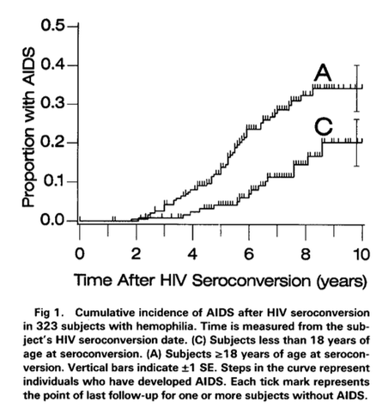

### 3) Lee 1989

* References et al 1989 as 8-yr cuminc of 37% in MSM and Goedert et al 1988 8-yr cuminc of 29% in hemophiliacs
* Also references a couple papers, Giesecke 1988 and Medley 1987, where "more sophisticated techniques" were used to estimate precise time of seroconversion

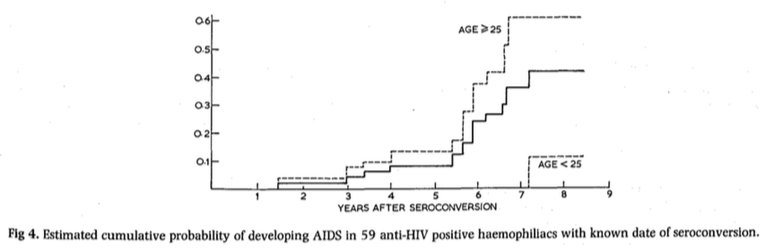

### 4) Eyster 1987

* It's a very small population - only 10 AIDS events

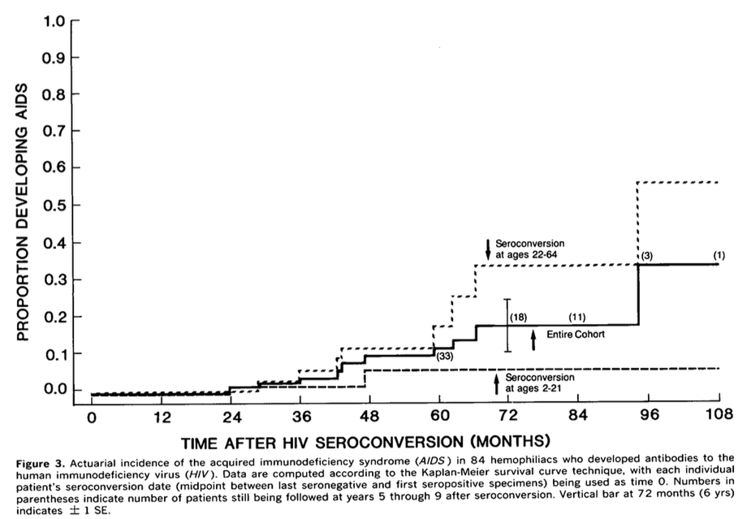

## 5) Longini 1989

* They use a Markov model to "efficiently and naturally" handle censoring…
* They call out a reference of mean incubation being 4.5 (Medley, Lui) as being subject to length-biased sampling and they are skeptical of the correction. Their Markov approach also uses constant hazard within each stage, as opposed to a (Weibull) increasing hazard over the whole disease course.
  + This sample was selected based on infection status, not development of AIDS, so not length-biased.
* They cite some other refs in the discussion with different results, e.g. Hessol gets 5-yr cum inc of 15% not 27% and they say it's due to differences in the cohorts…

### 6) Longini 1991

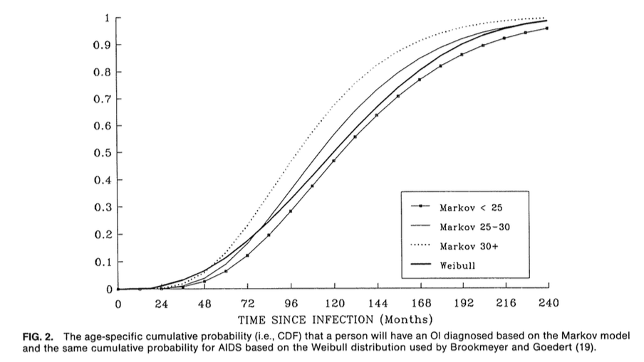

### 7) Lui 1986

* They define the incubation period as coming from an a probability distribution. Then they do a ML fit to the data to determine the distribution’s parameters. They start with Weibull and do some sensitivity analyses with other distributions.

### 8) Haynes 1996

## Other References to Check

Feinberg 1996 (http://www.ph.ucla.edu/EPI/faculty/detels/ChangeHist\_HIVdisease\_Lancet.pdf) references an Enger paper that I have requested to be scanned, placing mean time to AIDS at 10-11 yrs. Then it says this: “However, some individuals (≈20%) manifest full-blown AIDS within 5 years of infection, whereas others (10 years) symptomless HIV-1 infection without significant decline in CD4 counts. Only about 2% or less of HIV-infected persons seem to be able to contain viral replication to extremely low levels and maintain stable CD4 counts within the normal range for lengthy periods (>12–15 years)” and references “Toward an Understanding of the Correlates of Protective Immunity to HIV Infection” (Haynes 1996, Science)

From Eyster 1993:

