FLOOD EWS: A REAL-TIME FLOOD MONITORING SYSTEM WITH WATER LEVEL FORECASTING USING LORA-BASED WIRELESS SENSOR NETWORK

A Capstone Project Presented to the Faculty
School of Information Technology
Colegio De Sta. Teresa De Avila

In Partial Fulfillment of the Requirements for the Degree
BACHELOR OF SCIENCE IN INFORMATION TECHNOLOGY

DARCEY MAE G. VINSON
ARVIN JAY O. ISORENA
JOEMARIE P. GUIRON
EDRIAN A. DELA CRUZ

April 2026
APPROVAL SHEET

The capstone project entitled FLOOD EWS: A REAL-TIME FLOOD MONITORING SYSTEM WITH WATER LEVEL FORECASTING USING LORA-BASED WIRELESS SENSOR NETWORK, prepared and submitted by DARCEY MAE G. VINSON, ARVIN JAY O. ISORENA, JOEMARIE P. GUIRON, EDRIAN A. DELA CRUZ, in partial fulfillment of the requirements for the degree of Bachelor of Science in Information Technology.

HAROLD R. LUCERO, DIT
Adviser

Approved by the Panel of Examiners on __________________20____.

VALEREE MAREE A. ASUNCION, LPT, MSIT
Chairperson

MR. JEFFRY BOY D. DRILON MR. JOSHUA TRAZEN D. ACHONDO
Member Member

Accepted in partial fulfillment of the requirements for the degree Bachelor of Science in Information Technology.
HAROLD R. LUCERO, DIT
Dean
School of Information Technology
Date: ________________________

ACKNOWLEDGEMENT

We acknowledge the panel members for their insightful comments, suggestions, and valuable recommendations that strengthened our study. Their guidance played a significant role in refining our research.

We are also grateful to the school administrators for providing an environment that fosters learning, research, and innovation. Their support and commitment to academic excellence enabled us to carry out this study effectively and with confidence.

Our heartfelt thanks go to our friends and classmates who offered their encouragement, shared ideas, and provided help whenever needed. Their support made the research process more manageable and meaningful.

We extend our deepest appreciation to our families for their unwavering love, understanding, and support throughout this journey. Their patience, encouragement, and constant belief in our abilities inspired us to persevere and complete this study.

To everyone who contributed to this study, we express our heartfelt thanks. Your support has been vital to the success of this endeavor.

ABSTRACT

TABLE OF CONTENTS

Title Page…………………………………………………………………….. i
Approval Sheet……………………………………………………………….. ii
Acknowledgement………………...………………………………………….. iii
Abstract……………………………………………………………………….. iv
Table of Contents……………………………………………………………… v
List of Figures……………………...………………………………………….. vii
List of Tables……………………..………………………………………….. ix

Chapter Page
1. The Problem and Its Context ….………………………………………… 1
Project Context…………………………………………………………… 1
Objectives of the Study……...…………………………………………… 7
Scope of the Project………….…………………………………………… 9
Conceptual Framework…………………………………………………... 13
Definition of Terms…………..…………………………………………… 15
2. Review of Related Literature and Studies…………………………….…. 23
Internet of Things………………..………………………………….…….. 23
LoRaWAN………………..………………………………….………….... 26
Data Analytics……………….……………………………………..……… 29
Development Methodology and Evaluation Frameworks…………..…….. 33
Synthesis……………………..……………………………………..…….. 36
Technical Background……….……………………………………..…….. 40
3. Design and Methodology……..………………………………………..….. 54
Requirements Analysis………………………………………………….... 54
Data Gathering Procedures …………………………………...….. 54
Overview of the Current State of Technology …………….…..…. 56
Problem Analysis……………………………………………..…… 57
Requirements Documentation ……………………………………………. 58
Functional Requirements ……………………………………….... 59
Non-Functional Requirements ………………..…………………. 60
User Requirements…..……………………………………..…….. 61
Hardware and Software Requirements ……………………..……. 64
Use-Case Diagram….………………………………………..…… 67
Data Flow Diagram………………………………………….…… 68
Entity-Relationship Diagram ……………………………….…… 72
Design of Software, System Products, and Processes ………..………….. 74
System Architecture …………………………………..………….. 74
System Design……………………………………………………. 76
System Processes…………………………………………………. 84
Development and Testing…...……………………………………………. 92
Development………...……………………………………………. 92
Testing……………………………………………………………. 97

LIST OF FIGURES

Figure Page
- Conceptual Framework…………………………………………………… 13
- WB-19550377 Radar Sensor ….…………………………………………. 41
- WH-SP-RG Tipping Bucket Rain Gauge...….…………………………… 42
- Anemometer……………………………………………………………… 43
- LoRa32 Development Board …………………………….……………… 44
- Arduino IDE………………...………………………………….………… 45
- Visual Studio Code…………..…………………………………………… 45
- Flask……………………………………………………………………… 46
- Cloudflare………………………………………………………………… 47
- Gunicorn……………………..…………………………………………… 47
- Nginx……………………………………………………………………… 48
- MySQL……………………….…………………………………………… 48
- Flutter………………………...…………………………………………… 49
- Firebase……………………...……………………………………………. 49
- LightGBM………………………………………………………………… 50
- Open-Meteo Weather API…...…………………………………………… 52
- Docker Desktop……………...…………………………………………… 53
- Fishbone Diagram………………………………………………………… 57
- Use Case Diagram…………...…………………………………………… 67
- Level 0 Data Flow Diagram...…………………………………………….. 68
- Level 1 Data Flow Diagram..……………………………………………… 70
- Entity-Relationship Diagram ……………………………………………... 72
- System Architecture………...……………………………………………... 74
- Mobile View and Desktop View of the Web Interface Onboard Page…..... 76
- Mobile View and Desktop View of the Web Interface…………..........…... 77
Registration Page
- Mobile View and Desktop View of the Web Interface….......……..………. 78
Sign in Page
- Mobile View and Desktop View of the Web Interface.………………...….. 79
Homepage with Dashboard
- Mobile View and Desktop View of the Web Interface Alerts Page…..……. 80
- Mobile View and Desktop View of the Web Interface Profile Page ..……... 81
- Desktop Application Interface of the Admin Monitoring Dashboard ......... 82
- Desktop Application Interface of the Admin Operations Dashboard…….. 83
- Flowchart of the Machine Learning and Sensor Data ……………………. 85
Collection Process
- Flowchart of the Admin Users Process...……………………………..…… 88
- Flowchart of the Residents Users Process ……………………………….. 90
- IoT Design Methodology………………………………………………….. 92

LIST OF TABLES

Table Page
- Hardware Requirements…….……………………………………………. 64
- Software Requirements……..……………………………………………. 66
- Perceived Usefulness……….……………………………………………. 98
- Perceived Ease of Use……………………………………………………. 98
- Attitude Toward Using..…….……………………………………………. 99
- Behavioral Intention to Use……..………………………………………... 99
- Functional Suitability……..……………………………………………… 100
- Performance Efficiency……..…………………………………………… 100
- Compatibility………………..……………………………………………. 101
- Interaction Capability……….……………………………………………. 101
- Reliability…………………...……………………………………………. 101
- Security……………………...…………………………………………… 102
- Maintainability……………………………………………………………. 102
- Flexibility………………………………………………………………… 102
- Safety……………………………………………………………………... 102
- Likert Scale………………….……………………………………………. 103

Chapter 1
THE PROBLEM AND ITS CONTEXT

This chapter presents an overview of the proposed study. It includes the Project Context, which introduces and explains the background and significance of the study; the Objectives of the Study, which state the goals the project aims to achieve; the Scope of the Project, which defines the boundaries and limitations of the work; and the Definition of Terms, which clarifies key concepts and terminologies used in the study.

Project Context
The development of technology has made our lives easier over the years and its continuous innovation has led to the invention of remarkable devices. One of those technological innovations is the Internet of Things (IoT). According to an ongoing tracking and analysis of IoT connectivity, the number of connected IoT devices reached 18.5 billion in 2024 and is expected to reach 39 billion in 2030 (Sinha, 2025). It is constantly evolving into a network of interconnected objects with a variety of goals, including data collection interaction with the physical world, and use of existing internet standards to provide services for data transfer, analytic, applications, and communications (Choudhary, 2024). IoT is used in various domains and its major use is currently in healthcare, education, traffic system, smart cities, water management, waste management, agriculture, security (Rathi et al., 2025). Its capabilities for real-time data collection and two-way communication have made a significant impact on water resources application, which includes flood monitoring, flood forecasting, and flood alert systems (Ansari & Vidyarthi, 2025). Flood, primarily caused by heavy rainfall, are catastrophically natural events that can impact vast regions leading to significant loss of lives and damage to many infrastructures. In the Global Assessment Report on Disaster Risk Reduction (GAR) 2025 by United Nations Office for Disaster Risk Reduction, the current annual average losses associated with flooding totals USD 388 billion globally. This is projected to rise considerably soon as a result of climate change. Modern software and automated systems have greatly improved how communities prepare for disasters, especially in areas that experience frequent flooding. To tackle the risks associated with flood disasters, there is a need to think beyond structural interventions for flood protection and move to more non-structural ones, such as flood early warning systems (Byaruhanga et al., 2024). The implementation of flood monitoring systems help mitigate its negative impacts and are heavily utilized by disaster management agencies to monitor flood levels (Zakaria et al., 2023). The impacts of floods could be mitigated by having a flood prediction using flood monitoring system data that are accurate, timely, and capable of providing an early warning, which allows the residents to be informed quickly and efficiently (Faudzi et al., 2023).

The Philippines experiences heavy rains and severe weather conditions brought by typhoons or monsoons every year, which cause high levels of floods, making brown and muddy waters cover most communities and cities in the Philippines (Arante et al., 2025). According to PAGASA, more tropical cyclones are entering the Philippine Area of Responsibility (PAR) than anywhere else in the world with the average of twenty tropical cyclones in this region per year, with about 8 or 9 of them crossing the Philippines (PAGASA, 2026). According to Philippine Statistics Authority, citing data from the Office of Civil Defense, a total of 225 occurrences of small-scale natural hazard incidents were recorded in 2024. The most frequently reported incidents were flash floods or flooding, accounting for 53 occurrences or 23.6 percent. This was followed by tornadoes, destructive winds, or strong winds, with 34 occurrences or 15.1 percent, and fire incidents, which comprised 32 occurrences or 14.2 percent. Due to the widespread flooding in many parts of the country, the Department of Science and Technology has emphasized the importance of a science-based approach in handling flood control programs (DOST, 2026). There are multiple studies about flood management and mitigation, which includes the creation and development of flood monitoring or early warning systems. The integration of physical devices such as sensors and microcontrollers varies in such systems. Over time, these systems evolved with technological advancements and included flood prediction features using data analytics and machine learning algorithms. There is a study that used Light Detection and Ranging (LiDar) for water level measurement controlled by an Arduino UNO microcontroller and predicted flood using the multilayer perceptron model that achieved 99% accuracy and a linear regression model that achieved 88% accuracy(Abalos & Fajardo, 2023). Another study used an ultrasonic sensor controlled by a Raspberry Pi and used multiple algorithms for prediction such as Gradient Boosted Tree, SVM, Decision Tree, and Neural Networks (German & Evangelista, 2024). Some flood monitoring systems remain outdated, causing delays in information distribution and mitigation efforts. In response, researchers have turned to LoRa-based technology to improve detection speed and reliability (Te et al., 2024).

Flooding is also a recurring environmental concern in local communities, particularly during periods of heavy rainfall and severe weather conditions. In Barangay San Agustin, San Jose, Occidental Mindoro, a community that sits on low-lying agricultural land near the Busuanga River and faces the West Philippine Sea, the entry point for most typhoons hitting the country, a flood alert system was developed in response to the community's reliance on constant manual observation. Their system was capable of detecting water level, measuring temperature and humidity, transmitting data over long distances through LoRa, and sending SMS alerts through GSM (Paul et al., 2024). A similar study was conducted in Barangay Virgen Delas Flores, Baliwag, Bulacan, where officials also relied on manual measurement and megaphone announcements to disseminate alerts. The researchers developed a flood monitoring system that can detect water presence, indicate water level status using LED, send SMS alerts using a GSM module, and give barangay officials a web-based record through a website (Cedric et al., 2020). The same challenge was seen in a study conducted in Barangay Luna along the Surigao River in Surigao City, where recurring flooding has damaged homes across several nearby barangays. In response, a flood monitoring and warning system was developed, capable of measuring water level, sending alerts through SMS and a mobile application, and running on solar power (Mag-Usara, 2022).

The studies discussed show that researches regarding flood monitoring have taken multiple approaches that have yet to be integrated. Some studies focus on forecasting accuracy, using machine learning models to predict rising water levels, such as the multilayer perceptron model that achieved 99% accuracy (Abalos & Fajardo, 2023) and the comparison of Gradient Boosted Tree, SVM, Decision Tree, and Neural Network algorithms for flood prediction (Luzon-German & Evangelista, 2024). However, these studies emphasize forecasting accuracy while overlooking how predictions would translate into real-time alerts for residents. On the other hand, barangay-level systems have prioritized real-time alert delivery, using LoRa and GSM for SMS notifications (Paul et al., 2024), float switches with web-based logging (Cedric et al., 2020), and solar-powered ultrasonic sensors paired with a mobile application (Mag-Usara, 2022), yet these systems are reactive rather than predictive, issuing alerts only once water has already reached a critical threshold. Even more technically advanced systems, such as the LoRaWAN-based pressure sensor system, remain limited to real-time detection rather than forecasting (Te et al., 2024). What has yet to be explored is a system that combines multiple capabilities at once, which measures water level in real time, forecasts flooding in advance using machine learning, and disseminates alerts directly to residents and officials in real time through multiple platforms such as desktop, web, and mobile applications. This gap is what the proposed study seeks to address.

To address the gap identified above, this study focuses specifically on Barangay 178, Camarin, Caloocan City, where the same challenge is felt directly. The barangay personnel are currently dependent on physical observation and loudspeakers to monitor and warn residents, which are not effective when water rises quickly or when weather conditions make it unsafe to patrol outside. Although the city government maintains general early warning systems, Barangay 178 does not have its own localized system capable of tracking water levels in real time, making it difficult for officials to respond quickly during emergencies. This clearly points to a felt problem that requires a solution. This raises the question about how can a real-time, sensor-based flood monitoring and forecasting system be designed to improve flood detection speed, alert delivery, and disaster preparedness in Barangay 178, Camarin, Caloocan City. A desire to answer this question and improve the current flood monitoring system in Barangay 178 led to the proposal of designing and developing the Flood EWS: A Real-Time Flood Monitoring System with Water Level Forecasting using a LoRa-Based Wireless Sensor Network. The main objective of the study is to design and build such a system for Barangay 178 that collects real-time water level, wind speed, and rain count data using a sensor node placed on a creek, and transmits this data wirelessly through a long-range, low-power network so information reaches the server even during heavy rain. The system displays real-time readings through a desktop dashboard for barangay officials, while residents access alerts and updates through mobile and web applications, including automatic visual and sound notifications when water levels reach dangerous conditions, and GPS-based tracking when residents choose to share their location. The study also aims to integrate data analytics using a LightGBM machine-learning model to forecast rising water levels and identify early signs of flooding from sensor and weather data. Through this system, Barangay 178 can move from a slow, manual process to a more advanced, data-driven approach in flood preparedness and response. This study also supports the United Nations Sustainable Development Goals, which are a universal set of goals aiming to end poverty, protect the planet, and tackle inequalities. Among the 17 Goals, this project is aligned with SDG 7: Affordable and Clean Energy, which is about ensuring access to clean and affordable energy. The world depends on reliable and affordable energy; however, its consumption is the dominant contributor to climate change, accounting for two-thirds of total global greenhouse gas emissions. This study addresses Target 7.1, which ensures universal access to affordable, reliable, and modern energy services, by using solar photovoltaic (PV) technology in powering our sensor towers. A photovoltaic cell or solar cell is a device that converts sunlight directly into electricity, making our towers energy-efficient. The study is also aligned with SDG 9: Industries, Innovation, and Infrastructure, which seeks to create a strong foundation for a sustainable future. This project specifically addresses Target 9.1, aiming to develop quality, reliable, sustainable, and resilient infrastructure, including regional and transborder infrastructure, to support economic development and human well-being, with a focus on affordable and equitable access for all. The LoRa technology with its radio layer is also used on LoRaWAN protocol, which adds multi-channel gateway and a network server on top of it. In this system, the same radio layer is used for direct transmission from sensor node/tower to a LoRa32-Based gateway, which receives the data and forwards it to the database without a LoRaWAN network server layer. The System uses LoRa P2P (peer-to-peer) in the flood monitoring system, together with its forecasting capability, it provides a resilient infrastructure, helping communities withstand and respond to flood disasters. In addition, this project is also in alignment with SDG 11: Sustainable Cities and Communities, promoting sustainable urban development to create inclusive, safe, and resilient cities. This study addresses Target 11.5, which aims to reduce the number of deaths and the number of people affected and substantially decrease the direct economic losses relative to global gross domestic product caused by disasters, including water-related disasters, with a focus on protecting the people in vulnerable situations. The system directly addresses floods, a water-related disaster, and aims to reduce its impact and casualties in communities. Lastly, this study also aligns with SDG 13: Climate Action, which is about taking urgent actions to combat climate change and its impacts. This project directly addresses Target 13.1, which aims to strengthen resilience and adaptive capacity to climate-related hazards and natural disasters in all countries. Flooding is a natural disaster, but it is also a climate-related disaster due to human activities such as the burning of fossil fuels, improper waste disposal, and poor drainage systems. The flood monitoring system builds adaptive capacity, helping the community adapt and respond faster, which builds resilience.

Objectives of the Study
The main goal of this study is to design and develop a real-time flood monitoring system using long-range wireless sensor network with water-level forecasting using regression technique.

Specifically, it aims to:

1. To design and develop a real-time flood monitoring system that can:
- collect real-time water level data, wind speed, and rain count using sensor tower node placed on a creek within the community;
- send data wirelessly through a long-range, low-power wireless network to make sure information continues to reach the server even during heavy rain or poor weather without needing an internet connection;
- display real-time readings through a desktop application dashboard, where barangay disaster management officers or staff can view detailed monitoring data, while residents can access and receive important alerts and updates through both the mobile application and website application to help them prepare for possible flooding;
- receive, store, and process sensor data through a locally hosted backend server, ensuring system reliability and data integrity throughout the monitoring pipeline;
- generate predictive forecasts using a machine-learning model to help predict rising water levels before flooding occurs;
- monitor resident status via GPS location when they share their location. allowing barangay staff to visualize the most affected area

2. To integrate data analytics features that can provide real-time reports and flood forecasting by:
- analyzing real-time data from a water-level sensor, rainfall sensor, wind speed sensor, and environmental conditions from a weather application programming interface to identify patterns and early signs of flooding;
- predicting possible water-level increases using Light Gradient Boosting Algorithm machine-learning model;
- showing predictive results through label indicators and simple visual tools in the system interface to help officials and residents understand the upcoming flood risk and take action

3. To measure user acceptance of the system using the Technology Acceptance Model based on its usefulness, ease of use, and user satisfaction.

4. To evaluate the system’s quality based on the ISO/IEC 25010 software standards, specifically assessing:
- Functionality suitability;
- Performance efficiency;
- Compatibility;
- Interaction capability;
- Reliability;
- Security;
- Maintainability;
- Flexibility;
- Safety

Scope of the Project

This study focuses on designing and developing a real-time flood monitoring system with water-level forecasting using a long-range wireless sensor network. The system gathers, processes, and analyzes water level data and meteorological data to provide accurate and timely flood warnings for barangay personnel and residents. The system aims to help the community prepare for possible flooding by giving early and reliable information about water levels and weather conditions.
Specifically, the system covers functionalities such as collecting data from sensor nodes, measuring rain count, wind speed, and water levels, then sending the data wirelessly using long-range communication. All collected information is stored locally in a database, where it is organized and analyzed using a machine-learning model to produce accurate water-level forecasts. A mobile application displays the processed data in a simple and visual way, showing real-time water level readings, environmental conditions, rainfall intensity, and predicted changes in water levels, while a desktop application will be used by the barangay personnel displaying a detailed monitoring data and operational capability. Additionally, the system will provide automated alerts when critical thresholds are reached that notify residents and barangay personnel through the app when water levels reach dangerous conditions.
One of the most important features of the project is its forecasting capability. It uses LightGBM to predict possible flood events based on real-time and historical data, which helps the community receive early warnings, allowing residents and officials to take preventive steps before flooding occurs.
The system will undergo evaluation through two standards. First, user acceptance will be assessed using the Technology Acceptance Model (TAM) by measuring perceived usefulness, and perceived ease of use. Second, system quality will be evaluated based on ISO/IEC 25010 standards, focusing on functionality suitability, performance efficiency, compatibility, interaction capability, reliability, security, maintainability, and flexibility.
The development and testing of the system will take place during the Academic Year 2025–2026 in Barangay 178, Caloocan City.
This study will beneficial to the following:
In a global context, the study will contribute to United Nations, specifically to their Sustainable Development Goals. Given that the system is in line with SDG 7: Affordable and Clean Energy, SDG 9: Industries, Innovation, and Infrastructure, SDG 11: Sustainable Cities and Communities, and SDG 13: Climate Action, the system creates inclusive, safe, and resilient cities, ensures access to clean and affordable energy, and helps fight climate change and its impacts. It also offers a resilient infrastructure to help communities withstand flood disasters. Additionally, it supports the mission of the United Nations Office for Disaster Risk Reduction, which is to lead, empower, and accelerate global efforts in disaster risk reduction so that businesses, governments, and communities can protect people, assets, and advance in the face of increasing shocks and uncertainty. Additionally, the system’s architecture, sensor data, forecasting methods (such as LightGBM), or implementation outcomes can serve as foundations for further improving flood monitoring systems and might help future international researchers further improve other studies.

In national context, the study will be beneficial to Philippine Atmospheric, Geophysical and Astronomical Services Administration (PAGASA) by serving as a supplementary ground data to support and strengthen their flood forecasting and early warning efforts and contribute to faster and more localized warning capability in flood-prone communities. It also benefits the Department of Science and Technology (DOST) by serving as an example of a local IoT innovation that supports their goals for science-based disaster risk reduction. Academic institutions can also use the system as a teaching and research resource for courses in information technology, environmental science, and disaster risk reduction. It can help demonstrate how IoT, data analysis, and machine learning are applied to real-world problems such as flooding and other environmental challenges.

The direct beneficiary of our system, Barangay 178, Camarin, Caloocan City, will greatly benefit, given that the system will help barangay officials provide better service to their community. By having access to accurate and timely data, they can make informed decisions, issue warnings early, and allocate resources more effectively during flood events. The system can also provide the Barangay Disaster Risk Reduction and Management Council (BDRRMC) Staff the capability to use real-time water level readings, rainfall data, environmental conditions, and flood forecasts to make evacuation plans, coordinate response actions, and stay connected with residents and emergency teams. Emergency responders will also gain access to real-time information about the flood situation to help them identify which areas are most affected, prioritize rescue operations, and deploy their teams and equipment more effectively during emergencies. Lastly, the barangay residents will receive instant alerts through the mobile and web application, giving them enough time to prepare, secure their belongings, or evacuate when necessary. The timely information helps reduce risk and improve safety during heavy rain or flooding.
Limitations of the project include factors beyond the researchers' control, such as sensor-damaging incidents that affect the quality and reliability of raw sensor readings used in training the forecasting model, the volume of collectible sensor data within the academic deployment timeline, local server or network availability that may affect system access, physical and environmental conditions in the field that may degrade sensor accuracy or disrupt LoRa-based point-to-point signal transmission, and community-level constraints that may influence the consistent adoption of the FloodWatch application. The predictive accuracy of the forecasting model is further constrained by the amount of real-world data accumulated during deployment; initial pipeline validation was therefore conducted using synthetic data modeled after realistic flood patterns, with model performance expected to improve proportionally as on-site sensor data accumulates over time. Hardware additions such as audible alarm indicators and visual warning lights on the sensor tower were likewise identified as outside the project's current budget scope and are documented as recommendations for future implementation. Moreover, the study will focus solely on real-time flood monitoring and water level forecasting within the designated deployment area; it will not cover other disaster-related concerns such as landslide detection, storm surge monitoring, earthquake response, or integration with broader national disaster risk reduction and management systems.

Conceptual Framework
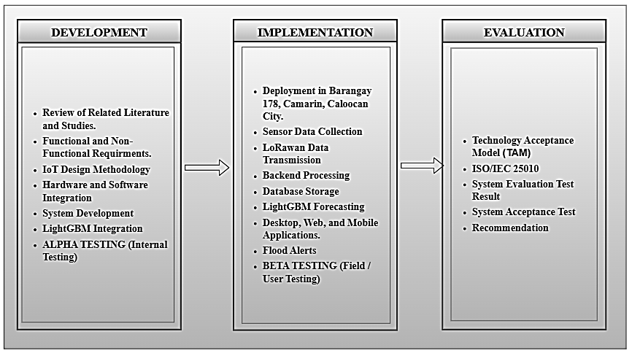Figure 1. Conceptual Framework

The conceptual framework of the study is based on the Development–Implementation–Evaluation (DIE) Framework, which illustrates the overall flow of the research from the development of the proposed system, its implementation in the target environment, and its subsequent evaluation. The framework serves as a guide in achieving the objectives of the study by ensuring that each phase is systematically carried out and contributes to the successful development of the proposed Flood EWS: A Real-Time Flood Monitoring System with Water Level Forecasting using a LoRa-Based Wireless Sensor Network.

The Development phase encompasses all activities related to the planning, design, and construction of the proposed system. This phase incorporates the knowledge acquired from the review of related literature and studies, the identified functional and non-functional requirements, the IoT Design Methodology, and the hardware and software technologies required for system development. The hardware components include the WB-19550377 FMCW Radar Sensor, WH-SP-RG Tipping Bucket Rain Gauge, Anemometer, LoRa32 Development Board, solar power components, and other supporting devices. Meanwhile, the software components include Arduino IDE, Visual Studio Code, Flask, Flutter, MySQL, Firebase Authentication, Gunicorn, Nginx, Cloudflare, Docker Desktop, Open-Meteo Weather API, and the LightGBM machine learning model. These technologies are integrated to develop a reliable real-time flood monitoring and water-level forecasting system.

The Implementation phase involves the deployment and operation of the developed system within Barangay 178, Camarin, Caloocan City. During this phase, the sensors continuously collect environmental data such as water level, rainfall, wind speed, and weather conditions. The collected data are transmitted through the LoRa-based Wireless Sensor Network to the backend server, where they are processed, stored in the database, and analyzed using the LightGBM forecasting model. The processed information is then presented through the desktop, web, and mobile applications, enabling barangay officials and residents to monitor real-time flood conditions and receive timely flood alerts and water-level forecasts.

The Evaluation phase determines the effectiveness, quality, and acceptability of the developed system. The system is evaluated using the Technology Acceptance Model (TAM) to measure the users' perceived usefulness and perceived ease of use, while the ISO/IEC 25010 Software Quality Model is utilized to assess the system's functional suitability, performance efficiency, compatibility, interaction capability, reliability, security, maintainability, and flexibility. The results of the evaluation determine whether the proposed system successfully satisfies the objectives of the study and meets the requirements of its intended users.

Definition of Terms

The following terms are defined operationally as they are used in the study:

Anemometer. A meteorological instrument used to measure wind speed. In this study, the anemometer is deployed as part of the sensor network to monitor atmospheric wind conditions, which help determine storm intensity and support early flood warning decisions.

API (Application Programming Interface). A defined set of protocols and tools that enables different software applications to communicate and exchange data with one another. In this study, an API is used to retrieve real-time meteorological data from an external weather service for integration into the flood monitoring system.

Cloud Computing. A computing model that delivers on-demand access to shared resources such as servers, storage, databases, and software over the internet. In this study, cloud infrastructure is used to store sensor data securely and ensure continuous system availability even during adverse weather conditions.

Data Analytics. The systematic process of collecting, processing, and examining large volumes of data to identify patterns, draw conclusions, and support informed decision-making. In this study, data analytics is applied to sensor readings and meteorological data to generate flood forecasts and real-time risk assessments.

Dashboard. A graphical user interface that consolidates and visually presents key data, metrics, and system statuses in a single view. In this study, dashboards are provided through the desktop and mobile applications to allow barangay disaster management officers and residents to monitor real-time water levels, rainfall readings, and flood forecasts at a glance.

Docker. An open-source containerization platform that packages an application and its dependencies into isolated, portable units called containers, ensuring consistent behavior across different computing environments. In this study, Docker is used to containerize the backend server, web server, and database components of the flood monitoring system, enabling reliable and reproducible deployment.

Docker Desktop. A graphical desktop application that provides a user-friendly interface for managing Docker containers, images, volumes, and networks on a local development machine. In this study, Docker Desktop is used during development to build, run, and manage the containerized components of the flood monitoring system, including the backend server and database, ensuring consistent behavior across development and production environments.

Early Warning System (EWS). An integrated set of technologies, protocols, and communication channels designed to detect hazardous conditions and deliver timely alerts to at-risk communities before a disaster occurs. In this study, the system incorporates automated mobile notifications and threshold-based alerts as core early warning mechanisms.

Firebase. A cloud-based platform developed by Google that provides backend services including authentication and user identity management. In this study, Firebase Authentication is used to manage resident account registration and login on the mobile application, enabling secure access to the flood monitoring system for barangay residents while Firestore will handle per user document information.

Flask. A lightweight Python web framework used to build server-side APIs and manage backend application logic. In this study, Flask serves as the backend bridge between the IoT sensor nodes and the database, handling data ingestion, processing, and endpoint management.

Flood Forecasting. The process of predicting the likelihood, timing, and severity of flood events by analyzing hydrological and meteorological data such as rainfall intensity, water levels, and wind conditions. In this study, flood forecasting is performed using the LightGBM machine learning model to generate water-level predictions.

Flutter. An open-source UI framework developed by Google that enables the development of natively compiled applications for mobile, web, and desktop platforms from a single codebase. In this study, Flutter is used to build the mobile and web applications that display real-time flood data and deliver alerts to residents and barangay personnel.

Gateway Device. A hardware component that acts as an intermediary between sensor nodes and a central server or cloud platform, receiving wirelessly transmitted data and forwarding it for processing and storage. In this study, the LoRa gateway collects readings from sensor nodes deployed in flood-prone areas of Barangay 178.

Internet of Things (IoT). A network of interconnected physical devices embedded with sensors, software, and communication technologies that collect and exchange data over the internet without requiring direct human intervention. In this study, IoT devices including water level sensors, rain gauges, and anemometers form the core data acquisition layer of the proposed system.

ISO/IEC 25010 Software Quality Model. An internationally recognized standard for evaluating software product quality across multiple characteristics, including functional suitability, performance efficiency, compatibility, usability, reliability, security, maintainability, and portability. In this study, this model is used as one of the primary frameworks for assessing the overall quality of the developed system.

IoT Design Methodology. A structured, ten-step methodology for the systematic design and development of Internet of Things systems, guiding developers from the initial definition of system purpose and requirements through domain modeling, information modeling, service specification, IoT level selection, functional and operational view definition, device and component integration, and application development.

LightGBM (Light Gradient Boosting Machine). A high-performance, gradient boosting machine learning framework designed for fast training and efficient prediction on large and complex datasets. In this study, LightGBM is employed as the primary forecasting model to predict water-level changes based on real-time and historical sensor data.

LoRa (Long-Range). A low-power radio modulation technology (the physical layer) designed for long-range data transmission, used by both LoRaWAN and LoRa P2P.

LoRa P2P (Peer-to-Peer). A direct wireless communication method in which LoRa radios exchange data with one another without a LoRaWAN gateway or network server. In this study, the field sensor node/tower transmit readings through LoRa P2P to a LoRa32 gateway, which receives the data and forwards it to the processing server.

LoRaWAN (Long-Range Wide Area Network). A low-power, wide-area network communication protocol built on LoRa (Long-Range) modulation technology, specifically designed for long-range data transmission between IoT devices. In this study, LoRaWAN is presented as a reference technology that shares the same LoRa radio layer as the LoRa P2P communication used by the system.

Machine Learning Model. A computational algorithm trained on historical datasets to identify patterns, relationships, and trends, and to generate predictions for new or unseen data. In this study, a machine learning model based on the LightGBM algorithm is trained on collected sensor data to forecast water level changes over time.

Microcontroller. A compact, integrated circuit that contains a processor, memory, and programmable input/output peripherals on a single chip, designed to control embedded systems and peripheral devices. In this study, the LoRa32 development board, built on the ESP32 chip, serves as the primary microcontroller that reads sensor data and manages LoRa P2P communication.

Mobile Notification. An automated alert message delivered to a user’s smartphone or mobile device through an application, typically triggered by a predefined event or threshold. In this study, mobile notifications are sent to residents when water levels reach critical conditions, enabling timely flood warnings even when users are not actively viewing the application.

MySQL. An open-source relational database management system that organizes data into structured tables and supports efficient querying, indexing, and storage. In this study, MySQL is used as the central database to store time-series sensor readings and processed data for both real-time monitoring and historical analysis.

Node Sensor Device. A tower sensor-equipped hardware unit deployed in the field that continuously collects environmental data and transmits it wirelessly to a central gateway or server. In this study, node sensor devices are installed in flood-prone areas of Barangay 178 to gather real-time water level, rainfall, and wind speed measurements.

Open-Meteo API. A free and open-source weather data service that provides real-time and forecasted meteorological information, including wind direction and cloud cover, based on geographic location. In this study, Open-Meteo supplements the physical sensor readings by supplying atmospheric data that enhances flood forecasting accuracy.

Predictive Analytics. A branch of data analytics that uses statistical algorithms, machine learning techniques, and historical data to forecast probable future outcomes. In this study, predictive analytics is applied to generate water-level forecasts that enable early flood warnings and proactive disaster response.

Radar-Based Water Level Sensor. A non-contact measurement device that uses electromagnetic radio waves to calculate the distance between the sensor and the surface of the water, thereby determining the current water level. In this study, the WB-19550377 FMCW radar sensor is used to continuously monitor water levels in the creek with high accuracy and resilience to adverse weather conditions.

Real-Time Monitoring. The continuous, instantaneous collection, transmission, and display of data from sensors or systems at the moment measurements are taken, without significant delay. In this study, real-time monitoring allows barangay disaster management officers and residents to view live water level readings, rainfall data, and meteorological conditions through the system dashboard.

Technology Acceptance Model (TAM). A theoretical framework used to assess the degree to which users accept and adopt a new information system, based on two primary factors: perceived usefulness and perceived ease of use. In this study, TAM is used as an evaluation instrument to measure the user acceptance of the flood monitoring system among barangay disaster management officers and residents.

Tipping Bucket Rain Gauge. A rainfall measurement instrument that collects precipitation in a funnel and directs it into a tipping bucket mechanism; each time the bucket fills to a preset volume, it tips and generates an electrical pulse recorded as a rainfall count. In this study, the WH-SP-RG tipping bucket rain gauge is used to measure rainfall intensity and accumulation, which are critical inputs for flood forecasting.

User Interface (UI). The visual and interactive layer of a software application through which users engage with system features, view data, and perform tasks. In this study, the UI encompasses the dashboards and alert screens of both the mobile and desktop applications, designed to present flood data in a clear and accessible format for different user groups.

Water Level Forecasting. The process of predicting future changes in water height within a body of water, such as a river or creek, based on current and historical sensor data combined with meteorological conditions. In this study, water level forecasting is a central feature of the system, enabling barangay disaster management officers and residents to anticipate rising water levels before flooding occurs.

Wireless Sensor Network (WSN). A network of spatially distributed, autonomous sensor nodes that wirelessly communicate with one another and with a central gateway to monitor and relay physical or environmental conditions. In this study, the WSN forms the backbone of the data acquisition infrastructure, enabling continuous and remote sensing of flood-related parameters across multiple locations in Barangay 178.

Chapter 2
REVIEW OF RELATED LITERATURES AND STUDIES

This chapter discussed the related literature and studies of the proposed research. It includes literature, studies, and related systems that strengthen the foundation of the project; the Synthesis, which summarizes and integrates major findings from the reviewed literature and studies; and the Technical Background, which discusses the hardware, software, tools, and platforms essential to the design, development, and implementation of the proposed system. Overall, this chapter aims to highlight existing solutions and identify the gaps that the proposed study seeks to address.
Internet of Things (IoT)

Flood monitoring and early warning systems have been relying on Internet of Things (IoT) technologies, such as water level sensors and rain sensors, together with machine learning techniques to support real-time monitoring and timely flood alerts (Siddique et al., 2023). In the study of Wicaksana and Nuha, they developed an IoT-based flood monitoring system using a NodeMCU V3 microcontroller and a waterproof A02YYUW ultrasonic sensor. Their system measured water levels in real time and triggered alerts when thresholds were breached. This approach proved to be a reliable approach for early warning dissemination in flood-prone areas (Wicaksana & Nuha, 2022).

While Wicaksana and Nuha's system relied on a single threshold to trigger alerts, Syamsi et al. expanded this into a multi-tier classification system. They developed an IoT-based flood early mitigation and water-level monitoring system integrating ultrasonic and rain sensors with a NodeMCU ESP8266 microcontroller, powered by solar, and backed by a local siren. The system successfully identified safe, alert, and danger levels, demonstrating a more granular approach to water-level classification than single-threshold systems, though without the adaptive reasoning of fuzzy logic-based methods (Syamsi et al., 2024).

Rigid threshold-based triggers, however, have limitations. To address this, Natividad and Mendez have applied fuzzy logic algorithms and implemented a real-time flood monitoring system combining ultrasonic sensors, GSM modules, and solar-powered energy sources, with data transmitted via SMS and web platforms. Their system applied fuzzy logic algorithms to classify warning levels as normal, moderate, critical, and emergency, and the prototype successfully delivered timely alerts while enabling interactive flood status inquiries, reinforcing the value of GSM and web technologies in community-based disaster preparedness (Natividad & Mendez, 2018). Building on this approach, Nasyta et al. designed an IoT-based flood detection system that likewise used ultrasonic sensors and fuzzy logic, but processed river water-level data through Amazon Web Services for real-time monitoring. Their study confirmed that ultrasonic sensors provide accurate water-level readings and that fuzzy logic improves the reliability of flood prediction, further strengthening disaster preparedness and supporting climate change adaptation in flood-prone areas.(Nasyta et al., 2021)

Other researchers have applied radar technology to develop non-contact water-level sensors that offer improved accuracy and resilience in harsh environmental conditions. In a research article by Wu et al., a study was conducted at Wuhan University, China, focusing on evaluating non-contact water level measurement technologies, including radar and computer vision systems. Their study highlights that radar-based sensors offer high-precision measurements unaffected by environmental factors such as air temperature gradients, making them suitable for challenging conditions like flowing water and turbulent environments. The researchers also discuss the advantages of radar sensors over ultrasonic sensors, particularly in terms of robustness and accuracy in various environmental conditions (Wu et al., 2023).

Collectively, these studies show a progression in IoT-based flood monitoring. Early systems relied on ultrasonic sensing with single-threshold alerts, which were later improved into multi-level and fuzzy logic classification that communicates flood severity more precisely. At the same time, the sensing itself has limits, since ultrasonic accuracy is affected by environmental conditions, and radar offers greater robustness in variable and turbulent settings. Most of these systems also respond to conditions as they happen rather than anticipate them. These findings point toward monitoring that combines reliable non-contact sensing, multiple environmental inputs, and predictive capability to support earlier and more dependable flood warnings.

LoRaWAN

LoRaWAN has performed reliably despite their distinct challenges across different environments. In urban areas, where dense buildings and population cause signal interference, a two-month campaign with 20 gateways at 303 outdoor locations in Brno, Czech Republic, characterized its signal behavior and supported its scalability for smart city applications (Masek et al., 2021). In rural areas, a deployment in Mozambique achieved a packet delivery rate above 89% and ran for over 24 hours on a single power bank, showing its low power consumption (Chapungo & Postolache, 2025) . In remote areas with limited infrastructure, flood alert nodes kept stable, low-latency connectivity (Raju et al., 2022), and marine weather buoys sent data up to 1.4 km over water without depending on the internet (Nilo, 2020).
Coverage in these environments depends largely on how gateways are placed. A strategy combining Agglomerative Hierarchical Clustering with the Okumura-Hata propagation model reached effective coverage of 2.07 km in urban, 3.98 km in suburban, and 13.49 km in rural settings, and its three-dimensional extension, LoRa-EAHC, kept signals reliable even without line of sight (Lutfie et al., 2025).

LoRaWAN has also been built into complete monitoring applications. A flood monitoring system sent ultrasonic and environmental sensor data to a cloud platform, flagged abnormal water-level patterns, and delivered alerts through SMS, email, and mobile notifications (Dhebe et al., 2023). In aquaculture, a modular device deviated less than 2% from standard BFAR equipment while supporting real-time monitoring and control through a mobile application (Tolentino et al., 2021). At the network level, performance depends on configuration. Simulated packet loss in a 42-node deployment degraded results, showing the need for optimized gateway configurations in dense deployments (Hossain et al., 2018). Adaptive Data Rate lowered transmission power from 15 dBm to –4 dBm and standardized the spreading factor to SF7, which reduced Time-on-Air and interference (Fialho, 2024).

Overall, the reviewed studies show that LoRaWAN is well suited as the communication layer of a flood monitoring system. It performed reliably in urban, rural, and remote environments at very low power consumption, and it carries data over long distances without depending on existing internet or cellular infrastructure. Complete sensor-to-gateway-to-cloud pipelines for flood alerting have also been validated in the field. The studies also show that performance depends on careful planning, since gateway placement, packet loss, and data rate settings all affect coverage and energy efficiency. These findings point toward a low-power, long-range network with well-planned gateways as a dependable foundation for real-time flood data transmission.

Data Analytics

Recent advances in flood water-level forecasting show that machine learning models can outperform traditional single-series statistical methods, particularly when long-term, multivariate, and nonlinear prediction is required. Review studies explain why machine learning can integrate diverse sensor streams, handle data quality issues, and surpass classical techniques such as ARIMA on complex time series (Shen, 2018). Remote sensing and geospatial data also strengthen predictive frameworks (Kashani, n.d.).

In a river water-level prediction in Sri Lanka, machine learning models including Random Forest and LightGBM outperformed ARIMA and other traditional methods, especially for longer-term forecasts (Rathnayake et al., 2023). Tree-based methods have also proven consistently effective in other settings. Random Forest and Gradient Boosting enabled scalable flood forecasting using open-access data in resource-limited context (Thakuri et al., 2022). In the Philippines, a Random Tree algorithm was run inside a mobile application for real-time urban flood prediction (Gaynor et al., 2018). Random Forest has also performed well beyond flood prediction, such as in sustainability forecasting (Lucero et al., n.d.).

Richer modeling of temporal and spatial patterns is offered in deep learning. LSTM, BiLSTM, and GRU models delivered accurate long-term predictions of streamflow and water level (Anwar et al., 2024) and combining LSTM with spatial feature extraction improved urban flood prediction (Situ et al., n.d.). Hybrid approaches pair machine learning with physical hydrological models, which improves accuracy and adaptability, including in ungauged basins (Ditthakit et al., 2021; Saber et al., 2023).

Other studies have also addressed practical challenges. Oversampling helped machine learning and deep learning models handle the class imbalance typical of flood-event records (Kabdrakhova et al., 2024). Others showed machine learning working in real-world contexts, from infrastructure risk assessment (Oliveira de Sousa et al., 2025) to real-time flash flood mapping (Mirzapour et al., 2025) to integration with IoT for monitoring and prevention (Bukhari et al., 2025).

Overall, the reviewed studies show that machine learning, particularly tree-based ensemble methods, is a strong approach for forecasting flood-related variables from multivariate environmental data. These methods tend to outperform classical statistical models, work with limited data and computing resources, and have been deployed in real-time applications. Deep learning and hybrid models can capture more complex patterns but typically need more data, computing power, or hydrological inputs. These findings point toward combining real-time sensor data with lightweight machine learning models to support timely, forecast-based flood warnings.

Development Methodology and Evaluation Frameworks

The development and evaluation of the proposed real-time flood monitoring system are grounded in four established frameworks: IoT Methodology for designing and deploying system hardware devices and connectivity, ISO/IEC 25010 for software quality evaluation, the Technology Acceptance Model (TAM) for user acceptance measurement, and User Acceptance Testing (UAT) for functional validation by end users.

The IoT Design Methodology provides a ten-step structured framework for the end-to-end development of IoT systems, encompassing Purpose & Requirements Specification, Process Model Specification, Domain Model Specification, Information Model Specification, Service Specifications, IoT Level Specification, Functional View Specification, Operational View Specification, Device & Component Integration, and Application Development (Chapter 5 IoT Design Methodology, 2015). This methodology is specifically designed to address the layered complexity of IoT systems, which require the simultaneous specification and integration of physical sensing devices, wireless communication protocols, cloud-based services, and user-facing applications, dimensions that generic software methodologies do not natively model. Deniziak and Arcab demonstrated that IoT systems involving real-time sensor data, wireless transmission, and time-critical application responses require a structured design approach that explicitly models task interactions, data flows, and system layers from the earliest stages of development, and that applying such a methodology reduces integration-phase errors and produces traceable, verifiable architectures across multi-component deployments (Deniziak et al., 2022). At the application level, Yuliandoko et al. confirmed that structuring an IoT flood detection system through domain model specification, information model definition, and service layer mapping produced clear data boundaries between sensor nodes, gateways, cloud platforms, and alert services, directly improving real-time reliability and operational alignment with community needs (Yuliandoko et al., 2018). These findings collectively support the adoption of the IoT Design Methodology in the present study, where the flood monitoring system spans sensor firmware for the LoRa32 microcontroller, LoRa P2P communication, Flask-based backend processing, LightGBM machine learning integration, and Flutter-based desktop, mobile, and web application development.

The user acceptance of the system is measured using TAM, which evaluates the degree to which intended users believe a system is useful and easy to use, and how these perceptions influence their intention to adopt it. Brar et al. applied a modified TAM to evaluate an IoT-based indoor disaster management tool and found, through structural equation modeling with 257 respondents, that perceived usefulness was the strongest predictor of behavioral intention particularly for users whose tasks involve safety-critical decisions in emergency contexts (Brar et al., 2022). A systematic review of 142 TAM-based studies across healthcare technology contexts further confirmed that perceived usefulness and perceived ease of use are the two most consistently significant predictors of behavioral intention, and that TAM reliably captures user acceptance in settings involving safety- and decision-support technologies (Alqudah et al., 2021). These findings directly inform the present study's use of TAM to evaluate acceptance among barangay officials and residents, for whom the system's practical value in flood preparedness is the primary expected driver of adoption.

User Acceptance Testing (UAT) is conducted to validate that the flood monitoring system functionally meets the requirements of its intended community users prior to deployment. Eremenco et al. established that structured UAT guided by a clear requirements document, well-defined acceptance criteria, and scenario-based test cases significantly reduces post-deployment defects and increases user satisfaction, particularly for systems that collect and display time-sensitive operational data (Gordon et al., 2022). At the application level, Afrianto et al. demonstrated that UAT using black-box methods combined with Likert-scale questionnaires effectively measures the real-world acceptance of systems designed for institutional or community users, producing actionable satisfaction scores aligned with system functionality (Afrianto et al., 2021). The present study follows this approach, administering UAT instruments that directly map to the flood monitoring system's functional and non-functional requirements, with barangay officials and residents serving as primary test participants.

The quality of the developed system is assessed using the ISO/IEC 25010 standard, which defines eight product quality characteristics functional suitability, performance efficiency, compatibility, usability, reliability, security, maintainability, and portability providing a comprehensive basis for multi-dimensional software evaluation. Keibach and Shayesteh applied ISO/IEC 25010 to evaluate five software tools in a structured experimental setting and demonstrated that the standard is effective in identifying specific quality gaps across dimensions including performance, compatibility, and functional operations (Keibach & Shayesteh, 2022). At the system level, Canlas et al. applied the ISO/IEC 25010 model to assess an institutional monitoring and prediction system, confirming that the standard's evaluation instrument is both interpretable and practical for systems serving administrative and supervisory user groups (Baul Canlas et al., 2021). These studies collectively justify the use of ISO/IEC 25010 as the quality evaluation framework for the present study, ensuring that the flood monitoring system's technical performance and user-facing features are assessed against globally recognized and structured quality criteria.

Synthesis

The reviewed literature and studies collectively show that IoT-based flood monitoring systems have become one of the most practical and effective ways to address the limitations of traditional, manual flood management approaches. Studies by Wicaksana and Nuha, Natividad and Mendez, Syamsi et al., and Nasyta et al. all demonstrate that real-time sensor-based systems significantly improve the speed and reliability of flood detection and early warning, reducing the dependence on on-site observation and delayed communication. These works confirm that integrating physical sensors with wireless communication and centralized data platforms is both technically feasible and practically beneficial for communities in flood-prone areas. Wu et al. further support this direction by showing that radar-based sensors offer higher precision and stronger resistance to environmental interference compared to ultrasonic sensors, making them more reliable for water level measurement under harsh weather conditions. This directly informed the selection of the WB-19550377 FMCW radar sensor as the primary water level measurement device in the proposed system.

In terms of communication technology, the reviewed studies highlight LoRaWAN as a well-suited protocol for IoT-based environmental monitoring. Raju et al., Chapungo and Postolache, and Dhebe et al. all confirm that LoRaWAN provides stable, long-range, and low-power data transmission, even in remote and resource-limited settings. Lutfie et al. further demonstrate that optimized gateway deployment can extend LoRaWAN coverage across urban, suburban, and rural environments, while Fialho and Masek et al. show that network performance can be further improved through adaptive configurations. Additional applications in aquaculture monitoring (Tolentino et al., 2021), marine weather sensing (Nilo, 2020), and even healthcare-based activity recognition (Hossain et al., 2018) reinforce LoRaWAN's flexibility and reliability across entirely different deployment contexts, confirming that it is not limited to environmental monitoring alone. These findings support the use of LoRaWAN as the primary wireless communication channel in the proposed system, particularly given the limited connectivity conditions that may be encountered in Barangay 178.

On the data analytics side, the reviewed literature shows a wide range of forecasting approaches, from traditional statistical models to machine learning and hybrid methods. Rathnayake et al. demonstrated that machine learning models such as LightGBM consistently outperform traditional approaches for water level prediction, especially when multiple environmental variables are involved. Deep learning models explored by Anwar et al. and Situ et al. show that recurrent and spatiotemporal architectures can also achieve strong results, particularly for longer forecasting horizons. Thakuri et al. and Kabdrakhova et al. further show that ML approaches remain robust even when working with open-source or imbalanced datasets, making them accessible for regions with limited resources. Broader reviews by Shen and Kashani confirm that ML and deep learning models are becoming essential in water resources forecasting, particularly when integrating diverse sensor streams and geospatial data. Practical deployments by Gaynor and Sevilleno and Bukhari et al. demonstrate that ML models can be successfully operationalized in real-world, sensor-based flood monitoring systems, including community-level applications similar to the proposed study. Additionally, Oliveira de Sousa et al., Mirzapour et al., Dobesova, and Lucero et al. collectively reinforce the reliability and flexibility of tree-based and gradient boosting methods across different environmental forecasting contexts. Hybrid approaches that combine physical hydrological models with machine learning, as explored by Saber et al. and Ditthakit et al. do show accuracy gains, but these come at the cost of significantly higher implementation complexity, greater data requirements for model calibration, and the need for domain-specific hydrological expertise that goes beyond the scope of this study. In contrast, Rathnayake et al. directly demonstrate that LightGBM achieves strong predictive performance for water level forecasting using multivariate sensor data alone, without requiring a physical model as a base. Given the available data sources, the deployment timeline, and the community-level scope of the system, the machine learning-only approach using LightGBM represents the most practical and well-supported choice.

Regarding the development approach, the IoT Design Methodology (Chapter 5 IoT Design Methodology, 2015) provides a structured, ten-step framework that directly addresses the layered complexity of IoT systems by guiding the co-design of hardware, communication, and software components from the beginning. Deniziak and Arcab confirm that this type of structured design approach reduces integration errors and produces verifiable architectures, while Yuliandoko et al. demonstrate its practical value in real IoT flood detection deployments. These findings support the adoption of this methodology in the proposed study, where multiple hardware and software components must be carefully integrated across sensor firmware, backend processing, machine learning, and user-facing applications.

For system evaluation, ISO/IEC 25010 serves as the framework for assessing software quality, supported by Keibach and Shayesteh and Canlas et al. TAM serves as the framework for measuring user acceptance, supported by Brar et al. and Alqudah et al. User Acceptance Testing (UAT) is not a separate evaluation framework in this study, but rather the structured testing process through which TAM questionnaires are administered to barangay officials and residents. Gordon et al. and Afrianto et al. confirm that UAT guided by clear acceptance criteria and scenario-based testing effectively validates whether a community-serving system meets its intended functional and usability requirements.

Overall, the reviewed literature establishes a strong foundation for the proposed Flood EWS: A Real-Time Flood Monitoring System with Water Level Forecasting using LoRa-Based Wireless Sensor Network. The reviewed studies confirm that IoT sensor integration and LoRa-Based technology communication are reliable components for real-time data acquisition, that LightGBM is a well-supported choice for flood forecasting without the added complexity of a hybrid approach, and that IoT Design Methodology, ISO/IEC 25010, TAM, and UAT together provide a complete and credible framework for both developing and evaluating the system. While many existing systems focus on general flood detection or broader geographic scales, most lack a localized, community-specific solution that combines real-time monitoring, machine learning forecasting, and mobile alert delivery within a single integrated platform. The proposed system directly addresses this gap by developing a solution specifically designed for the flood conditions and needs of Barangay 178, Camarin, Caloocan City.

Technical Background

In this project, the role of technology is vital in both development and functionality, as the system requires various hardware and software technologies to create a real-time, and reliable system that operates efficiently. To achieve accurate and real-time flood monitoring and forecasting, the hardware components work together with software components to ensure seamless data processing, communication, and system operation.

To implement the system effectively, specific hardware components are required to support its real-time monitoring and communication functions. For the development, the hardware specifications require a laptop or workstation with at least an Intel Core i5 processor running at 2.5 GHz or higher, 8GB of RAM, and 512GB of storage to provide sufficient processing power and memory capacity to handle multiple simultaneous tasks such as programming, database management, and the testing of the system’s software components. For the deployment, various IoT hardware components are utilized to ensure accurate and reliable flood monitoring.
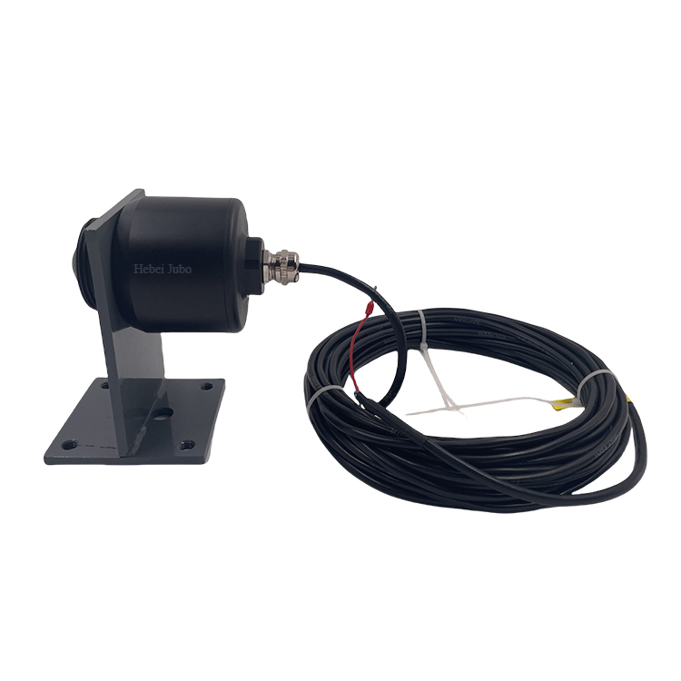
Figure 2. WB-19550377 FMCW Radar Sensor

Figure 2 illustrates the WB-19550377 FMCW Radar Sensor, a non-contact measuring device used for monitoring water levels in the proposed system. It is a frequency modulated continuous wave (FMCW) radar that emits a radar frequency that continuously increases or decreases over a defined frequency bandwidth (bw). The sensor emits electromagnetic waves and measures the time it takes for the echoes to return, allowing it to determine the distance between the sensor and the water surface. The accuracy of radar sensor is less affected by sunshine, fog, night and other meteorological conditions that affect visibility. They also have longer effective range and stronger anti-jamming ability, ensuring reliable and accurate water-level readings.

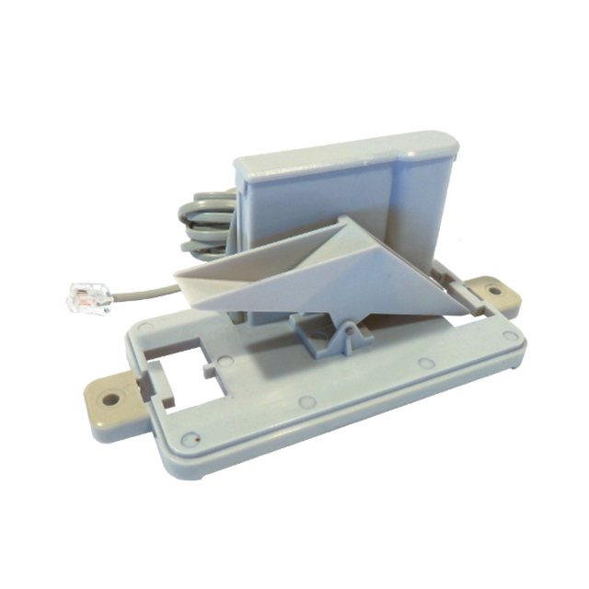

Figure 3. WH-SP-RG Tipping Bucket Rain Gauge

To further enhance environmental monitoring, Figure 3 illustrates the WH-SP-RG tipping bucket rain gauge, a rainfall measurement sensor which measures rainfall amount and intensity over time. It operates by collecting rainwater in a small funnel that directs it into a tipping bucket mechanism. Each time the bucket accumulates a preset volume of water, it tilts and empties, generating an electrical pulse that the microcontroller registers as one rainfall count. The accumulated number of tips is then converted into a rainfall depth measurement, typically in millimetres per hour (mm/hr). This rain gauge is designed for outdoor environmental monitoring, allowing it to withstand prolonged exposure to sunlight, rain, and wind. It also complements the other sensors by helping correlate precipitation levels with rising water levels and enhances the accuracy of flood forecasting and early warning.

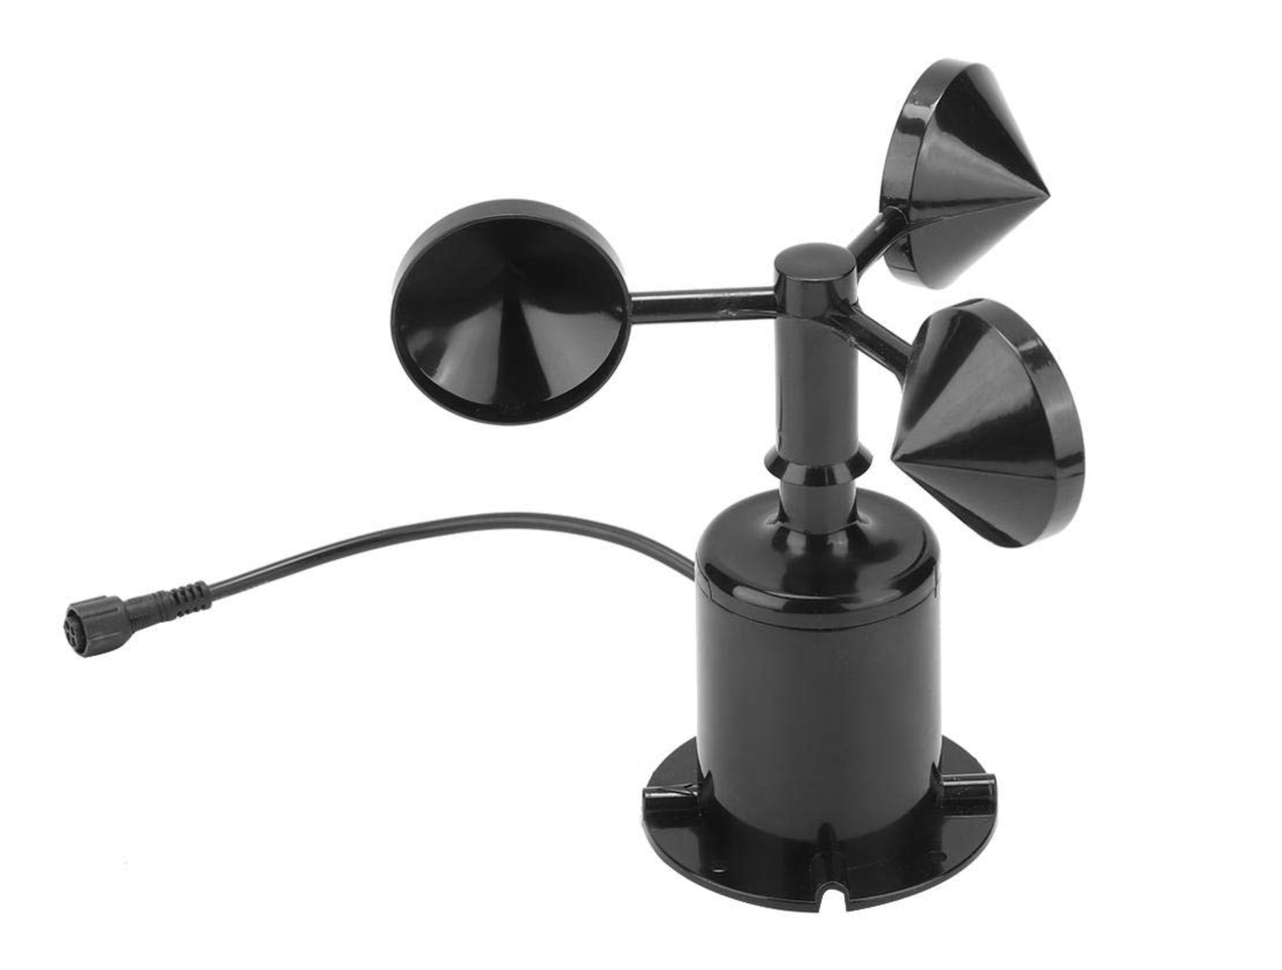
Figure 4. Anemometer

To measure the wind speed, Figure 4 illustrates anemometer to determine the intensity of wind conditions. Monitoring wind speed helps in determining the movement and intensity of a storm, providing essential data for predicting the severity of inland flood events. It acts as an early warning indicator which is important for assessing potential weather-related hazards and supporting early warning decisions.

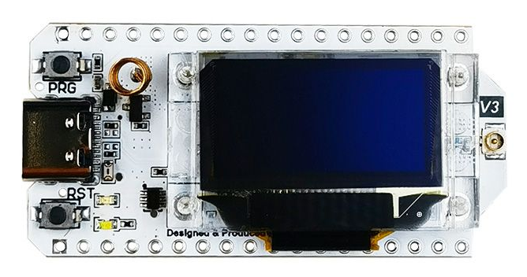
Figure 5. LoRa32 Development Board

After collecting data from all sensors, Figure 5 illustrates the LoRa32 development board as its main microcontroller and communication module. Built on the ESP32 chip, the LoRa32 integrates Wi-Fi, Bluetooth, and LoRa (Long-Range) module for long-range communication capabilities. It functions as the central unit that reads sensor data, processes it locally, and transmits it wirelessly to the other LoRa32 acting as gateway via the LoRa P2P communication. The LoRa32 is particularly suitable for remote flood monitoring due to its low power consumption and long communication range, ensuring that real-time data can be transmitted even in areas with limited internet connectivity. This stable, long-distance communication between sensor nodes and the central server is essential for timely flood alerts and effective decision-making.

Figure 6. Arduino IDE

Figure 6 illustrates the Arduino IDE used to program the LoRa32 board were its firmware was developed and uploaded. This environment provided the necessary libraries, debugging tools, and serial monitoring functions required for configuring sensor inputs, handling LoRa communication, and ensuring stable data transmission from the sensor nodes to the central server. Once sensor data is transmitted to the central server via the LoRa P2P communication, the software layer processes and analyzes the incoming information.


Figure 7. Visual Studio Code

For backend development, Figure 7 illustrates Visual Studio Code, was used as the primary development environment. It provided an organized workspace for managing the project’s source code, conducting debugging, and handling the various modules used throughout the system. It supports Python (Flask and Machine Learning), Dart (Flutter), and Arduino programming, making it a centralized tool for managing all software components of the project.


Figure 8. Flask

Figure 8 illustrates the system’s backend was built using a Flask API, which serves as the bridge between the IoT hardware and the database. Flask receives HTTP requests from both the IoT devices and the Flutter applications, processes the incoming sensor readings, and ensures that the data follows the required formats. It also manages the flow of information between the devices and the database, handles application logic, and provides the necessary endpoints for data retrieval, user access, and system interactions The Flask application is deployed on a local server, ensuring stable and efficient handling of incoming requests from multiple sensor nodes.


Figure 9. Cloudflare

For remote access during testing and development, Figure 9 illustrates Cloudflare which is used to expose the locally hosted Flask server to the internet, allowing external IoT nodes to transmit data seamlessly even without a publicly hosted backend.


Figure 10. Gunicorn

The Flask server is deployed using Gunicorn with a Gevent worker class, enabling asynchronous request handling and persistent WebSocket connections for real-time data delivery. This setup ensures stable handling of concurrent connections from multiple sensor nodes and client applications, and provides a more secure and efficient environment for backend operations.

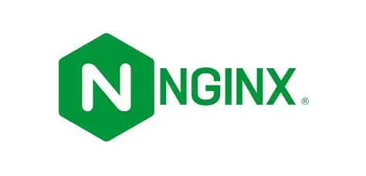
Figure 11. Nginx

Figure 11 illustrates Nginx which acts as the reverse proxy in front of Gunicorn, managing client connections, load balancing, and providing an additional layer of security. Once the backend receives sensor data, it stores the processed information in a MySQL database, allowing efficient retrieval for both real-time monitoring and historical analysis.



Figure 12. MySQL

Figure 12 illustrates MySQL, offers a reliable and scalable platform for managing time-series data, allowing efficient retrieval for both real-time monitoring and historical analysis. It supports structured data organization, indexing, and optimized query execution, which ensures fast access to large volumes of sensor readings. Additionally, MySQL provides strong data integrity, backup capabilities, and compatibility with various backend frameworks, making it suitable for long-term storage and processing within the flood monitoring system.


Figure 13. Flutter

For user interaction, the frontend is developed using the Flutter framework. It is used to provide a responsive portal UI accessible to barangay disaster management officers and users. The interface is primarily designed to notify the barangay and residents when water levels reach predefined thresholds, ensuring timely flood alerts through mobile notifications. Flutter allows a single codebase to be deployed to Web, Mobile, and desktop environments. This design approach reduces development complexity while ensuring consistency in design and functionality across all platforms.

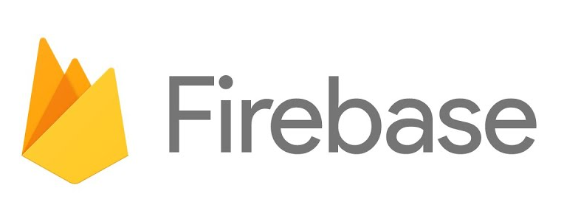
Figure 14. Firebase

Figure 14 illustrates Firebase, which is integrated into the resident-facing mobile application to handle user account management. Firebase Authentication is used to manage resident registration and login, enabling secure and reliable identity verification for mobile users. The Desktop application, intended exclusively for system administrators and barangay technical staff, used a locally stored account system, which allows admin-level operations to continue even during internet disruptions or in restricted network environments. This separation between cloud-based resident authentication and local admin authentication enhances security and ensures reliable system management under varying operational conditions. Flutter’s ability to produce native-like performance across multiple platforms makes it suitable for this project, ensuring accessibility, responsiveness, and future system scalability.


Figure 15. LightGBM

To enhance predictive capabilities, Figure 15 illustrates LightGBM, a gradient boosting framework, designed for fast training and efficient prediction on large datasets. LightGBM can efficiently handle nonlinear relationships and complex interactions between rainfall intensity, humidity, and water level. It improves the system’s predictive accuracy when working with large datasets, particularly under rapidly changing weather conditions.

LightGBM focuses on learning patterns and relationships between multiple environmental variables and recent sensor readings, improving the system’s ability to produce more responsive and accurate predictions over time.

Overall, the integration of carefully selected hardware and software technologies ensures that the system can achieve real-time, reliable, and accurate flood monitoring and forecasting. The combination of IoT-enabled sensors, the LoRa32 microcontroller, mobile application notifications, and the LoRa radio layer, which LoRaWAN and LoRa P2P both build on and which this system uses, provide strong data acquisition and transmission even in remote or disaster-prone areas. On the software side, the use of Flask API, Flutter, MySQL, Firebase, and server components such as Gunicorn and Nginx enables efficient data processing, visualization, user management, and alert notification. Development tools such as Visual Studio Code for backend and frontend programming, and the Arduino IDE for microcontroller firmware preparation, support streamlined coding, debugging, and sensor integration. Cloudflare is additionally used to provide secure temporary public URLs, allowing external testing and remote interaction with the local server. Techniques including LightGBM further enhance measurement accuracy and predictive capabilities, supporting timely and informed decision-making. These technologies are appropriate, feasible, and well-aligned with the study’s goal of developing a comprehensive, and effective flood monitoring system.

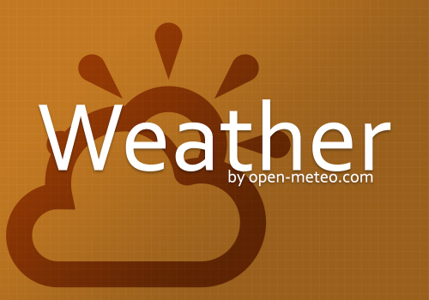
Figure 16. Open-Meteo Weather API

To measure environmental data such as humidity, temperature, air pressure, and other atmospheric conditions, Open-Meteo, a free and open-source weather API, is used to provide real-time and location-based weather information, which supplements the sensor readings and enhances the accuracy of the system’s monitoring and forecasting capabilities.


Figure 17. Docker

Figure 17 illustrates Docker Desktop, is a containerization platform that allows developers to build, package, and run applications along with all their dependencies inside isolated environments called containers. Unlike traditional deployment setups, containers ensure that an application behaves consistently regardless of the host machine's operating system or configuration. Docker Desktop provides a graphical interface for managing containers, images, volumes, and networks locally during development. It is widely used in modern software development for simplifying deployment, improving system portability, and enabling reproducible environments across different machines.
Chapter 3
DESIGN AND METHODOLOGY

This chapter presents the overall design and methodology adopted in the development of the proposed system. It includes the data gathering procedure, analysis and documentation of the functional and non-functional requirements, design of the software, processes and architectural models that serve as blueprint for development, and outline of the implementation plan to provide a structured guide on how the system will be deployed and evaluated.

Requirements Analysis

Data Gathering Procedures

The data-gathering procedures for this study utilized paper-based survey methods to ensure comprehensive respondent participation within Barangay 178, Camarin, Caloocan City. The researchers prepared a survey questionnaire, which was printed and distributed manually. Interviews with barangay officials were conducted using an interview guide to validate the survey findings and gather additional contextual information regarding existing flood response practices. The researchers conducted data gathering procedures to determine the flood experiences of the residents in selected areas, specifically along Durian Street and Phase VI in Barangay 178, Camarin, Caloocan City. The objective of this procedure was to identify flood-prone areas and analyze how residents prepare for and respond to flood events.

The researchers gathered data from the primary source, specifically barangay personnel, and secondary sources such as residents and existing Barangay Disaster Risk Reduction Management (BDRRM) documents provided by the barangay. Multiple data techniques were employed, such as interviews on barangay personnel and surveys administered to residents, to acquire more comprehensive and reliable information.

First, an interview was conducted with a desk officer at the Barangay Hall, to obtain information about flood-prone areas and the existing flood management system in the barangay. Second, a survey was conducted with the assistant secretary of the barangay about the practices, existing facilities, communication systems, and preparedness strategies under the barangay’s disaster risk reduction management program. Demographic documents were also provided by the barangay to support the study. Lastly, another survey was conducted among residents to gather their personal experience with flooding and to help identify the flood-prone areas.

In gathering data, multiple tools were also utilized such as interview guide questions and survey questionnaires. The interview guide questions consisted of semi-structured and open-ended questions that allowed the barangay personnel to discuss their flood preparedness measures and disaster response strategies. Meanwhile, the survey questionnaire conducted among residents consisted of both closed-ended and open-ended questions to obtain measurable data and personal insights about their flood experiences. In addition, a separate survey was conducted with the barangay’s assistant secretary to gather information about the existing flood management system, communication channels, and disaster preparedness strategies implemented within the barangay.

To validate the responses, the researchers compared the data gathered from barangay personnel to the information gathered from residents. This ensured the consistency and reliability of the gathered information.

After the development of the prototype, another round of data gathering was conducted to evaluate the system. The Technology Acceptance Model (TAM) was used to measure user acceptance, focusing on the respondents' perceived usefulness, perceived ease of use, attitude toward using, and behavioral intention to use the system. The ISO/IEC 25010:2023 standard was used to assess software quality across its product quality characteristics, including functional suitability, performance efficiency, compatibility interaction capability, reliability, security, maintainability, flexibility, and safety. The evaluations were administered through questionnaires created in GForms and printed copies, with items rated on a four-point agreement scale.
To determine the number of resident respondents for the evaluation, the researchers used Slovin’s formula at a 5% margin of error, where n is the sample size, N is the total population, and e is the margin of error.
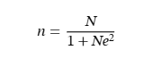
Based on the demographic documents provided by the barangay, Barangay 178 has a total population of 110, 224. Applying the formula, n = 110,224 / (1 + 110,224(0.08)²) = 156.03. Rounded up, the sample size is 157 respondents. Thus, 157 residents were selected as respondents through convenience sampling, where residents who were available and willing to participate were surveyed. The barangay’s disaster management officer and other barangay officials were selected through purposive sampling due to their direct role in flood management and disaster response. The barangay’s disaster management officer was also included as a respondent due to their direct role in flood management. The barangay’s disaster management officer was included as a respondent due to their direct role in flood management.

Overview of the Current State of Technology
This section presents the current technologies and processes utilized by Barangay 178, Camarin in monitoring and managing flood-related events. It identifies their existing system and the challenges encountered based on the gathered data from the conducted interviews, surveys, and documents provided by the barangay. It also outlines the barangay’s capabilities and limitations which identifies the need for a localized monitoring and forecasting solution based on gathered data, interviews, and documents.

The barangay currently relies on a city-managed early warning system located along a nearby creek. Despite the existence of such a system, flood data access is limited to the city level and is unavailable to barangay personnel, making them incapable of direct control and visualization of the data. Within the barangay, the barangay personnel mainly depend on on-site observation and sound system to inform the residents of a possible flood event. These communication tools allow the barangay to alert the residents, but they do not gather and record real-time data regarding flood conditions.

Despite such a system providing local alerts, it mainly benefits residents near the creek and does not provide the barangay with continuous and accessible water-level data. The barangay’s communication system currently functions reactively, sending alerts only when flooding is already visible. The barangay cannot anticipate floods in advance or issue timely warnings to all affected residents, especially residents far from the creek or main sound system coverage.

In conclusion, the limitations revealed that while a flood detection system exists, the barangay still lacks a localized and data-driven flood monitoring and forecasting tool which would provide support to its personnel and residents. The proposed project aims to address the gap by developing desktop-based flood monitoring dashboard for disaster management officers that presents real-time data visualization, web/android-based platforms accessible to residents, water-level forecasting, and mobile application alerts. The system complements the city’s early warning system and strengthens the barangay’s ability to warn residents, prepare for flood events, and respond effectively to flooding.

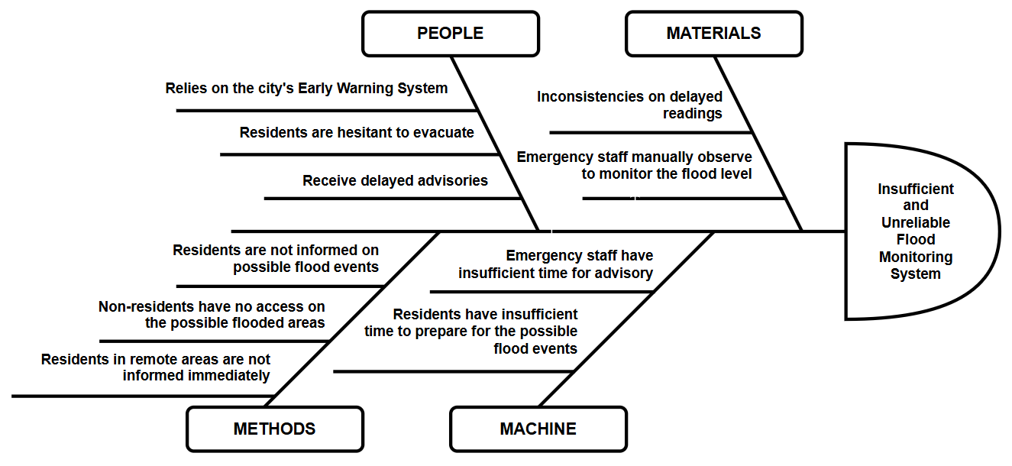
Problem Analysis

Figure 18. Fishbone Diagram

Figure 18 illustrates the root causes of the inefficiency and unreliability of the existing flood warning system in Barangay 178, Camarin, Caloocan City. In this diagram, the researchers identified that the main problem was the “Inefficient and Unreliable Flood Warning System.” The causes were grouped into four categories: People, Materials, Methods, and Machine. Under People, the issues include reliance on the city’s early warning system, residents’ hesitance to evacuate, and the receipt of delayed advisories which are factors that contribute to delayed response and reduced preparedness during flood events. Under Materials, the inconsistencies in delayed readings and the need for emergency staff to manually observe and monitor flood levels were identified, indicating a lack of reliable and efficient monitoring tools. Under Methods, problems include residents not being informed about possible flood events, non-residents lacking access to flood-related information, and delays in informing residents in remote areas, which reveal the gaps in communication and information dissemination processes. Under Machine, limitations such as emergency staff having insufficient time to issue advisories and residents lacking time to prepare for possible flood events were observed, reflecting inefficiencies in system support and operational capacity. These findings guided the researchers in developing and designing a real-time flood monitoring system with water-level forecasting that addresses the root problems.

Requirements Documentation

This outlines the functional and non-functional requirements necessary for the design, development, and implementation of the Flood EWS: A Real-Time Flood Monitoring System with Water Level Forecasting using LoRa-Based Wireless Sensor Network for Barangay 178, Camarin, Caloocan City. It serves as a structured guide describing what the system should accomplish and the conditions under which it must operate.

Functional Requirements

After a thorough data gathering, the researchers identified the following functional requirements for the system to be developed. These requirements are considered essential for the successful completion of the proposed system.

1. Admin User Account Management The administrators such as barangay personnel or BDRRM staff that will operate the system must be able to create secure accounts and log into the system. This ensures that access to flood-related data is limited to authorized personnel responsible for monitoring and management.
2. Water Level Detection Module The system must continuously collect data from the sensor nodes located on the creek near flood-prone areas. This module will acquire readings from multiple sensors such as water-level and environmental sensors.
3. Data Transmission Module This module must ensure stable and reliable data transmission among the sensor nodes, central database, and web-based platform. The system shall utilize a LoRa gateway to transmit the collected sensor readings from the nodes to the central database, which will then forward the data to the web dashboard for monitoring and visualization.
4. Forecasting Module This module analyzes the collected flood data and applies predictive algorithms to forecast future flood events. The system shall employ LightGBM for machine learning-based prediction.
5. Data Visualization and Reporting The system shall visualize collected and forecasted flood data. On the admin side, the system shall display detailed numerical data and predictive results, complemented by visual representations such as graphs and charts. On the user side, the system shall provide a more simplified visualization, such as a human outline with a water level indicator, to ensure the information is easy to understand. The information presented will be helpful in supporting the barangay’s decision-making and future planning.
6. Alert Module This module is responsible for automatically sending notifications through the mobile application and desktop application once the flood water level reaches a predefined threshold. These alerts inform barangay personnel and residents of the situation in real time, enhancing preparedness and facilitating prompt response during potential flood events.

Non-Functional Requirements

In addition to the functional requirements that define what the proposed system must accomplish, the study also outlines its non-functional requirements. These requirements focus on the overall quality and performance characteristics of the system rather than on specific features. They ensure that the system will not only perform its intended functions but will also meet standards. By addressing these non-functional requirements, the researchers aim to guarantee that the system will deliver a prominent level of user satisfaction and sustainability in real-world use.

Below is the list of the non-functional requirements of the proposed system:

- Functional Suitability - The system should perform all its functions correctly and meet the needs of the users.
- Performance Efficiency - The system should respond quickly and use resources efficiently without slowing down.
- Compatibility - The system should work properly on different devices, operating systems, and web browsers.
- Interaction Capability - The system should be easy to use and understand for all users.
- Reliability - The system should work consistently without errors or failure over time.
- Security - The system should protect user data and prevent unauthorized access.
- Maintainability - The system should be easy to update, fix, and improve when needed.
- Flexibility - The system should be able to adapt to changes, such as new devices, additional sensors, or more users.
- Safety - The system should help prevent harm by giving timely and clear flood warnings.

User Requirements

Based on the interviews, surveys, and data gathering conducted by the researchers, the following user requirements were identified for the proposed Flood EWS: A Real-Time Flood Monitoring System with Water Level Forecasting using LoRa-Based Wireless Sensor Network. These requirements reflect the needs of barangay disaster management officers and residents, and serve as the foundation for the system’s design and development.

1. Account and User Management
- The system shall allow administrators and authorized users (such as barangay disaster management officers) to create accounts and manage user access levels.
- The system shall provide a secure login feature using a unique username and password.
- The system shall allow users to update their profile and contact information as needed.
- The system shall restrict unauthorized access to sensitive monitoring and forecasting data.

2. Real-Time Monitoring
- The system shall continuously collect data from multiple sensors, including radar, rainfall, and wind speed sensors.
- The system shall display real-time readings of water levels, cloud cover, rain height, rainfall, wind speed, and wind direction through a desktop, mobile, and website application.
- The system shall visualize sensor data using graphs and indicators for easy interpretation by users.
- The system shall update sensor data at defined intervals to ensure accurate and timely monitoring.

3. Forecasting and Analysis
- The system shall process real-time and historical sensor data using a forecasting algorithm, specifically LightGBM.
- The system shall display predicted water levels and potential flood risks on the dashboard.
- The system shall provide early warnings based on forecasted flood conditions.
- The system shall allow administrators to adjust forecasting thresholds when necessary.

4. Alert and Notification Management
- The system shall automatically activate visual and auditory alerts (such as mobile app notifications) when critical water-level thresholds are reached.
- The system shall send notifications to registered officials and residents regarding flood alerts and forecast updates.
- The system shall log all alerts and notifications for review and reporting.

5. Data Logging and Reporting
- The system shall store all collected sensor data and forecast results in a centralized database.
- The system shall allow administrators to generate reports related to sensor readings, alert events, and system performance.
- The system shall enable exporting of reports in formats such as XLSX file.
- The system shall provide historical trend analysis for review and decision-making.

6. System Maintenance and Accessibility
- The system shall be accessible via desktop and mobile devices through a secure web interface.
- The system shall allow administrators to manage, add, or remove sensor nodes remotely.
- The system shall include a power monitoring feature to ensure uninterrupted operation of the sensor network.
- The system shall provide backup and recovery mechanisms for stored data.
These user requirements serve as the primary guide for the system’s design and implementation. They ensure that the proposed system meets the functional needs of its intended users improving flood preparedness, response time, and community safety.

Hardware and Software Requirements

Table 1
Hardware Requirements

Component | Minimum Specification | Recommended Specification | Purpose
Processor (CPU) | Intel Core i3 (10th Gen) or AMD equivalent | Intel Core i5/i7 or AMD Ryzen 5/7 | To handle system programming, database management, and real-time processing tasks.
Memory (RAM) | 4 GB | 8 GB or  higher | Ensures smooth operation of development and simulation tools.
Continuation Table 1

Storage | 500 GB HDD | 256 GB SSD + 1 TB HDD | Provides sufficient storage and faster access to development files and datasets.
Display/Monitor | 14” HD (1366 x 768) | 15.6” Full HD (1920 x 1080) | For better visualization of dashboards and system interfaces.
Network | Wi-Fi enabled, Ethernet port | Wi-Fi 6 with Gigabit Ethernet | Supports stable network communication for real-time data transfer.
Peripherals | Keyboard, Mouse | Ergonomic peripherals | For communication, testing, and documentation.
Server (for deployment) | Dual-core CPU, 8 GB RAM, 500 GB storage | Quad-core CPU, 16 GB RAM, 1 TB storage | To host backend applications, manage databases, and store real-time data.
Microcontroller | LoRa32 (ESP32) with LoRa Module | LoRa32 with external antenna | For collecting and transmitting sensor data through LoRa technology.
Sensors | WB-19550377 FMCW Radar Sensor, WH-SP-RG Tipping Bucket Rain Gauge, Anemometer | Non-contact, ±1 mm accuracy, up to 65 m range, IP68 waterproof, Tipping-bucket, 0.3 mm per tip. | For water-level and rainfall measurement.

Continuation Table 1

Power Source | 12V Battery | 12V Battery with Solar Panel and Charge Controller | For continuous operation during power outages.

Table 2
Software Requirements
Category | Minimum Specification | Recommended Specification | Purpose
Operating System | Windows 10 (64-bit) | Windows 11 Pro (64-bit) | Main development environment and testing development.
Programming IDE | Arduino IDE | Arduino IDE (latest version) | For coding and uploading firmware to LoRa32 microcontroller.
Backend Framework | Flask API | Flask with Gunicorn and Nginx | For handling requests and data processing from IoT devices.
Frontend Framework | Flutter | Flutter | For developing responsive web and mobile dashboards.
Database Management | MySQL 8.0 | SQLyog | For data storage, querying, and analysis.
Server Software | Nginx / Gunicorn WSGI | Nginx / Gunicorn WSGI | For hosting backend and frontend services.
Version Control | Git | GitHub | For source code management and collaboration.

Use-Case Diagram

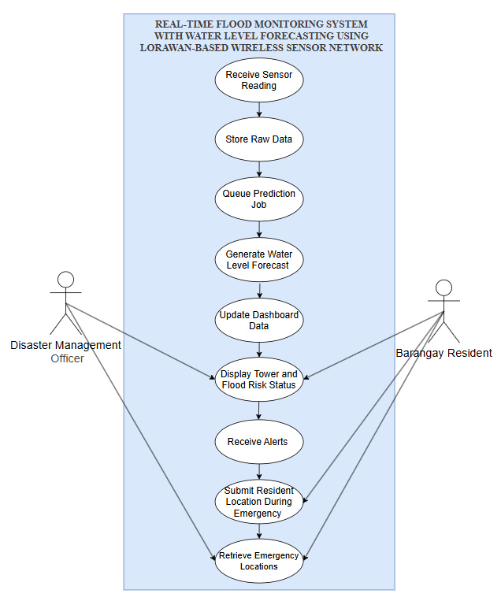
Figure 19. Use Case Diagram of the Flood EWS: A Real-Time Flood Monitoring System with Water Level Forecasting using LoRa-Based Wireless Sensor Network

Figure 19 illustrates the interactions between the disaster management officers, barangay residents, and the system. It shows how the system processes data and how the users interact with its core functionalities. The process begins when the system receives sensor readings, which are then stored as raw data. A prediction job is queued to generate water level forecasts, followed by the computation of the flood risk level. The processed data is then used to update the dashboard, where both users can view real-time water levels and flood risk status. The system also enables the automatic sending of alerts, which are received by both the Disaster Management Officer and Barangay Residents to ensure timely response. During emergencies, residents can submit their location, allowing authorities to retrieve and monitor affected areas more effectively.

Data Flow Diagram

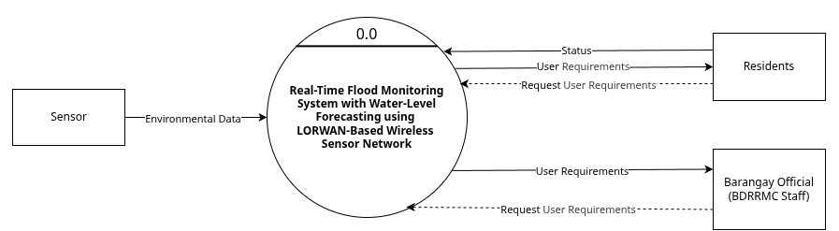
Figure 20. Level 0 Data Flow Diagram of the Flood EWS: A Real-Time Flood Monitoring System with Water Level Forecasting using LoRa-Based Wireless Sensor Network

Figure 20 presents the Level 0 Data Flow Diagram, illustrating the system as a single high-level process interacting with its external entities which are the local residents and outside visitors, and the admin. Local residents and outside visitors can access the system either as non-account users or through account creation and login. They can view forecast and environmental status, receive alerts and updates, and update their current location to support real-time monitoring and emergency response. On the other hand, the admin interacts with the system by adding and updating node sensors, requesting residential and forecast reports, and viewing additional forecast data. The system processes these inputs and provides the admin with generated forecasts and residential reports. Overall, the diagram shows the primary data flows between users and the central flood monitoring system.

Figure 21 shows the Level 1 Data Flow Diagram, which decomposes the main system process into its major subprocesses. Sensor nodes transmit water-related environmental data via LoRa P2P communication to Process 1.0, where the data is received. Process 2.0 handles processing and data storage, sending records to the central server for data insertion and updating the processes queue table. A worker process then performs additional processing before the forecasted data is stored in Process 3.0. Finally, Process 4.0 generates reports and alerts, which are delivered to residents and barangay disaster management officers through the desktop and mobile applications. The diagram illustrates how raw sensor data flows through processing, queuing, forecasting, and reporting.

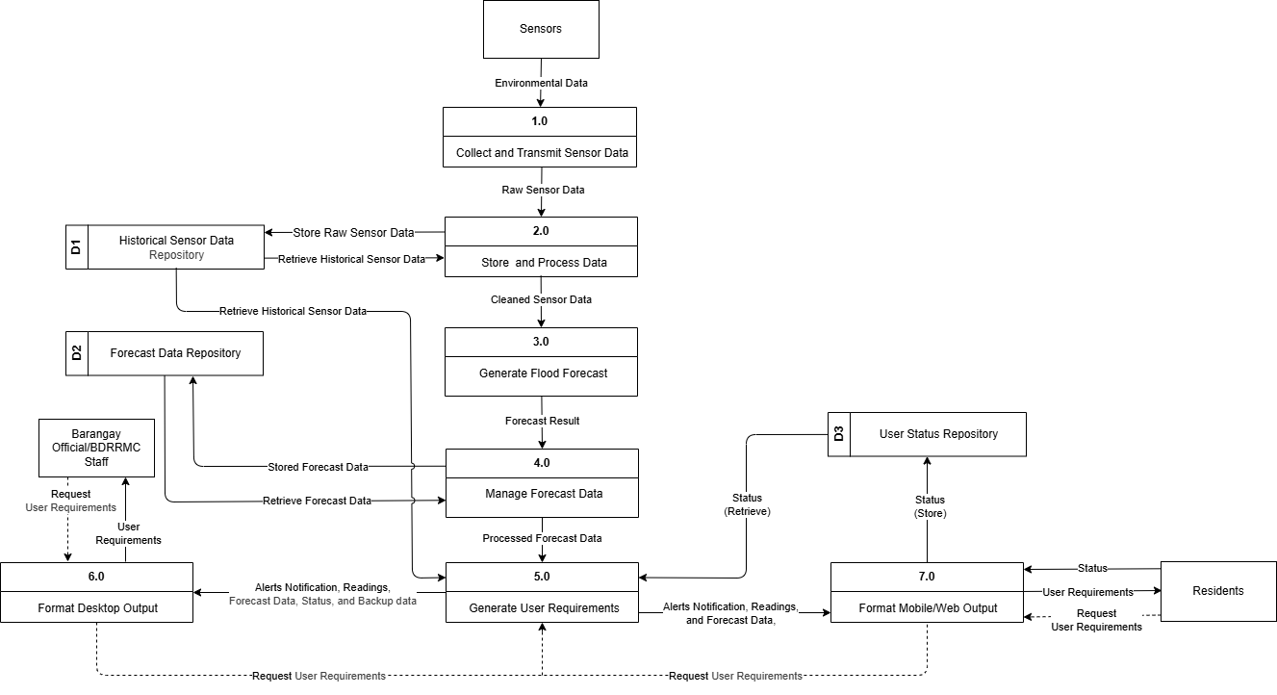
Figure 21. Level 1 Data Flow Diagram of the Flood EWS: A Real-Time Flood Monitoring System with Water Level Forecasting using LoRa-Based Wireless Sensor Network

Entity Relationship Diagram

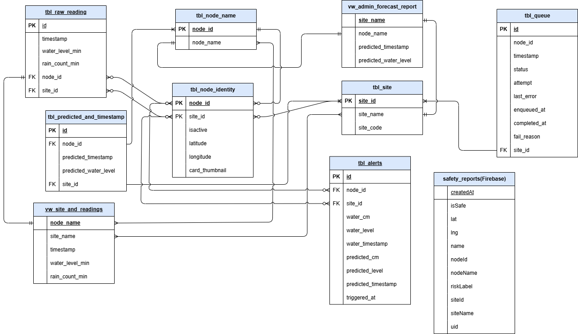
Figure 22. Entity-Relationship Diagram of the Flood EWS: A Real-Time Flood Monitoring System with Water Level Forecasting using LoRa-Based Wireless Sensor Network

Figure 22 shows the Entity-Relationship Diagram (ERD) of the system, outlining the database structure and the relationships between its core tables. The diagram includes entities for raw sensor readings, predicted water-level values, node information, site profiles, alert records, user accounts, user roles, and status classifications. The ERD highlights how nodes and sites are linked to sensor readings and predictions, how alerts are stored, and how user roles and statuses are associated with user records to provide a clear representation of how data flows and connects within the database.

Design of Software, Systems Products and Processes

System Architecture

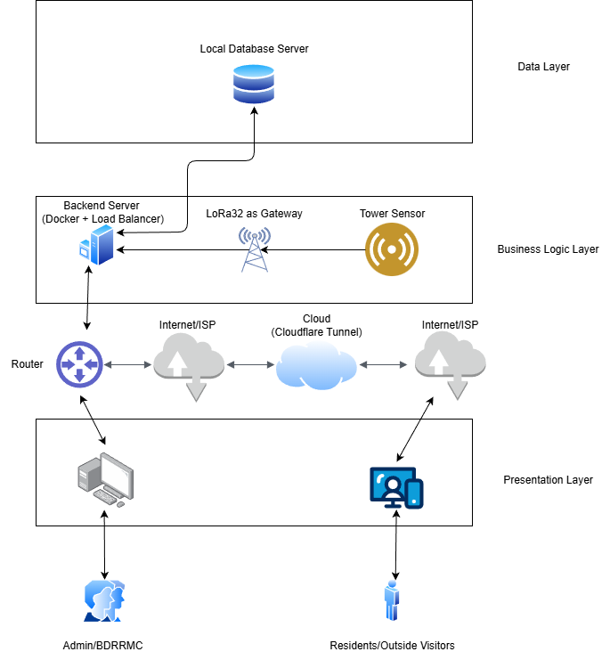
Figure 23. System Architecture

Figure 23 illustrates the overall system architecture of the Real-Time Flood Monitoring System with Water-Level Forecasting. The diagram is structured into three layers: the Data Layer, Business Logic Layer, and Presentation Layer. At the Data Layer, a local database server stores sensor readings, processed data, and generated outputs. The Business Logic Layer includes the backend server deployed using Docker with a load balancer which communicates with the LoRa32 gateway receiving transmissions from tower-mounted sensors. These components handle data processing, forwarding, and system operations.

The Presentation Layer shows how administrators (BDRRMC) and residents or external visitors access the system. Users connect through the Internet/ISP, routed through a cloud service (Cloudflare Tunnel) that provides secure and reliable connectivity between the backend server and client interfaces. The architecture highlights the end-to-end flow from sensor data acquisition to backend processing and finally to user access through web and mobile interfaces.

System Design
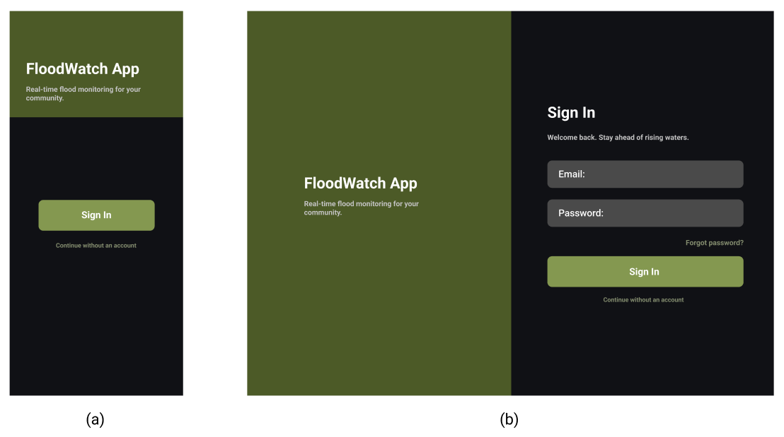
Figure 24. Mobile View and Desktop View of the Web Interface Onboard Page. (a) Mobile view. (b) Desktop view.

Figure 24 (a) illustrates the Onboard Page of the system’s mobile and desktop application platform. As shown in (a), it displays the mobile view of the initial interface where users, such as barangay personnel or residents, can choose whether to sign in with an account or continue without an account. Users who select “Continue without account” are granted quick access to real-time water level and rainfall data. Meanwhile, users who choose to sign in with an account can receive flood alerts through notifications and report their safety status to the barangay by indicating whether they are safe or not during flood events. On the other hand, (b) shows the desktop view of the interface.

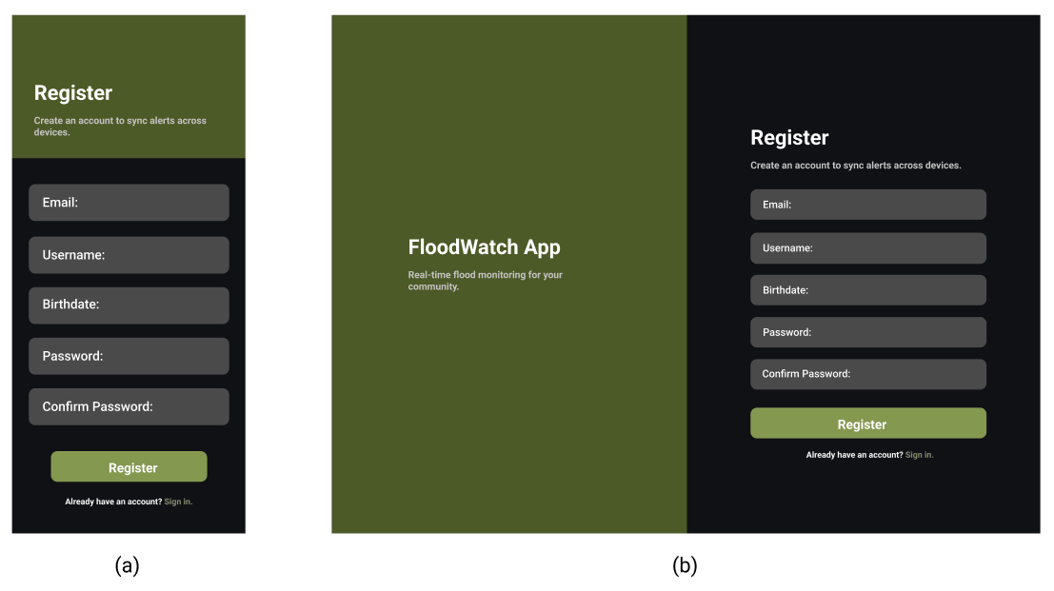
Figure 25. Mobile View and Desktop View of the Web Interface Registration Page. (a) Mobile view. (b) Desktop view.

Figure 25 illustrates the Registration Page of the system. As shown in (a), it displays the mobile view of the page where users will create their account by providing their email address, username, birthdate, and password. On the other hand, (b) shows the desktop view of the interface.

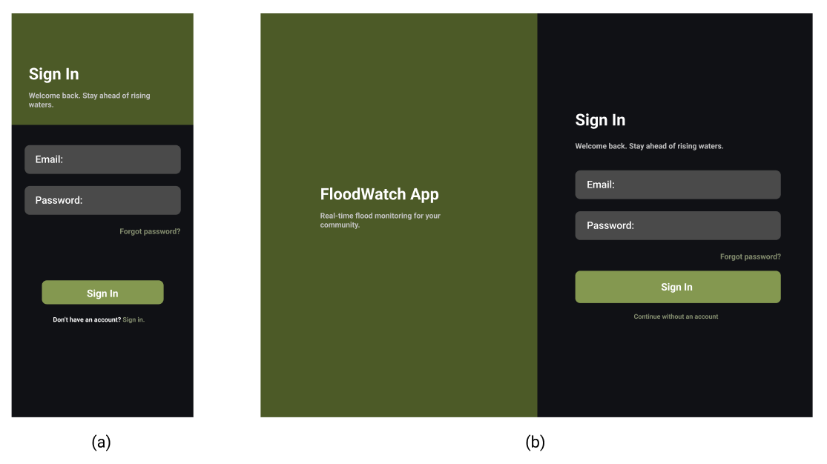
Figure 26. Mobile View and Desktop View of the Web Interface Sign in Page. (a) Mobile view. (b) Desktop view.

Figure 26 illustrates Login Page of the system. As shown in (a), it displays the page where they will be provided with an option to log in by manually entering their email and password or log in by using their Google account for quicker authentication. Users without an existing account are provided with an option to create a new account, ensuring easy access to the system’s features. On the other hand, (b) shows the desktop view of the interface.

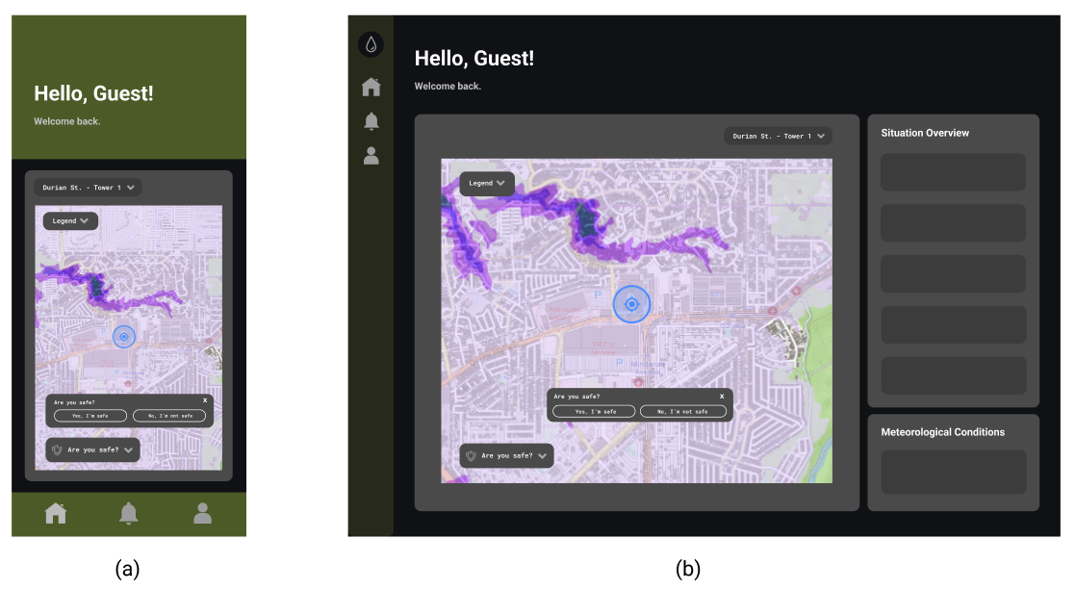
Figure 27. Mobile View and Desktop View of the Web Interface Homepage with Dashboard. (a) Mobile view. (b) Desktop view.

Figure 27 illustrates the Homepage of the system. As shown in (a), it will display the user’s selected tower location and a map showing surrounding flood susceptibility zones. A color-coded legend is available in a dropdown menu so users can easily identify the flood risk level associated with each color and a safety status reporting popup where users can indicate whether they are safe or not. When scrolled down, it will display the situation overview containing flood water level information, rain count, wind speed, and recommended actions when the water reaches a certain level. In addition, it will also display the meteorological conditions section, which contains cloud cover and wind direction. On the other hand, (b) shows the desktop view, where the situation overview section and meteorological conditions section are located on the right side of the interface.
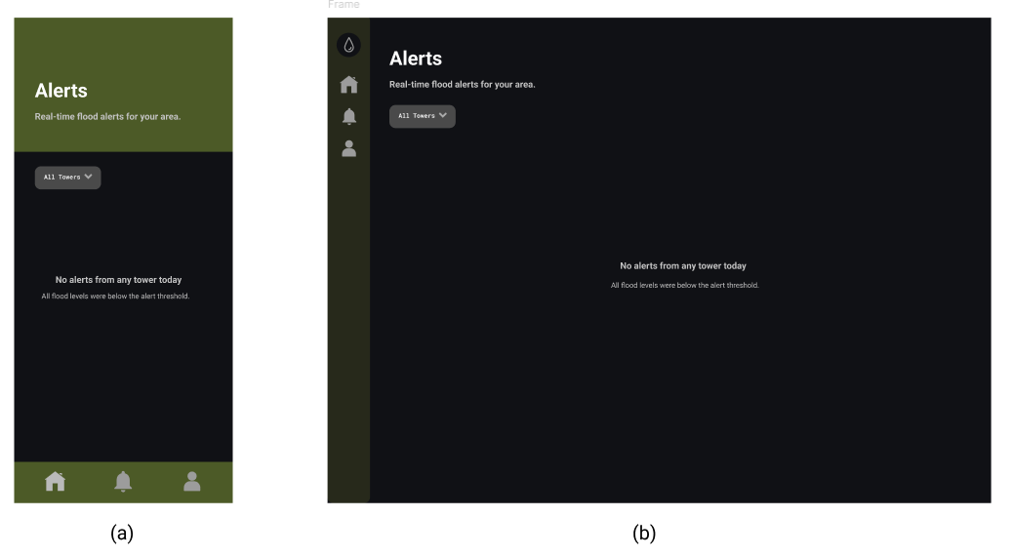
Figure 28. Mobile View and Desktop View of the Web Interface Alerts Page. (a) Mobile view. (b) Desktop view.

Figure 28 illustrates the Alerts page of the system. As shown in (a), it will display the real-time flood alerts for the user's monitored area, with filter options to view alerts by specific tower. When there are no alerts from any tower, it means that all flood levels are below the alert threshold. On the other hand, (b) shows the desktop view of the interface.
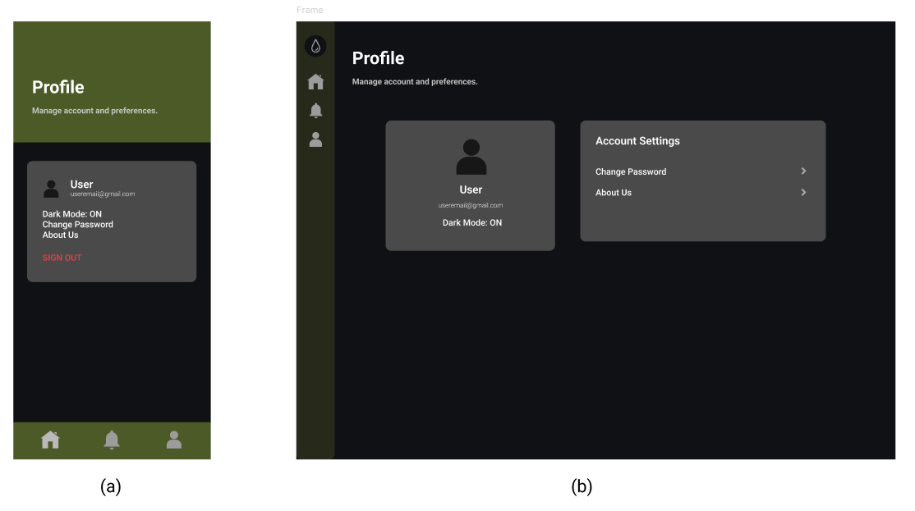
Figure 29. Mobile View and Desktop View of the Web Interface Profile Page. (a) Mobile view. (b) Desktop view.

Figure 29 illustrates the Profile page of the system. As shown in (a), it displays where users are allowed to view their account information including their username and email address. It also provides options for switching to light mode or dark mode, changing their password, accessing the “About Us” section to see more information about the application. Through this page, users can maintain accurate account information and personalize their experience within the application. On the other hand, (b) shows the desktop view of the interface.

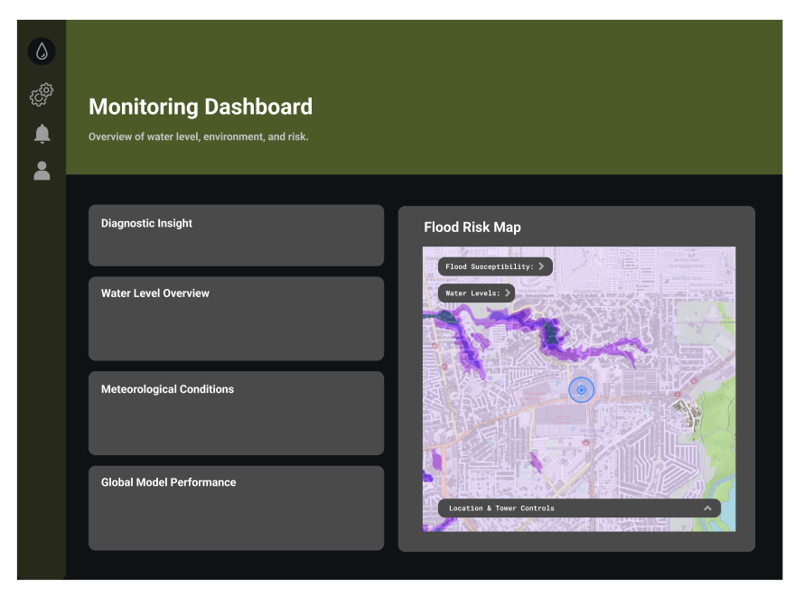
Figure 30. Desktop Application Interface of the Admin Monitoring Dashboard

Figure 30 illustrates the Monitoring Dashboard page of the system on the admin’s end. It displays a Diagnostic Insight section displaying the overall risk level along with a summary of current water level trends and forecasts. There is a Water Level Overview section, which shows the forecast time, past water level, current water level with its corresponding body level indicator, and the predicted water level. The meteorological conditions section contains information such as cloud cover, rain, wind speed, and wind direction. In addition, there is also Global Model Performance section, where it presents the machine learning model's R² score and RMSE, along with the last training date. On the right side, a Flood Risk Map is displayed, overlayed with a flood susceptibility popup, which shows the color-coded flood susceptibility zones and another popup showing water levels. Below the map, a Location and Tower Controls section allows users to filter by location and view a Google Maps street view image from each monitoring tower’s location.

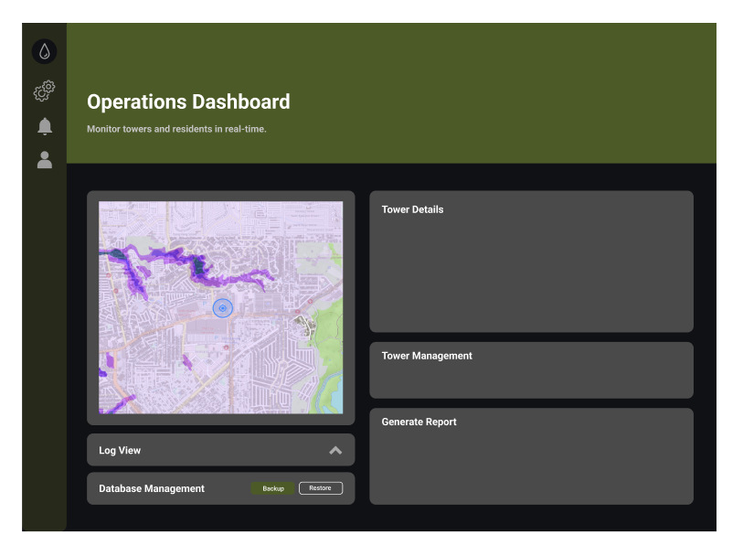
Figure 31. Desktop Application Interface of the Admin Operations Dashboard

Figure 31 illustrates the operations dashboard of the system on the admin’s end. This page monitors towers in real time. It features an interactive map showing the geographic locations of monitoring towers, along with a log view and database management section at the bottom, where the admin can backup and restore data. On the right side, a Tower Details section displays a street map image, site name, tower ID, status, and coordinates of the selected tower. A Tower Management section shows the total number of towers and provides options to access master data, edit tower information, or register a new tower. A Generate Report section allows users to select the report type, month, and year, and export data such as monthly summaries and readings and predictions as an Excel (.xlsx) file.

System Processes

The Flood EWS: A Real-Time Flood Monitoring System with Water Level Forecasting using LoRa-Based Wireless Sensor Network was developed for Barangay 178, which frequently experiences flooding in Durian Street, Phase 6, and Aurora. The system operates under a client–server architecture that enables continuous monitoring, data processing, and real-time communication between the central server, sensor network, and end users. Its main components include sensor nodes, gateways, a processing server, a database, and user interfaces for both desktop administrators and mobile residents.

Within this architecture, a tower sensor is installed in flood-prone areas continuously collect meteorological data such as water level, rainfall intensity, rain height, cloud cover, wind direction, and wind speed. These readings are transmitted via the LoRa P2P protocol to the server. The processed data are then stored in a local MySQL database, forming the foundation for the LightGBM machine learning model that forecasts flood levels and provides predictive alerts. The system’s design ensures that both administrators and residents receive accurate and actionable information in real time to strengthen disaster preparedness in Barangay 178.

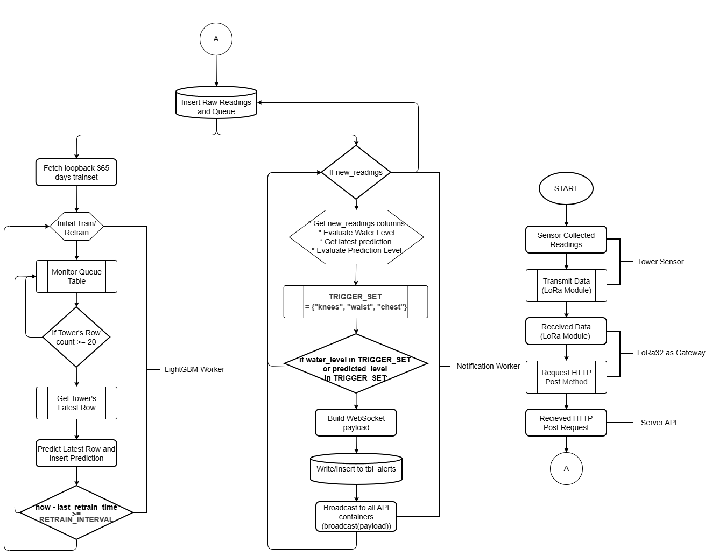

Figure 33. Flowchart of the Machine Learning Process and Sensor Data Collection

Figure 33 illustrates how the system interprets and transforms stored sensor data into actionable flood forecasts. Using the LightGBM model, the system predicts upcoming flood conditions by analyzing both real-time and historical readings from the database. The process begins with either an initial training or retraining phase of the model, which is triggered automatically when new batches of validated sensor data are available.

A background worker process, which runs continuously, monitors the queue table within the database. When it detects new readings, it retrieves the latest dataset and evaluates whether the minimum required data threshold for prediction has been met. If sufficient data exist, the LightGBM model executes the forecasting computation. If not, the process loops back, waiting until new sensor readings are added. This mechanism ensures that predictions are always based on complete and reliable data.

The model generates a time-to-flood forecast, estimating when water levels may reach critical thresholds (for example, “Water level may reach danger height within 1 hour”). These predictions are automatically inserted into the forecast table in the database and made available for visualization through the admin dashboard and mobile applications. The looped structure of this process allows for continuous prediction updates, enabling Barangay 178 officials and residents to receive up-to-date forecasts that improve readiness and local response efforts.

In addition, the Notification Worker evaluates both actual and predicted water levels against a defined trigger set consisting of “lower,” “raised,” and “check.” When thresholds are met, it builds a WebSocket payload, inserts an alert into the alerts table, and broadcasts the notification to all API consumers. This ensures that timely warnings are delivered to residents and officials whenever water levels reach critical conditions.

Sensor data collection begins at the field-deployed sensor nodes, where FMCW radar and water-level sensors continuously measure the current water height at the creek or flood-prone area. These readings are gathered at fixed intervals and transmitted through the LoRa communication module embedded in each node. Once collected, the raw sensor values are packaged and wirelessly sent to the LoRa gateway, which then forwards the data to the server through an HTTP POST request. This ensures that every measurement from the physical environment is captured, transmitted reliably, and stored in the system database, making it available for machine learning processing, notification broadcasting, and flood forecasting.

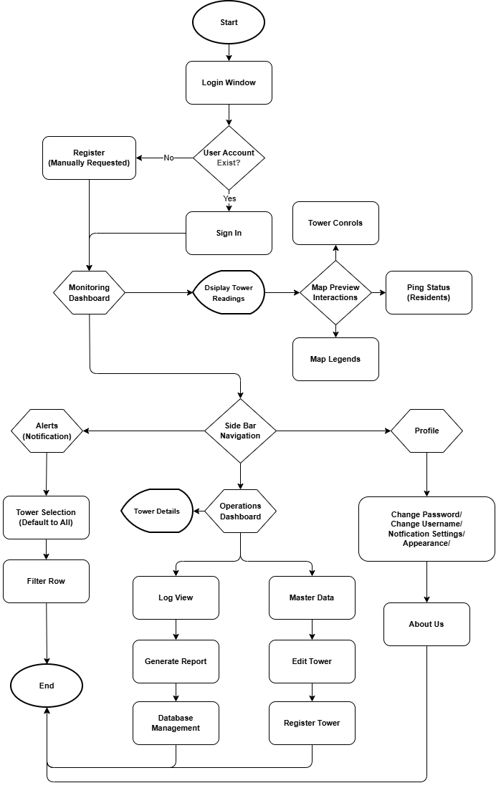
Figure 34. Flowchart of the Admin Users Process

Figure 34 outlines the sequence of interactions within the administrative user system, beginning from the login window and progressing through authentication, data access, and available management actions. The process starts with the login window, where the system checks if a user account exists. If no account is found, the user proceeds to registration; otherwise, they sign in to access the system. Upon successful authentication, the dashboard is displayed, showing both the map with current sensor readings and forecasted readings.

From the dashboard, users can navigate through several options provided in the side menu. Under Notifications, users may select towers (defaulting to all), apply filters, and view related alerts. The Operations section allows administrators to view logs, register new towers, edit tower information, manage master data, monitor residents’ distress locations, and generate forecast reports. Meanwhile, the Profile section provides access to profile actions, the “About Us” page, and password management features.

The flow concludes once the user completes their chosen operations, such as managing towers, viewing forecasts, or updating their profile, and exits the application, marking the end of the interaction process.
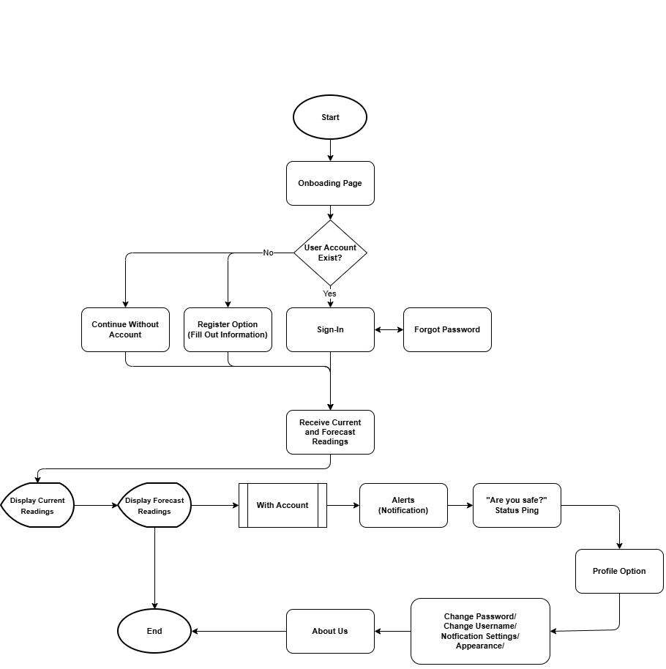
Figure 35. Flowchart of the Resident Users Process

Figure 35 illustrates the interaction flow for residents using the mobile application, beginning from the onboarding stage and progressing through account management, data access, and notifications. The process starts at the onboarding page, where the system checks if a user account already exists. If no account is found, residents may either continue without creating an account or register by filling out the required information. If an account exists, the user proceeds to sign in.

After sign-in or continuing as a guest, the application displays both current sensor readings and forecasted water levels. Notification alerts are triggered to inform users of critical updates or sudden changes in flood conditions. For residents with an account, additional features are available, including the ability to send a GPS ping to notify the Barangay Disaster Risk Reduction and Management Council (BDRRMC) in emergency situations. Account holders also gain access to profile options, such as changing their password, and can navigate to the support section for assistance.

The process concludes once the resident finishes viewing readings, notifications, or performing profile-related actions, marking the end of the interaction sequence.

Development and Testing

Development
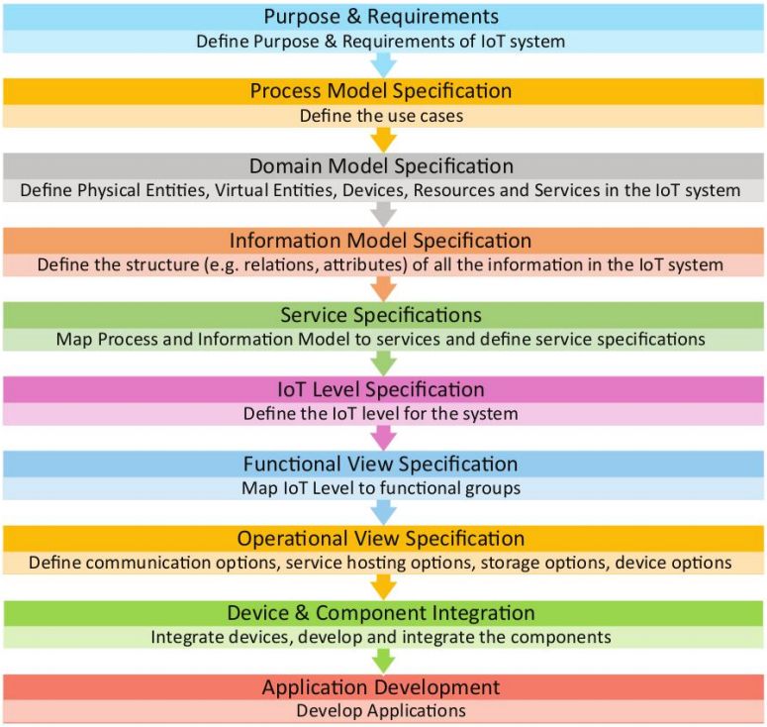
Figure 36. IoT Design Methodology

The researchers adopted the IoT Design Methodology proposed by Bahga and Madisetti as the structured development approach for the Flood EWS: A Real-Time Flood Monitoring System with Water Level Forecasting using LoRa-Based Wireless Sensor Network. This methodology was selected because it is specifically designed to address the multi-layered complexity of IoT systems, where physical devices, wireless communication protocols, cloud-based services, and user-facing applications must be co-designed and integrated in a coherent and technology-independent manner. Unlike general-purpose software methodologies, the IoT Design Methodology ensures that hardware and software concerns are jointly addressed from the earliest design stages, making it particularly suitable for sensor-driven systems that involve both firmware development and application-layer services.

The first step is Purpose and Requirements Specifications. It defined the purpose, behavior, and requirements of the system. The system's purpose was identified as providing real-time flood monitoring, water-level forecasting, and automated alert dissemination for Barangay 178, Camarin, Caloocan City. Data collection requirements, sensor integration needs, communication requirements, user interface specifications, and security requirements were captured at this stage. This step was informed by interviews with barangay officials, surveys with residents, and analysis of BDRRM documentation gathered during the data collection phase.

The second step is Process Model Specification. It formally described the use cases of the system derived from the purpose and requirements. The system's process model defined the interactions among sensor nodes, the LoRa gateway, the backend server, the database, and end users. Use-case scenarios were specified for water-level data collection, threshold-triggered alert generation, machine learning-based forecasting, and dashboard data visualization for both barangay disaster management officers and residents.

The third step is Domain Model Specification. The domain model identified the physical entities, virtual entities, devices, resources, and services within the IoT system. Physical entities included the creek, the water surface, and the surrounding environment. Virtual entities included digital representations of water-level readings, rainfall counts, and wind speed measurements. Devices included the LoRa32 microcontroller, radar sensor, tipping bucket rain gauge, and anemometer. Resources included the Flask API endpoints and the MySQL database, while services included data ingestion, alert notification, and forecasting.

The fourth step is Information Model Specification. The information model defined the structure, attributes, and relationships of all data in the system. This included the schema of sensor readings stored in the MySQL database, including timestamp, water level, rainfall count, wind speed, and forecasted water level, as well as resident identity records managed through Firebase Authentication for mobile account access. The information model ensured that data consistency was maintained across the sensor nodes, the backend server, and the frontend interfaces.

The fifth step is Service Specifications. Service specifications defined the services in the system, their types, inputs and outputs, endpoints, schedules, and preconditions. RESTful services implemented through the Flask API were specified for sensor data ingestion, data retrieval for dashboards, alert triggering logic, and LightGBM model inference. A WebSocket-based notification service powered by Gevent was specified for delivering real-time push alerts to connected clients upon reaching critical water-level thresholds.

The sixth step is IoT Level Specification. The IoT level was defined as a multi-tiered deployment involving edge-level sensor nodes, a gateway node, a locally-deployed backend server with public tunnel access via Cloudflare, and cloud-based user services through Firebase. This level specification confirmed that the system operates as a distributed IoT architecture with both local processing for firmware and remote cloud access for end-user applications, suitable for environments with intermittent connectivity.

The seventh step is Functional View Specification. The functional view mapped the IoT level to functional groups: Device (sensor nodes and LoRa32 microcontroller), Communication (LoRa P2P protocol), Services (Flask API), Management (Docker containerization, Nginx, and Gunicorn), Security (Firebase Authentication for resident mobile accounts, local authentication for admin desktop, HTTPS), and Application (Flutter mobile, web, and desktop dashboards). This functional grouping guided the organization of development tasks across the team.

The eight step is Operational View Specification. The operational view defined the deployment options for the system, including service hosting via a locally-deployed Docker container environment, storage using MySQL for time-series sensor data and application records, Firebase Authentication resident identity management on the mobile platform, device options for sensor node hardware, and application hosting via Cloudflare for external access. The operational specifications ensured that all components could be consistently deployed and reproduced across development and production environments.

The ninth step is Device and Component Integration. Device and component integration involved the physical assembly and software configuration of all hardware components. The LoRa32 development board was programmed using Arduino IDE to interface with the WB-19550377 radar sensor, WH-SP-RG tipping bucket rain gauge, and anemometer. LoRa P2P communication was configured between the sensor node/tower and the another LoRa32 acting as gateway. The gateway was connected to the Flask backend, and end-to-end data transmission was validated from field sensors through to the MySQL database and dashboard visualizations. Solar panels, charge controllers, step-down converters, and 12V batteries were integrated into the sensor node hardware for field deployment.

The tenth and last step is Application Development. The final step involved the development of all user-facing applications. The Flutter-based desktop application was developed for barangay disaster management officers, providing a detailed monitoring dashboard with real-time water-level graphs, forecasting outputs, and sensor status indicators. The Flutter-based mobile and web applications were developed for residents, featuring simplified flood risk indicators, push notifications, and community alert feeds. The LightGBM machine learning model was trained on historical sensor data and integrated into the Flask backend to generate water-level forecasts. All modules were tested, integrated, and validated against the functional and non-functional requirements defined in the earlier methodology steps.

Through the implementation of the IoT Design Methodology, the development of the Real-Time Flood Monitoring System became structured, traceable, and systematically aligned with both hardware constraints and software requirements. The ten-step process ensured that every physical device, virtual entity, communication service, and user interface was formally specified and validated before and during implementation, resulting in a coherent and deployment-ready flood monitoring and forecasting system for Barangay 178.

Testing

The testing phase validates the usability and quality of the developed system. This section presents the testing tools and standards applied in the study: the User Acceptance Test (UAT) using the Technology Acceptance Model (TAM), and the system evaluation based on the ISO/IEC 25010:2023 software product quality model. Together, these frameworks ensure that the system functions effectively and meets the needs of its intended users. To ensure objectivity, all results will be analyzed using appropriate statistical treatment.

The Technology Acceptance Model (TAM) will be used to evaluate the system's level of user acceptability. This framework assesses how intended users, such as barangay disaster management officers and residents, perceive and are likely to adopt the system. It covers four constructs: Perceived Usefulness, which determines whether users believe the system enhances their tasks; Perceived Ease of Use, which determines whether interacting with the dashboards and mobile application feels intuitive and manageable; Attitude Toward Using, which reflects users' overall feelings about using the system; and Behavioral Intention to Use, which indicates whether users plan to continue using the system once it is deployed. Together, these constructs provide a structured method for analyzing the likelihood of successful user adoption.

Table 3
Perceived Usefulness
Statements
- The system provides accurate water-level readings during heavy rainfall.
- The system’s water-level forecasting feature helps anticipate possible flooding earlier.
- The system’s automated alerts help respond quickly to rising water levels.
- The system’s information helps in planning evacuations or safety measures.

Table 4
Perceived Ease of Use
Statements
- The system interface is easy to understand and navigate.
- The system’s visual indicators (water-level icons, color-coded risk indicators) are easy to interpret.
- The system makes it clear when critical thresholds have been reached.
- The user can operate the system with minimal instruction or training.

Table 5
Attitude Towards Using
Statements
- I think using the system is a good approach to flood monitoring in the barangay.
- I like the idea of relying on the system for water-level and flood information.
- I have a favorable opinion of using the system as part of our flood-response process.
- I feel more confident about flood preparedness when using the system.
- I would rather use the system than depend only on manual or informal flood-monitoring methods.

Table 6
Behavioral Intention to Use
Statements
- I intend to continue using the system in future rainy seasons.
- I plan to use the system regularly for flood monitoring, not just during emergencies.
- I would recommend the system to other residents or barangay officials.
- I would rely on the system as my primary source of flood-related information.
- I am willing to use the system even if it requires occasional troubleshooting or updates.

The ISO/IEC 25010 standard will serve as the basis for assessing the system’s software quality. This model evaluates key quality characteristics such as functional suitability, performance efficiency, compatibility, interaction compatibility, reliability, security, maintainability, and flexibility, and safety. Through this evaluation, the researchers will determine whether the system meets professional software quality expectations and whether its technical performance is sufficient for deployment in a flood-prone community.

Table 7
Functionality Suitability
Statements
- The system accurately collects real-time water level, rainfall, and wind data from sensor nodes.
- The system provides accurate flood forecasts using the LightGBM model.
- The system provides complete features such as monitoring, forecasting, alerts, and reporting.
- The system delivers relevant and accurate information needed for flood preparedness and decision-making.

Table 8
Performance Efficiency
Statements
- The system responds quickly when displaying real-time data on the dashboard.
- The system processes and transmits sensor data with minimal delay.
- The system efficiently handles multiple users (residents and disaster management personnel) without slowing down.
- The system generates results and recommendations within an acceptable time.

Table 9
Compatibility
Statements
- The system works properly across different devices (mobile, desktop, web).
- The system is compatible with different operating systems and browsers.
- The system efficiently handles multiple users (residents and disaster management officer) without slowing down.

Table 10
Interaction Capability
Statements
- First-time users can easily learn how to check water-level readings and alerts on the system.
- The system's interface (water-level icons, color-coded risk indicators, forecasts) is clear, organized, and understandable.
- Users can easily navigate between the system's features (live readings, forecasting, alerts, diagnostic insights).
- The system provides clear feedback when users perform an action, such as logging in, refreshing data, or viewing a forecast.
- The system enables residents and the disaster management officer to quickly and conveniently check flood conditions and respond.

Table 11
Reliability
Statements
- The system operates continuously even when unexpected failures occur.
- The system maintains stable data transmission using LoRa even during poor weather conditions.
- The system ensures data availability even when some sensor nodes disconnect.
- The system can recover and continue operation after interruptions.

Table 12
Security
Statements
- The system protects user accounts through secure login authentication.
- The system ensures safe transmission and storage of sensor and user data.
- The system maintains data integrity and prevents data loss or manipulation.

Table 13
Maintainability
Statements
- The system can be easily updated or improved when new features are required.
- The system structure (modular design: sensors, backend, frontend) supports easy maintenance.
- Problems in the system, such as a sensor node that stops sending data, can be easily identified and diagnosed.

Table 14
Flexibility
Statements
- The system can accommodate additional sensor nodes or more users without major changes.
- The system can be installed or set up in a new environment (e.g., another barangay) with minimal modification.
- The system's components (sensor nodes, backend, database) can be replaced or upgraded without major disruption to the whole system.

Table 15
Safety
Statements
- The system accurately shows the current flood risk level based on the sensor readings.
- The system gives clear and easy-to-understand flood warnings that are sent early enough for residents to prepare or evacuate.
- The system notifies users or administrators when a sensor node goes offline or stops sending data.

Statistical Treatment of Data

Numerical Value | Value Interpretation
4 | Strongly Agree
3 | Agree
2 | Disagree
1 | Strongly Disagree

Table 16
Likert Scale
After collecting responses through surveys, the researchers applied statistical techniques to summarize and interpret the data. The following methods were used to analyze user and evaluator responses:

- Weighted Mean – used to identify the average or central value of responses for each item.
- Likert Scale Interpretation – converts numerical scores into descriptive categories to support qualitative evaluation.
To compute the results and their interpretations, the researchers applied the weighted mean formula:

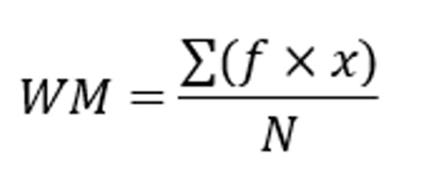

The statistical treatment of data was employed to objectively interpret the responses gathered from the TAM and ISO 25010-based survey instruments used during the system evaluation phase. Since the study utilized structured questionnaires distributed through printed copies, the collected data were quantified using a Likert scale to obtain measurable indicators of user acceptance and software quality. The weighted mean was computed to summarize respondent evaluations and determine the overall assessment for each criterion, while the simple mean was used to identify the central tendency of individual survey items. Percentage distribution was also applied to analyze the frequency of responses and identify patterns among participants. To provide clear interpretation, each computed weighted mean was classified based on the Likert scale interpretation adopted in the study.

Chapter 4
RESULT AND DISCUSSIONS

Results

Discussions

Chapter 5
SUMMARY, CONCLUSION AND RECOMMENDATIONS
Summary of Findings

Conclusions

Recommendation

Bibliography:

Abalos, M. S., & Fajardo, A. C. (2023). INTERNATIONAL JOURNAL OF MULTIDISCIPLINARY RESEARCH AND ANALYSIS Iot Based Flood Detection, Alarm and Monitoring System Using Multilayer Perceptron and Regression. https://doi.org/10.47191/ijmra/v6-i7-16
Afrianto, I., Heryandi, A., Finadhita, A., & Atin, S. (2021). User Acceptance Test For Digital Signature Application In Academic Domain To Support The Covid-19 Work From Home Program. International Journal of Information System & Technology Akreditasi, 5(3), 270–280. https://tt-el.my.id/.
Alqudah, A. A., Al-Emran, M., & Shaalan, K. (2021). Technology acceptance in healthcare: A systematic review. In Applied Sciences (Switzerland) (Vol. 11, Number 22). MDPI. https://doi.org/10.3390/app112210537
Ansari, S. A., & Vidyarthi, V. K. (2025). Use of Internet of Things in water resources applications: challenges and future directions: a critical review. In Discover Internet of Things (Vol. 5, Number 1). Springer Nature. https://doi.org/10.1007/s43926-025-00193-7
Anwar, H., Khan, A. U., Ullah, B., Taha, A. T. B., Najeh, T., Badshah, M. U., Ghanim, A. A. J., & Irfan, M. (2024). Intercomparison of deep learning models in predicting streamflow patterns: insight from CMIP6. Scientific Reports, 14(1). https://doi.org/10.1038/s41598-024-63989-7
Arante, H. R. C., Sybingco, E., Roque, M. A., Ambata, L., Chua, A., & Gutierrez, A. N. (2025). Development of a Secured IoT-Based Flood Monitoring and Forecasting System Using Genetic-Algorithm-Based Neuro-Fuzzy Network. Sensors, 25(13). https://doi.org/10.3390/s25133885
Baul Canlas, R., Cruz Piad, K., & Carpio Lagman, A. (2021). An ISO/IEC 25010 Based Software Quality Assessment of a Faculty Research Productivity Monitoring and Prediction System. ACM International Conference Proceeding Series, 238–242. https://doi.org/10.1145/3512576.3512619
Brar, P. S., Shah, B., Singh, J., Ali, F., & Kwak, D. (2022). Using Modified Technology Acceptance Model to Evaluate the Adoption of a Proposed IoT-Based Indoor Disaster Management Software Tool by Rescue Workers. Sensors, 22(5). https://doi.org/10.3390/s22051866
Bukhari, S. A. S., Shafi, I., Ahmad, J., Butt, H. T., Khurshaid, T., & Ashraf, I. (2025). Enhancing flood monitoring and prevention using machine learning and IoT integration. Natural Hazards, 121(4), 4837–4864. https://doi.org/10.1007/s11069-024-06986-3
Byaruhanga, N., Kibirige, D., Gokool, S., & Mkhonta, G. (2024). Evolution of Flood Prediction and Forecasting Models for Flood Early Warning Systems: A Scoping Review. In Water (Switzerland) (Vol. 16, Number 13). Multidisciplinary Digital Publishing Institute (MDPI). https://doi.org/10.3390/w16131763
Cedric, D., Reyes, D., Cabreros, R., Paulino, J. L., Garcia, P. J., & Santos, R. (2020). BANTAYBAHA: FLOOD MONITORING SYSTEM WITH SMS NOTIFICATION.
Chapter 5 IoT Design Methodology. (2015). http://www.internet-of-things-book.com
Chapungo, N. J., & Postolache, O. (2025). Experimental Evaluation of LoRaWAN Connectivity Reliability in Remote Rural Areas of Mozambique. Sensors, 25(19), 6027. https://doi.org/10.3390/s25196027
Choudhary, A. (2024). Internet of Things: a comprehensive overview, architectures, applications, simulation tools, challenges and future directions. In Discover Internet of Things (Vol. 4, Number 1). Springer Nature. https://doi.org/10.1007/s43926-024-00084-3
Deniziak, S., Płaza, M., & Arcab, Ł. (2022). Approach for Designing Real-Time IoT Systems. Electronics (Switzerland), 11(24). https://doi.org/10.3390/electronics11244120
Dhebe, S., Dhalge, H., Suryavanshi, V., & Shinde, H. (2023). Flood Monitoring and Alerting System. International Journal for Research in Applied Science and Engineering Technology, 11(8), 223–230. https://doi.org/10.22214/ijraset.2023.55145
Ditthakit, P., Pinthong, S., Salaeh, N., Binnui, F., Khwanchum, L., & Pham, Q. B. (2021). Using machine learning methods for supporting GR2M model in runoff estimation in an ungauged basin. Scientific Reports, 11(1). https://doi.org/10.1038/s41598-021-99164-5
Faudzi, A. A. M., Raslan, M. M., & Alias, N. E. (2023). IoT based real-time monitoring system of rainfall and water level for flood prediction using LSTM Network. IOP Conference Series: Earth and Environmental Science, 1143(1). https://doi.org/10.1088/1755-1315/1143/1/012015
Fialho, V. (2024). A Comprehensive Strategy for Implementing Adaptive Data Rate (ADR) in LoRaWAN Technology: Optimizing IoT Networks. International Journal of Innovative Technology and Exploring Engineering, 13(12), 25–30. https://doi.org/10.35940/ijitee.L1005.13121124
Gaynor, by, Sevilleno, A.-L. K., & Nicolette, C. S. (2018). Matina Flood Watch: An Urban Flooding Prediction Application using Random Tree Algorithm.
Gordon, S., Crager, J., Howry, C., Barsdorf, A. I., Cohen, J., Crescioni, M., Dahya, B., Delong, P., Knaus, C., Reasner, D. S., Vallow, S., Zarzar, K., & Eremenco, S. (2022). Best Practice Recommendations: User Acceptance Testing for Systems Designed to Collect Clinical Outcome Assessment Data Electronically. Therapeutic Innovation and Regulatory Science, 56(3), 442–453. https://doi.org/10.1007/s43441-021-00363-z
Hossain, T., Doi, Y., Tazin, T., Atiqur Rahman Ahad, M., & Inoue, S. (2018). Study of LoRaWAn technology for activity recognition. UbiComp/ISWC 2018 - Adjunct Proceedings of the 2018 ACM International Joint Conference on Pervasive and Ubiquitous Computing and Proceedings of the 2018 ACM International Symposium on Wearable Computers, 1449–1453. https://doi.org/10.1145/3267305.3267510
Kabdrakhova, S. S., Seilkhan, A., & Assan, Z. (2024). FLOOD FORECASTING IN MALAYA ALMATINKA RIVER VIA MACHINE LEARNING AND DEEP LEARNING WITH OVERSAMPLING. Journal of Problems in Computer Science and Information Technologies, 2(1), 15–24. https://doi.org/10.26577/jpcsit2024020102
Kashani, A. (n.d.). Springer Remote Sensing/Photogrammetry Flood Monitoring through Remote Sensing. Retrieved https://www.researchgate.net/publication/390349221
Keibach, E., & Shayesteh, H. (2022). BIM for Landscape Design Improving Climate Adaptation Planning: The Evaluation of Software Tools Based on the ISO 25010 Standard. Applied Sciences (Switzerland), 12(2). https://doi.org/10.3390/app12020739
Lucero, H. R., Soriano, L. D., Dela Cruz, J. D., Magniyo, R. I., & Marvic Hernaez, J. G. (n.d.). Planting Sustainability Prediction Using Random Forest Algorithm. https://doi.org/10.51244/IJRSI
Lutfie, K. A., Purnamasari, P. D., Gunawan, D., Enriko, I. K. A., & Juwono, F. H. (2025). Hierarchical Clustering-Based Algorithm for Deployment Planning of LoRa Gateway. IEEE Access, 13, 25837–25857. https://doi.org/10.1109/ACCESS.2025.3539369
Luzon-German, C., & Evangelista, R. (2024). Real-time Water Level Monitoring System in Oriental Mindoro Using Neural Networks. Journal of Innovative Technology Convergence, 6(2), 99–108. https://doi.org/10.69478/JITC2024v6n002a10
Mag-Usara, A. E. (2022). Surigao River Flood Watch and Warning App System. International Research Journal of Advanced Engineering and Science, 7(1), 263–269.
Masek, P., Stusek, M., Svertoka, E., Pospisil, J., Burget, R., Lohan, E. S., Marghescu, I., Hosek, J., & Ometov, A. (2021). Measurements of lorawan technology in urban scenarios: A data descriptor. Data, 6(6). https://doi.org/10.3390/data6060062
Mirzapour, H., Haghizadeh, A., & Motlagh, M. S. (2025). Evaluating machine learning efficiency and accuracy for real time flash flood mapping. Scientific Reports. https://doi.org/10.1038/s41598-025-34037-9
Nasyta, J., Santoso, P., Tisna, T., Hartini, F., & Suryaperdana Agoes, A. (2021). Flood Detection System Using Ultrasonic Sensor with Fuzzy Logic Method.
Natividad, J. G., & Mendez, J. M. (2018). Flood Monitoring and Early Warning System Using Ultrasonic Sensor. IOP Conference Series: Materials Science and Engineering, 325(1). https://doi.org/10.1088/1757-899X/325/1/012020
Nilo, M. A. (2020). Long Range Communication Technology for Weather Buoy. International Journal of Emerging Trends in Engineering Research, 8(8), 4399–4404. https://doi.org/10.30534/ijeter/2020/58882020
Oliveira de Sousa, F., Ariza Flores, V. A., Cunha, C. S., Oda, S., & Xavier Ratton Neto, H. (2025). Multi-Criteria Assessment of Flood Risk on Railroads Using a Machine Learning Approach: A Case Study of Railroads in Minas Gerais. Infrastructures, 10(1). https://doi.org/10.3390/infrastructures10010012
Paul, A., Abella, N., & Enriquez, M. D. (2024). Community-based flood alert system using long-range technology for Brgy. San Agustin, San Jose, Occidental Mindoro. In Mindoro Journal of Social Sciences and Development Studies (MJSSDS) (Vol. 1, Number 2).
Rathi, B., Thapaswi, S., Kambhampati, M., Jain, V., Akshay, P., Pandey, T. N., & Pradhan, S. K. (2025). Realizing the potential of Internet of Things (IoT) in Industrial applications. In Discover Internet of Things (Vol. 5, Number 1). Springer Nature. https://doi.org/10.1007/s43926-025-00141-5
Rathnayake, N., Rathnayake, U., Dang, T. L., & Hoshino, Y. (2023). Water level prediction using soft computing techniques: A case study in the Malwathu Oya, Sri Lanka. PLoS ONE, 18(4 April). https://doi.org/10.1371/journal.pone.0282847
Saber, M., Boulmaiz, T., Guermoui, M., Abdrabo, K. I., Kantoush, S. A., Sumi, T., Boutaghane, H., Hori, T., Binh, D. Van, Nguyen, B. Q., Bui, T. T. P., Vo, N. D., Habib, E., & Mabrouk, E. (2023). Enhancing flood risk assessment through integration of ensemble learning approaches and physical-based hydrological modeling. Geomatics, Natural Hazards and Risk, 14(1). https://doi.org/10.1080/19475705.2023.2203798
Shen, C. (2018). A Transdisciplinary Review of Deep Learning Research and Its Relevance for Water Resources Scientists. In Water Resources Research (Vol. 54, Number 11, pp. 8558–8593). Blackwell Publishing Ltd. https://doi.org/10.1029/2018WR022643
Siddique, M., Ahmed, T., & Husain, M. S. (2023). Flood Monitoring and Early Warning Systems – An IoT Based Perspective. In EAI Endorsed Transactions on Internet of Things (Vol. 9, Number 2). European Alliance for Innovation. https://doi.org/10.4108/eetiot.v9i2.2968
Sinha, S. (2025). Number of connected IoT devices growing 14% to 21.1 billion. https://iot-analytics.com/number-connected-iot-devices/
Situ, Z., Wang, Q., Teng, S., Feng, W., Chen, G., Zhou, Q., & Fu, G. (n.d.). Improving Urban Flood Prediction using LSTM-DeepLabv3+ and Bayesian Optimization with Spatiotemporal feature fusion.
Syamsi, N., Ulfah, M., & Lesmideyarti, D. (2024). Water Level Monitoring for Flood Early Mitigation Based on Internet of Things (IoT). TEPIAN, 5(2), 58–64. https://doi.org/10.51967/tepian.v5i2.2504
Te, M. C. L., Bautista, J. A. T., Dimacali, S. M. E. V., Lood, A. V. M., Pangan, M. G. M., & Chua, A. Y. (2024). A Smart IoT Urban Flood Monitoring System Using a High-Performance Pressure Sensor with LoRaWAN. HighTech and Innovation Journal, 5(4), 918–936. https://doi.org/10.28991/HIJ-2024-05-04-04
Thakuri, S., Parajuli, B. P., Shakya, P., Baskota, P., Pradhan, D., & Chauhan, R. (2022). Open-Source Data Alternatives and Models for Flood Risk Management in Nepal. In Remote Sensing (Vol. 14, Number 22). MDPI. https://doi.org/10.3390/rs14225660
Tolentino, L. K., Chua, E. J., Añover, J. R., Cabrera, C., Hizon, C. A., Mallari, J. G., Mamenta, J., Quijano, J. F., Virrey, G., Madrigal, G. A., & Fernandez, E. (2021). IoT-based automated water monitoring and correcting modular device via LoRaWAN for aquaculture. International Journal of Computing and Digital Systems, 10(1), 533–544. https://doi.org/10.12785/IJCDS/100151
Wicaksana, M. A., & Nuha, H. H. (2022). PREDICTION, MONITORING, AND EARLY WARNING SYSTEM OF WATER LEVELS IN FLOOD PROGRAM AREAS IN BANJARMASIN USING IoT AND LINEAR REGRESSION. JURNAL SOCIUS, 11(2), 31. https://doi.org/10.20527/js.v11i2.14576
Wu, Z., Huang, Y., Huang, K., Yan, K., & Chen, H. (2023). A Review of Non-Contact Water Level Measurement Based on Computer Vision and Radar Technology. In Water (Switzerland) (Vol. 15, Number 18). Multidisciplinary Digital Publishing Institute (MDPI). https://doi.org/10.3390/w15183233
Yuliandoko, H., Subono, Wardhany, V. A., Pramono, S. H., & Siwindarto, P. (2018). Design of flood detection system based on velocity and water level sensor in Arduino with SWOD application on Kalimati-Kretek Gantung DAM Banyuwangi. IOP Conference Series: Materials Science and Engineering, 403(1). https://doi.org/10.1088/1757-899X/403/1/012066
Zakaria, M. I., Jabbar, W. A., & Sulaiman, N. (2023). Development of a smart sensing unit for LoRaWAN-based IoT flood monitoring and warning system in catchment areas. Internet of Things and Cyber-Physical Systems, 3, 249–261. https://doi.org/10.1016/j.iotcps.2023.04.005

