Inventory Strategy Analysis
Using sales and inventory data to support practical inventory decisions

1. Project Overview
This project looks at retail sales and inventory performance across products, stores, and categories. The goal is to identify where inventory can be reduced, where additional inventory is justified, which categories are worth further expansion review, and which stores should be reviewed operationally first.

2. Business Challenge
Inventory ties up cash, so increasing stock everywhere is not always the best choice. On the other hand, reducing inventory too aggressively can affect products that are performing well. I therefore compared revenue, units sold, inventory, and inventory turnover together instead of relying on a single metric.

3. Approach & Tools
Data: Retail sales, product, store, and inventory data from the Maven Toys dataset.
SQL: PostgreSQL was used to prepare the analysis, calculate inventory value and turnover, rank products and stores, and build the recommendation logic.
Power BI: Used to present the results in an executive dashboard.
Analysis | How I approached it
Inventory reduction | Calculated inventory value from inventory quantity and product cost, then prioritized products using sales and inventory-efficiency measures. A 20% inventory-value reduction target was used to determine the reduction amount.
Store investment | Compared revenue, units sold, inventory, and inventory turnover. Stores with stronger sales performance and better inventory efficiency received higher investment priority.
Category expansion | Compared revenue, units sold, inventory turnover, and inventory by category. Revenue and units sold received more weight because they directly reflect sales performance.
Operational improvement | Looked for stores with relatively low revenue and units sold, low inventory turnover, and relatively high inventory. These stores were flagged for operational review before adding more stock.

4. Key Findings
Inventory reduction: $59.99K represents a 20% reduction in inventory value. The analysis identifies 13 products with a recommended reduction; the target is reached after the highest-priority products are reduced and Dinosaur Figures contributes a further 17.3%.
Additional inventory: Three stores stand out as the strongest candidates for additional inventory: Maven Toys Guanajuato 1, Maven Toys Saltillo 1, and Maven Toys Ciudad de Mexico 1.
Category expansion: Toys has the highest expansion-priority score at 0.583, followed by Art & Crafts at 0.427 and Electronics at 0.408.
Operational improvement: The highest-priority stores combine lower revenue and units sold with lower turnover and relatively high inventory. They are better candidates for operational review before additional inventory is added.

5. Business Recommendations
- Reduce inventory selectively instead of applying the same reduction to every product.
- Direct additional inventory toward the small number of stores where sales performance and inventory turnover support the investment.
- Use Toys, Art & Crafts, and Electronics as the first categories for further expansion review.
- Review operational performance at weaker stores before committing additional inventory.

6. Dashboard
The Power BI dashboard brings the recommendations together in one page, making it easy to compare inventory reduction priorities, store investment opportunities, category expansion priorities, and stores that need operational review.
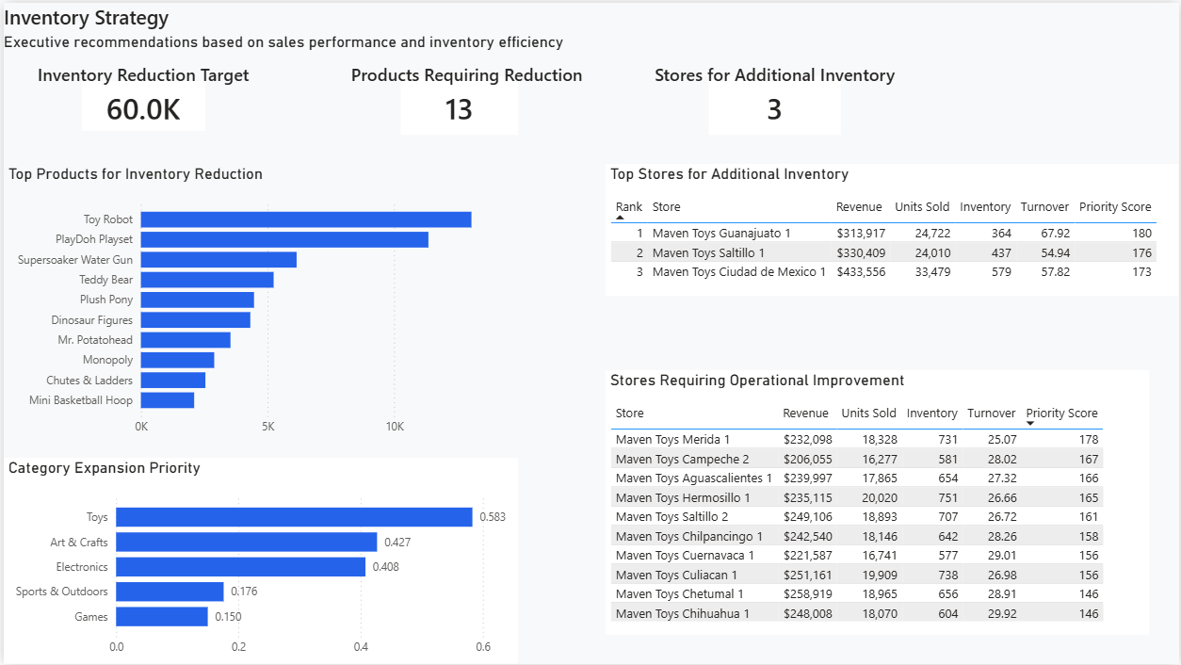
Inventory Strategy dashboard
Tools: PostgreSQL / SQL • Power BI

