CaseStudyNotes-Jenkins:

<https://www.guru99.com/jenkins-tutorial.html>

CI-CD:

In Continuous Integration after a code commit, the software is built and tested immediately. In a large project with many developers, commits are made many times during a day. With each commit code is built and tested. If the test is passed, build is tested for deployment. If the deployment is a success, the code is pushed to Production. This commit, build, test, and deploy is a continuous process, and hence the name continuous integration/deployment.

[CI vs CD](https://www.guru99.com/continuous-integration-vs-delivery-vs-deployment.html): Continuous Integration (CI) is an approach of testing each change to codebase automatically, whereas Continuous Delivery (CD) is an approach to obtain changes of new features, configuration, and bug fixes.

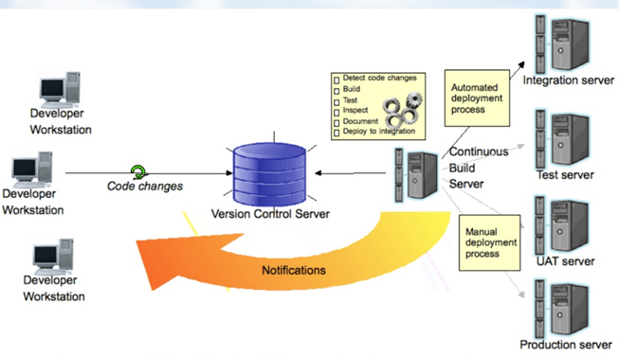

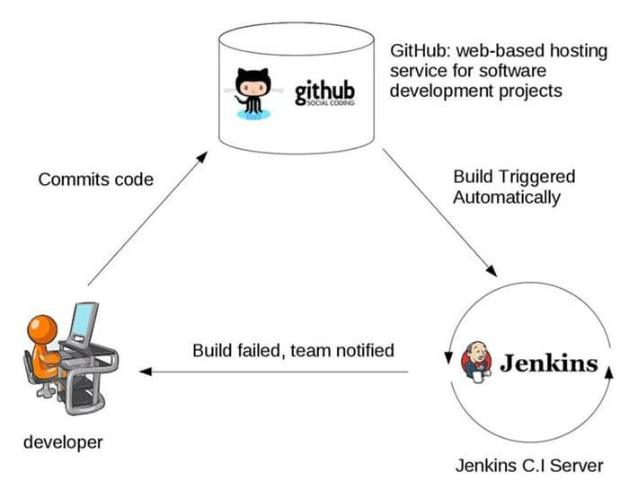

**Jenkins Plugins**

By default, Jenkins comes with a limited set of features. If you want to integrate your Jenkins installation with version control tools like Git, then you need to install plugins related to Git. In fact, for integration with tools like Maven, Amazon EC2, you need to install respective plugins in your Jenkins.

## Conclusion:

* In Continuous Integration, after a code commit, the software is built and tested immediately
* Jenkins used for orchestrating a chain of actions for Continuous Integration in a software project
* Before Jenkins when all Developers had completed their assigned coding tasks, they used to commit their code all at same time. Later, Build is tested and deployed.
* After Jenkins the code is built and test as soon as Developer commits code. Jenkin will build and test code many times during the day
* By default, Jenkins comes with a limited set of features. If you want to integrate your Jenkins installation with version control tools like Git, then you need to install plugins related to Git
* The biggest pros of Jenkins is that it is managed by the community which holds public meetings and take inputs from the public for the development of Jenkins projects
* The biggest con of Jenkin is that Its interface is out dated and not user friendly compared to current UI trends.

How to install Jenkins:

<https://www.guru99.com/download-install-jenkins.html>

for manual start, go to C:\Apps2022; Jenkins.exe start/stop/restart and the port is set to 8008. It can be changed in configuration file.

Jenkins can be start by command or with docker run.

Use Manage Jenkins to add plugins, users, etc.

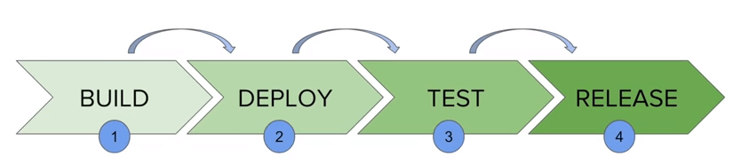

Jenkins pipelines can be defined using a text file called **JenkinsFile.**You can implement pipeline as code using JenkinsFile, and this can be defined by using a domain specific language (DSL). With JenkinsFile, you can write the steps needed for running a Jenkins pipeline.

**Declarative versus Scripted pipeline syntax:**

There are two types of Jenkins pipeline syntax used for defining your JenkinsFile.

1. Declarative
2. Scripted

// TODO: need a good example

