**武汉大学2019-2020年度第二学期**

**《网络与分布式计算》 A卷**

学号 __________ 姓名___________院（系） _____________分数 ___________

(注：1. 考试时间为120分钟； 2. 所有解答必须写在答题纸上。)

Network and Distributed Computing

Welcome to the Final Exam for Computer Network and Distributed Computing at such a tough time of the new coronavirus. This exam is open book. There are nine required problems of differing point values. Each question is clearly labeled with its value. Read each problem carefully. You may have with you a calculator, a laptop, pencils and/or pens, erasers, and blank papers. You are allowed to surf the web while working on the solution of all the problems. All your problem solutions must be handwritten on the answer sheets in pencil or ink. Solutions are NOT allowed written on the problem sheet. You have 120 minutes for this exam. Please make sure use separate answer sheets for the solution to each problem. Good luck and be sure to show your work!

**Predefined parameters:**

Please carefully read all these paragraphs to get a well understanding of the predefined parameters. All the variables predefined here will be used throughout the whole examination.

Suppose that string A is your student ID and the 32 bits unsigned integer B is the last 6 digital value of your student ID. For example, if your student ID is 2012302580001 then A = “2012302580001”, B = 580001.

Now write down your input predefined variables as **the first two lines on the head of your answer sheet**:

A = “ ”

B =

**Before proceed to the questions below, please carefully check the above inputs several times to make sure that your inputs are correct. Most of the problems will be based on these predefined parameters.**

**Problem #1** ( 10 points )

**Suppose that C is the 16-bit word of the low-order word of the predefined variable B. Let D = 1110 0000 0000 0001 be another 16-bit word. Calculate to show the internet check sum of the bits of C and D.**

**Problem #2** ( 10 points )

**Suppose that C is as defined as in Problem 1. Let C_1 be the low-order byte of C and C_2 be the high-order byte of C.** **Recall that with the CSMA/CD protocol, the adapter waits 512K bit times after a collision, where K is drawn randomly. Suppose now that adapter A_1 experienced a collision with adapter A_2. Adapter A_1 randomly chosen K = C_1 via adapter A_2 randomly chosen K = C_2. How long does each adapter wait for in a 10 Mbps broadcast channel? What about for a 100 Mbps broadcast channel?**

**Problem #3** ( 10 points )

**Suppose that a web server uses HTTP GET method to design an HTML form to input student ID in the requested URL. If the inputted data (in the form fields) in the requested URL is your student ID (as the predefined parameter A), and the web server is cs.whu.edu.cn. What will the corresponding extended URL be most likely look like (you input in the address bar of your browser)?**

**Problem #4** ( 10 points )

**Suppose that C_1 and C_2 are as defined as in Problem 2. Let E = 2400 + C_1. Consider sending a datagram with E bytes into a link that has an MTU of 700 bytes. Suppose the original datagram is stamped with the identification number** **C_2 as defined in Problem 2. How many fragments are generated? What are the values in the various fields in the IP datagram(s) generated related to fragmentation?**

**Problem #5** ( 15 points )

**Let C_1 be as defined as in Problem 2. Consider the network fragment shown below. x has only two attached neighbors, w and y. w has a minimum-cost path to destination u (not shown) of value 5 + C_1, and y has a minimum-cost path to u of value 6 + C_1. The complete paths from w and y to u (and between w and y) are not shown. All link costs in the network have strictly positive integer values.**

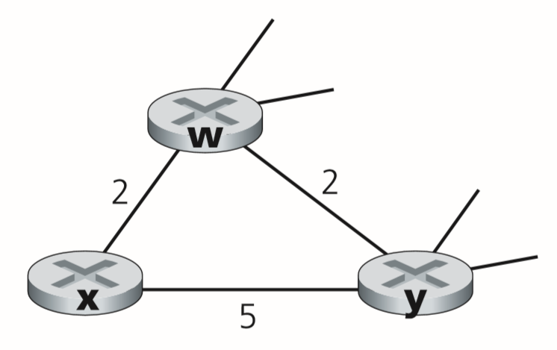

1. **Give x’s distance vector for destinations w, y, and u.**
2. **Give a link-cost change for either c(x,w) or c(x,y) such that x will inform its neighbors of a new minimum-cost path to u as a result of executing the distance-vector algorithm.**
3. **Give a link-cost change for either c(x,w) or c(x,y) such that x will not inform its neighbors of a new minimum-cost path to u as a result of executing the distance-vector algorithm.**

**Problem #6** ( 10 points )

**Suppose that C_1 is as defined as in Problem 2. Suppose a sender using the CRC generator polynomial x4+x+1 sends C_1 as a sequence of 8 bits. What is the result sequence the sender sends out? Show your work. Now that the receiver received these bits and the first bit ( the most significant bit ) is bit flipped during transmission, how does the receiver detect out this error? Show with detail computation.**

**Problem #7** ( 10 points )

**Suppose that C is as defined as in Problem 1. Consider a datagram network using 16-bit host addresses. Suppose a router uses longest prefix matching and has the following forwarding table:**

|  |  |
| --- | --- |
| **Prefix Match** | **Interface** |
| **1101 1001 1010 0** | **0** |
| **1101 1001 1010 010** | **1** |
| **1101 1001 1010 01** | **2** |
| **1101 1001 1010 1** | **3** |
| **1101 1001 1010 110** | **4** |
| **1101 1001 1010 11** | **5** |
| **1101 1001 1011 0** | **6** |
| **1101 1001 1011 010** | **7** |
| **1101 1001 1011 01** | **8** |
| **1101 1001 1011 1** | **9** |
| **otherwise** | **10** |

**Describe how this forwarding table determines the appropriate link interface for datagrams with destination addresses C ( as defined in Problem 1 ).**

**Problem #8** ( 10 points )

**Suppose that C is as defined as in Problem 1. Let M_3 be the hex value of C ( calculating this hex value using Calculator of Win10 ). Let Mac_0 =** **00-15-5D-41-80-A8 be a MAC address. Suppose the MAC address of NIC of a laptop is Mac_1 is equal to Mac_0 except the last word replaced by M_3 ( for example if M_3 = B3A7, then Mac_1 = 00-15-5D-41-B3-A7 ). Suppose that the above laptop connected to a switch, and a desktop host with the MAC address Mac_0 is also connected to the same switch. If the laptop sends a series of frames to the desktop host, how will the switch table be created and updated? What will the final switch table look like. Give the hexadecimal value for the two-byte type field of the Ethernet Frame of a ARP request message. What upper layer protocol does this type field correspond to?**

**Problem #9** ( 15 points )

**List all the different wireless network technologies you know and their characteristics. If you have a choice between multiple technologies, why do you prefer one over another? Design a network system (convenient for wireless access) for our school campus of Wuhan University, describe what kind of protocols will be used in each specific situation for student consumption. What is your idea to direct traffic across different campus, for example, from Campus One to Campus Four? You may consider HFC and VLAN in your blueprint, and all other techniques you learned in this course to make a marvelous designation. Please give a detail description of your designation.**