**Assignment 1**

1. **Ping another computer (my macbook)**

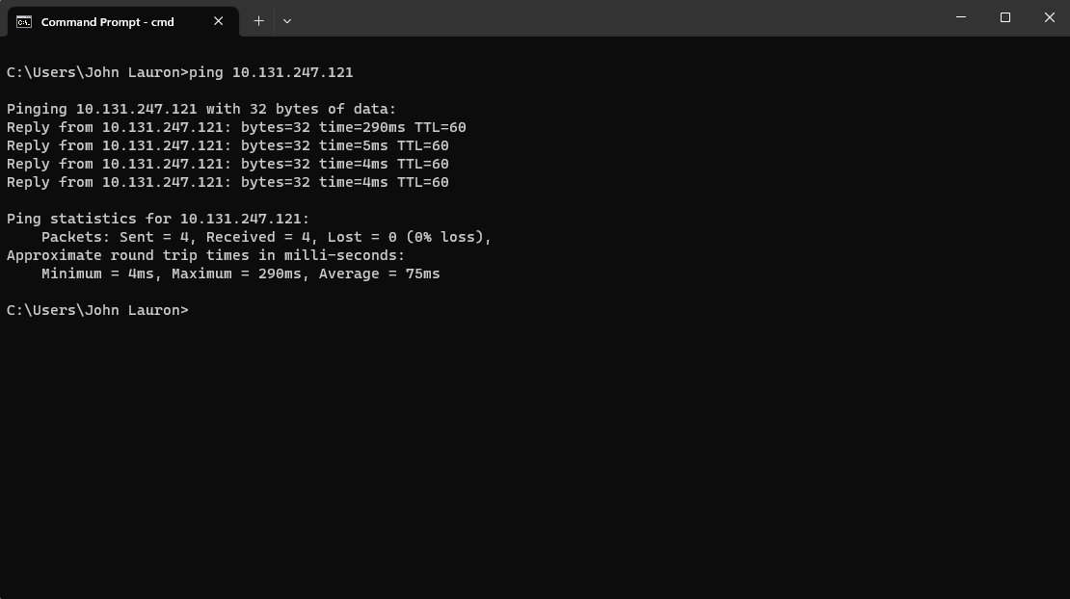

1. **Tracert a server (Stanford University Website)**

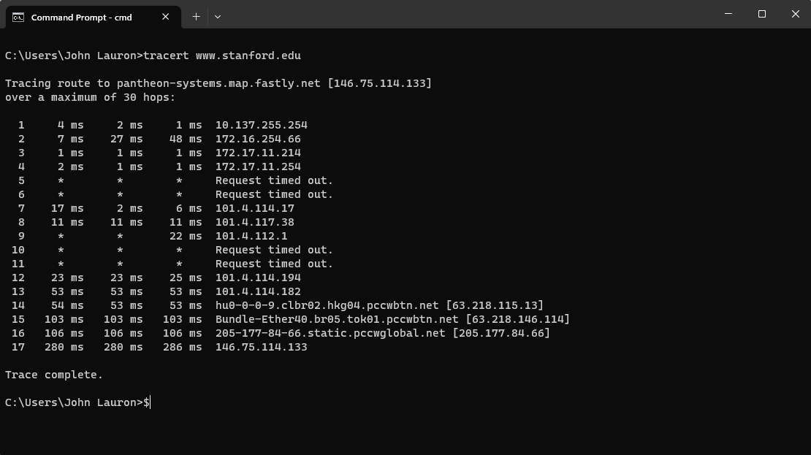

1. **Register a github account, download lab resource from https://github.com/wireshark/wireshark**