Computer Networking

Assignment 10

# Homework 10

## Problems of Chapter 5:

P3

Consider the following network. With the indicated link costs, use Dijkstra’s

shortest-path algorithm to compute the shortest path from x to all network nodes.

Show how the algorithm works by computing a table similar to Table 5.1.

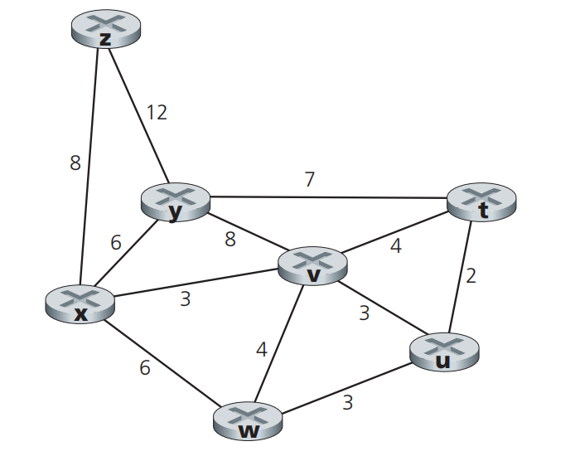

|  |  |  |  |  |  |  |
| --- | --- | --- | --- | --- | --- | --- |
| **S’** | **l(t), c(t)** | **l(u),c(u)** | **l(v),c(v)** | **l(w),c(w)** | **l(y),c(y)** | **l(z),c(z)** |
| **x** | ∞ | ∞ | 3,x | 6,x | 6,x | 8,x |
| **xv** | 7,v | 6,v | 3,x | 6,x | 6,x | 8,x |
| **xvu** | 7,v | 6,v | 3,x | 6,x | 6,x | 8,x |
| **xvuw** | 7,v | 6,v | 3,x | 6,x | 6,x | 8,x |
| **xvuwy** | 7,v | 6,v | 3,x | 6,x | 6,x | 8,x |
| **xvuwyt** | 7,v | 6,v | 3,x | 6,x | 6,x | 8,x |
| **xvuwytz** | 7,v | 6,v | 3,x | 6,x | 6,x | 8,x |

Where,

S’ = subset of nodes

c(t) = Current path of node t

l(t) = Least cost path of node t

Therefore, the following are the shortest paths from x along with their costs:

|  |  |  |
| --- | --- | --- |
| **From x to** | **The shortest path** | **Cost** |
| t | x,v,t | 7 |
| u | x,v,u | 6 |
| v | x,v | 3 |
| w | x,w | 6 |
| y | x,y | 6 |
| z | x,z | 8 |

P5

Consider the network shown below, and assume that each node initially

knows the costs to each of its neighbors. Consider the distance-vector algorithm and show the distance table entries at node z.

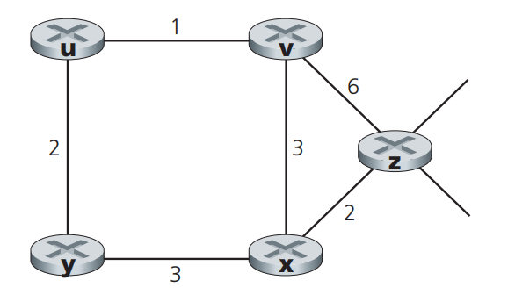

Step 1:

|  |  |  |  |  |  |
| --- | --- | --- | --- | --- | --- |
| **Cost from v,x,z To u,v,x,y,z** | **u** | **v** | **x** | **y** | **z** |
| v | ∞ | ∞ | ∞ | ∞ | ∞ |
| x | ∞ | ∞ | ∞ | ∞ | ∞ |
| z | ∞ | 6 | 3 | ∞ | 0 |

Step 2:

|  |  |  |  |  |  |
| --- | --- | --- | --- | --- | --- |
| **Cost from v,x,z To u,v,x,y,z** | **u** | **v** | **x** | **y** | **z** |
| v | 1 | 0 | 3 | ∞ | 6 |
| x | ∞ | 3 | 0 | 3 | 2 |
| z | 7 | 5 | 2 | 5 | 0 |

Step 3:

|  |  |  |  |  |  |
| --- | --- | --- | --- | --- | --- |
| **Cost from v,x,z To u,v,x,y,z** | **u** | **v** | **x** | **y** | **z** |
| v | 1 | 0 | 3 | 3 | 5 |
| x | 4 | 3 | 0 | 3 | 2 |
| z | 6 | 5 | 2 | 5 | 0 |

Step 4:

|  |  |  |  |  |  |
| --- | --- | --- | --- | --- | --- |
| **Cost from v,x,z To u,v,x,y,z** | **u** | **v** | **x** | **y** | **z** |
| v | 1 | 0 | 3 | 3 | 5 |
| x | 4 | 3 | 0 | 3 | 2 |
| z | 6 | 5 | 2 | 5 | 0 |

P9

Consider the count-to-infinity problem in the distance vector routing. Will

the count-to-infinity problem occur if we decrease the cost of a link? Why?

How about if we connect two nodes which do not have a link?

**If the cost of a link is reduced, the count-to-infinity problem may occur. This happens when nodes update their least costs based on received updates and send out their own updates for distance vector. Additionally, when two nodes are connected, this problem can cause difficulties in proper data propagation and result in errors when determining the minimum cost paths.**