Computer Networking

Assignment 11

# Homework 11

## Problems of Chapter 5:

P12 - Describe how loops in paths can be detected in BGP.

**Answer:**

**To identify loops in the Border Gateway Protocol (BGP):**

**Since BGP spreads and receives information about the availability of all neighboring Autonomous Systems (AS), routing is determined using the AS-PATH and NEXT-HOP attributes. Therefore the router checks all the AS numbers listed in the path. If it detects its own AS number, it will reject the advertisement to prevent looping.**

P16- Consider the following network. ISP B provides national backbone service

to regional ISP A. ISP C provides national backbone service to regional

ISP D. Each ISP consists of one AS. B and C peer with each other in two

places using BGP. Consider traffic going from A to D. B would prefer

to hand that traffic over to C on the West Coast (so that C would have

to absorb the cost of carrying the traffic cross-country), while C would

prefer to get the traffic via its East Coast peering point with B (so that B

would have carried the traffic across the country). What BGP mechanism

might C use, so that B would hand over A-to-D traffic at its East Coast

peering point? To answer this question, you will need to dig into the BGP

specification.

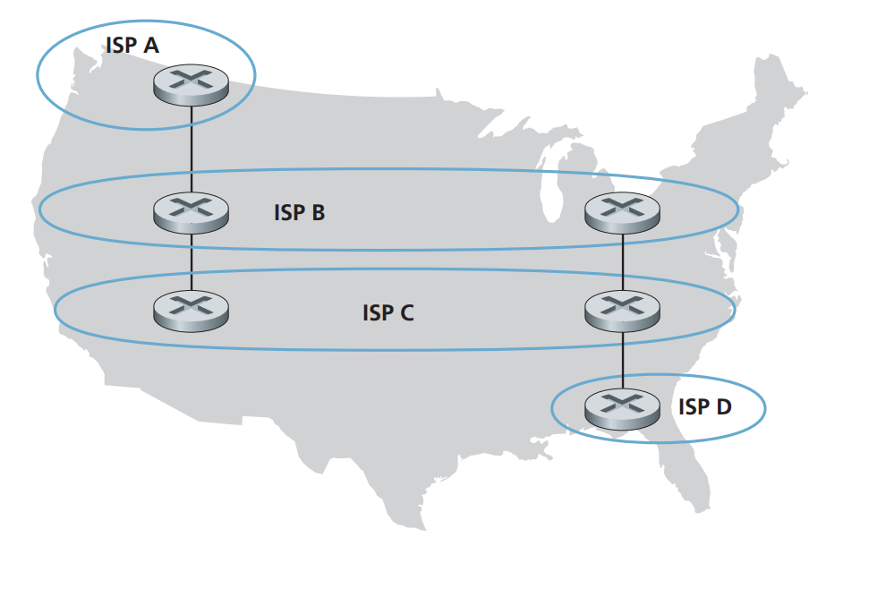

**Answer: To make B redirect all its traffic to D on the east coast, C can achieve this by advertising its route to D solely through its east coast peering point with B.**

P20- Suppose ASs X and Z are not directly connected but instead are connected

by AS Y. Further suppose that X has a peering agreement with Y, and that Y

has a peering agreement with Z. Finally, suppose that Z wants to transit all

of Y’s traffic but does not want to transit X’s traffic. Does BGP allow Z to

implement this policy?

**Answer: Yes, BGP allows Z to implement the given policy. Given that AS X, AS Y, and AS Z are part of the network, the Inter-AS routing protocol used in this network is Border Gateway Protocol (BGP).**

**And thus,**

* **Neighboring AS provides subnet reachability information.**
* **AS X and AS Y have a peering agreement.**
* **AS Y and AS Z have a peering agreement.**
* **AS Z has the ability to create policies using this protocol.**
* **Each AS retains the BGP route information.**
* **AS Y must inform AS X that it has no path to AS Z.**
* **AS X is unaware that AS Y has a path to AS Z.**
* **AS X does not route traffic.**
* **AS Z is capable of receiving all traffic from AS Y.**

P22- In Section 5.7, we saw that it was preferable to transport SNMP messages in

unreliable UDP datagrams. Why do you think the designers of SNMP chose

UDP rather than TCP as the transport protocol of choice for SNMP?

**Answer: The creators of SNMP, a protocol used for managing networks, decided to use UDP instead of TCP as the preferred transport protocol because if SNMP were to use TCP, it would stop sending messages. If a network manager needs to send SNMP messages, the TCP's control mechanism would interfere with SNMP and cause it to back off.**

## Lab

https://www.github.com/network-whu/lab/

3.Wireshark_ICMP.docx