Computer Networking

Assignment 12

# Homework 12

## Problems of Chapter 6:

P1- Suppose the information content of a packet is the bit pattern 1110 0110 1001

0101 and an even parity scheme is being used. What would the value of the field

containing the parity bits be for the case of a two-dimensional parity scheme?

Your answer should be such that a minimum-length checksum field is used.

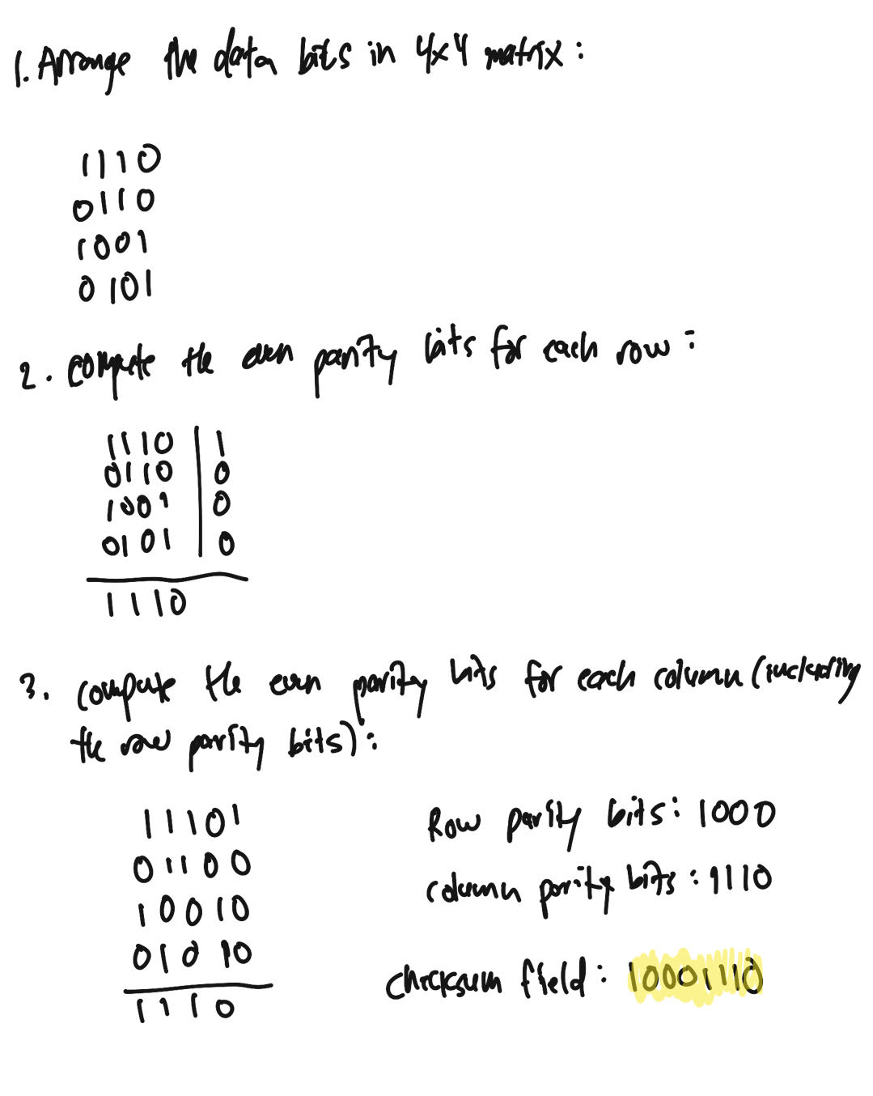

P5- Consider the 5-bit generator, G = 10011, and suppose that D has the value

1010101010. What is the value of R?

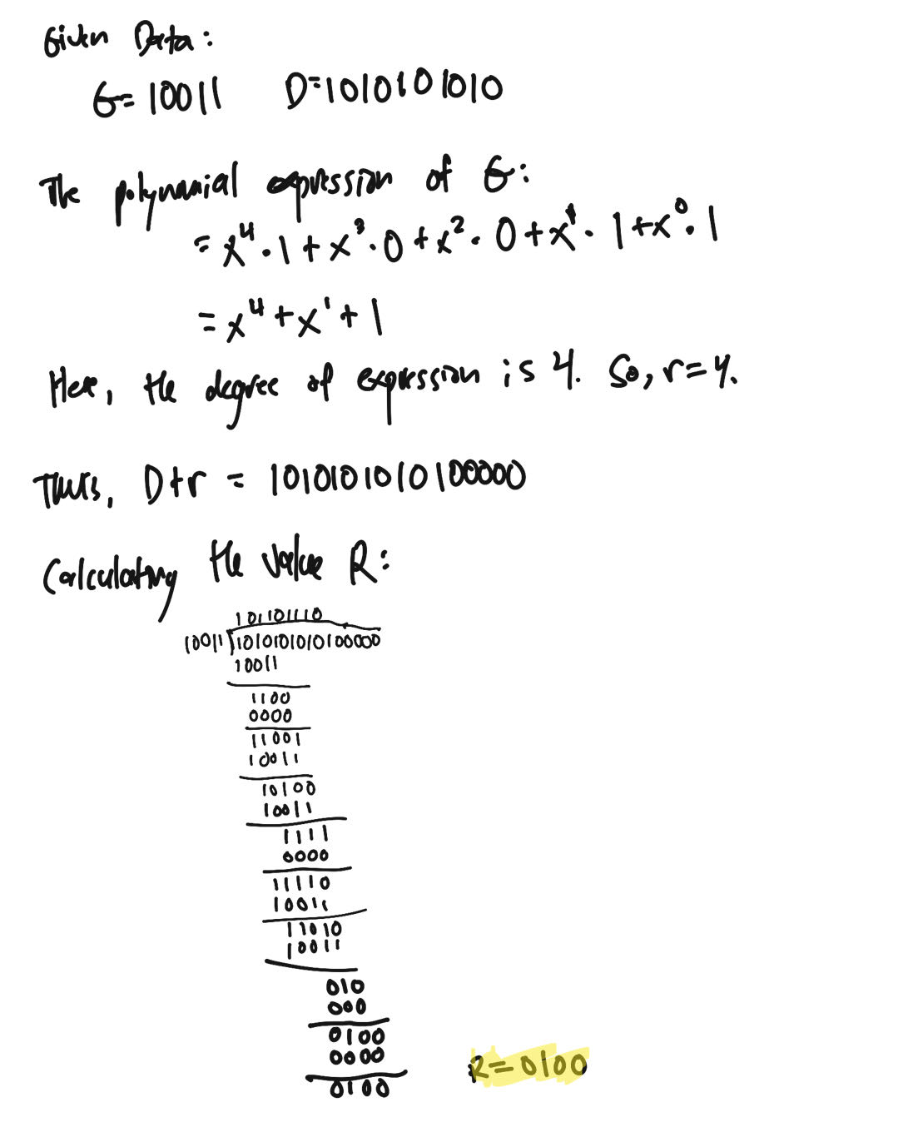

P17- Recall that with the CSMA/CD protocol, the adapter waits K # 512 bit times

after a collision, where K is drawn randomly. For K = 100, how long does

the adapter wait until returning to Step 2 for a 100 Mbps broadcast channel?

For a 1 Gbps broadcast channel?

**Answer:**

**With the CSMA/CD protocol, the adapter waits K # 512 bit times after a collision before attempting to retransmit.**

**For K = 100, the adapter would wait 100 * 512 = 51,200 bit times before attempting to retransmit on a 100 Mbps broadcast channel.**

**On a 1 Gbps broadcast channel, the wait time would be shorter because the channel has a higher data rate. The time to transmit one bit at 1 Gbps is 1 nanosecond (ns). Therefore, the adapter would wait 100 * 512 * 1 ns = 51.2 microseconds (μs) before attempting to retransmit on a 1 Gbps broadcast channel.**

P19 -

Suppose nodes A and B are on the same 10 Mbps broadcast channel, and the propagation delay between the two nodes is 245 bit times. Suppose A and B send Ethernet frames at the same time, the frames collide, and then A and B choose different values of K in the CSMA/CD algorithm. Assuming no other nodes are active, can the retransmissions from A and B collide? For our purposes, it suffices to work out the following example. Suppose A and B begin transmission at t = 0 bit times. They both detect collisions at t = 245t bit times. Suppose KA = 0 and KB = 1. At what time does B schedule its retransmission? At what time does A begin transmission? (Note: The nodes must wait for an idle channel after returning to Step 2—see protocol.) At what time does A’s signal reach B? Does B refrain from transmitting at its scheduled time?

**Answer:**

**Following the collision detection at t = 245, A and B select different values for K. Since KA = 0, A immediately begins sensing the channel and will start transmitting again at t = 245. B receives A's transmission at t = 490 (245 + 245 = 490) and then begins transmitting at t = 490. As a result, A and B do not collide.**

## Lab

https://www.github.com/network-whu/lab/

8.Wireshark_Ethernet_ARP.docx