Computer Networking Assignment 4

Due in 2 weeks

**Part 1- Telnet**

b2392d2362236b03ae0c601259c029e

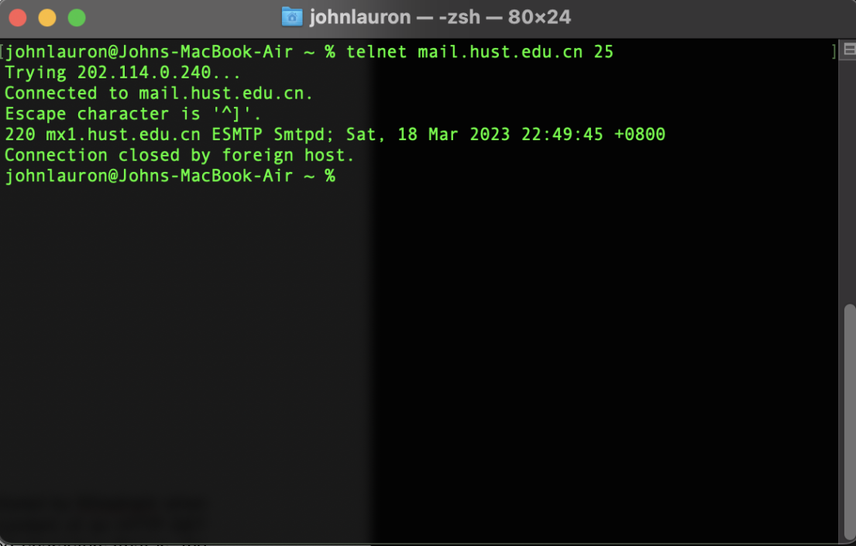

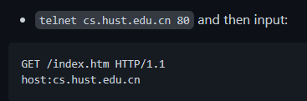

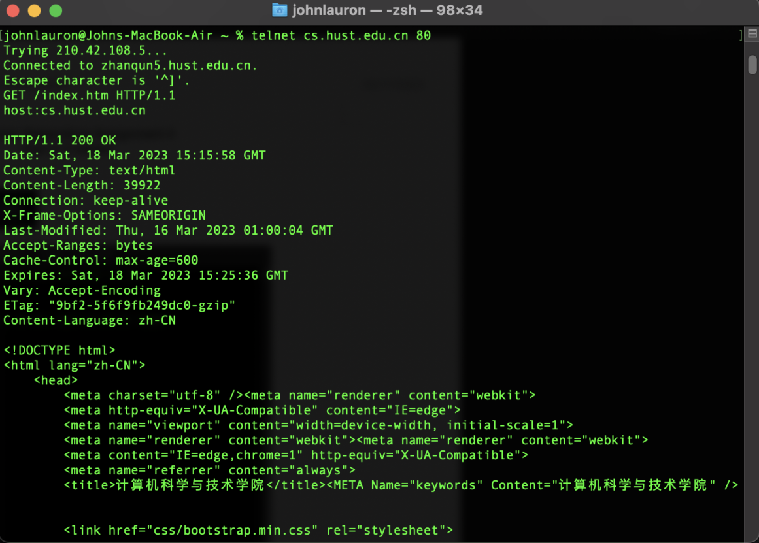

**Part 2 - Chapter 2 Textbook Problems**

**P4**: Consider the following string of ASCII characters that were captured by Wireshark when the browser sent an HTTP GET message (i.e., this is the actual content of an HTTP GET message). The characters <cr><lf> are carriage return and line-feed characters (that is, the italized character string <cr> in the text below represents the single carriage-return character that was contained at that point in the HTTP header). Answer the following questions, indicating where in the HTTP GET message below you find the answer.

GET /cs453/index.html HTTP/1.1*<cr><lf>*Host: gai

a.cs.umass.edu*<cr><lf>*User-Agent: Mozilla/5.0 (

Windows;U; Windows NT 5.1; en-US; rv:1.7.2) Gec

ko/20040804 Netscape/7.2 (ax) *<cr><lf>*Accept:ex

t/xml, application/xml, application/xhtml+xml, text

/html;q=0.9, text/plain;q=0.8,image/png,*/*;q=0.5

*<cr><lf>*Accept-Language: en-us,en;q=0.5*<cr><lf>*Accept

Encoding: zip,deflate*<cr><lf>*Accept-Charset: ISO

-8859-1,utf-8;q=0.7,*;q=0.7*<cr><lf>*Keep-Alive: 300*<cr>*

*<lf>*Connection:keep-alive*<cr><lf><cr><lf>*

1. What is the URL of the document requested by the browser? **http://giai.cs.umass.edu/cs453/index.html.**
2. What version of HTTP is the browser running? **HTTP Version 1.1**

c. Does the browser request a non-persistent or a persistent connection? **A persistent connection (can be seen through the “Keep-alive” connection).**

d. What is the IP address of the host on which the browser is running? **Since the IP address is not contained in an HTTP message, this question cannot be answered directly. In order to have such information, we would need access to the information present in IP datagrams.**

e. What type of browser initiates this message? Why is the browser type needed in an HTTP request message? **The type of browser that initiated this message is Mozilla/5.0. The browser type is needed in an HTTP request message because the server may have to send a different types of the same object to different browsers.**

**P12:** Write a simple TCP program for a server that accepts lines of input from a client and prints the lines onto the server’s standard output. (You can do this by modifying the TCPServer.py program in the text.) Compile and execute your program. On any other machine that contains a Web browser, set the proxy server in the browser to the host that is running your server program; also configure the port number appropriately. Your browser should now send its GET request messages to your server, and your server should display the messages on its standard output. Use this platform to determine whether your browser generates conditional GET messages for objects that are locally cached.

OperaGX Browser (with localhost IP 127.0.0.1)

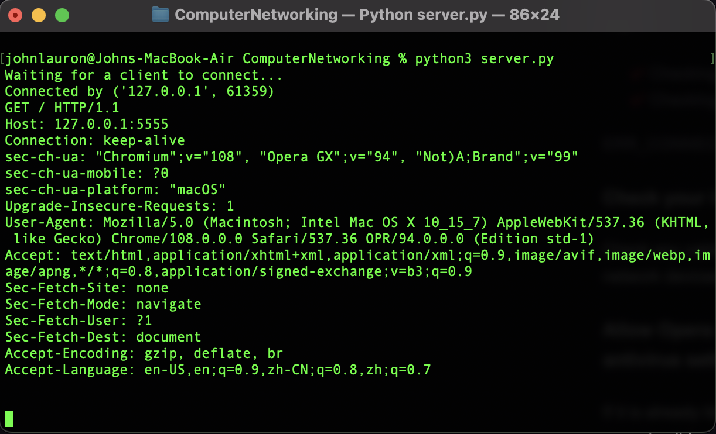

Google Chrome Browser (with localhost IP 127.0.0.1)

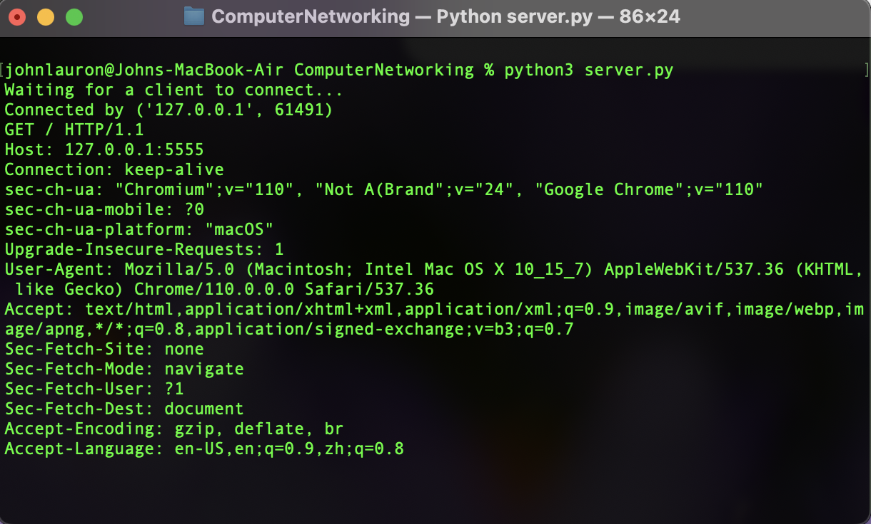

**If the client browser’s IP address’s is configured to the host’s loopback address (localhost 127.0.0.1 and same port) , then it will connect to the server and generate conditional GET messages for objects that are locally cached.**

**Part 3- Wireshark Lab**

- do lab 2.Wireshark_HTTP.docx

- check final lab report