Computer Networking- Homework 7

Due in 2 weeks

**## Problems of Chapter 3:**

P26. Consider transferring an enormous file of L bytes from Host A to Host B.

Assume an MSS of 536 bytes.

a. What is the maximum value of L such that TCP sequence numbers are not exhausted? Recall that the TCP sequence number field has 4 bytes.

b. For the L you obtain in (a), find how long it takes to transmit the file. Assume that a total of 66 bytes of transport, network, and data-link header are added to each segment before the resulting packet is sent out over a 155 Mbps link. Ignore flow control and congestion control so A can pump out the segments back to back and continuously.

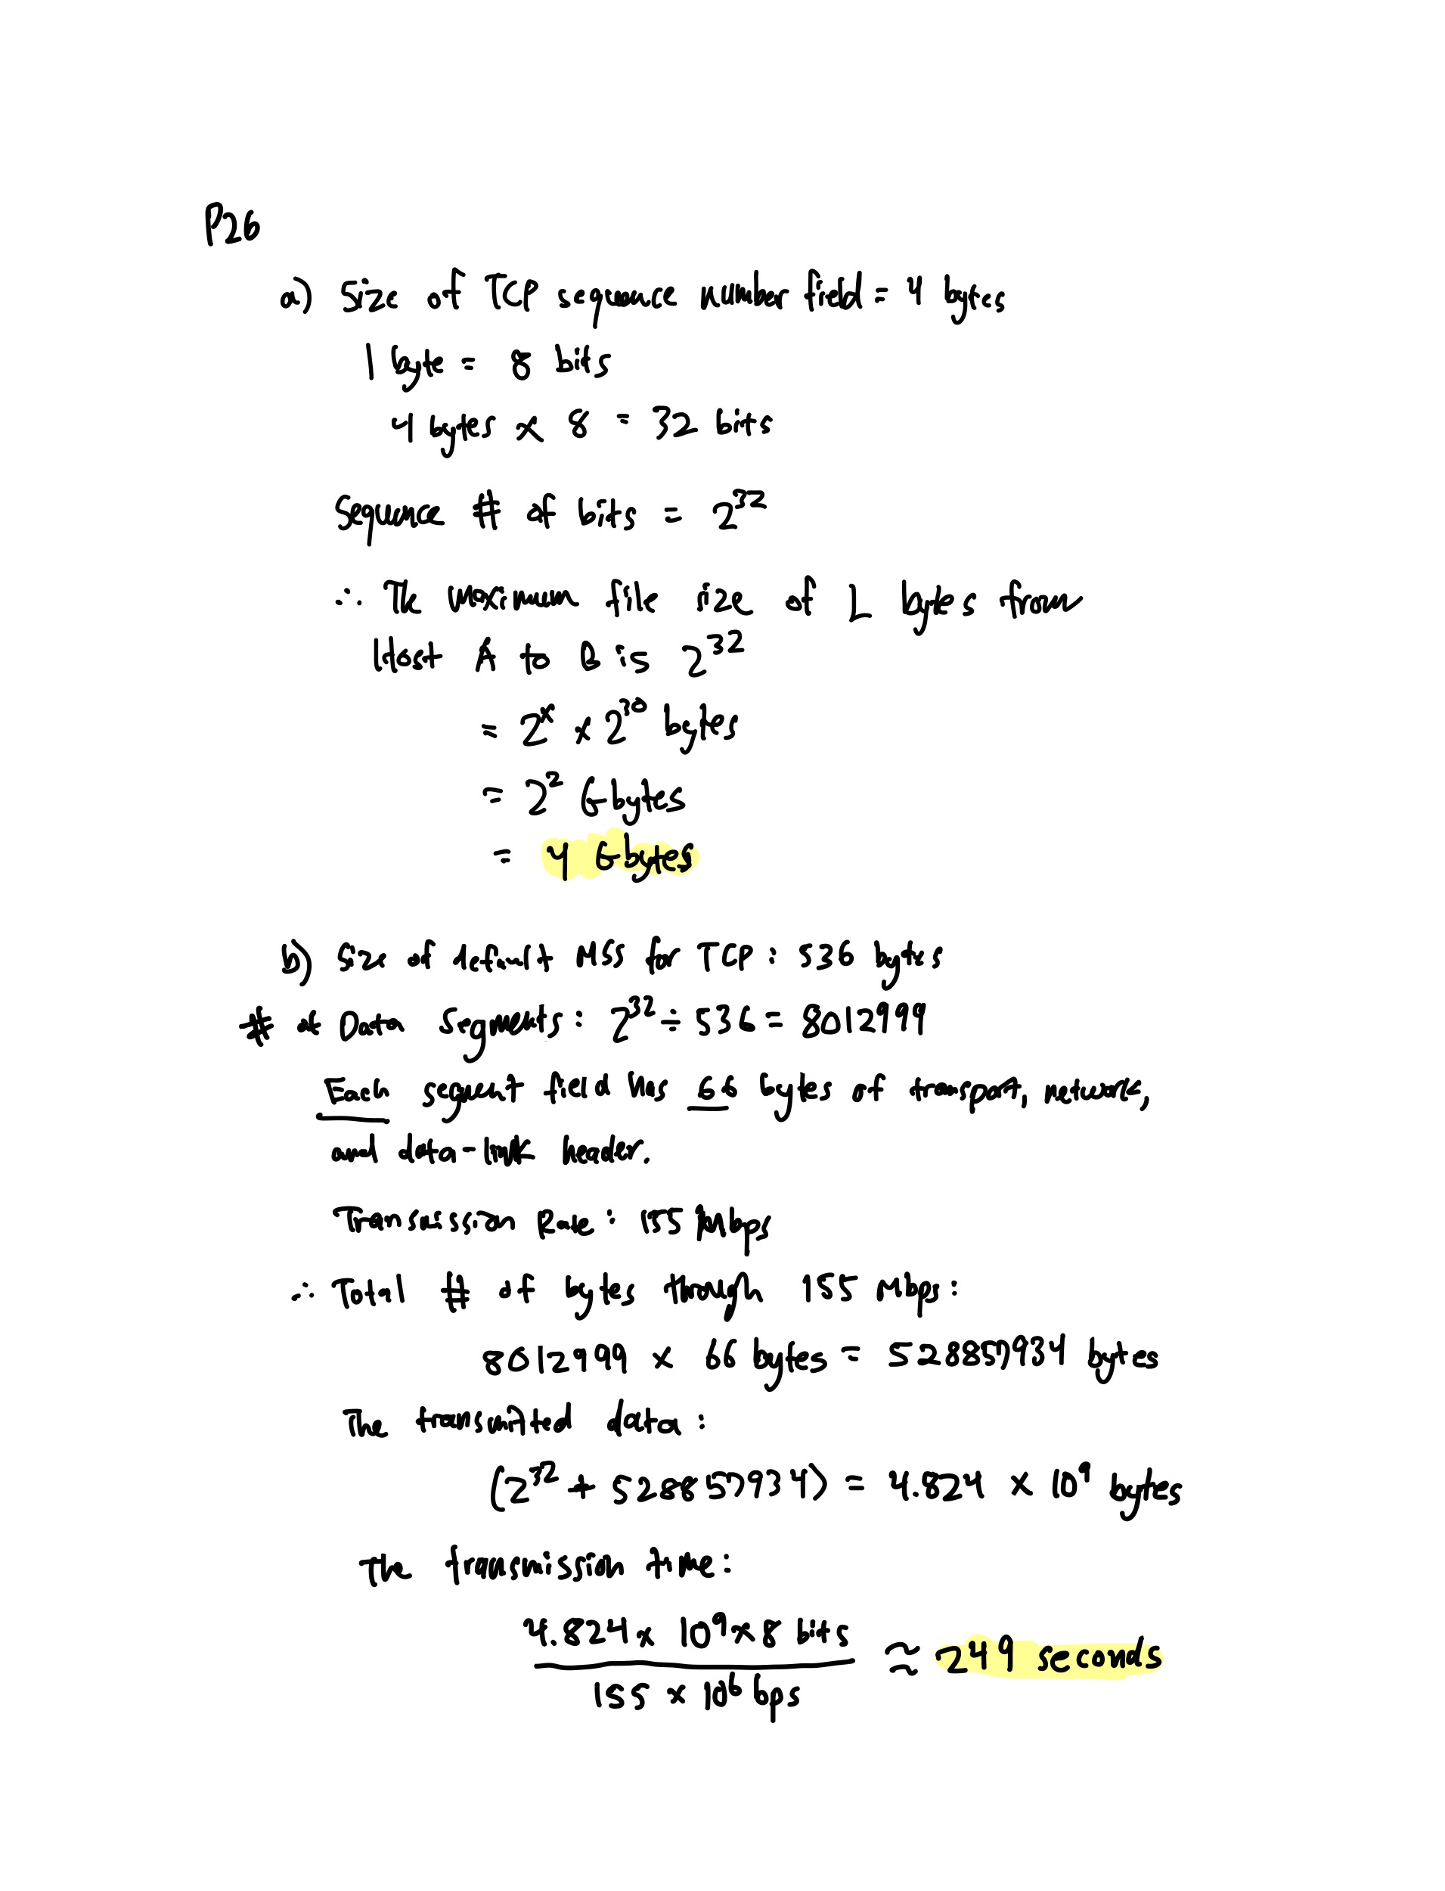

P27. Host A and B are communicating over a TCP connection, and Host B has already received from A all bytes up through byte 126. Suppose Host A then sends two segments to Host B back-to-back. The first and second segments contain 80 and 40 bytes of data, respectively. In the first segment, the sequence number is 127, the source port number is 302, and the destination port number is 80. Host B sends an acknowledgment whenever it receives a segment from Host A.

1. In the second segment sent from Host A to B, what are the sequence number, source port number, and destination port number?

b. If the first segment arrives before the second segment, in the acknowledgment of the first arriving segment, what is the acknowledgment number,

the source port number, and the destination port number?

c. If the second segment arrives before the first segment, in the acknowledgment of the first arriving segment, what is the acknowledgment number?

d. Suppose the two segments sent by A arrive in order at B. The first acknowledgment is lost and the second acknowledgment arrives after the first timeout interval. Draw a timing diagram, showing these segments and all other segments and acknowledgments sent. (Assume there is no additional packet loss.) For each segment in your figure, provide the

sequence number and the number of bytes of data; for each acknowledgment that you add, provide the acknowledgment number.

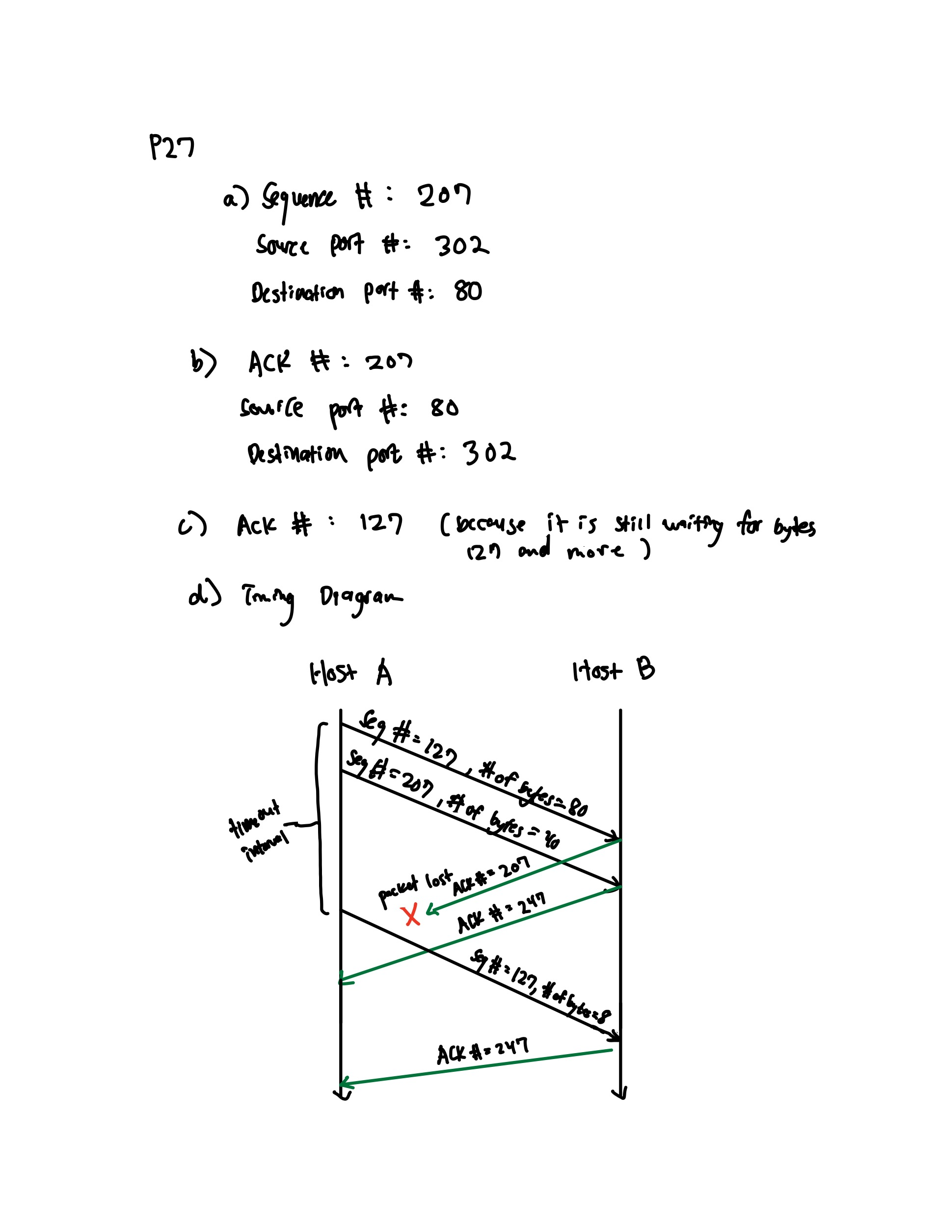

**## Lab**

`https://www.github.com/network-whu/lab/`

- 5.Wireshark_UDP.docx