.cComputer Networking

Assignment 9

# Homework 9

## Problems of Chapter 4:

P11

Consider a router that interconnects three subnets: Subnet 1, Subnet 2,

and Subnet 3. Suppose all of the interfaces in each of these three subnets

are required to have the prefix 223.1.17/24. Also suppose that Subnet 1 is

required to support at least 60 interfaces, Subnet 2 is to support at least 90

interfaces, and Subnet 3 is to support at least 12 interfaces. Provide three

network addresses (of the form a.b.c.d/x) that satisfy these constraints.

**223.1.17.0/26**

**223.1.17.128/25**

**223.1.17.192/28**

P17

Suppose datagrams are limited to 1,500 bytes (including header) between

source Host A and destination Host B. Assuming a 20-byte IP header, how

many datagrams would be required to send an MP3 consisting of 5 million

bytes? Explain how you computed your answer.

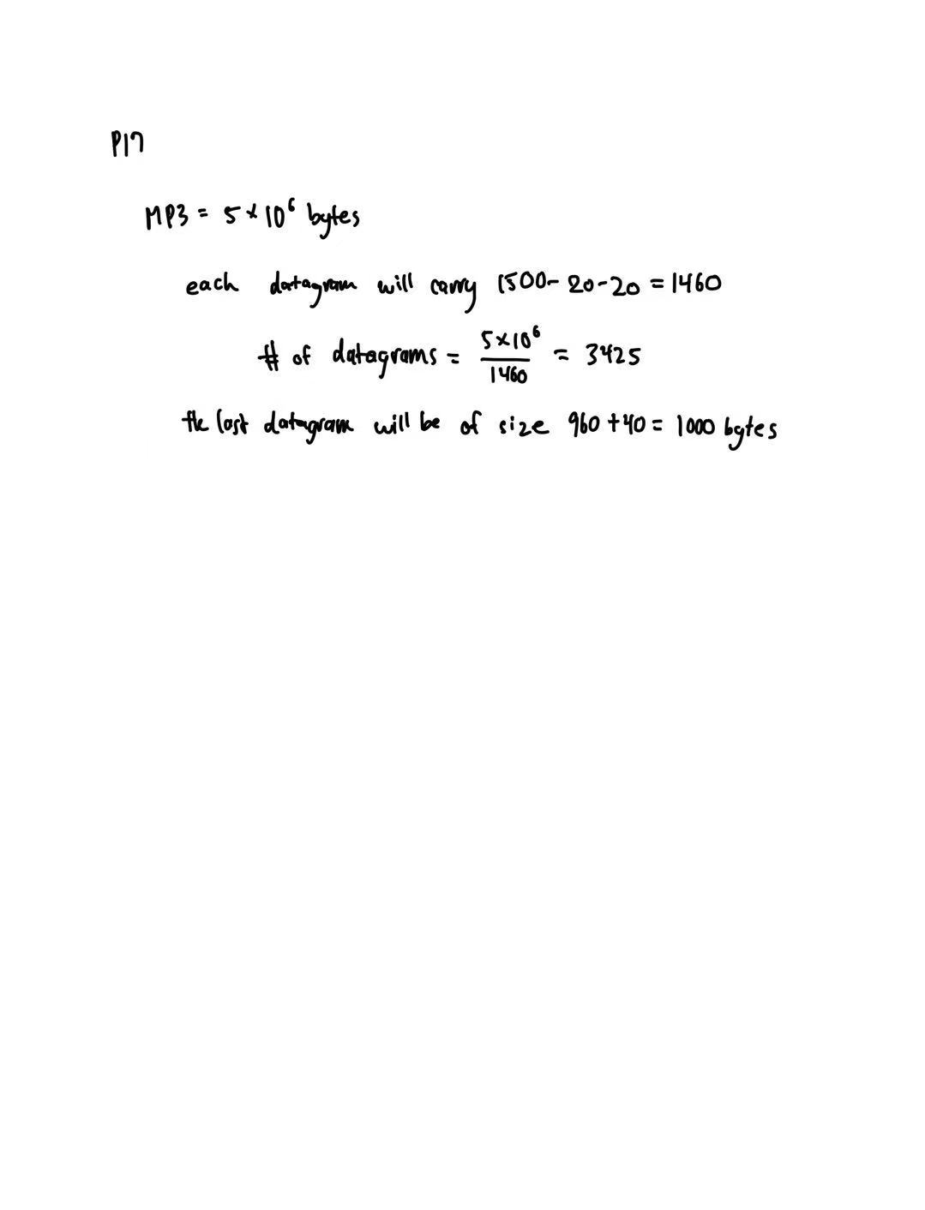

## Lab

`https://www.github.com/network-whu/lab/`

- 7.Wireshark_IP.docx