Assignment 1

- Ping another computer (my macbook)
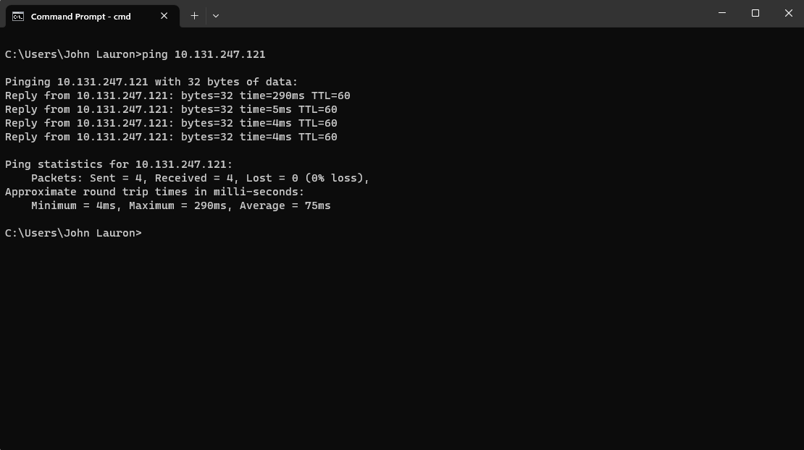

- Tracert a server (Stanford University Website)

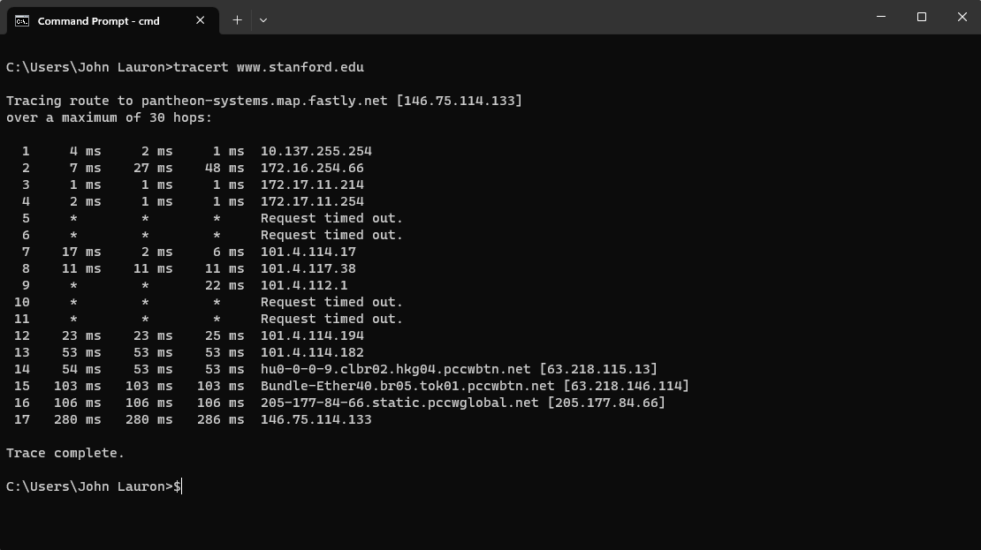

- Register a github account, download lab resource from https://github.com/wireshark/wireshark