Computer Networking- Assignment 2
Part 1

With 35 users, the probability is > 10 active at the same time is less than 0.0004.
  - How did we get this value 0.0004?

See photo below
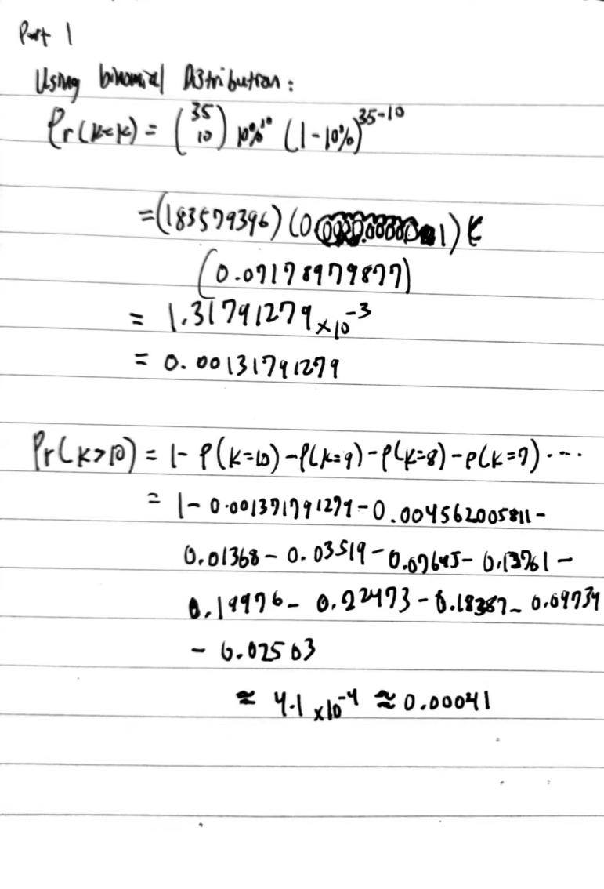
  - What happens if > 35 users?

If > 35 simultaneous active users, then the aggregate arrival rate of packets over-exceeds the output capacity of the link and packet switching is no longer capable of supporting all active users at the same time.
Part 2
Do Chapter 1: P8, P25, P27

P8. Suppose users share a 10 Mbps link. Also suppose each user requires 200 kbps
when transmitting, but each user transmits only 10 percent of the time. (See
the discussion of packet switching versus circuit switching in Section 1.3.)

- When circuit switching is used, how many users can be supported?

10 Mbps / 200kbps = 50 users can be supported when circuit switching is used. This is because the transmission rate (200 kbps) must be reserved for each user at all times. In other words, when it comes to sharing a 10 Mbps link, the bandwidth and transmission are fixed.
- For the remainder of this problem, suppose packet switching is used. Find the probability that a given user is transmitting.
- Suppose there are 120 users. Find the probability that at any given time, exactly n users are transmitting simultaneously. (Hint: Use the binomial distribution.)
Transmission rate = 10% = 1/10 = 0.1
Therefore, the probability that a given user is transmitting is 0.1.
The binomial distribution formula is P(n)=(k n) p^{n} q^{k-n}.
k= 120
n= ?
p= 10% = 0.1
q= 1-p = 0.9
P(n) = ¹²⁰C_{n} (0.1)^{n}(0.9)^{120-n}
- Find the probability that there are 51 or more users transmitting simultaneously.

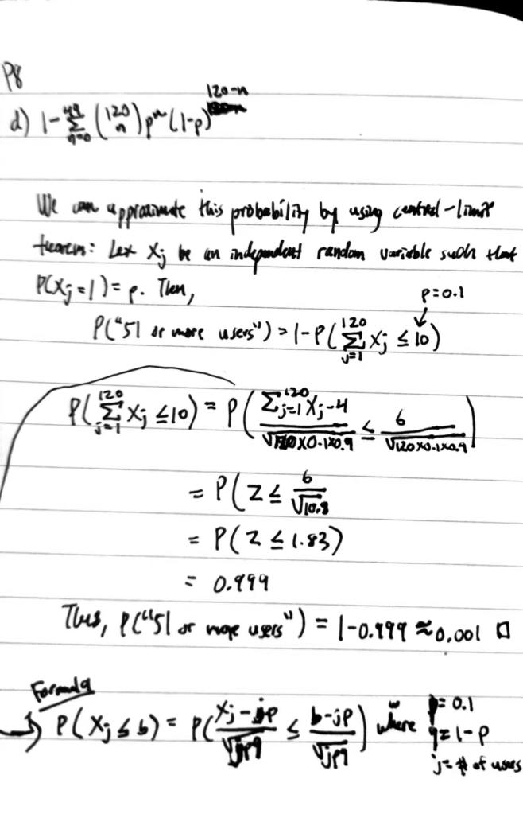
P25. Suppose two hosts, A and B, are separated by 20,000 kilometers and are connected by a direct link of R = 5 Mbps. Suppose the propagation speed over
the link is 2.5 * 10⁸ meters/sec.

- Calculate the bandwidth-delay product, R * d_{prop}.

See photo below
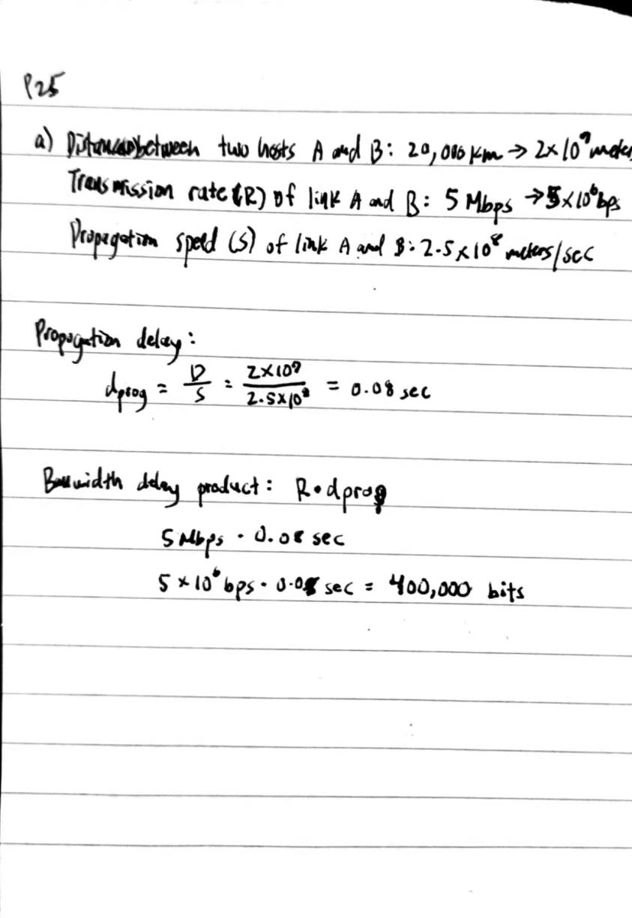

- Consider sending a file of 800,000 bits from Host A to Host B. Suppose the file is sent continuously as one large message. What is the maximum number of bits that will be in the link at any given time?

See photo below
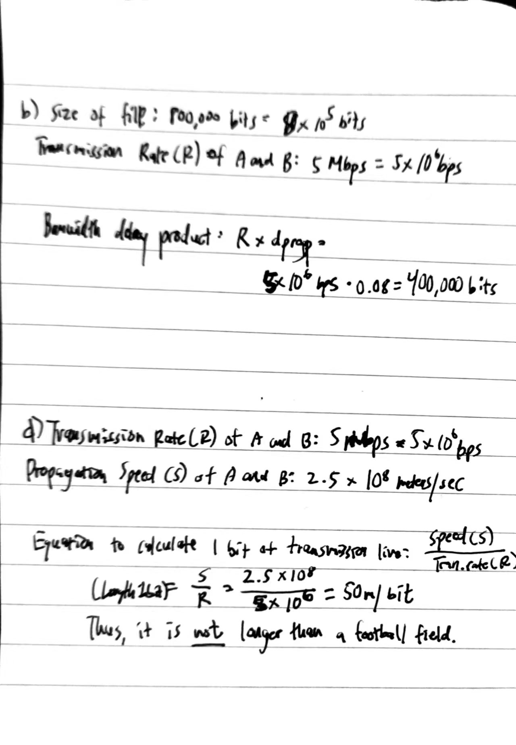
- Provide an interpretation of the bandwidth-delay product.

The bandwidth-delay product of a link is the maximum number of bits that can be in the link.
- What is the width (in meters) of a bit in the link? Is it longer than a football field?

See photo below

- Derive a general expression for the width of a bit in terms of the propagation speed s, the transmission rate R, and the length of the link m.

A general expression for the width of a bit would be: (Transmission Rate * Speed)/Length of the link (m). So, the expression would be (T * S)/m.
P27. Consider problem P24 but now with a link of R = 500 Mbps.
- Calculate the bandwidth-delay product, R * d_{prop}.
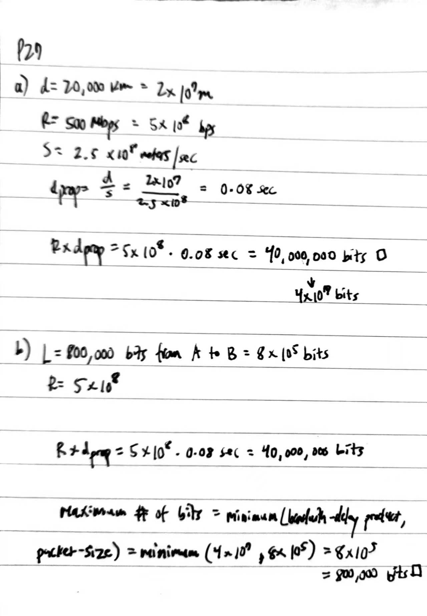

- Consider sending a file of 800,000 bits from Host A to Host B. Suppose the file is sent continuously as one big message. What is the maximum number of bits that will be in the link at any given time?

- What is the width (in meters) of a bit in the link?
