**Assignment 3**

1. **TCP, DNS, HTTP**
2. **About 0.2 sec**
3. **My computer: 10.131.206.12 School: 23.204.146.160**
4. 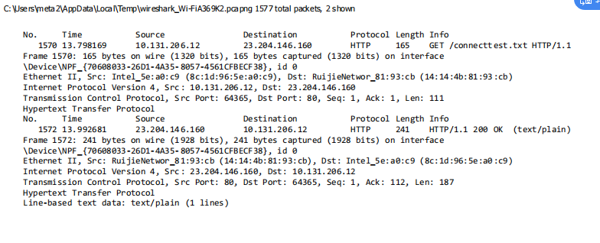

**Assignment 2**

**Problem 8:**

1. 10Mbps / 200kbps = 50
2. 1/50 x 0.1 = 0.002
3. P[n users are transmitting at the same time]=1−Sum[ Binomial(120, i)×0.1^i×0.9^120-i ,i=0,n]
4. Using the above binomial formula

120∑n=51 P[n users are transmitting at the same time]

**Problem 25:**

1. 20000000m/2.5 x 10^8 m/sec = 0.08 sec

R x d = 5 x 0.08 = 400000 bits

1. 800000 bits / 5Mbps = 0.16sec

dtrans > dprops, therefore, 400000 bits will be in the link at any given time.

1. Bandwidth-delay product shows us the bit capacity of the link.
2. 20000km / 400000 bits = 50 m , No it is not longer.
3. (m x s)/R

**What is the difference between Abstraction and Encapsulation?**

Abstraction refers to the concept of hiding the underlying complexities of the network infrastructure and presenting a simplified view to the users or higher-level applications. Encapsulation, on the other hand, involves packaging data and protocols into units (such as packets) for transmission over the network, providing a protective layer and ensuring reliable delivery.

1. Ping another computer.

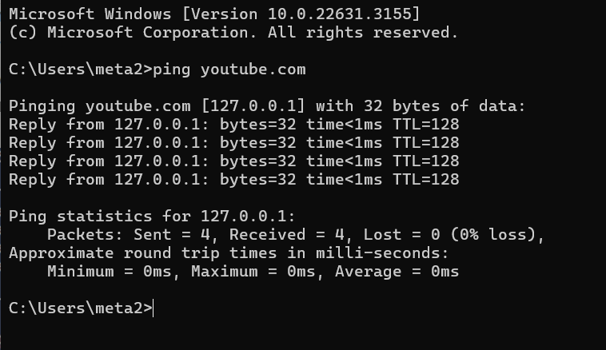

1. Tracert a server.

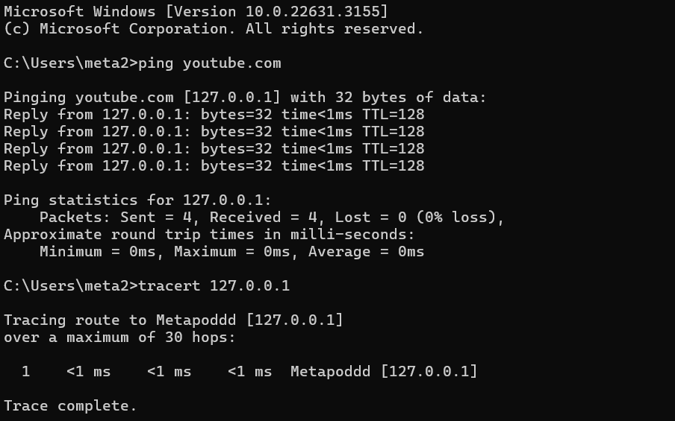

1. Download lab resource.