**Assignment 4**

**Chapter 2**

**P4:**

a). gaia.cs.umass.edu/cs453/index.html

b). HTTP/1.1

c). Persistent, Connection:keep-alive

d). The host IP address doesn’t contain in the string. It’s just a HTTP GET message.

e). Mozilla 5.0, the server needs to know in order to provide an appropriate type of information and functionality.

**Lab**

1. Both are running on HTTP version 1.1
2. Accept-Language: en-US,en;q=0.5\r\n
3. My computer: 10.131.155.88 Server: 45.90.210.10
4. HTTP/1.1 101 Switching Protocols\r\n
5. Date: Tue, 02 Apr 2024 17:18:57 CEST\r\n
6. 511 bytes
7. No, all data in the packet-listing window is also written in the raw data packet content window.
8. No, 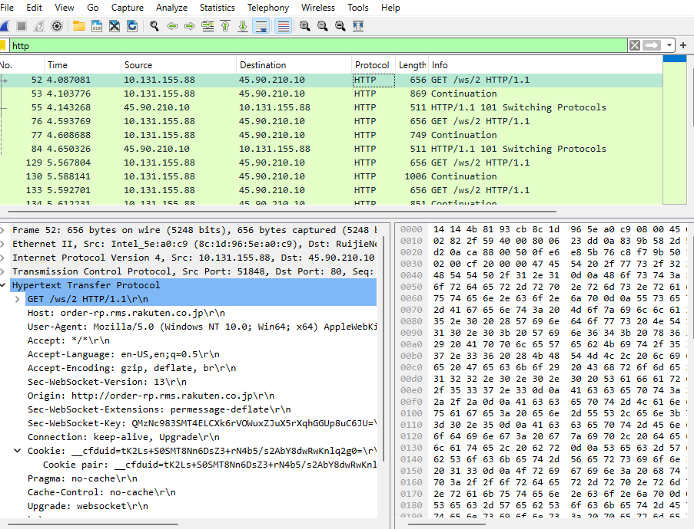
9. No, X-Content-Type-Options: nosniff\r\n
10. No, it wasn’t in the HTTP GET request.
11. HTTP/1.1 101 Switching Protocols\r\n , No the server didn’t explicitly return the contents of the file. X-Content-Type-Options: nosniff\r\n for both return messages from server.

(I have no idea what I did wrong with wireshark. I followed every steps, but I couldn’t get the same results as my friends or the website I found <https://maxwellsullivan.wordpress.com/2013/02/27/wireshark-lab-2-part-3-retrieving-long-documents/>)

This is my wireshark for part 3. I also believe that my part 2 is not accurate as the messages I received were also the same to this. I have tried to redo it multiple times, ended up having the same result. Thus, I’m writing this to clarify my unusual encounter with wireshark while doing the lab.

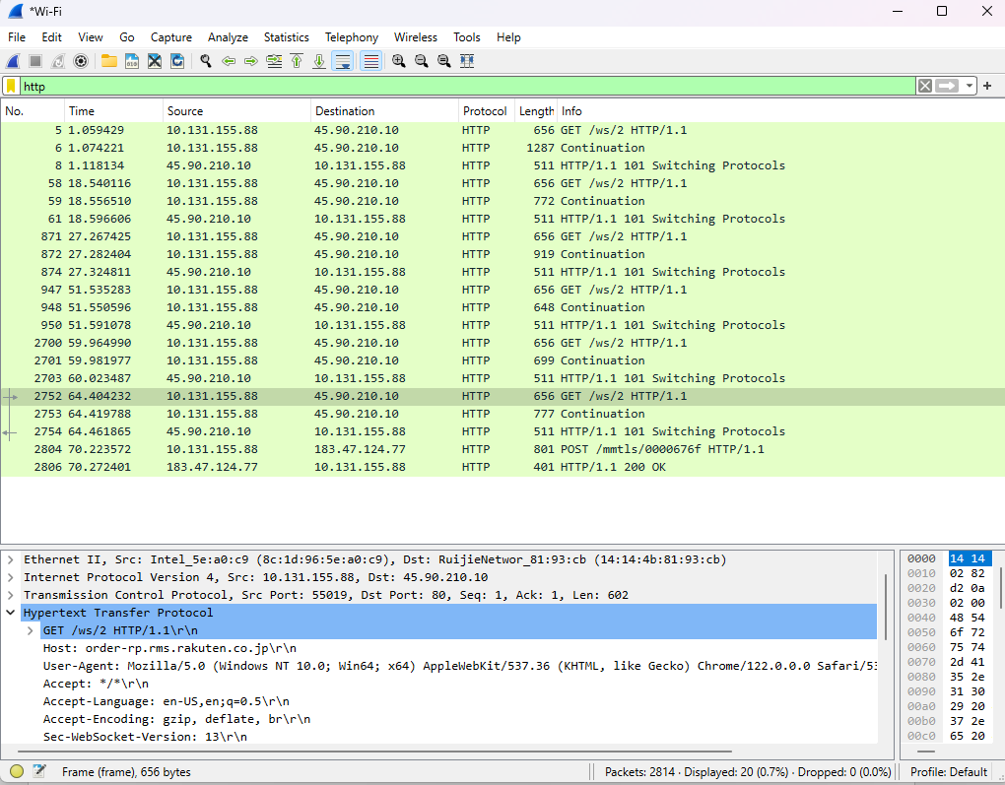

1. I received 6 GET message. But none of them specifically contain the GET message for the Bill or Rights.

This is my wireshark for part 4

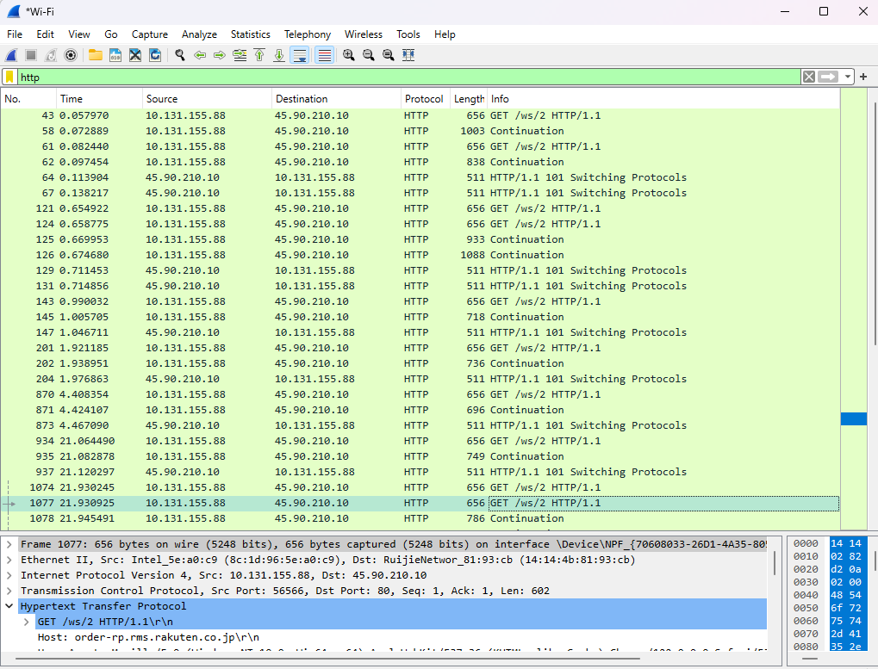

16. I got 10 GET messages. 45.90.210.10

17. Cannot tell, behind GET messages are not specify the requests.

This is my wireshark for part 5

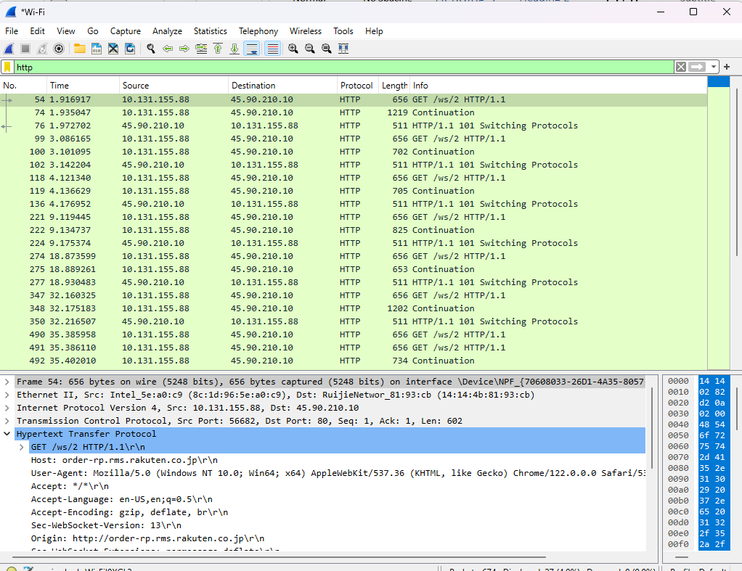

18. Not specified

19. Not specified

***I have no idea in which step I did wrongly. I tried to slowly follow each step for multiple times. However, the result I got was not the desire one. I compared to my classmate and the website I found, and it was different from theirs. I’m deeply disappointed that myself couldn’t successfully complete this assignment. Once I know the mistake I have committed that caused me to unable to do the assignment, I certain I will come back and accomplish it.

**Assignment 3**

1. **TCP, DNS, HTTP**
2. **About 0.2 sec**
3. **My computer: 10.131.206.12 School: 23.204.146.160**
4. 