**Assignment 5**

1. 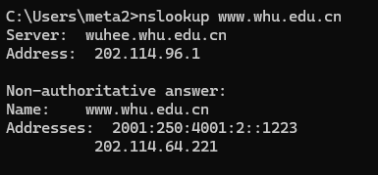
2. 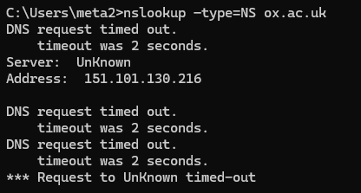
3. 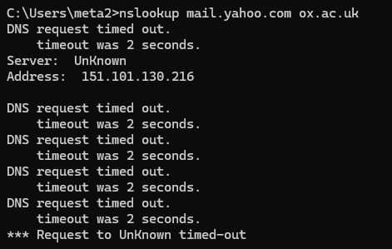 IP address is 151.101.130.216
4. UDP

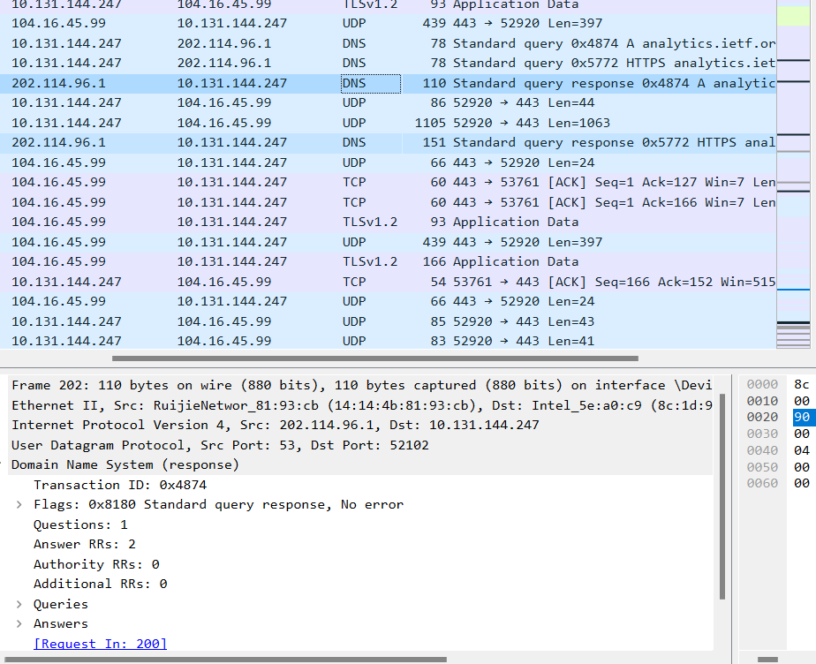The destination port for the DNS query is 52102 and the source port pf DNS response message is 53.

1. 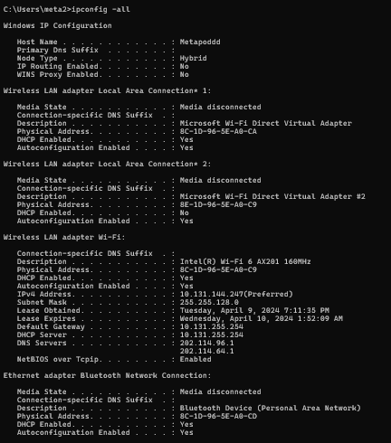 IP address : 202.144.96.1 Yes it is the same as one of my DNS servers.
2. It is a standard query and does not contain any answers.
3. 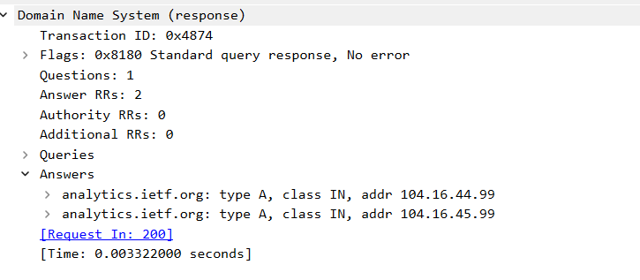two answers received.
4. The first SYN packet was sent to 104.16.44.99 which corresponds to the address in DNS query message.
5. No.
6. 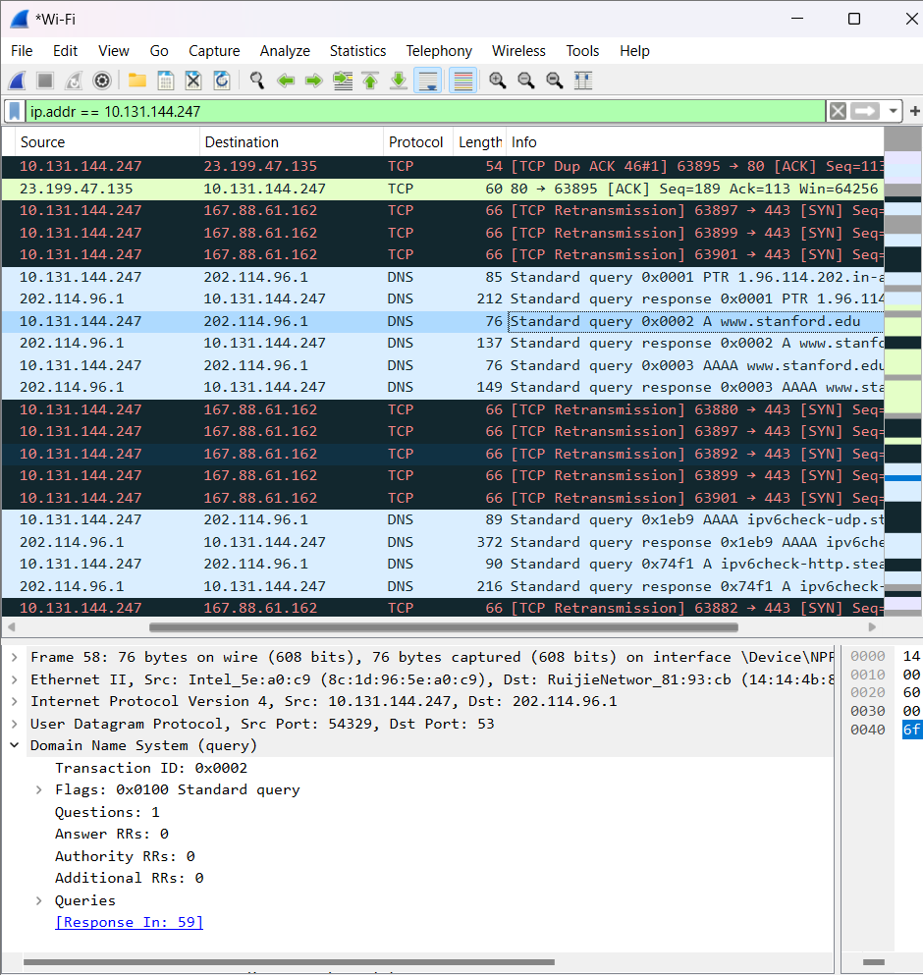 Destination Port for query message is 53 and source port for response message is 53 as well.
7. It is sent to 202.114.96.1 and yes it is the default local DNS server according to the ipconfig -all.
8. Type A. No, it doesn’t contain any answers.
9. 2 answers. Contains the following information: 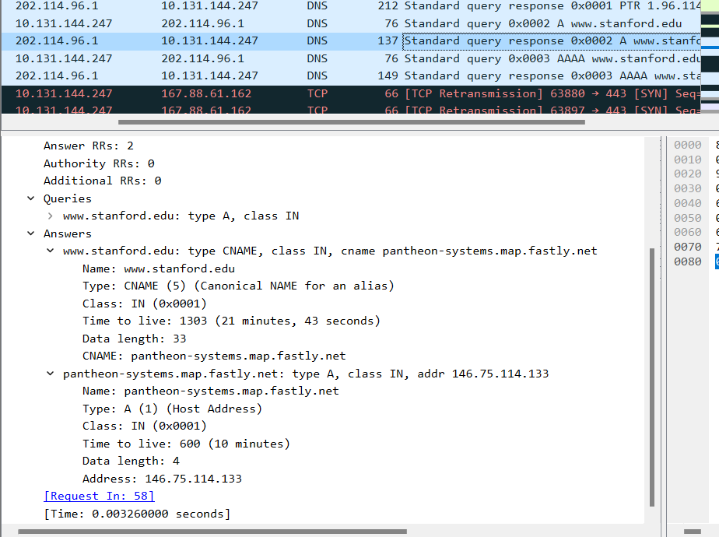
10. **Screenshot**
11. 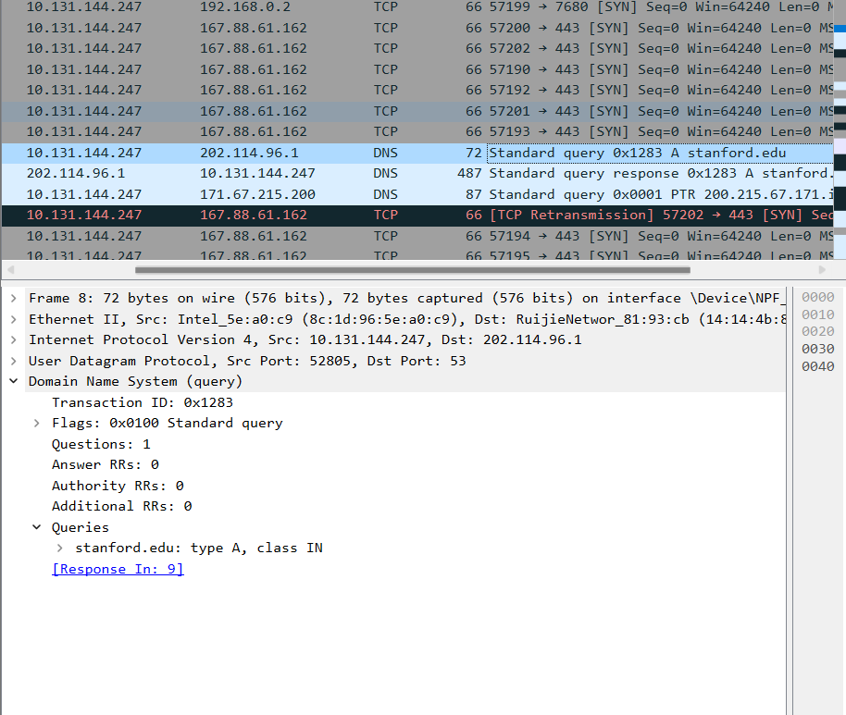202.144.96.1 which is my default DNS server.
12. It is a type A and has no answer.
13. 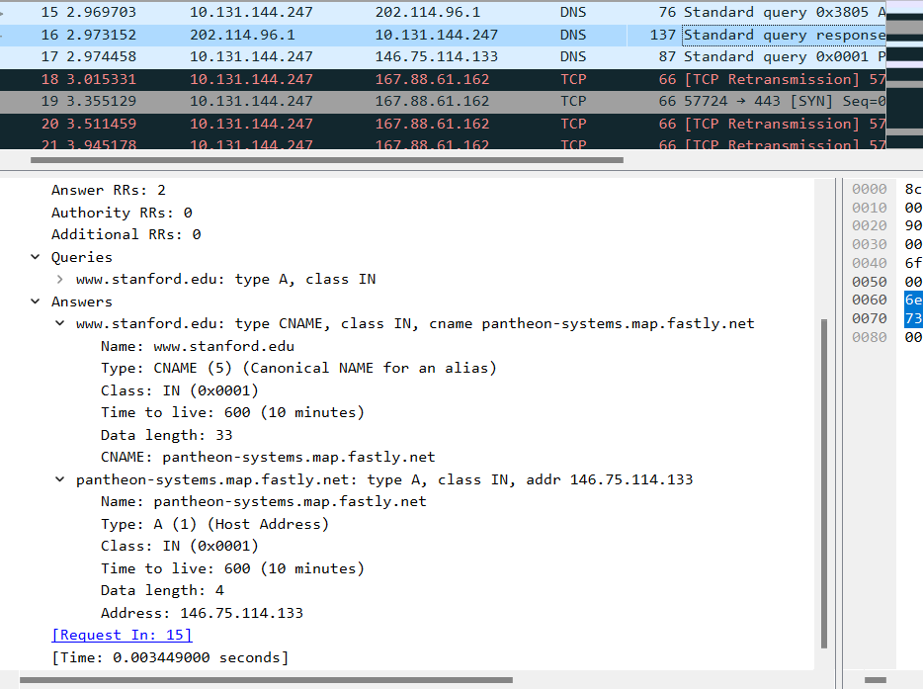 pantheon-systems.map.fastly.net
14. Screenshot
15. 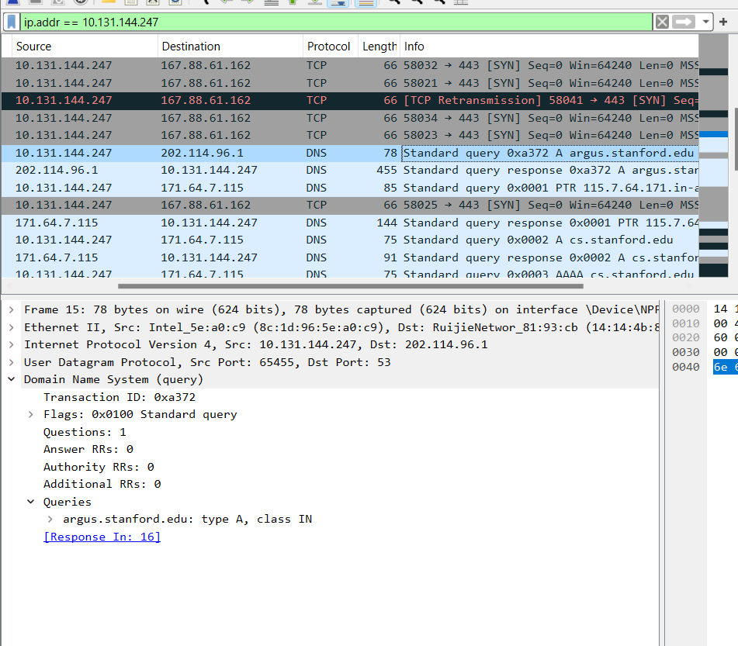202.144.96.1 for argus.stanford.edu and 171.64.7.115 for cs.stanford.edu. One of them is my default server while another has never appeared before.
16. Type A and doesn’t contain any answers
17. One answer for both argus.stanford.edu and cs.stanford.edu.
18. 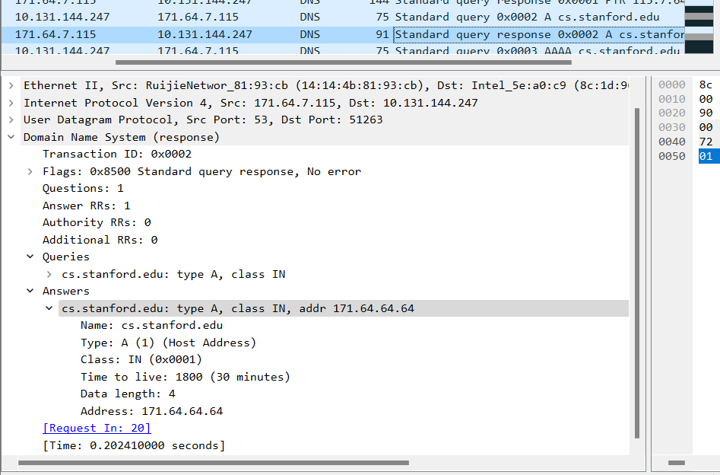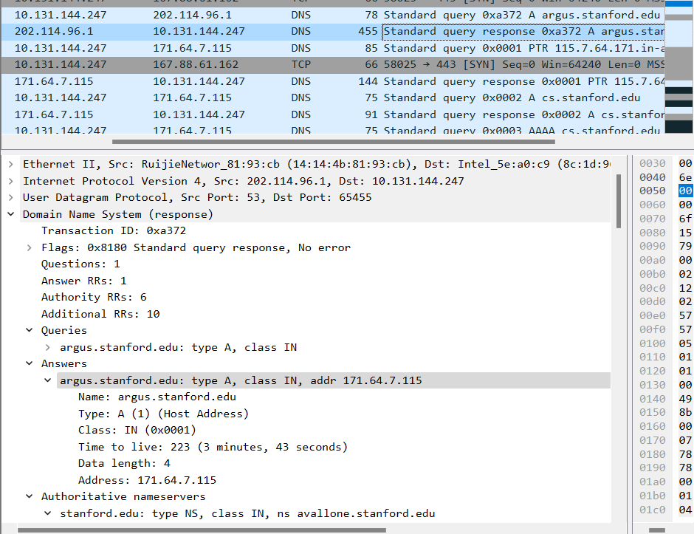

**Assignment 4**

**Chapter 2**

**P4:**

a). gaia.cs.umass.edu/cs453/index.html

b). HTTP/1.1

c). Persistent, Connection:keep-alive

d). The host IP address doesn’t contain in the string. It’s just a HTTP GET message.

e). Mozilla 5.0, the server needs to know in order to provide an appropriate type of information and functionality.

**Lab**

1. Both are running on HTTP version 1.1
2. Accept-Language: en-US,en;q=0.5\r\n
3. My computer: 10.131.155.88 Server: 45.90.210.10
4. HTTP/1.1 101 Switching Protocols\r\n
5. Date: Tue, 02 Apr 2024 17:18:57 CEST\r\n
6. 511 bytes
7. No, all data in the packet-listing window is also written in the raw data packet content window.
8. No, 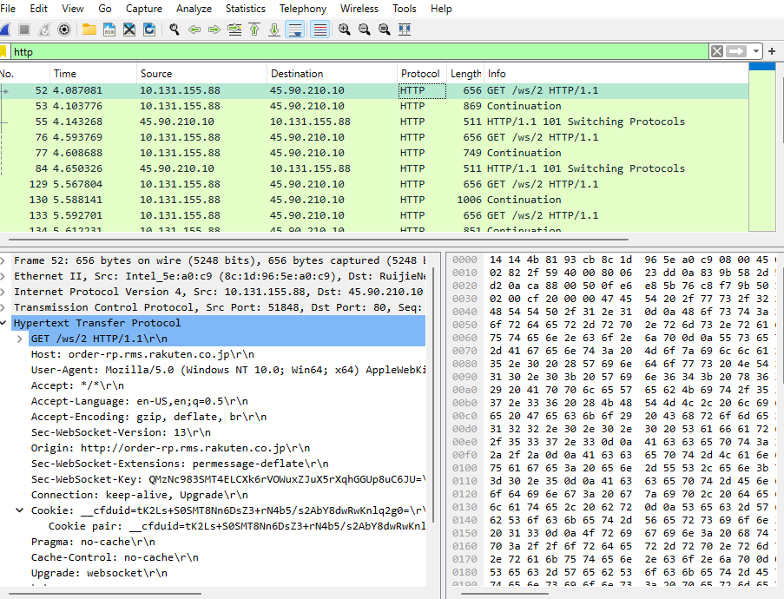
9. No, X-Content-Type-Options: nosniff\r\n
10. No, it wasn’t in the HTTP GET request.
11. HTTP/1.1 101 Switching Protocols\r\n , No the server didn’t explicitly return the contents of the file. X-Content-Type-Options: nosniff\r\n for both return messages from server.

(I have no idea what I did wrong with wireshark. I followed every steps, but I couldn’t get the same results as my friends or the website I found <https://maxwellsullivan.wordpress.com/2013/02/27/wireshark-lab-2-part-3-retrieving-long-documents/>)

This is my wireshark for part 3. I also believe that my part 2 is not accurate as the messages I received were also the same to this. I have tried to redo it multiple times, ended up having the same result. Thus, I’m writing this to clarify my unusual encounter with wireshark while doing the lab.

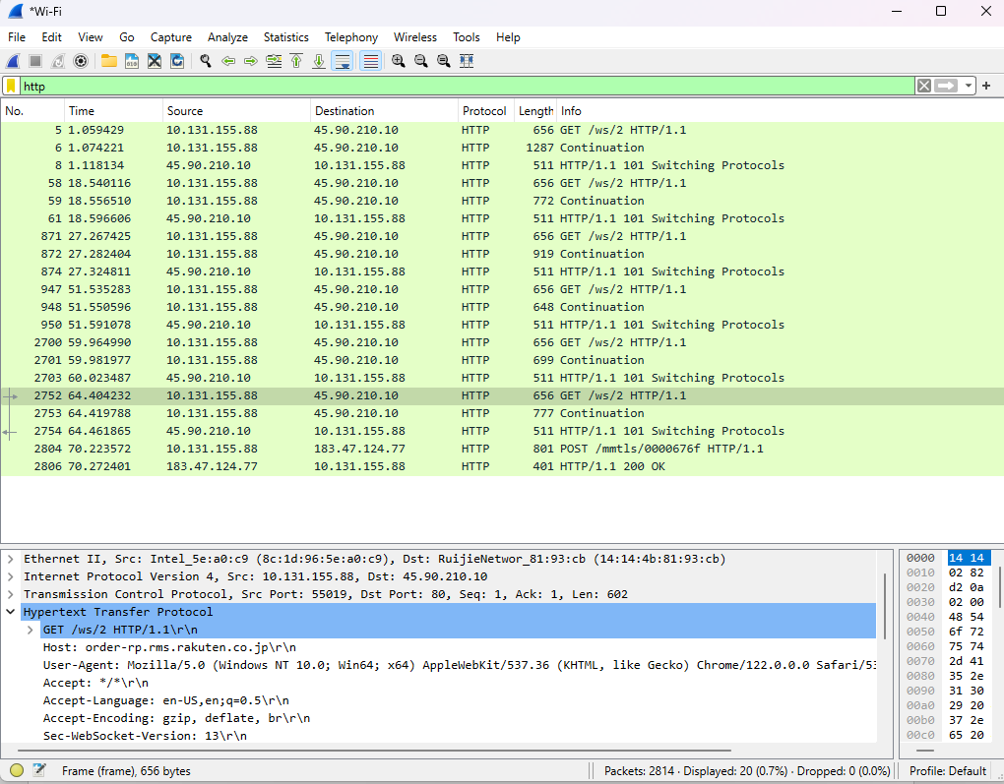

1. I received 6 GET message. But none of them specifically contain the GET message for the Bill or Rights.

This is my wireshark for part 4

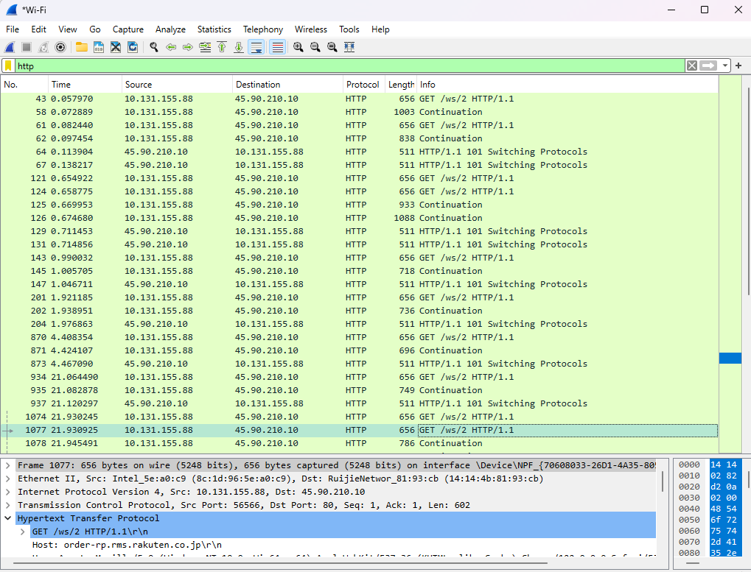

16. I got 10 GET messages. 45.90.210.10

17. Cannot tell, behind GET messages are not specify the requests.

This is my wireshark for part 5

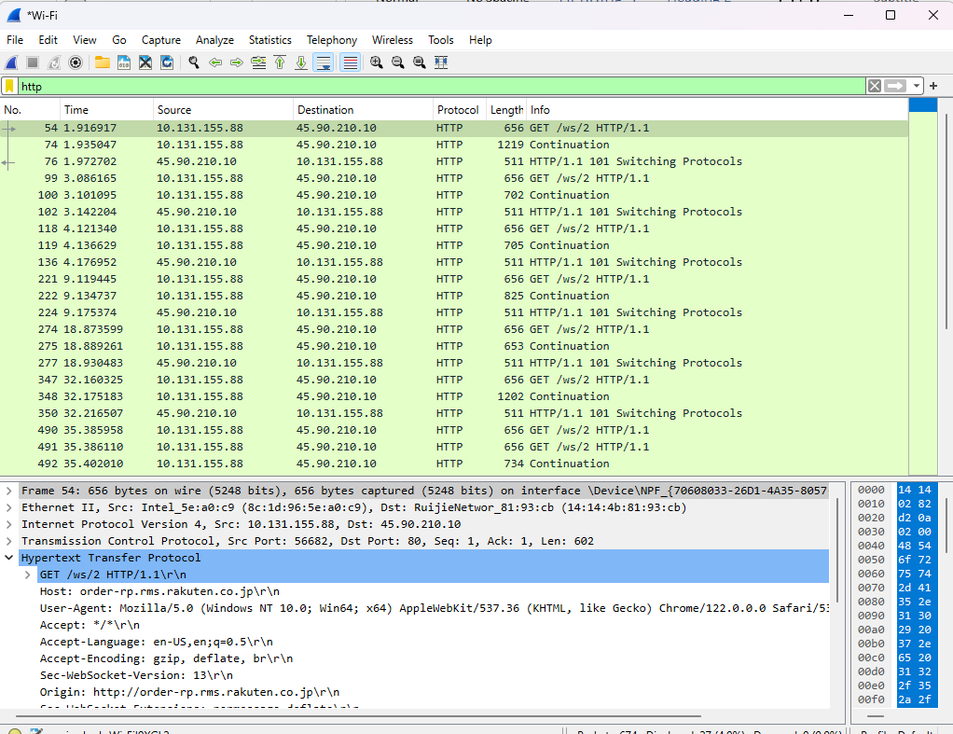

18. Not specified

19. Not specified

***I have no idea in which step I did wrongly. I tried to slowly follow each step for multiple times. However, the result I got was not the desire one. I compared to my classmate and the website I found, and it was different from theirs. I’m deeply disappointed that myself couldn’t successfully complete this assignment. Once I know the mistake I have committed that caused me to unable to do the assignment, I certain I will come back and accomplish it.

**Assignment 3**

1. **TCP, DNS, HTTP**
2. **About 0.2 sec**
3. **My computer: 10.131.206.12 School: 23.204.146.160**
4. 