***P12.*** A packet switch receives a packet and determines the outbound link to which the packet should be forwarded. When the packet arrives, one other packet is halfway done being transmitted on this outbound link and four other packets are waiting to be transmitted. Packets are transmitted in order of arrival. Suppose all packets are 1,500 bytes and the link rate is 2.5 Mbps. What is the queuing delay for the packet? More generally, what is the queuing delay when all packets have length L, the transmission rate is R, x bits of the currently-being-transmitted packet have been transmitted, and n packets are already in the queue?

Answer:

To calculate the queuing delay for the packet, we need to consider the time it takes for the packets ahead of it in the queue to be transmitted.

The queuing delay can be calculated using the following formula:

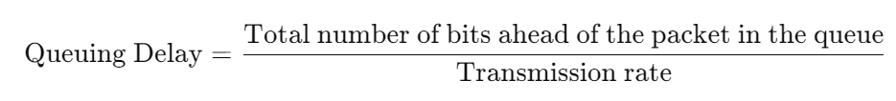

Given:

Packet length (L) = 1500 bytes = 12000 bits

Transmission rate (R) = 2.5 Mbps = 2.5×10^6 bits per second

Number of bits of the currently-being-transmitted packet that have been transmitted (x) = half of the packet length = 6000 bits

Number of packets already in the queue (n) = 4

First, let's calculate the total number of bits ahead of the packet in the queue:

Total bits ahead=(n×L)+x=(4×12000 bits)+6000 bits=48000 bits+6000 bits=54000 bits

Now, let's calculate the queuing delay:

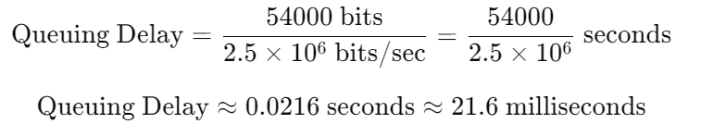

So, the queuing delay for the packet is approximately 21.6 milliseconds.

***P15.*** Let a denote the rate of packets arriving at a link in packets/sec, and let µ denote the link’s transmission rate in packets/sec. Based on the formula for the total delay (i.e., the queuing delay plus the transmission delay) derived in the previous problem, derive a formula for the total delay in terms of a and µ.

Answer:

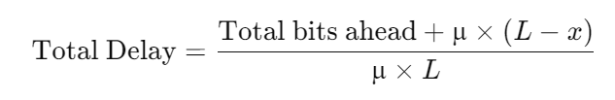

***P20.*** Consider the throughput example corresponding to Figure 1.20(b). Now suppose that there are M client-server pairs rather than 10. Denote Rs, Rc, and R for the rates of the server links, client links, and network link. Assume all other links have abundant capacity and that there is no other traffic in the network besides the traffic generated by the M client-server pairs. Derive a general expression for throughput in terms of Rs, Rc, R, and M.

Answer:

Given:

Rs = Server link rate

Rc = Client link rate

R = Network link rate

M = Client-server pair

Instantaneous throughput and average throughput are two types of throughputs. The server throughput Rc faster than Rs.

Networks always depends on client-server links(M). The min is a simple two link network links on the network.

Therefore, general expression for throughput in terms of Rs, Rc, R, and M is min {Rs, Rc, R/M}.