P40. Consider Figure 3.61. Assuming TCP Reno is the protocol experiencing the behavior shown above, answer the following questions. In all cases, you should provide a short discussion justifying your answer.

a. Identify the intervals of time when TCP slow start is operating.

b. Identify the intervals of time when TCP congestion avoidance is operating.

c. After the 16th transmission round, is segment loss detected by a triple duplicate ACK or by a timeout?

d. After the 22nd transmission round, is segment loss detected by a triple duplicate ACK or by a timeout?

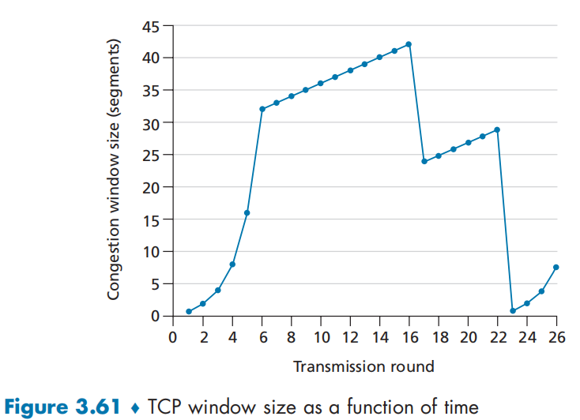

e. What is the initial value of ssthresh at the first transmission round?

f. What is the value of ssthresh at the 18th transmission round?

g. What is the value of ssthresh at the 24th transmission round?

h. During what transmission round is the 70th segment sent?

i. Assuming a packet loss is detected after the 26th round by the receipt of a triple duplicate ACK, what will be the values of the congestion window size and of ssthresh?

j. Suppose TCP Tahoe is used (instead of TCP Reno), and assume that triple duplicate ACKs are received at the 16th round. What are the ssthresh and the congestion window size at the 19th round?

k. Again suppose TCP Tahoe is used, and there is a timeout event at 22nd round. How many packets have been sent out from 17th round till 22nd round, inclusive?

Answer:

1. The slow start times are from 1 to 6 and from 23 to 26. These are slow start times because

the congestion window size is picking up at a slope, slower at first and becoming exponentially faster until it gets to a linear section and is no longer in slow start.

1. This is between transmission rounds 6 and 16 and between rounds 17 and 23. This is when

it is linearly rising.

1. After the 16th transmission round, packet loss is recognized by a triple duplicate ACK. If there was a timeout, the congestion window size would have dropped to 1.This one is detected by a timeout for the reasons listed above.
2. After the 22nd transmission round, segment loss is detected due to timeout, and hence the congestion window size is set to 1.
3. The threshold is initially 32, since it is at this window size that slow start stops and congestion avoidance begins.
4. The threshold is set to half the value of the congestion window when packet loss is detected. When loss is detected during transmission round 16, the congestion windows size is 42. Hence the threshold is 21 during the 18th transmission round.
5. The threshold is set to half the value of the congestion window when packet loss is detected. When loss is detected during transmission round 22, the congestion windows size is 29. Hence the threshold is 14 (taking lower floor of 14.5) during the 24th transmission round.
6. During the 1st transmission round, packet 1 is sent; packet 2-3 are sent in the 2nd transmission round; packets 4-7 are sent in the 3rd transmission round; packets 8-15 are sent in the 4th transmission round; packets 16-31 are sent in the 5th transmission round; packets 32-63 are sent in the 6th transmission round; packets 64 – 96 are sent in the 7th transmission round. Thus packet 70 is sent in the 7th transmission round.
7. The threshold will be set to half the current value of the congestion window (8) when the loss occurred and congestion window will be set to the new threshold value + 3 MSS . Thus the new values of the threshold and window will be 4 and 7 respectively.
8. threshold is 21, and congestion window size is 1.
9. round 17, 1 packet; round 18, 2 packets; round 19, 4 packets; round 20, 8 packets; round 21, 16 packets; round 22, 21 packets. So, the total number is 52.

P44. Consider sending a large file from a host to another over a TCP connection that has no loss.

a. Suppose TCP uses AIMD for its congestion control without slow start. Assuming cwnd increases by 1 MSS every time a batch of ACKs is received and assuming approximately constant round-trip times, how long does it take for cwnd increase from 6 MSS to 12 MSS (assuming no loss events)?

b. What is the average throughput (in terms of MSS and RTT) for this connection up through time = 6 RTT?

Answer:

1. In AIMD congestion control, the congestion window (cwnd) increases by 1 maximum segment size (MSS) for every batch of acknowledgements received. Since the cwnd increases by 1 MSS every time a batch of ACKs is received, to increase from 6 MSS to 12 MSS, it would take 6 batches of ACKs. Since the round-trip times are approximately constant, we can assume that each batch takes 1 round-trip time (RTT) to arrive. Therefore, it would take approximately 6 RTTs for the cwnd to increase from 6 MSS to 12 MSS.
2. Given data:

Connection up through time = 6 RTT

Average throughout (in terms of MSS and RTT) = (6+7+8+9+10+11)/6**=8.5 MSS/RTT**