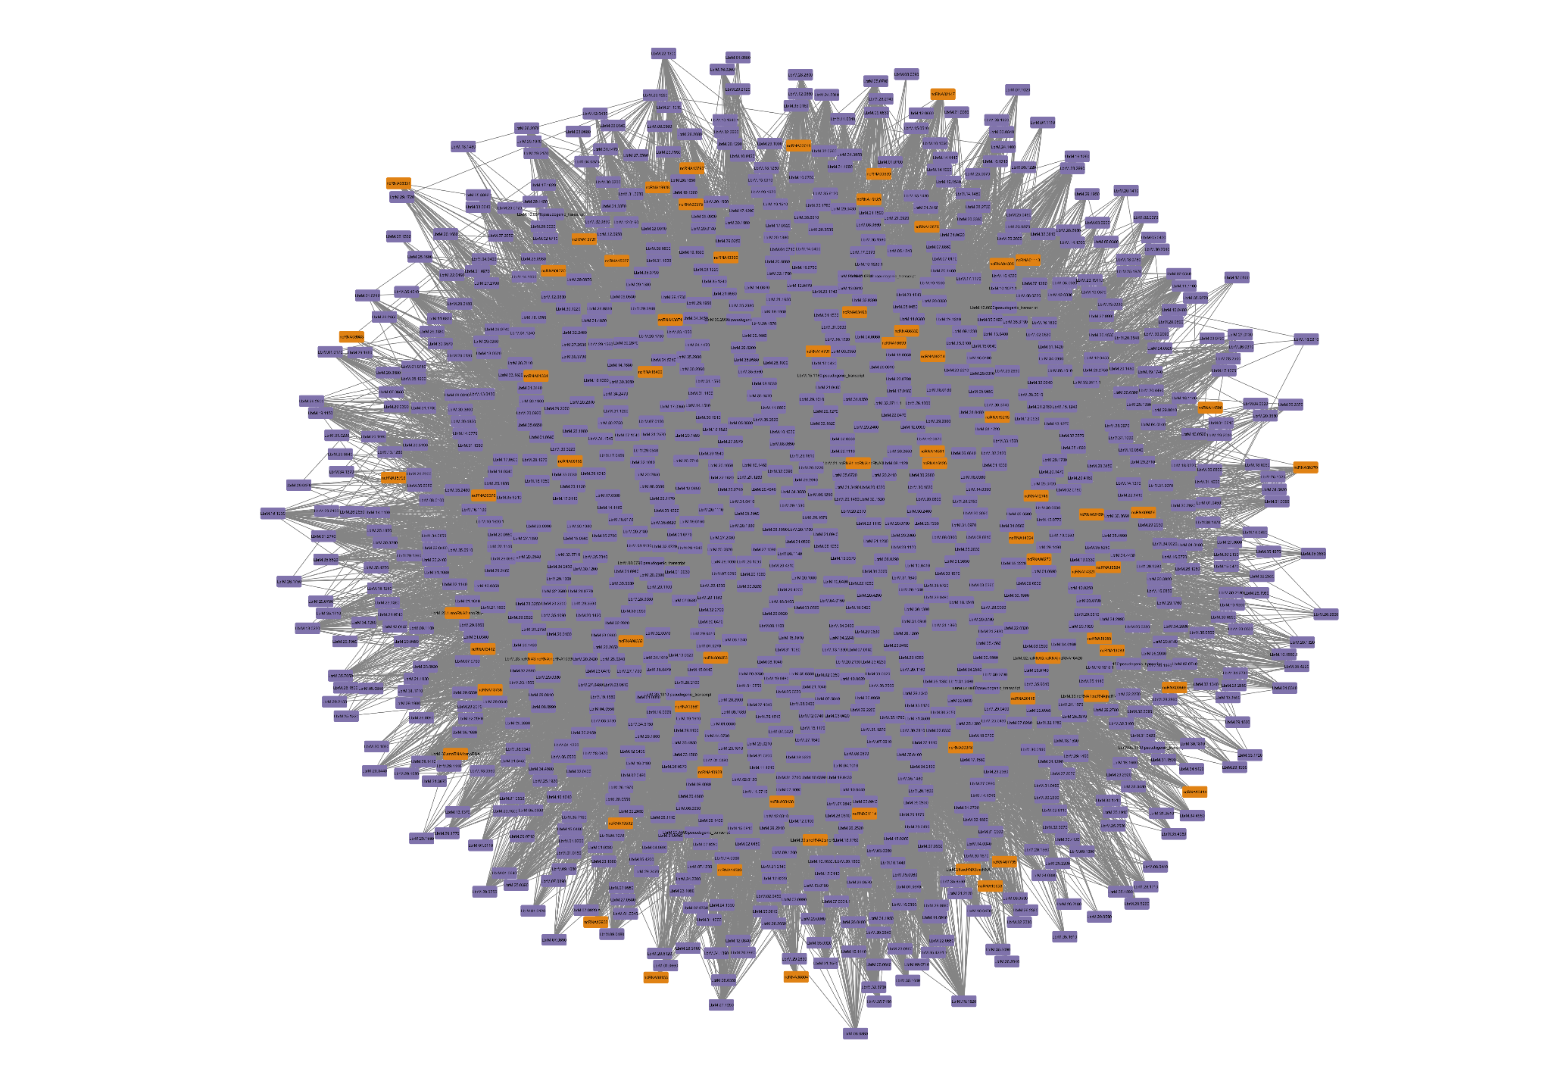

Supplementary Figure S1. Module associated to Amastigote developmental stage in *L. braziliensis*. In orange represented the ncRNAs and in purple the protein-coding genes