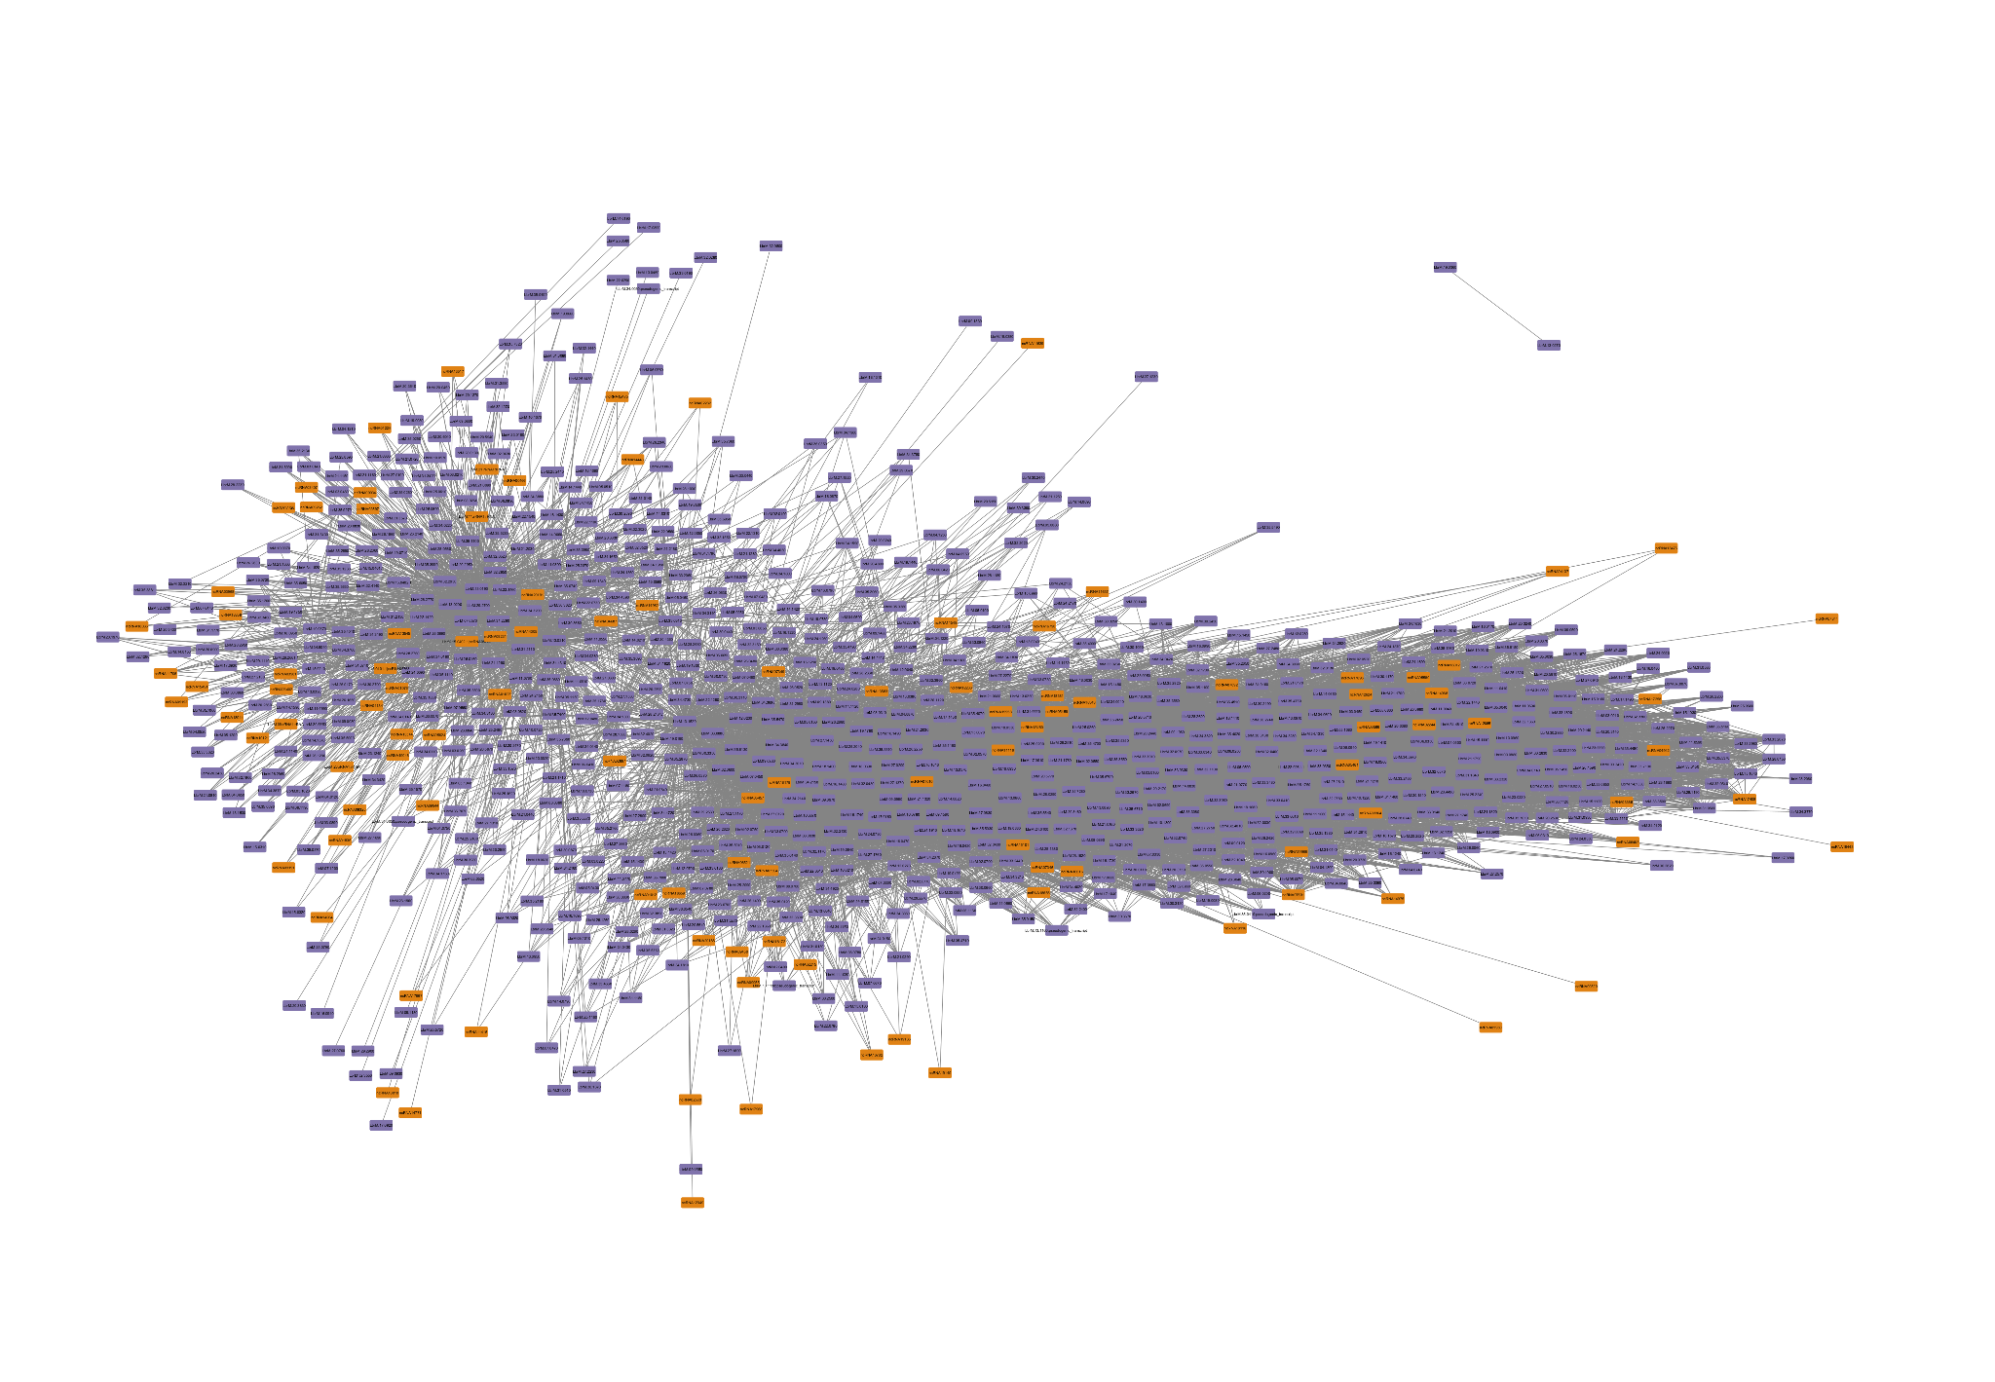

Supplementary Figure S2. Module associated with the procyclic promastigote developmental stage in *L. braziliensis*. In orange represented the ncRNAs and in purple the protein-coding genes