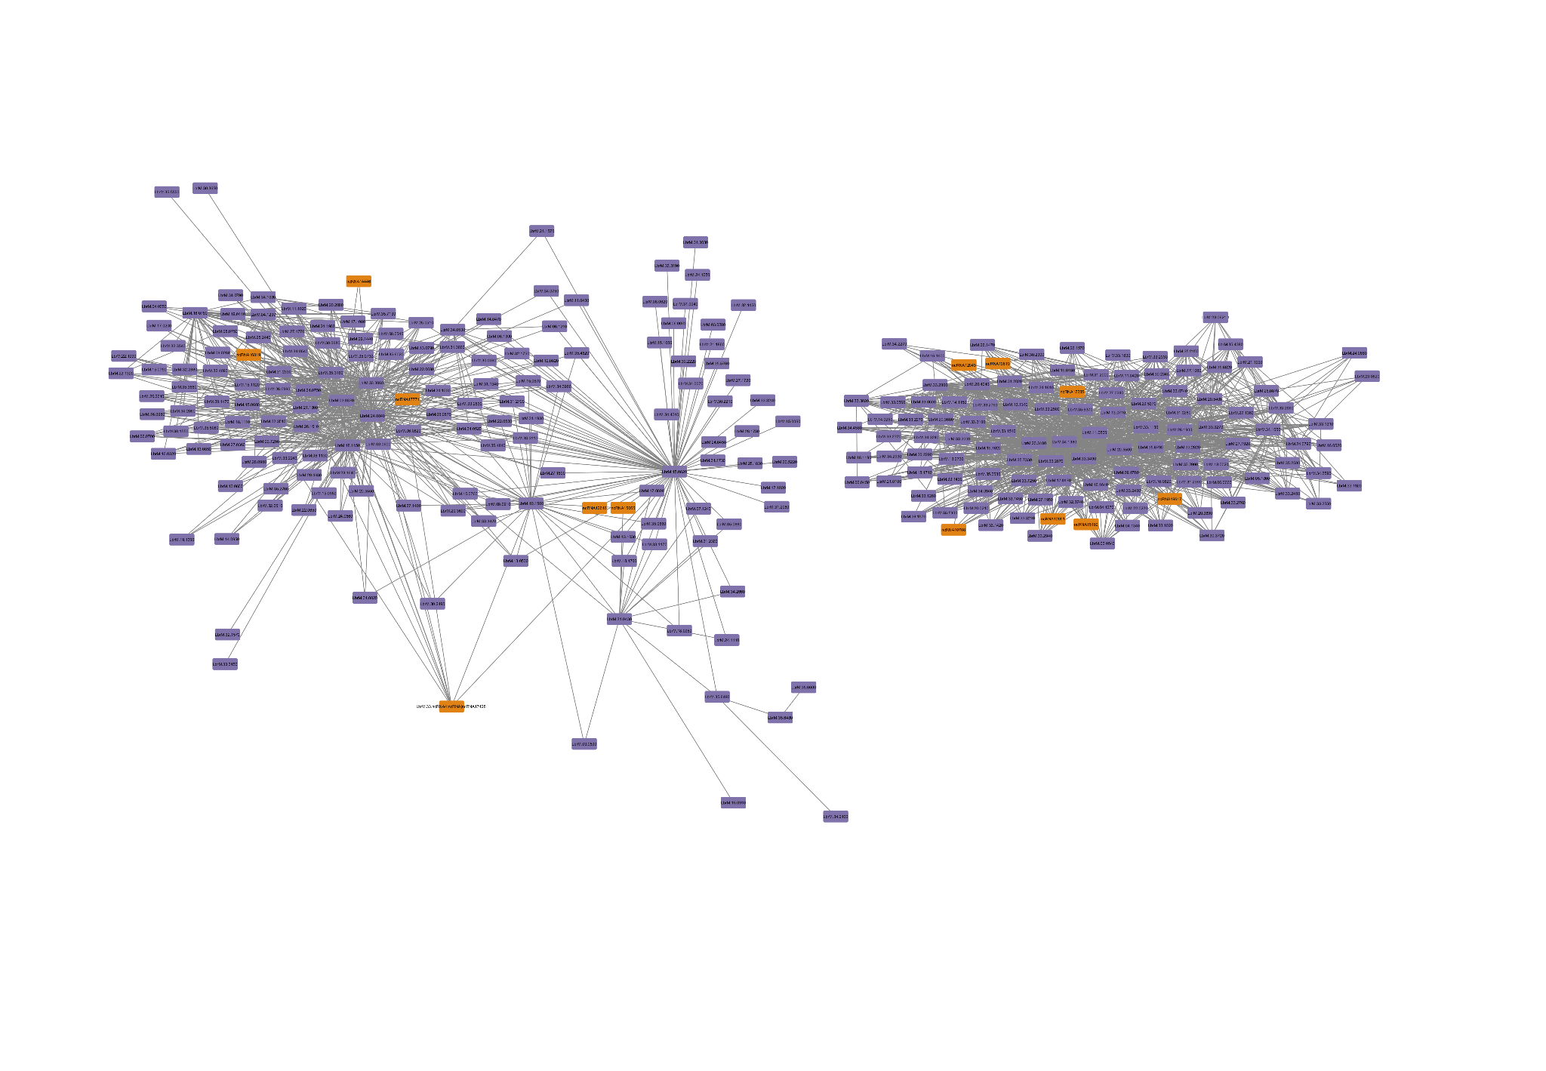

Supplementary Figure S3. Module associated to the Metacyclic promastigote developmental stage in *L. braziliensis*. In orange represented the ncRNAs and in purple the protein-coding genes