# 回顾

## Maven的好处

节省空间 对jar包做了统一管理 依赖管理

一键构建

可跨平台

应用在大型项目可提高开发效率

## Maven安装部署配置

## Maven的仓库

本地仓库

远程仓库（私服）

中央仓库

## 添加依赖

从网络上搜索

在本地重建索引，以索引的方式搜索

## 项目构建

## 依赖范围

Compile struts2 框架jar

Provided jsp-api.jar 重点

Runtime 数据库驱动包

Test junit.jar

## 总结

<modelVersion>

坐标 GAV

<groupId>cn.itcast</groupId>

<artifactId>ssh</artifactId>

<version>0.0.1-SNAPSHOT</version>

Packaging 打包方式

Jar war pom

<dependencies>

<dependency>

<build> 里面放的是插件

<plugins>

<plugin>

# 整合ssh框架

## 依赖传递

只添加了一个struts2-core依赖，发现项目中出现了很多jar，

这种情况 叫 依赖传递

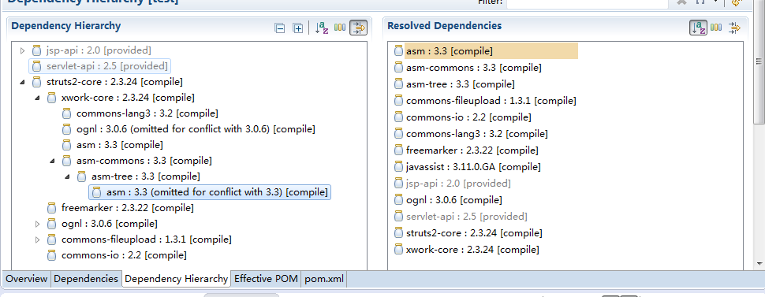

## 依赖版本冲突的解决

1. 第一声明优先原则

<dependencies>

<!-- spring-beans-4.2.4 -->

<dependency>

<groupId>org.springframework</groupId>

<artifactId>spring-context</artifactId>

<version>4.2.4.RELEASE</version>

</dependency>

<!-- spring-beans-3.0.5 -->

<dependency>

<groupId>org.apache.struts</groupId>

<artifactId>struts2-spring-plugin</artifactId>

<version>2.3.24</version>

</dependency>

1. 路径近者优先原则

自己添加jar包

<dependency>

<groupId>org.springframework</groupId>

<artifactId>spring-beans</artifactId>

<version>4.2.4.RELEASE</version>

</dependency>

1. 排除原则

<dependency>

<groupId>org.apache.struts</groupId>

<artifactId>struts2-spring-plugin</artifactId>

<version>2.3.24</version>

<exclusions>

<exclusion>

<groupId>org.springframework</groupId>

<artifactId>spring-beans</artifactId>

</exclusion>

</exclusions>

</dependency>

1. 版本锁定原则

<properties>

<spring.version>4.2.4.RELEASE</spring.version>

<hibernate.version>5.0.7.Final</hibernate.version>

<struts.version>2.3.24</struts.version>

</properties>

<!-- 锁定版本，struts2-2.3.24、spring4.2.4、hibernate5.0.7 -->

<dependencyManagement>

<dependencies>

<dependency>

<groupId>org.springframework</groupId>

<artifactId>spring-context</artifactId>

<version>${spring.version}</version>

</dependency>

</dependencies>

</dependencyManagement>

需求：

传客户ID 页面上显示客户信息

准备数据库

## 构建项目

1. 创建数据库，

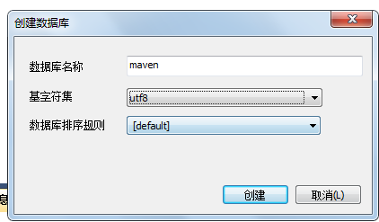

1. 执行准备好的sql脚本

Sql脚本的位置：

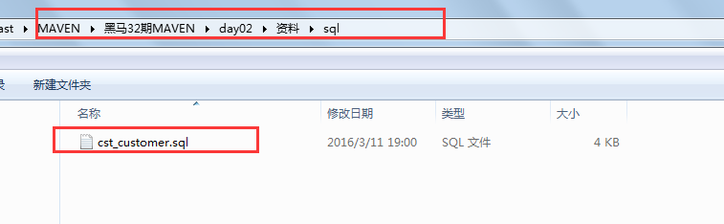

1. 完善pom.xml文件，把ssh相关的依赖都添加上去

<!-- 属性 -->

<properties>

<spring.version>4.2.4.RELEASE</spring.version>

<hibernate.version>5.0.7.Final</hibernate.version>

<struts.version>2.3.24</struts.version>

</properties>

<!-- 锁定版本，struts2-2.3.24、spring4.2.4、hibernate5.0.7 -->

<dependencyManagement>

<dependencies>

<dependency>

<groupId>org.springframework</groupId>

<artifactId>spring-context</artifactId>

<version>${spring.version}</version>

</dependency>

<dependency>

<groupId>org.springframework</groupId>

<artifactId>spring-aspects</artifactId>

<version>${spring.version}</version>

</dependency>

<dependency>

<groupId>org.springframework</groupId>

<artifactId>spring-orm</artifactId>

<version>${spring.version}</version>

</dependency>

<dependency>

<groupId>org.springframework</groupId>

<artifactId>spring-test</artifactId>

<version>${spring.version}</version>

</dependency>

<dependency>

<groupId>org.springframework</groupId>

<artifactId>spring-web</artifactId>

<version>${spring.version}</version>

</dependency>

<dependency>

<groupId>org.hibernate</groupId>

<artifactId>hibernate-core</artifactId>

<version>${hibernate.version}</version>

</dependency>

<dependency>

<groupId>org.apache.struts</groupId>

<artifactId>struts2-core</artifactId>

<version>${struts.version}</version>

</dependency>

<dependency>

<groupId>org.apache.struts</groupId>

<artifactId>struts2-spring-plugin</artifactId>

<version>${struts.version}</version>

</dependency>

</dependencies>

</dependencyManagement>

<!-- 依赖管理 -->

<dependencies>

<!-- spring -->

<dependency>

<groupId>org.springframework</groupId>

<artifactId>spring-context</artifactId>

</dependency>

<dependency>

<groupId>org.springframework</groupId>

<artifactId>spring-aspects</artifactId>

</dependency>

<dependency>

<groupId>org.springframework</groupId>

<artifactId>spring-orm</artifactId>

</dependency>

<dependency>

<groupId>org.springframework</groupId>

<artifactId>spring-test</artifactId>

</dependency>

<dependency>

<groupId>org.springframework</groupId>

<artifactId>spring-web</artifactId>

</dependency>

<!-- hibernate -->

<dependency>

<groupId>org.hibernate</groupId>

<artifactId>hibernate-core</artifactId>

</dependency>

<!-- 数据库驱动 -->

<dependency>

<groupId>mysql</groupId>

<artifactId>mysql-connector-java</artifactId>

<version>5.1.6</version>

<scope>runtime</scope>

</dependency>

<!-- c3p0 -->

<dependency>

<groupId>c3p0</groupId>

<artifactId>c3p0</artifactId>

<version>0.9.1.2</version>

</dependency>

<!-- 导入 struts2 -->

<dependency>

<groupId>org.apache.struts</groupId>

<artifactId>struts2-core</artifactId>

</dependency>

<dependency>

<groupId>org.apache.struts</groupId>

<artifactId>struts2-spring-plugin</artifactId>

</dependency>

<!-- servlet jsp -->

<dependency>

<groupId>javax.servlet</groupId>

<artifactId>servlet-api</artifactId>

<version>2.5</version>

<scope>provided</scope>

</dependency>

<dependency>

<groupId>javax.servlet</groupId>

<artifactId>jsp-api</artifactId>

<version>2.0</version>

<scope>provided</scope>

</dependency>

<!-- 日志 -->

<dependency>

<groupId>org.slf4j</groupId>

<artifactId>slf4j-log4j12</artifactId>

<version>1.7.2</version>

</dependency>

<!-- junit -->

<dependency>

<groupId>junit</groupId>

<artifactId>junit</artifactId>

<version>4.9</version>

<scope>test</scope>

</dependency>

<!-- jstl -->

<dependency>

<groupId>javax.servlet</groupId>

<artifactId>jstl</artifactId>

<version>1.2</version>

</dependency>

</dependencies>

<build>

<plugins>

<!-- 设置编译版本为1.7 -->

<plugin>

<groupId>org.apache.maven.plugins</groupId>

<artifactId>maven-compiler-plugin</artifactId>

<configuration>

<source>1.7</source>

<target>1.7</target>

<encoding>UTF-8</encoding>

</configuration>

</plugin>

<!-- maven内置 的tomcat6插件 -->

<plugin>

<groupId>org.codehaus.mojo</groupId>

<artifactId>tomcat-maven-plugin</artifactId>

<version>1.1</version>

<configuration>

<!-- 可以灵活配置工程路径 -->

<path>/ssh</path>

<!-- 可以灵活配置端口号 -->

<port>8080</port>

</configuration>

</plugin>

</plugins>

</build>

1. 完成实体类代码

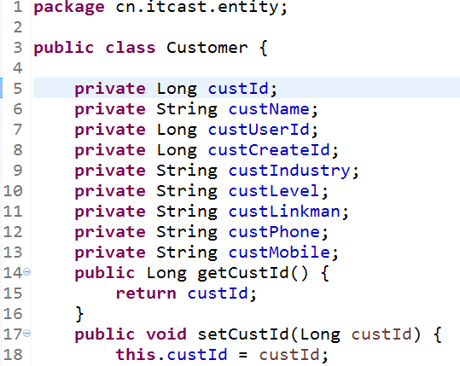

1. 完成dao代码

接口

**package** cn.itcast.dao;

**import** cn.itcast.entity.Customer;

**public** **interface** CustomerDao {

**public** Customer getById(Long id);

}

实现类

**package** com.itcast.dao.impl;

**import** org.springframework.orm.hibernate5.support.HibernateDaoSupport;

**import** cn.itcast.dao.CustomerDao;

**import** cn.itcast.entity.Customer;

**public** **class** CustomerDaoImpl **extends** HibernateDaoSupport **implements** CustomerDao {

@Override

**public** Customer getById(Long id) {

**return** **this**.getHibernateTemplate().get(Customer.**class**, id);

}

}

1. 完成service代码

接口

**package** com.itcast.service;

**import** cn.itcast.entity.Customer;

**public** **interface** CustomerService {

**public** Customer getById(Long id);

}

实现类

package com.itcast.service.impl;

import com.itcast.service.CustomerService;

import cn.itcast.dao.CustomerDao;

import cn.itcast.entity.Customer;

public class CustomerServiceImpl implements CustomerService {

private CustomerDao customerDao;

public void setCustomerDao(CustomerDao customerDao) {

this.customerDao = customerDao;

}

@Override

public Customer getById(Long id) {

return customerDao.getById(id);

}

}

1. 完成action代码

package cn.itcast.action;

import com.itcast.service.CustomerService;

import com.opensymphony.xwork2.ActionSupport;

import cn.itcast.entity.Customer;

public class CutomerAction extends ActionSupport {

//两个成员变量

private Customer customer;

private Long custId;

public Customer getCustomer() {

return customer;

}

public void setCustomer(Customer customer) {

this.customer = customer;

}

private CustomerService customerService;

public void setCustomerService(CustomerService customerService) {

this.customerService = customerService;

}

public Long getCustId() {

return custId;

}

public void setCustId(Long custId) {

this.custId = custId;

}

public String findById(){

customer = customerService.getById(custId);

return SUCCESS;

}

}

1. 拷贝配置文件并修改

从如下图位置拿到配置文件

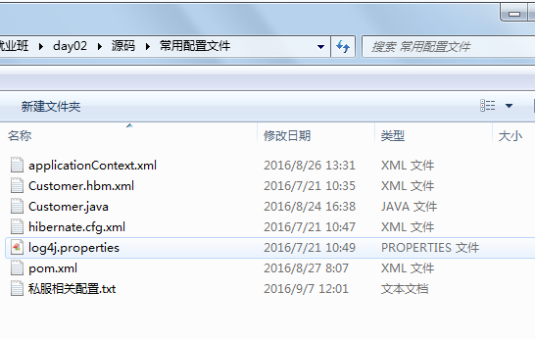

放入到 src/main/resources目录中

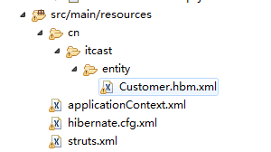

修改内容 略

1. 修改web.xml 添加spring的监听

<listener>

<listener-class>org.springframework.web.context.ContextLoaderListener</listener-class>

</listener>

<context-param>

<param-name>contextConfigLocation</param-name>

<param-value>classpath:applicationContext.xml</param-value>

</context-param>

1. 运行项目

# 分模块开发

依赖范围对依赖传递造成的影响（了解）

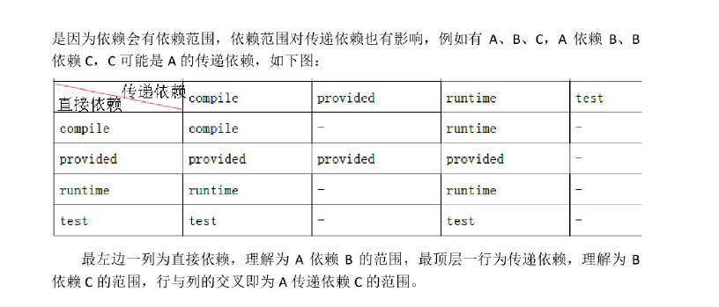

父工程来管理 聚合

## 创建父工程：

1、

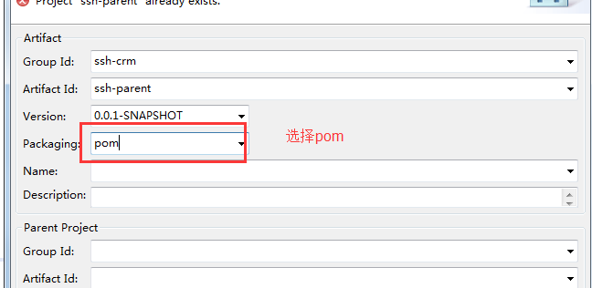

2、创建出的父工程如下



3、在pom.Xml中添加以下信息：

<!-- 属性 -->

<properties>

<spring.version>4.2.4.RELEASE</spring.version>

<hibernate.version>5.0.7.Final</hibernate.version>

<struts.version>2.3.24</struts.version>

</properties>

<!-- 锁定版本，struts2-2.3.24、spring4.2.4、hibernate5.0.7 -->

<dependencyManagement>

<dependencies>

<dependency>

<groupId>org.springframework</groupId>

<artifactId>spring-context</artifactId>

<version>${spring.version}</version>

</dependency>

<dependency>

<groupId>org.springframework</groupId>

<artifactId>spring-aspects</artifactId>

<version>${spring.version}</version>

</dependency>

<dependency>

<groupId>org.springframework</groupId>

<artifactId>spring-orm</artifactId>

<version>${spring.version}</version>

</dependency>

<dependency>

<groupId>org.springframework</groupId>

<artifactId>spring-test</artifactId>

<version>${spring.version}</version>

</dependency>

<dependency>

<groupId>org.springframework</groupId>

<artifactId>spring-web</artifactId>

<version>${spring.version}</version>

</dependency>

<dependency>

<groupId>org.hibernate</groupId>

<artifactId>hibernate-core</artifactId>

<version>${hibernate.version}</version>

</dependency>

<dependency>

<groupId>org.apache.struts</groupId>

<artifactId>struts2-core</artifactId>

<version>${struts.version}</version>

</dependency>

<dependency>

<groupId>org.apache.struts</groupId>

<artifactId>struts2-spring-plugin</artifactId>

<version>${struts.version}</version>

</dependency>

</dependencies>

</dependencyManagement>

<!-- 依赖管理 -->

<dependencies>

<!-- spring -->

<dependency>

<groupId>org.springframework</groupId>

<artifactId>spring-context</artifactId>

</dependency>

<dependency>

<groupId>org.springframework</groupId>

<artifactId>spring-aspects</artifactId>

</dependency>

<dependency>

<groupId>org.springframework</groupId>

<artifactId>spring-orm</artifactId>

</dependency>

<dependency>

<groupId>org.springframework</groupId>

<artifactId>spring-test</artifactId>

</dependency>

<dependency>

<groupId>org.springframework</groupId>

<artifactId>spring-web</artifactId>

</dependency>

<!-- hibernate -->

<dependency>

<groupId>org.hibernate</groupId>

<artifactId>hibernate-core</artifactId>

</dependency>

<!-- 数据库驱动 -->

<dependency>

<groupId>mysql</groupId>

<artifactId>mysql-connector-java</artifactId>

<version>5.1.6</version>

<scope>runtime</scope>

</dependency>

<!-- c3p0 -->

<dependency>

<groupId>c3p0</groupId>

<artifactId>c3p0</artifactId>

<version>0.9.1.2</version>

</dependency>

<!-- 导入 struts2 -->

<dependency>

<groupId>org.apache.struts</groupId>

<artifactId>struts2-core</artifactId>

</dependency>

<dependency>

<groupId>org.apache.struts</groupId>

<artifactId>struts2-spring-plugin</artifactId>

</dependency>

<!-- servlet jsp -->

<dependency>

<groupId>javax.servlet</groupId>

<artifactId>servlet-api</artifactId>

<version>2.5</version>

<scope>provided</scope>

</dependency>

<dependency>

<groupId>javax.servlet</groupId>

<artifactId>jsp-api</artifactId>

<version>2.0</version>

<scope>provided</scope>

</dependency>

<!-- 日志 -->

<dependency>

<groupId>org.slf4j</groupId>

<artifactId>slf4j-log4j12</artifactId>

<version>1.7.2</version>

</dependency>

<!-- junit -->

<dependency>

<groupId>junit</groupId>

<artifactId>junit</artifactId>

<version>4.9</version>

<scope>test</scope>

</dependency>

<!-- jstl -->

<dependency>

<groupId>javax.servlet</groupId>

<artifactId>jstl</artifactId>

<version>1.2</version>

</dependency>

</dependencies>

<build>

<plugins>

<!-- 设置编译版本为1.7 -->

<plugin>

<groupId>org.apache.maven.plugins</groupId>

<artifactId>maven-compiler-plugin</artifactId>

<configuration>

<source>1.7</source>

<target>1.7</target>

<encoding>UTF-8</encoding>

</configuration>

</plugin>

<!-- maven内置 的tomcat6插件 -->

<plugin>

<groupId>org.codehaus.mojo</groupId>

<artifactId>tomcat-maven-plugin</artifactId>

<version>1.1</version>

<configuration>

<!-- 可以灵活配置工程路径 -->

<path>/ssh</path>

<!-- 可以灵活配置端口号 -->

<port>8080</port>

</configuration>

</plugin>

</plugins>

</build>

4、发布到本地仓库

dao service web

## 创建dao子模块

1、在ssh-parent项目上右击 ，创建时选择 Maven Module

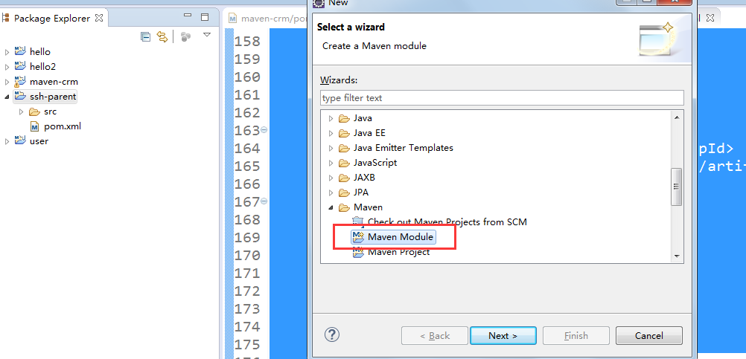

2、填写子模块名称ssh-dao

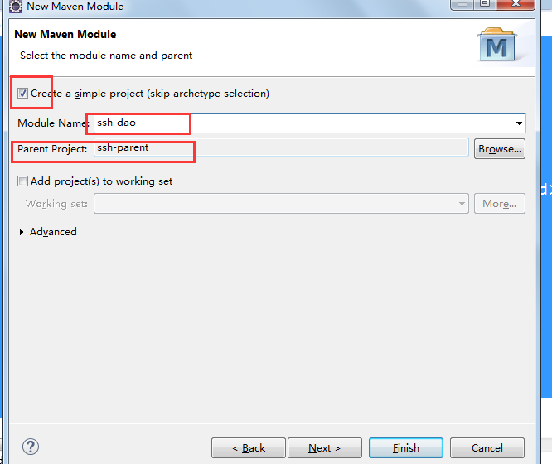

3、把属于dao的代码拷贝到 该模块中：

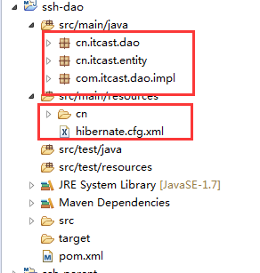

4、完成后发布到本地仓库中

## 创建service子模块

1、创建方式如上：

2、把属于service的代码拷贝到该工程中

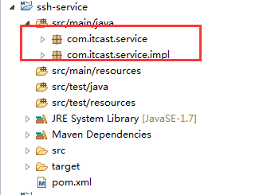

3、发布到本地仓库中

## 创建Action子模块

1、选择war的打包方式

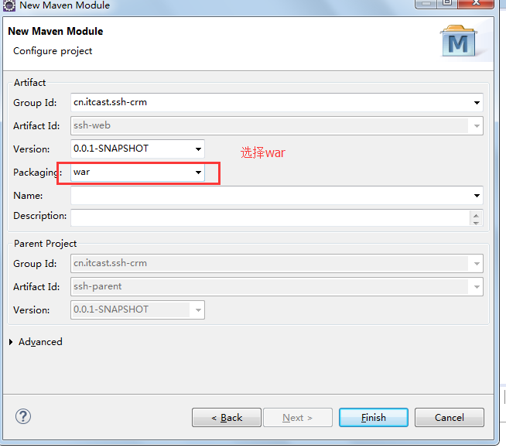

1. 拷贝属于action的代码和配置文件

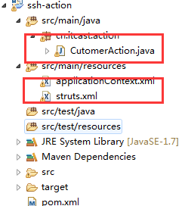

1. 修改web.xml 添加spring监听

<listener>

<listener-class>org.springframework.web.context.ContextLoaderListener</listener-class>

</listener>

<context-param>

<param-name>contextConfigLocation</param-name>

<param-value>classpath*:applicationContext-*.xml</param-value>

</context-param>

4、添加页面：

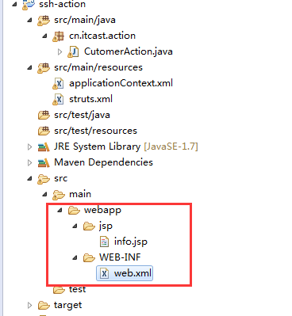

# 私服 nexus

安装nexus



启动服务

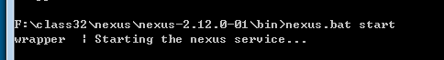 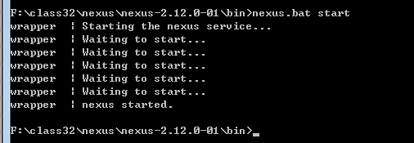

启动失败的解决方法：

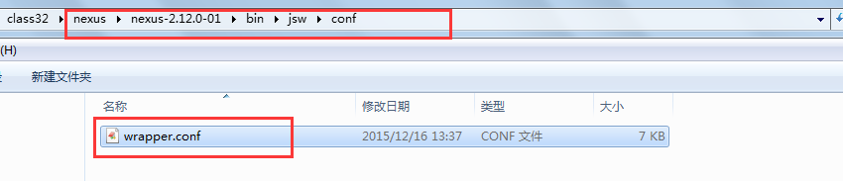

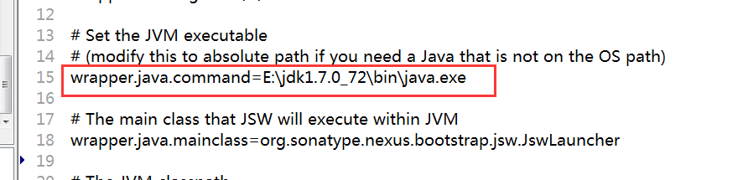

登录nexus

用户名/密码 admin/admin123

仓库类型

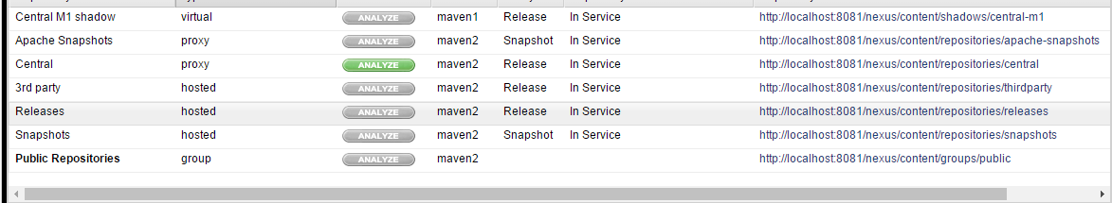

Virtual 虚拟仓库

Proxy 代理仓库

Hosted 宿主仓库 本地仓库

Group 组

需求：

把dao放到私服上，然后service从私服上下载

需求 ：将ssh_dao的这个工程打成jar包，并放入到私服上去.

## 上传dao

第一步： 需要在客户端即部署dao工程的电脑上配置 maven环境，并修改 settings.xml 文件，配置连接私服的用户和密码 。

此用户名和密码用于私服校验，因为私服需要知道上传都 的账号和密码 是否和私服中的账号和密码 一致。

<server>

<id>releases</id>

<username>admin</username>

<password>admin123</password>

</server>

<server>

<id>snapshots</id>

<username>admin</username>

<password>admin123</password>

</server>

第二步： 配置项目pom.xml

配置私服仓库的地址，本公司的自己的jar包会上传到私服的宿主仓库，根据工程的版本号决定上传到哪个宿主仓库，如果版本为release则上传到私服的release仓库，如果版本为snapshot则上传到私服的snapshot仓库

<distributionManagement>

<repository>

<id>releases</id>

<url>http://localhost:8081/nexus/content/repositories/releases/</url>

</repository>

<snapshotRepository>

<id>snapshots</id>

<url>http://localhost:8081/nexus/content/repositories/snapshots/</url>

</snapshotRepository>

</distributionManagement>

注意：pom.xml这里<id> 和 settings.xml 配置 <id> 对应！

第三步：执行deploy命令发布到私服

## 下载dao

第一步 修改settings.xml

<profile>

<!--profile的id-->

<id>dev</id>

<repositories>

<repository>

<!--仓库id，repositories可以配置多个仓库，保证id不重复-->

<id>nexus</id>

<!--仓库地址，即nexus仓库组的地址-->

<url>http://localhost:8081/nexus/content/groups/public/</url>

<!--是否下载releases构件-->

<releases>

<enabled>true</enabled>

</releases>

<!--是否下载snapshots构件-->

<snapshots>

<enabled>true</enabled>

</snapshots>

</repository>

</repositories>

<pluginRepositories>

<!-- 插件仓库，maven的运行依赖插件，也需要从私服下载插件 -->

<pluginRepository>

<!-- 插件仓库的id不允许重复，如果重复后边配置会覆盖前边 -->

<id>public</id>

<name>Public Repositories</name>

<url>http://localhost:8081/nexus/content/groups/public/</url>

</pluginRepository>

</pluginRepositories>

</profile>

<activeProfiles>

<activeProfile>dev</activeProfile>

</activeProfiles>

第二步 删除本地仓库中的dao

第三步 update service工程，出现以下信息说明已经成功

