A Depth Model for Informing Chinook Salmon Bycatch Risk in the Gulf of Alaska

- Marcel Gietzmann-Sanders (Corresponding Author), University of Alaska Fairbanks College of Fisheries and Ocean Sciences, 2150 Koyukuk Drive, 245 O’Neill Building, PO Box 757220, Fairbanks, Alaska 99775-7220
- Michael Courtney, University of Alaska Fairbanks College of Fisheries and Ocean Sciences, 17101 Point Lena Loop Rd., Juneau, AK 99801
- Andrew Seitz, University of Alaska Fairbanks College of Fisheries and Ocean Sciences, 2150 Koyukuk Drive, 245 O’Neill Building, PO Box 757220, Fairbanks, Alaska 99775-7220
- Curry J. Cunningham, University of Alaska Fairbanks College of Fisheries and Ocean Sciences, 17101 Point Lena Loop Rd., Juneau, AK 99801

Abstract
Background
Bycatch of Chinook salmon (Oncorhynchus tshawytscha) in the Gulf of Alaska walleye pollock (Gadus chalcogrammus) fishery poses both conservation and management challenges. While fleet communication and excluder devices have improved mitigation efforts, effective reduction ultimately depends on anticipating overlap—especially near the seafloor where pollock are targeted. To support context-specific bycatch mitigation strategies, we developed a probabilistic deep learning model that predicts Chinook salmon depth occupancy using fisheries-independent telemetry data and environmental, temporal, and spatial covariates.

Results
The best-performing model incorporated season, diel period, and salinity as key predictors of Chinook salmon depth occupancy in the Gulf of Alaska. Seasonal and diel effects were observed to represent a repeating annual cycle, with strong diel patterns appearing in late summer and fall. Salinity was also predictive in some months with shallower depth occupancy corresponding to lower surface salinity. Using the model, spatial and temporal patterns in the likelihood of Chinook salmon occupying depths targeted by trawl gear were mapped, revealing seasonal and diel hotspots of overlap.

Conclusions
The model reveals a dynamic landscape of depth occupancy for Chinook salmon in the Gulf of Alaska. The predictions so derived provide a foundation for bycatch mitigation strategies that account for both behavioral rhythms and environmental variability, underscoring the role of such models could have in advancing dynamic ocean management.

Keywords
- Dynamic Ocean Management
- Deep Learning
- Satellite Tags
- Fish Behavior
Background
Bycatch — the capture of non-target organisms — is a persistent issue in many fisheries [1, 2]. While it first gained public attention through incidental take of charismatic megafauna [2] subsequent research has illuminated a range of concerns. These include the waste of edible protein [2 , 3], conflicts between fisheries targeting different species [4, 5], increased extinction risk for vulnerable species [6, 7], trophic disruption [8], and destabilization of population dynamics [2]. As a result, considerable attention has been directed toward reducing bycatch.

Of particular concern in the state of Alaska is the incidental capture of Chinook salmon (Oncorhynchus tshawytscha) in the walleye pollock (Gadus chalcogrammus) fishery [5]. The walleye pollock fishery is the largest in the United States by volume [5]. The retained 2020 catch in just the Gulf of Alaska (GOA) totaled 107,000 metric tons and had a first wholesale value of $70.6 million [9]. Within this fishery, Chinook salmon bycatch is considered prohibited species catch (PSC) meaning it is bycatch that cannot be retained or sold. PSC allowances are granted to the fishery but if those allowances are exceeded, the fishery is shut down regardless of the remaining allowable catch [10]. For the Gulf of Alaska these limits are set at 18,316 fish for the Central GOA and 6,684 for the Western GOA, (Amendment 93) with limited provisions for reallocation of unused PSC between sectors (Amendment 103) [10]. As recently as 2024 two boats accidentally brought in enough Chinook salmon over a single weekend to exceed these allowances [11]. With such limited allowances, bycatch avoidance practices have been an area of active development.

Of those developments, one of the most promising has been cooperative data-sharing amongst fishers [5]. Through such programs fishers can dynamically adjust their response to bycatch risk based on up-to-date information shared through the whole fleet. This information is also used to setup short-term closures in high-bycatch zones [5] – yet another tool in the dynamic ocean management toolbox that draws its power from near real-time, local information on bycatch risk [12]. However, improved understanding of the spatial ecology of Chinook salmon while at sea, including their habitat and depth preferences may improve the efficacy of bycatch mitigation actions by identifying high risk zones.

Adding information on depth occupancy to this toolbox could prove fruitful. Adult walleye pollock are largely demersal [13, 14] whereas Chinook salmon are very active in the water column [15, 16, 17]. While Chinook salmon spend most of their time between 0 and 50m their overall observed range extends beyond 500m [15, 16]. They also display flexible diel behaviors, sometimes reverse their movement patterns seasonally [15, 16, 18], and seem to vary their depth occupancy in relation to temperature, productivity indicators, and current velocity [17, (Freshwater, 2024; Hinke, 2005). In contrast, while walleye pollock are known to exhibit diel patterns, [13, Miyashita, 2004) the majority of adult walleye pollock are primarily demersal – a pattern reinforced by the fact that the fishery targets them at or near the sea floor (De Robertis, 2006). These differences suggest that bycatch risk could be further mitigated if localized and temporally dynamic information on Chinook salmon depth occupancy was available.

A model of localized, Chinook salmon depth occupancy has not yet been built. Most studies on depth occupancy in Chinook salmon have focused on understanding the factors influencing depth as opposed to developing inferential tools for localized prediction (Freshwater, 2024). One exception was Freshwater et al., (2024) who trained a model that leveraged localized environmental and temporal covariates to predict expected depth for Chinook salmon along the coast of Washington (WA) and British Columbia (BC). However, to assess relative risk with specific depth range, a model would need to estimate the distribution of fish over the entire water column. Arostegui et al. [18] did produce such a distributional model but only used season and day/night as features and only used data from a study area in Puget Sound, preventing the model from being amenable to localized and dynamic predictions. Combining these two approaches remains an open opportunity for Chinook salmon.

Our goal was to explore the extent to which probabilistic deep learning can inform Chinook salmon bycatch mitigation strategies, by building a model capable of predicting depth distribution at localized spatial scales. We did this in three steps. First, we built a model that leveraged environmental and temporal features (such as time of day and/or seasonality) to predict the relative likelihood of depth-bin occupancy by Chinook salmon throughout the water column. The predictor variables or features considered included oceanographic, biochemical, seasonal, and diurnal characteristics. Second, we evaluated the model’s predictions against observed depth occupancy and compared it to patterns observed in past research. Finally, we generated a year's worth of predictions across the spatial domain of the Gulf of Alaska to illustrate how those predictions can inform the selection of places and times where there is lower risk of Chinook occupancy near the sea floor, at depths proximate to where trawl fishing for pollock often occurs.

Methods
Overview of Model Training
To predict fish occupation of discrete depth bins using environmental and temporal features (e.g. day of year and time of day), we applied probabilistic deep learning (Dürr, 2020) and framed the problem as a classification of fish occupancy within those depth bins. As such, the model was trained over a dataset where each sample in that dataset corresponds to one fish at a specific location and time, and that fish's "classification" is defined as the depth bin it was observed to occupy. Features for each sample are derived from the environmental and/or temporal variables associated with the depth bins at that position. Model training then aimed to reduce categorical cross entropy – a loss function whose negative is proportional to the likelihood of the observed data given the predictions. Deep learning was selected as such models can learn highly non-linear, combinatorial patterns (Dürr, 2020).

Broadly, models were built using the following steps. First, we retrieved Chinook salmon movement tracks from prior research in the Gulf of Alaska and Eastern Bering Sea (Seitz, 2024). The position and depth data were then transformed to provide samples for a classification model and split into training (65%) and validation (35%) sets. Environmental data was retrieved from the Copernicus Marine Service and temporal data derived from “ephem” and “suntimes” packages in Python. These data were then aggregated, scaled, and joined to the movement tracks to provide model features. Given the high dimensionality of this feature space, a novel dimensionality reduction technique was applied. Models were trained over a variety of increasingly comprehensive feature sets and the final model selected using loss over the validation set. The following paragraphs describe each of these steps in detail.

Details of Model Training
Chinook salmon movement tracks (Seitz, 2024), consisting of daily estimated positions (Figure 1) and depths were used to train and test our models. Fish (62-100cm fork length) were caught and tagged near Dutch Harbor, AK (n=20), Chignik, AK (n=16), Craig, AK (n=8), Homer, AK (n=20), Kodiak, AK (n=13), Yakutat, AK (n=16), Sitka, AK (n=15), and in the Central Bering Sea (n=3). In the Eastern Bering Sea (EBS) they were caught via midwater trawl or by hook whereas all other catches happened by hook and line (Seitz, 2024). All fish, not just those in the prediction region, were included in this study to encourage generalization in the models. Fish were then monitored using pop-up satellite archival tags that collect temperature, ambient light intensity, and depth information at specified (sub day) intervals during deployment and then release from the fish, surface, and transmit collected data over satellite. While the data was sampled at a sub-minute interval, the central tendency of depth occupancy was summarized per (2.5–15-minute) period before being uploaded due to limited battery life. If the tag was recovered, the full dataset is available. To standardize our data all reported depths were averaged to one record per 15-minute interval. To obtain location estimates, the data from the tag was passed through a proprietary hidden Markov model from Wildlife Computers that uses the tag’s data to estimate the likely paths taken by the fish during tag deployment (Wildlife Computers, 2025). An estimate of location for each day was then be derived as the central tendency of those paths on a particular day. In total 7,532 observation days were collected across the fish. These data were especially well suited to our problem as they have the distinct advantage of being fisheries independent and giving a comprehensive view of depth occupancy throughout tag deployment rather than a single snapshot value.

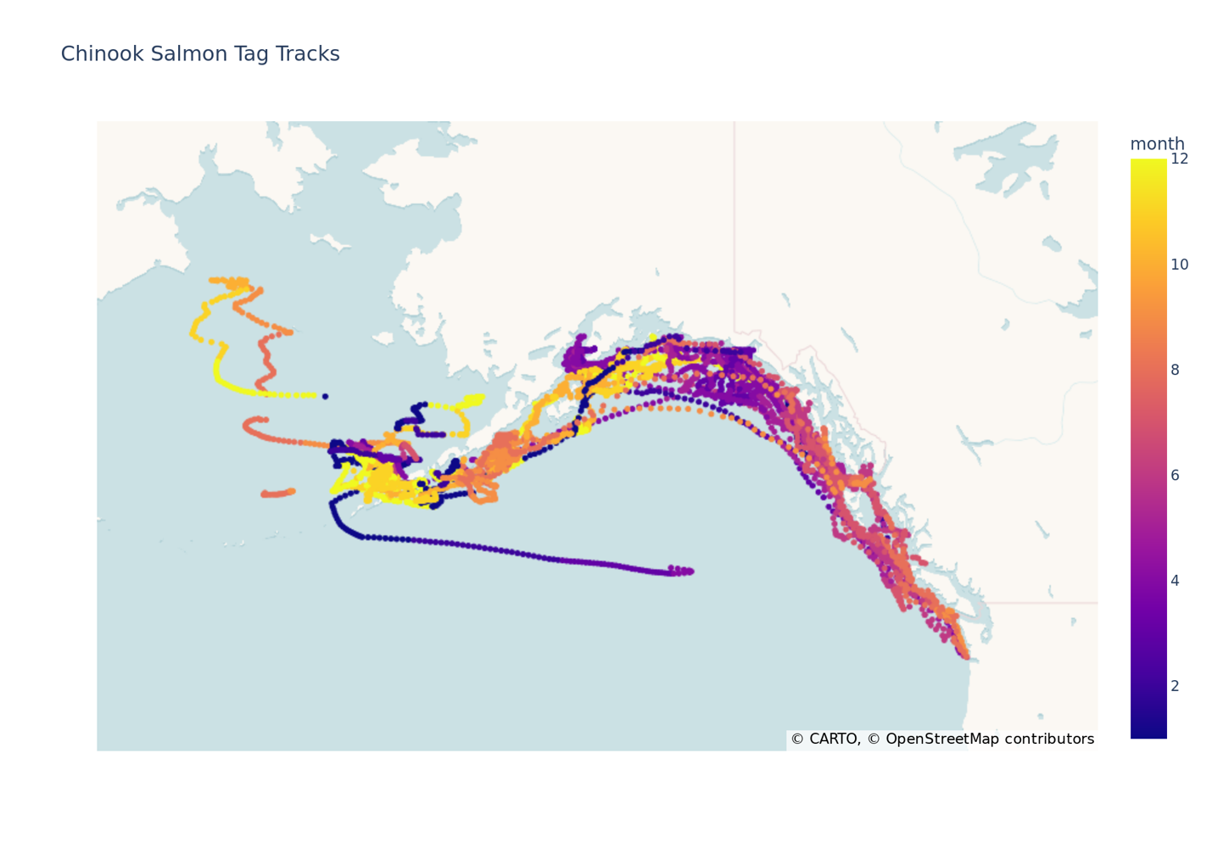Figure 1: Chinook Salmon Tag Tracks. Estimated, daily positions, colored by month of year, of all Chinook salmon tag tracks used in this study.

After collecting these tag tracks, observations were prepared for use in classification. To prevent over-representing the precision of the uploaded depth data, we resampled each reported depth from a normal distribution centered at that depth with a standard deviation equal to 10% of the reported depth. We then discretized these measurements into bins corresponding to 25, 50, 75, 100, 150, 200, 250, 300, 400, and 500 meters. Each number indicates the upper bound of a bin and does not include depths from shallower bins. These depth bins were then normalized to a decimal between 0 and 1, with bin 25 corresponding to 0.1, 50 to 0.2, and so on. Finally, daily fish positions were aggregated to a fixed, hexagonal spatial grid - resolution 4 Uber H3 cells (Brodsky, 2018) – in order to not over-represent the accuracy of the estimated positions.

Environmental conditions were derived from the Global Ocean Biogeochemistry Hindcast (10.48670/moi-00019) and Global Ocean Physics Reanalysis (10.48670/moi-00021) datasets provided by the E.U. Copernicus Marine Service. Data were drawn for each day between January 2013 and January 2023 in the Northern Pacific and values were aggregated to means per day, depth bin (for values that changed across the water column), and Uber H3 cell at resolution 4. A daily resolution was chosen to match the resolution of the Biogeochemistry Hindcast data. Environmental variables chosen for exploration included chlorophyll, net primary production, nitrate, oxygen, phosphate, silicate, bottom elevation, mixed layer thickness, salinity, temperature, and north and easterly current velocity. These were then joined to the fish tracks on location and time.

Seasonality, lunar cycle, and diel features were derived using the datetimes associated with each sample along with the “ephem” and “suntimes” packages in Python for lunar and diel features respectively. In all cases, time was represented by taking the cycle in question, decomposing it to radians (0 at the beginning of the cycle and $2π$ at the end of the cycle), and then providing the sine and cosine of that feature to the models. Specifically, we constructed temporal features representing the day of year (seasonality), progression through the day or night (cosines at 0 for sunrise and sunset, sines positive during the day and negative at night), and a final set of sines and cosines indicating progress through the lunar cycle.

To ensure all covariates were on the same scale, chlorophyll, net primary production, and mixed layer thickness were log scaled and then all environmental features were rescaled to be between 0 and 1. Given the range of sines and cosines are -1 to 1, no further normalization was needed for the temporal features.

We framed the problem as a classification task (Dürr, 2020), where we sought to predict the probability that a fish at a given location and time would occupy a particular depth bin. In this framework, the depth bins served as our classification categories, while each sample in our dataset represented a single fish at a specific spatiotemporal point. Given the potentially non-linear relationships between our features and classes we chose machine learning as it is well known to excel in non-linear learning (CITE).

However we made a modification to the typical approach in order to reduce the dimensionality of our feature set. Given we had features for each depth bin, selecting N covariates would have resulted in a feature space of dimension 10N (N features across 10 depth bins). The 10x multiplier was an issue because the volume of data required to fit a model effectively can grow exponentially with the dimensionality of the feature space (Verleysen, 2005). To overcome this we instead trained a model that predicted the log odds of occupancy in a specific depth bin. As only one depth bin’s features were needed in this model, our dimensionality dropped to N. However, given we had no ground truth for these log odds we had to pass the predictions for each depth bin through a function that transformed them into probabilities per depth bin. This was done by using a softmax activation layer whose weights were an untrainable identity matrix. This combined model allowed us to train over the whole feature space while having a model parametrized only for the features of one depth bin - greatly reducing the dimensionality of the space.

This dimensionality reduction technique excluded the use of techniques such as Random Forests as we were optimizing our parameters through a transformation (in this case softmax). However given neural nets are optimized through gradient descent, we were able to apply this technique without modification. This was the primary reason for using Neural Networks as opposed to other algorithms such as Random Forests.

This introduced a class imbalance in our data, because with 10 depth bins most instances of the internal log-odds model are encouraged to report very low log-odds. Therefore, we rebalanced the data by taking advantage of the fact that the log-odds of one choice is independent of the others. As a result, we down-sampled the number of choices in any decision to just two and achieved a balance between the positive and negative classes. To ensure we captured the variety in choices, we then resampled the same decisions repeatedly to get different pairs of selected and unselected choices. We call this process contrast sampling as we are sampling selected vs unselected contrasts. In this specific case we decided on a random sample (with replacement) of 5,000 decisions per individual and 10 choices per decision. Over a validation/training split of 35/65 this resulted in 5,550,000 contrasts of which 3,600,000 were used in training and the rest in validation. Fish were chosen at random to belong to either the validation/training set. This ensures that there is no information leakage due to the autocorrelated nature of the tracking data per fish. Given that sampling was inhomogeneous between years we did not hold out a specific set of time.

Models were implemented in Keras (Chollet, 2015) and trained for 100 epochs using a batch size of 200,000 and an Adam optimizer (Kingma, 2015) with a learning rate of 0.001. A grid search was performed over 2 and 3 hidden layers and 24 and 32 units per hidden layer and the model with the lowest validation over the contrast set was then selected. Amazon Web Service’s Batch Fargate service (AWS Batch) was used for computations and training was performed on instances with 2 vcpus and 4GB memory.

To facilitate feature selection and investigate the predictive power of different feature sets, several models were trained over feature sets of increasing complexity. All feature sets were subsets of the environmental and temporal features discussed above. The model with the lowest loss over the contrast validation set was selected as the final model. Then, starting from no features, the final model’s features were incrementally added to build additional models used to investigate the importance of each set of features. Each incremental feature was selected according to whichever caused the maximal drop in loss. For each of these models, to make comparisons, categorical cross entropy was computed over the validation and training sets for both the contrasts and the original decisions. A related, but more directly interpretable, metric – geometric mean probability (gmp) was also computed to aid comparison. This was computed by taking the geometric mean over the probabilities the model assigned to the observed depth bins in the data and gave a central tendency for the probability of selecting the observed depth bin.

Evaluation of Model Predictions
To evaluate the final model’s predictions against observed depth occupancy we summarized depth occupancy and predictions across each of the selected features. For seasonal effects we compared the proportion of tagged fish in each depth bin per month (independent of year) in the validation set to the mean probability of fish in each depth bin as predicted by the model. To evaluate diurnal variation, we converted our sin_sun and cos_sun features back into radians and then computed the actual proportions of the fish at depths deeper than 25m across months for both the training and validation sets. 25m was chosen to distinguish between near surface waters, where Chinook salmon spend most of their time, and waters away from the surface. This was then compared to the mean probability of depth occupancy below 25m across the day as predicted by the model over the validation set. To illustrate the effect of salinity we looked at the predicted proportions of fish near the surface (<25m depth) when salinity was above (high salinity) and below (low salinity) 31.3ppt (25th percentile of surface salinity over the tagging dataset). To control for the effects of depth we produced these proportions for each overall depth (as measured by the maximum depth bin at the location) and month where we had both low and high samples and then averaged over these proportions thus weighting all depths evenly. In addition to this we also computed the change in model loss across month when we added salinity to the model.

Informing Bycatch Mitigation
To illustrate how the model predictions could guide mitigation of incidental capture near the seafloor we back predicted depth occupancy over a subsection of the Gulf of Alaska in the year of 2022 and then used the predictions to explore how the individual features of the model drive risk of overlap with fishing gears deployed near the bottom. First, in the same manner as described for model training, we built a dataset of model features that included each depth bin, over every single H3 resolution 4 cell in the Gulf of Alaska and Eastern Bering Sea, for each hour over the full year of 2022. This resulted in over 96 million individual entries in space and time. W then ran model inference over these points to determine the likelihood of Chinook salmon presence associated with each of the entries. We then subset this data to just a portion of the GOA of interest and removed entries where the average depth was greater than 600m as Chinook are rarely seen deeper than 500m.

Using this dataset we then explored the effect each of our features had on depth occupancy in the deepest depth bin available to each H3 cell. First, to look at seasonality, we computed the 5th percentile risk in the deepest depth bin per H3 cell across the months of February and August (examples from winter and summer respectively). A 5th percentile was taken as absolute minimums can often be misleading. Then to better understand seasonal and diurnal variation we plotted the risk per depth bin across the entire year for one H3 cell (index=840ccebffffffff, lat=55.9N, lon=-158.2E) near Chignik where a number of the fish in this study were caught. To further understand variation in depth occupancy as a function of time of day, we computed, per H3 cell on August 15 and February 15, the average of our sin_sun feature where depth occupancy was below its 5th percentile for that day and H3 cell. Positive values of this aggregate indicate that occupancy was minimized during the day, negative values indicate a minimization at night.

Results

Model Evaluation

The model with the lowest validation loss (providing the highest likelihood of the data) included depth_bin, season, diel, and salinity as features (model D in Table 1). Starting from a null model with a loss of 1.740 (geometric mean probability [gmp] of 17.6%), adding depth_bin (model A) reduced the loss to 1.457 (gmp 23.3%). Including season (model B) brought it to 1.368 (gmp 25.5%), and adding the diel features (model C) lowered it again to 1.352 (gmp 25.9%). With salinity included (model D), the final validation loss reached 1.340 (gmp 26.2%).
Model | Features | Loss Train | Loss Validation | Geometric Mean Probability  Validation
Null |  | 1.835 | 1.740 | 17.6%
A | depth_bin | 1.412 | 1.457 | 23.3%
B | A + season | 1.330 | 1.368 | 25.5%
C | B + diel | 1.313 | 1.352 | 25.9%
D | C + salinity | 1.308 | 1.340 | 26.2%
Table 1: Model Improvements over Features. Deep learning was used to train on and then predict the depth bins occupied by individual Chinook salmon at 15 minute intervals in the Gulf of Alaska and Eastern Bering Sea. The objective of the training was to optimize the overall likelihood of the data given the predictions by minimizing a categorical cross entropy loss function. Beginning with a null model - predicting equal probabilities across all depth bins – each new model (A – D) demonstrates the improvement in loss each new feature brings to our selected model D. Training loss represents the loss over the data the model saw during training, validation loss is the loss over a holdout set. Geometric mean probability is the geometric mean of the probability of the data given the model.

Depth occupancy, as observed by the tags and predicted by the model, skewed toward relatively shallow water. Nearly half (46.4%) of the observations were near the surface in the 0–25 m depth bin, and 85.6% were within 100 m of the surface (Table 2). The predictions paralleled this with predicted proportions of 45.6% and 85.5% respectively.
Depth Bin | Proportion of Samples | Predicted Proportion of Samples
[0, 25] | 46.4% | 45.6%
(25, 50] | 16.6% | 16.4%
(50, 75] | 13.0% | 12.6%
(75, 100] | 9.6% | 10.8%
(100, 150] | 10.1% | 9.8%
(150, 200] | 3.1% | 3.8%
(200, 250] | 0.6% | 0.8%
(250, 300] | 0.3% | 0.2%
(300, 400] | 0.1% | <0.1%
(400, 500] | <0.1% | <0.1%
Table 2: Depth Skew. Proportion of samples in each depth bin (units in meters) using observations of depth at 15-minute intervals from individual Chinook salmon (GOA and EBS), as well as the proportions predicted by the selected deep learning model.

In both the observations and the predictions, Chinook salmon depth occupancy varied seasonally (Figure 2). The proportion of observations near the surface (0-25m) was at a maximum in June, at ~68% (~66% in predictions). The proportion of time spent in the top 25m of the water column decreased throughout the fall to only 30% of observations (26% predicted) being near the surface by November. Depth occupancy remained skewed toward deeper waters throughout the winter months (35–40% above 25m) before beginning to shift back toward the surface again in early spring (March-April).
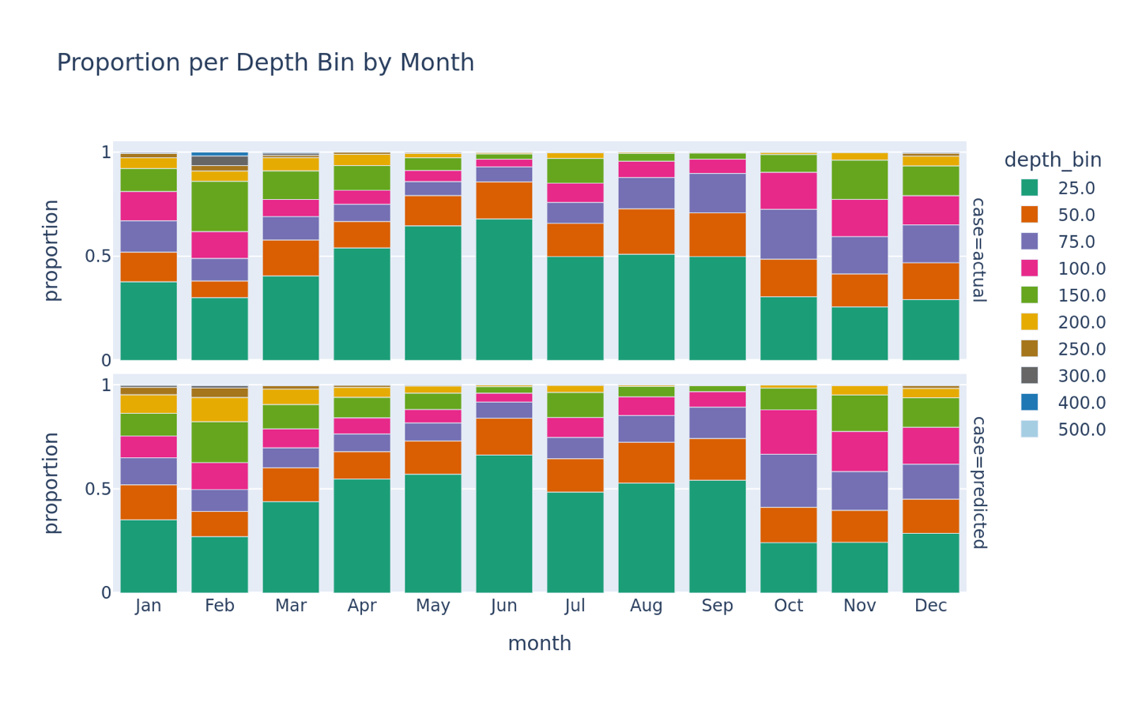

Figure 2: Seasonal Shifts in Depth Occupancy. (Top) Using measurements of depth at 15-minute intervals from individual Chinook salmon (GOA and EBS), the proportions of samples in each depth bin across all months. (Bottom) Across the measured samples, mean predicted probability of the occupied depth from a deep learning model binned across all months.

Diel variation in depth occupancy also appeared, with notable seasonal shifts (Figure 3). During the summer, fall, and most of winter fish in the validation set tended to be closer to the surface at night. August had the largest swing in observed depth occupancy with nearly three quarters (73%) of observations in the validation set near the surface (0-25m) at night but only around a quarter (27%) near the surface during the day. This diel swing of 46% weakened throughout fall and winter (37% by October and 17% by January) and in February the pattern reversed with fish more likely to be near the surface during the day.
The diel patterns of the individual fish themselves were quite variable. For example, out of 28 fish observed in August, four spent over 70% of their time near the surface during the day while six had 85% of their daytime observations below 25m. At night a similar degree of variation was observed with four fish spending most of their time (>50%) at depth (>25m) whereas seven fish were near the surface in more than 85% of observations.
Corresponding to this individual variability was considerable variation in diel patterns between the validation and training sets (Figure 3). The most extreme case occurred in May with fish being near the surface far more often (37-52% of observations) in the training set as compared to the validation set (12-31%). Likewise, in October the validation set showed a clear diel pattern with fish being closer to the surface at night (49%) than during the day (15%), but in the training set for October fish were just as likely to be near the surface throughout the day.
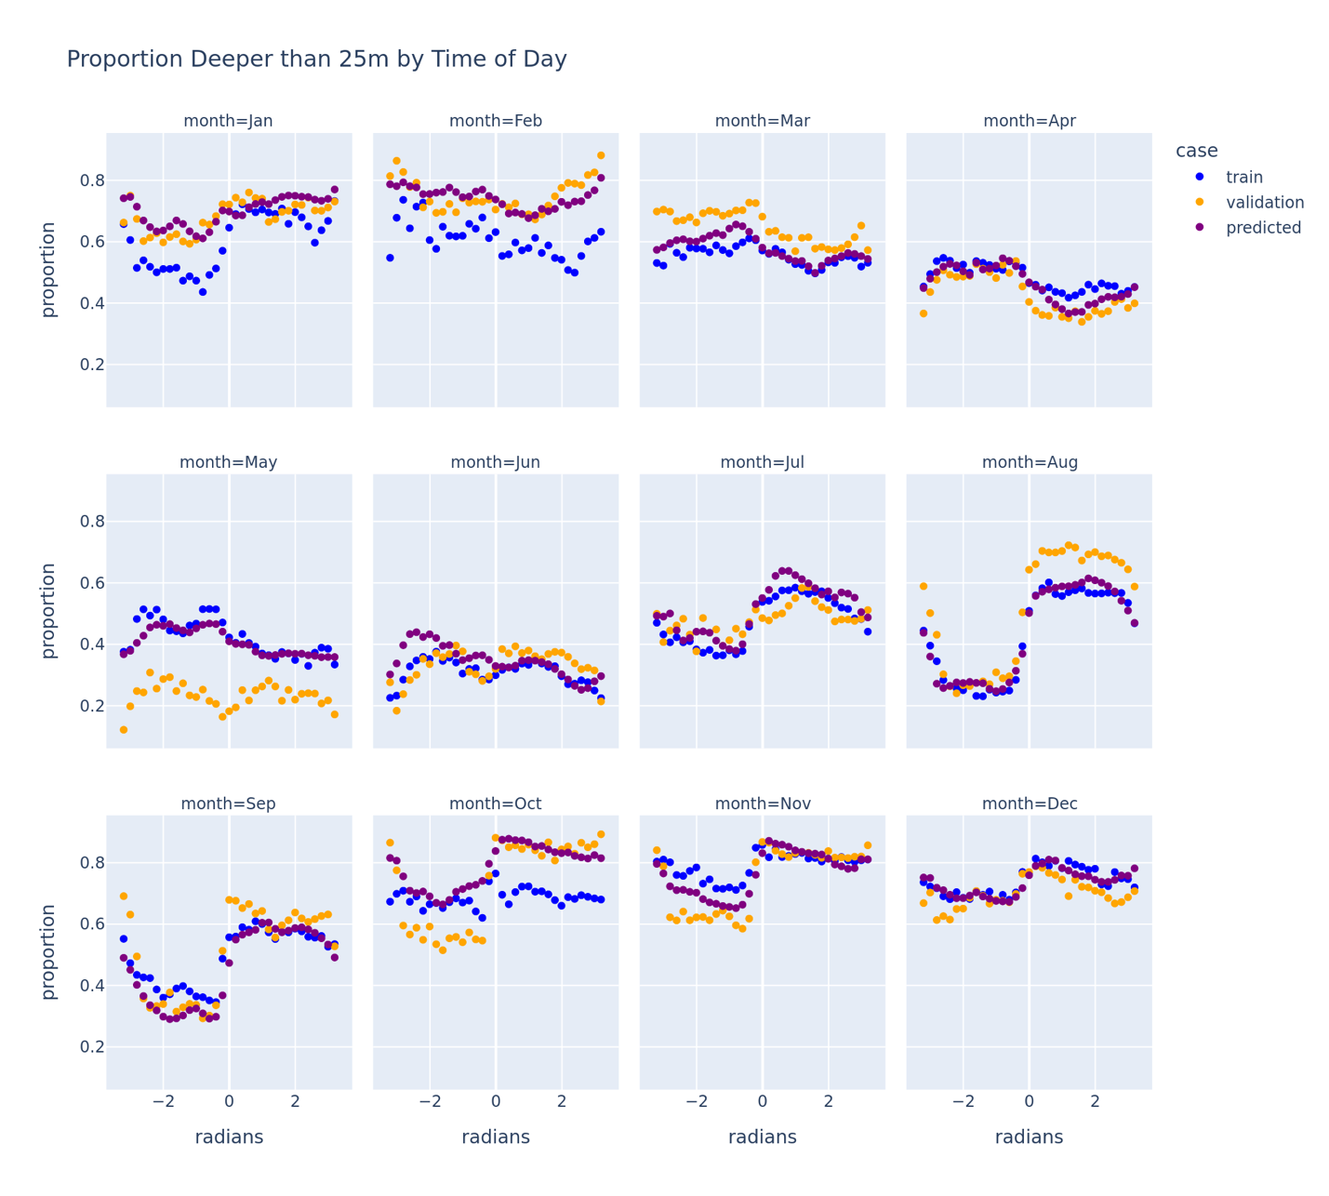
Figure 3: Diel Variation Using observations of depth at 15-minute intervals from individual Chinook salmon (GOA and EBS),, the proportions of samples deeper than 25m as a function of time of day across all months. Validation is the proportion over the validation data; train is the proportion over the training data and predicted is the mean predicted probability of the occupied depth over the validation data. The radians on the x-axis indicate time of day with negative numbers indicating nighttime and positive numbers indicating daytime.

In terms of the final feature – salinity – after controlling for depth, model predictions indicated that less saline (<31.3ppt) surface waters had higher occupancy than more saline surface (>31.3ppt) waters in all months except August and September (Figure 4). This pattern was strongest during the early winter (14% difference in December). During the months of August and September the pattern switched and occupancy near the surface was predicted to be higher in the more saline areas.
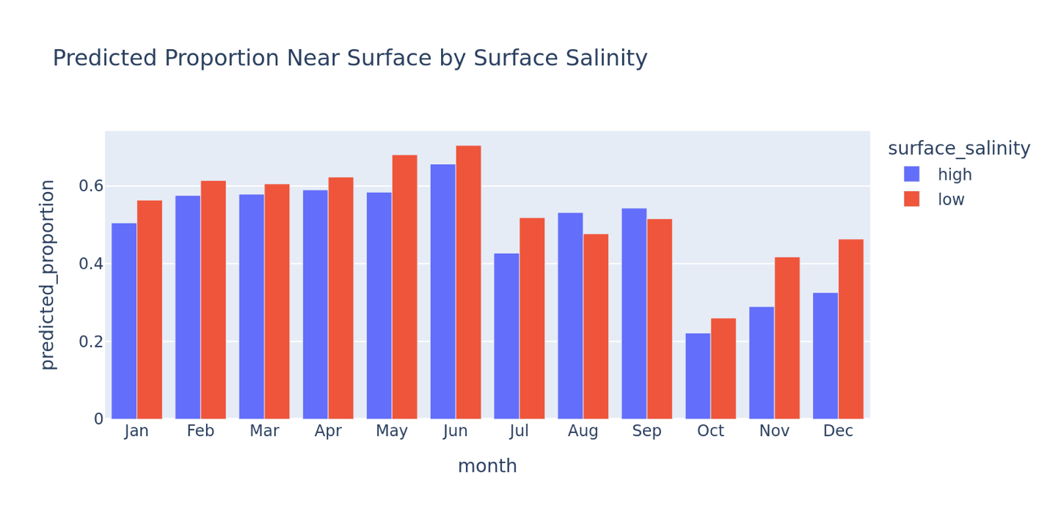
Figure 4: Effect of Salinity Predicted proportions of fish within 25m of the surface when surface salinity is above (high) and below (low) 31.3ppt. Predictions were made over the validation dataset.

However, the effect of salinity on model loss differed between the training and validation sets (Figure 5). From December to February, the two sets showed opposing trends. In December and January, the model with salinity better represented the fish in the training set than the model without salinity (with a drop in loss of 0.03 and 0.05 respectively). However, the fish in the validation set were more poorly represented (with an increase in loss of 0.02 and 0.05). In February the salinity feature made no difference for the fish in the training set but made for a much better representation of fish in the validation set (here a drop in loss of 0.14 was observed). During the remaining months, changes in loss were smaller (up to 0.03), yet discrepancies in magnitude between the validation and training sets persisted even though the direction of the change was aligned.
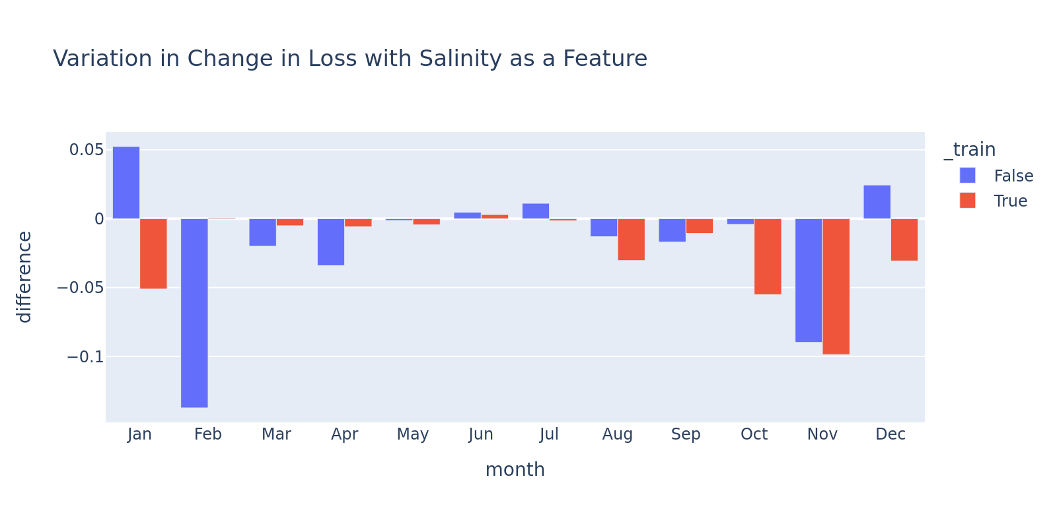
Figure 5: Variation in Performance of Salinity as a Feature Change in loss across months when adding salinity as a feature to a deep learning model of Chinook salmon depth occupancy. Red indicates the training dataset whereas blue indicates the validation dataset.

Informing Bycatch Mitigation
To assess the model’s implications for Chinook salmon bycatch we were interested in where and when the likelihood of Chinook salmon occupying the deepest depth present at a given point in space, i.e., the portion of the water column often occupied by both pelagic and non-pelagic trawl gear. Specifically, where those likelihoods were minimized over time.
The 5th percentile predicted likelihood of occupancy in the deepest bin varied across space and season (Figure 6). In February (example month representing winter), the 5th percentile likelihood of Chinook salmon occupying the deepest bin occurred along the shelf edge, where they dropped below 1%. Across the shelf, these values varied considerably, with neighboring cells often differing by 10% or more. In August (example month representing summer), 5th percentile likelihoods remained low (<1%) except for several persistent hotspots that were shared with February. One such hotspot, located just west of Kodiak, showed a 5th percentile likelihood of 15%, roughly three times higher than the surrounding areas.
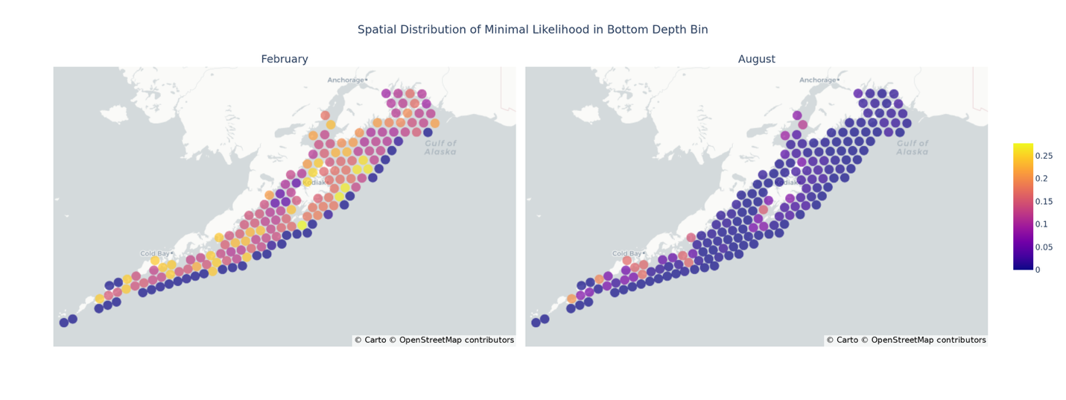
Figure 6: Spatial Distribution of 5th Percentile Likelihood. 5th percentile likelihood of Chinook salmon occupancy in the deepest bin over each hour in the months of February (left) and August (right) as predicted by our deep learning model. Employed Uber H3 resolution 4.

The times of day in which Chinook were least likely to be near the seafloor varied across space and season as well (Figure 7). In August, fish had the lowest probabilities of being near the seafloor at night in nearly all locations, with only one exception. In contrast, February showed much more spatial variation. Along the shelf edge, like in August, Chinook salmon were least likely to be near the seafloor at night. However, on the shelf, depending on which area was considered, fish were most likely to be away from the seafloor at dusk, dawn, or even during the day indicating that diel variation during February depends on location.
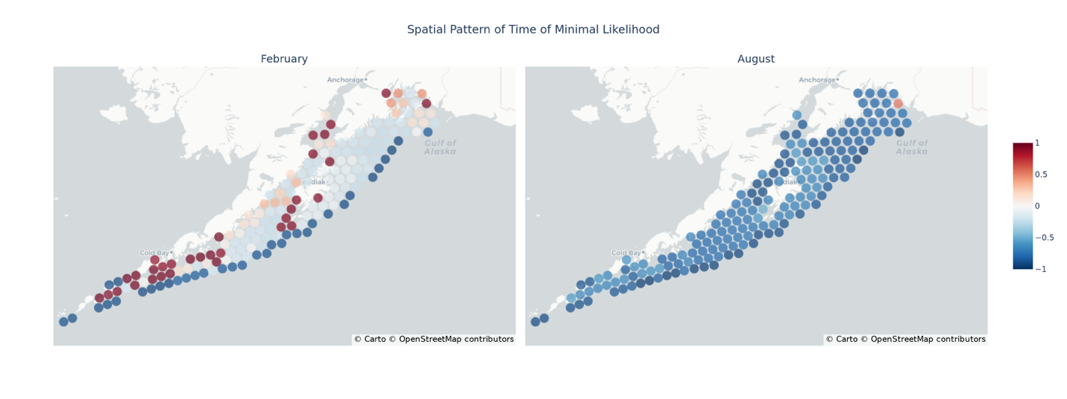
Figure 7: Time of Day Minimization. Time of day when the predicted likelihood, from our selected model, in the deepest bin for Chinook salmon is below the 5th percentile for the locations indicated on February (left) and August (right) 15. Negative values indicate nighttime whereas positive values indicate daytime. Employed Uber H3 resolution 4.

In a specific H3 cell near Chignik (Figure 8), both depth occupancy and diel variation changed considerably over the year. During winter, Chinook salmon were at greater depths, with ~50% of samples deeper than 25 m. At the same time, diel variability (the difference between maximum and minimum likelihood over the day) decreased during the winter, from nearly 20% in the 100 m depth bin (near seafloor) in November to 10% in January. Beginning in March, Chinook salmon shifted toward shallower water, with only ~30% of predicted observations deeper than 25 m by May. Diel variation increased again in July and August reaching ~15% (in the 100m bin). As a result of this high daily variation in summer as compared to spring, Chinook salmon were most likely to be found near the surface (0-25m) at night during the summer.
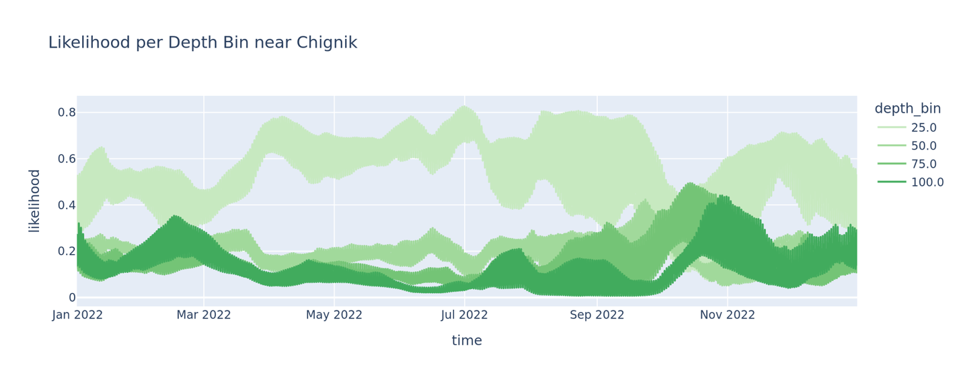
Figure 8: Full Year of Likelihoods Predicted likelihood, using our selected model, of occupancy per depth bin for Chinook salmon across all hours in 2022 for an H3 cell near Chignik, AK. The apparent width of the time series indicates the degree of diel variation at that point in time.

Discussion
Chinook Salmon Behavior
Born in freshwater streams that drain into the Pacific Ocean, Chinook salmon then may travel vast distances - thousands of kilometers – in the ocean, with many stocks occurring throughout this species’ US west coast range, spending considerable time (1-5 years) in the Gulf of Alaska. Here they remain until they mature and make the journey back to their natal rivers to spawn and then die (Quinn, 2018). By applying probabilistic deep learning to a multiyear tagging dataset, we were able to uncover fine-scale patterns in the depths occupied by near-mature Chinook salmon in the Gulf of Alaska. Specifically, we found that Chinook salmon appear to demonstrate predictable seasonal patterns in depth occupancy, diel patterns in depth occupancy that vary among seasons, and that the depths occupied appear to correlate with the salinity of surface waters, but this pattern depends on season as well.

Our analyses revealed considerable and predictable seasonal variation in Chinook salmon depth occupancy. In parallel with prior research [18, (Freshwater, 2024) we identified a pattern of deeper depth occupancy during the fall and winter as compared to spring and summer seasons. However, by using day of year instead of a categorical season feature we were able to identify the specific transitions between these two observed modes, similar to past research (Freshwater et al. 2024). Akin to the seasonal depth distributions described for Chinook salmon near British Columbia and the Washington/Oregon coasts (Freshwater, 2024) we saw a dramatic shift at the end of September to increased occupancy of deeper waters - a result that puts Chinook salmon deepest in mid to late fall rather than in winter. However, our results suggest a different pattern in the shift back toward shallower waters. Specifically, while Chinook salmon near British Columbia shifted abruptly back to shallower water occupancy in April, we observed a more gradual shift in Chinook depth occupancy beginning in February and extending all the way through June.

These subtle differences in the timing of the spring transition toward shallower depth distribution are perhaps not surprising, given the pattern of primary and secondary production in the Gulf of Alaska. The composition of Chinook salmon diets suggests that there should exist an ecological link between shifts in primary production and their observed behavior. While variable across their range and through the seasons, their diet composition tends to center on prey such as squid, euphausiids, and small pelagic fishes (Davis, 2009; Kaeriyama, 2004; Hunt, 1999) - organisms whose abundance and availability are closely tied to primary productivity. Therefore, alignment between Chinook occupancy and primary productivity would make some sense - alignment we did in fact observe. For example, primary and secondary productivity is lowest in the GOA during the late fall and winter months due to wind driven mixing and short photoperiods (Stabeno, 2004) and this is the same period in which we observed minimum Chinook salmon occupancy near the surface. However, in the spring, as the photoperiod increases and mixing decreases, a cascade of phytoplankton blooms begin that culminate in August. This period of primary productivity aligns with increased shallow water occupancy that we observed. Then in August strong surface stratification sets in – when the strongest diel variation was observed - and remains until October when winds and ensuing mixing begin to increase again – at which point Chinook salmon begin to return to deeper overall occupancy. Furthermore, the prediction that Chinook salmon occupy near-surface waters with low salinity may also be a result of productivity differentials in the GOA. Due to its lower density, freshwater is known to enhance surface stratification – an important condition for increased local productivity (Miller, 2012) - and freshwater also supplies key limiting nutrients such as iron and silicate used by phytoplankton (Miller, 2012).

This hypothesized driver of behavior also seems to be shared with other highly mobile, predatory species. For example, while largely surface oriented, the diving depths of Atlantic salmon have been noted to be directly correlated with stratification of the surface layer (Strøm, 2018) and yellowfin tuna are known to occupy deeper depths during the winter in the Pacific when the mixed layer is deeper at that time (Schaefer, 2007).

While patterns in marine productivity appear to be a plausible hypothesis for the realized depth occupation for these species, thermoregulation may influence diving behavior as well. There is evidence that the diving behavior of many fishes, including billfishes and tunas, is regulated as a behavioral warming mechanism after diving into much colder, deeper water (Abascal, 2010; Rohner, 2022; Schaefer, 2007; Howell, 2010). In contrast, there is evidence that chum salmon attempt to occupy cooler waters during migration to reduce metabolic demands as they try to maintain their body condition by reducing energy expenditure prior to spawning (Tanaka, 2000). While in this study temperature did not improve model performance, its impact cannot be discounted due to the strong correlation between temperatures, depth, and time of year in the Gulf of Alaska. As such, further investigation into the relationships between productivity, thermoregulation, and the environment would likely be a valuable source of further insight.

Beyond observed seasonal patterns of depth occupancy, our results indicate significant diel variation. Specifically, we found that during the summer, fall, and most of the winter, GOA Chinook salmon occupy shallower depths at night, and are deeper during the day. However, there was some evidence that this diel pattern in depth occupancy reversed in late winter (February). The presence of predictable day/night patterns have been explored in prior research [17 Freshwater, 2024) but the results and interpretation have been varied. For example, Arostegui et al. [18] documented acoustically tagged Chinook salmon near the Salish Sea and Puget sound and found fish to occupy shallower depths during the day for most of the year (except in winter). In contrast, the Freshwater et al. (2024) study near the B.C and WA/OR coast, found the opposite behavior with Chinook salmon tending to occupy shallower depths at night. Our results corroborate the latter study for the fall and summer seasons; however, Chinook salmon were found to be closer to the surface during the day during the late winter and early spring seasons.

Beyond just categorizing behaviors as occurring in day/night, by using a time-of-day feature in our models, as we were able to capture when the shift between day-like behavior and night-like behavior occurs as well as the speed of these transitions. The results of these analyses suggest two overall modes of behavior with only a small portion of the day spent in transition. Such time-of-day shifts (e.g., day, night, crepuscular) have been observed in other many species of mobile, predatory fishes, including Billfishes, tuna, and Pacific and Atlantic salmon. For example, Black (Istiompax indica) and Striped marlin (Kajikia audax) (Rohner, 2022), Bigeye tuna (Thunnus obesus) (Howell, 2010), Yellowfin tuna (Thunnus albacares) (Shaefer, 2007) have all been demonstrated to have shallower distributions during the day than at night. Additionally, Atlantic salmon (Salmo salar) both dive deeper during the day and tend to be much more surface oriented during the long polar night (Strom, 2018).

Finally, we documented a tendency for Chinook salmon to shift deeper as the depth of the water column increases, yet we did so without requiring an overall depth feature. This overall tendency is well documented [17, 18 Freshwater, 2024; Walker, 2007) and because our model produces an odds of occupancy per depth bin, the addition of deeper and more depth bins has the effect of reducing the likelihood of occupying shallower depth bins. Nonetheless it was surprising that this simple fact of math captured enough of the bathymetry effect on Chinook salmon that depth as a feature was unnecessary. Perhaps this is related to the finding in a prior study (Freshwater et. al) that the relative position in the water column was a more predictive feature than the actual depth.

In summary, these findings highlight the value of probabilistic deep learning for resolving fine-scale ecological patterns across time and space. By capturing both known and previously unresolved structure in Chinook salmon depth distribution, our model not only reinforces existing knowledge but also refines key timelines that shape depth occupancy by this species within the Gulf of Alaska. Furthermore, because the model provides estimates across the entire water column, it enables detailed examination of behavior within specific depth ranges of interest.

Bycatch Mitigation
Our model reveals that Chinook salmon occupancy at depth is anything but static: it shifts with season, time of day, and location. These results are directly applicable for strategies seeking to improve selectivity by anticipating overlap between target species and Chinook salmon. For the pollock fishery, which utilizes pelagic gear but primarily targets fish near the seafloor (De Robertis, 2006), this means focusing on the water column immediately above the seafloor. Specifically, one estimate of bycatch risk can be obtained by understanding the likelihood of Chinook salmon occupying the region near the seafloor, where they are likely to overlap with pollock trawl gear and are at risk for capture. By helping to resolve and describe these dynamics, the model provides insight into how and when risk can be reduced—and where it cannot.

First, mapping the minimum likelihood over time of Chinook salmon occupancy near the seafloor illustrates that risk mitigation is shaped by space and time. For example, in February the landscape is variegated: some areas allow risk to be reduced to 5% or less, while others only allow a reduction to approximately 25%. As a result, in February, spatial selection of where to fish is a powerful tool for mitigating encounters with Chinook salmon. However, by August, minimum risk is much lower—near zero—and more uniform, suggesting that time of day becomes the stronger lever. Still, key hotspots persist where risk never falls below ~15% in our model.

Our findings underscore that risk identification is inherently dynamic - a pattern that has been observed across a variety of other fisheries as well. In Lake Huron, Lake Trout (Salvelinus namaycush) are more often caught in the Lake Whitefish (Coregonus clupeaformis) fishery during spring and summer (Bergstedt 2016), turtles are more likely to be hooked on pelagic longlines near weather fronts (Gilman 2006), and whale entanglements rose sharply in the Dungeness crab (Metacarcinus magister) fishery during a heatwave (Santora 2020).

Another example of this that is specific to Chinook salmon comes from work in the U.S. West Coast Pacific hake (Merluccius productus) fishery, where trends in Chinook salmon bycatch explicitly shifted across time and space (Sabal 2023; Shirk 2023). In this fishery, risk increased as Chinook salmon sought thermal refuge, specifically, when surface waters exceeded 18 °C, salmon moved deeper and overlapped more with hake, resulting in higher bycatch. Bycatch risk thus became a function of shifting sea surface temperatures. Archival tagging data off the coasts of Oregan and California has also shown a tendency for Chinook salmon to move to deeper water to stay within a specific thermal habitat (8 – 12 °C ) (Hinke, 2005). Temperature was not a predictor of Chinook salmon depth occupancy in our study, but this does not actually contradict the findings in the Pacific hake fishery as the thermal refuge pattern occurred only in southern populations exposed to such high temperatures, weakening and disappearing further north. This suggests a gradient of Chinook behavior along the Pacific coast shaped by local temperature regimes.

In addition to spatial selection, time of day can also be leveraged in bycatch mitigation – especially in summer and fall. Our results from the GOA suggest that during August there is a strong diel pattern: Chinook tend to rise toward the surface at night, thereby reducing the probability of interaction with bottom trawls – a real possibility given there are no restrictions on the time of day of fishing for the pollock fleet. In contrast, in southern portions of the Pacific Hake fishery of the WA/OR coast, Chinook salmon show the opposite pattern, with Chinook more surface-oriented by day and descending at night (Sabal 2023; Shirk 2023). This diel gradient weakens northward, suggesting that our “opposite” pattern may be a northern extension of a behavioral continuum. Yet the diel behavior also shifts with season: in February, weak or inverted diel patterns result in lower risk by adopting daytime or crepuscular fishing. These results further support the conclusion that bycatch mitigation strategies must be tuned to their spatiotemporal context.

Our results provide further support that diel patterns are part of a broader principle. These observations add to mounting evidence that time-of-day behaviors can inform effective targeting strategies for highly mobile marine predators. In the Gulf of Mexico, for instance, pelagic longline bycatch studies revealed strong diel and lunar patterns across blue (Makaira nigricans) and white marlin (Kajikia albida), wahoo (Acanthocybium solandri), dolphinfish (Coryphaena hippurus), swordfish (Xiphias gladius), and several tuna species—patterns that could be exploited to reduce bycatch (Orbesen 2017). Fishermen have long drawn on similar rhythms to target swordfish and yellowfin tuna. Even in freshwater, Lake Trout displayed diverse diel behaviors across individuals (Bergstedt 2016). Across these studies a central theme emerges, namely that understanding diel patterns can benefit harvester efficacy, but fish behavior is always a moving target, shaped by space, season, lunar cycles, and location (Orbesen 2017; Goodyear 2008; Sabal 2023; Shirk 2023; Bergstedt 2016).

While choosing to fish at specific times of day and spatial selectivity are powerful levers for risk mitigation, zooming in on specific locations shows that other timing strategies matter as well. Near Chignik, for example, risk at depth drops by nearly 10% between mid-January and March. By late February, the diel pattern itself becomes increasingly useful, adding another layer of leverage in this area. More broadly, these interactions between space and time mean that models cannot be read as static maps of risk. Monthly shifts, daily rhythms, and environmental variability all change the risk of fishing at particular times and places. As Goodyear (2008) noted for another highly mobile pelagic predator - blue marlin - habitat use is a four-dimensional problem. Dynamic, practical visualizations are therefore essential so that fishermen can take full advantage of this 4D habitat.

To be useful, tools that capture 4D habitat must also fit within the strategies already used by the GOA pollock fleet to mitigate Chinook salmon bycatch. The fishery already employs excluder devices (Gauvin 2016), fleet communication protocols through SeaState (Gilman 2006), test trawls, and - most importantly - the fishermen’s own knowledge of where and when to fish (Gilman 2006). Our model and the tools built from it are intended to augment these approaches. Excluders, for instance, can reduce but not eliminate bycatch when Chinook are encountered - lowering the likelihood of encounter remains essential. Fleet communication protocols are reactive, while this framework could support proactive decision-making. And by offering a new perspective grounded in telemetry, these models can enhance - and perhaps even catalyze - the on-the-water knowledge the fleet already holds.

It should also be explicitly pointed out that the approach detailed herein is only one part of a broader picture of risk prediction. The fact that the features used by a model such as this need themselves to be predictable. For such things as time and overall depth this is no issue. But for environmental covariates such as salinity the model will be limited by our ability to predict these. Ocean models such as those provided by Copernicus Marine Service often have forecasted components but these are limited in duration. As with any prediction, the further in time one projects the more uncertain the results and at some point historical averages may become the best indicator of expectations.

Furthermore this model only predicts depth occupancy given the assumption that there are fish present in a given location. Predicting horizontal density patterns is a problem of its own. Therefore one limitation of this model is that even if an area is predicted as high risk from a depth perspective it may not actually be high risk if there are reasons to believe that Chinook salmon density will be low in the area(s) indicated. To tie into a complete sense of risk both pieces are needed.

Finally, beyond making results more accessible, there is a need to improve the models themselves through additional data collection. Gradients in salmon behavior (from the southernmost portions of the Pacific Hake fishery to the Gulf of Alaska), variation among individuals, and complex ties to environmental parameters, prey fields, and temperature tolerance all point to how much remains unresolved about Chinook behavior. Only with more comprehensive data collection across space and time can the turning points and gradients in that behavior be illuminated. Greater clarity will not only advance understanding but also strengthen efforts to reduce overlap between Chinook salmon and the fisheries that share their range.

Conclusion
This study set out to develop a probabilistic depth model for Chinook salmon that could support context-specific bycatch mitigation strategies in the Gulf of Alaska. By leveraging fisheries-independent telemetry data and framing depth occupancy as a probabilistic classification problem, we created a model that resolved fine-scale patterns in vertical distribution across environmental, seasonal, and diel gradients. Crucially, by providing explicit spatiotemporal predictions, our model demonstrates that bycatch risk is not a static condition but a dynamic intersection of behavior, oceanography, and fishing activity. Models such as these can therefore complement existing bycatch mitigation strategies and continue to evolve as more data become available.
Abbreviations
- BC: British Columbia
- GOA: Gulf of Alaska
- PSC: Prohibited Species Catch
- EBS: Eastern Bering Sea
- GMP: Geometric Mean Probability
- WA: Washington
- OR: Oregon
Declarations
Ethics Approval
All fieldwork was conducted under the University of Alaska Fairbanks Institutional Animal Care and Use Committee assurance #495247 and State of Alaska Aquatic Resource Permits (CF-13-110, CF-14-112, CF-15-125, CF-16-044, CF-17-026, CF-17-110, CF-20-039, CF-21-027, CF-21-085, CF-22-034)

Consent for Publication
Not Applicable

Availability of Data and Materials
The packages built for this study can be found at:
- Zenodo: https://zenodo.org/account/settings/github/repository/networkearth/mimic
- Zenodo: https://zenodo.org/account/settings/github/repository/networkearth/haven
- Zenodo: https://zenodo.org/account/settings/github/repository/networkearth/watercycle
The training/inference data and models can be found at:
- https://s3.us-east-1.amazonaws.com/networkearth-shared
Note: The authors are more than willing to use another data storage facility if this does not suit the purpose.

Competing Interests
The authors declare that they have no competing interests.

Funding
Tag deployments were funded by Arctic-Yukon-Kuskokwim Sustainable Salmon Initiative, Pollock Conservation Cooperative Research Center, Pacific States Marine Fisheries Commission, and the US Navy, Commander Pacific Fleet, under the Navy’s Marine Species Monitoring Program, through a Cooperative Ecosystems Studies Unit agreement (Cooperative Agreement #N62473-20-2-0001) administered by Naval Facilities Engineering Systems Command Southwest.

Author’s Contributions
MG, AS, MC, and CC were all participant in the design of the work. MC provided all the tag tracks and significant guidance on the use of the data. MG acquired all other data, built the models, wrote the code, performed the analyses, and wrote the initial drafts of this manuscript. AS, MC, and CC provided significant review and substantiative revisions. All authors read and approved the final manuscript.

Acknowledgements
Not Applicable

References

- Davies RWD, Cripps SJ, Nickson A, Porter G. Defining and estimating global marine fisheries bycatch. Marine Policy. 2009 Jul;33(4):661–72.
- Hall MA, Alverson DL, Metuzals KI. By-Catch: Problems and Solutions. Marine Pollution Bulletin. 2000 Jan;41(1–6):204–19.

- Zeller D, Cashion T, Palomares M, Pauly D. Global marine fisheries discards: A synthesis of reconstructed data. Fish and Fisheries. 2018 Jan;19(1):30–9.
- Lomeli MJM, Wakefield WW, Herrmann B, Dykstra CL, Simeon A, Rudy DM, et al. Use of artificial illumination to reduce Pacific halibut bycatch in a U.S. West Coast groundfish Bottom trawl. Fisheries Research. 2021 Jan;233:105737.
- North Pacific Fishery Management Council. Bering Sea salmon bycatch update [Internet]. 2022 [cited 2026 Feb 5]. Available from: https://files.npfmc.org/bycatch/BeringSeaSalmonBycatchFlyer.pdf

- Wallace BP, Kot CY, DiMatteo AD, Lee T, Crowder LB, Lewison RL. Impacts of fisheries bycatch on marine turtle populations worldwide: toward conservation and research priorities. Ecosphere. 2013 Mar;4(3):1–49.
- D’agrosa C, Lennert‐Cody CE, Vidal O. Vaquita Bycatch in Mexico’s Artisanal Gillnet Fisheries: Driving a Small Population to Extinction. Conservation Biology. 2000 Aug 15;14(4):1110–9.
- Estes JA, Terborgh J, Brashares JS, Power ME, Berger J, Bond WJ, et al. Trophic Downgrading of Planet Earth. Science. 2011 Jul 15;333(6040):301–6.
- Monnahan CC, Thorson JT, Kotwicki S, Lauffenburger N, Ianelli JN, Punt AE. Incorporating vertical distribution in index standardization accounts for spatiotemporal availability to acoustic and bottom trawl gear for semi-pelagic species. Godo OR, editor. ICES Journal of Marine Science. 2021 Sep 7;78(5):1826–39.
- North Pacific Fishery Management Council. Fisheries Management Plan for the Groundfish fisheries of the Gulf of Alaska [Internet]. 2024 [cited 2026 Feb 5]. Available from: https://files.npfmc.org/fmp/GOA/GOAfmp.pdf
- Mapes L. Bycatch of nearly 20,000 Chinook salmon shuts down Alaska trawl fishery. The Seattle Times [Internet]. 2024 Oct 1 [cited 2026 Feb 5]. Available from: https://www.seattletimes.com/seattle-news/climate-lab/nearly-20000-chinook-salmon-bycatch-shuts-down-alaska-trawl-fishery/
- Squires D, Ballance LT, Dagorn L, Dutton PH, Lent R. Mitigating Bycatch: Novel Insights to Multidisciplinary Approaches. Front Mar Sci. 2021 Mar 19;8:613285.
- Adams CF, Foy RJ, Kelley JJ, Coyle KO. Seasonal changes in the diel vertical migration of walleye pollock (Theragra chalcogramma) in the northern Gulf of Alaska. Environ Biol Fish. 2009 Oct;86(2):297–305.
- Duffy-Anderson JT, Ciannelli L, Honkalehto T, Bailey KM, Sogard SM, Springer AM, et al. Distribution of age-1 and age-2 walleye pollock in the Gulf of Alaska and eastern Bering Sea: sources of variation and implications for higher trophic levels. In: Browman HI, Skiftesvik AB, editors. The Big Fish Bang. Proceedings of the 26th Annual Larval Fish Conference; 2003; Bergen (Norway): Institute of Marine Research; 2003.
- Courtney MB, Evans MD, Strøm JF, Rikardsen AH, Seitz AC. Behavior and thermal environment of Chinook salmon Oncorhynchus tshawytscha in the North Pacific Ocean, elucidated from pop-up satellite archival tags. Environ Biol Fish. 2019 Aug;102(8):1039–55.
- Courtney MB, Evans M, Shedd KR, Seitz AC. Understanding the behavior and ecology of Chinook salmon (Oncorhynchus tshawytscha) on an important feeding ground in the Gulf of Alaska. Environ Biol Fish. 2021 Mar;104(3):357–73.
- Orsi JA, Wertheimer AC. Marine Vertical Distribution of Juvenile Chinook and Coho Salmon in Southeastern Alaska. Transactions of the American Fisheries Society. 1995 Mar;124(2):159–69.
- Arostegui MC, Essington TE, Quinn TP. Interpreting vertical movement behavior with holistic examination of depth distribution: a novel method reveals cryptic diel activity patterns of Chinook salmon in the Salish Sea. Anim Biotelemetry. 2017 Dec;5(1):2.

- Abascal FJ, Mejuto J, Quintans M, Ramos-Cartelle A. Horizontal and vertical movements of swordfish in the Southeast Pacific. ICES Journal of Marine Science. 2010 Apr 1;67(3):466–74.

- Bergstedt RA, Argyle RL, Taylor WW, Krueger CC. Seasonal and Diel Bathythermal Distributions of Lake Whitefish in Lake Huron: Potential Implications for Lake Trout Bycatch in Commercial Fisheries. North American Journal of Fisheries Management. 2016 Aug 1;36(4):705–19.
- Brodsky I. H3: Uber's hexagonal hierarchical spatial index [Internet]. San Francisco (CA): Uber Technologies Inc.; 2018 Jun 27 [cited 2026 Feb 5]. Available from: https://www.uber.com/en-NZ/blog/h3/
- Chollet F, et al. Keras [Internet]. Version 3.6.0; 2015 [cited 2026 Feb 5]. Available from: https://keras.io

- Copernicus Marine Service. Global Ocean Biogeochemistry Hindcast [Internet]. 2024 [cited 2026 Feb 5]. Available from: https://doi.org/10.48670/moi-00019

- Copernicus Marine Service. Global Ocean Physics Reanalysis [Internet]. 2024 [cited 2026 Feb 5]. Available from: https://doi.org/10.48670/moi-00021

- Davis ND, Myers KW, Fournier WJ. Winter Food Habits of Chinook Salmon in the Eastern Bering Sea. North Pacific Anadromous Fish Commission. 2009;(5):243–253.
- De Robertis A, Wilson CD. Walleye pollock respond to trawling vessels. ICES Journal of Marine Science. 2006 Jan 1;63(3):514–22.

- Dürr O, Sick B. Probabilistic Deep Learning. Shelter Island (NY): Manning; 2020.

- Freshwater C, Anderson SC, Huff DD, Smith JM, Jackson D, Hendriks B, et al. Chinook salmon depth distributions on the continental shelf are shaped by interactions between location, season, and individual condition. Mov Ecol. 2024 Mar 15;12(1):21.
- Gauvin J. Bering Sea Salmon Excluder EFP 15-01 Final Report. Seattle (WA): North Pacific Fisheries Research Foundation; 2016.

- Gilman EL, Dalzell P, Martin S. Fleet communication to abate fisheries bycatch. Marine Policy. 2006 Jul;30(4):360–6.
- Goodyear C, Luo J, Prince E, Hoolihan J, Snodgrass D, Orbesen E, et al. Vertical habitat use of Atlantic blue marlin Makaira nigricans: interaction with pelagic longline gear. Mar Ecol Prog Ser. 2008 Aug 18;365:233–45.

- Hinke J, Foley D, Wilson C, Watters G. Persistent habitat use by Chinook salmon Oncorhynchus tshawytscha in the coastal ocean. Mar Ecol Prog Ser. 2005;304:207–20.
- Howell EA, Hawn DR, Polovina JJ. Spatiotemporal variability in bigeye tuna (Thunnus obesus) dive behavior in the central North Pacific Ocean. Progress in Oceanography. 2010 Jul;86(1–2):81–93.
- Hunt S, Mulligan T. Oceanic feeding habits of chinook salmon, Oncorhynchus tshawytscha, off northern California. Fishery Bulletin. 1999;97:717–721
- Kaeriyama M, Nakamura M, Edpalina R, Bower JR, Yamaguchi H, Walker RV, et al. Change in feeding ecology and trophic dynamics of Pacific salmon ( Oncorhynchus spp.) in the central Gulf of Alaska in relation to climate events. Fisheries Oceanography. 2004 May;13(3):197–207.
- Kingma DP, Ba J. Adam: A Method for Stochastic Optimization. In: Proceedings of the 3rd International Conference on Learning Representations (ICLR); 2015 May 7-9; San Diego (CA). 2015.

- Miller C, Wheeler P. Biological Oceanography. West Sussex (UK): Wiley-Blackwell; 2012.

- Miyashita K, Tetsumura K, Honda S, Oshima T, Kawabe R, Sasaki K. Diel changes in vertical distribution patterns of zooplankton and walleye pollock ( Theragra chalcogramma ) off the Pacific coast of eastern Hokkaido, Japan, estimated by the volume back scattering strength (Sv) difference method. Fisheries Oceanography. 2004 Dec;13(s1):99–110.

- Orbesen E, Snodgrass D, Shideler G, Brown C, Walter J. Diurnal patterns in Gulf of Mexico epipelagic predator interactions with pelagic longline gear: implications for target species catch rates and bycatch mitigation. bms. 2017 Apr 1;93(2):573–89.

- Quinn T. The behavior and ecology of Pacific salmon and trout. 2nd ed. Seattle (WA): University of Washington Press; 2018.

- Rohner C, Bealey R, Fulanda B, Prebble C, Williams S, Pierce S. Vertical habitat use by black and striped marlin in the Western Indian Ocean. Mar Ecol Prog Ser. 2022 Jun 2;690:165–83.
- Sabal MC, Richerson K, Moran P, Levi T, Tuttle VJ, Banks M. Warm oceans exacerbate Chinook salmon bycatch in the Pacific hake fishery driven by thermal and diel depth‐use behaviours. Fish and Fisheries. 2023 Nov;24(6):910–23.
- Santora JA, Mantua NJ, Schroeder ID, Field JC, Hazen EL, Bograd SJ, et al. Habitat compression and ecosystem shifts as potential links between marine heatwave and record whale entanglements. Nat Commun. 2020 Jan 27;11(1):536.
- Schaefer KM, Fuller DW, Block BA. Movements, behavior, and habitat utilization of yellowfin tuna (Thunnus albacares) in the northeastern Pacific Ocean, ascertained through archival tag data. Mar Biol. 2007 Sep;152(3):503–25.
- Seitz AC, Courtney MB. Telemetry and Genetic Identity of Chinook Salmon in Alaska: Final Report. Fairbanks (AK): University of Alaska Fairbanks, College of Fisheries and Ocean Sciences; 2024. Cooperative Agreement No.: N62473-20-2-0001. Submitted to Naval Facilities Engineering Systems Command.

- Shirk PL, Richerson K, Banks M, Tuttle V. Predicting bycatch of Chinook salmon in the Pacific hake fishery using spatiotemporal models. Zhou S, editor. ICES Journal of Marine Science. 2023 Jan 25;80(1):133–44.

- Stabeno PJ, Bond NA, Hermann AJ, Kachel NB, Mordy CW, Overland JE. Meteorology and oceanography of the Northern Gulf of Alaska. Continental Shelf Research. 2004 May;24(7–8):859–97.
- Strøm JF, Thorstad EB, Hedger RD, Rikardsen AH. Revealing the full ocean migration of individual Atlantic salmon. Anim Biotelemetry. 2018 Dec;6:2.
- Tanaka H, Takagi Y, Naito Y. Behavioural Thermoregulation of Chum Salmon During Homing Migration in Coastal Waters. Journal of Experimental Biology. 2000 Jun 15;203(12):1825–33.
- Verleysen M, François D. The Curse of Dimensionality in Data Mining and Time Series Prediction. In: Cabestany J, Prieto A, Sandoval F, editors. Computational Intelligence and Bioinspired Systems. Berlin, Heidelberg: Springer Berlin Heidelberg; 2005. p. 758–70. (Hutchison D, Kanade T, Kittler J, Kleinberg JM, Mattern F, Mitchell JC, et al., editors. Lecture Notes in Computer Science; vol. 3512).
- Walker RV, Sviridov VV, Urawa S, Azumaya T. Spatio-Temporal Variation in Vertical Distributions of Pacific Salmon in the Ocean. North Pacific Anadromous Fish Commission Bulletin. 2007;(4):193–201.

- Wildlife Computers. MiniPAT [Internet]. Redmond (WA): Wildlife Computers; [date unknown] [cited 2026 Feb 5]. Available from: https://wildlifecomputers.com/our-tags/pop-up-satellite-tags-fish/minipat/

