Introduction
Understanding how animals utilize their environment is essential to effective management and conservation. In the United States, the identification of essential fish habitat (EFH) provides critical information on how habitat is used for spawning, migration, and foraging (NOAA, 2026). Critical habitat must also be identified for those animals listed under the Endangered Species Act and any activity within requires consultation with the federal government (ESA, 1973). At an international level, the Biological Diversity of Areas Beyond National Jurisdiction agreement was created to protect areas important to species that move across internation boundaries (United Nations, 2023).
Determining how animals utilize their environment requires monitoring for specific behaviors. Identifying where and when sailfish (Istiophorus albicans) herd and the attack forage fish would tell us where they feed (Domenici, 2014). Having a means for identifying carousel feeding in killer whales (Orcinus orca) would give us insights into where they target forage fish (Similä, 1993). Monitoring for specific diving patterns in fish has already enabled the identification of spawning in both tuna and pacific halibut (Block, 2001) (Seitz, 2005). In general, specific behaviors act as markers for behavioral states, allowing for monitoring of habitat utilization.
Such direct monitoring is made difficult, however, by the extreme mobility of many species of marine animal. For example, blue marlin (Andrzejaczek, 2023), whale sharks (Hueter, 2013), southern bluefin tuna (Patterson, 2018), and pacific salmon (Quinn, 2018) can all travel thousands of kilometers within the span of a year. A highly mobile solution is required for such highly mobile species.
Pop-up satellite archival tags (PSATs) provide such a solution for the study of movement. A suite of onboard sensors capture the pressures, temperatures, and ambient light levels experienced by the tag as it is brought along by the tagged animal. Then, at the end of its deployment it detaches and transmits that data back via satellite, enabling the collection of data no matter where the animal goes. This platform might also present an opportunity for further behavioral monitoring as the suite of onboard sensors suggest an opportunity for sensor fusion.
Sensor fusion provides a means of estimating the overall state of a body using noisy sensors that only measure a portion of the state each. For example, a measurement of depth combined with a measurement of orientation can then provide an estimate of overall body velocity during a dive. So, if the right kinds of sensors are present in the right configurations a PSAT should be able to use the data to estimate the overall body motion of an animal which in turn could be used to identify the behaviors being expressed at any moment in time.
Three key problems would require solution before true behavioral tracking would be possible. First, as already mentioned, the right sensors and configurations would need to be identified. This would determine whether the approach is at all feasible. Second, the tag’s frame and the animal’s frame are not equivalent. An approach to identify behaviors through the tag-body coupling would need to be developed. Finally, a means for dealing with the resulting, voluminous data would have to be identified. However, the latter two problems require that the former is already solved because only after identification of the required sensors and configurations would the requirements of the other two problems be clear.
Therefore, our goal is to identify the toolkit needed to enable on-tag sensor fusion as this information will inform the feasibility of behavior monitoring through sensor fusion.
Goals
G1: To provide sensor and filter specifications that would capture tag trajectories during interesting behaviors for a species of fish, shark, and cetacean.
G2: To make the tooling required to answer G1 openly accessible and easy to use for other marine animals.

Design – The Tooling
Overview
Sensor fusion depends on three things – a state distribution describing the filter’s uncertainty about the actual state of the object, a process model that predicts the evolution of the state distribution into the next timestep, and an observation model that updates the predicted state distribution based on a set of sensor measurements. Choosing these carefully is essential to good filter development.
Selection of sensors and models must account not only for nominal conditions but sensitivity to deviations as well. That is, selections must be made that remain robust even under variation in the environment and/or behaviors of the animals.
Therefore, the required tooling must allow for (1) the identification of solutions under nominal conditions and (2) enable exploration of sensitivity under deviations.
In terms of identify a solution under nominal conditions, an iterative approach can be taken. As noted above, sensor fusion proceeds by taking a predicted state distribution, projecting it forwards with a process model, and then, given measurements, using the observation model to update that distribution. The update itself can be thought of as a weighting of the original distribution by the likelihood of the given measurement at each point within the state distribution. Each of these changes to the state distribution represent a diagnostic that, if visualized, can guide a designer in their selection of an initial solution.
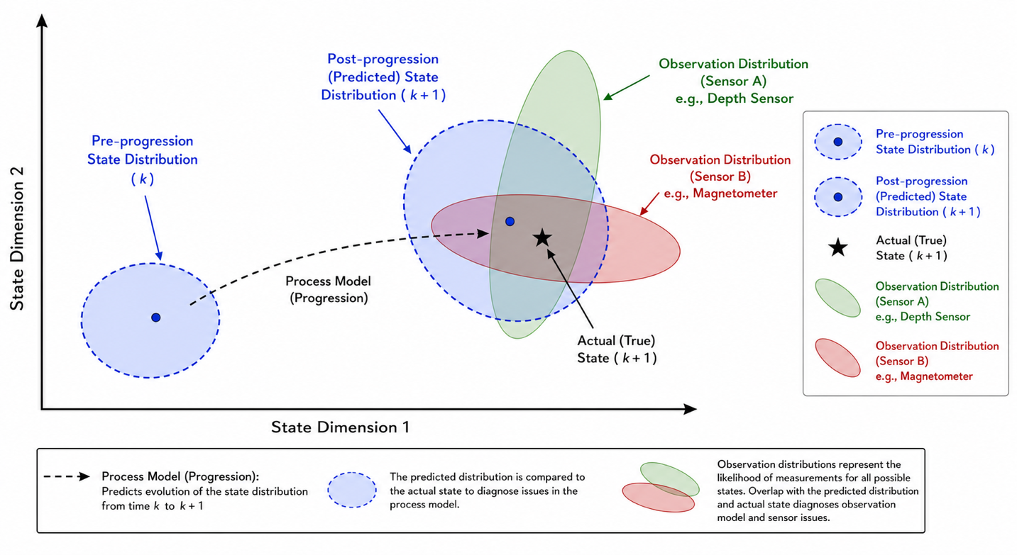
For example, issues in the process model can be diagnosed by comparison of the progressed state distribution to the actual known state. If the process model is adding unnecessary uncertainty this will be observed in a rapid divergence of the span of the progressed state. Likewise, if the progressed model leaves the actual known state behind, the specific dimensions in which it does so can inform fixed to the process model.
In a similar manner, issues in the observation model and sensor specification can be identified by comparing the overlap of the observation model distributions with the progressed state and the actual known state. Each set of measurements will generate a conditional distribution of the likelihood of the full possible state space. If there is little overlap between that distribution and the actual state that indicates a need to increase the uncertainty in the observation model. Alternatively, the specific way there is an overlap mismatch is also diagnostic. For example, if depth is well represented but heading is divergent it indicates that the depth sensor is working well, and a new magnetometer or corresponding observation model is required.
Ultimately, the results of a simulation, if visualized conveniently can provide the directives to “debug” a poorly functioning filter.
If the means for adding noise and other issues to the simulation are included, then such a simulation will also enable testing of sensitivity to deviations from nominal conditions.
Therefore, to reach G2 and subsequently G1, a simulation of sensor fusion along with an inspector that enables convenient inspection of the relevant distributional diagnostics are required.

Simulation
The simulation proceeds in a series of distinct steps that build off one another.
First there is simulation of the actual animal behavior as a rigid body. This results in a series of coordinates in the physical state space. This state space should include statistics such as velocity and orientation in addition to position. Following behavioral simulation, one must then model the likely deviations the tag will experience given the fact that the animal is not a rigid body, the tag has a specific attachment mechanism and position, and the fact that the tag is immersed in fluid. Ultimately, the result of this step is once again a series of coordinates in the physical state space. With the tag’s movement through space resolved, sensor models can be employed to simulate the measurements the tag would collect. At this point the information necessary to run a filter has been collected and all that remains is to initialize a state distribution in the filter’s state space, select a process and observation model, and proceed to simulate sensor fusion itself. The result of this process, however, will be cast in the filter’s state space requiring a translation back into the same physical state space of the behavioral model for later inspection.
Two observations fall out of this staged process.
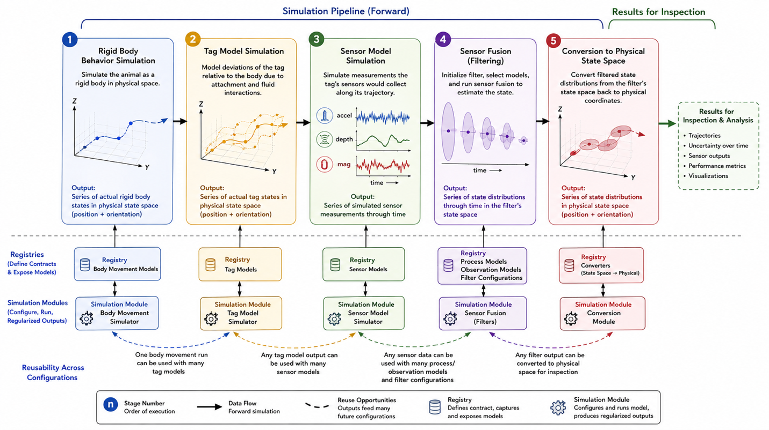
First, given the large variety of potential behavior models, tag models, sensors, and process and observation models, it seems prudent to associate each with a registry. The registry will define the necessary contract for each registered model, capture and expose each addition to the user, and provide a means for the simulation module to pull the requested model. The simulation module will then configure the model as requested, run the model on the specified data, and then provide regularized outputs for the stage in question. In so doing we will enable the addition of new models to the framework without the overhead of a full codebase contribution.
Second, each stage is largely reusable by the stages that come after it. Rigid body movement data can be used with a large set of different tag models, the data from any of those of tag model simulation runs can be used with a variety of sensor models, and so on. Therefore, it will save a great deal of user time and computational resources to build the simulation in such a way that components are only rerun if necessary.
We proceed to brief overviews of the requirements of each step and model.
Body Movement Models
A specific body movement model will be represented as a parametrized function of time with configuration parameters.
$$x,y,z,\dot{ x},\dot{y},\dot{z}, ω=f\left(t;α,β,…,η\right)$$
These functions will produce rigid body motions like what would be expected from the animal behavior in question. There will be one such model per animal behavior of interest.
Tag Models
These models represent transformations of the body frame into the tag frame. The nature of these will be determined once the relevant tag complications have been identified. (See development plan)
Sensor Models
This model must incorporate not only the physical aspects of the sensors but also their associated costs to understand the feasibility of specific selections.
The interesting aspects include:
- Sampling Rate: how often measurements are taken.
- Precision: the number of significant digits in each of the measurements.
- Error: this can come in several forms – noise, bias, and drift
Each of these parameters can be changed through either sensor choice (incurring monetary cost or changing size/shape considerations) or sensor configuration and the corresponding costs in terms of power draw, energy consumption, and data storage requirements. Therefore, it is important that the entire “aspect – cost” surface is captured in these sensor models.
It will also be useful to indicate the specific kind of sensor being referenced so that recommendations can be made against actual hardware instead of hypothetical and potentially infeasible hardware options.
Process Model
The process model is made up of a few distinct components:
- State Space: the specific coordinate space representation. Examples could include quaternions or Euler angles for headings, inclusion or exclusion of acceleration, etc. This state space is defined for convenience of the mathematics as opposed to convenience of visual representation.
- Process Noise: representing uncertainty in the state’s process noise not only governs the expansion of uncertainty overtime but also enables indirect inclusion of forces/parameters not directly captured in the state space.
- Sensor Inputs: beyond providing input to the observation model, if measurements are accurate enough, they can be used to dead reckon.
- Process Laws: these are the specific laws of motion governing the evolution of the state space through time.
Each process model will have a series of hyperparameters (such as process noise covariance matrices) that allow for several instantiations of the same model. However, if any of the above change categorically, it will require registration of a new model.
Observation Model
Here we simply need the function by which a measurement is converted into a state space distribution. There will be a class of these for each category of sensor (accelerometers vs depth sensors vs gyroscopes, etc.) each with their own set of hyperparameters.
Filter Configuration
There are many algorithms capable of sensor fusion, each of which comes with its own configuration. We will begin with particle filters as they are the most general but do not want to preclude the potential for other models in the future and so will treat this, loosely, as a registry as well.
Conversion
Given the filter operates in the state space of the process model, converters will be required to transform the data back to our canonical physical coordinates to facilitate inspection. There should not be an inspector per process model state space.
UI
Given the large number of components and configurations, a well-designed UI will be required to orchestrate all these components.

Finally, it should be noted that particle filters are far from new and implementing them from scratch is not the intention of this work. There already exist a series of packages (StoneSoup and Dynamax for example) that provide the underlying primitives for simulation along with implemented and optimized filter algorithms. The novelty here is in providing the specific models required for this study along with the data, compute, and UI infrastructure needed to facilitate this particular kind of problem. Packages like StoneSoup and Dynamax are intended to deal with any state estimation problem and many conveniences in a specific problem space must be stripped away to deal with this level of abstraction. In terms of tool building, this proposal’s intention is provide conveniences specific to this problem space.

Inspector
The inspector will need to display for a selected timepoint:
- Pre-progression state distribution
- Post-progression state distribution
- Any selected observation distributions
- The actual tag state and body state
This in turn will require selection mechanisms for:
- A specific simulation run
- A specific projection of the physical state space (as it will be high dimensional)
- Observation distributions to view
Finally given there can be many epochs we will want to display a timeline of relevant statistics (such as state distribution entropy) that enable a user to quickly pick out timepoints of interest.

Design – The Case Studies
The first step for each of our species will be identifying a suitable range of behaviors that should be representative of the kinds of behaviors (known or otherwise) that would be interesting to identify and then study. It is critical that these behaviors cover a spectrum so that we can build a sensor fusion recommendation that is not likely to miss interesting behaviors when out in the field. The result of this work will be a set of additions to our behavior model registry.
After this, we will need to identify the expected deviations from rigid body motion that the tags will have. These can come, broadly, from three sources – tag attachment, means of locomotion, and fluid dynamics. This will give us our simulation’s tag models.
The final step in design constraints will be considering the limitations on cost, size, and power in each of the sensors and then using these guidelines to generate a sample of sensor models to incorporate into the simulation. These models should be derived from actual sensors on the market.
With these three aspects identified we will be able to simulate movements, understand how deviations from rigid body movement will affect sensor fusion, and understand the boundaries of the sensors available to us and the constraints on designing tags that could feasibly be used in the field.
At this stage we can use the simulation and inspector to search for a feasible solution for each of our species using the process described in the overview of the tool design. Once initial solutions are found we will then proceed to sensitivity analyses. This will involve varying the tag deviations, noise sources, and behavior parameters until we are satisfied that we have a solution that can withstand reasonable deviations from nominal conditions. The ultimate outcome of this process will be a recommendation of sensors, configurations, and filters along with characterizations of filter performance and curves expressing how performance changes around nominal conditions.

Deliverables
G1:
A manuscript covering:
- Registry entries for each species.
- Recommendations for each species.
- Anticipated issues and sensitivities of each the recommendations.
G2:
A GitHub repository containing:
- Simulation application code
- Inspector application code
- A container or other means of quickly and efficiently running both
- Technical documentation including a user guide, design documents, and guidance on adding to the registries

Development/Study Plan
Requirements Research
- Select Species: work with committee members to select three species for study.
- Gather Examples: survey committee members, experts, and the literature to gather:
  - Comprehensive understanding of movements of interest for each species
  - Likely tag transformations/noise
  - Power, cost, size constraints for sensors
  - Available sensor specifications
- Build Illustrative Example: take the simplest use case from the above to build a working proof of concept filter (sans the infrastructure we will later setup). This will provide a means of failing fast and providing examples during the next step.
- User Journey Research: work through actual the actual user journeys with the committee and put together wireframes to collect requirements for the sims, registries, and inspector.
- Technology Solution Exploration: explore options for the following to select the most appropriate tech stack to use.
  - Sensor fusion packages
  - Data storage and management
  - UI deployment
- Specification: given the accumulated information create specifications for every component that will be built. The intention is to provide all the technical documentation needed for a human assisted artificial intelligence to go and build the applications.
Tool Build
- Registries: build each of the registries and test them using the examples identified for the case studies.
- Simulations: build each of the simulation backends and ensure that their interfaces work with one another and that they can communicate with the registries.
- Simulation UI: tie everything together with a UI that captures the requirements in the user stories identified earlier.
- Inspector: build the inspector back and front ends.
- Deployment: setup the repository for easy setup and use by non-developers.
- Technical Documentation: ensure all design documentation and user guides are present.
- Review: reusing the illustrative example review the built tools with the committee. Any feedback at this point should go into technical design and then follow the same loop.

Case Studies
- Identify Feasible Nominal Solutions: using the tooling and a nominal base case, identify a working solution (no matter how brittle). An outcome of this stage should not only be the recommendation but the reason for the recommendations along with supporting data from simulation. The process of finding the nominal solution should read as a story from a naïve base case.
- Incorporate Stresses: push away from the nominal case and identify what is required to remain stable. As before capture the why as well as the how.
In either of these steps additional entries to the registry will likely be required and close and continuous review with the committee will be a necessity.

Write Up
- Write Manuscript: put together a manuscript that can then begin its own review process within the committee.

References
Andrzejaczek, S., Mikles, C. S., Dale, J. J., Castleton, M., & Block, B. A. (2023). Seasonal and Diel Habitat Use of Blue Marlin Makaira Nigricans in the North Atlantic Ocean. ICES Journal of Marine Science, 80(4), 1002–1015. doi:10.1093/icesjms/fsad020
Block BA, Dewar H, Blackwell SB, Williams TD, Prince ED, Farwell CJ, et al. Migratory Movements, Depth Preferences, and Thermal Biology of Atlantic Bluefin Tuna. Science. 2001 Aug 17;293(5533):1310–4. doi:10.1126/science.1061197
Domenici P, Wilson ADM, Kurvers RHJM, Marras S, Herbert-Read JE, Steffensen JF, et al. How sailfish use their bills to capture schooling prey. Proc R Soc B. 2014 Jun 7;281(1784):20140444. doi:10.1098/rspb.2014.0444
Endangered Species Act of 1973. 16 U.S.C. § 1531 et seq. 1973
Hueter, R. E., Tyminski, J. P., & De La Parra, R. (2013). Horizontal Movements, Migration Patterns, and Population Structure of Whale Sharks in the Gulf of Mexico and Northwestern Caribbean Sea. PLoS ONE, 8(8), e71883. doi:10.1371/journal.pone.0071883
National Oceanic and Atmospheric Administration, Department of Commerce. Essential Fish Habitat (EFH). Title 50 C.F.R. § 600, Subpart J. 2026
Patterson, T. A., Eveson, J. P., Hartog, J. R., Evans, K., Cooper, S., Lansdell, M., … Davies, C. R. (2018). Migration Dynamics of Juvenile Southern Bluefin Tuna. Scientific Reports, 8(1), 14553. doi:10.1038/s41598-018-32949-3
Quinn T. The behavior and ecology of Pacific salmon and trout. 2nd ed. Seattle (WA): University of Washington Press; 2018.
Seitz AC, Norcross BL, Wilson D, Nielsen JL. Identifying spawning behavior in Pacific halibut, Hippoglossus stenolepis, using electronic tags. Environ Biol Fish. 2005 Aug;73(4):445–51. doi:10.1007/s10641-005-3216-2
Similä T, Ugarte F. Surface and underwater observations of cooperatively feeding killer whales in northern Norway. Can J Zool. 1993 Aug 1;71(8):1494–9. doi:10.1139/z93-210
United Nations. Agreement under the United Nations Convention on the Law of the Sea on the conservation and sustainable use of marine biological diversity of areas beyond national jurisdiction. New York: United Nations; 2023
Wildlife Computers. MiniPAT [Internet]. Redmond (WA): Wildlife Computers; [2026 Aug 15]. Available from: https://wildlifecomputers.com/our-tags/pop-up-satellite-tags-fish/minipat/

