APPENDIX B

FIELDWORK

B.1 Pavement Condition Surveys

Condition surveys are essentially required to assess a pavement’s physical distress and form the basis of a diagnosis regarding the maintenance or rehabilitation needs. Together with drainage, destructive and non-destructive testing, they are mandatory before rehabilitation design.

Flexible Pavements

One of the stated objectives of the PMS is to provide a pavement condition evaluation system. A condition survey conducted for a specific project, in order to be compatible with the PMS of the network, must follow the same method. Also, by using the same method, the results of the specific condition survey can be forwarded to the Office or Branch in charge of the PMS and incorporated into the PMS Road Data Bank.

Following is a summarized description of the method of classification and quantification of visible damage, adapted from the “VIZIR method”, as presented in the Manual of Procedures for PMS (Ref 12) and copied for reference in Appendix A.

General

The method of classification and quantification of damage is intended to provide a picture of the road surface condition at the time of inspection and to identify zones of equal quality (in terms of three damage levels). The damage is divided into two categories:

- Type A damage, which characterizes the structural condition of the pavement and includes four types as follows:
- deformation
- rutting
- (fatigue) cracking
- crazing
- Type B damage, generally unrelated to the pavement structural capacity. This type of damage may be caused either by defective placement, or by deficient materials quality, or by some special local condition, aggravated by traffic. Type B damage includes:
- cracking other than fatigue cracking, i.e. longitudinal joints and transverse thermal shrinkage cracks,
- potholes,
- raveling and, more generally, all surfacing defects such as fretting, bleeding, etc.

Survey and Grading of Damage

The survey is intended to record, for any damage:

- its type;
- its severity;
- its extent, i.e. the length of road affected, or, as appropriate, the area.

It is to be noted that the method was designed for use with automatic data recording equipment, which facilitates the recording of the distresses and the calculation of quality ratings. Nevertheless, the survey can also be done manually.

The severity of each type of damage is described in detail, in tabulated form as well as by illustrations (photographs) in Appendix A. Following are some examples.

Description of Type A Damage

Rutting appears in wheel tracks about 50 to 80 cm from the pavement edge. It may be due to settlement of the materials under heavily channelized traffic, or occasionally due to creep within the bituminous layers only.

As an example, rutting is characterized by the following levels of severity:

Severity 1 h < 2 cm
Severity 2 2 cm < h < 4 cm (see Figure B.1)
Severity 3 4 cm < h

Where h is the depth of rutting measured by a straight edge. As indicated earlier, complete illustrations and guidance regarding severity levels are given in Appendix A for rutting, as well as for other types of Type A damage, and the user should refer to that Appendix for complete details.

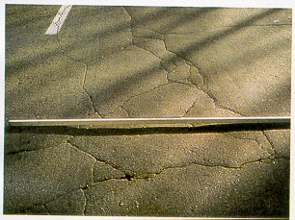

Figure B.1 Rutting – Severity Level 2

Description of Type B Damage

Similarly, damage of Type B is characterized by a severity level, as detailed in Appendix A. One example is that of cracking of longitudinal joints. This type of crack is initially single and straight (Severity 1, e.g. Figure B.2). Under traffic, the crack evolves, branches or doubles, and eventually loses material at the edges (Severity 2, 3).

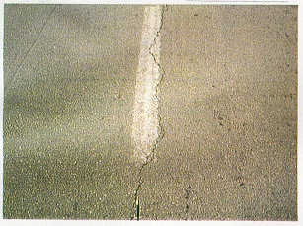

Figure B.2 Cracking – Severity Level 1

Rigid Pavements

As for flexible pavements, a visual condition (distress) survey is essential for planning rehabilitation efforts. In order to make knowledgeable decisions, the engineer should have the following information:

- Distress type,
- Distress severity,
- Distress amount.

The distress type will assist in defining probable cause(s) of the distress and ultimately help in selecting a rehabilitation strategy suitable to repair and prevent the recurrence of the problem. The distress is not necessarily related to traffic loads. Tables B.1 and B.2 (from Ref. 3) classify the distress types of jointed concrete and continuously reinforced concrete pavements respectively.

The condition survey will also document the severity of the distress and provide a record of the pavement condition at the time of the survey, including the location of the distress. Thus, differences between sections of the pavement (or lanes) will become apparent and guide in the rehabilitation design process.

Definitions of the major distress types and of severity levels suggested for use during the condition survey are presented in Appendix A, together with recommended methods of measurement (to record the distress amount).

B.2 Drainage Survey

In the design of pavement rehabilitation, the possible contribution of drainage improvement should be investigated. The existing drainage of the pavement and subgrade may be inadequate and the pavement distress may result from this condition or be accelerated by it.

The pavement condition survey will often indicate moisture-related distress. Distress types in flexible pavements which may either be caused or be accelerated by moisture include stripping, rutting, depression, fatigue cracking and potholes. In rigid pavement, they include pumping, “D” cracking, joint deterioration, faulting and corner breaks.

Subsequent to the pavement condition survey and depending on whether or not drainage-related distress is apparent, a determination needs to be made regarding the need for a specific drainage survey.

Table B.1 General Categorization of Jointed Concrete Pavement Distress
(from Ref. 3)

Distress Type | Primarily  Traffic Load Caused | Primarily Climate/Materials Caused
1. Blow-up |  | X
2. Corner break | X
3. Depression |  | X
4. Durability “D” cracking |  | X
5. Faulting of transverse joints and cracks | X
6. Joint load transfer associated distress | X | X
7. Joint seal damage of transverse joints |  | X
8. Lane/shoulder dropoff or heave |  | X
9. Lane/shoulder joint separation |  | X
10. Longitudinal cracks |  | X
11. Longitudinal joint faulting | X | X
12. Patch deterioration | X (M, H) | X (L)
13. Patch adjacent slab deterioration | X | X
14. Popouts |  | X
15. Pumping and water bleeding | X (M, H) | X (L)
16. Reactive aggregate durability distress |  | X
17. Scaling, map cracking and crazing |  | X
18. Spalling (transverse and longitudinal joints) | X (M, H) | X (L, M. H)
19. Spalling (corner) |  | X
20. Swell |  | X
21. Transverse and diagonal cracks | X (L, M, H) | X (L)

Table B.2 General Categorization of Continuously Reinforced Concrete Pavement Distress (from Ref. 3)

Distress Type | Primarily  Traffic Load Caused | Primarily Climate/Materials Caused
1. Asphalt patch deterioration | X
2. Blow-up |  | X
3. Concrete patch deterioration | X (M, H) | X (L)
4. Construction joint distress |  | X
5. Depression |  | X
6. Durability “D” cracking |  | X
7. Edge punchout | X
8. Lane/shoulder dropoff or heave |  | X
9. Lane/shoulder joint separation |  | X
10. Localized distress |  | X
11. Longitudinal cracking |  | X
12. Longitudinal joint faulting | X | X
13. Patch adjacent slab deterioration | X | X
14. Popouts |  | X
15. Pumping and water bleeding | X (M, H) | X (L)
16. Reactive aggregate distress |  | X
17. Scaling, map cracking and crazing |  | X
18. Spalling | X | X
19. Swell |  | X
20. Transverse cracking | X (M, H) | X (L, M)

Note: L, M, H refer to low, medium and high severity levels.

It should be recognized that even when moisture-related distress is absent, drainage deficiencies may exist which need to be corrected. Maintenance personnel regularly involved with a particular section of road under evaluation should be consulted in this regard, as they are a good source of relevant information.

The first step in drainage evaluation will include a review of the as-built documents collected as part of the data collection discussed in Chapter 2. That will encompass the determination of the initial drainage provisions, and examination of pavement cross-sections and profiles. If moisture-related distress is apparent, then the original drainage system is inadequate (due to design or present condition). The next step of the evaluation will include an examination of topographical features. This may lead to discovering streams or wet areas above the pavement elevation.

The drainage evaluation also requires a site investigation (preferably during a wet season), with the aim of answering such questions as the following:

- Where and how does water move across the pavement surface?
- Where does water collect on and near the pavement?
- How high is the water level in the ditches?
- Do the joints and cracks contain any water?
- Does water pond on the shoulder?
- Does water-loving vegetation flourish along the roadside?
- Are deposits of fines or other evidence of pumping (blowholes) visible at the pavement’s edge?
- Do the inlets contain debris or sediment buildup?
- Are the joints and cracks sealed well?

If the original drainage design appears adequate, the site investigation should also verify that it has actually been entirely built as planned, and determine whether changes have taken place since it was built.

Drainage problems often encountered include shallow side ditches, broken or clogged pipes and outlets, permeable shoulders and slow draining aggregate roadbase with no outlets or outlets of insufficient capacity.

Subgrade problems related to drainage include pockets of poor soils (e.g. saturated silts and/or clays, or organic materials) and localized springs, groundwater seepage or non-functioning subsurface drainage systems.

B.3 NDT Deflection Measurements

The use of non-destructive testing (NDT) for the measurement of pavement deflection under applied loading has been part of the process of structural evaluation and rehabilitation design for decades, using various types of equipment (e.g. Ref. 13). The total deflection under load has been used as an indicator of the load-carrying capacity of the pavement, especially for flexible pavements, by correlating allowable repetitions of ESAs to the maximum deflection. This has later been refined by taking into consideration only the “rebound” or “elastic” portion of the deflection as the key indicator of performance, rather than the total deflection under load. Various methods utilizing measurements of the slope (e.g. radius of curvature) of the deflection basin (or deflection bowl) under load have also been developed to further characterize the pavement behavior and structural capacity.

In this manual, emphasis is placed on measurements of the rebound deflection made by means of a Benkelman Beam. This presents the advantages of a certain consistency with the procedures of the PMS, a relatively simple field procedure, and a consistency with the selected overlay design methods presented further in the manual. An alternate deflection survey procedure is also outlined, using a Falling Weight Deflectometer (FWD). This method, which is well suited and actually intended to make use of deflection bowl measurements, requires more logistical support and is more expensive.

Benkelman Beam Rebound Deflection Testing Procedure

The following (adapted from Ref. 11) gives a procedure for determining the static Benkelman Beam rebound deflection at a point on an asphalt pavement structure under specified axle load, tire size, tire spacing and tire pressure. The absolute minimum spacing of sample locations should be 100 m, on either side (in either direction) of the road. Shorter intervals should be adopted if practical, and in areas of special concern (particular distress).

Equipment

Major equipment includes:

- A Benkelman Beam as per AASHTO T256.

Painting the beam white or aluminum will reduce temperature effects.

- A 4.5 metric tonne truck as the reaction load. The vehicle shall have an 8.2 tonne load equally distributed on the two dual wheels of the rear axle. The clear distance between two tires of each dual shall be a minimum of 50 mm. The tires shall be 10.00 x 20, 12 ply, inflated to a pressure of 552 kPa. The use of tires with tubes and rib treads is recommended.

- Tire pressure-measuring gauge.

- Standard Iron-Constantan thermocouple wire and a temperature potentiometer (any other surface temperature measuring equipment that gives results comparable to the thermocouple potentiometer equipment may be used).

Procedure

- The preselected point to be tested is located (usually only the outside lane is tested) and marked on the pavement. Points should be located 0.6 m from the pavement edge if the lane width is less than 3.35 m; 0.9 m from the pavement edge if the lane width is 3.35 m or more.

- Center one set of dual wheels of the truck over the marked point. A location within 75 mm of the point is acceptable.

- Insert the probe of the Benkelman Beam between the dual wheels and place on the selected sample point.

- Remove the locking pin from the beam and adjust the front legs to permit approximately 13 mm travel of the dial gauge stem.

- Start the buzzer on the beam and record the initial dial reading.

- Immediately after recording the reading, drive the truck slowly forward 9 m or more.

- Record the final dial reading. When the dial movement stops, stop the buzzer. The dial movement may resume after a short pause, but no more readings are necessary.

- Measure the pavement surface temperature∗ in the following manner:

- At a point not less than 254 mm from the pavement’s edge, drive a small hole into the pavement 3 mm in diameter and 3 mm in depth.

- Fill the hole with water or asphalt. Insert a thermocouple with the wire bent at right angles 5 mm from the end, 3 mm into the water or asphalt.
- Read the temperature with a temperature potentiometer. At this time, also record the air temperature.

- Check the truck tire pressure once a day and correct to the 552 kPa standard equipment, if necessary.

- Determine the total thickness, to the nearest 25 mm of asphalt-bound components in the pavement structure. This may be done from construction records (cf. Chapter 2), by core drilling, or by a small excavation at the pavement’s edge. Determine also the types and general condition of materials in the remainder of the pavement structure, i.e., “granular roadbase, wet” or “granular subbase, saturated and contaminated with silt from subgrade”.

Calculations

Subtract the final dial reading from the initial dial reading and record. The total pavement rebound deflection is twice the dial movement during the test (two-to-one is the usual ratio for the Benkelman Beam; some models may be built with a different ratio).

Report

The report shall include the following:

Sample location
Total pavement rebound deflection
Pavement surface temperature
Air temperature
Asphalt pavement thickness

For rigid pavements, the deflection measurements using the Benkelman Beam are made along the edge of the concrete slab, according to the following guidelines essentially taken from those of the Asphalt Institute (Ref. 11):

For two-lane highways, the deflection measurements are made on the outside edge on both sides of the centerline. For divided highways, deflections should be measured on the outermost edge only. Additional deflection measurements should be made at corners, joints, cracks, and deteriorated pavement areas, to determine load-transfer capability. The total vertical movement in these areas is important, but the differential movement from one slab to another is more important, because it may indicate the need for undersealing. The differential movement is considered a measurement of the load-transfer capability of the slab. Load-transfer is defined as the ratio of the deflection on one side of the joint or crack to the deflection on the opposite side. This is illustrated in Figure B.3.

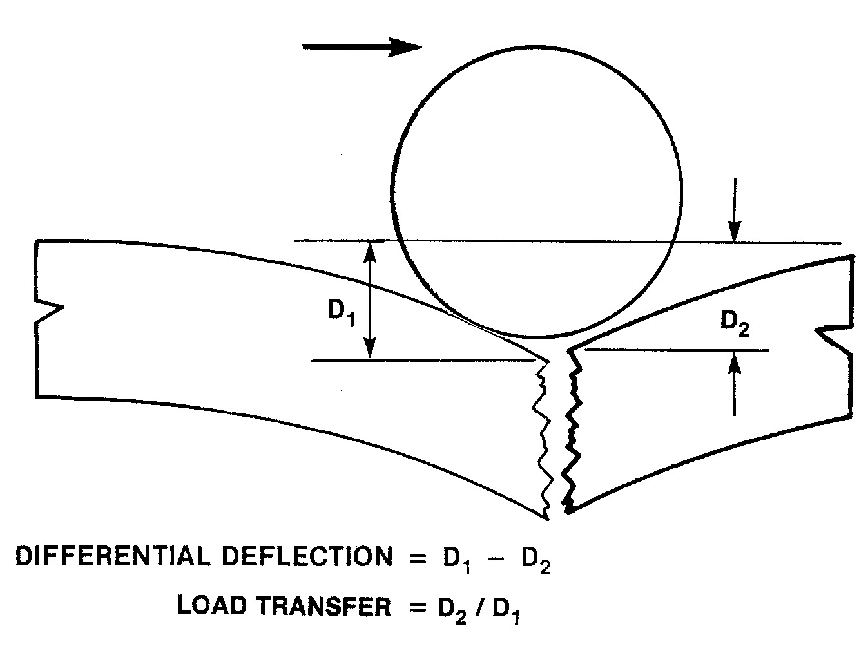

Figure B.3 Differential Deflection and Load Transfer (from Ref. 11)

The deflection testing procedure for rigid pavements is as follows:

The Benkelman Beam should be positioned on the shoulder as shown in Figure B.4.

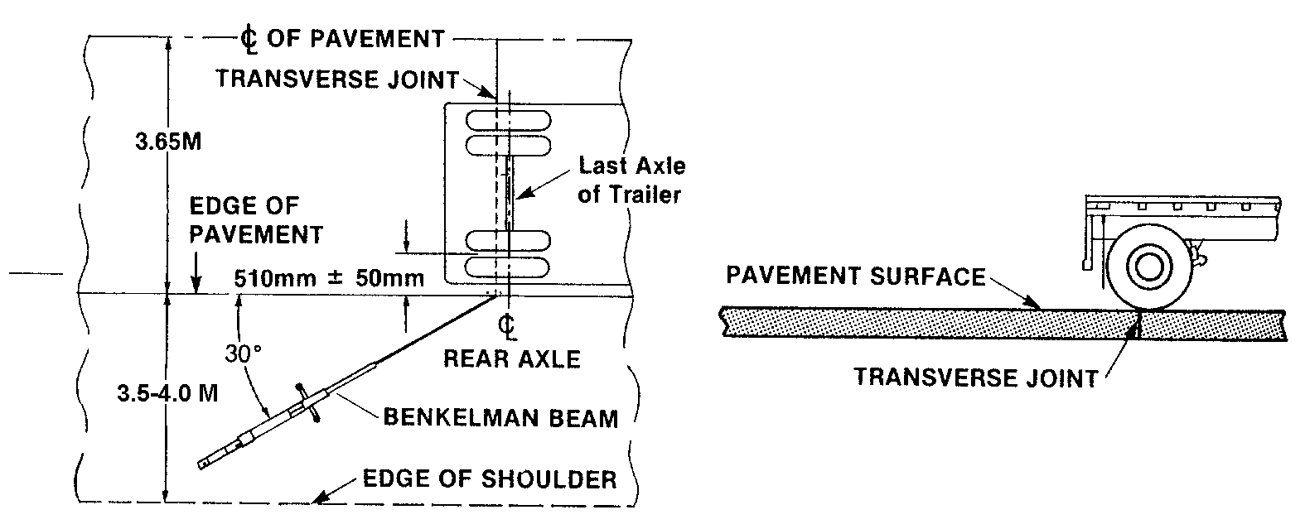

Figure B.4 (after Ref. 11) Position of vehicle and Benkelman Beam for making static rebound deflection measurements on rigid pavements.

Measurements should be made on either side of the joint or crack to determine the parameters described in Figure B.3. They should be taken, to the extent practical, during the most severe environmental circumstances, e.g. at the end of a wet season. A suggested minimum spacing is 100 m, with more closely spaced sample locations where cut and fill sections alternate rapidly.

Falling Weight Deflectometer (FWD)

The Falling Weight Deflectometer (FWD) is classed as an impulse deflection device providing a non-destructive means of determining a pavement response to dynamic loading.

Various models and manufacturers (e.g. Dynatest, Foundation Mechanics, KUAB, etc.) exist, which follow the same principle and provide similar information. A typical arrangement is given schematically in Figure B.5.

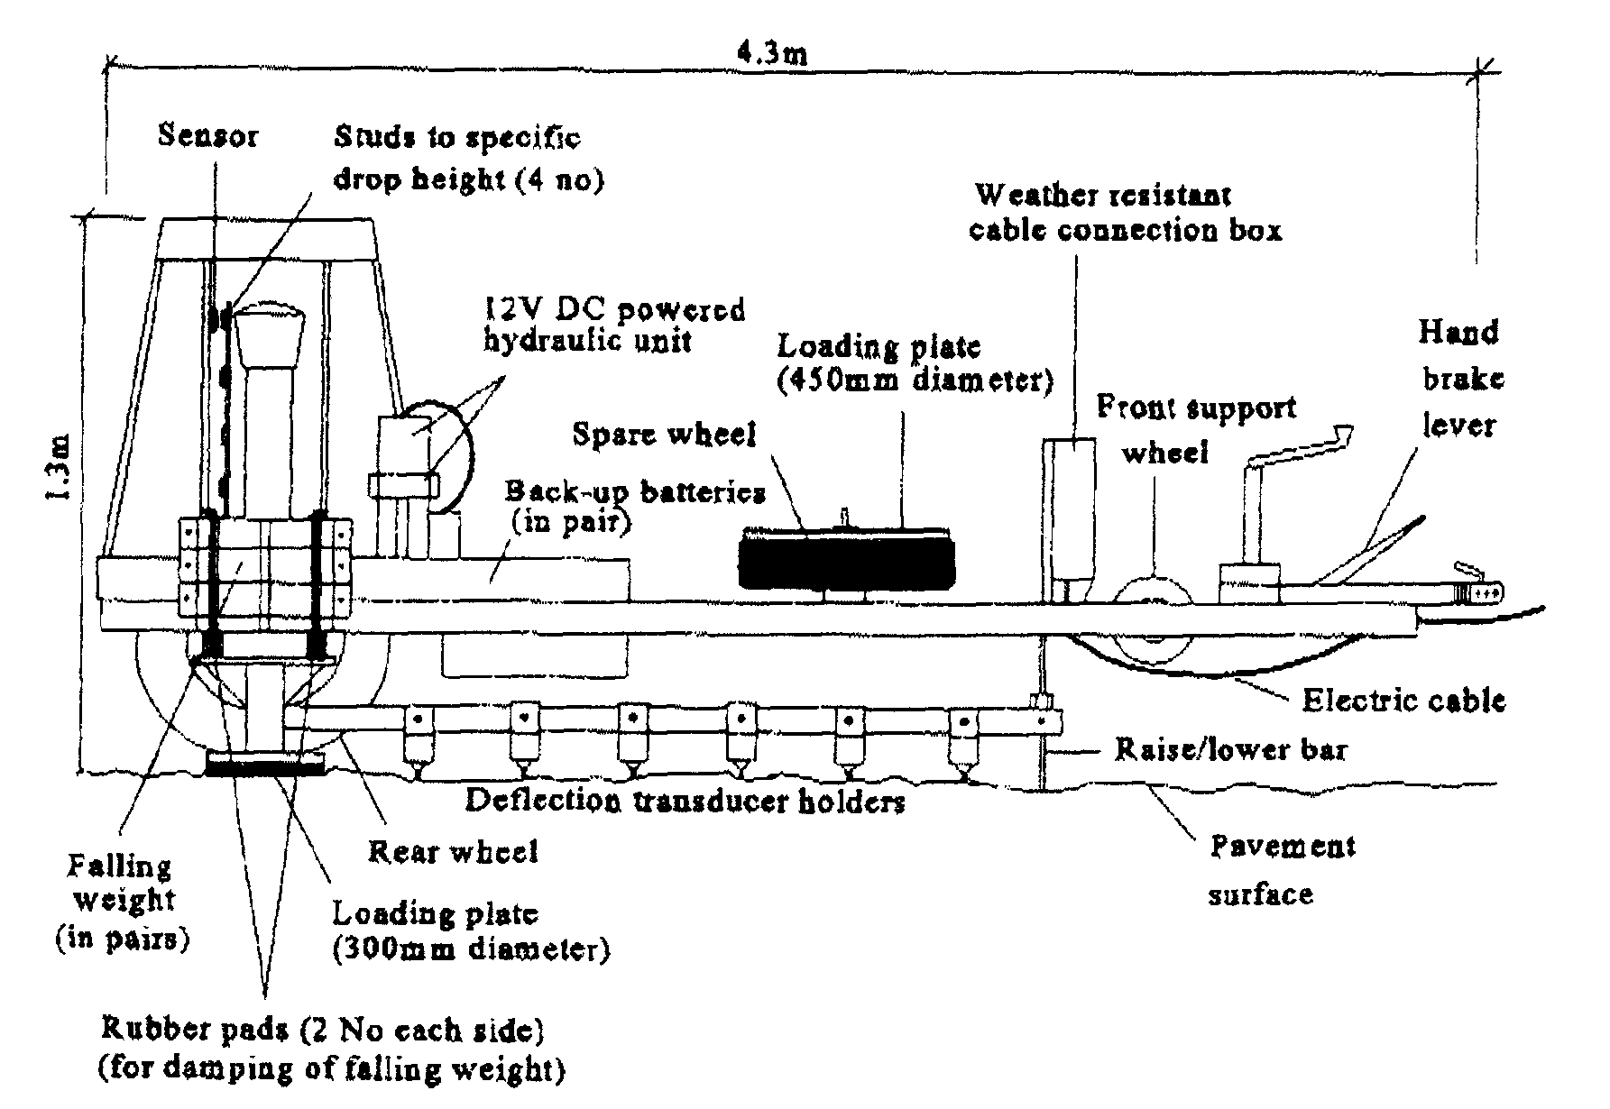

Figure B.5 Falling Weight Deflectometer

Weights are raised to a predetermined height and allowed to fall on a specially-designed plate, transmitting an impulse force to the pavement. The shape of the load pulse obtained is somewhat similar to that obtained from a moving wheel load. Figure B.6 schematically illustrates a typical pavement structure under a FWD dynamic load. By varying the weights dropped and the height from which they are dropped, the force developed upon impulse can be varied, as can the range of wheel load effects simulated. For instance, a typical dynamic force of 40 KN (a generally recommended magnitude) applied to a 30 cm diameter disk by a dropping weight on the order of 60 kg is common.

Usually, six or seven geophones (sensors, or velocity transducers) record the deflections at offset distances from the center of load application. A typical configuration for flexible pavements is given in Figure B.7.

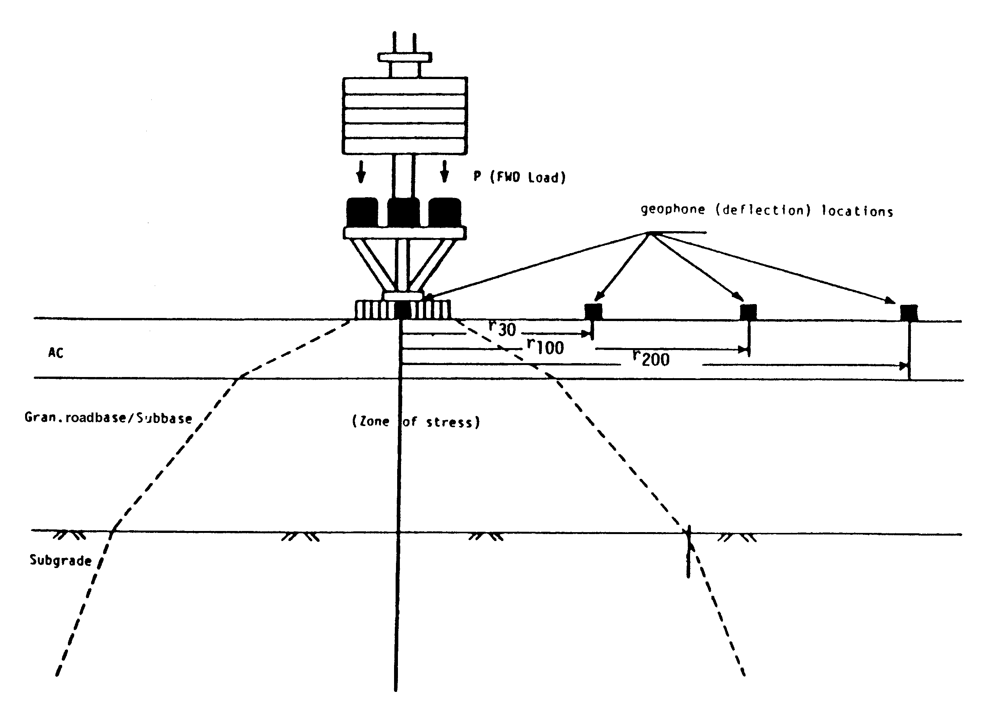

Figure B.6 Schematic of Stress Zone within Pavement Structure under the FWD Load (from Ref. 3)

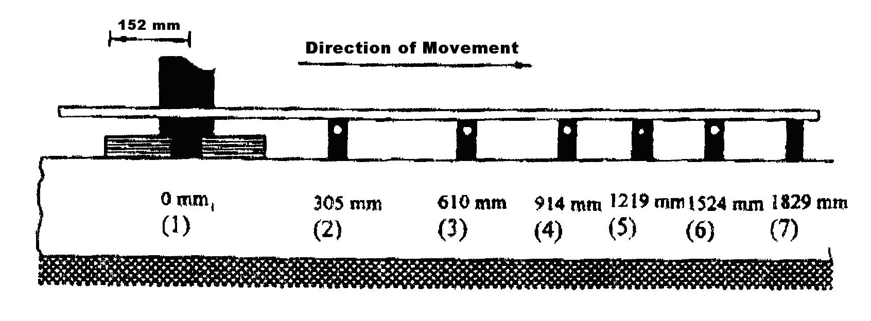
Figure B.7 Deflection Sensors Configuration for Flexible Pavement Testing

The tests should be made in the outer wheelpath at intervals sufficient to adequately assess conditions. Intervals of 25 m to 250 m are typical. Areas that are seriously deteriorated and obviously will require repairs should not be tested, or tested separately so as not to influence statistical analyses of the results.

B.4 Existing Pavement Structure and Subgrade Assessment

The data obtained from PMS records and the subsequent review of those records should serve as the basis for the fieldwork. The PMS data can be reconfirmed by carrying out a specific field study and reviewing the field data.

In general, field testing is categorized into two broad areas: nondestructive testing (NDT) and destructive testing. Destructive tests (such as test pits, DCP tests) require the physical removal of pavement layer material in order to obtain a sample (either disturbed or undisturbed) or to conduct an in-situ test. Such testing has many disadvantages and limitations, particularly when conducted on moderate to heavily trafficked roadways. Practical restraints in terms of time and money severely limit the number and variety of destructive tests conducted on routine rehabilitation studies.

Nondestructive testing, on the other hand, does not necessitate physical disturbance of the pavement. The most widely used form of NDT is associated with the field deflection tests noted in Section B.3.

In spite of their disadvantages, destructive tests are the only definitive means of determining pavement layer thicknesses and layer material type.

Test Pits

Test pits represent one of the common methods of investigation to determine the thickness and type of the various pavement layers and to assess the subgrade. Samples from each pavement layer and subgrade can be collected for visual inspection and subsequent laboratory testing. The test results can be used in the rehabilitation design analysis and to check conformance of the material with standard specifications. Test pits shall be dug through the pavement layers and into the subgrade soil for a minimum total depth of 0.80 m (alternatively, the pit should extend at least 0.20 m below subgrade level).

The spacing of the test pits should depend on sound engineering judgement and be guided by a prior review of all possible documents, as well as a visual pavement condition survey.

However, as a general guideline, one test pit every 500 meters, alternating on either side of the roadway, is recommended. The position of each test pit shall be accurately determined and reported.

DCP Testing

DCP testing frequency can be the same as that of the test pits, i.e. every 500 m. In fact, the DCP test location can be adjacent to the test pit location. However, as mentioned before, depending on the pavement location, the frequency can be altered to better assess the pavement and to optimize the testing program.

The DCP instrument is designed for the rapid in-situ measurement of the structural properties of existing road pavements (with the exception of hard layers like concrete) and subgrade. In cases of material that the DCP cannot penetrate, a hole can be drilled through that layer using a suitable drill. Lower layers of the pavement can then be tested in the normal way.

The DCP test results can be compared with the laboratory test results, and the data collected from review of the possible documents, including PMS records. Additional testing may be necessary in case of discrepancies to better evaluate pavement conditions.

 One pavement surface temperature measurement an hour usually will be sufficient. Make the measurement at the location currently being tested for deflection.

