APPENDIX A

VIZIR METHOD
FOR QUALITY EVALUATION OF PAVED ROADS

A.1 Classification and Quantification of Damages

General

The first part of VIZIR is a method of classification and quantification of damage that forms part of general road maintenance management studies or special route maintenance studies. It is intended to provide a picture of the surface condition of a road at a given time and to identify zones of equal quality (in terms of three damage levels).

These zones of equal quality and these three damage levels are used to determine the nature and type of work required; in some cases, the very identification of the damage determines the solution, while in others it is only one factor in a more complex diagnosis involving other criteria.

The damage classified in the VIZIR method is relevant primarily to flexible pavements with bituminous surfacings. This damage is divided into two categories:

Type A Damage

This characterizes the structural condition of a pavement, affecting either all of its courses and the ground or the surfacing only. This damage is caused by a structural deficiency of the pavement, and its identification is used in the search for a solution in conjunction with other criteria, in particular the bearing capacity as characterized by the static deflection.

Type A damage includes four types:

- Deformation,
- Rutting,
- (fatigue) cracking,
- crazing.

Type B Damage

This damage leads to repairs that are generally unrelated to the pavement’s structural capacity. It may be caused by defective placement, by deficient product quality, or by some special local condition, possibly aggravated by traffic.

Type B damage includes:

- cracking other than fatigue cracking, i.e. longitudinal joint cracks, transverse thermal shrinkage cracks, and longitudinal and transverse clay shrinkage (desiccation) cracks;
- potholes;
- raveling and, more generally, all surfacing defects such as fretting, bleeding, etc.

A.2 Survey and Grading of Damage

The damage is surveyed by an operator who travels the length of the route and records, for any damage:

- its type,
- its severity,
- its extent, i.e., the length of road affected or, as appropriate, the area.

VIZIR provides a damage topology and, for each type of damage, three levels of severity.

The survey can be done manually, while travelling the road on foot or by car. The operator in this case enters his observations (identification of damage and estimate of its severity) on a route diagram, a document representing the route as a straight line, the scale and precision of which are appropriate to the type of study.

The survey may also be done using the LCPC’s DESYROUTE equipment. Carried in a car, it makes it easy to record the type, severity, and location of any damage (position on curved x-axis based on information from the distance indicator). Its data entry and retrieval software allows all sorts of calculations, such as a mean severity index and an extent as a percentage of a given length, or an overall quality index based on a combination of several types of damage. It can also read out all of these data, either in the form of a route diagram identical to the one produced by hand or in the form of files that can be incorporated in a road data bank (for instance the VISAGE road data bank).

To help the operator in his work, VIZIR proposes a catalogue of damage and a method of graphic representation that are summed up in Table 1 (Type A damage) and Table 2 (Type B damage).

In the route diagram, damage is represented by a rectangle of which the background (white, grayish, or black) indicates the level of severity, while the two sides represent the co-ordinates of the beginning and end of the damaged zone, or in other words, its extent.

The severity values given in Tables 1 and 2 are average values suitable for many road networks. However, they can be altered to fit the assigned maintenance objectives and the expected level of severity.

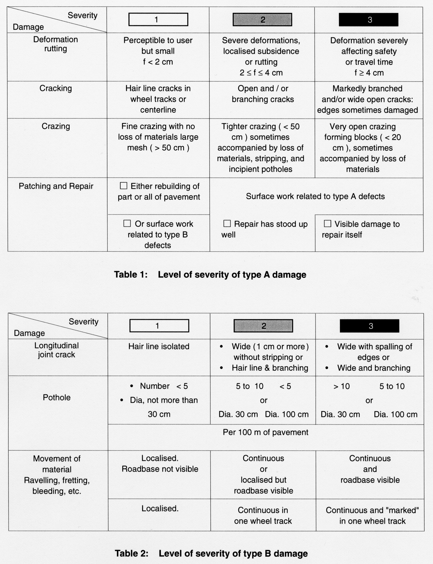

Each type of damage and each associated level of severity, as indicated in Tables 1 and 2, is described in detail in the next sub-section and shown in a photograph attached to the present appendix.

A.3 Description of Type A Damages

This concerns the following types of damage:

- Deformation, rutting
- Fatigue cracking and crazing
- Patching and repairs

Deformation and Rutting

The deformations specific to flexible pavements almost always lead to rutting or subsidence. Their degree of severity is determined by the depth h measured on a straightedge 1.5 m long placed crosswise on the pavement (see following figure).

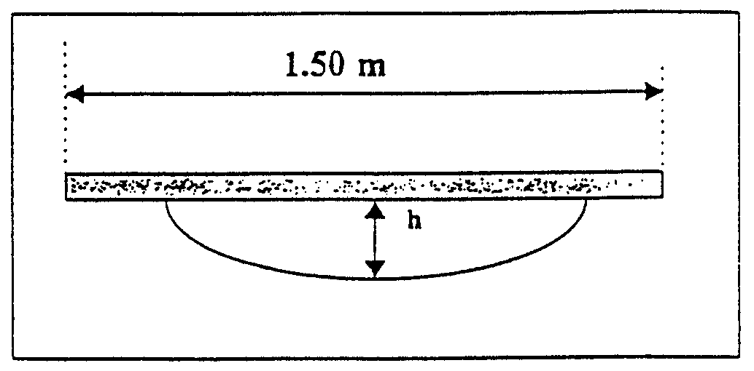

Figure A.1 Measurements of Deformation

Rutting appears in the wheel tracks, on the back of the pavement about 50 to 80 cm from the edge. It is caused by settlement of the materials under heavy, channelized traffic, possibly but not necessarily aggravated by a deficiency of bearing capacity of the soil. There may also be rutting through creep of the bituminous courses only, but this is found most often in semi-rigid pavement or in pavements with a bituminous roadbase.

The following values are given for guidance:

Severity 1 h < 2 cm
Severity 2 2 cm < h < 4 cm
Severity 3 h > 4 cm

Subsidence affects the entire edge of the pavement. It is a result of deficiencies of bearing capacity or of stability, possibly caused by materials of poor quality or excessively high water contents. Subsidence often occurs in bends and in zones of very high stress: It can be in the form of:

Localized subsidence of severity 1
Subsidence of severity 3 or
Ridge of severity 1, 2 or 3

Longitudinal deformations generally show up in the evenness measurement (sag of a few cm, wavelength from 1 to 20 cm) and must not be counted twice. However, longitudinal deformation in the form of an isolated ridge may properly be recorded with transverse deformations.

Fatigue Cracking

This category does not include cracks resulting from faulty construction, such as the longitudinal joint between two mix spreading bands, or cracks caused by some particular behavior of the material, such as longitudinal or transverse thermal shrinkage cracks or clay shrinkage cracks.
Longitudinal fatigue cracks, on the other hand, are recorded. Most often initially single and isolated, they evolve toward continuous cracking, sometimes branching, before multiplying in the wheel tracks to the point of becoming very closely spaced.

Severity 1 Single or clearly separated longitudinal cracks
Severity 2 Continuous cracks, branched or clearly open
Severity 3 Extensively branched cracks foreshadowing crazing
or wide open cracks

Patching and Repairs

In some damage survey methods, repairs may not be counted. This is true of the OECD Manual– Road monitoring for question of maintenance – DC1 – 1990. The LCPC has always held that repairs, like damage, are an integral part of the visual examination. The 1977 guide to the examination of flexible pavements, in fact, says, “a recent repair conceals a problem; frequent repairs call attention to it”. Repairs are intended to palliate the deficiencies of a pavement, temporarily or permanently; their number, extent, and frequency in time are elements of the diagnosis. In the VIZIR method, repairs must be rated in the course of the visual examination, because some of them are used in determining the index of pavement appearance. Two cases are distinguished:

- The repair has definitively eliminated the defect, in which case it will appear on the survey document (route diagram) but not be counted when calculating the surface quality index;
- The repair has more or less adequately eliminated the defect, but not its cause, and will doubtless reappear here or there or nearby; the repair is therefore reflected as an aggravating factor in calculating the visual index.

The first category includes repairs of Type B defects or partial or complete rebuilding of the pavement, in good condition. VIZIR rates them as being of severity 1. Rebuilding may be of the surfacing only or of the whole pavement:

Rebuilding of wearing course at longitudinal joint (Type B damage)

Rebuilding of pavement (Type A damage)

Patching of the wearing course (Type B damage)

Structural defects of pavement after repair (Type A)

The second category includes localised pavement repairs of Type A defects, classed as severity 2 if in good condition and severity 3 otherwise. Only severities 2 and 3 may, according to their extent, increase the visual index. Photos 21 and 24 illustrate such cases.

Table A.3 Extent of Patching and Repair vs. Severity

Extent  Severity | 0 to 10% | 10 to 50% | > 50%
1 | 0 | 0 | 0
2 | 0 | 0 | +1
3 | 0 | +1 | +1

Table for calculating the correction of surface damage I_{s} according to the severity and extent of repairs.

A.4 Description of Type B Damages

The common Type B damage in flexible pavements includes:

- Cracking of longitudinal joint;
- Potholes
- Raveling and, more generally, any surface defect such as fretting, bleeding, etc.

There are others that depend on extreme climatic conditions or particular materials, such as:

Thermal shrinkage of bituminous materials;

- Clay shrinkage of pavement courses.

VIZIR is intended for flexible pavements, and so does not cover the thermal shrinkage cracking of hydraulic materials. If they had to be included, they would be in category B.

Cracking of Longitudinal Joint

This is a failure of bonding between two adjacent bands of coated materials. This type of crack is initially single and straight, and can be repaired by treatment specific to such cracking (severity 1). Traffic causes the crack to branch or double and lose material at the edges (severity 2, 3). Repairs are more costly: complete rebuilding of the damaged zone or placement of a new wearing course.

Severity 1 Single hair line crack
Severity 2 Branching crack
Severity 3 Wide, branching crack with loss of materials

Potholes

Potholes most often result from wear or destruction of the wearing course, sometimes from the presence of foreign bodies in the surfacing.

They are small when they first appear. In the absence of maintenance, they grow and reproduce in rows, often with a pitch equal to the circumference of a truck type.

Depending on the degree of severity of these potholes, it may be necessary to rebuild part of the wearing course or, if they have become too deep, of the wearing course and roadbase. In some cases, it may even be necessary to rebuild the whole pavement. If there are too many potholes, it may be necessary to rebuild a considerable length of pavement.

The three levels of severity depend on the nature of the work:

Severity 1 Small number of potholes that can be plugged
by ordinary patching
Severity 2 Large number of small potholes in surface

Severity 3 Potholes or crazing formation – pavement
must be rebuilt or overlaid

Movement of Material: Ravelling, Fretting, Bleeding, etc.

Movements of materials include ravelling and bleeding: some ravelling is caused by excessive wear of the wearing course and may lead to the formation of potholes. It is normally counted as cracking or crazing.
Ravelling of severity 1 on crazing of severity 2, counted as Type A damage

Other ravelling is caused by defective construction. The following damages are distinguished:

- Ravelling: more or less large losses of gravel from surface dressings (deficiency of bonding, hence of the quality and/or quantity of bitumen);
- Scabbing: loss of all or part of a thin (<3 cm) wearing course of coated materials and separation from its substrate; this is often preceded by major cracking of the wearing course;
- Fretting: deficient implementation due to bad equipment operation: poor distribution of bitumen by the sprayer, hence surface unequally covered by the bitumen or bad gravel distribution on the pavement;
- Bleeding: upward movement of excess bitumen in hot weather.

The following examples show the severity levels that can be manifested by some of the above mentioned pavement defects:

Severity 1 Localised raveling (scabbing) or discontinuous ravelling of plucking type

Severity 2 Continuous ravelling

Severity 3 Very marked generalised fretting

Severity 3 Generalised bleeding

Shoulder and Ditch Erosion

There are other forms of damage that are specific to a climate, a country, or a given traffic pattern and that may require rebuilding of the shoulders as part of maintenance:

- Lacy edge: this damage occurs in pavements in which the roadbase and shoulders are of the same type, and is caused by the frequent stopping of vehicles on the shoulders. The extent of the damage is more important than its severity.

Severity 1 Onset of lacy edges

Severity 2 Lace cutting more than 0.50 m into the pavement

Severity 3 Extreme erosion approaching destruction of the pavement

- Low shoulders: this damage is caused by maintenance of the shoulders, which gradually become lower than the pavement surface.

Severity 1 From 1 to 5 cm lower

Severity 2 From 5 to 10 cm lower

Severity 3 More than 10 cm lower

- Ditch and shoulder erosion: the erosion may take a number of forms (rainwash of ditch; rainwash and destruction of ditch; destruction gravely endangering a part of the pavement). The severity code follows this progression:

Severity 1 Erosion of ditch – repairs limited to ditch

Severity 2 Erosion and rainwash of shoulder

Severity 3 Threat to or destruction of a part of the pavement

A.5 Use of Damage Quantifiers to Determine Maintenance Needs

General

In the previous chapter, two types of damage have been distinguished (A and B). For each type of damage, a scale of classification according to three levels of severity has been provided. Each type of damage is accordingly quantified by two estimators:

- its extent (length of road affected);
- its severity.

VIZIR quantifies damage to estimate the quality of a pavement, investigated either in connection with a road maintenance management study (network) or with a view to particular work (route). In both cases, even if the levels of precision are different, rehabilitation approaches must be identified.

In the case of type B damage, the maintenance approach follows from the identification of the damage by itself, and no other parameters are needed for the diagnosis. For example, centerline cracking requires bridging of the cracks, lacy edges require rebuilding of the edges and shoulders, and so on.

This is not true of type A damage; the approach will depend on other factors, and the diagnosis will be based on damage, bearing capacity, traffic, etc. It is therefore necessary to establish an overall rating of visual condition, similar to the ratings or classes used for the other parameters. Type A damage leads to major work such as rebuilding or overlaying of the surfacing. This work remedies type B damage in passing: bridging a centerline crack to prevent the infiltration of water is pointless if a wearing course is going to be applied over the pavement. Generally, type B damage influences the type of work done only if there is no type A damage (whence the choice of the order A and B) and, conversely, the global visual index used to qualify the pavement counts only type A damage.

Damage Index Is

The global visual index Is is calculated for a specified length of road from three damage groups:

- cracking and crazing;
- deformation and rutting;
- repairs.

A cracking index I_{f}, depending on the severity and extent of cracking or crazing of the length of road in question, is calculated first. When both cracking and crazing are present, the larger of both values is used.

A deformation index I_{d}, depending on the severity and extent of deformation and rutting is then calculated in a similar manner.

I_{f} and I_{d} are combined in a first pavement quality index. It may, as appropriate, be corrected to reflect the severity and extent of certain repairs. It has already been pointed out that some repairs conceal pavement deficiencies, and so are treated as aggravating factors when estimating surface quality.

This correction yields a global damage index I_{s} that qualifies the pavement over the length chosen for the calculation. I_{s} ranges from 1 to 7. Ratings 1 and 2 reflect good surface conditions that need no work (or at least on which work may safely be postponed). Ratings 3 and 4 represent a rather intermediate surface condition, bad enough to trigger maintenance work in the absence of any other consideration. Ratings 5, 6 and 7 represent very poor surface conditions requiring major maintenance or overlay work.

The baseline length on which I_{s} is calculated may depend on the type of study, the database, other parameters included in the diagnosis, and the operator.

For studies of road maintenance management systems, which are global studies, the route diagram is plotted to a scale of about 2 cm per km; the database itself is established with a step on the order of 500 m. I_{s} may therefore be calculated for 500 m lengths.

For route maintenance planning, the survey is plotted to a scale of about 5 cm per km, and a 200 m step may be used for the calculation.

Finally, in the case of a test section, the route diagram is plotted to a scale of about 20 cm per km; a high degree of precision is attained and I_{s} may be calculated for 50 m lengths.

When the damage survey is done using DESYROUTE, the software of which includes VIZIR, simply indicate, during data processing, the measurement length on which the calculation should be based and the scale on which the route diagram should be printed out.

Extent and severity
of cracking:

cracking index

Extent and severity
of deformation:

deformation index

Surface condition rating

Possible correction
for repairs

Damage index
I_{s}

Figure A.2 Principles of Determination of Surface Condition Rating

No cracking or deformation | 0

Visual Examination |  | (1) | Extent | 0 to 10% | 10 to 50% | >50% |  | Deformation | Extent | 0 to 10% | 10 to 50% | > 50%
Visual Examination |  |  | Severity | 0 to 10% | 10 to 50% | >50% |  | Deformation | Severity | 0 to 10% | 10 to 50% | > 50%
Visual Examination |  | Cracking | 1 | 1 | 3 | 3 |  | Index | 1 | 1 | 3 | 3
Visual Examination |  | Index | 2 | 2 | 3 | 4 |  |  | 2 | 2 | 3 | 4
Visual Examination |  | If | 3 | 3 | 4 | 5 |  | Id | 3 | 3 | 4 | 5

- Separate calculation for longitudinal cracking and crazing.  The larger of the two indices is used. |  | First damage index |  | If | 0 | 1-2 | 3 | 4-5
 |  | First damage index |  | Id
 |  | First damage index |  | 0 | 1 | 2 | 3 | 4
 |  | First damage index |  | 1-2 | 3 | 3 | 4 | 5
 |  | First damage index |  | 3 | 4 | 5 | 5 | 6
 |  | First damage index |  | 4-5 | 5 | 6 | 7 | 7

Extent | 0 to 10% | 10 to 50% | > 50%
Severity | 0 to 10% | 10 to 50% | > 50%
1 | 0 | 0 | 0
2 | 0 | 0 | +1
3 | 0 | +1 | +1
Correction for repairs

Surface
Damage
Index
Is
Scale from (best) to 7 (worst)
Final rating

Figure A.3 (from Ref. 12) Determination of Damage Index I_{s}

A.6 Development of Solutions

General

The development of maintenance or overlay solutions from a diagnosis combining a visual examination with other parameters such as bearing capacity and traffic is not independent of the context of the study. This section deals with the search for solutions in the context of road maintenance management systems.

The methodology of the studies performed by the LCPC may be represented schematically as follows:

a. Construction of a database, field survey of data, determination of network quality at time t₀

- Analysis of data, determination of “technical solution”, i.e. what should be done to the road network on the basis of its quality image at time t₀ to restore a certain level of service, in the absence of any budgetary constraints.

- Search for an “optimised solution” reflecting both technical requirements and budgetary constraints, including staging of the work over several years, and time projection of the image of the network at time t₀ and of the technical solution. For this, laws describing change against time must be available. The World Bank’s HDM III model proposes such laws for developing countries.

The technical solution is determined in two stages.

- First, “visual condition” and “bearing capacity” are combined; the bearing capacity is indicated by the deflection value and the visual condition is represented by index I_{s} as determined in the previous section. The combination generates a pavement quality rating on a scale from 1 to 9 and a conclusion as to what needs to be done: nothing, maintenance or an overlay.

- Then, in a second stage, the pavement quality rating and the level of traffic are combined and the work to be done is decided for each pair of values.

Pavement Quality Rating Q_{i}

The pavement quality rating Q_{i} is estimated by combining the value of the Index I_{s} qualifying the pavement surface and the deflection value qualifying the combined bearing capacity of the pavement and foundation soil.

Damage Index I_{s}

The damage index is divided into three ranges:

Rating 1 or 2 Little or no cracking or deformation; good surface condition requiring no (or only just requiring) immediate maintenance.

Rating 3 or 4 Cracks with little or no deformation, or deformation without cracking; intermediate surface condition, bad enough to trigger maintenance work in the absence of any other consideration.

Rating 5, 6 or 7 Extensive cracking and deformation; poor surface condition requiring major maintenance or overlay work.

Deflection

Deflection is also divided into three ranges, by thresholds d1 and d2:

d1 value above which pavement performance is generally good

d2 value above which pavement performance is poor

d1-d2 range of indecision.

The choice of thresholds d1 and d2 depends on many factors, such as climate, type and thickness of pavement, soils, axle loads, and so on. These values are generally based on a particular country’s experience. They may, where possible, be based on the examination of control sections during the general study of the network. If values based on experience are not available in a country, this calibration may be done during the study. As far as Ethiopia is concerned, the issue of the determination of d1 and d2 is discussed in Part III of the present manual.

Table 4 gives the pavement quality rating Q_{i} as a function of the Index I_{s} and the deflection value. Three main ranges have to be considered:

Q₁, Q₂, and Q₃ : these ratings mean that there is nothing that needs to be done, or at most maintenance work depending on the traffic carried by the road. When sealing is required, the cracking index is used to determine the data and type of work.

Q₇, Q₈, and Q₉ : these ratings mean that the pavement requires an overlay, the thickness of which is determined by the traffic.

Q₄, Q₅, and Q₆ : this is a zone of indetermination for which the index I_{s} and the deflection value seem inconsistent. These cases should be further examined and eventually reclassified. The procedure is as follows:

Q₄ : pavement with marked damage in spite of a good bearing capacity. The validity of the deflection measurement should be checked together with the nature of the damages (in particular rutting layers of coated materials, unrelated to the deflection measurement). Depending upon the answer, Q₄ will be reclassified as Q₂ (priority to deflection) or Q₇ (priority to damage).

Q₅ : same analysis as above; allowance will be made for the position of the deflection with respect to the limits and to the traffic; depending upon the answer, may be reclassified as Q₃, Q₇, or Q₈.

Q₆ : pavement having a large deflection value without apparent damage; to validate or unvalidate the surface condition, check the age of the pavement or the date of the most recent work, together with the traffic level. Depending upon the answer, may be reclassified as Q₃ or Q₈.

Deflection d1 d2
Surface damage index Is
Q1

(maintenance)
Q3

(maintenance)
Q6

(to be reclassified)
Q2

(maintenance)

Q5

(to be reclassified)
Q8

(overlay)*

Q4

(to be
reclassified)
Q7

(overlay)*
Q9

(overlay)*
1 - 2

Little or no cracking or no deformation
3 - 4

Cracks with little or no deformation,
deformation without cracks
5 - 6 - 7

Cracks and deformation
Class 1
Class 2
Class 3

* or other rehabilitation method

Figure A.4 Pavement Quality Rating (Q_{i}) and Required Road Works
(adapted from Ref. 5)

